SOFT & CHEWY CHOCOLATE CHIP COOKIES Sweet Lesson 4

Caroline’s Easy Baking Lessons Sweet Lessons

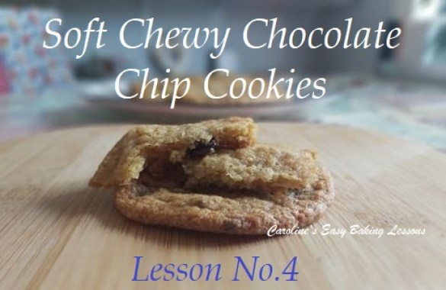
These soft & chewy cookies are make using Anna Olson’s recipe, and I have re-written the recipe in more depth for you. As well as making a few small changes. These are my go-to cookie recipe for my youngest son. You can of course add more things like nuts or change the type of chocolate but try this basic recipe first to avoid disappointment. Simple biscuits or cookies, are easy to prepare but it’s the knowing when to take out of the oven that is key. You have to keep checking and turning as a lot can happen in a minute in cookie land. A timer with seconds is essential and your phone will do. The ideal time to remove the cookies from the oven is when they are just firming up around the edges.
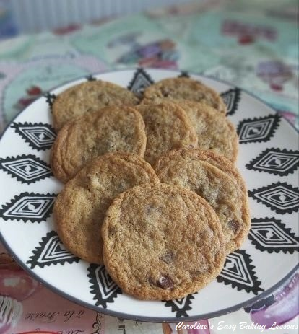
The middle will still be soft, but if you go by the time frame specified in the recipe, then it’s ready to take out and will continue to cook while on the baking tray/sheet. But don’t remove from the tray until the time the recipe advises as too early and the bake might break on transferring. A good tip is to transfer using the baking/parchment paper to avoid dropping any cookies.
This really is a super simple recipe, that it had to be the first of the cookie recipes for the lessons. Look on this as your introduction to cookies if you are new to them or baking in general. The recipe is thorough, but the video below, is real-time and shows you every step in the process, what to look out for and the reasons we do certain things in baking. Please check it out and consider subscribing to my YouTube channel for free.

DOWNLOAD THE LESSONS – Lessons are available to download as a Word Document, by saving to your phone or computer for future use or printing. You can alternatively click the print button either on the bottom or right of your screen. To save to your phone/computer, click the ‘download’ button below:
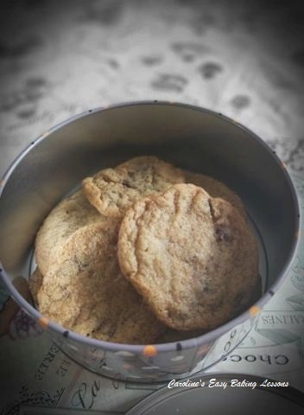

INGREDIENTS (Makes about 14 large cookies)
- 128g Plain flour (4.5oz, 1 Cup AP)
- 1tsp Cornflour (cornstarch)
- 1/2tsp Bicarbonate of soda (Baking soda)
- 90g Chocolate chips/chopped chocolate
- (3 oz, 1/2 Cup) any kind you like.
- 85g Soft butter, cubed & unsalted (3 oz, 1/3 Cup)
- 100g Light Brown sugar (3.5 oz, 1/2 Cup)
- 25g Granulated sugar (scant 2 tbsp, 0.75 oz, or 1/8 cup)
- 1 Egg (medium – large)
- 1 tsp Vanilla

EQUIPMENT
- Scales/Measuring Cups
- Measuring Spoons
- Stand/Hand Mixer or Large bowl & wooden spoon
- Spray Oil or something to grease (optional)
- Baking/parchment Paper
- Baking tray/sheet x 2
- Scoop or spoons for portioning
- Timer or Phone Timer
- Cooling Rack

- OVEN: 180/160c fan/350f/Gas Mark 4

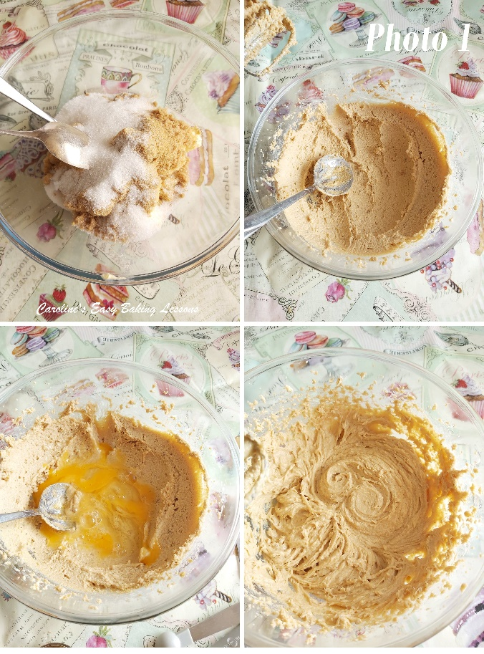

INSTRUCTIONS
1. Weigh out the butter while cubing at the same time and leave out to soften and come to room temperature. Cut into cubes, as a smaller surface area of butter will soften quicker. See the video above, or go to a hack I reviewed for softening butter in 12 minutes.
2. Place the prepared butter in the mixer bowl and beat for about 1 minute with the stand mixer/hand mixer until soft and no longer cube shaped. Otherwise beat well with a wooden spoon for 2-3 minutes.
3. Place the bowl over the scales and set to zero. Weigh in the sugar and mix for 1 minute. This mixing of the sugar and butter is called 'creaming'. See Photo 1 for how it will look once ready. For less powerful mixers, this can take longer. You just want it all combined, and a little paler in colour. It won't change too much though since we are using brown sugar. You don't want to over mix as we don't want as much air in the mixture as say cakes.
4. Add in the egg & also spoon in the vanilla. Mix through well till homogenised or emulsified. These are terms you might hear but all you need to know is it's about combining 2 different elements (different in structure) and making one uniform or similar mass or mixture.
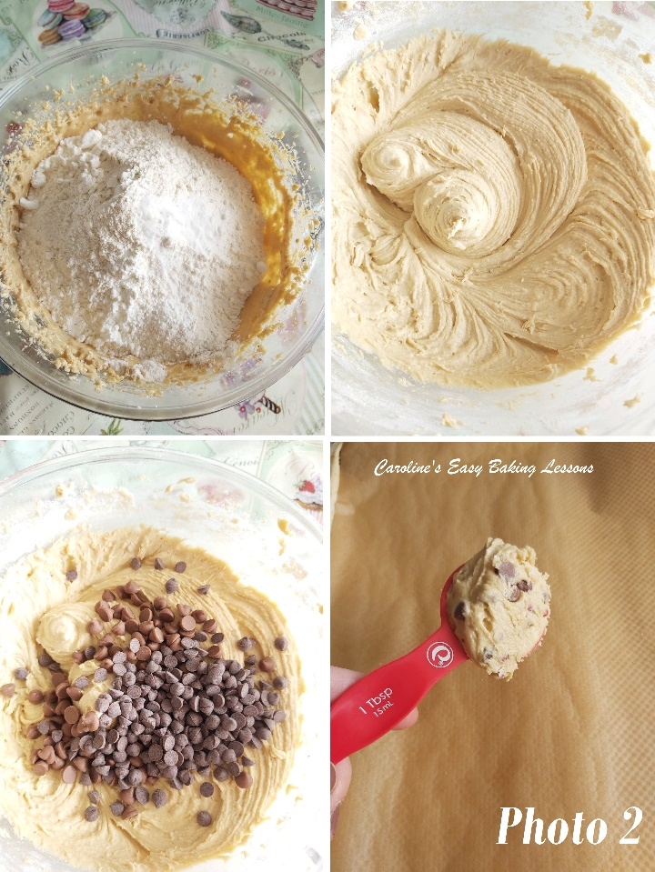
5. Place the bowl over the scales, set to zero and weigh in the flour & spoon in the bicarbonate of soda (baking soda) & cornflour (cornstarch). Alternatively you can mix these 'dry ingredients' in one bowl but I like to save on the washing up. Give just a light mix through by hand with a spoon and then turn the mixer onto low speed, and mix till combined and no flour is visible. Stop during this process to scrape down any mixture from the sides of the bowl to ensure everything is incorporated. (See my video above). Then simply fold in the chocolate by hand. See Photo 2.
6. Prepare the baking trays/sheets by greasing, and placing baking/parchment paper on top. Note you only need to grease them in position if your trays/sheets don't have a lip - otherwise your cookies might fall off (it has happened to me :(
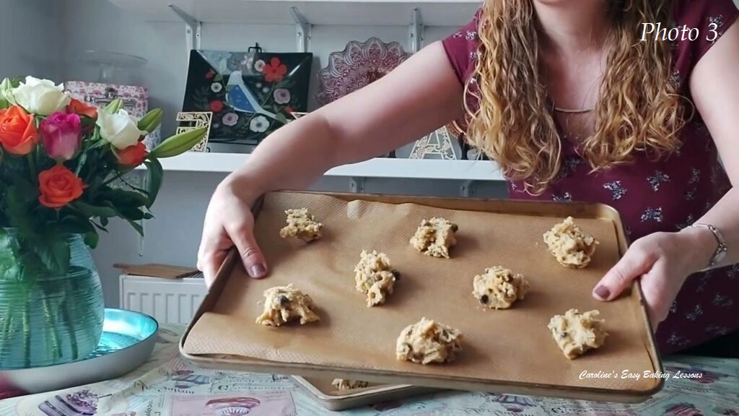
7. Heat up the oven to 180/160c fan/350f/Gas Mark 4 .

8. Meanwhile, scoop out balls of the dough using a table spoon (tbsp) or small scoop. I like a heaped or rounded tbsp worth. Place on the baking tray/sheet about 2 inches/5 cm apart and don’t flatten them out. See Photo 3.
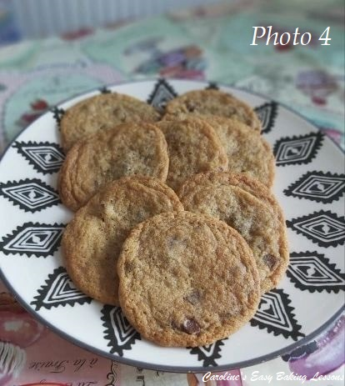
9. Place in the centre of the oven, baking for 8-10 minutes, when the cookies will be golden, but still very soft. In my old oven I used to bake over the 2 levels for 3 minutes, then turn these trays/sheets & bake another 3 minutes. Next I would turn them again and rotate between the shelves and bake for 2 more minutes. At this 8 minute mark I would check to see if they were ready. The ends will be firming and setting up, but the centre soft. I usually give 1 more minute before taking them out. In my new oven, I was able to bake in 9 minutes with no turning. Note however, that this may take up to 10 or 11 minutes in different ovens. Even after cooling these are very soft fragile cookies, so try not to over-bake. Bear in mind too, that they will continue cooking once out of the oven, from the residual heat of the baking sheet/tray. (See Photo 4).

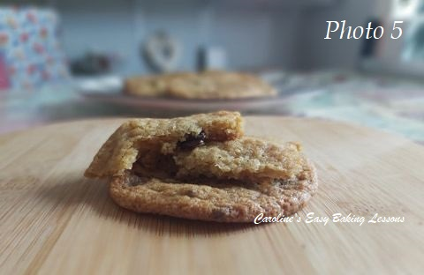
10. Leave on the baking trays for 5 mins before transferring to a cooling rack by lifting the biscuits with the paper. Leave to cool for another 5 -10 mins and then very carefully release the cookies from the paper with a palette knife & eat or store in a tin or airtight container. Don’t leave on the rack too long or they will loose their soft texture and go hard.
- These can be flash frozen after scooping, placed in a food baggie. Bake after leaving out to defrost a little on the counter, and bake as normal.

DIFFICULTY LEVEL : easy, beginner

NEXT STEP
Now that you have completed Sweet Recipe No.4, either practice this recipe again with some more additions like nuts, or proceed to Theory Lesson 8 . Remember to read the lesson before attempting the next recipe and refer to Essential Equipment Lesson if needed.

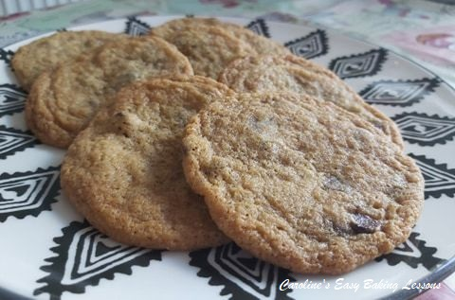

Thanks for reading & watching.
Happy Baking & Making
Happy Memories & Tummies!

Caro x

