EASY MICROWAVE CHOCOLATE FUDGE
Caroline’s Easy Baking Lessons THE SAFER WAY TO MAKE FUDGE!

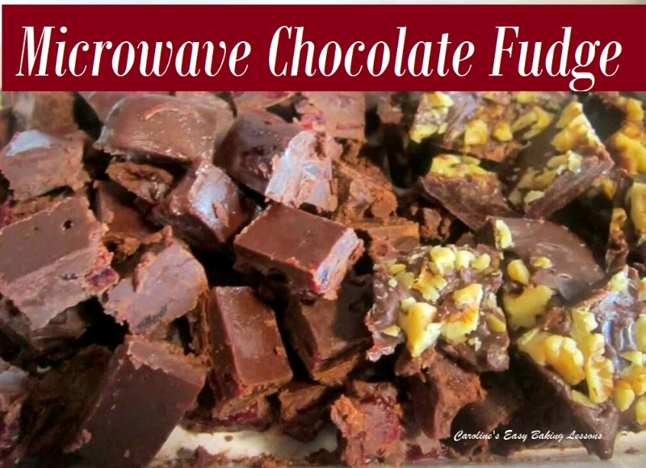
This recipe I came up with myself after trying so many versions of fudge making. I don’t like making anything like this on the stove as mine doesn’t work right and I always burn things, including myself!. So I turned to the microwave and after a lot of practice came up with the best recipe and the quickest. It is best to use a medium-large plastic bowl as when the mixture is nearly ready it starts to come away from the sides of the bowl. You will need some square or rectangular containers, maybe food storage dishes or even chocolate moulds if you want them to look fancy. I have tried Xmas shape and chocolate moulds, but they don’t always come out perfect. So if you use dishes with straight sides/edges, you can concentrate on making sure they are chilled long enough and using a sharp knife cut them cleanly to give a more professional look. But if you aren’t bothered about that, don’t worry, just make sure to oil/grease the dish before putting the fudge mixture in so as to aid removal. The longer you leave them in the fridge, the better they will cut.

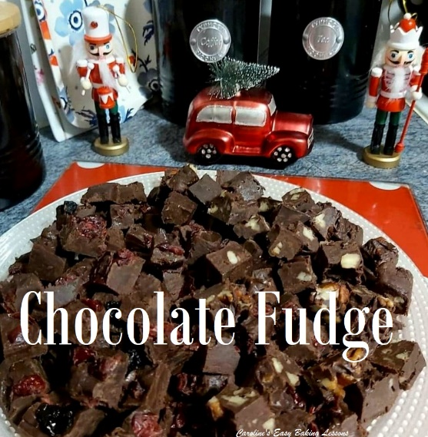
Now be careful of other microwave fudge recipes. Those that just melt and heat, don’t make proper fudge. My recipe is designed to simulate the mixing and heating process of the stove top method. If you heat and mix well enough and keep an eye on the visual cues that it’s ready (ie. the mixture becomes thicker and comes away from the sides of the dish), then you will produce something very very close to stove top fudge. If you want to be super precise, get heating and mixing in bursts, until the mixture reaches 114 to 115 °C (237 to 239 °F).
This batch was made with 1 tin/can of sweetened condensed milk, and I made 3 different flavours out of it: chocolate, chocolate and pecan & chocolate and cranberry. They are all yummy, but you can alter according to different tastes/food allergies etc. These are perfect for food gifts, Valentines and for Xmas presents. Be sure to label the tag that they should be kept in the fridge, so they don’t melt and will keep longer. Check out the quick video on the fudge making process.
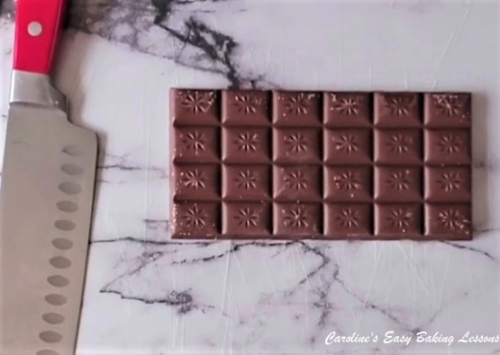
INGREDIENTS

- 200g Dark/Plain/Bitter Chocolate (7 oz)
- 200g Milk/Semi-sweet Chocolate (7 oz)
- 25g Butter, unsalted (2 level tbsp)
- 1 Tin Sweetened Condensed Milk (397g/14 fl oz, 1+ 1/3 cup)
- 2 tsp Icing/powdered Sugar, sieved
- Handfuls of Nuts of choice, (chopped), cranberries, raisins etc (optional)

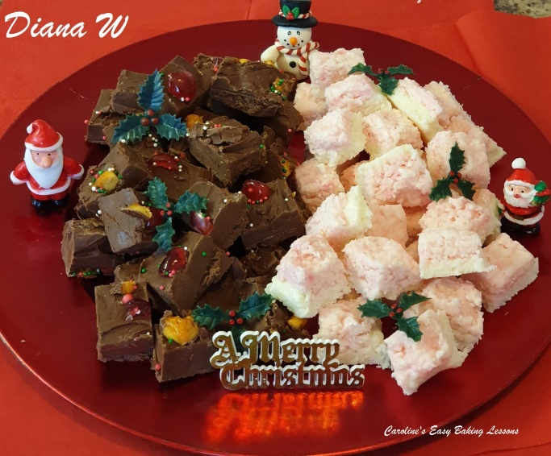
EQUIPMENT
- Scales or Measuring Cups
- Measuring Spoons
- Medium to Large plastic bowl
- Spoons
- Microwave
- Sieve (or small sieve)
- Baking spray or Cake Release Spray
- Cling Film/plastic wrap
- Square/Rectangular plastic tubs, sweet or chocolate moulds

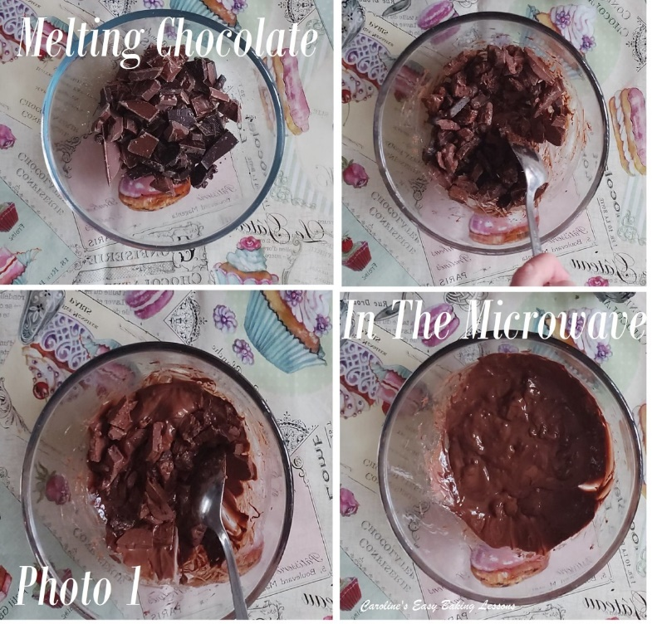

INSTRUCTIONS
1. Break up the chocolate into pieces and place in the large plastic bowl before microwaving for 1 minute.
2. Give the chocolate a good stir around and place back in the microwave for another 30 seconds.
3. Mix thoroughly again as the chocolate will be melting quite a bit now. If it is all melted, proceed to step 5. Depending on the power of your microwave, the time taken to completely melt will vary.
4. If the chocolate is not all completely melted, microwave for a further 30 secs, mixing thoroughly until all melted. It is important to not go higher than 30 seconds or you can ‘burn’ the chocolate and made it hard. See Photo 1.

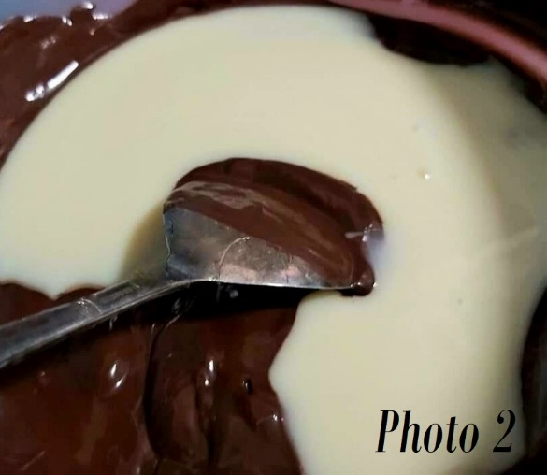
5. Now immediately add the butter and mix well until it is all melted and combined.
6. Next add the tin of condensed milk, (see Photo 2), and mix through before microwaving for 30 secs.
7. Mix the mixture well another time, and microwave for a further 30 seconds. The mixture will be becoming thicker each time.

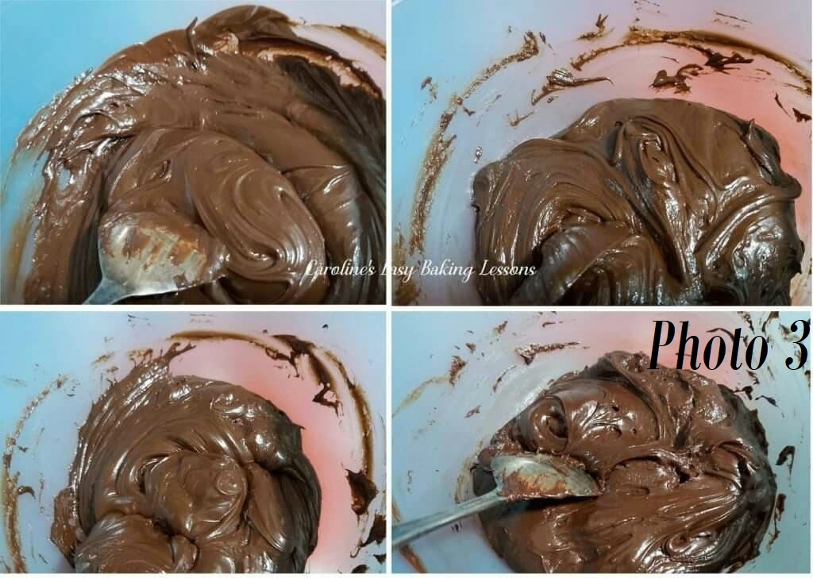
8. Mix again and microwave a further 30 seconds. If the mixture is now coming together and coming away from sticking to the sides of the bowl, proceed to step 10. See Photo 3 above for how the mixture thickens.
9. If not quite ready, microwave a further 30 seconds and give a good mix through and repeat till like in the last pic in Photo 3 above. If you want to be super precise, get heating and mixing in bursts, until the mixture reaches 114 to 115 °C (237 to 239 °F).
10. Now add in the sieved icing sugar (powdered sugar) and mix until all combined.

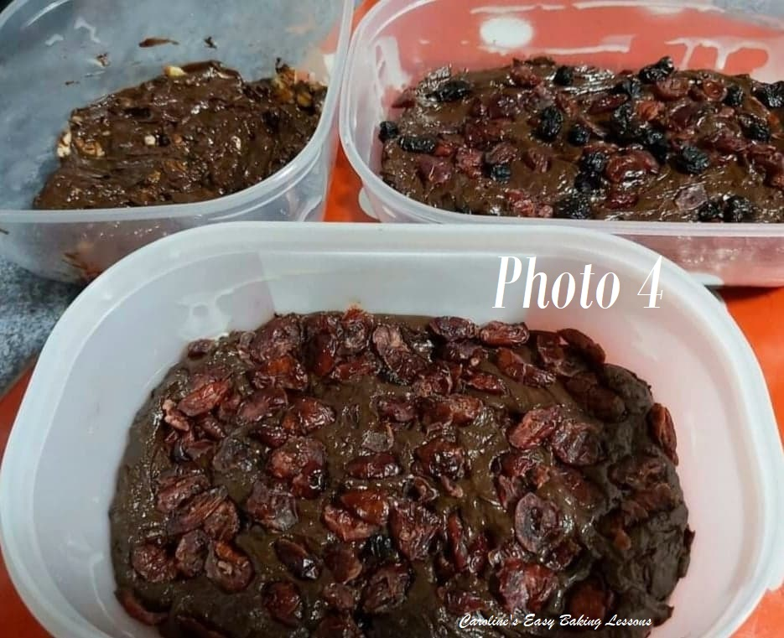
11. Oil/grease the dishes/moulds you have chosen to use. If you want to add other ingredients to the chocolate fudge, do so right now. For this batch I made some with dried cranberries, some with nuts and some with honeycomb. To do this I divided the mixture into 3 dishes and then added the additional ingredients. Then I spooned the mixture into the prepared oiled dish, using a second spoon to help get into the corners, etc. Try to smooth the top as best you can. You can also add some of the ingredients to the top of the mixture too and then it doesn’t need to be as smooth a finish. See Photo 4 above and Photo 5.
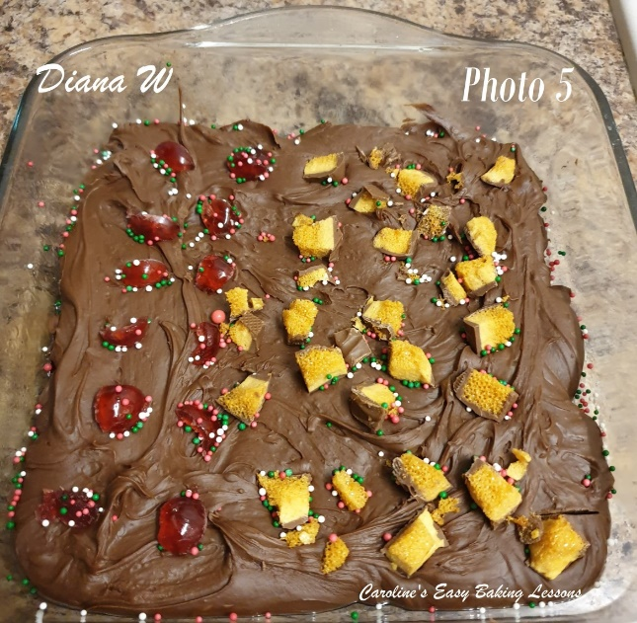

12. Cover with a lid or cling film/plastic wrap and refrigerate for at least 3 hours.
**They will appear set before this but leaving as long as possible makes removal and cutting much much easier.
13. Once set, turn out onto a chopping board and tap until the fudge comes out. Cut with a sharp knife into whatever sizes you like. Run a butter knife all arounds the sides if removal isn’t easy.
**See Photo 5 of Diana’s fudge, with cherries, sprinkles and chocolate honeycomb pieces.

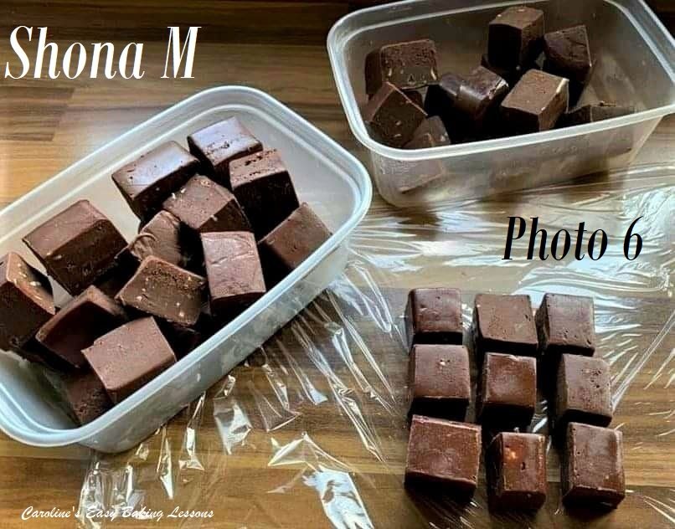
14. They are best kept in the fridge or somewhere cold and wrapped or in an airtight container and can last for weeks.
15. Recently website follower and baker Shona, used the recipe and made those shown in Photo 6. Here’s what she said in a Facebook post – “Chocolate orange fudge using Caro’s recipe but swapping ordinary plain and milk chocolate for orange plain (bitter) & milk (semi-sweet) – YUM! Absolutely unctuous, a real treat! Thank you Caro for a faultless amazing recipe.” I think Shona’s fudge looks amazing and she has got them so neat and straight. Simply perfect and a great treat for Father’s Day (or any other day!)
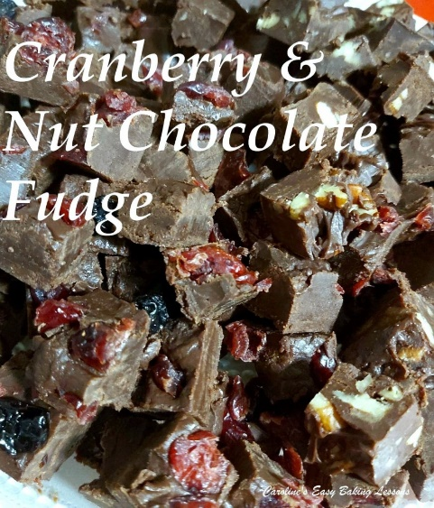

DIFFICULTY LEVEL: easy, beginner

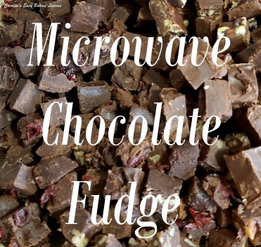
Thanks for reading
Happy Baking & Making
Happy Tummies & Memories!

Caro xx

