Easy Peasy Smokin’ Cheezee Squares

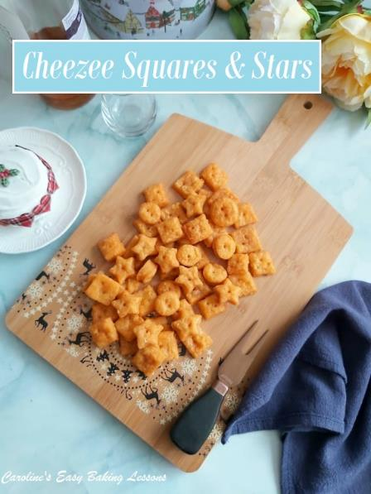
Savoury Lesson No.2
Caroline’s Easy Baking Lessons

Here’s my quick to prepare savoury snack – Easy Peasy Smokin’ Cheezee Squares! Not quite pastry, not quite a cracker, these cheesy snacks are great for entertaining, gifting or nibbling on movie night.
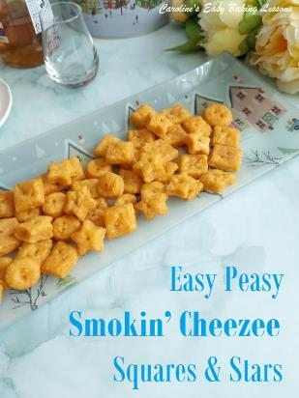

What Is This Snack?
I didn’t know what to call these cheesy morsels. I used extra mature Scottish cheese and smoked paprika, (as I love smoked paprika & I love mature cheese too! It’s like extra sharp cheddar). They aren’t exactly crackers as they are thicker and almost puffy but there’s no difficult process involved like in making puff pastry. Whatever you want to call them – they are very morish. Cheezee squares are kind of like eating cheese & crackers in one bite.
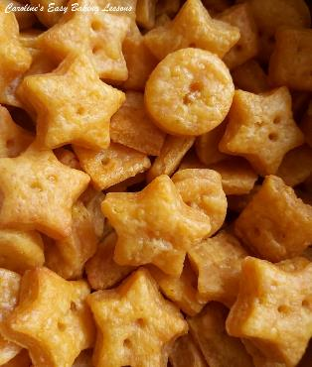

A Spicy Version – Cheespicy Smokin’ Squares
Now the name suggestions also threw up an idea to make a spicy version with hot smoked paprika, which I developed with the help of my friend CJ and she named them Cheespicy Smokin’ Squares! So details of the ingredients for how to make the spicy ones, are included at the very bottom of the recipe. (See Photo).

Quantity Made
I have actually updated the recipe and doubled the quantity as making just one tray of them, is never enough – they taste that good! Quantity of course will depend on what size you make them. But if you make 1″/2.5cm squares, you will get about 110 pieces. But you can easily half the recipe or increase it.
Prepare Ahead Of Time
For speed you can also prepare the dough ahead of time, say night before and place in the fridge. Or, prepare the dough, leave to chill 1 hour, roll and cut out and then place in the fridge to bake next day.

If You Don’t Like Smoked Paprika
If you don’t like smoked paprika, they are just as tasty without. Just make sure to season well and try to get mature hard cheese (sharp cheddar), as this is the strongest flavour that comes through. (You can also replace the smoked paprika with mustard powder and you can find that alongside pickles in the supermarkets).

Chilling Is Key
Don’t skip the chilling time for the Easy Peasy Smokin’ Cheezee Squares either as this really helps the gluten in the flour relax, as well as the bites keeping their shape whilst baking. I use unsalted butter, but if you only have salted, omit it from the recipe.
Perfect For Food Gifting Too
I have been making these Cheezee Squares to include in food gift baskets for Christmas, for several years now. Not everyone likes sweet baked treats (strange I know), so these are perfect as a savoury alternative. Everyone loves cheese, right?

Almost Real-time Video – check the online recipe or my YouTube channel

EQUIPMENT
- Scales or Measuring Cups
- Measuring Spoons
- Grater
- Knife
- Food Processor
- Baking/parchment paper
- Spray Oil or Bottled (optional)
- Large baking tray (or 2 small)
- Cooling Rack
- Wooden Cocktail stick or BBQ Skewer
- Timer or Phone Timer
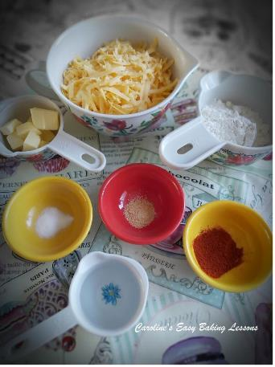
OVEN: 170/150C Fan Oven/325f/Gas Mark 3
INGREDIENTS
- 226g Scottish Extra Mature Cheese
- (or any mature/sharp hard cheese).
- (2 1/4 cup, 8 oz Extra Sharp Cheddar)
- 58g Butter, cubed (unsalted)*
- (1/2 stick, 2 oz)
- 125g Plain Flour
- (4 1/2 oz, or 1 Cup All Purpose Flour)
- 1/2 tsp Salt (omit is using salted butter)
- 1 tsp Smoked Paprika*
- 1/2 tsp Garlic Powder (or onion powder/flakes)
- 3 tbsp Very Cold Water (approx.)
*(As an alternative to smoked paprika, mustard powder can also be used. Omit salt if using salted butter)

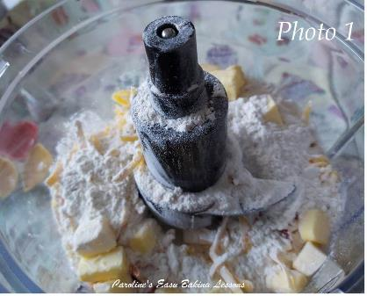
INSTRUCTIONS
1.Cube and weigh out your butter and leave out a little to take the cold edge off. It doesn’t need to be soft.
2.Grate/shred the cheese and weigh out the flour.
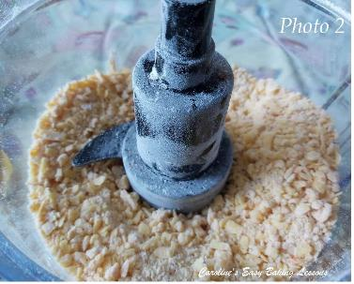
3. Next, place all ingredients except for the water into a food processor (see Photo 1 above). Pulse the ingredients until the mixture resembles breadcrumbs. See Photo 2 of how it should look.

4. Add in the cold water and pulse again until all combined. You can watch this process in the video above or in Photo 3, where the mixture suddenly comes together in a ball, cleaning the sides of the bowl as it does. You might need a little more water to get to this stage but add in very small drops.
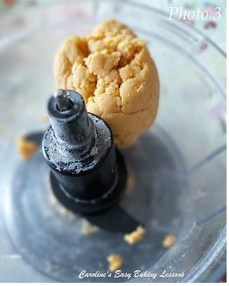

5. Tip the dough out onto baking/parchment paper or cling film/plastic wrap and form into a ball and then flatten to an even thickness disc and then either a rough square or rectangular shape. See Photo 4 (This will make it easier when rolling out later).
**Note if you are going to use a cookie cutter to cut out the snacks, you don’t need to flatten into a square or rectangular shape.

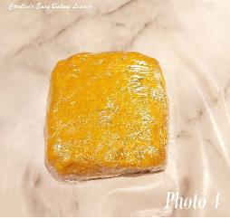
6. Loosely wrap the dough in the paper (or cling film/plastic wrap) & put in the fridge for 1 hour. This is crucial and makes re-rolling of the dough scraps easier too. Go wash the dishes or have a rest and a coffee
7. Prepare your baking sheets/tray(s) by lightly oiling them and placing baking/parchment paper on top. (This is if they have no lip – my cookies have fell off the baking tray/sheet before and you don’t want that).

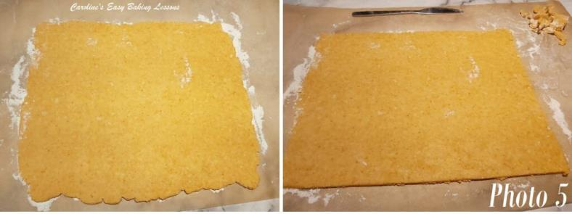
8. Now give the dough a few hard bangs with the rolling pin whilst pushing down and putting a lot of weight on it. Open out the paper & now roll out and try to get an even thickness all-around of about ¼ in or 6mm. (Lightly flour baking/ parchment paper for rolling if you used cling film/plastic wrap). If you are able to roll out into a square or rectangular shape, this will make cutting into squares easier. (Or trim to shape like in Photo 5 above). But if not don’t worry and you can always use a small cookie or fondant cutter. Any cracks forming when rolling, just join back together before continuing rolling. See Photo 5 above.
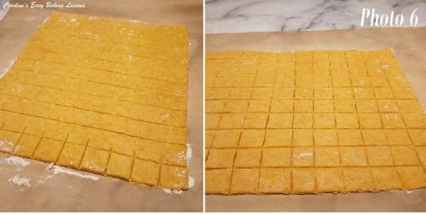
Cutting squares for Cheezee Squares
9. Now cut vertical strips, leaving a 1 in/2.5cm gap in-between. See Photo 6 above.
10. Turn the baking/parchment paper so you can cut lines in the opposite direction to make 1 in/2.5cm wide squares. See Photo 6, right pic.

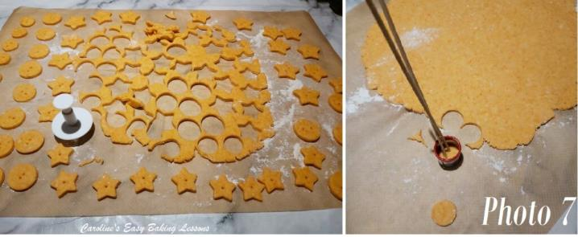
11. Heat up the oven to 170/150c Fan Oven/325f/Gas Mark 3.
12. Remove any incomplete squares. Place the full squares of dough on the prepared baking tray(s) and leave a little space in-between them. See Photo 8.
13. Now use a wooden cocktail stick or BBQ skewer to make 2 or 3 holes in the centre of each square, going down about halfway. See Photo 7 & 8 (If making a big batch, for speed, I held 2 bbq sticks with a little gap in-between to make 2 holes at once).

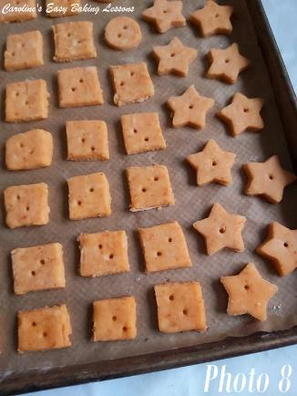
14. Now roll up the excess dough and roll out to the same thickness as before and cut out more squares. Repeat until all dough is used up. Place remaining dough squares onto the sheet/tray. See Photo 8.
For Christmas and New Year I also tried making these with cookie and fondant cutters. In the end it was much quicker than cutting the squares (I was a little OCD with that and measured them to cut the lines). The push release cutters were the easiest. I really liked the star shaped ones, and made in small (about 2.5cm/1″) and tiny ones (at about 3/4″/8mm). The stars really held the shape good and are great for New year. (See Photos 7 & 8).
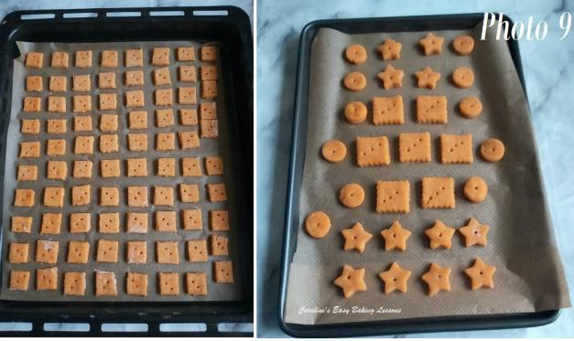

15. Bake in the oven for about 8 – 10 minutes, turning sheets/tray(s) during baking to ensure an even bake. With the colour of the smoked paprika it is more difficult to tell when done. For plain ones, they are done when golden, but at about 8 minutes. They will be puffed up & when you will be able to move them slightly, when gently pushed, take them out. Mine bake at 9 minutes. See Photo 10 below. Note the tiny ones took about 7 minutes. I also made some squares a little bigger than 1″/2.5cm and these took about 10-11 minutes.
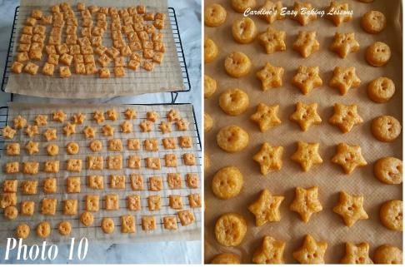
16. They will still be a little soft, so leave on the baking sheet/tray for at least 5 minutes, before transferring to a cooling rack, paper and all. See Photo 10. They will deflate just a little once out of the oven.
17. Eat when you can’t wait any longer and store in a tin or airtight container (if there is any left that is!)

CHEESPICY SMOKIN’ SQUARES
For the spicy version, make as above, but add the following to the dry ingredients:
- Swap 1 tsp Smoked Paprika with 1 tsp Hot Smoked Paprika
- 2 tsp Oregano (rounded/heaped)
- 1 tsp Cumin

DIFFICULTY RATING – Easy, Beginner Level
Rating: 1 out of 5 in difficulty

Thanks for reading & watching the video. Please let me know if you make these & enjoy them.
Next step is to proceed to Theory Lesson 5 – Mixing Cake Batter & Dense Cakes.

Happy Baking
Caro
Caroline’s Easy Baking Lessons
https://easyonlinebakinglessons.com

