PINEAPPLE UPSIDE DOWN BUNDT CAKE
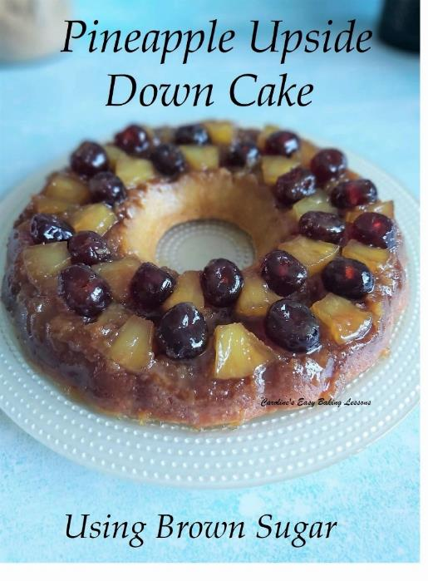
Caroline’s Easy Baking Lessons

Here's my recipe for classic Pineapple Upside Down Cake, but this time I used a new Bundt pan I got. It's a little wider than my other one, so the cake is a little less deep than the old one I used to bake it in. It is 26cm (10") at its widest point.

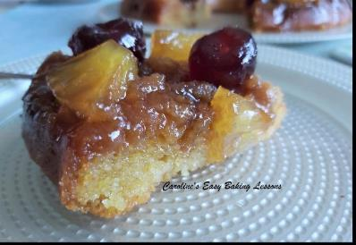

The pan I normally use is 22cm (8.5 ") diameter at it's widest, 16cm (6") at it's smallest and 10.5cm (4") in full depth. But you can make in regular round tins up to a diameter of 23cm (9 inches) and with a depth of 5cm (2 inches). I would not recommend going any wider a tin than that or the cake will be too shallow, as it isn't a deep cake as it is.

What I love about this cake the most is not the sugary fruit topping or the pretty way it looks once baked and turned upside down. It's the moisture that the cake absorbs from the sugar mixture and fruit, that works it's way up the cake (when baking) and gives the cake such a moist flavourful taste. See Photo 2 above of the inside of the cake.

The recipe is super simple too, there’s just a few tips you need to know to get the cake out of the tin successfully to produce a photo ready cake. (You can also read my tips on lining cakes of any shape - go to article).

Full instructions given in the recipe below. Now just a little note on the ingredients and method. Some recipes have you making caramel first, this recipe is easier, and skips this part. You can also make it using light brown or white sugar. Most of my photos are of it using the light brown sugar but I have also included pics by my friend Diana, who made it using white sugar. The brown sugar gives it a darker colour and slightly deeper flavour than the white sugar, but the choice is yours.

INGREDIENTS

For The Topping:
113g Butter, unsalted, cubed & softened (1 stick or 1/2 cup, 4 oz)
170g Light Brown Sugar (1 packed cup's worth less 2 tbsp, or 6 oz total)* see notes
2 tbsp White Sugar
OR 200g White Sugar (7 oz, 1 cup)
4.5 tsp Maple Syrup or Pure Honey
1/4 tsp Vanilla Extract
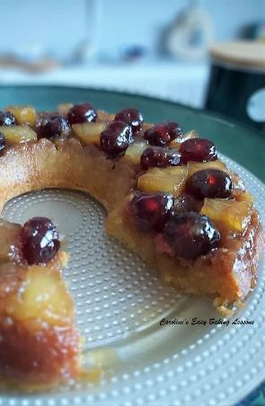
Pineapple slices or chunks, from a can (My can was 420g/ 10.5 fl oz with juice and I used about half. I used only 3 rings, so even a small can would be fine, but depends on the size of your tin and the design you want to make.)
200g Maraschino/Glace Cherries (will need at least half, so about 3.5 oz)

For The Cake Batter:
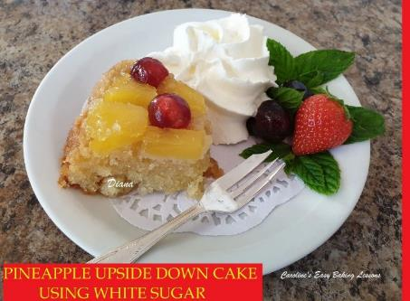
Photo 5 – Diana’s white sugar cake

113g Butter, unsalted cubed & softened(1 stick, 1/2 cup, 4 oz)
125g Granulated Sugar (scant 2/3 cup or 4.5 oz)
2 Eggs, large & room temperature (Extra large US)
4 tsp Milk
157g Self-raising Flour (1 & 1/4 cup or 5.5 oz)
OR All Purpose/Plain Flour plus 1.5 tsp Baking Powder & 1/8 tsp salt
2 tsp Baking Powder (be sure to also add if not using self-raising)
1/2 tsp • Vanilla Extract

EQUIPMENT

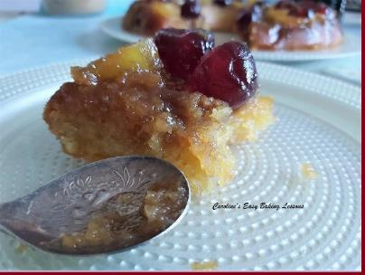
Scales or measuring cups
measuring spoons
Stand/hand Mixer
Knife and chopping board
Bundt pan or round pan (see above)
Timer or phone timer
Cocktail stick or toothpick
Cooling rack
2 baking trays/sheets,(at least size of pan)
Tea-towel

OVEN: 170c/150c Fan Oven/ 325f/ Gas mark 3.
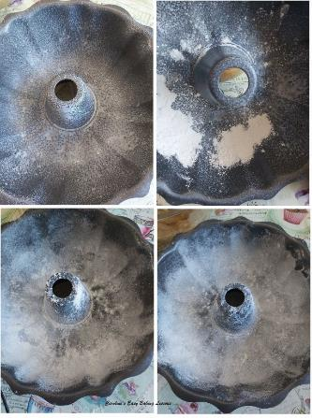
INSTRUCTIONS

Photo 7 - greasing & lining a bundt pan

1. Weigh or measure out the butter while cubing it and leave out to soften. Separate into 2 dishes for the topping and for the cake batter.

2. Once the butter is softened (it should squash easily between your fingers when gently squeezed), prepare the cake pan by greasing or oiling it really well with baking spray, and pay particular attention to the curved areas. You can also add flour on top if you like. Just add some and shake the pan and tilt it, to let more flour be moved about until all covered. See Photo 7. **If using a regular tin, grease & line the bottom of the tin with paper too.
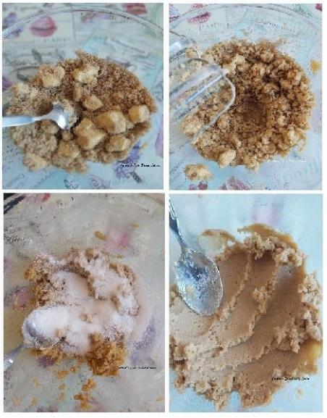
Photo 8

3. Prepare the sugar topping mixture by mixing one of the softened butters & your white or brown sugar together in a large bowl by hand, just until the butter is coated with the sugar. See Photo 8, top left pic. Then with a stand or hand mixer (use the 'k' or paddle attachment on your stand mixer for this), begin to beat the mixture till the butter starts to break up. If using the light brown sugar, remember to also add the 2 tbsp of white sugar. Add in the vanilla & honey or maple syrup, & mix on medium - high speed for about just 15 - 20 seconds. Press down on the mixture with the back of a spoon and it should be like a paste, but a gritty paste. See Photo 8, bottom right pic.
Photo 9 – preparing cake batter
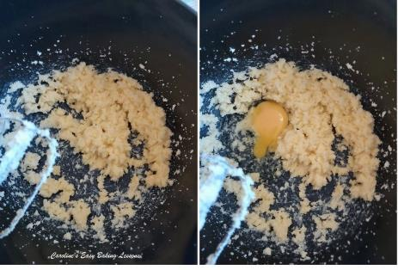

4. Set the sugar paste mixture aside, and prepare the cake batter. Begin by creaming the soft butter & sugar till lighter, smooth and creamy looking. See Photo 9.

5. Now add in the eggs, one at a time, mixing till incorporated in-between each addition & finally mix in the vanilla & milk.
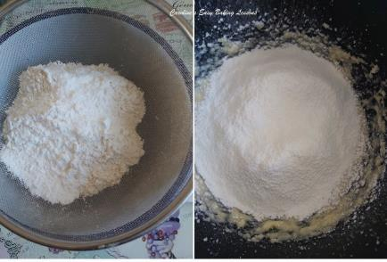

Photo 10 – sieving & adding in flour

6. If using plain or All Purpose flour, sieve the flour and baking powder into a separate bowl. Then sieve this flour again into the sugar, butter & egg mixture. If using self-raising, you only need to sieve once. Remember to also sieve the baking powder and also the two amounts of it, if not using self-raising. See Photo 10.
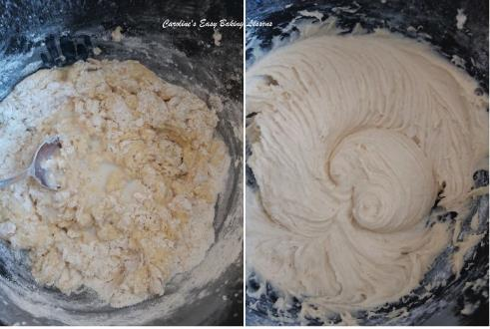
Photo 11 – beating the batter.

7. Fold in the flour by hand lightly so that the mixture takes on some of the flour and doesn't go everywhere once you switch the mixer on. If you have a splash guard, use that. Then use the mixer to incorporate the flour into the mixture. Don't over-mix as this is what leads to a dense bake. Just mix until no more dry ingredients are seen. Be careful to check the bottom of the bowl, as well as scraping down the sides of the bowl if need be. See Photo 11.

8. Heat up the oven to: 170c/150c Fan Oven/ 325f/ Gas mark 3.

9. Now you can add the sugar paste mixture onto the bottom of the prepared bundt pan before adding the fruit, or the opposite way around. I usually add sugar paste mixture first, but last time taking these pics I wasn't thinking & did it the opposite way.

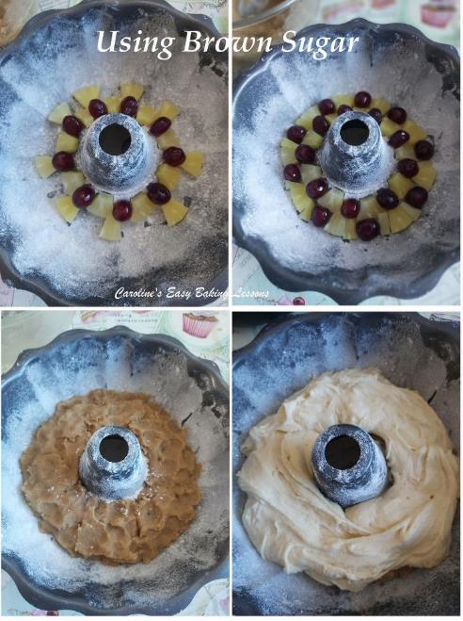
Photo 12 – filling the pan using light brown sugar

I added on the cherries near the centre of the tin, leaving space for pineapple pieces and then positioned some on the outer edge, where I also cut smaller pieces of pineapple to fill the wider gaps. So before preparing your tin, it's a good idea to decide on what kind of patter you want, if any. And remember you can use whole pineapple rings if baking in a regular cake tin.

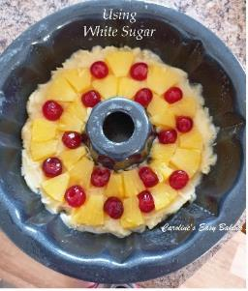

Photo 13 – Diana’s using white sugar & different order or preparation

10. I then took large spoons worth of the sugar paste and squeezed together in my hands and flattened out to position carefully on top of the fruit. I continued until all sugar was used up and made sure the fruit was all covered. If you are worried about messing up the fruit pattern, add the sugar paste first and then add the fruit, just as Diana did, when she used white sugar for the recipe. See Photo 13 above.

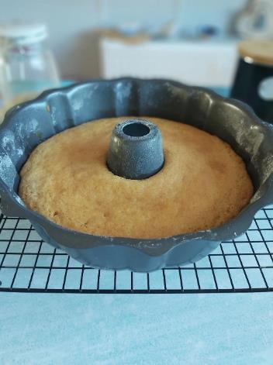
11. Now spoon the cake batter into the pan, ensuring there's an even layer of batter on top by spreading out with a spoon. See Photo 12 above. Then give the pan a few gentle taps on the worktop/counter to expel an air bubbles.

Photo 14 – baked caked

12. Place pan on top of a baking sheet/tray for easy moving and to ensure it sits level. Bake for about 30 - 40 minutes till a wooden toothpick comes out clean of crumbs. My oven doesn't bake evenly, so I turned the tray at about the 20 minute mark. If the top is browning too quickly, cover with some foil & another baking sheet if need be. Mine baked at the 32 minutes mark but if you use a deeper pan it may take longer. See Photo 14.

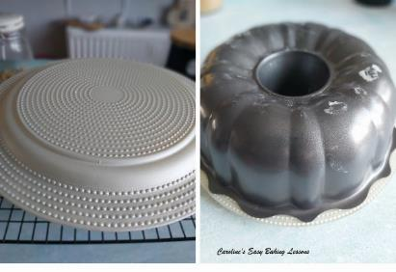
13. Leave on the tray and in the pan, and place on a cooling rack. It will continue to cook, so leave for at least 30 minutes to cool down a little. But to ensure you get the cake out, fruit and all, do not let it get completely cooled down. Run something rubber or plastic down the sides of the cake, only part of the way so as not to break off the fruit (only if needed). Place a serving plate on top of the pan and while holding both, flip it over. Then place both onto the worktop/counter and gently tap and try to release the pan from the cake. Hopefully it will come off easily. If it's not too cool, there won't be too much sugar mixture left behind and the fruit and cake should all be moist. See Photo 16 of Diana's using white sugar.

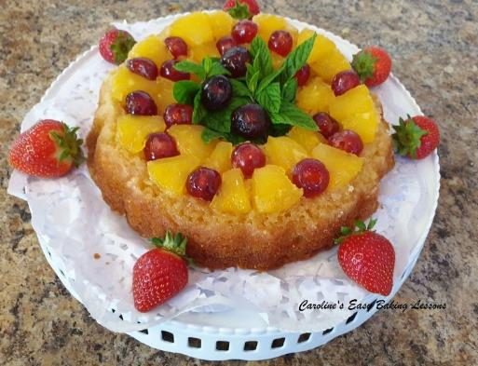

Photo 16 – Diana’s cake using white sugar.

15. Slice and enjoy! Store any leftovers in a cake tin or sealed container for a several days. After time, the sugar mixture will become crispier.

Thanks for reading.

