BAKING TIPS - OVER-MIXING CAKE BATTER - Dense Cakes
Caroline’s Easy Baking Lessons Theory Lesson 5

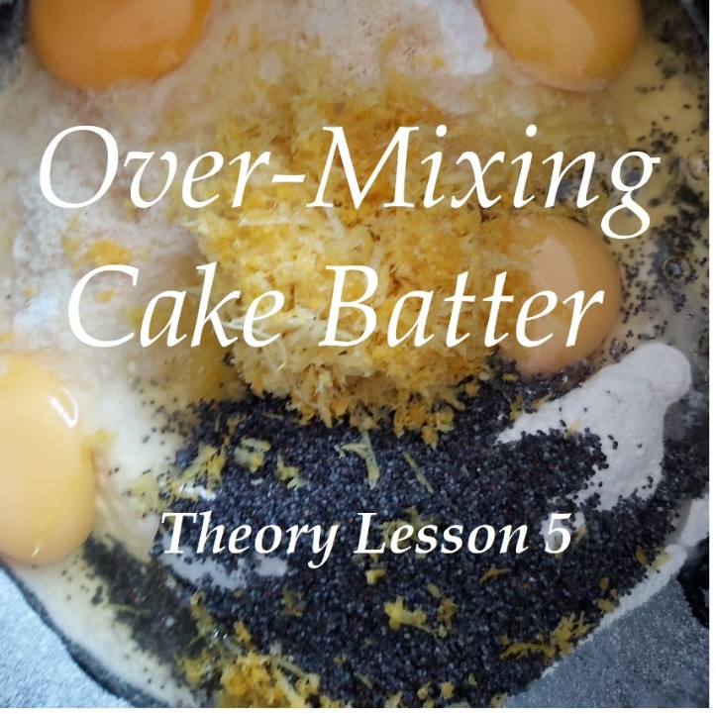
I often hear people asking why their cakes turn out dense all the time and don't have the correct rise they should. So I thought I would do a video discussing how over-mixing the cake batter can cause this, as well as what other things can cause this too. The video is real-time to show how little mixing is required to get the ingredients to an 'incorporated' state.

Go to the video.

THINGS THAT CAN CAUSE A DENSE BAKE

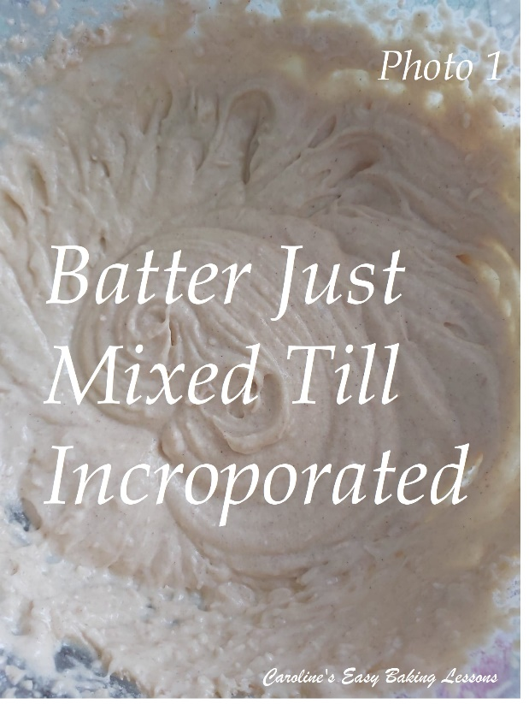
1. Over-mixing the cake batter. Any air incorporated will be lost and you are deflating the bake. Only mix until everything is incorporated. Often you will hear or read 'just till incorporated'.

2. Using an 'All-In-One' Method instead of 'creaming' the butter and sugar together. Creaming is very important to incorporate air - the friction between the small sugar grains and the butter create this. Omitting this important step greatly reduces the amount of air in the butter. With 'All-In-Ones' there's a tendency to over-mix too, to ensure everything is distributed evenly.

3. Using oil instead of butter means no creaming and less air in the batter, just like in number 2 above.

See Photo 1.

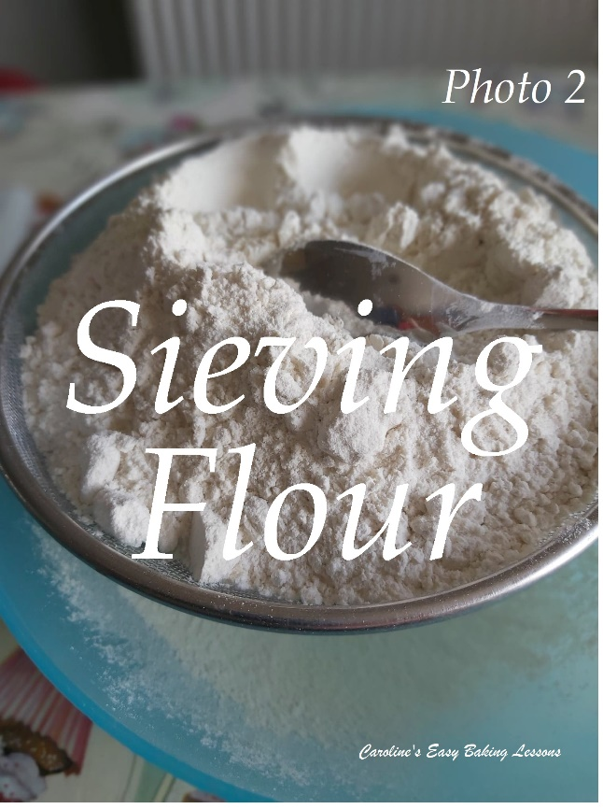
4. Not sieving the flour and raising agent. This doesn't just get lumps out, it incorporates air too. I always sieve and sometimes twice. The higher up you can hold the sieve the better. You can also mix the dry ingredients whilst sieving, ensuring an even distribution.

5. Raising agent might be out of date. The baking powder, bicarbonate of soda (baking soda) or cream of tartar might be past it's best. Also note that the bicarbonate (baking soda) is moisture activated, so always bake the batter as soon as you can. Don't leave over-night for example. If there is baking powder only, that is heat activated so can be prepared in advance without too much adverse effects.

6. Not tapping the tin or cupcake tray on the counter/worktop before putting in the oven. I do this always, just to ensure no trapped air.

See Photo 2

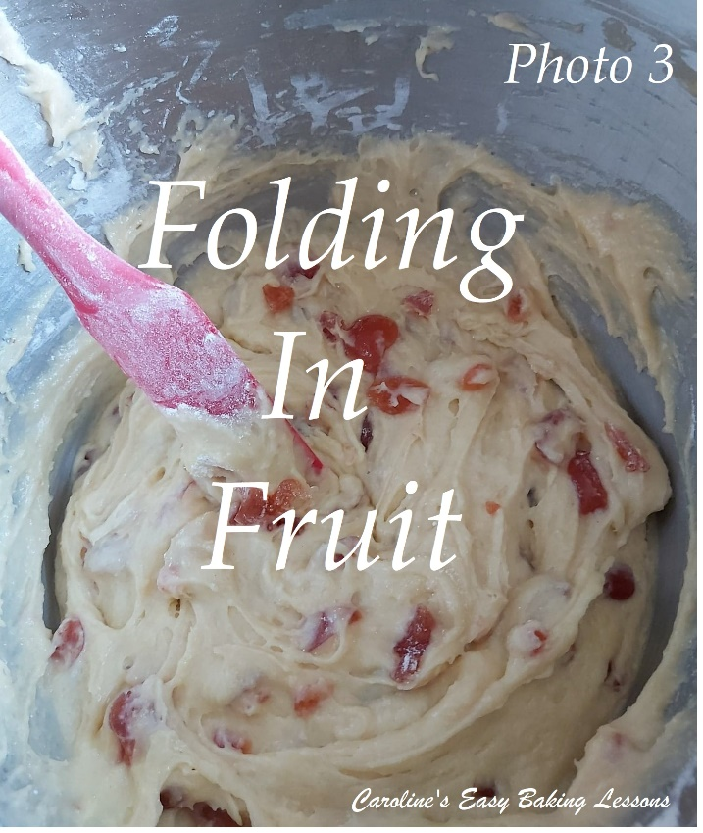
7. Recipe with too much raising agent. Recipes for example with self-raising flour and additional baking powder, can contain too much leavening. There can be too much baking powder in proportion to the flour and cause a premature rise, and because there is not enough flour or eggs to support this rise, it has nowhere to go but down. In addition to this, it can give the bake a bitter metallic after-taste that is not pleasant. This is why when I give the amounts for using plain/all purpose flour instead of self-raising for US/Canadian readers, I use slightly less than normally recommended.

8. The recipe can be poorly written and not tested enough. Unfortunately, there are way too many recipes on-line & indeed in books, that just don't work they way they should. I have reviewed enough to know this and often research and check feedback before attempting them.

9.Using a metal spoon/spatula for folding. Using a plastic/silicone or rubber spatula is best when folding in ingredients. Metal is sharper, and whilst it can 'cut-through' better, it knocks out incorporated air. Folding is also important if you have whisked egg whites or yolks for example because you don't want to deflate the batter. Folding should be done as if you are writing a number 8 just until no more of the dry ingredients are visible.

I have a few more cake related videos that might be of interest. Check them out on the Everything Cake Playlist on my Youtube Channel.

Happy Baking & Making
Happy Memories & Tummies!
Caro xx

