CHEESE SCONES – A Savoury Version Of My Classic British Scones

Caroline’s Easy Baking Lessons
Here’s my version of a cheese scone (as in British Scones). After my scones recipe was used in a worldwide group bake along earlier this year (in a Facebook Great British Bake Off Group), I was asked to develop some flavoured versions. To get the classic rise and split structure of this type of bake, there are important things not to do, and this also includes being very careful with any weight you add to the dough. So I have developed a cheese one and I used small cubes of Scottish Extra Mature Cheddar (like a very sharp cheddar) inside the dough and near to the end of baking, added some grated/shredded cheese on top.

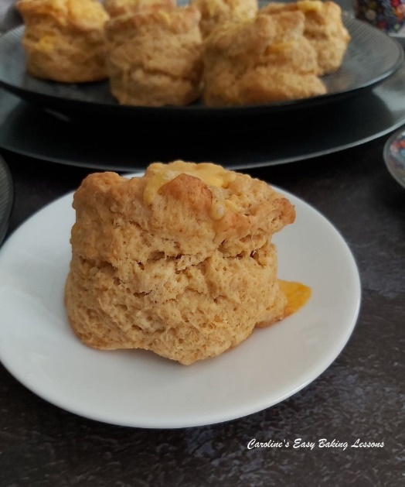
They are also flavoured with mustard powder. I had never tried this before I needed it in a cheese recipe I wanted to try, and eventually found it in Asda in the condiments aisle. It really does bring out the cheese flavour. As a substitute, you can also use Smoked Paprika. I also added a little sprinkle of garlic powder in the dough and sometimes a touch of smoked paprika on the top. You can add more of these if you want, but try these as they are first and take it from there.

A NOTE ON INGREDIENTS
Just a little note on the other ingredients. I used self-raising flour and you can also use self-rising. Plain or All Purpose flour also works well. These scones were successfully baked in the States in the bake-along with generic all purpose flour. (Just remember to add the 2 stated amounts of baking powder). Even gluten free flour works too, (with the addition of 1 & 1/8 tsp Xanthan Gum), and some used coconut and goats milk because of intolerances. Both

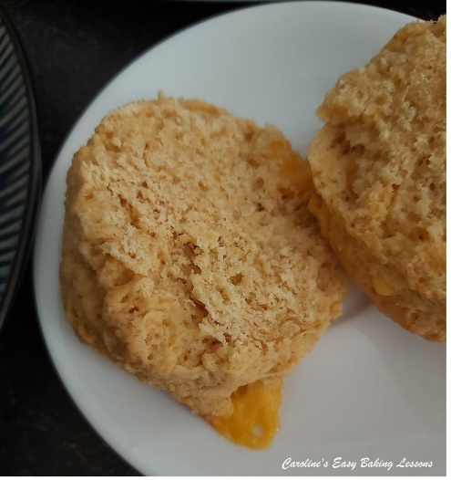
worked but give less of a golden finish to the scones because of lower fat and sugar content. The recipe also uses caster sugar. Now it is only a small amount and is purely there to help with the structure of the bake and also preserves the bake a little too. Extra/ultra fine or bakers sugar is a perfect alternative or you could just pulse the sugar from regular granulated sugar. Just note that US granulated is a little finer a granule size than our UK equivalent. See photo below of our sugars in the UK.

If you want to learn more about Differences Between UK & US Baking Ingredients – click here. My recipes ALWAYS include tested measurement conversions, but if you are needing help with other recipes, check out my Conversion Of Common Baking Ingredients article. It includes a handy table, easily shared or saved

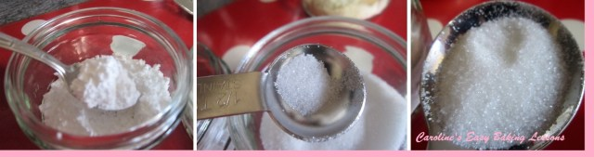
UK Icing (Powdered) Sugar (L), Caster Sugar (M) & UK Granulated (R)

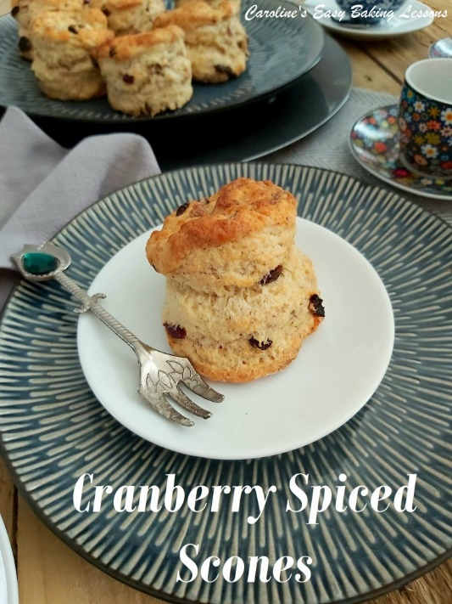

VIDEO TUTORAIL – REAL-TIME
Now I also have a couple of videos on the process of scone making. One about the things not to do, as this is where most problems arise. For more details on that, see this video on scone tips. For an almost real-time video, go to my Classic Scones Tutorial below. (My 2020 one is still on my Youtube Channel, but I made a better quality one this year which you can view below). This shows how little and gentle handling is required. Many people who joined in and used my recipe, have now got the rise to their scones just from watching this video, so well worth a watch.

INGREDIENTS
- 450g Self-raising Flour (15.75 oz) OR (3 & 2/3 cups Self-rising Flour
- OR AP/Plain Flour, plus 5 + 1/2 (level) tsp Baking powder + scant 1 tsp salt) *
- 2 tsp Baking Powder (2 rounded tsp)
- 75g Butter, unsalted, cubed & at room temp (level 2/3 stick or 1/3 cup, 2.5 oz)
- 2 – 3 tsp Mustard Powder or Smoked Paprika (optional but worth it)
- 1 tsp Garlic Powder (optional)
- 1/2 tsp Salt
- 50g Castor Sugar (level ¼ cup*, 1.75 oz)
- 100g Extra Mature Cheese, chopped to about 7.5cm (about 1/3 Inch)
- (1 1/3 cup extra sharp cheddar, cut as above)
- 2 Eggs, med-large
- 225ml Milk (up to 1 cup, 8 fl oz approximately)

Topping:
- 50 – 75g same cheddar cheese, grated (optional) (3/4 cup, 1.75 – 2.5 oz Extra sharp cheddar, shredded)

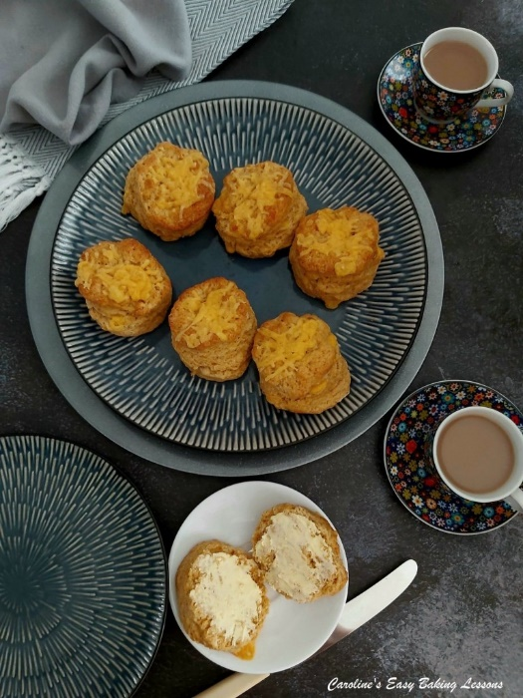
My Cheese Scones, sliced & buttered

EQUIPMENT
- Scales or Measuring Cups
- Measuring Spoons
- Knife
- Chopping board
- Grater/shredder for cheese
- Small Jug
- Large Bowl
- Pastry Cutter (optional)
- Large Spoon
- Cookie Cutter (round), or Glass rim (6-7cm or 2 1/3 – 2 3/4″)
- Baking Tray – 1 Extra Large or 2 medium
- Baking/Parchment Paper
- Pastry Brush or new Artist/Paint brush
- Timer or Phone Timer
- Small Bowl
- Cooling Rack

OVEN: 220c/200c Fan Oven/425f/Gas Mark 6.

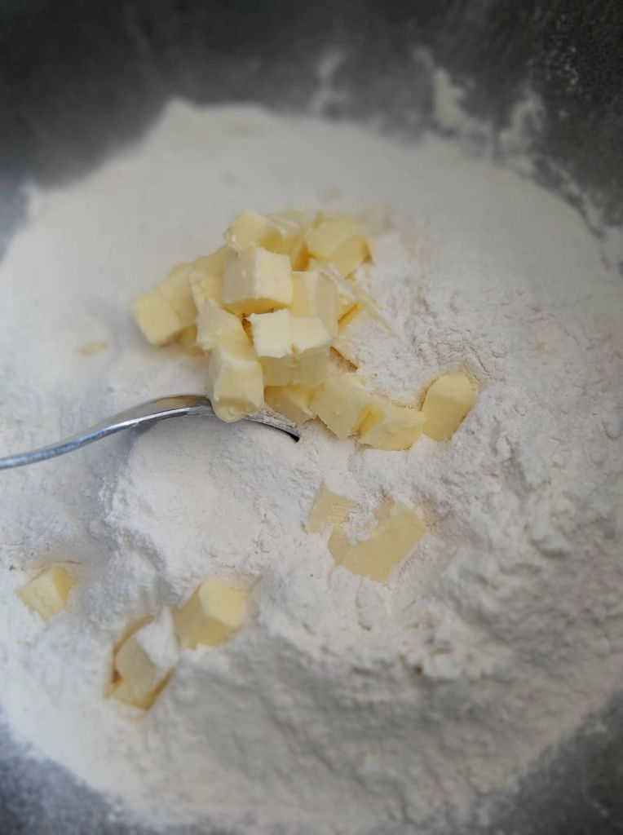

INSTRUCTIONS
1. Weigh out the butter whilst cubing it and leave out to come to room temperature. I like to cut my butter to about 1 1/4cm (1/2″) size as smaller surface area will soften quicker. But if you are short on time, try this hack I reviewed, for softening butter in about 11 minutes. See Photo 1.
2. Place baking/parchment paper on top of the baking sheets/trays. (Hold in position with some baking spray/butter/lining paste if they are flat and have no lip or your bake can fall off – this has happened to me with cookies!
3. Weigh or measure in the flour into the same bowl, spoon in the baking powder & give it a mix through before you drop in the butter. See Photo 1.

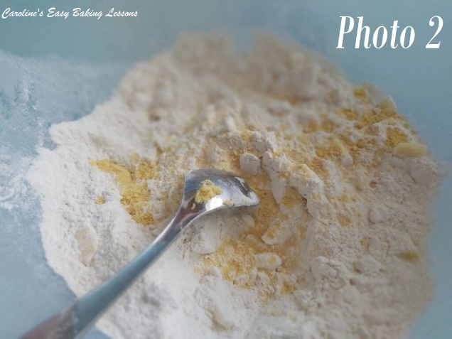
4. Using your fingertips, rub the butter into the flour & continue to do this until the mixture resembles breadcrumbs, (tiny pieces). See the video for how this is done. I use a pastry cutter for this job as my fingers get sore. You push down into the bowl and do a squishing motion whilst rotating the cutter left and right. Repeat this until all the butter is now in very tiny pieces coated by the flour. Alternatively, you can use two butter knives and cut through the butter (this is where the term ‘cutting in’ comes from). See Photo 2.
5. Then add/weigh in the sugar & mix till distributed evenly. Next add in a pinch of salt, garlic & mustard powder or smoked paprika and mix till evenly distributed. See Photo 2 where mustard powder was used.

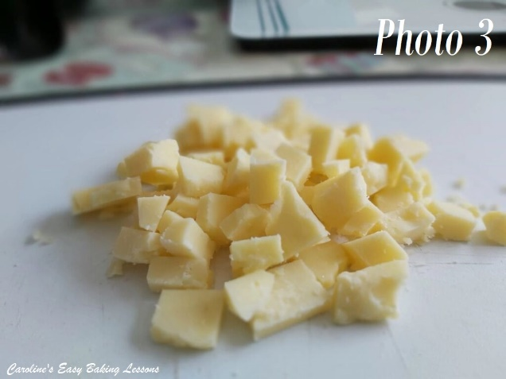
6. Next roughly dice the cheese into pieces about 7.5cm ( 1/3 “) like in Photo 3.
7. Add in the chopped cheese and mix till coated in the dry mixture.
8. Now beat the eggs in a jug and then top up to the 300ml (10 fl oz,1 1/4 cup) mark with the milk, (depending on the size of the eggs, you might not need as much milk).
9. Give the liquid a good whisk and then take 2 tbsp of it out and place in a small bowl to use later.

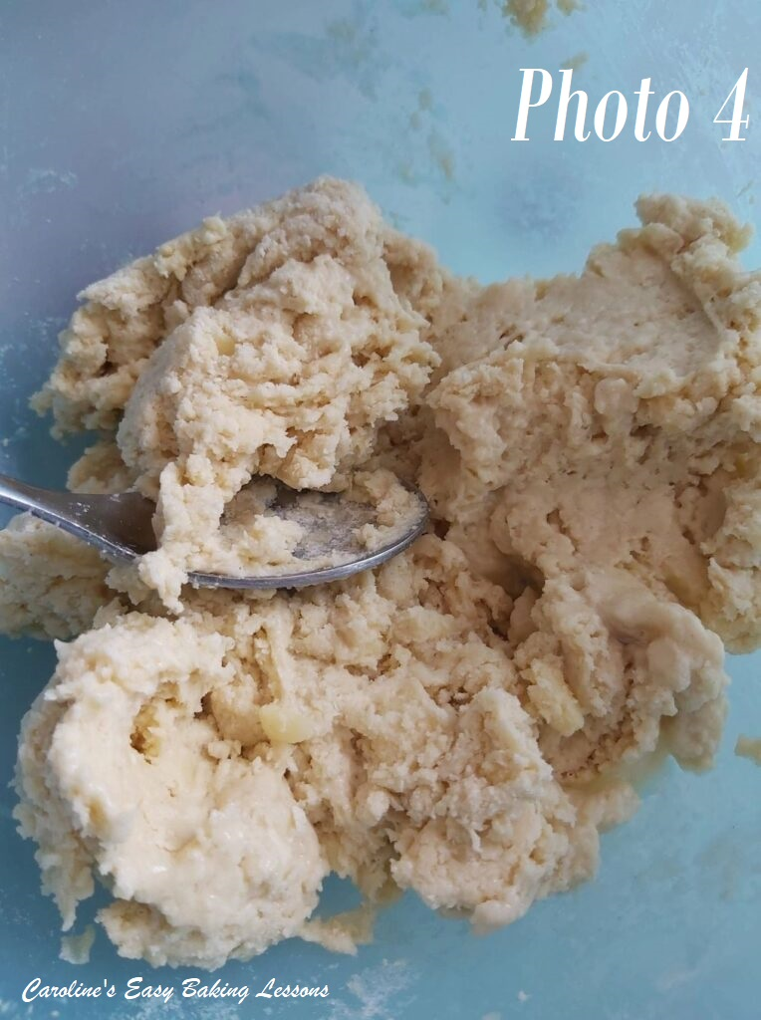
10. Gradually add the egg/milk mixture to the dry ingredients, mixing with a wooden spoon or spatula, until a soft dough is formed. Be aware that the dough being a little bit sticky is good for the scones to rise. But only add enough of the liquid until just sticky. **So you may not need all the liquid. See Photo 4, (of the dough using mustard powder – if using smoked paprika, it will have a stronger orange tinge). Do this by hand and don’t use a food processor as it can make the scones tough. Same goes for kneading, only bring the dough together until combined and soft. (See video)
11. Next flour a pastry board or worktop/counter or use some baking/parchment paper with a little flour on top.
12. Heat up the oven to: 220c/200c Fan Oven/425f/Gas Mark 6, (or do so sooner if your oven takes longer to come to temperature).

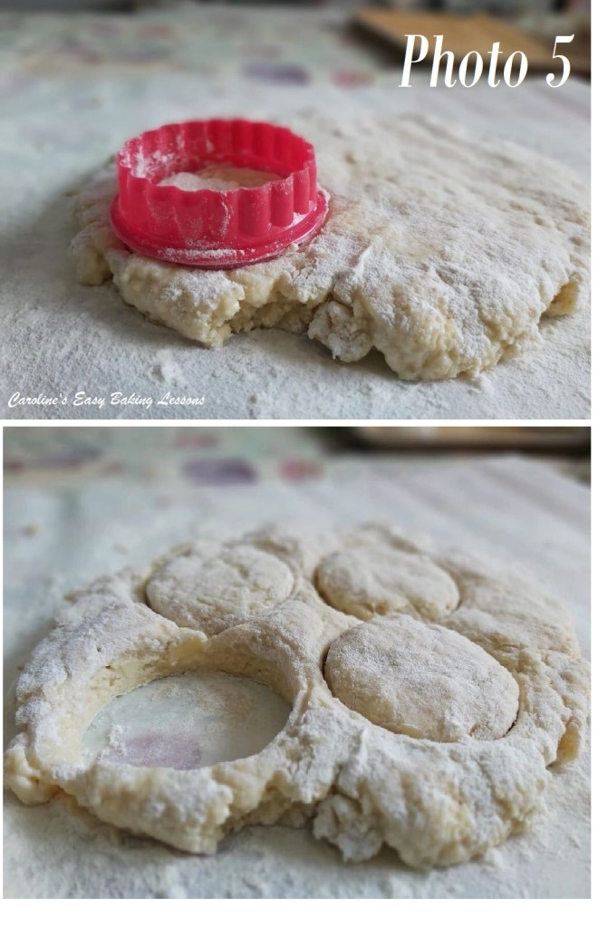
13. Meanwhile put the dough down and flatten gently with your hands until you have a level piece of dough about 1″ (2.5cm) high. Try not to go smaller than this (taller is fine). Don’t be tempted to roll out the dough as this won’t help the scones to rise. (If too sticky, just pat some flour on your hands and on top of the flattened dough. Do not roll back up or knead). See Photo 5.
14. Flour the cutter or glass and cut out the scones. Push the cutter down and DO NOT TWIST the cutter. I know it’s tempting, but twisting can ruin the outer structure of the scones – you want that characteristic ‘rise & split’ appearance of a good scone. Use a spatula or knife to very carefully transfer to the prepared baking tray, (or let it fall onto the prepared tray). Try to touch the sides of the scones as little as possible. .
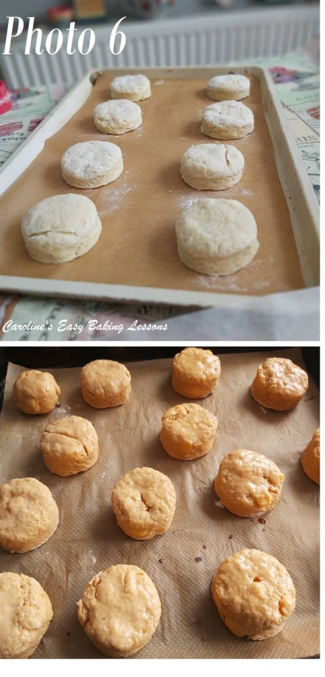

15. Gently roll up the scraps of dough by hand and flatten out to cut out however more scones you can get, remembering only lightly knead and handle as little as possible. (I usually get about 14 scones per batch). See Photo 6, top pic of the scones using mustard powder. (Note that the scones from the rolled up off-cuts, will not look as perfect as the first lot and it’s because of more ‘handling’ of the dough. As an alternative, you can divide the dough in half first and then cut out and bring the 2 lots of scrap dough together at the end.
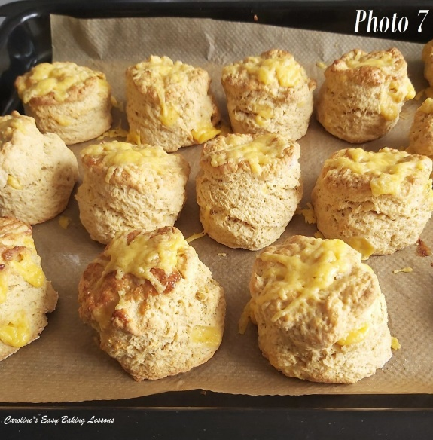
16. Now using a pastry brush, very carefully brush the egg/milk liquid you reserved earlier, onto the tops of the scones only. If the liquid goes down the sides, it can ruin the rise of the scones. So, the best way to avoid it is by shaking/tapping the brush before moving to the scone and then starting to brush from the centre and going outwards, so there is less liquid on the brush to spill down the sides. Watch the video for a visual of how to do this. See Photo 6, bottom pic, egg-washed and of the scones using smoked paprika.

17. Bake for 10-15 minutes until well risen and golden in colour, on top and on the bottom. For an even bake and colouring, and depending on your oven, turning and rotating the trays can help. You can also bake just one tray at a time if you want. For even more of a cheese kick, I like to add some grated cheese about the 8-10 minute mark. Once the scones are well risen and started to colour on top, add the grated/shredded cheese on top (squeeze it together, about 1 tsp worth and then place on top – that way you get more cheese on). Then let them bake another 1 – 3 minutes, just long enough for the cheese to melt nicely but not burn or go too hard. Keep an eye on it as it can turn quickly. Leave on the baking tray 5 minutes. See Photo 7.
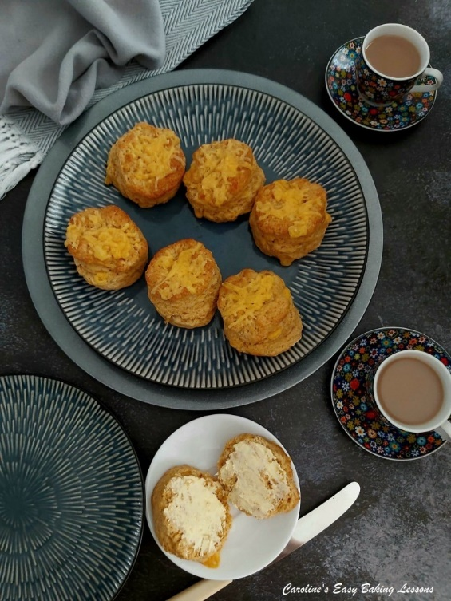
18. Then transfer to cool a little on a cooling rack and enjoy warm with whatever fillings you enjoy. **You can freeze these scones and once defrosted, heat a little in a warm oven. Alternatively, slice in half and heat in the microwave for about 20 seconds.

DIFFICULTY LEVEL: easy, with guidance

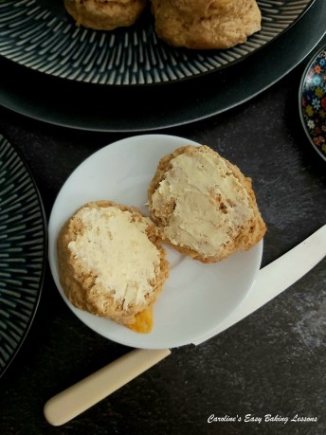

Thanks for reading. Caro xxx

