QUICKER TEAR-&-SHARE DINNER ROLLS – On The Table In Under 2hrs
Caroline’s Easy Baking Lessons LESSONS

SAVOURY LESSON 4
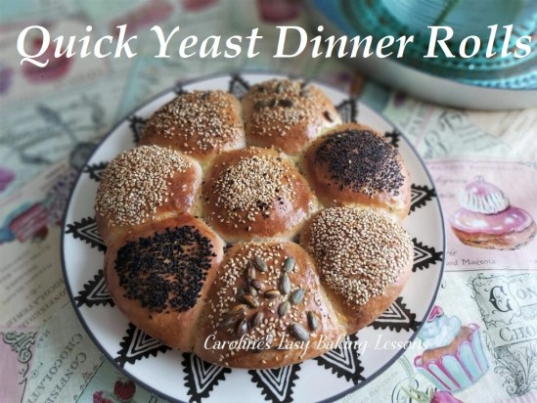
The following is my adaptation of my go-to tear-&-share roll recipe, but using a quicker method, that I discovered in the book ‘Easy Culinary Science For Better Cooking’, by Jessica Gavin (2018). She uses a revolutionary new method for preparing the yeast dough and it reduces the total time considerably. I have adapted lots of my go-to recipes using this method, and decided to add here as an introduction to bread making & working with yeast. This recipe makes 8 small rolls, ideal as an accompaniment to any meal. You can start and have these on the table in under 2 hours. So ideal to start before dinner.
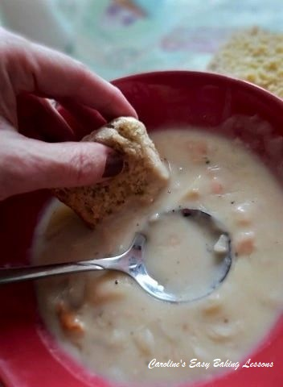

If you are new to this quicker yeast recipes, let me tell you that there is no compromise in size, rise, texture or taste. The activation of the yeast is simply speeded up. You spend a little more time at the beginning of preparing the dough, compared to conventional methods. However, the rising time is significantly reduced. Some recipes I have managed to reduce by 1/3 – 1/2 of the normal time. You are simply providing ideal conditions or environment if you like, for the yeast to do it’s job effectively.
This recipe is perfect if you have never worked with yeast before, or had problems doing so. As it is part of my savoury lessons series for beginners, the recipe is thoroughly detailed as is my style of writing. Nothing left to the imagination and lots of photos to guide you onto the right track. You might also want to read my article for beginners to bread making – go to article.
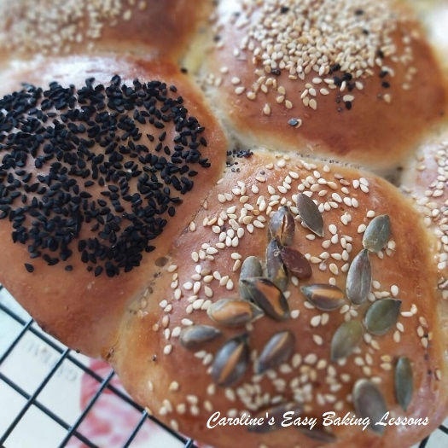
The initial mixing process consists of mixing in the flour in three batches, referred to in my recipe as F1, F2 & F3. Please stick to this as it contributes to the success of the recipe. This recipe uses all white plain/all purpose flour. You can of course use strong/bread flour but it is not essential. In my other quicker recipes you will also find some with wholewheat flour. If you want to use whole-wheat in this recipe, use it in place of F1 flour and increase the water content by 11%. Additionally, let the dough sit for 2 minutes after the mixing in of F1 flour, so that the flour can absorb the water. Also check out the 90 Minute Soft Breadsticks.

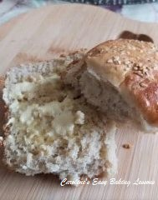
*An additional note on the yeast. Normally I use fast acting instant dry yeast, but during the lockdown and shortages, I was only able to get active dry yeast in bulk. So this recipe has been developed and tested using Active Dry yeast. If you want to get the same rise and have Instant Dry yeast, you can use 5g or just stick to the 7g (2 1/4 tsp) & have a slightly higher roll. If you can only get fresh yeast, you want 14g of this type of yeast. For more conversions of different yeast, see my Yeast Table

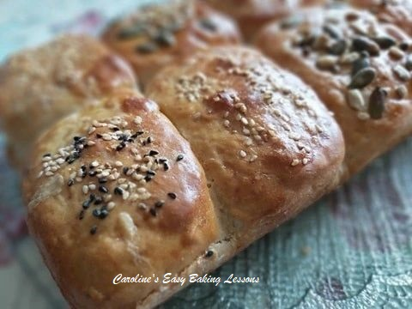

Please also see the sharing options or even printing, at the right/bottom of your screen (bottom of your screen for mobile devices, and down the right-hand side on computers). You can even pin this to your own Pinterest page. Alternatively, you can download this article, see below. You could also leave some feedback if you like at the foot of the recipe.

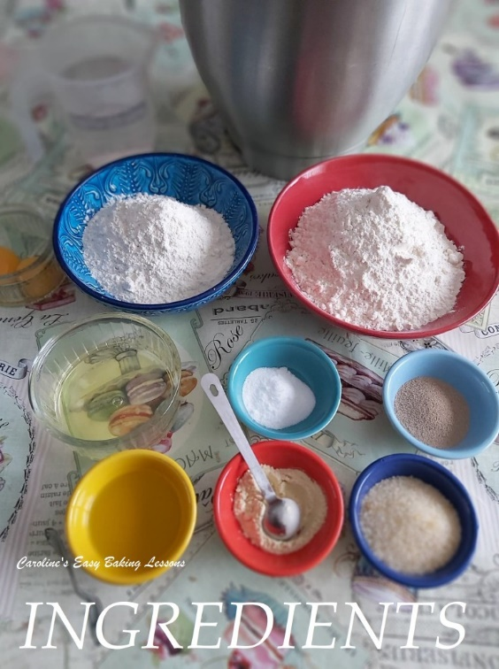

INGREDIENTS
- 125g Plain/A.P. Flour (1c, 4.5oz) – [F1]
- 63g Plain/A.P. Flour (1/2c, 2.25oz) – [F2]
- 94-125g Plain/A.P. Flour (3/4 – 1c, 3.25-4.5oz) – [F3]
- 1 tsp Salt
- 7g Fast Acting/Instant/Active yeast (2 1/4 tsp)*
- 1 tsp Onion or Garlic Powder (optional)
- 1 tbsp Sugar
- 2 tsp Olive Oil or E.V.O.O.
- 1 Egg White
- 180ml Water (3/4c or 6 fl oz)
* (heated to 49-54c/120-129f) * *see below

- Topping:
- Egg wash – 1 Egg yolk + 2 tsp milk
- Seeds of choice – I used sesame, sunflower, pumpkin & Nigella seeds (optional)
- OVEN: 400f/200c/180c fan oven/Gas mark 6
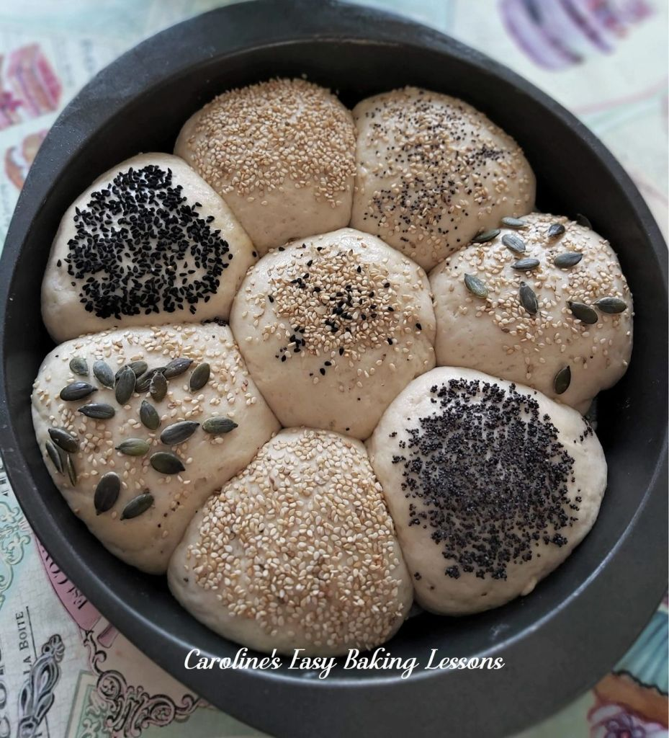

EQUIPMENT
- Scales or measuring cups
- Measuring Spoons
- Small Measuring jug
- Stand Mixer (Or large bowl and spoon)
- Small – medium microwave safe bowl if using.
- Food thermometer (optional)
- 2 small bowls to separate the egg
- Pastry brush (or small artist/paint Brush)
- Large spoon
- 1 Cake or Oven dish, round, square or rectangular. ( I have used a rectangular ceramic dish 23 x 13.5cm (9×5 inches) at the base in some of the pics, and a round 23cm/9″ cake tin in the video. Something that will fit all 8 rolls of dough with a little space.)
- Lining paste or something like baking spray to line the tin (see link below).
- Timer or Phone timer
- Cooling rack
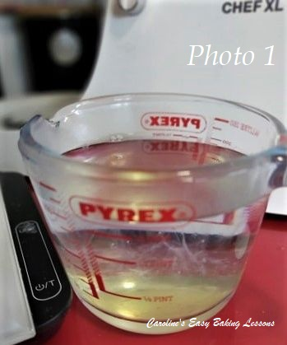

INSTRUCTIONS
1. Weigh or measure out the flours labelled [F1], [F2] & [F3]. I like to add [F1] to the stand mixer bowl as it will be used first.
2. Next add in the salt to [F1] flour, and mix to distribute well. Never let the yeast and salt come into direct contact as it retards the power of the yeast. This method ensures that the salt is coated by flour.
3. Now add in the yeast and sugar and mix well. Add in the garlic or onion powder now too if using.
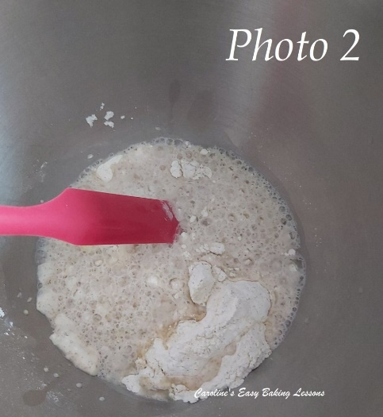
4. Now time to warm the water. You can either heat the water in the microwave for 30-45 seconds until the water is above lukewarm. Or take water from a warm kettle and check the temperature with a thermometer. You want it to be between 49-54c/120-129f. Never use hot or very warm water as it can kill the yeast. It will be just above tepid. Once you feel the temperature by hand, you will know for next time and not need a thermometer.

5. Once at the correct temperature, separate your egg and add in the white to the water, and also the 2 tsp oil and mix through. See Photo 1 above. (Reserve the yolk in a small bowl for later).
6. Add this liquid to the mixing bowl with [F1] and using the stand mixer and paddle attachment, mix on medium speed for 2 minutes. Please time this as these steps are important. See Photo 2.
7. Next add in [F2] flour, (the smallest amount) and let the machine mix for another 2 minutes as before. See Photo 3 below, middle pic.
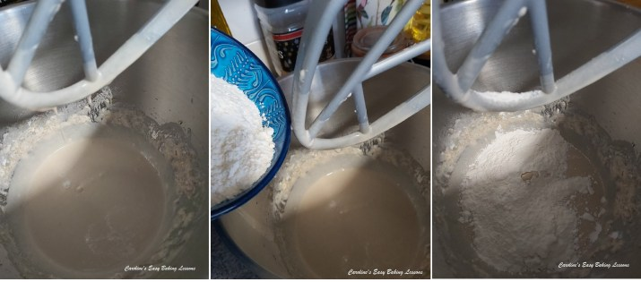
Stages of adding the flour

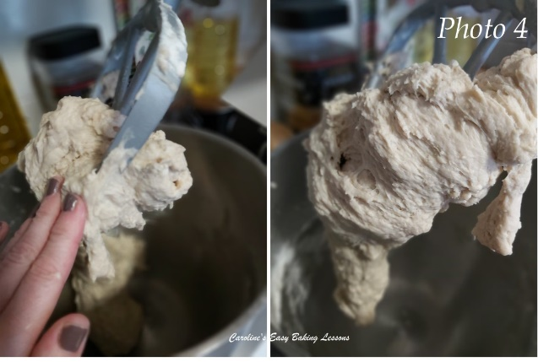
8. Finally add in half of the flour from [F3] bowl and let the machine mix through (scrape down any flour from the sides if need be). Gradually add in more of the flour until you have a dough that is just a little sticky to touch. Let it mix for 1 more minute. It will be coming together and sticking to the paddle like in Photo 4. You might not need all the flour or need more. This is because different flour, different places and ways it’s milled determine how much liquid it will absorb.
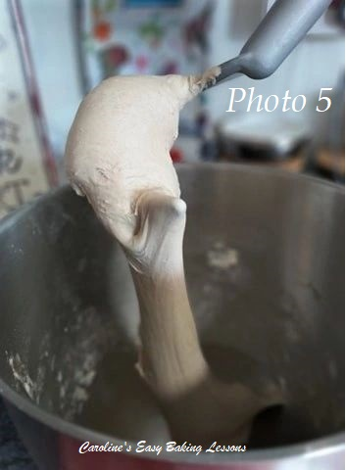
9. Switch from the paddle attachment to the kneading hook, scraping down the dough, off the paddle. Using a palette or spatula for this is ideal. Now knead on medium speed for 4 minutes. Again, time this. Then turn the dough over and knead again for another 4 minutes. If the dough is too sicky to handle, oil your hands a little first. Alternatively knead by hand on an oiled worktop/worksurface for about 10 minutes. I like to knead like this, to ensure all the dough is well kneaded.
10. The dough will be smoother looking and to touch now. (*Note that bread flour and whole-wheat or whole-meal flour or blends, will not look quite as smooth as in Photo 5). It will even be hanging and stretching onto the hook when you lift it up. This is a visual indication that the gluten is being worked well. See Photo 5.

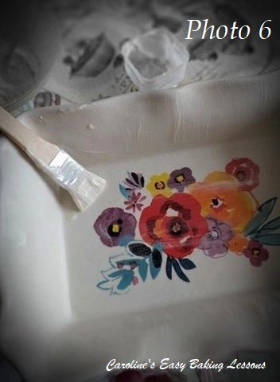
11. Form into a nice neat ball and place at the bottom of the bowl, covering with a clean tea-towel. Again use oiled hands if too sticky. Leave in a consistently warm, draught free place for 10 minutes
12. Now prepare your baking dish. You can use a 23cm (9″) round cake pan (as long as it’s 5cm/2 inch deep at least. But on this occasion I used my Pioneer Woman casserole dish that I calculated to have the same area to take the rolls. It measures 30.5 x 20cm (12 x 8 inches) at the top edge, but more importantly, 23 x 13.5cm (9×5 inches) at the base. You can grease the pan with butter or as I did, use Great British Bake Off winner Nancy's lining paste, just to make sure the rolls come out easily once baked. See Photo 6.

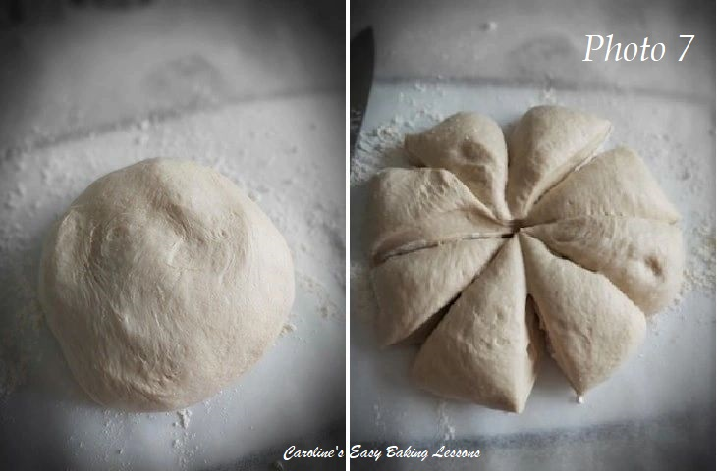
13. Once the 10 minutes is up, next is the shaping of the rolls. I like to place a wide sheet of baking/parchment paper on top of a large chopping board. Dust the paper with some flour and then with flour on my hands, I coax the dough out of the bowl and onto the board. Then turn it over and form into a nice smooth ball and flatten a little on top of the paper. Using a large sharp knife, cut the circle of dough in half twice and then more cuts to end up with 8 equal ‘slices’. This is the easiest way to get roughly the same size without weighing them. (Rub some flour along the sides of the knife blade if needed).
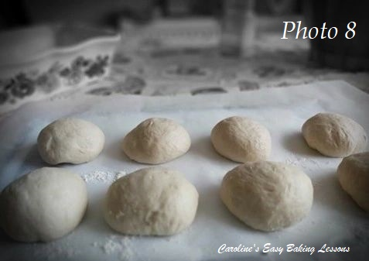
14. Take one of the ‘slices’ of dough (with some flour on your hands) and form it into a nice neat and tight ball. I like to flatten a little in my hand and then form into a rough ball. Next I pull sections of the round dough under itself, working my way around. It’s like pulling the edges of the ball at several points and tucking under itself. It helps stretch the dough and ultimately make a tight ball. Repeat around the ball of dough 5 or 6 times and then with the ball in one hand, use the opposite hand, cup the ball and go round in circles motion to form a neat ball. Note that plain or A.P. flour will produce a smoother looking ball of dough than wholemeal flour. Repeat for all other 7 pieces of dough. ** See video below of how to do this stage and also Photo 8.

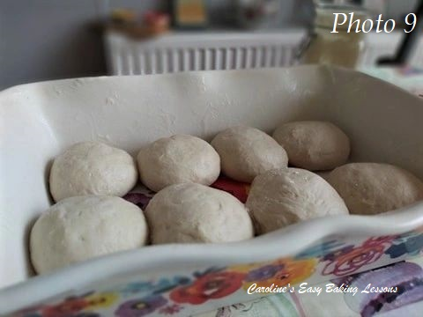
15. Once all 8 balls of dough are formed, position them in your chosen tin/dish. Don’t worry if there are some gaps, that is fine as they will expand on their second prove and once baking. See Photo 9.
In the video I egg washed the rolls and then dipped in bowls of the seeds to get a good coverage. This is optional and you can just sprinkle on top as well. Even if you don’t want seeds, you still need egg wash to get a nice colour and prevent burning. Simply mix the milk in with the left over egg yolk and have a brush ready.

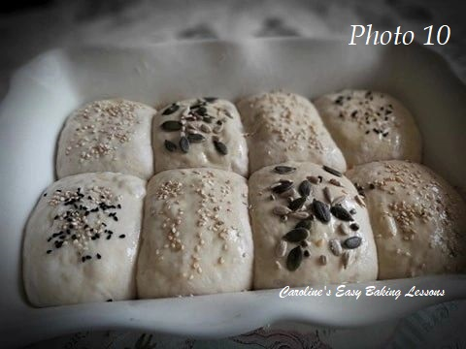
Note most recipes have you applying the egg wash after the 2nd prove (rising), but I find it can deflate the dough and is much easier to generously coat the dough before it rises. Now there will be some outer areas that don’t have the egg wash after proving and expanding, but I like to apply more egg wash part way through baking too.
16. Next, leave in the same warm place for 40 minutes for a 2nd prove. See Photo 10.
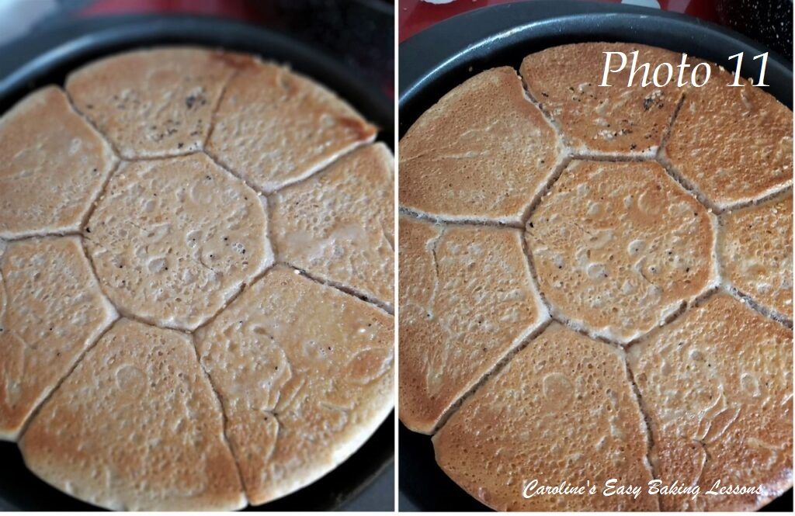
17. Before the time is up, heat up the oven to:

19. Now place in the oven for 25 – 30 minutes until golden and fully cooked. Mine were done after 26 minutes. My oven doesn’t heat evenly so I always put the timer on and turn the tray. So after the 10 minutes I applied more egg wash and covered with foil loosely, as the tops had a good colour already. Then I baked for another 10 minutes, turning in between and applying more eggwash. At this 20 minute mark, I eased the rolls out onto a baking sheet to test the bottom. Tap the tops of the rolls and then remember that sound when doing the same on the bottoms. You want a hollow sound. The top will sound hollow with a sharper sound. If the bottoms sound softer, they aren’t quite done. So apply more egg wash on these bottoms and around the sides and bake for a few more minutes at a time, checking each time for a difference in sound and a golden colour. See Photos 11 & 12.

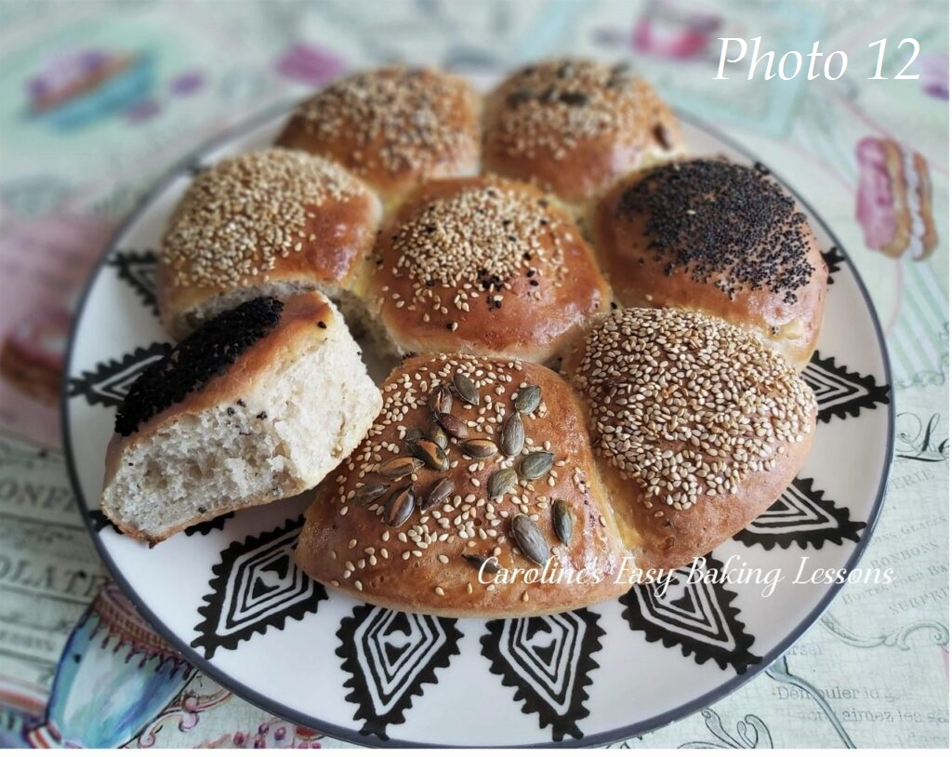
20. Once ready, you can remove from the oven and slide them, paper and all onto a cooling rack to cool down. Cover with a clean tea-towel if you like. Wait until a little cooler before pulling apart.
21. Store cool rolls in a bread bin or tin, in food bags or cling film/plastic wrap and will be fine for a few days. You can freeze the balls of dough or the rolls baked, by wrapping individually but don’t use foil directly on the bread, as it can taint the food.

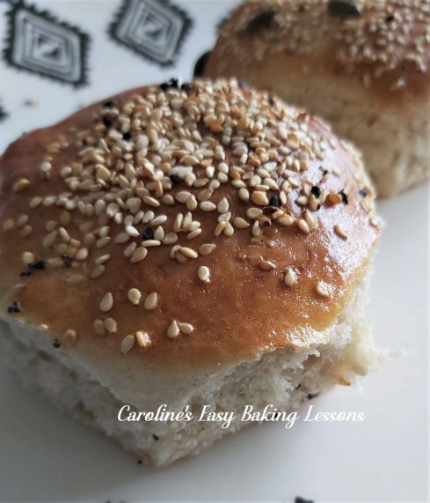
My fluffy tear-and-share quicker rolls
Enjoy your bake. Be sure to note the saving and sharing options as mentioned before the recipe video. For beginners following the structured lessons, please now proceed to THEORY LESSON 9 – with tips for beginners to using yeast.

SKILL LEVEL: beginner, easy (with direction)
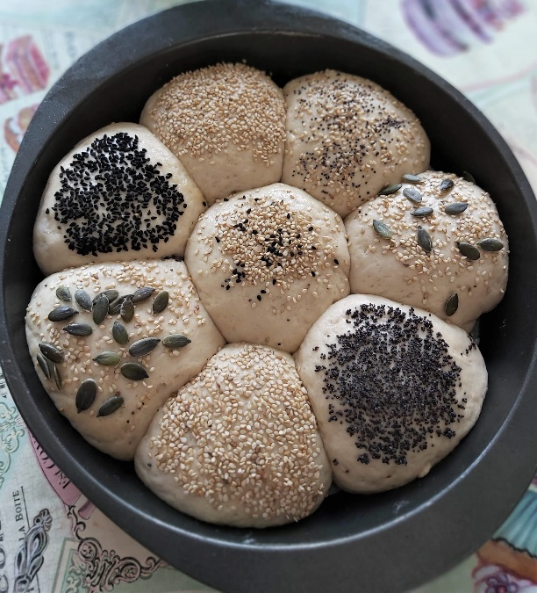

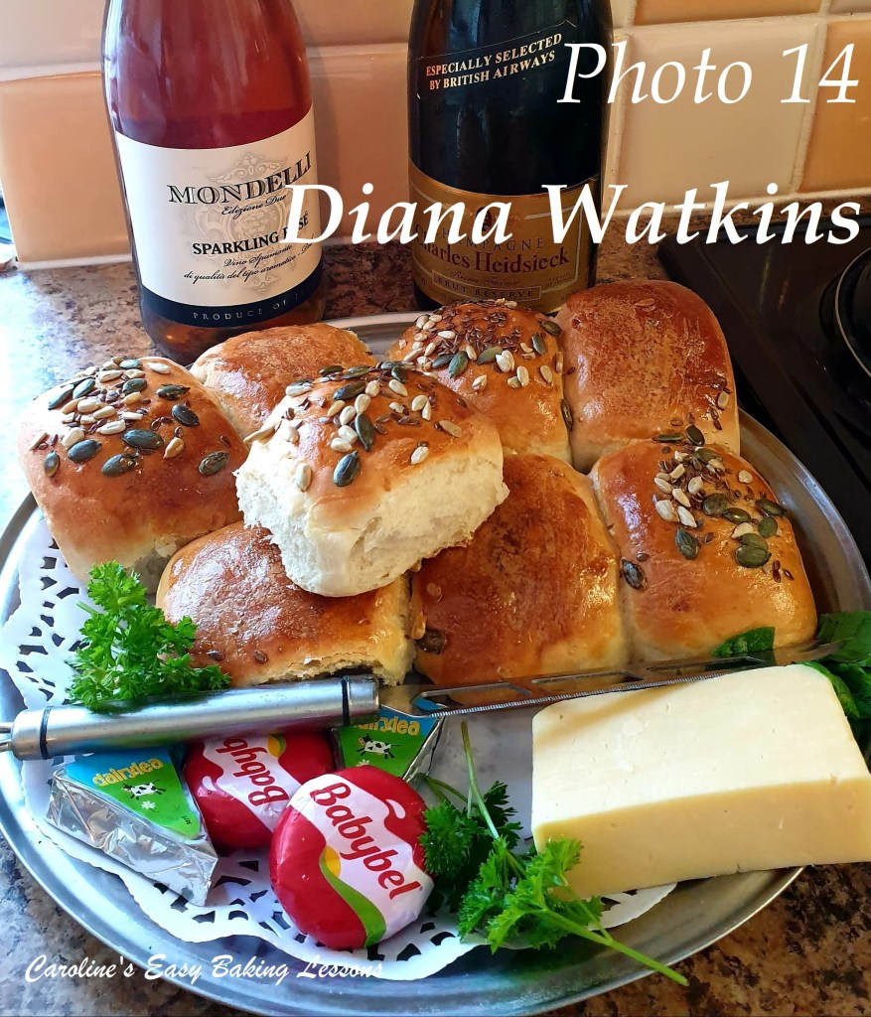

FACEBOOK BAKE-ALONG
This recipe and my video tutorial were used in a Great British Bake off Facebook group that I help run. We used it in a bake-along, as an introduction to bread making for beginners and even those who made bread before, really liked how the process could be speeded up. Here’s a photo of Diana’s first time bread bake .

Happy Baking & Making
Happy Memories & Tummies!

Caro x

