THEORY LESSON 2 - ALTERNATIVE EQUIPMENT - Household Substitutes
FROM: Caroline’s Easy Baking Lessons

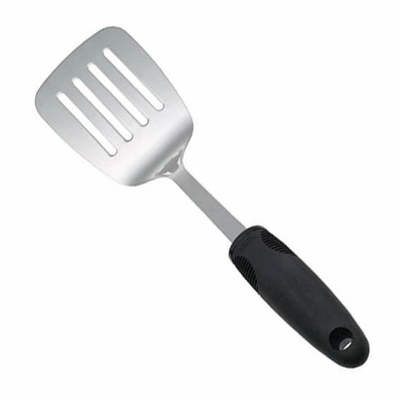
1. A METAL COOKING SPATULA

A metal cooking spatula can be used in place of a BAKING PALETTE KNIFE as a lifting apparatus, moving your bakes to the cooling rack for example.

You can also use it to flip over to bake the under side of your bake if need be, as it is often really hot at this point!

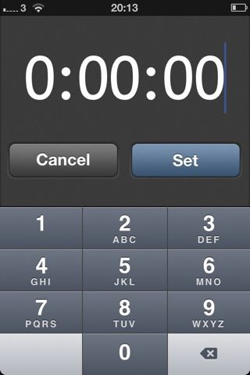
Mobile/cell phone timer.

2. A PHONE TIMER or OVEN TIMER

A mobile/cell phone can be used instead of purchasing a cooking timer.
They are also more accurate than for example oven times, as you can also use seconds in your timings.

Timing is very important in baking, as no recipe can be exact as everyone's ovens are different and some running warmer than indicated. Buying an oven thermometer to check what temperature your own oven is actually at, is worth while doing and can be bought quite cheaply on the internet. Once you know what the correct temperature is, you can adjust accordingly in the future. I personally set my times for about the half way mark, so I can turn or the rotate the tray/dish to ensure an even bake and then put the timer on for checking every so often there after. Taking a note of your own timing on the recipe you are using, is also beneficial for future baking.

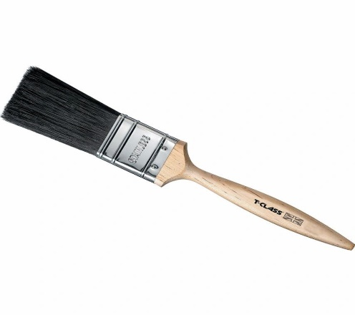
3. ARTIST OR PAINT BRUSH

An unused artist of paint brush can be a good substitute for a PASTRY BRUSH. One that is 1 – 2 cm wide will do fine. Just make sure that it’s got good bristles that don’t fall out.

Is used to egg wash things such as bread & pastry to prevent burning, to give a prettier appearance and to improve taste.

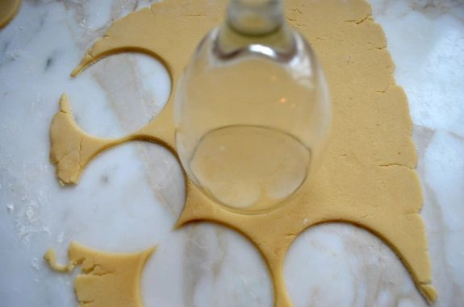
.
4. LIDS or the RIM OF A DRINKING GLASS can be used as an alternative to a COOKIE CUTTERS. Particularly ideal, as coming in a variety of sizes.
Can also be used when cutting out fondant and pastry shapes.

Remember though to dip in flour or icing/confectioners' sugar before cutting so as to avoid the dough sticking to the glass.

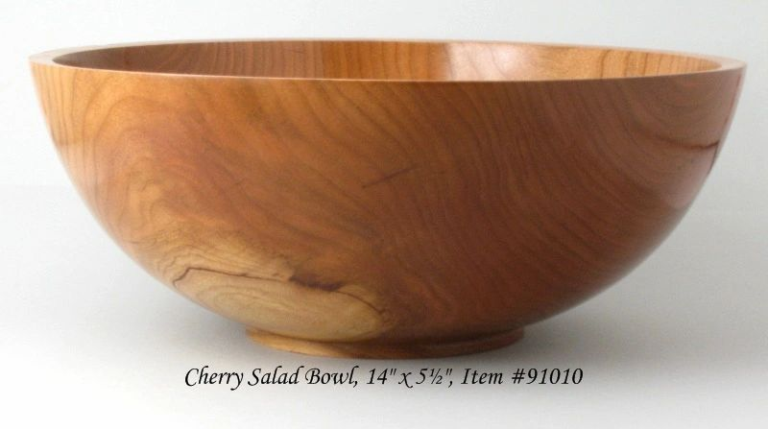
large salad bowl can be used as a mixing or proving bowl.

5. SALAD BOWLS are a good substitute for a LARGE MIXING OR BREAD DOUGH PROVING BOWL. As a rule, the bigger the better, especially for proving dough. I prefer plastic bowls to ceramic because of their weight, and your bread dough sticks less often I find.

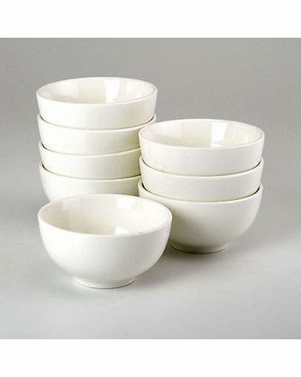

6. CEREAL, DESSERT OR SOUP BOWLS.

These types of bowls are sufficient for weighing out small - medium quantities of ingredients and therefore purchasing SMALL MIXING/BAKING BOWLS is not necessary.

Let's face it, we all tend to not have enough cupboard space and so not having to purchase more bowls and find a place to store them if a plus.

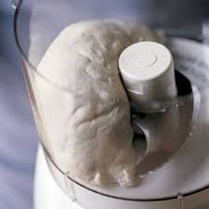
Food Processor in action.

7. SOME FOOD PROCESSORS can manage to mix ingredients and form a ‘bread-crumb looking appearance’ when mixing flour and butter. Therefore it can be used in place of a PASTRY CUTTER. Note though that it's best to not over-do it with the processor if you are making pastry or scone dough, as it will work the dough & the gluten too much and might produce a tough bake.

Some Processors also have kneading attachments, but I can’t say if these are any good, as a very strong motor is also required for any descent kneading.

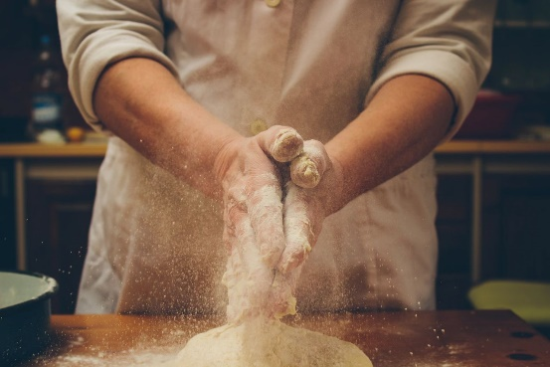
Using your hands in baking

8. YOUR TWO HANDS - can be used for mixing (although messy), bringing the dough together and kneading bread dough. Using your hands is best for things like pastry and making British scones, as machines tend to over work the dough like mentioned before. These bakes require just gently kneading the dough until it comes together in one lump. You also get used to how the dough should feel by using your hands more.

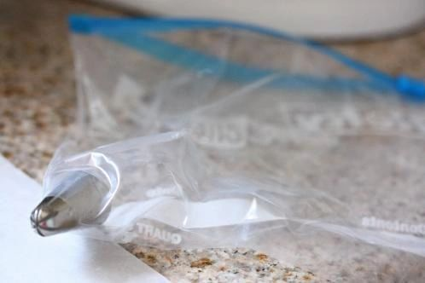
Using a food baggie as a piping bag

9. FOOD BAGGIE - Food or freezer bags can be used as a piping bag. You can snip one corner and not need a piping nozzle (although if you want a different shape or size, you can still place a piping nozzle inside the bag.

Can also be used for crushing biscuits/cookies and nuts instead of using a processor or chopping. See Google for how to make from baking/parchment paper too.

10. WINE OR LARGE GLASS BOTTLE can be used as a make-shift rolling pin. Just be sure to flour or dust in icing/confectioners' sugar so the dough doesn't stick to the bottle.

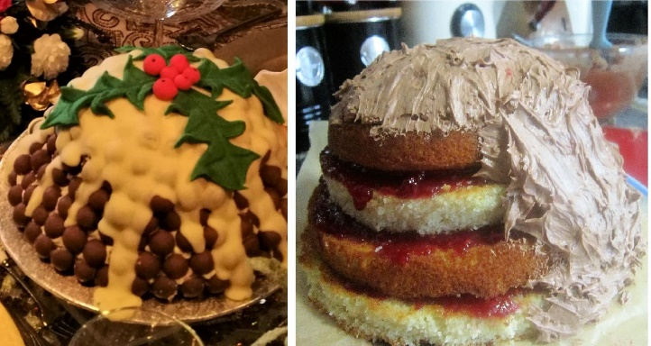
11. SEVERAL DIFFERENT SIZED ROUND CAKE TINS - several different sized round cake/sandwich tins can be used instead of a sphere cake tin. Those tins take a very long time to bake and on a very low heat. It is much simpler and quicker to stack different sized round cake layers and carve them a little to get a dome shape. (see how I made my Xmas Pudding Cake). Alternatively, you could use two very deep round tins, but your carving would have to be better.
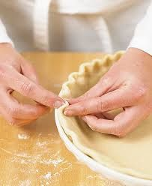
Crimping pastry pie edge.

12. FORK OR THUMB & INDEX FINGER - A fork or your thumb & index finger can be used for crimping (sealing and making a decorative edging) on your pastry. Simply put the fork prong's done on top of the pastry. For using your fingers, you are squeezing the pastry edge of your pie, between your thumb and index finger. There are a few different ways to do by hand, that you can Google, as well as using a large spoon. (I only use one hand for this). So you really don't need special pastry crimpers, as there will always be another way to have the same design.

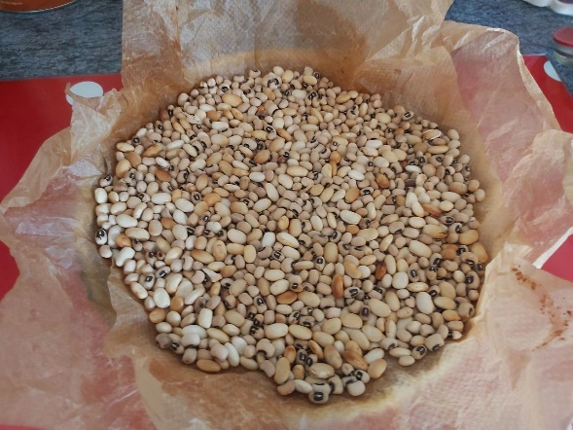
My dry beans being used as 'baking beans'
13. DRY BEANS/PULSES - dry beans/pulse can be used instead of ceramic baking beans. These are placed in a lined uncooked pastry case, for when the pastry is blind baking (no filling) and the weight of the beans stops the pastry from puffing up whilst baking. After that you remove and insert the filling before continuing baking. I like to use tin foil/aluminium foil as a liner but you can use baking/parchment paper too. A handy tip is to scrunch the paper into a ball and then unfold so there are no sharp paper edges getting into the uncooked dough. Be very careful lifting the beans out and save in a jar once cooled down, and you can use again and again).

14. EMPTY TINS/CANS - empty tins/cans can be used in bake cakes in. I have even heard of tuna cans be used as ring mould in baking, where both top and bottom of the can is removed. Just be very careful of the edges, that should be filed down.

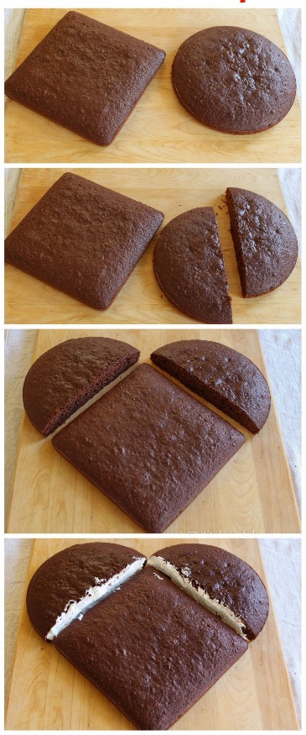
How to make a heart shaped cake.

15. SQUARE & ROUND CAKE TIN - A square and a round cake tin can be used in lace of a HEART SHAPED TIN. Simply bake a cake in a square and round cake tin (see photo, first pic).
Then cut the round one in half. (see second pic). Then join the two half circles to the square cake, when it's tilted, with one corner pointing upwards (see pic 3). Then sandwich with butter cream to join them and produce a heart shaped cake. (see fourth pic). You can then cover and decorate.

There are many more baking hacks out there and if any more come to mind I will update you. For decorating cakes, you don't need all the latest or most expensive tools. often other things you will have on hand will do. I use a pastry cutter instead of a food processor for making the dough like breadcrumbs, when making pastry for example. But like this one, they will be included with the relevant recipe or lesson.

NEXT STEPS

Now proceed to read Savoury Lesson 1, making sure to read it thoroughly before attempting to make it.

Happy Baking & Making
Happy Memories & Tummies

Caro xx

