TRADITIONAL CHRISTMAS CAKE - GBBO Fans Group Bake-Together Part 1 FROM: Caroline’s Easy Baking Lessons

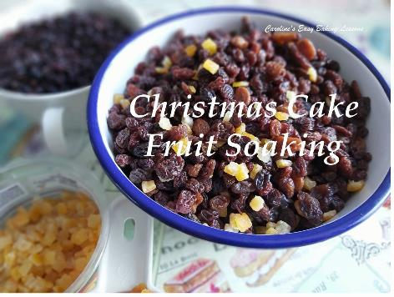
So, this year in the Facebook group GBBO Fans (The Great British Bake Off or Baking Show in the states & Canada), I decided having another group bake-along would be good for preparing a Christmas cake. You soak the dry fruit for about a week, & then bake the cake, brush on alcohol for a few months, every week or so, before then decorating the cake.

We are using my good friend Christine's family recipe, (she is known as CJ in the Facebook group she created 3 years ago). This is an old Be-Ro recipe. And for those that don't know, it's a book that's been around for a long time, with lots of editions and they also make baking products like flour being one example. This particular recipe has been used for at least 3 generations, every year and so as close to a traditional cake as you will get.

In the states and Canada, some things are not as easy to come by as in the UK. Examples being the citrus peel & Glacé cherries. Maraschino cherries can also be used & or the citrus peel, that’s similar to candied citrus. There are recipes on the internet to make your own, which of course you can try, or add another dried fruit, such as cranberries. The recipe for the cake also uses UK self-raising flour. But I have included how much baking powder to add if using plain or All Purposes flour instead & tested it. There is also caster sugar used, but because the cake is baked for a long time on a lower heat, granulated sugar can also be used. Lastly, ground almonds. By that we mean almond meal. Almond flour is finer, but if you have to use it, this can be used too. Just now the texture will be slightly different. Mixed spice is very similar to US/Canadian Pumpkin Spice.
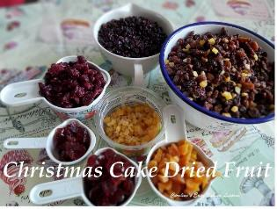

INGREDIENTS

For Flavouring & Soaking The Fruit
8 oz Currants ***(226g, 1 & 2/3 cups)
8 oz Raisins (226g, 1 & 1/2 cups)
8 oz Sultanas (226g, 1 & 1/2 cups)
4 oz Glacé Cherries or Maraschino (113g, level 2/3 cup, chopped)
4 oz Mixed Citrus Peel, cut (113g, 1 & 1/2 cups Candied Peal)
750ml Alcohol, such as Brandy, Port or even Whiskey. (25.3 fl oz, or 3 cups + 2 tbsp)

You can also use less alcohol or none at all. I used a combination & added 300ml of Orange juice, partly because I don't like too strong an alcohol taste & because I didn't have enough alcohol in the cupboard. This amount is approximate. You need to have enough to cover the top of the fruit once all added together.

**NON ALCOHOLIC VERSION - Use pure orange juice and add some orange and lemon zest to the fruit when soaking.***

For The Cake Batter

For a 8" (19cm) Square or 9" (23cm) Round deep tin (at least 3", so about 7.5cm)

12 oz Self-Raising Flour* (340g, 2 & 3/4 cup)
OR Plain/All Purpose Flour & 4 & 1/8 tsp baking Powder
1 tsp Mixed Spice **
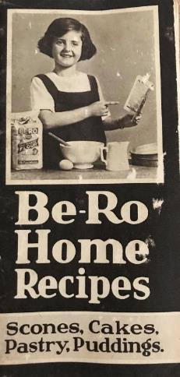
4 oz Ground Almonds/Almond Meal (113g, 1 & 1/4 level cups)***
8 oz Butter, unsalted & softened (226, 1 cup, 2 sticks)
8 oz Caster Sugar (226g, 1 & 1/8 cup) OR Granulated Sugar (same as above)
4 Medium - Large Eggs, beaten with -
8 tbsp Milk (or /12 milk & 1/2 Brandy) (120ml, 4 fl oz or 1/2 cup)
32 oz Dried Fruit, Soaked as per the above ingredients & directions below.

EQUIPMENT
Measuring cups or digital scales Large Mixing Bowl
Knife and chopping board big spoon
Measuring Jug Large jar (optional)
Cling Film/plastic wrap (optional)

INSTRUCTIONS
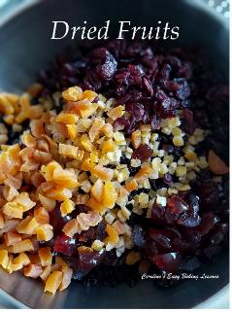
1. So for today, we just concentrate on soaking the dried fruit. But the rest of the cake recipe is there for you to know what to have in.

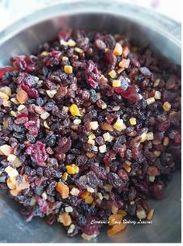
2. Start by chopping the cherries and mixed peal if in strips. My mixed peel was already chopped. I didn't have quite enough cherries so added cranberries to make up the difference and a few chopped apricots. All to about the same size and to the correct weight. In the recipe it said to chop the cherries in half, and I know Christine quarters them, but since I had less and like cherries, I cut into 1/6 or 1/8 depending on the size of the cherries, as some were bigger than others. Also gave a better distribution of them.

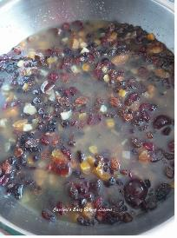
3. Add the fruit to a large mixing bowl or a container that
you can store it all in. I made a double batch to make more cakes and didn't know how big a container I would need so used a big mixing bowl first. I then simply used a big spoon (or spatula) to mix it all up.

4. Then I added in the alcohol and fruit juice (if using). Gave it a good mix and then checked where it came to in the bowl. If it covers the fruit that's enough. Mine was just covered, but when I transferred to another jar, it needed more orange juice.

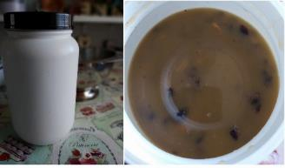
**NON ALCOHOL VERSION - add pure orange juice to cover the fruit, and also add in the zest of 1 or 2 oranges & of 1 lemon to the fruit. Store in the fridge or somewhere quite cool and in a tightly sealed jar.

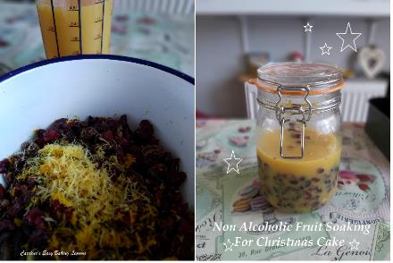
5. Leave in the same bowl if you like or transfer to another container. I managed to get into a big plastic jar, ones I am using for storing flour. It gave me enough room to be able to shake it periodically. If leaving in the bowl, cover with cling film/plastic wrap.

6. Leave out or in a cupboard for about 1 week. During that time you can give a mix or a shake to make sure all the fruit is getting an even soaking

7. Once the week is up you will use the fruit to prepare the cake. See Part 2 of the Traditional Christmas Cake Bake-along.

