CHRISTMAS DODGERS - Jam & Cream Filled Soft Sandwich Cookies
FROM: Caroline’s Easy Baking Lessons
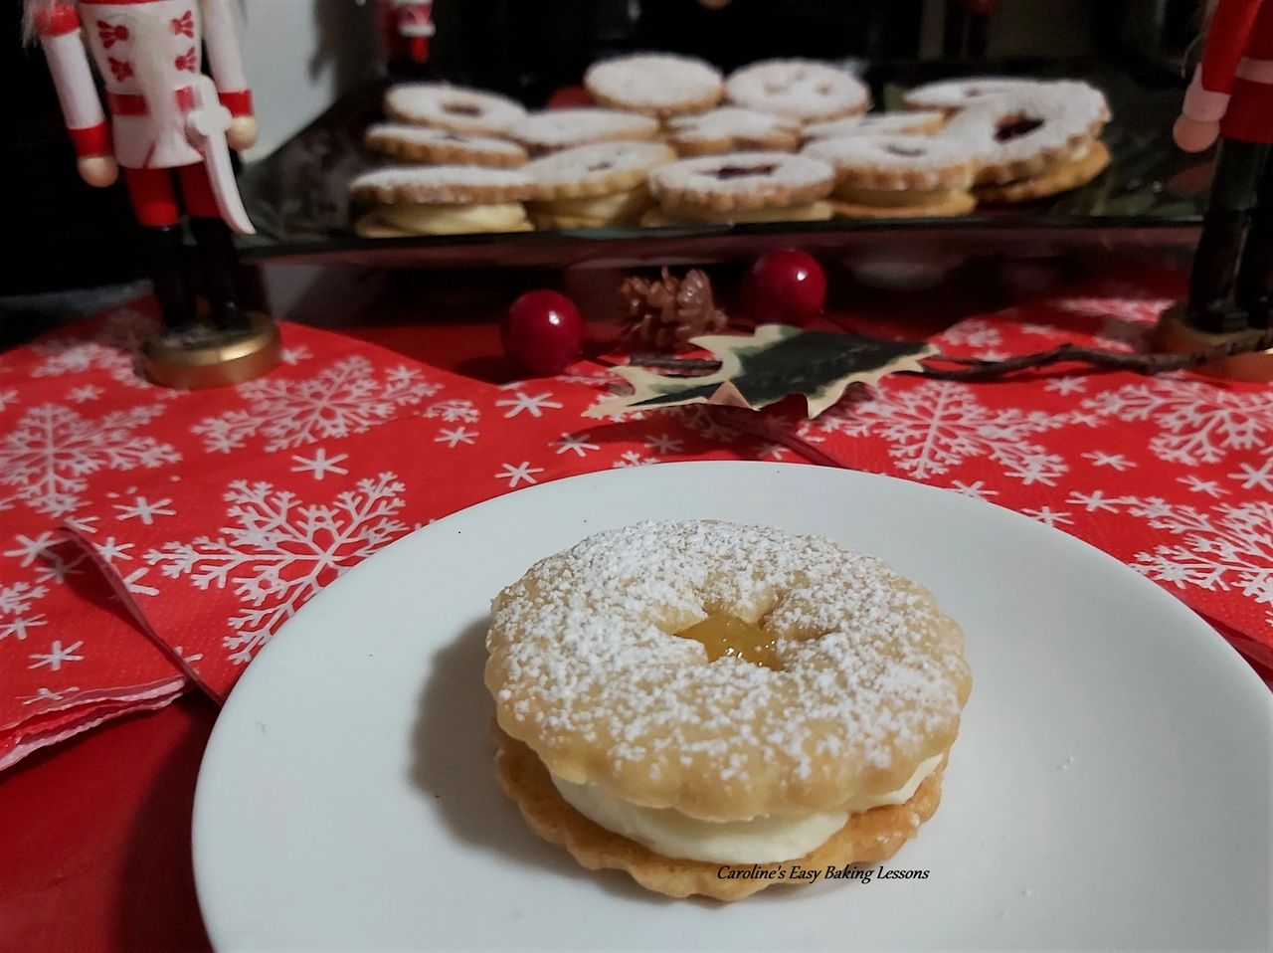
These are an alteration of my soft sugar cookies, this time sandwiched together with not only jam/jelly, but also a firm buttercream, that is amazing with it. Simple to make recipe, just takes some time, as you have to do several chilling periods for the cookies to keep their shape, and because this recipe makes about 20 sandwich cookies. But it really is worth it.

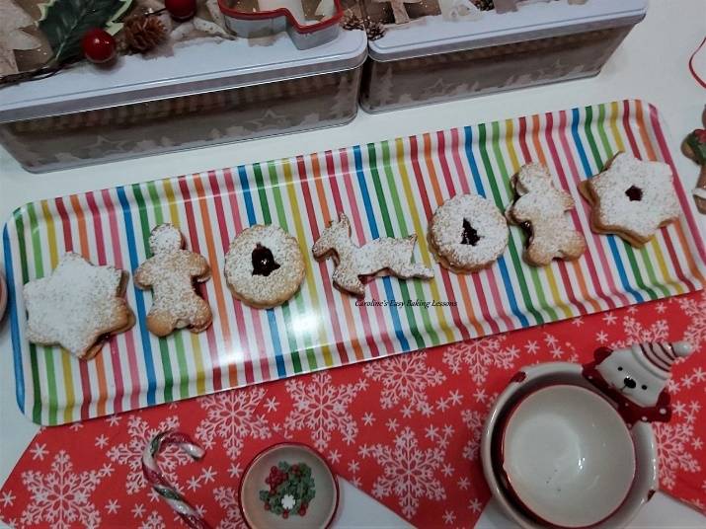
You can use some of your holiday cookie cutters or even fondant cutters, for cutting out the cookies, or cutting out the centre of the cookie. My rounded fluted cutter for most of the cookies, has a 5.6cm (2.5 inch) diameter. The larger star cutter, was 7.2cm (2 3/4 inches) at it's widest points. The gingerbread man cutter was 7.5cm (3 inches) long and the reindeer was 8.5cm (3 1/2 inches) wide. See Photo opposite.

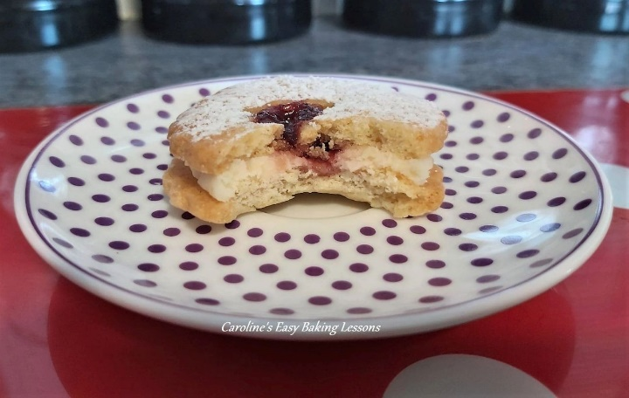
If you use lots of different sized cutters, you will need to watch your baking times, as well as trying to keep all the bigger ones on the same baking sheet/tray. You only want just a little colour starting on these cookies when you get them out the oven.

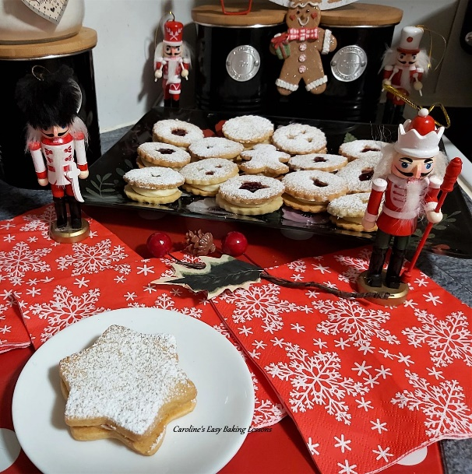
Fill the cookies with any jam/jelly you like or even curd. Our favourites are raspberry jam and lemon curd ones. Make use of any preserves you have made your self, and these would make the perfect holiday food gift. For stacking them once filled, it is good to place them inside a paper cupcake or muffin case, depending on how big you make the cookies. Makes them easier to move too, without messing up the sugar dusted tops.

I know you are eager to get onto the recipe, so here goes:

INGREDIENTS

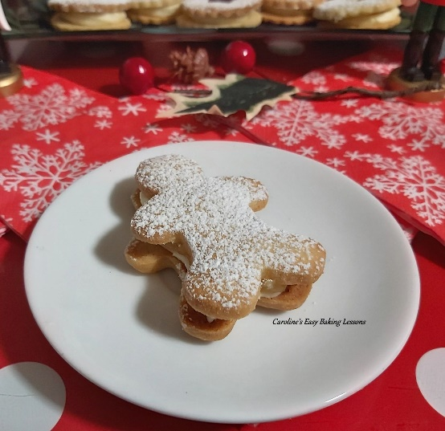
170g Butter, soft & cubed (3/4 c)
134g Granulated Sugar (2/3 c)
1 Egg
2 tsp Vanilla Extract
¼ tsp Almond Extract
281g Plain Flour
(2 ¼ level cups, All Purpose)
Rounded 1/4 tsp Baking Powder
¼ tsp Salt

For The Filling:
80g Butter, cubed and softened (1/3 cup, 2 3/4 oz)
250g Icing/confectioners' sugar (2 cups, sieved)
1/2 tsp Vanilla Extract
2 tbsp Milk
Jams/jelly/preserves, of your choice. Raspberry is a favourite, and lemon curd is good too.

EQUIPMENT
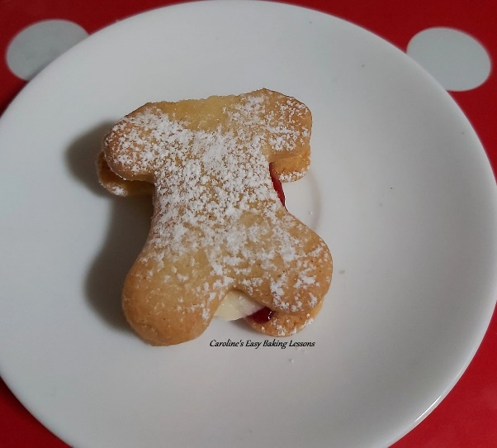

Scales or measuring cups
Measuring spoons
Stand/Hand mixer
Large mixing bowl
Med-large bowl
Knife
Baking/parchment Paper (minimum 4 large pieces)
Rolling Pin
Baking Tray x 3
(Large trays – optional)
Baking spray or butter to grease
Sieve
Piping nozzle and piping bag (optional. I used a long star, 9mm nozzle that is 1/3 inch)

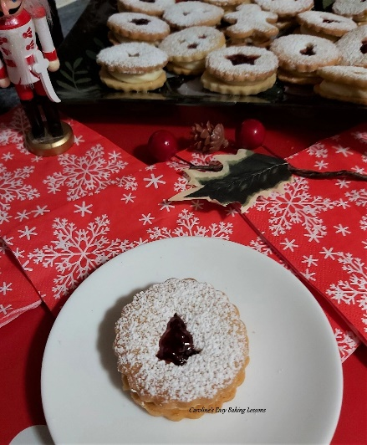
Piping nozzle and piping bag (optional. I used a long star, 9mm nozzle that is 1/3 inch)
Cookie Cutters/Glass of your choice (see notes above)
Teaspoons
Small sieve (optional)
Tin or other airtight container.
Timer or phone timer

OVEN: 180/160c Fan Oven/350f/Gas mark 4

INSTRUCTIONS

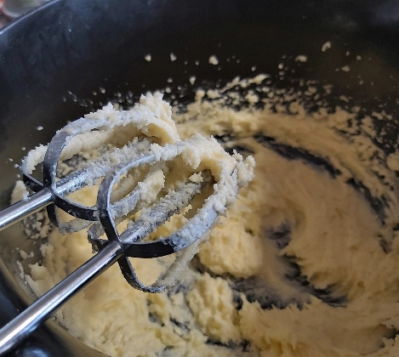
Photo 1 - the 'creamed' butter & sugar.

1. Cube and weigh out your butter and leave till softened. Once ready, beat the butter for 1 minute with a timer (don't just guess) & then add the sugar and mix for a further 3 minutes in a stand/hand held mixer. See Photo 1.

2. Add the egg, vanilla & almond extract to the mixture & then mix on high speed for 2 minutes.

3. Place the mixing bowl over the scales and set them to zero. Weigh or measure in the flour and spoon in the baking powder & salt.
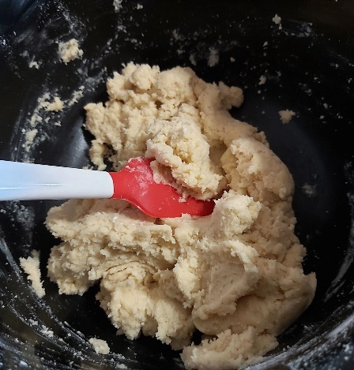
Photo 2 - the dough coming together.
4. Mix on low speed until all the dry mixture is absorbed and no ‘white bits’ are visible anymore. Now take a plastic/rubber spatula, and scrape down the side of the bowl, making sure nothing is left behind, and there are no flour patches at the bottom of the bowl. Don’t over-mix it or the biscuit will be tough. See Photo 2, of how it is coming together.

5. Cut out baking/parchment paper to fit your baking sheets/trays or ordinary trays (which ever will fit in your fridge). You will need at least 4 pieces.

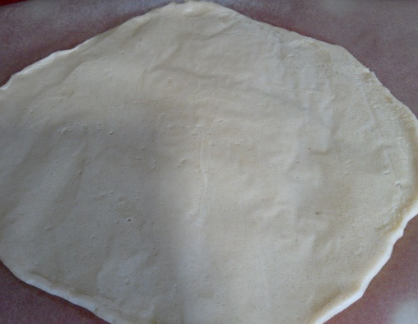
Photo 3 - rolling out half of the cookie dough.

6. Place one piece of the paper on a worktop/counter. Take ½ of the dough from the bowl and form into a disc. Place in the centre of the paper. Place a 2nd piece of baking/parchment paper on top and there will be no need to flour the rolling pin. Roll out till the dough is 7/8mm (height of 2x £1 + 2p coins – 1/3 inch). Don’t go any thinner than this at the edges). See Photo 3.
7. Repeat with the 2nd half of the dough and put both into the fridge for 1 hr to firm up. Stack them on top of each other if you can with the extra pieces of paper in between them.

8. Now prepare the baking trays by lightly oiling and placing 1 of the top baking/parchment papers on top. (You can re-use the baking paper).

9. Take 1 tray from the fridge. Prepare your cutters by lightly dipping in flour or icing/confectioners' sugar.

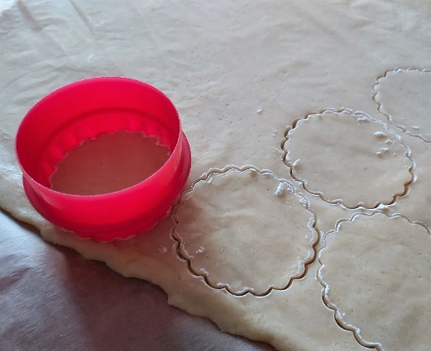
Photo 4 - cutting out the round/fluted cookies

10. Cut out as many shapes as you can from this one piece and place on one of the prepared baking trays, (with about 1/2cm or 1/5 inch space in-between). These will be the base cookies, if you are doing any with cut out middles. Roll up the scrap pieces of dough, and roll back out before placing back in the fridge to firm up. Be sure to roll between 2 sheets of paper. See Photo 4.

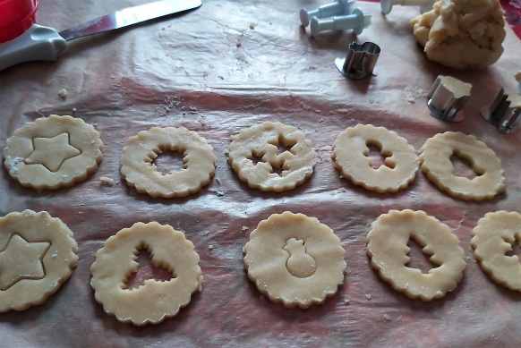
Photo 5 - cutting out the centre of the cookies

11. Now move on to the second tray of dough, and cut out the tops for the cookies, that will have cut out centres. If you are just doing shaped cutters, like the reindeer, remember to turn the cookie cutter the other way round, so that you will have a proper pair once baked to join together, that will join up nicely. Alternatively you can turn the cut out over before baking. I found it easier to make pairs, at the cutting out stage. Remember to re-roll excess and chill again, until all the dough is used up. Just cut out the centres with any of the holiday cutters you have, ensuring they are not too big for the size of the cookie. (See Photo 5 above). Then chill the cut out cookie dough for 1 hour.

12. Heat up the oven just before your one hour chilling time is up. Oven: 180/160c Fan Oven/350f/Gas mark 4.
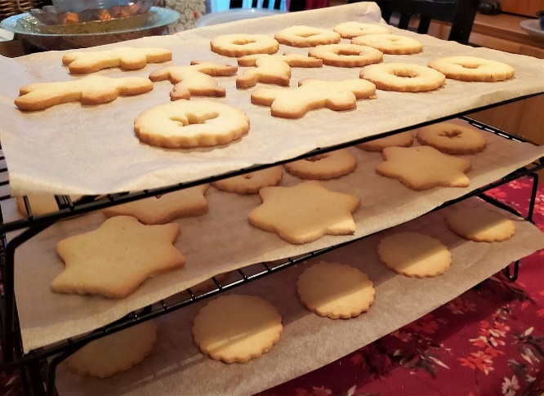
Photo 6 - cooling all the cookies

13. Bake the biscuits/cookies for 8-11 minutes. Turn and rotate the trays after 4 mins. The biscuits are ready when the biscuits are very pail coloured on top and around the edges are just starting to colour. They will be quite pale like shortbread, soft and appear not done. It will however move, when you very gently push with a spatula or knife.

14. Let the biscuits cool for 5 minutes on the tray. Then very carefully slide the cooked biscuits onto a cooling rack with the paper, (be careful not to drop them as they will still be soft). See Photo 5 above. Leave to cool down. You can store once cooled in a tin or airtight container if not filling just now.
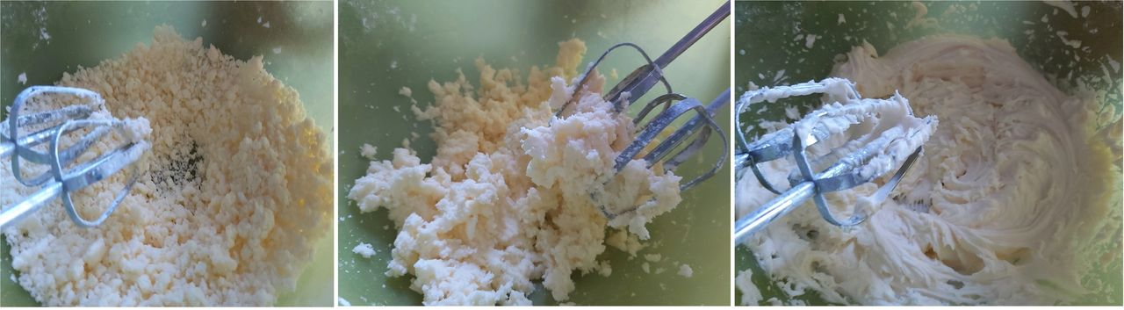
Photo 7 - the stages of making up the buttercream.

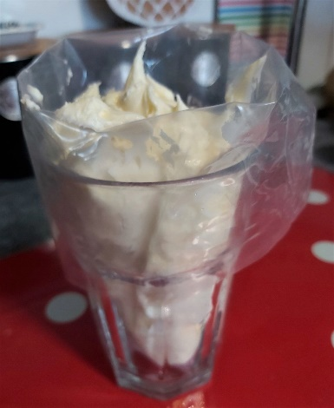
Photo 8 - how to fill the piping bag up easily.

15. Now make the buttercream, by sieving the icing/confectioners' sugar into a large bowl (or it will go everywhere), and add in the softened cubed butter. I start off using a spatula to mix it all together, pressing down on the butter, so it take sup some of the sugar. Then proceed onto mixing with a hand/stand mixer, as it will take some time to get it all whipped up nicely. It will transform like in the stages in Photo 7 above. Once nice and cream like, add in the milk and vanilla extract and beat till incorporated fully.

16. Now fill a piping bag with a nozzle (or just pipe through a 9mm or 1/3 inch hole on the end of the piping bag). I like to use a tall glass to help get the buttercream into the piping bag. Position it in (with piping nozzle pointed upwards, and if not using a nozzle, don't cut the bag yet), and turn the ends of the bag over and onto the rim of the glass. See Photo 8 above. Then open it out with your hand, and spoon in buttercream. I like to use a palette knife to scrape it off the spoon and into the bag. Once all filled up, push the buttercream down and twist the top of the bag. Then lift out of the glass and squeeze to get the buttercream nearer to the tip.

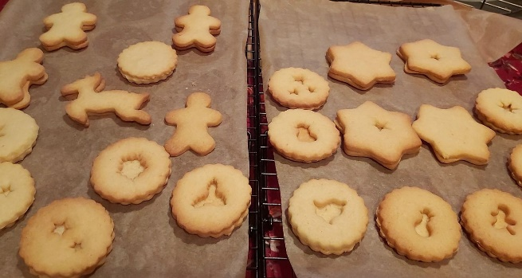
Photo 9 - pairing up the shaped cookies.
17. Now before piping the filling, it's ideal to pair up your cookies so that they are all the same size/shape. Then open them back up and keep the tops next to the bottoms. See Photo 9. Now get your jam/jelly, lemon curd ready. Originally I used slightly watered down jam, but found it better to use as is for these. Even if the lemon curd is thick, don't worry.
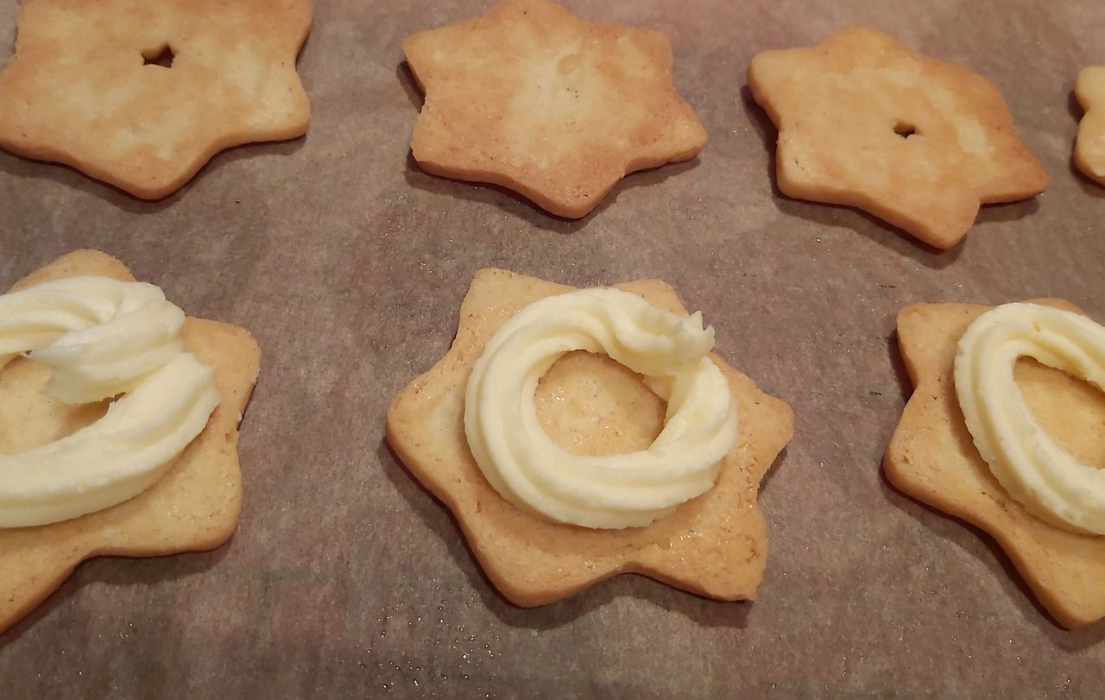
Photo 10 - piping on the buttercream filling

18. Now pipe a ring of buttercream on the bottom cookie, near to the edges. Pipe onto all of the cookie bottoms, and then if any buttercream left, you can fill in the middle also. For the shaped ones, you can pipe a little different, and use the end of a small spoon or sugar craft tool, to put near to the edges of the shaped parts. See Photo 10.

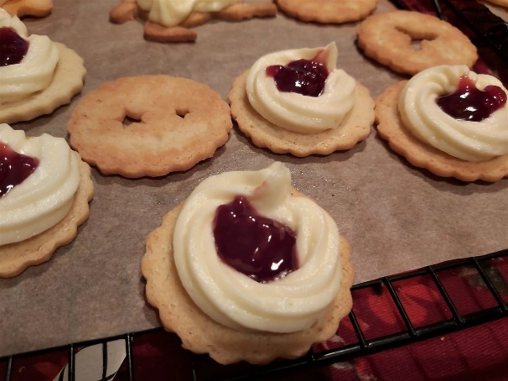
Photo 11 - filling with the raspberry jam/jelly

19. Now spoon on some jam/jelly or curd into the middle of the filling, sliding it in place with another spoon, (or your finger).

For the reindeer one, I instead spread the jam on the bottom of the top cookie piece, finding this much easier and neater to do. See Photo 11.

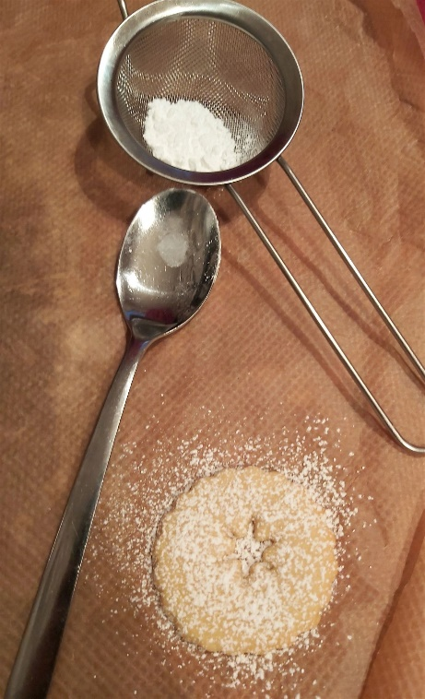

Photo 12 - dusting the cookies with sugar 'snow'

20. Now take one cookie top (one that has a shape cut from the centre), turn it over and place on some baking/parchment paper. Next take a small sieve (preferably small), and sieve a spoon of icing/confectioners' sugar over the top of the cookie, completely covering it in 'snow'!

Then gently position on top of it's 'bottom' cookie and squeeze together while holding the ends of the cookies (trying to avoid the sugar coating).

Doing one cookie at a time, means you don't mix up the cookies that you paired earlier. See Photo 12.

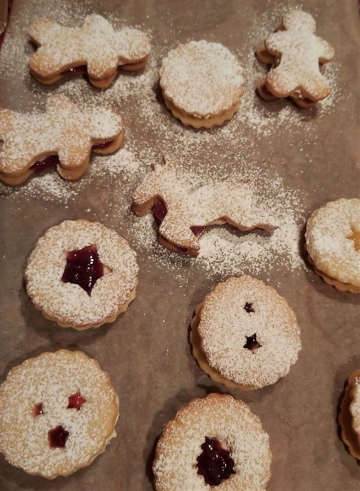
Photo 13 - covering all the cookies with sugar.

21. Now for the cookies with a solid 'top' cookie, simply position on top of it's partner and gently squeeze together. Then sieve over the icing/confectioners' sugar as before. See Photo 13.

Now either serve on a nice plate and chill in the fridge for a few hours for the filling to firm up. Or store for later. I found it easiest to place each one in a paper cupcake/muffin case, depending on the size of the cookies. This way you can even store on top of each other, in a tin or cupcake carry case.
Just keep them somewhere cold, so that the filling stays nice and firm.

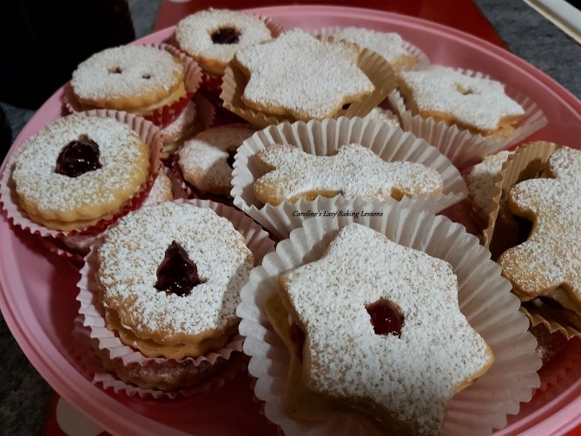
The cookies stored in paper cupcake cases

Thanks for reading.

Happy Baking & Making
Happy Memories & Tummies
Caroline x

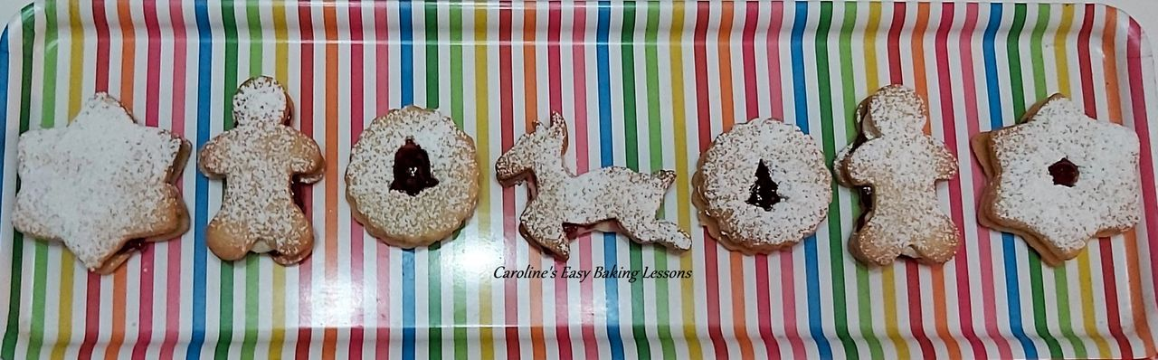My assortment of my Christmas Dodgers - star, gingerbread man, round and reindeer shapes

