CHRISTMAS MINCEMEAT SLICES – Mincemeat Isn’t Just For Mince Pies!
Caroline’s Easy Baking Lessons
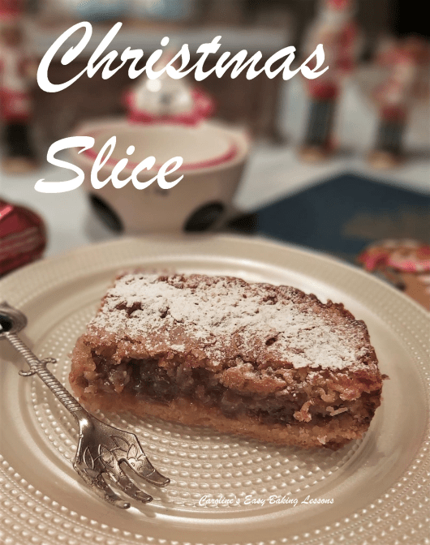
I love mincepies, especially with marzipan as the topping, but often there is left over mincemeat. So when a friend showed me a recipe with mincemeat between two layers, I immediately thought of my popular Paradise Slices. They are constructed from a shortbread style base, sandwiching a raspberry jam filling and topped with a coconut batter. The one my friend showed me had a crumble type of topping, so my planned version would be softer than that. But also a little bit different with the unexpected coconut twist!

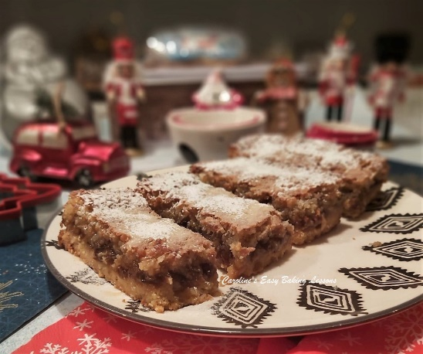

So off I set to testing out my recipe. It took a few attempts to get it where I wanted it, but I hope you will be pleased with it. You can use left over mincemeat for this, or even add to a brown sugar cake.

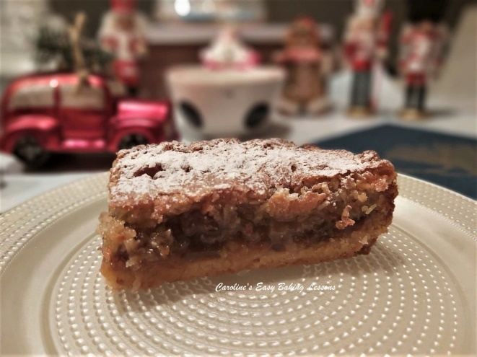
*Just a quite mention of the ingredients, I used caster sugar, which is equivalent to extra/super fine in the states. You can process your own by lightly grinding granulated sugar, so no need to go to the expense of purchasing expensive versions on the internet. Just only little process it – see my photo below of the different types of UK sugars. If you want to learn more about this, read my article – Differences Between UK & US Baking Ingredients. I also used ground almonds. Now the equivalent of this is almond meal and can be important in cake recipes for structure, so almond flour in that case doesn’t work. However, for the purposes of this recipe’s base layer, almond flour would be ok as an alternative too.

INGREDIENTS
For The Base:
- 175g Butter, cubed & softened (6oz or 3/4 cup)
- 75g Caster Sugar (3oz or 1/3 cup Extra/Super Fine Sugar*)
- 150g Plain Flour (5 1/4 oz or 1 1/4 cup All Purpose)
- 100g Ground Almonds ( 3 1/2oz or 1 cup**)
For The Filling:
- 470g Mincemeat (Approx. depending on size of tin) (16.5 oz)

For The Topping:
- 110g Butter, cubed & softened (3 3/4oz or 1 stick/ 1/2 cup)
- 150g Caster Sugar* (5 1/4oz or 2/3 cup)
- 3 Medium Eggs
- 2 tsp Mixed Spice (or more if you like)
- (All Spice, Pumpkin Spice, or combination of Cinnamon, Nutmeg, Goner & Cloves, with cinnamon being in a larger proportion)
- 175g Desiccated Coconut
- (6oz or 1 1/2 rounded cups Unsweetened shredded)
- 1 tsp Baking Powder, sieved
- 31g Plain Flour (1oz or 1/4 cup A.P. flour)
- Icing/Powdered Sugar to dust.

EQUIPMENT
- Scales or measuring cups Measuring Spoons
- Hand/Stand Mixer (optional) Food Processor (optional)
- Pastry Cutter (optional) Fork
- Baking tin/dish – 26x26cm/ 10 inch tin upto 30x23cm/ 12×9 in
- Baking/parchment paper Timer or Phone Timer
- Lining paste, butter or release spray for greasing Knife or baking palette knife
- Large spoon or spatula Cooling Rack.
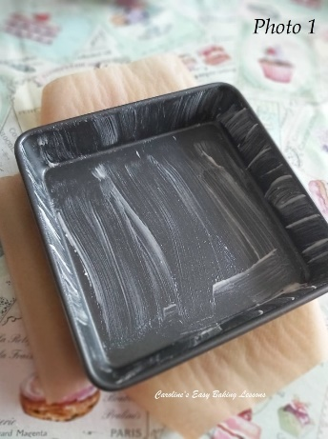

INSTRUCTIONS
1. Grease and line a baking tin or dish, (see above for sizing) with baking/parchment paper. For how to line tins – click here. See Photo 1, where after cutting I just place inside the tin nicely.

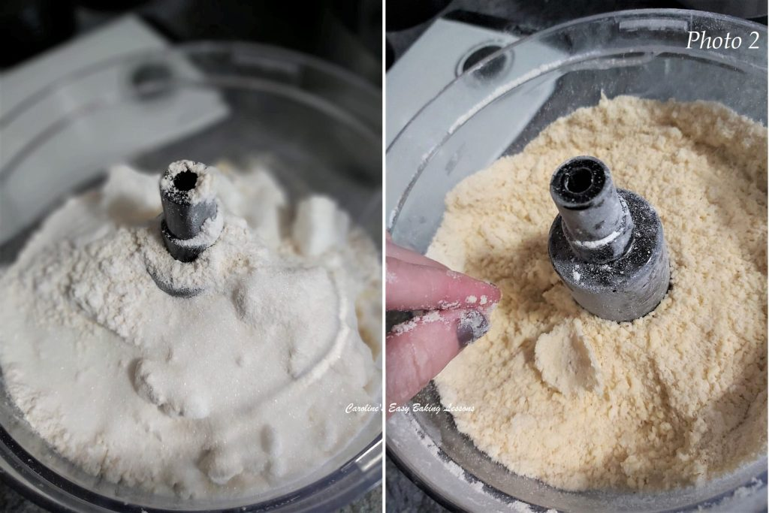
2. Put the base ingredients (butter, sugar, flour & ground almonds into a mixer or food processor and reduce down to crumbs and clumps. See Photo 2, left pic. Alternately, mix the ingredients and then rub the mixture between your fingers. You can also use a pastry cutter to reduce to fine breadcrumbs size, push down on the bottom of the bowl and rotating left and right. To check it will hold together, squeeze some of the mixture between your fingers. If it is like in Photo 2, then it’s fine. If it doesn’t hold at all, add a tiny drop of water.

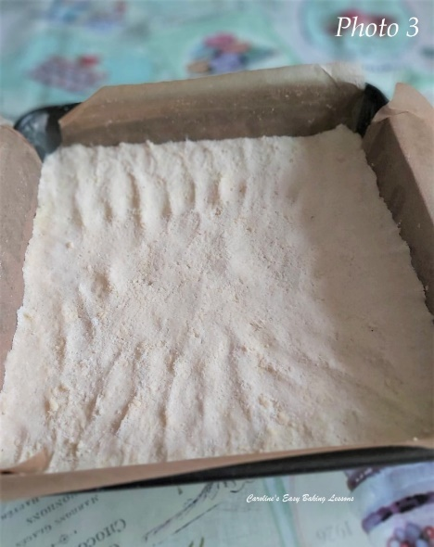
3. Tip the mixture into the prepared tin and spread it out evenly to cover all the bottom of the dish. Be sure to push up towards the corners, so there are no gaps. See Photo 3 above.
4. Cover the dish with cling film/plastic wrap and chill for 1 hour. Alternatively freeze for 30 minutes.

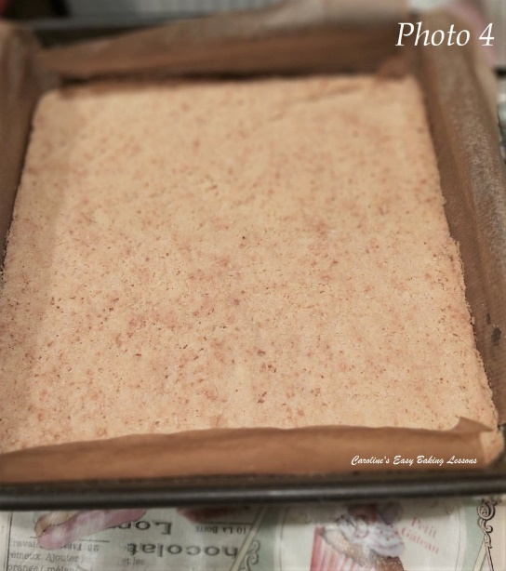

5. Heat up the oven to 160c/140c Fan Oven/ 325f/Gas Mark 3 before the chilling time is up.
6. Bake the base mixture for 18 – 25 minutes until just starting to colour. See Photo 4.

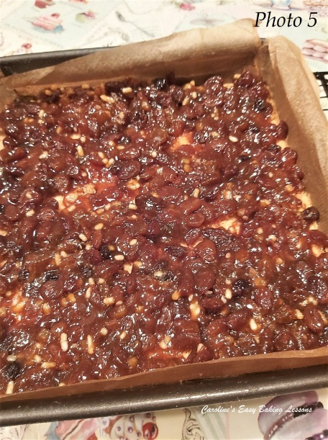
7. Increase the oven temperature to 190c/170c Fan Oven/375f/Gas Mark 5.
8. Spoon out the mincemeat and then spread evenly on top of the base layer. Depending on the size of the dish you used, you may need more or less mincemeat. See Photo 5.

9. For the topping: cream the butter and sugar together, (until light and fluffy like in Photo 6) and then gradually add in the eggs, one at a time. Mix only until incorporated. The mixture will look a bit funny and thin, but don’t worry.

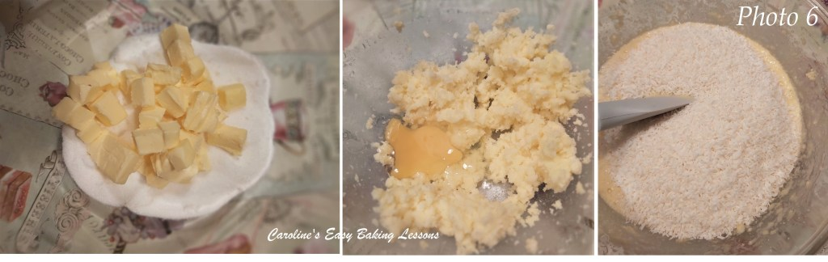Preparing the topping for the Christmas Slice

10. Mix in the flour, spice and baking powder. Then fold in the coconut and spoon this mixture over the jam/jelly and spread to cover as best you can. See Photo 6 above.

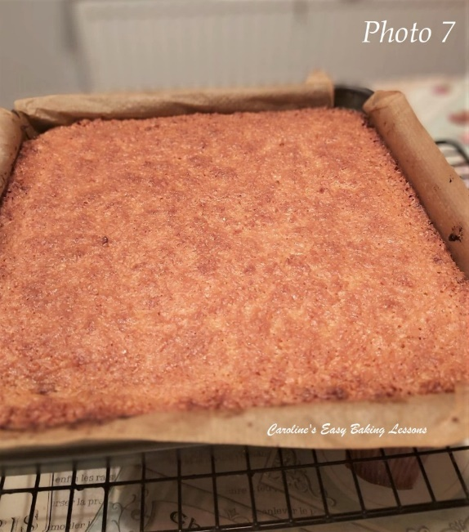
11. Bake for 18 – 25 minutes until golden brown. See Photo 7. Mine colours quickly but not evenly so I turn the tin a lot. Use a tooth pick/cocktail stick to test the centre. It will still appear a bit wobbly when moved but the stick will be clean of crumbs when ready. If too browned and not ready, simply cover with paper and continue to bake. Leave to cool in the dish on the worktop/counter for 10 minutes and then place on top of a cooling rack to cool completely.

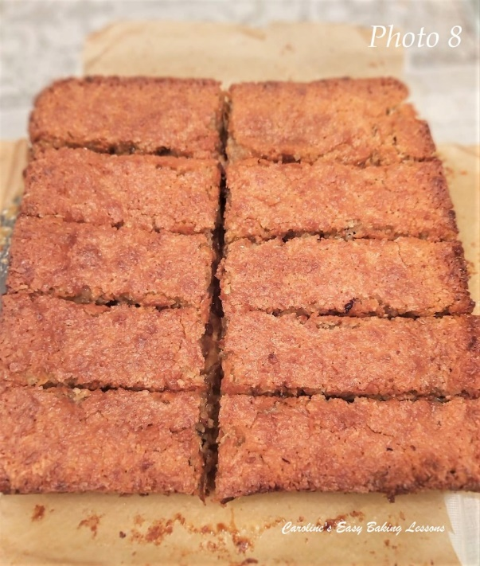

12. Once cooled you can cut into slices and dust with sieved icing/confectioner’s sugar if you like. (If impatient like me, I cracked the top of the cake a bit when lifting the cake & paper out of the tin). I got 10 good size slices out of this tin. But in hindsight and after eating them, I would suggest half that size as it is very rich. So maybe 20 small slices, or even 15. See Photo 8.
13. Sieve over a dusting of icing/powdered sugar and the bake is ready to be served.
14. Left overs can be stored best in an airtight container, (I like metal ones) for several days (if you are lucky!)

SKILL LEVEL: Beginner, Easy

Thanks for reading.
Happy Baking & Making
Happy Memories & Tummies!

Caro x

