HOW TO COLOUR FONDANT

Part 5 of Traditional Christmas Cake Bake-Together

Caroline’s Easy Baking Lessons Fondant Tutorials
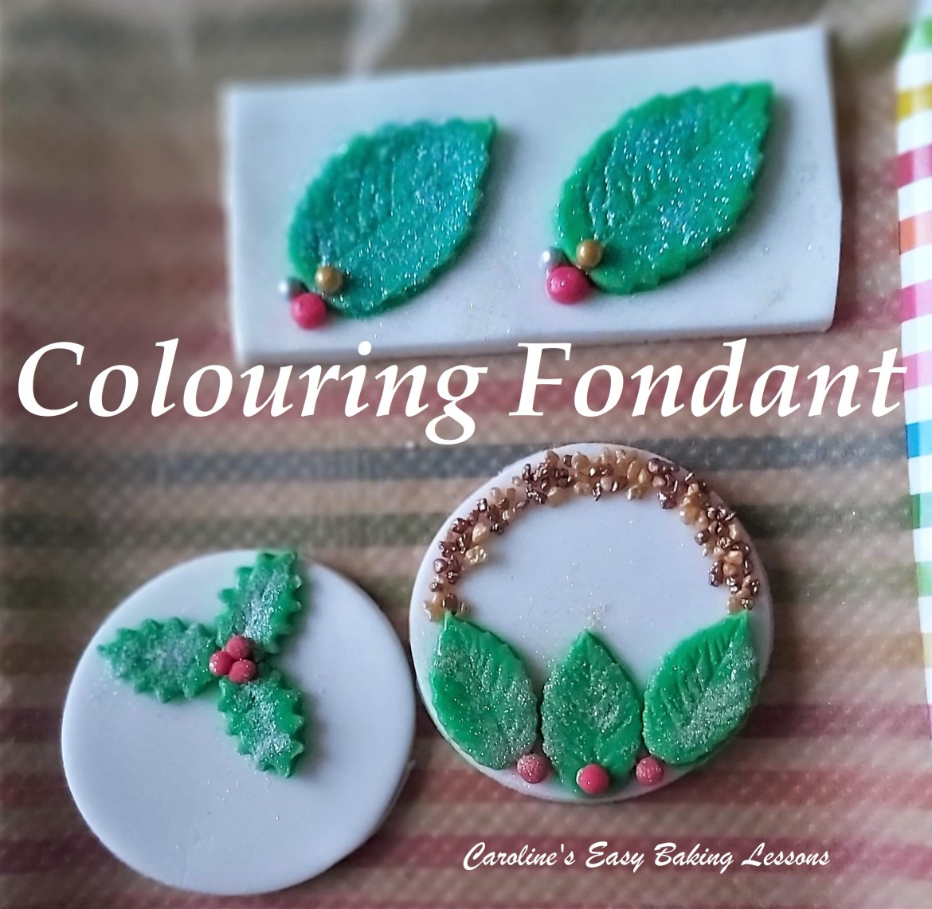
So some of you might want to make your own fondant toppers and models, and need to colour your fondant. You can of course get fondant in various colours but if you already have a lot of white fondant, colouring your own to the shade you want is useful. Then you can just make up what you want, instead of having lots of odd bits of coloured fondant left over.

But where to start? Well my advice is to completely avoid the liquid colourings from the supermarket. Lots of people use the gel colourings, but even better than that, is the colouring in the form of a paste. The idea is, to have as little moisture in the colouring source as possible, as it adds to the fondant when mixed and can make the fondant really sticky and hard to work with. I highly recommend Sugarflair brand. I buy them on eBay and Amazon, and they are cheaper in sets. Just get yourself some basic colours that you can even use to make other colours – such as primary colours. They do offer loads of different shades and finishes too. They are very concentrated and you really don’t use as much. Just a note though, on darker colours like black, you want to either buy black fondant or an equally dark colour like maybe chocolate fondant and then only need a small amount of black colouring to get a true black colour.

Equipment
- White fondant
- Food safe dye (Paste colouring best)
- Baking/Parchment/Non-stick Paper
- Disposable Gloves
- Wooden Cocktail sticks
- Cling film/plastic wrap
- Food Baggie

Instructions
• Prepare some baking/parchment or non-stick paper on the area you will work on. This will protect the surface from the dye. Also a must is gloves – never use without gloves as it will stain quite a bit.
- Take some of your fondant (a little more than you think you will need – maybe before hand test how much you need for a specific thing you are working on). Knead the fondant till nice and soft and pliable. It can start off quite hard and cracked but should come together with kneading and the heat of your hands.
- Form the fondant into a ball, then flatten on top of the paper just with your fingers (no need for a rolling pin). See Photo 1 below.
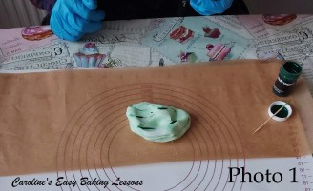
Photo 1
- Using a wooden cocktail stick, take some of the food colouring and scrape it in strips on the top of the opened up fondant. See Photo 1 above.
- Then simply fold over the fondant into the centre and knead the fondant. See Photo 2 below. Keep kneading and folding the fondant over to get any even distribution of the colouring through out the fondant.

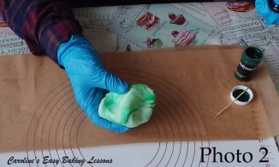
Photo 2
- With this time of kneading, the colouring also has time to develop and deepen. So don’t add too much to begin with – always add in small amounts.
- You can achieve a marbled look to the fondant at this stage if desired, or continue till a uniform shade. See Photo 3 below.
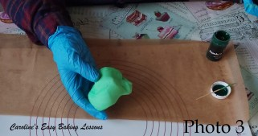
Photo 3
- Then simply add more colouring like before, and repeat as needed, with plenty kneading in-between, until you achieve the desired shade you are looking for.
- Then roll out and use, or wrap well in cling film/plastic wrap and place in a food baggie until ready to use. Fondant will last for months if stored correctly and not allowed to dry out. See Photo 4 below of different shades of green fondant.
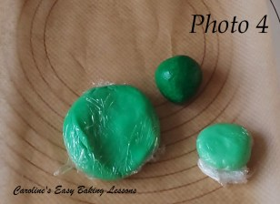
Photo 4

- Part 6 will follow shortly to give you some ideas for how to make some cute fondant toppers for your Christmas cakes.

- DOWNLOAD this guide onto your phone or computer, to use or print off later. Click the ‘download’ button below:

DIFFICULTY LEVEL – Beginner, Easy

Thanks for reading.
Happy Baking & Making, Happy Memories & Tummies!
Caro xx

