CHEDDAR & MOZZARELLA MUFFINS

Caroline’s Easy Baking Lessons

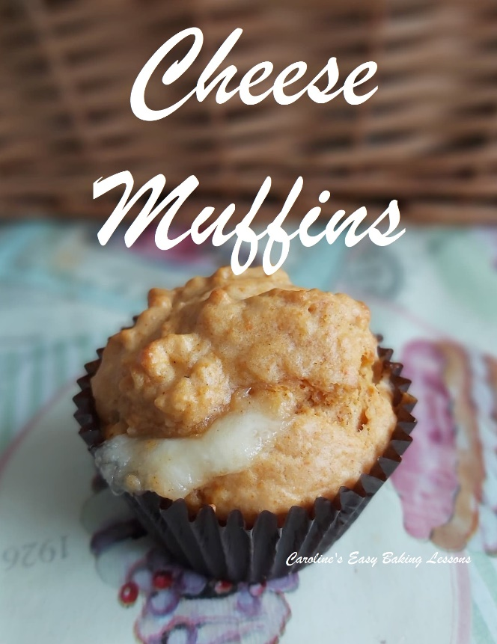
This is my adaptation of a very popular recipe I reviewed back during the first lockdown’s of 2020. The original recipe was from The Practical Encyclopaedia Of Baking’, by Marth Day (Lorenz Books, 1999). This review and that of Syrian Onion breads, almost went viral. I still don’t know what happened, but think someone/somewhere the reviews were published and so I had literally thousands of views between these 2 recipes in just 6 days.

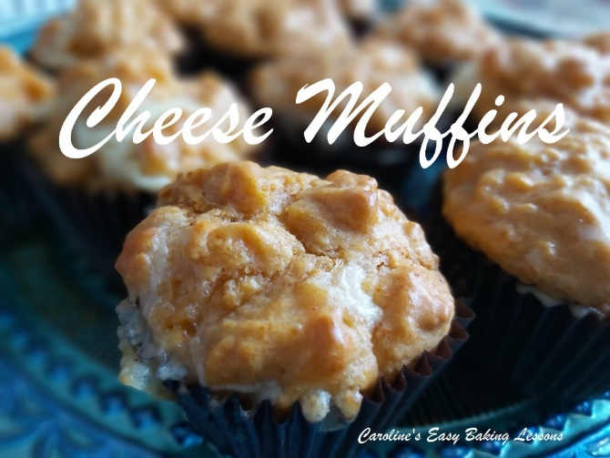
But that aside this recipe had potential to be amazing, so I set about altering it. I tweaked the recipe and wrote my own style of thorough instructions and pics. So without further ado, onto the recipe

INGREDIENTS
- 83g Butter, cubed, unsalted & softened
- (3 oz or 1/3 cup)
- 292g Plain Flour, sieved
- (10.25 oz or 2 1/3 cups A.P.)
- 3 tsp Baking Powder (level)
- ¾ tsp Salt
- 2 ¼ tsp Smoked Paprika
- (And/Or, 2 ¼ tsp Mustard Powder)
- 3 Eggs (med-large)
- 180ml Milk
- (6 fl oz or ¾ cup)
- 100g Extra Mature Cheddar, cut into 1.25cm (1/2” pieces)
- (3.5 oz Extra Sharp Cheddar, cut as above)
- 76g (or 24 x 1cm (1/3″) cubes) Mozzarella (3.5 oz)
- *If hard to cut, freeze for a little while
- Pinch of Pepper & Garlic Powder
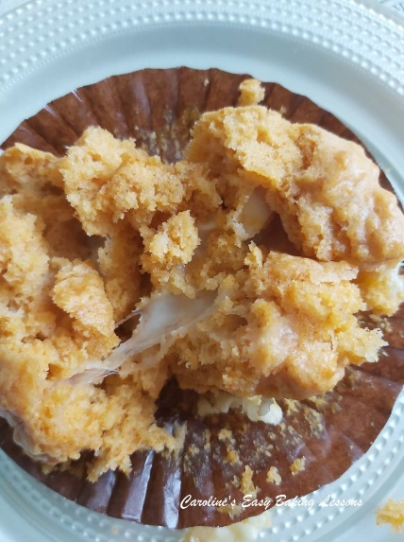

EQUIPMENT
- Scales or measuring cups
- Measuring spoons
- Sieve
- 2 Bowls, one of which large (or stand mixer)
- Hand/stand mixer (optional)
- 12-hole cupcake tray
- 12 Paper cases
- Timer or Phone timer
- Cooling rack

- OVEN: 190c/170c Fan oven/365f/Gas Mark 5

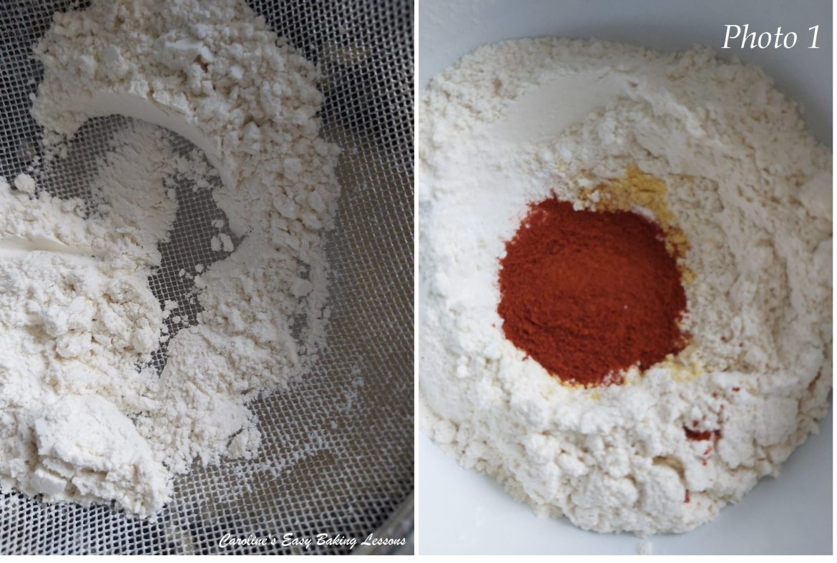

INSTRUCTIONS
1.Heat your oven to 190c/170c Fan oven/365f/Gas Mark 5 and line a 12 hole cupcake tray with 12 muffin or large cupcake paper cases.
2.Sieve together the dry ingredients and mix to combine. See Photo 1.

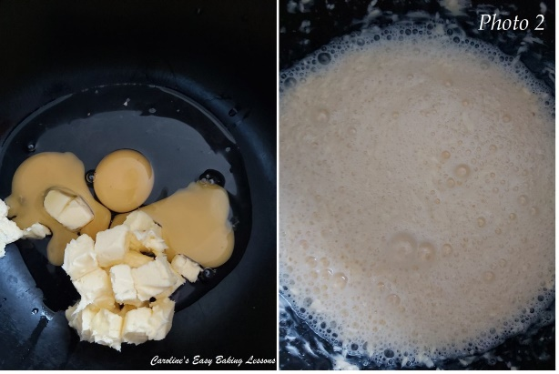

2. In another bowl, combine the eggs, milk & butter and beat together until well combined. Start on low speed and progress onto high, as it comes together and beat about 15 seconds longer to incorporate air into the batter. The liquid mixture should be foaming and containing lots of bubbles. See Photo 2.

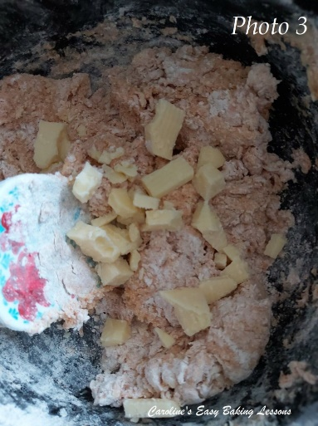
3. Next add in the dry ingredients to the wet, and starting on a low speed, beat together just until all blended and smooth. (I like to just mixing a little by hand just to stop flour going everywhere and then start the hand mixer). Next step is to fold in the mature (sharp cheddar) cheese in 2 increments, just to get an even distribution. See Photo 3. Note the batter will be quite thick.

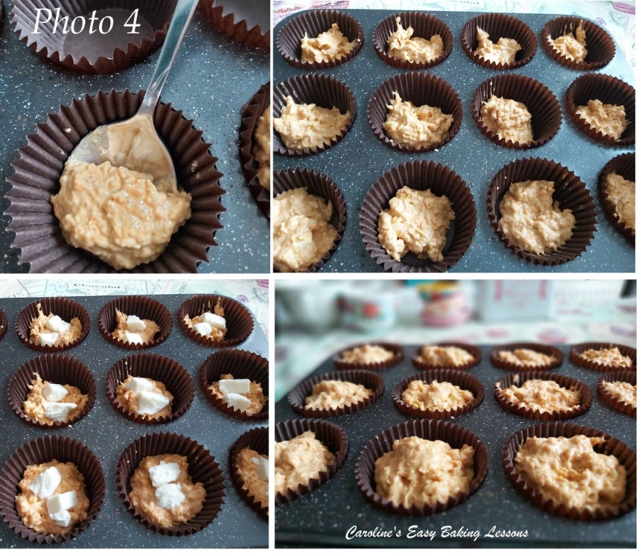
4. Place about 1 heaped tsp of batter into each of the 12 paper cases.
5. Now add 2 cubes of the mozzarella, placing near the centre. See Photo 4.
6. Top this with another heaped tsp of batter, and then distribute all the remaining batter between the cases equally. The cases should be about 75-80% full. If you use smaller cases, you might want to make more than 12. See Photo 4.

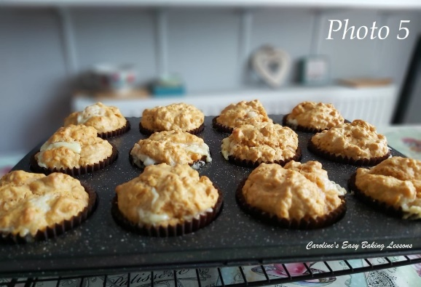
7. Give the cupcake tray a few taps on the worktop/counter to expel any trapped air pockets and then bake on the middle shelf for 12 – 15 minutes. The muffins will be set and a little golden but hard to really tell by the colour, because of the original batter colour. Test them with a wooden cocktail stick that should come out clean of crumbs (just try to avoid the cheese areas). See Photo 5.

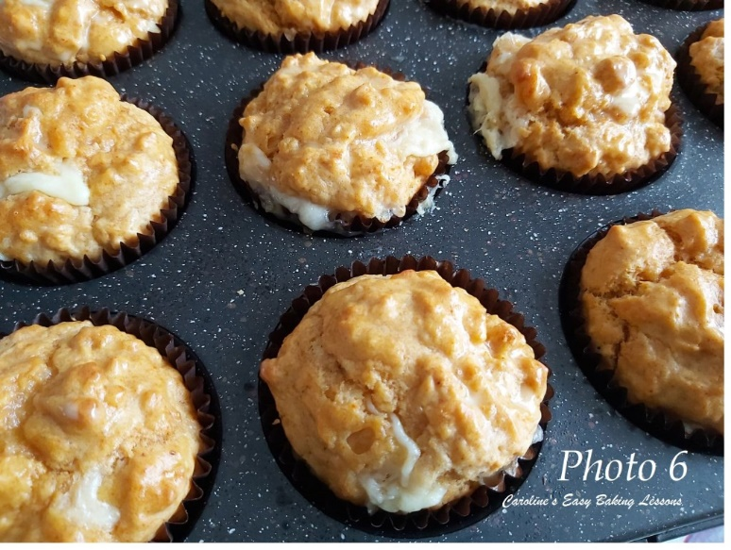
8. Leave the muffins in the tray and place on top of a cooling rack, for 5 – 10 minutes. You can also at this point brush on some melted butter if you like. It gives nice shine to the muffins. See Photo 6.
9. After 10 minutes, remove the muffins from the tray and leave to cool down more. You can of course eat while still warm, and even brush on some more melted butter at this point too!
10. Once completely cooled down, these can be stored in a tin or airtight container for several days. You can even freeze them and defrost sitting out at room temperature.

Thanks for reading, I hope you enjoyed the recipe.
Please see the sharing options or even printing, at the right/bottom of your screen (bottom of your screen for mobiles, and down the right-hand side on computers). You can even pin this to your own Pinterest page. Alternatively, you can download this article, see below. You could also leave some feedback if you like.
Here’s also the recipe, tested by my friend Diana.

DIFFICULTY – easy, beginner

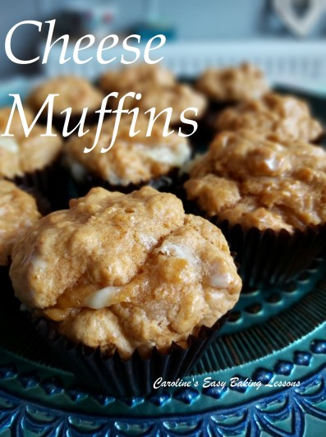

Happy Baking & Making
Happy Tummies & Memories!

Caro xx

