CONVERSION OF UK & US COMMON BAKING INGREDIENTS – With A Handy Table To Save
Caroline’s Easy Baking Lessons BLOG-INFO
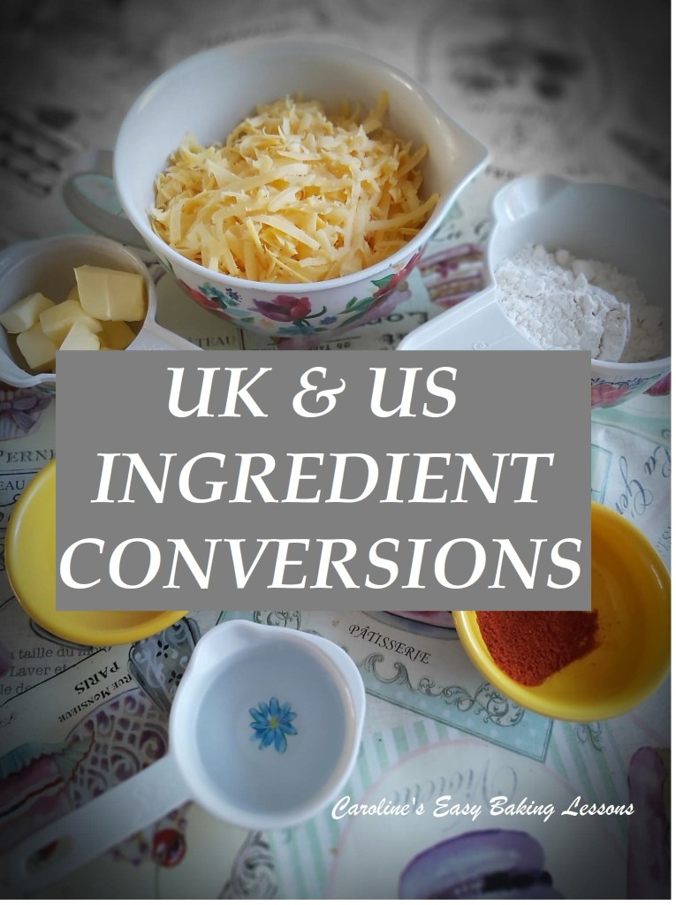
Since I have many followers from the US & Canada, I thought I would take the time to talk about the differences in UK measurements. Likewise, if you watch US/Canadian food programs or are trying out a recipe in different measurements, this should be of benefit to you. With the Great British Bake Off tv show being so popular abroad, I do often read frequently, on Facebook groups, people asking questions about ingredients and measurements but sometimes, there are incorrect answers. So I will talk a little about the common ones that pop up and at the end I will produce a table for printing and quick reference. I should also point out, that I produced this table by personally measuring all these ingredients in all methods. And this not only was for authenticity, but also because online conversion sites/tables, are often inconsistent or inaccurate. For all my recipes, I always give the ingredient measurements in grams and cups, and more recently have included ounces.

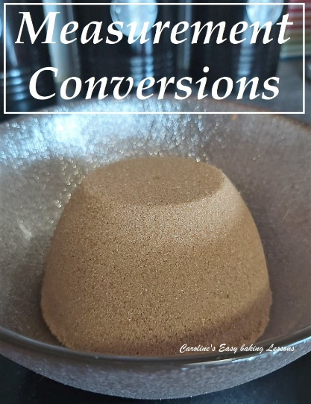
Beware of websites that state: “1 cup = 125g”. That only applies for flour. 1 cup of granulated sugar weighs 200g and butter 227g. Please also note that not all sugars weigh the same because of the size and weight of the grains. As an example, 1 cup of caster sugar (also known also as ‘super/extra fine sugar’) weighs 225g in comparison to regular sugar weighing 200g. And as baking is very much a science, getting the weight correct can influence the result of the bake. If in doubt look it up on my table or for any other ingredient not listed, check Google. However, when using Google to search, do so in this way: ‘1 cup chocolate chip in grams’ not just ‘1 cup of chocolate in grams’ as there will be a difference in the answer for both of these. I advise checking a few different websites to get a general consensus on the answer as far too many of them are inconsistent and even inaccurate. I like Traditionaloven.com and find it most accurate. Also note that if you purchase scales, not only will measuring be more accurate and in grams, some models also have other units of measurements on them, for example oz, which is also commonly used as an alternative to cups.
A note to people used to weighing their ingredients, but are trying out using measuring cups. Be aware that sometimes ‘level cup’, ‘heaped cup’ , ‘packed cup’ or ‘scant cup’ may be advised. A level cup is just as it sounds, levelled off (usually with a knife) and heaped is a big cup, heaped high, or ’rounded’. Packed cups are usually advised when using brown sugar as it’s softer and if it’s packed in tight you get more sugar in and inevitably a heavier weight in grams. A scant cup is just short of a full cup
Below is a list of common baking items that I have a note of for anytime I bake It has grams and US cups measurements, as well as ml and ounces (oz). Note I have used these in both ways in my recipes as I write them and test them in cups and grams before finalising a recipe. If you also want you can also read about the Difference Between UK & US Baking Ingredients, or got to my Oven Temperature Conversion Table.

MOBILE users – scroll right to see rest of table Caroline’s Easy Baking Lessons
INGREDIENTS | .TSP.. | TBSP | 1/8c | 1/4c | 1/3c | 1/2c | 2/3c | 3/4c | 1c | INGREDIENTS
Butter | 5g | 15g 0.5oz | 28g (1oz) | 57g  (2oz) | 76g  (2.7oz) | 113g (4oz | 152g  (5.25oz | 170g  (6oz) | 226g (8oz) | Butter
Flour*, Icing/Powdered Sugar | 2.6g | 7.8g | 16g  (0.5oz) | 31g  (1oz) | 42g  (1.5oz) | 62g  (2oz) | 83g  (3oz) | 93g  (3.25g) | 125g  (4.5oz) | Flour*, Icing/Powdered Sugar
Granulated and Brown Sugar** | 4.2g | 12.5g | 25g (0.75oz | 50g  (1.75oz | 67g  (2.25oz | 100g  (3.5oz) | 134g (4.75oz | 170g (6oz) | 200g (7oz) | Granulated & Brown Sugar**
Caster, Super or Extra Fine Sugar | 4.6g | 14g | 28g (1oz) | 56g (2oz) | 75g (2.5oz) | 113g  (4oz) | 150g (5.25oz | 169g (6oz) | 225g (8oz) | Caster, Super/Extra Fine Sugar
Chocolate Chips | _ | _ | 20g (0.75oz | 45g (1.5oz) | 60g  (2oz) | 90g (3oz) | 115g (4oz) | 130g (4.5oz) | 175g (6.25oz) | Chocolate Chips
Rolled Oats | _ | _ | 14g (0.5oz) | 28g (1oz) | 38g (1.25g) | 52g (1.75g) | 76g (2.75oz | 86g (3oz) | 114g (4oz) | Rolled Oats
Ground Almonds/Almond Meal | 5g | 8g | 12g (0.5oz) | 24g (0.75oz | 37g (1.25oz | 46g (1.5oz) | 61g (2oz) | 69g (2.5oz) | 92g (level, 3.25oz) | Ground Almonds/Almond Meal
Cornflour/starch | 3g | 9g | 19g (0.75oz | 39g (1.25oz | 51g (1.75oz | 76g (2.75oz | 101g (3.5oz) | 114g (4oz) | 152g (5.25oz) | Cornflour/starch
Coconut Sugar | 4g | 11g | 18g (0.75oz | 36g (1.25oz) | 48g (1.75oz) | 72g (2.5g) | 96g (3.25g) | 108g (3.75g) | 144g (4oz) | Coconut Sugar
Vegetable Shortening*** | _ | _ | 26g (1oz) | 51g (1.75oz) | 68g (2.25oz) | 102g (3.5oz) | 136g (4.75oz) | 153g (5.25oz) | 204g (7oz) | Vegetable Shortening***
Pumpkin Puree, home-made | _ | _ | 28g (1oz) | 55g (2oz) | 74g (2.5oz) | 111g (4oz) | 147g (5oz) | 166g (5.75oz) | 221g (7.75oz) | Pumpkin Puree, home-made
Water, Oil, Milk etc. | 5ml  0.2  fl oz | 15ml  0.5  fl oz | 30ml  1  fl oz | 60ml  2 fl oz | 80ml 2.75  fl oz | 120ml 4 fl oz | 160ml 5.5 fl oz | 180ml  6 fl oz | 240ml  8 fl oz | Water, Milk, Oil etc.
NOTES
* Flour is approximate, as different types can vary a little amount, but for most recipes, you add enough flour till you get the right consistency. Also different flour, different places and how it was milled, affect the amount of fluid it absorbs, so sometimes you will need more or less flour.

** I tested the light and dark brown sugar in a cup that I before had double-checked held 200g worth of granulated. I filled the cup in increments, packing the sugar in each time until no more could go in.

*** Vegetable Shortening is also branded as ‘Crisco’ in the states and can be purchased in bigger supermarkets in the UK, under the brands ‘Trex’ and even ‘Crisp ‘n Dry’ Vegetable Oil Block, can also work.

Taken from Caroline’s Easy Baking Lessons website @ https://easyonlinebakinglessons.com
January 2021 updated.

