‘PROTEIN POWER-BALL’ TRUFFLES Caroline’s Easy Baking Lessons
These might just look like truffles, but these yummy chocolate bites, are a good source of protein too. I came up with them after I had left over chocolate ganache (my youngest had helped himself to too many of the chocolate cupcakes that I had not all decorated yet, so thought of something else to use of the left-overs.
I made 2 versions of them, in terms of added ingredients, so that said son could have some. But really they were for me and my oldest boy, you is into fitness and eating healthier. And he buys a protein supplement, so I wanted to make sure these had a good amount of protein rich ingredients in it and less processed sugar.

The ganache is simply made up of chocolate and double (heavy/whipped) cream. And in essence firm ganache, rolled up makes a simple truffle. But I added chopped dates for some added texture and a little sweetness to cut the dark chocolate taste from the ganache. This was version one for the truffles and they were rolled in cocoa. The second version also had chopped hazelnuts in them, and also some raisins and cranberries in, to which I finally rolled in desiccated coconut.
These would be good for an afternoon energy snack and even as a gift for Valentine’s day. Just keep them somewhere cold.
* A little note on the ingredients, this is what’s called a 1:1 ratio of chocolate to cream, but note if you want to use white chocolate, the ration is more like 3:1, that being 3 parts white chocolate to 1 part cream. The ratios can also change depending on what consistency you want for a particular use of the ganache, as well as if the environment is hot or humid, when a 4:1 ratio might be better. To maintain consistency, you always want to use the same type of chocolate.
*Which leads me on to the form of the chocolate. You can use real chocolate (as opposed to ‘fake’ which is made up of vegetable fats, whereas real chocolate is cocoa butter), in bars or chips. I used a generic cheap Aldi dark and milk (bitter and semi-sweet) for this. I find that using dark chocolate increases the cocoa content and so the lower price brand doesn’t bring any detrimental effect to the end result.
If using just milk chocolate, I would recommend choosing a middle price ranged chocolate, or even baking chocolate. (Note US professional baking chocolate can be termed ‘Couverture’ but the chocolate found in the baking aisle in the UK should also work). But it also comes down to taste, and for this recipe, the 50-50 milk and dark chocolate gives a dark chocolate over-all taste (bitter), using 100% dark is just too heavy and bitter. If you find this too bitter, play about with the ratio and add more milk (semi-sweet) than the other chocolate. Just remember to keep the amount of cream to the same total amount of chocolate.
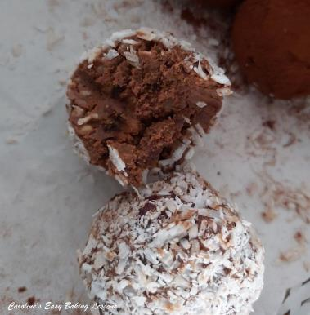
** I used hazelnuts as my choice of nut in this recipe, since it’s in my opinion a great nut to use in baking, but you can use any unsalted nuts you have or omit if need be.
***The dried fruit I used was a mix of cranberries and raisins from Aldi, and it had ‘flame raisins’ in it that I had never heard of, but they are very good and big and juicy. You could of course use just cranberries or your favourite dried fruit.

INGREDIENTS
- 300ml Double Cream (10 fl oz)
- (1 & 1/4 cup Heavy/Whipping Cream)
- 150g Milk Chocolate
- (5.25 oz semi-sweet chocolate)
- 150g Dark Chocolate)
- (5.25 oz bitter chocolate) * See above
- 70g Dates (2.5 oz)
- (1/2 cup) 12-14 pitted dried dates, not Medjool that are bigger and heavier
- 70g Hazelnuts** see above
- (1/2 cup, 2.5 oz)
- 50g Cranberries & Raisin mix*** (1/4 cup, 1 3/4 oz)
- Some cocoa powder and/or desiccated coconut (or chopped shredded unsweetened coconut).

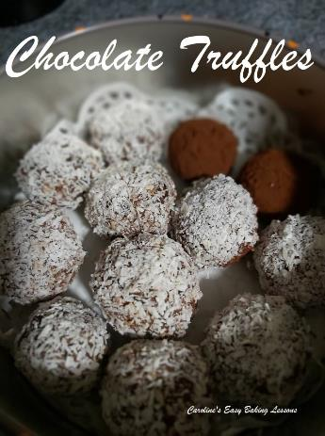

EQUIPMENT
- Scales or Measuring Cups
- Small Jug (optional)
- Medium pan or Microwave-safe Bowl
- Chopping board and large knife
- Mixing spoon
- Cling film/Plastic wrap
- Food Processor
- Tbsp
- Shallow bowl or plate for dipping x 2 (if using)
- Baking/Parchment Paper & scissors
- Tray to fit in the fridge
- Tin or airtight container for storing
INSTRUCTIONS
1. Make the ganache by first breaking up and then chopping the chocolate, as this will make melting much quicker.
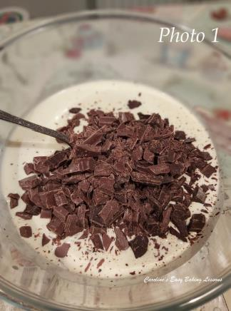
2. Heat the cream on the stove or microwave till warm. On the stove top, you want to heat on a medium heat just until it starts to bubble, but not as hot as boiling more of a gentle simmer. For the microwave, use a large microwave safe bowl, and heat in 1 minute intervals, mixing in-between because there can be hot spots. This can take about 3 minutes depending on the power of your microwave. Just make sure the bowl is nice and hot but not boiling and always check on it so it doesn’t boil over.
3. Next, if you heated the cream on the hob, transfer to a large mixing bowl. For the microwave heated cream, leave in that bowl.
4. Add the chopped chocolate to the hot cream. Leave for 5-10 minutes and don’t stir yet. You can place a clean tea-towel on top of the bowl if you like. See Photo 1.
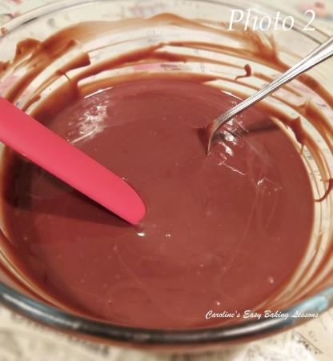
5.After 5-10 minutes, you can now stir the chocolate into the cream, until the chocolate has all melted and is evenly combined (or homogenized) with the cream. See Photo 2.
6. Leave to cool down for about 15 – 30 minutes (at this stage you can use as a drip for some cakes if you want long drips and to completely flood a cake).
7.Next place the bowl of ganache in the fridge for at least 3 hours (or overnight if you like – just cover with cling film/plastic wrap). You can even just leave out on the counter/worktop is the room temperature is cool. **Tip for cooling quicker – transfer the warm ganache to a wide shallow pan, giving the ganache a large surface area, allowing it to lose heat quicker and hence cool.
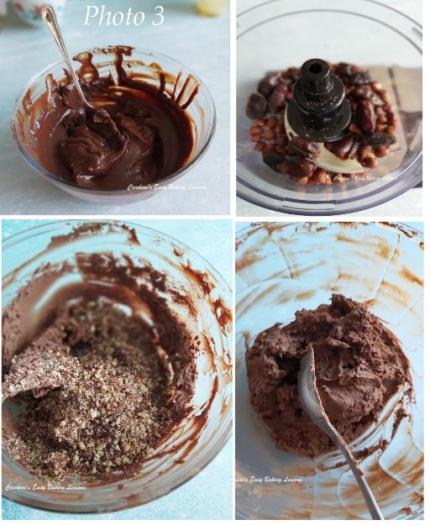
8. Once the ganache is set, with body to it now (kind of light smooth peanut butter consistency), as opposed to a liquid consistency (as in Photo 2 above), you can make the truffles. Begin by placing dates in a food processor (and hazelnuts if using) and pulse until of a fine consistency. See Photo 3, top 2 pics.
**Note too that I whipped the ganache before adding the other ingredients. I was trying that technique out for another recipe, and it gives more volume, and a lighter colour and over-all taste. You don’t have to do that stage though to make truffles.
9.Next add the nut/date mixture to the ganache in 2 or 3 increments, stirring in-between each addition. This will help get an even distribution of ingredients. Now add the cranberries and raisins if using and fold through. See Photo 3

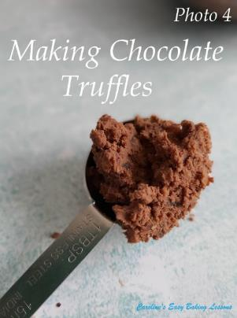
10.Now to get messy. Prepare a long plate or bowl with the cocoa or coconut, which ever you are using. Then get a tablespoon and place baking/parchment paper on top of a tray or plate that will fit in the fridge. Also have a 2nd piece of paper ready. Now wash your hands.
11.Scoop some of the truffle mixture into the tbsp, to make a rounded tbsp. Then use a small spoon or your fingers, to remove it, into your hand and roll into a ball. See Photo 4.
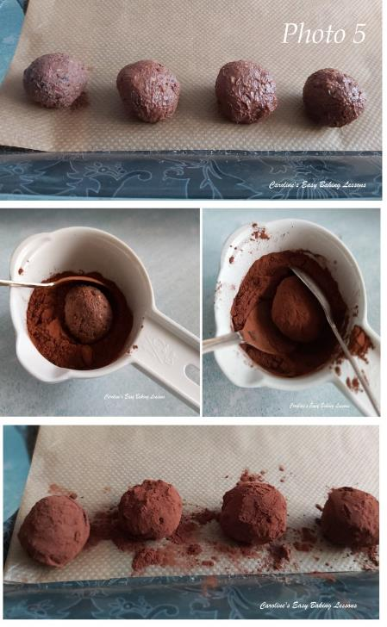
12. Next make more truffles from all of the mixture, placing the rolled balls on top of the second piece of paper. See Photo 5.
13.Finally roll the truffle balls in cocoa or coconut, (or even sprinkles or coloured sugar crystals), and place on the paper lined tray See Photo 5 & 6 below. The coconut ones were easy to just roll, but for less mess and waste of the cocoa powder, I used 2 small spoons to turn the truffle and coat it, before picking up with the 2 spoons and shaking the excess off.
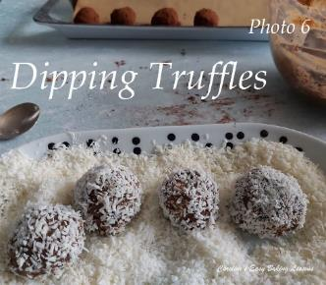
14.Place the truffles in the fridge for at least 3 hours to firm up again and then enjoy!
15. Store in the fridge after or somewhere very cool, preferably in a tin or airtight container and they will last minimum of 4 days. Depending on how big you roll the truffles (mine were not all the same size), you will get at least 18 truffles.
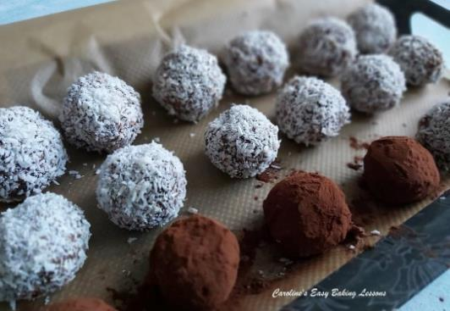
DIFFICULTY LEVEL: easy, beginner
