ITALIAN BREADSTICKS – Yeast Bread In 90 Minutes – A Recipe Review
Caroline’s Easy Baking Lessons Reviews

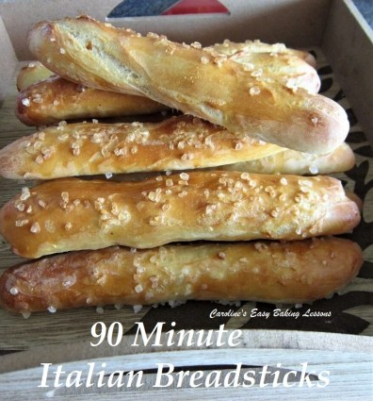
I recently tried out this quicker recipe for making soft breadsticks. It comes from the book ‘Easy Culinary Science – For Better Cooking’ by Jessica Gavin. This revolutionary book has recipes that explain how everything works and from that leads on to how to make things easier and faster but with the same results. It is still a yeast based dough, but only has a short prove after shaping the 12 breadsticks. You spend maybe 5 – 10 minutes longer preparing the dough at the beginning of this process, but the typical 2 hours of proving (1.5 hrs 1st prove and 30 minute second prove), is drastically shortened to 30-40 minutes. I really didn’t think they would rise much in such a short time or even on baking. I thought they would be hard breadsticks – but they weren’t.
Quicker Italian Breadsticks
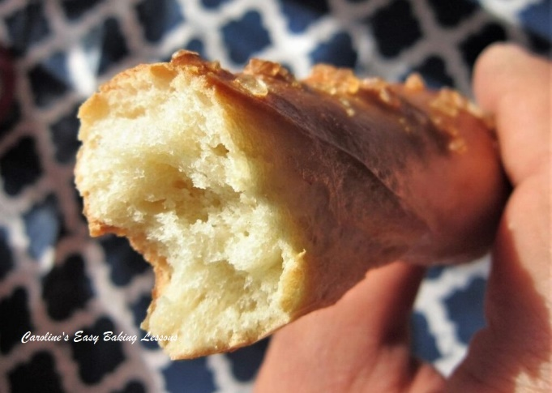
And when I refer to them as breadsticks, they are also not thin like you would imagine, but more like a mini baguette size (a little over 8 inches/20cm long and maybe 1.5 inches/4cm wide). The recipe called for rock salt, which I luckily had, but it was a bit too hard and over-powering (they did look great but). I would recommend maybe grinding them a little to maybe half the size and using less. Sesame seeds would be lovely but they are also great without.

Instead of adding dry oregano, basil & thyme, I added a little onion powder. I also added much more flour than the recipe called for as it was extremely sticky and you needed to roll out 20cm/8in long pieces, which would have been impossible with a specific amount of flour.
Once you try these, you will love them and want to make more, with variations and in different sizes. You can try dividing the dough to make 8 breadsticks instead of 12, to make them 50% wider or even make 6 and they will really look like baguettes! When they have their proving, they even split a little and look like the slit you create when making baguettes. These are better though, as they are soft, with a lovely texture.

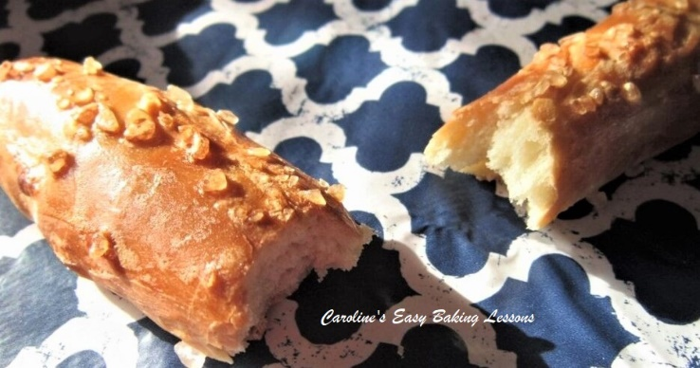
The recipe itself does not have any process photos (which if you know me, I don’t like). That said, the instructions are simple enough (for bread makers at least). And because she explains the science of it all, I think that helps us understand and retain the information better. So considering that these turned out lovely and were made in the time the recipe claimed, I am giving this recipe a 9/10. One of my highest ever marks. I plan to alter my other go-to bread recipes using this great technique and use it as an introduction to beginners to bread making and using yeast.

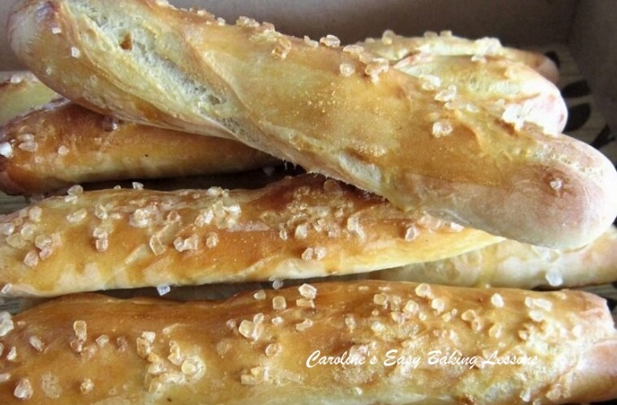
Below I listed the recipe as per the book (the on-line version was slightly different), and I have included some conversions and things I did differently. But all praise goes to Jessica Gavin for providing us with such a great and user friendly recipe and technique. You have inspired me Jessica!
Note that this recipe uses 285 -313g (2 1/4 – 2 1/2 cups), but I have listed it in the size of increments you need to add in at different stages. I will refer to each as F1, flour batch one, etc. Please stick to this process as it is how the recipe can work faster.

ITALIAN BREADSTICKS By Jessica Gavin

(with my alterations & conversions)

INGREDIENTS
- 125g Plain/All Purpose or Bread flour (1 cup) – F1
- 63g ” ” ” ” (1/2 cup) – F2
- 94-125g ” ” ” (3/4 – 1 cup) – F3
- 1 tsp Salt
- 7g Instant/fast Action Yeast (2 1/4 tsp)
- 1 tbsp Sugar
- 180ml Water (3/4 cup/ 6 fl oz)
- 2 tsp Olive Oil, or EVOO (10ml)
- 1 Egg White
- For the egg wash:
- 1 Egg yolk
- 1 tbsp Milk (15ml)
- Rock Salt or sesame seeds (optional)

EQUIPMENT
- Scales or measuring cups
- Measuring Spoons
- Small Measuring jug
- Stand Mixer (Or large bowl and spoon)
- Small – medium microwave safe bowl
- 2 small bowls to separate the egg
- Pastry brush (or small artist/paint brush)
- Large spoon
- Large baking tray/sheet x 2
- Baking/parchment paper
- Timer or Phone timer
- Cooling rack
- OVEN: 220c/200c Fan Oven/ 450f/Gas Mark 8

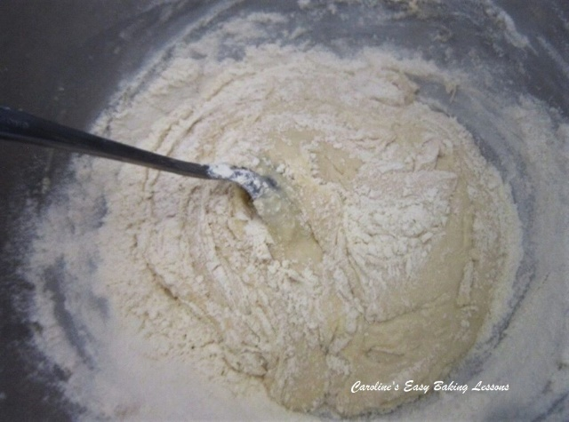

INSTRUCTIONS
1. Mix 125g/1 cup of the prepared flour [F1], with the salt in a stand mixer and mix well. Then add in the sugar and yeast and mix through. Never let yeast come into direct contact with the salt as it kills the rising power of the yeast.
2. Place the water and oil in a smaller microwavable bowl or jug and heat for approximately 30 seconds or until it reaches 120-130f (49-54c). This is about ‘warm’ and just above tepid. Never use very hot or boiling liquid when using yeast, as this again kills the yeast. Alternatively, use boiled and cold water in a jug till you correct temperature.
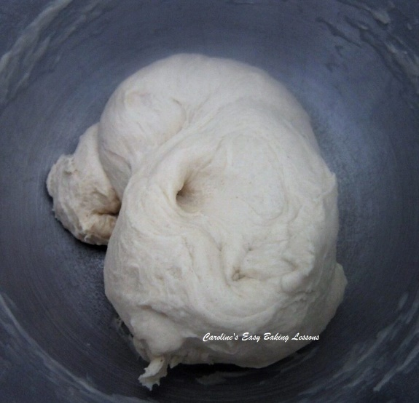
3. Add the warm oily water and the egg white to the dry mixture and with the paddle attachment, mix on medium speed for 2 minutes.
4. Add the 63g/ (1/2 cup) flour [F2] and beat on high for 2 minutes.
5. Now gradually stir in 94-125g (3/4 – 1 cup), [F3] flour until you get a dough that is no longer sticky.
6. Now knead with the dough hook for 8 minutes. If you want to do this by hand, it will take a good 10 minutes, on a lightly floured work surface. See Photo for how the dough texture should look – soft and silky. I like to knead for 4 minutes and then turn the dough over and knead another 4 minutes just to ensure it is evenly kneaded.
7. Cover the dough with a towel and let it rest for 10 minutes somewhere without a draft. See Photo.
8. Meanwhile prepare 2 large baking trays/sheets with some baking/parchment paper. What I also did was to take a small piece of baking/parchment paper and draw a 20cm/8″ line on one side of the paper with a thick dark marker pen and turn it over. This I used to help you getting all the breadsticks the same length. (See photos further down)
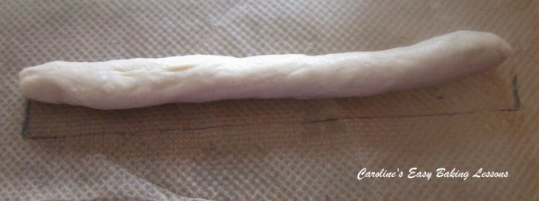
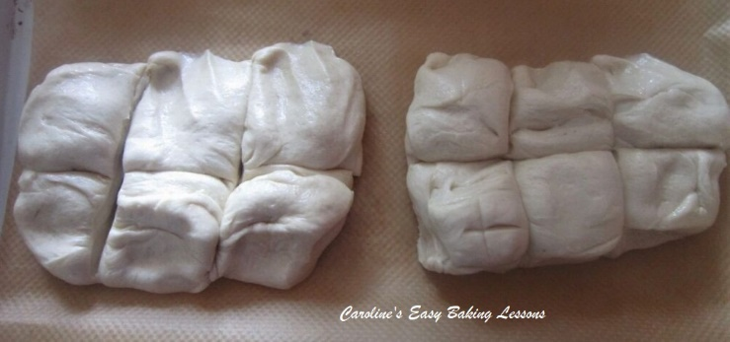

9. Cut the dough in half and divide each half into 6 pieces, to make 12 breadsticks. See photo above.
10. Take one piece of dough and roll into a ball. Then roll it into a rope shape between the middle of the palms of your hands, starting from the middle and working your way out. Continue until it is the length of the line you made on the paper. You can lay the rope dough on top of the paper to measure it and even roll on top of it. See Photo.

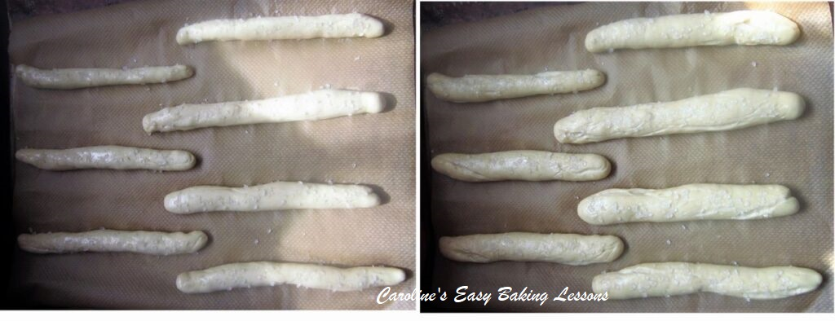
11. Place the breadstick dough on the prepared baking sheet/tray and repeat with the other 11 pieces of dough.
12. Mix up the egg yolk and milk well and then using a pastry brush, generously coat all exposed areas of the breadsticks and then sprinkle rock salt or sesame seeds on top.

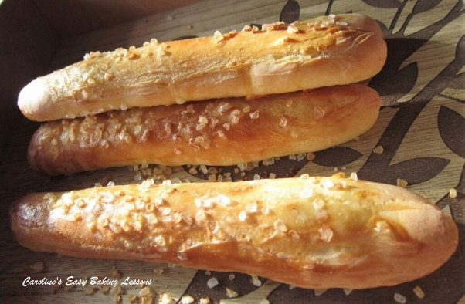
13. Leave, loosely covered with a towel in a draft free area for 30 – 40 minutes, while they will swell up and almost double in size. (This is known as proving). See Photo above for a before and after proving shot.
14. Heat up the oven to 220c/200c Fan Oven/425f/Gas Mark 7.

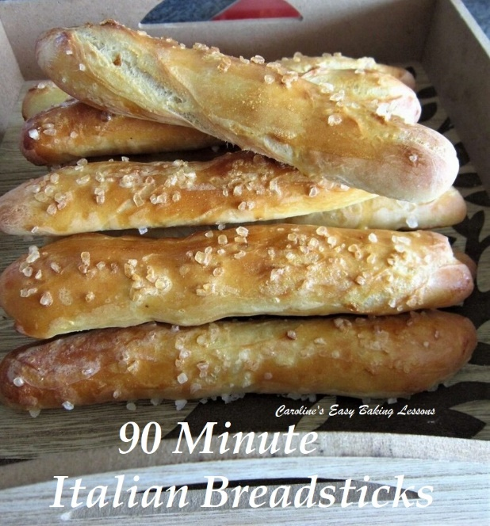
15. Bake the breadsticks for 10 – 12 minutes until golden brown. I like to bake for 3 minutes, turn and rotate the trays between the shelves and bake a further 3 minutes. I then apply more egg wash and turn and bake for 2 minutes. Turn and rotate the trays and bake another 2 minutes. (Apply more egg wash if you like). At this point, see if they are all evenly golden brown and ready. If not turn the tray if needed and bake for 1 more minute. Leave on the trays for 5 minutes and then transfer via the paper onto a cooling rack and serve warm.
16. These are lovely warm with butter, or used to dip into your soup or meal. Store any left overs in a sealed food bag.

ENJOY. Next time try making 8 or 6 pieces of dough for bigger breadsticks more like rolls/subs. More of these quick recipes I have developed from my old go-to recipes, can be found by clicking on the link – got to more quick recipes.
Please see the sharing options or even printing, at the right/bottom of your screen (bottom of your screen for mobile devices, and down the right-hand side on computers). You can even pin this to your own Pinterest page. Alternatively, you can download this article, see top of recipe. You could also leave some feedback if you like.

SKILL LEVEL – Easy (with guidance)

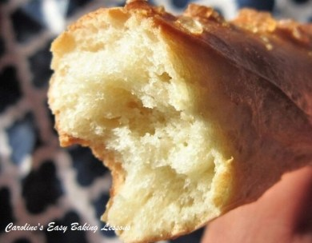
Happy Baking & Making
Happy Tummies & Memories.

Caro xx

