YEAST CONVERSION TABLES
Caroline’s Easy Baking Lessons INFO-BLOG

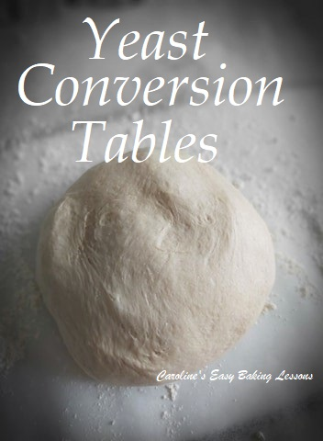
As I am often asked for the conversions of different types of yeast, I thought it about time I wrote an article and made up some tables. When trying out a new recipe (especially from older books), I calculate the amount needed when using instant yeast. And because there are shortages of yeast right now, some people are having to use yeast that is new to them. Fresh yeast, Active dry yeast & Instant dry yeast, are not interchangeable on a 1:1 basis. So below I have made 3 tables with all 3 types of yeast. 3 tables so that you refer to whichever one your recipe calls for first.
For example, if the original recipe calls for 14g Fresh yeast & you only have Active Dry Yeast, go to Table 1. And you will see you require 7g of Active Dry yeast. If you have the more commonly used Instant Dry yeast, only 5g is required.
If you have Instant dry yeast, and the recipe calls for 14g Active dry yeast, go to Table 2. There you will see you will use 10g Instant dry yeast.
And if your recipe calls for 7g Instant Dry yeast but you only have fresh yeast. Go to table 3, and see that 20g of fresh is required.

ORIGINAL RECIPE USING FRESH YEAST

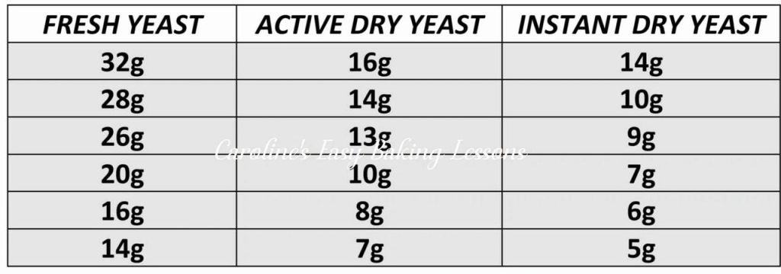

Table 1 – Recipe Using Fresh yeast – Conversion table

ORIGINAL RECIPE USING ACTIVE DRY YEAST
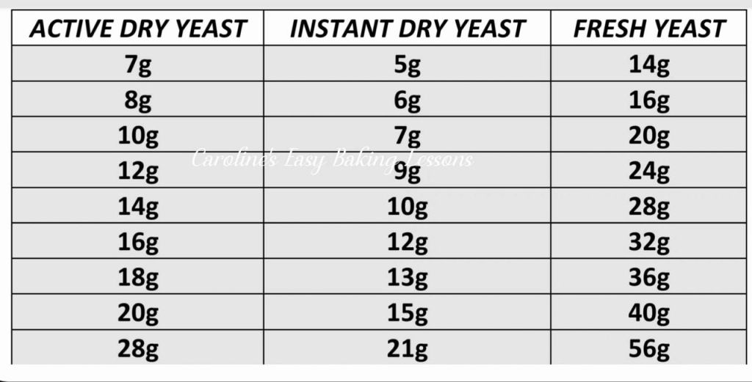 Table 2 – Recipe Uses Active Dry Yeast Conversion Table

ORIGINAL RECIPE USING INSTANT DRY YEAST
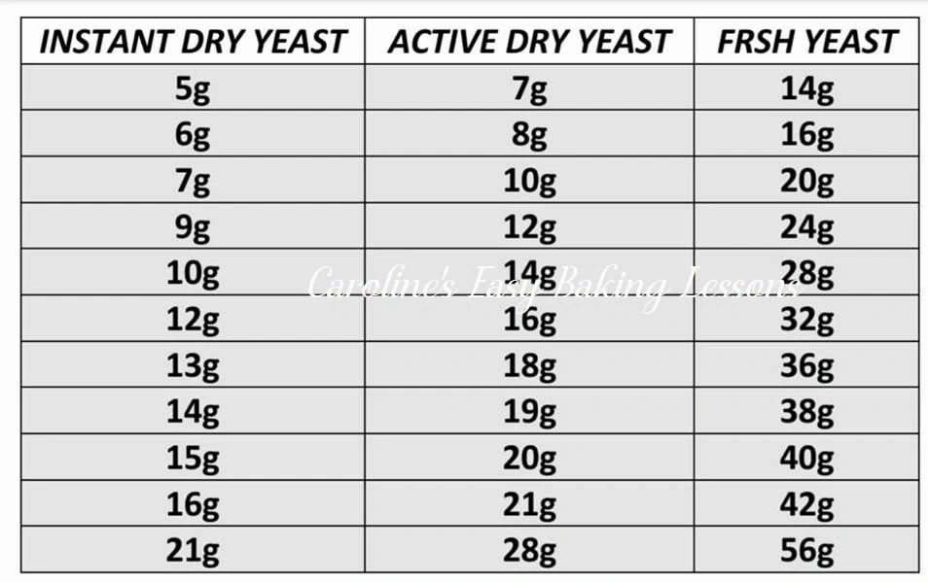 Table 3 – Recipe Using Instant Dry Yeast

Happy Baking & Making
Happy Memories & Tummies! Caro x

