HOW TO EASILY MAKE CHOCOLATE GANACHE
Caroline’s Easy Baking Lessons
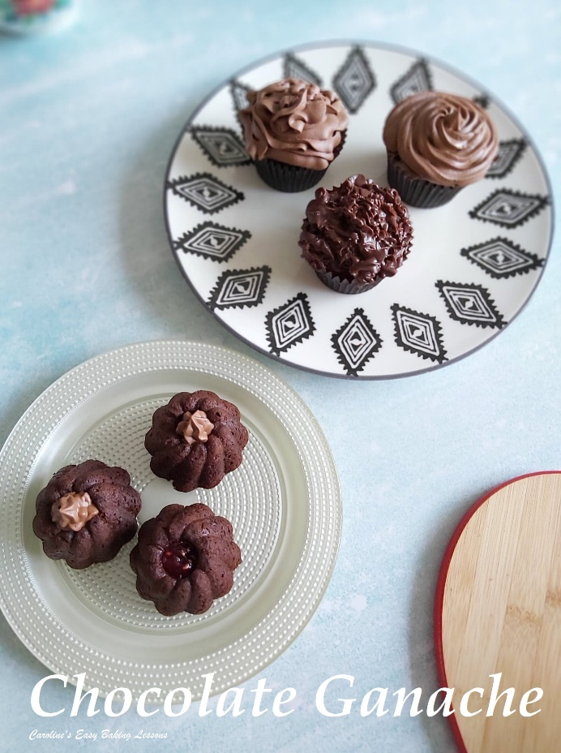
Ganache is simply made up of chocolate and double (heavy/whipped) cream. And in essence firm ganache, rolled up makes a simple truffle. You might like my Protein ‘Power-Ball’ Truffles that are an easy no-bake chocolate and nut fix. BUT, chocolate ganache can also be used as a simple drizzle over cakes, for Drip Cakes, or piped to resemble buttercream in appearance. You can also whip the ganache and then pipe it

This not only makes the colour lighter, but it incorporates a lot of air into the mixture, making it increase in volume, as well giving a ‘lighter’ taste. So in this recipe, I am going to show you how to make the ganache and how to apply it for simple, but effective and tasty decorations.

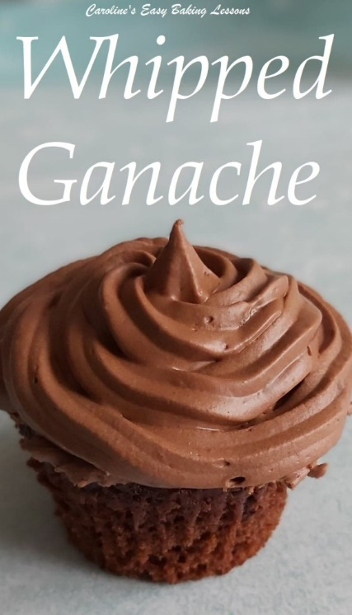
* A little note on the ingredients, this is what’s called a 1:1 ratio of chocolate to cream, but note if you want to use white chocolate, the ration is more like 3:1; that being 3 parts white chocolate to 1 part cream. The ratios can also change depending on what consistency you want for a particular use of the ganache, as well as if the environment is hot or humid, when a 4:1 ratio might be better. To maintain consistency, you always want to use the same type of chocolate.

*Which leads me on to the form of the chocolate. You can use real chocolate (as opposed to ‘fake’ which is made up of vegetable fats, whereas real chocolate is cocoa butter), in bars or chips. I used a generic inexpensive Aldi dark and milk (bitter and semi-sweet) for this. I find that using dark chocolate increases the cocoa content and so the lower price brand doesn’t bring any detrimental effect to the end result. If using just milk chocolate, I would recommend choosing a middle price ranged chocolate, or even baking chocolate. (Note US professional baking chocolate can be termed ‘Couverture’ but the chocolate found in the baking aisle in the UK should also work). But it also comes down to taste, and for this recipe, the 50-50 milk and dark chocolate gives a dark chocolate over-all taste (bitter), using 100% dark is just too heavy and bitter. If you find this too bitter, play about with the ratio and add more milk (semi-sweet) chocolate than the other chocolate. Just remember to keep the amount of cream to the same total amount of chocolate.

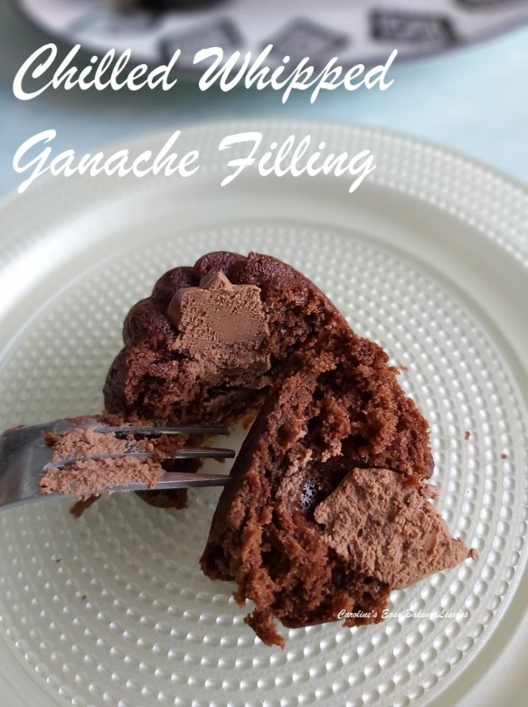

INGREDIENTS
- 300ml Double Cream (10 fl oz)
- (1 & 1/4 cup Heavy/Whipping Cream)
- 150g Milk Chocolate
- (5.25 oz semi-sweet chocolate)
- 150g Dark Chocolate
- (5.25 oz bitter chocolate) * See above
- Orange Extract (optional, or any other flavouring)

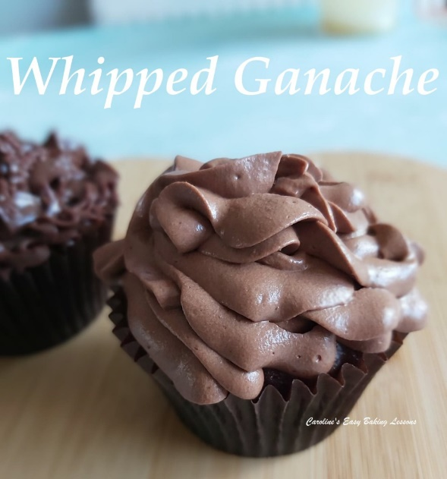

EQUIPMENT
- Scales or Measuring Cups
- Small Jug (optional)
- Medium pan or Microwave-safe Bowl
- Chopping board and large knife
- Mixing spoon
- Mixing bowl for if whipping
- Hand/stand mixer if whipping
- Piping bag & nozzle (or food baggie with a small hole cut off the end)
- Cakes to use the ganache on – for my Versatile Chocolate Cake recipe, click here. Or go to my Cake list.

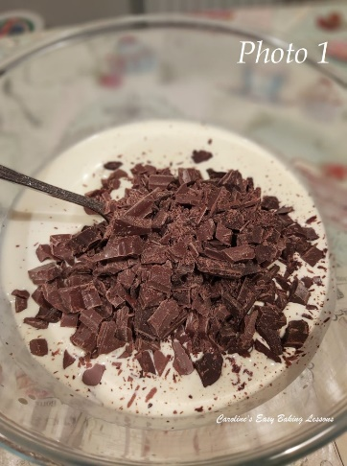
INSTRUCTIONS
1. Make the ganache by first breaking up and then chopping the chocolate, as this will make melting much quicker.
2. Heat the cream on the stove or microwave till warm. On the stove top, you want to heat on a medium heat just until it starts to bubble, but not as hot as boiling more of a gentle simmer. For the microwave, use a large microwave safe bowl, and heat in 1 minute intervals, mixing in-between because there can be hot spots. This can take about 3 minutes depending on the power of your microwave. Just make sure the bowl is nice and hot but not boiling and always check on it so it doesn’t boil over.
3. Next, if you heated the cream on the hob, transfer to a large mixing bowl. For the microwave heated cream, leave in that bowl.
4. Add the chopped chocolate to the hot cream. Leave for 5-10 minutes and don’t stir yet. You can place a clean tea-towel on top of the bowl if you like. See Photo 1.

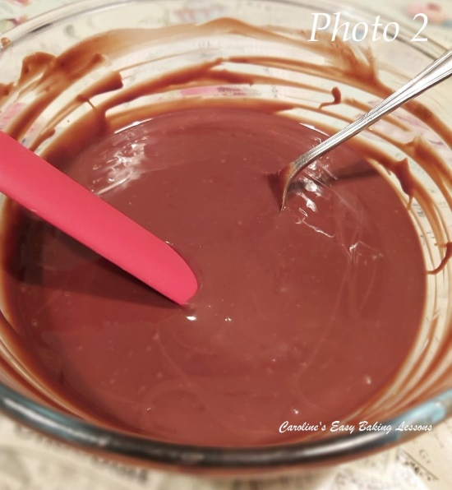
5.After 5-10 minutes, you can now stir the chocolate into the cream, until the chocolate has all melted and is evenly combined (or homogenized) with the cream. See Photo 2.

6. Leave to cool down for about 15 – 30 minutes (at this stage you can use as a drip for some cakes if you want long drips and to completely flood a cake).

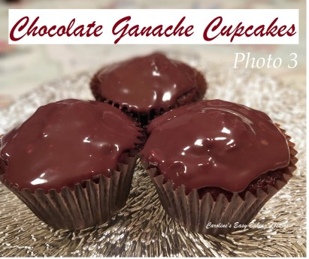
Simply Drizzled Ganache Cupcakes

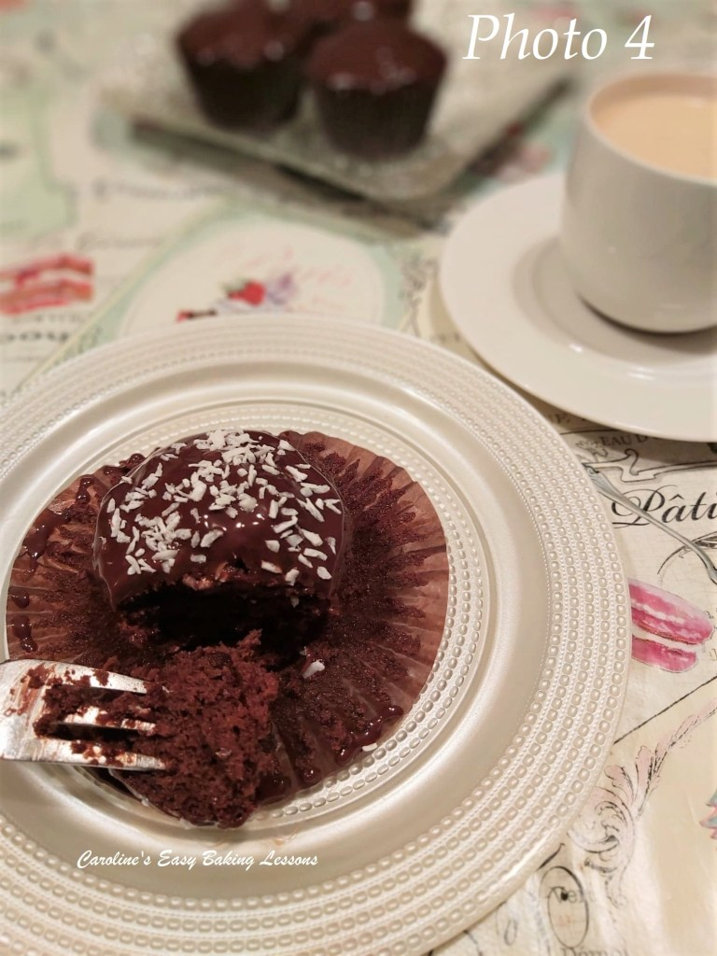
7. If you want just a drizzle or glaze of the ganache, you can simply pour or spoon on the ganache, after about 30 – 60 minutes. You can test some on a plate – spoon a little on and then tilt the plate to see how far it drips or moves down. You only want a little drip, enough for whatever you want to use it for.
8. See Photo 3 above, where I just spooned it on after about 45 minutes. Adding some coconut on top is also nice. See Photo 4, Here I made some very simple cupcakes form my go-to chocolate cake recipe.

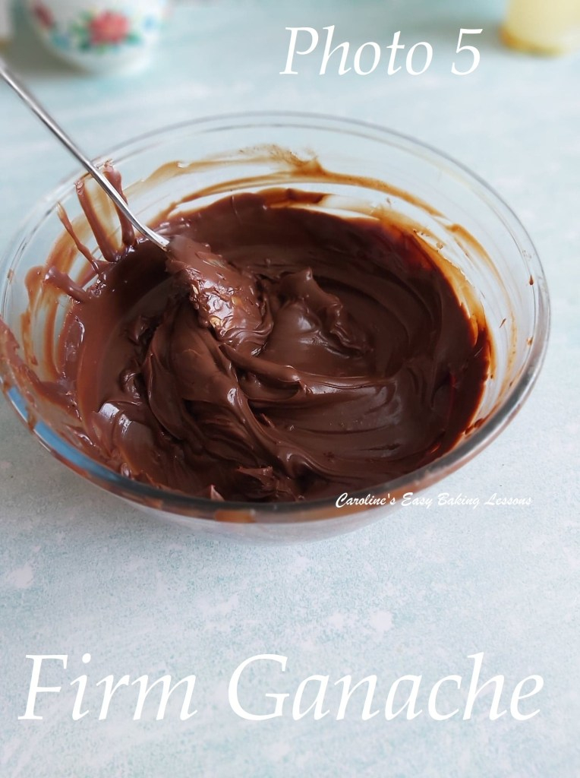
8. If you want to pipe it, or have a very thick spreadable ganache, say to spread between cake layers you need it to set up more. So place the bowl of ganache in the fridge for at least 3 hours (or overnight if you like – just cover with cling film/plastic wrap). You can even just leave out on the counter/worktop if the room temperature is cool.
**Tip for cooling quicker – transfer the warm ganache to a wide shallow pan, giving the ganache a large surface area, allowing it to loose heat quicker and hence cool quicker.
9. Once the ganache is set, with body to it now (kind of light smooth peanut butter consistency), as opposed to a liquid consistency (as in Photo 2 above), you can make the truffles or use as a firmer cake topping or filling. See Photo 5.

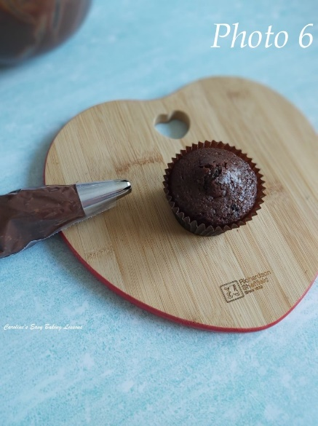

10. The firmer ganache can now be spread as a filling between layer cakes, or on the outsides of a cake, with a palette knife.
11. Or, you can choose to pipe the ganache. Simply scrape in to a piping bag or a food baggie, and pipe on top of the cake or cupcakes, with any nozzle type you wish. Just make sure that the ganache is not too cold or hard set, so it doesn’t get stuck in the nozzle. This is why room temperature setting of it is best. See Photo 6 & 7.

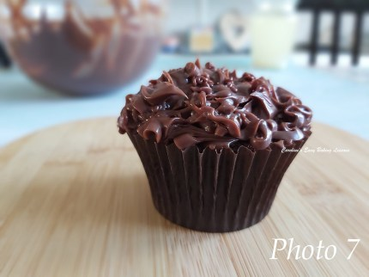Piped Ganache Topped Cupcakes

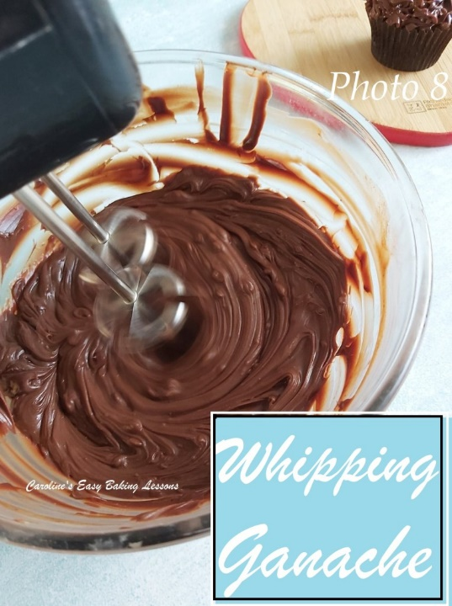
12. Alternatively, you can whip the ganache. This increases the volume, & lightens the colour and taste. Simply mix with a hand or stand mixer, on high speed till increased in volume, lighter and with a smooth appearance. See Photo 8 & 9 below.

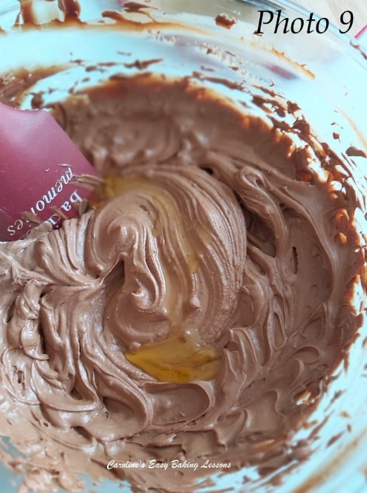

13. I also took the opportunity at this stage, to add some Seville Orange extract into the ganache to give a nice chocolate orange taste. I just mixed in until all incorporated and enough till a taste I was happy with. I used about 2 tsp in this batch. See Photo 9.

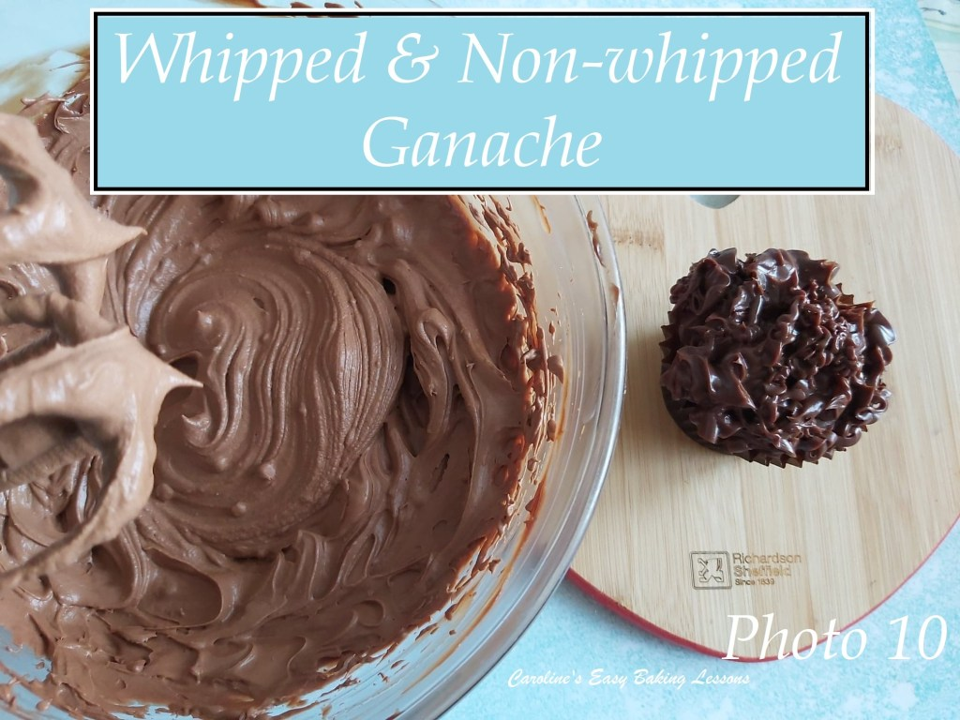

14. Here is a pic of the whipped ganache, compared to a piped firm ganache. See Photo 10. You can see the difference in texture and colour. The whipped is a pale brown colour and with a lighter, mousse like texture.

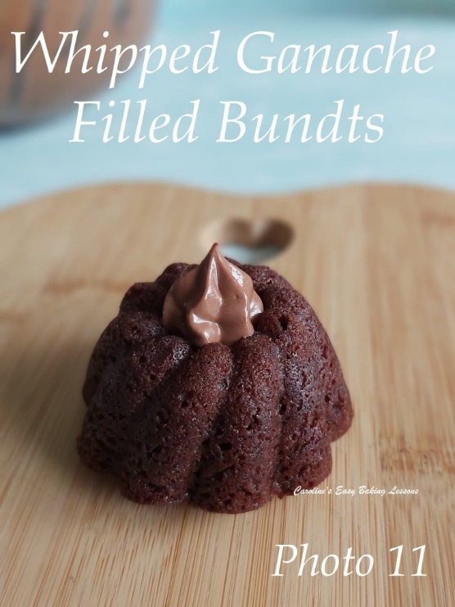

15. Now you can spread on or pipe like before onto any cakes you wish. See Photo 11 where I piped into the centre of mini chocolate bundt cakes. You can eat the cakes with the ganache as is, with a soft texture. Or, firm some more by placing in the fridge (see Photo 12 below), where it firms up really nice and perfect for a little hiding spot in these cakes.

DIFFICULTY LEVEL: easy, beginner

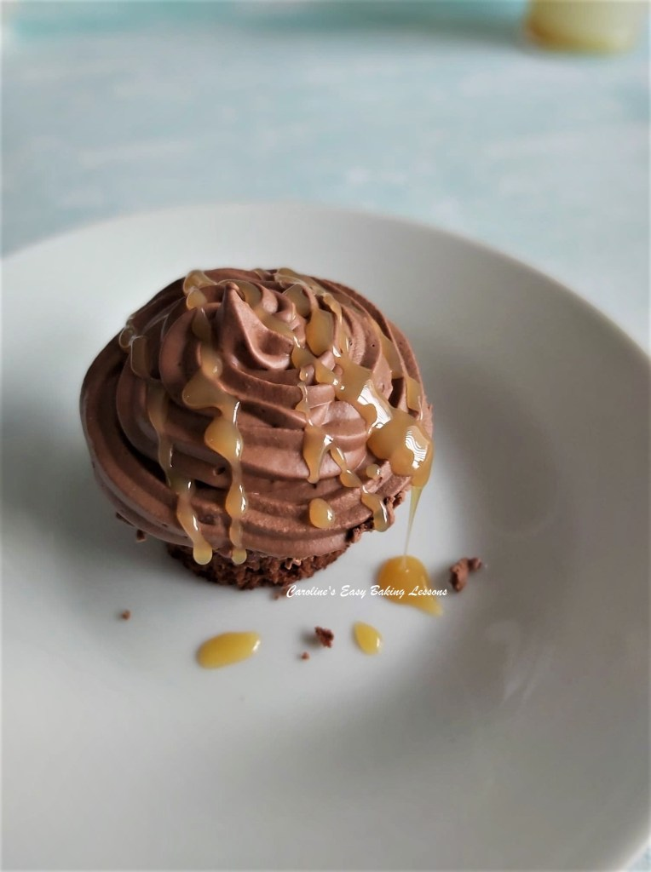
Thanks for reading
Happy Baking & Making
Happy Tummies & Memories!

Caro xx

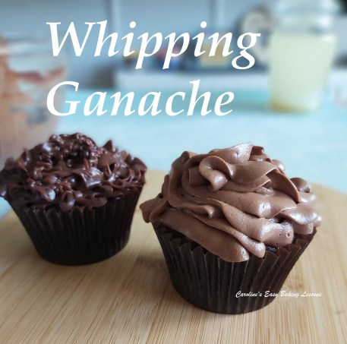 Caroline’s Easy Baking Lessons

.

