EASTER CARROT CAKE With Fondant Carrots Tutorial
FROM: Caroline’s easy Baking Lessons
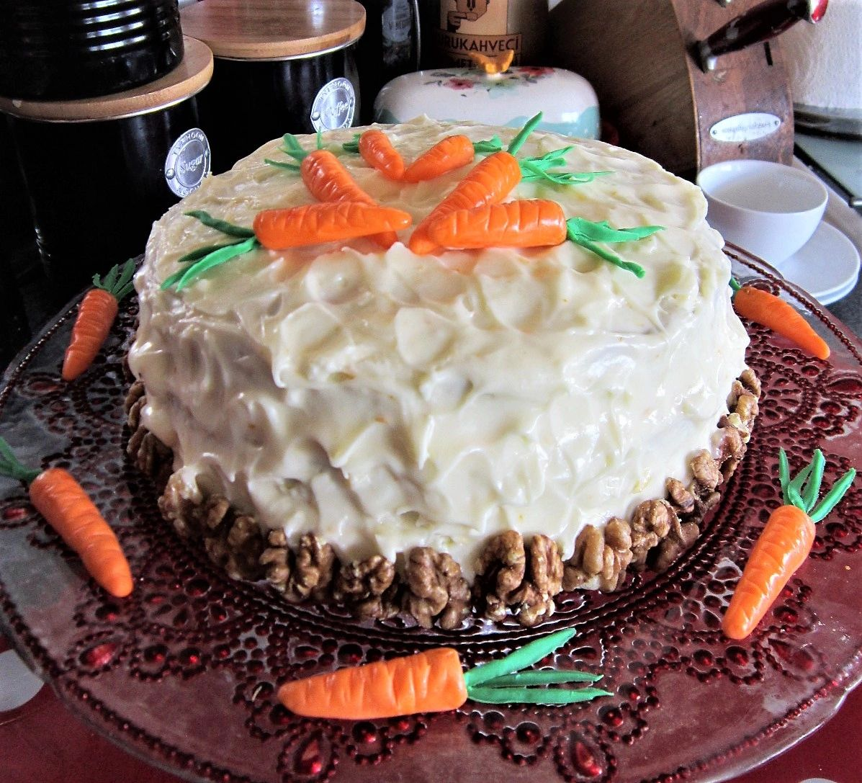
This carrot cake recipe is an alteration of Mary berry’s recipe, with a few additions of flavour and a different cream cheese frosting that I decided this time to add orange zest to. I don’t add nuts into the cake batter, as my youngest boys doesn’t like nuts in other things! So I just add some for decoration at the end. Previous years I also decorated with foam carrots, but this time I went for making some fondant ones myself.

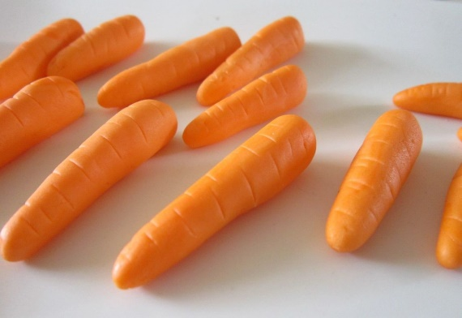
I will show you how to make this easy cake, that is tasty and impressive to look at. I will also show you how to make each of the fondant cake toppers by hand, with no need for any fancy tools. You can buy coloured fondant quite easily in a range of colours and shades, or buy white and colour them with food dye. You could of course make your own fondant from marshmallows and colour these too. There are many recipes on You Tube for how to do this.

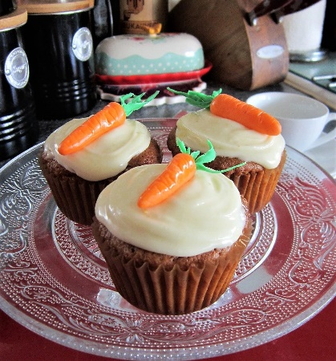
A note on the ingredients. Light brown or even light muscovado sugar can be used. You could even try molasses to make even healthier. If I had remembered, I would have also tried using whole-wheat flour for half of the flour. As an alternative to the self-raising flour, you can make from plain/All Purpose flour by adding baking powder and salt. As a general rule, for every 1 cup (125g) of flour, you are meant to add 2 tsp baking powder and ¼ tsp salt. However, when using more than 1 cup and if there is added baking powder already in the recipe, I tend to air on the side of caution. Too much baking powder can leave an after taste and cause too much of a rise that then sinks. I prefer to use 1.5 level spoons of baking powder and a scan ¼ tsp of salt and I have tested this on English scones. So for this recipe I suggested 3.5 tsp baking powder and ½ level tsp salt. **Remember to also add the baking powder listed in the ingredients. If you can't get Mixed Spice, you can use All Spice, Pumpkin Spice or make your own (search the internet for the ratios, but it's basically cinnamon (about 50%), ginger, cloves, pimento & ginger in the one I use. But recently I started adding nutmeg too.)

This recipe will make a 3 layer cake, using 3 x 7 inch (18.5cm) round cake tins. You can of course use 2 tins, a different shape of tin also. Just don't use too wide a tin or you won't get much of a rise. You can also make 12 good sized cupcakes from half of the ingredients.
**UPDATE - I have made a Gluten Free version, that I downsized to bake in a bundt tin. I also used plain flour and extra baking powder so I could replicate how t is using All Purpose flour, instead of self-raising. Go to Gluten free bundt cake. But if you still want to make this 3 layer cake as a gluten free version, then use the appropriate flour and if there is no Xanthan gum or other binder in it already (see flour ingredients), add 1 & 1/4 tsp of this powder to the dry ingredients.

INGREDIENTS (3 x 7 inch (18.5 cm) layers)

250ml Sunflower or vegetable oil
(approx. 1 cup, or just under 9 fl oz)
4 Medium eggs
225g Light brown sugar*
(1 cup + 2 tbsp)
300g Self raising flour*
(2.5 cups self-rising flour)
OR 2.5 c Plain/All Purpose flour + level 3.5 tsp baking powder + level 1/2 tsp of Salt
2 tsp Baking powder
1 tsp Mixed spice*
1 tsp Ginger powder
½ tsp Cinnamon powder
200g Carrots, grated/shredded
(2 rounded cups)

** Note - half these ingredients will make 12 large cupcake/muffins.

FROSTING/ICING

375g Cream Cheese (8 oz), softened room temp.
85g Butter, cubed, soft (1/4 cup, ½ stick)
1.5 tsp Vanilla (optional)
750g Icing/confectioner’s sugar, sieved
(4 cups), sieved
1 Orange - zest and a little juice, or orange extract according to taste.

EQUIPMENT

Weighing scales or measuring cups
Small measuring jug
Mixing spoon
Stand or Hand Mixer and mixing bowl
Sieve
Measuring spoons
Grater/shredder and bowl for carrots
Cake tins - 3 x 7 inch (18.5cm) pans
Oil or butter for greasing tins
Baking/parchment paper & scissors
Timer or Phone timer
Cooling rack
Cocktail stick/tooth pick or wooden BBQ skewer
tea-towel
Fine grater/zester
Baking palette knife or butter knife

EQUIPMENT TO MAKE CARROTS

Green and orange fondant (or white and food dye)
(For dying I recommend using gloves so as not to stain you hands)
Silicone mat or baking/parchment paper
Sugar craft tools - cutter, roller cutter (straight edged), ball ended dresden tool (or small knife, small paint brush or wooden bbq skewer)
Small paint brush
Food glue, Clear alcohol or water to join the fondant.
Clear alcohol for shine (see other methods on You Tube)

INSTRUCTIONS
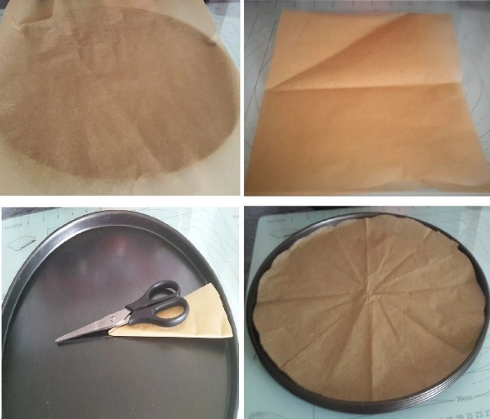
Photo 1 - How to cut a paper circle
.
1. Prepare your cake tins, by oiling/greasing them well, (bottom and sides) and covering the bottom with baking/parchment paper. For help on how to cut a circle to fit your tin, see Photo 1 or go to my article with more photo directions - go to article.

2. In a mixing bowl, add the oil, eggs and sugar. Using a stand or hand mixer, mix them thoroughly together until incorporated.

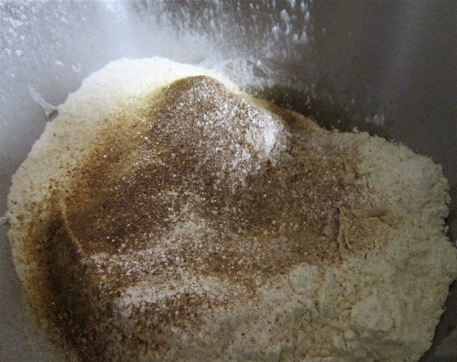
Photo 2 - Adding in the dry ingredients.

3. Place your sieve over the mixing bowl, (on top of the scales and set to zero), add in the flour and baking powder. Use the back of a spoon to rub them both through the sieve.
4. Now sprinkle in the mixed spice, ginger and cinnamon.

See Photo 2.

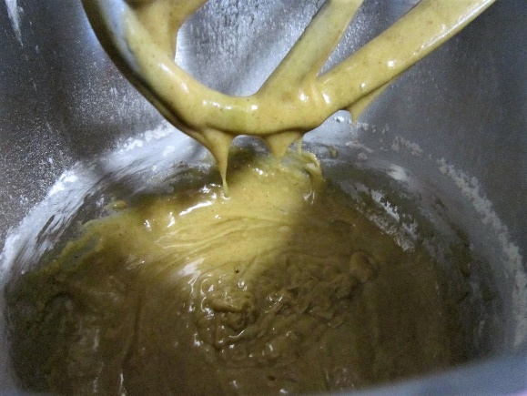
Photo 3 - Wet & dry ingredients mixed up.

5. With the mixer on low to begin with, mix all the ingredients until they come together, with no flour visible.
See Photo 3.

6. Now add in your carrots and mix just until incorporated evenly.

7. Heat up the oven to: 180c/160c Fan/350f/Gas Mark 4.
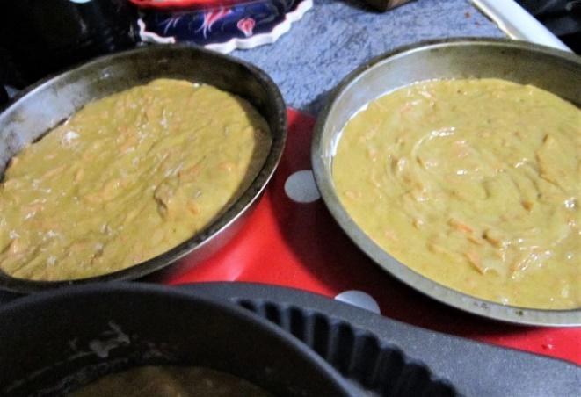
Photo 4 - Batter in the cake tins.

8. Spoon the batter into the 3 cake tins as evenly as you can, spreading it out and down. Then spread out from the centre a little so as to make a little dent in the centre of the batter. This is try to create cake layers with less thick rounded tops. Also give the tins a tap on the worktop to expel any air.
See Photo 4

Photo 5 - Cake later baked & cooling.

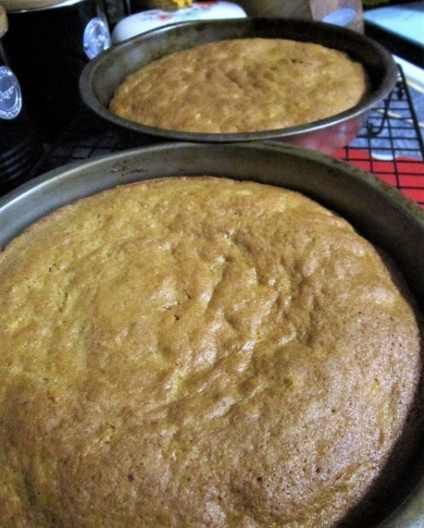
9. Bake in the oven for between 20 -25 minutes until golden brown. Check they are done by inserting a wooden cocktail stick/tooth pick into the centre of the cake and if it comes out clean it is ready. Another way to check is if the cake springs back when pressed with a finger gently. If it isn’t done yet, continue to bake for a further 2 minutes and check again. Continue until fully baked. If they are colouring too much on top, cover with some foil/aluminium. My oven doesn’t cook evenly, so I turn the tins and rotate between the shelves and use my timer to do so on intervals. Be sure to use a timer. See Photo 5.

Photo 6 - Cakes out of the tins.
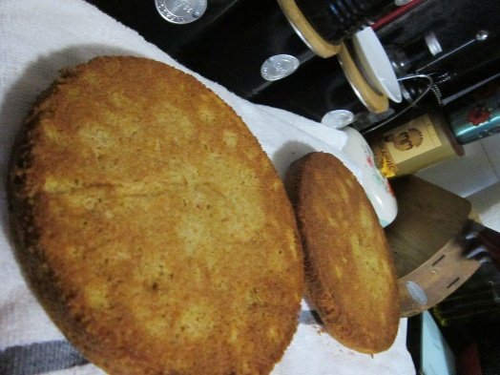
10. Leave to cool for 5 minutes and then place on a cooling rack, still in the tins.

11. Let the cakes cool down as much as possible before attempting to remove from the tins. You may need to run a palette knife down the sides to release the cake and then turn over and tap out onto a large plate. Very carefully peel back and remove the paper. Place a tea towel on the cooling racks and put the cake layers on top. This will reduce the likelihood of indents on the cake from the rack appearing. Leave to cool completely. If not using soon, wrap well in cling film/plastic wrap, in room temperature, until ready to use. They can also be frozen like this, which some foil/aluminium on top and in a food bag.

CREAM-CHEESE FROSTING
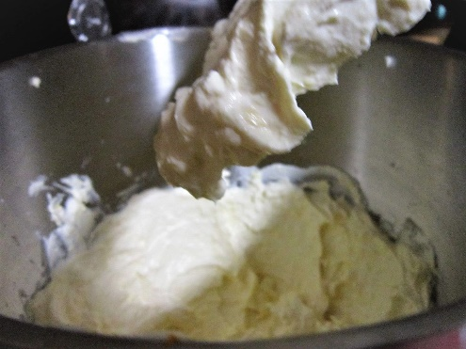
Photo 7 - Cream Cheese & Butter.
1. Beat the butter, cream cheese & vanilla with an electric whisk, on low speed until smooth.
See Photo 7.

2. Add the zest of one orange and add some squeezes of the orange juice, (about 1 tbsp).

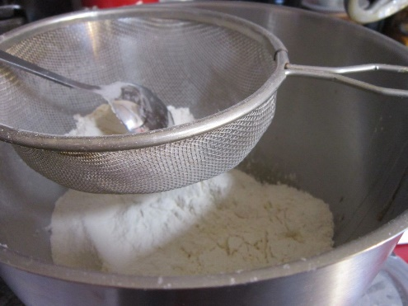
Photo 8 - Sieve in the icing/powdered sugar.

3. Sieve in the icing/confectioner’s sugar, one cup at a time until smooth and spreadable.

See Photo 8.

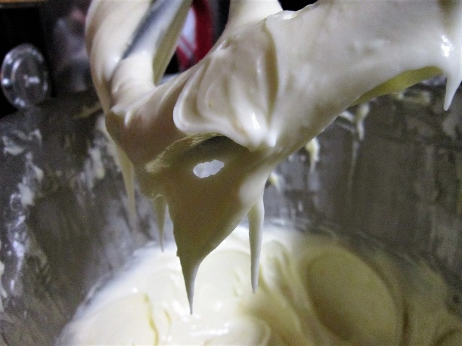
Photo 9 - Cream Cheese Frosting Ready.
4. If still too thick, add more orange juice. If too think, simply sieve in more sugar until you get a thick spreadable consistency.
See Photo 9 where the frosting is holding onto the mixer hook once held up. If you don’t want to use orange flavouring, you can simply replace with milk. But at this stage, have a taste to see if you want to add more zest or orange extract. Only add more orange juice if you have more sugar to thicken the mixture. Leave somewhere cool to firm up till using.

MAKING THE FONDANT CARROTS
Photo 10 - How to make orange fondant with food dye.

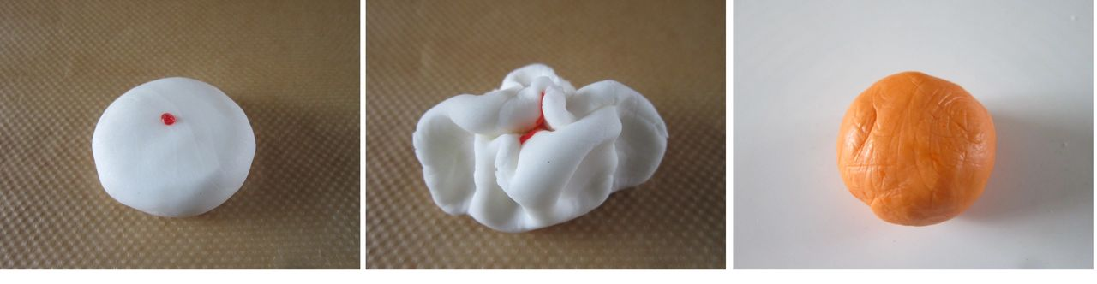
1. Use coloured fondant or custom colour your own by adding food dye to white fondant. See Photo 10 for how this is done. Use gloves as the food colouring stains! Add single drops at a time and knead the fondant until all colour is evenly distributed. In you want more colour, simply add another drop and repeat this process until you get the desired colour and shade. Do not cover the fondant at this stage, as the extra even better still paste (like Sugarflair), as they add less moisture to the fondant and make it easier to work with.

2. Make the carrot by starting with a ball of orange fondant about 3cm (1 + 1/5 in) wide and then roll between the palm of your hands into an oblong about 4cm (1 + 2/3 in) long. See Photo 11 below.

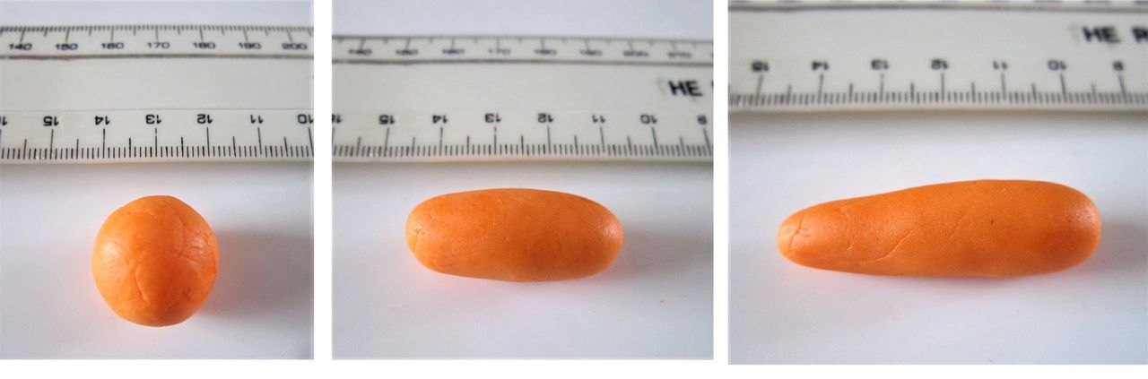
Photo 11 - Making the fondant carrots (part 1) - see instructions 2 & 3.

3. How roll again at one end and make it a little thinner to make the pointy end of the carrot. Pat to flatten the opposite end that will be the top of the carrot (making it less rounded). See Photo 11 above.

4. Using something small and rounded (I used a sugar craft tool but even the end of a very small paint brush will do), make a hole in the ‘top’ of the carrot, and go down about a 1/3 of the length of the carrot. See Photo 12 below.

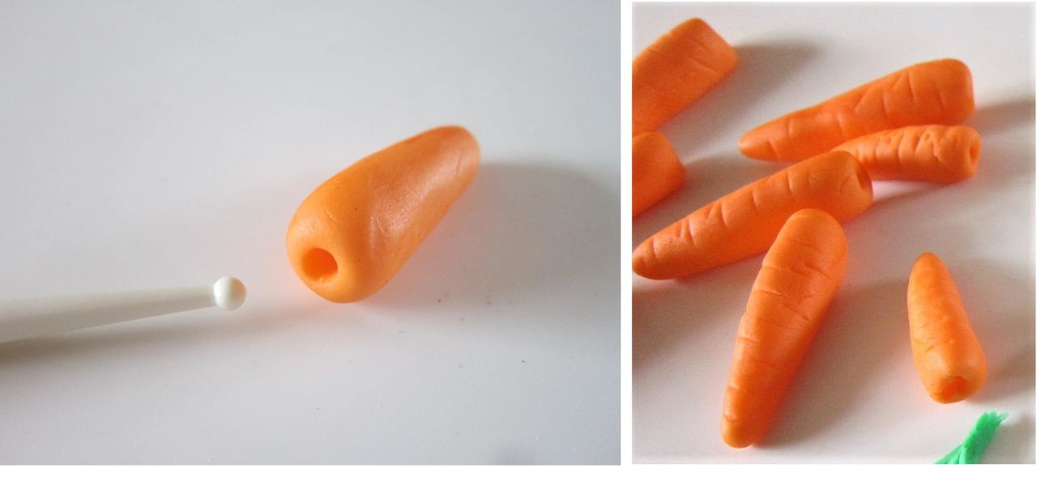
Photo 12 - Making the fondant carrots (part 2) - see instructions 4 & 5

5. Using a small knife. Make alternating lines on the top of the carrots, remembering to continue to the sides. See Photo 12 above. Continue to make more like this and vary their size by starting off with smaller balls of fondant. Leave to dry a little on a silicone mat or baking/parchment paper.
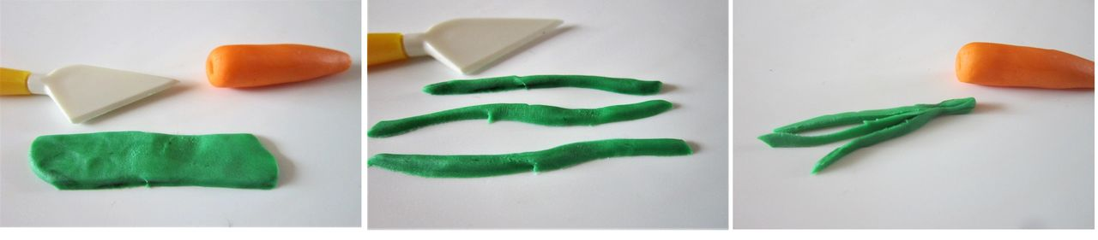
Photo 13 - Making the Carrot 'greens' - instructions 6 & 7.

6. To make the carrot tops, from a ball of green fondant roll out into a very flat oblong. Use a straight pastry cutter or similar sugar crafting tool (or knife), make strips. These will look best if not all straight or precisely cut and rough edges are fine. See Photo 13 above. Cut as many as you can get from this piece of fondant. We will even use small ones and make smaller carrots too.

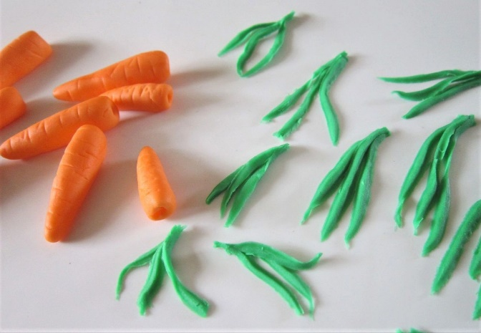
Photo 14 - Prepared carrots & carrot greens.

7. Roll out more green fondant and make lots of strips of ‘carrot greens’. Once you have a lot try to make bundles of 3 or 4 pieces, as in Photo 14 with shorter ones on the outer sides. Make more than enough to go with however many carrots you have made. Save any small or broken pieces as we can use them too. Squeeze the ends of the ‘greens’ together and allow to dry a little.

8. Once ready to attach the ‘greens’ to the carrots, make sure the hole you made is big enough to take in the ‘greens’, so you may have to widen it a little. See Photo 15 below.

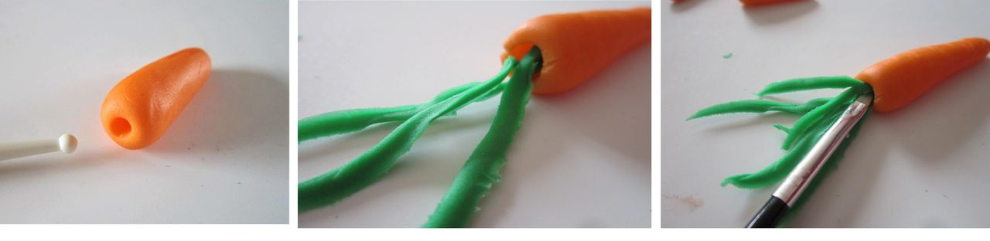Photo 15 - Adding the greens to the carrot - instructions 8, 9 & 10.

9. With a small paint brush apply some food glue, clear alcohol or water, to inside this hole you made.

10. Very carefully place the ‘greens’ into the carrot top, using the paint brush to push down and in if needed. If any pieces fall off, simply apply a bit more glue and push into the carrot tops. See Photo 15 above, varying lengths give a more natural look.
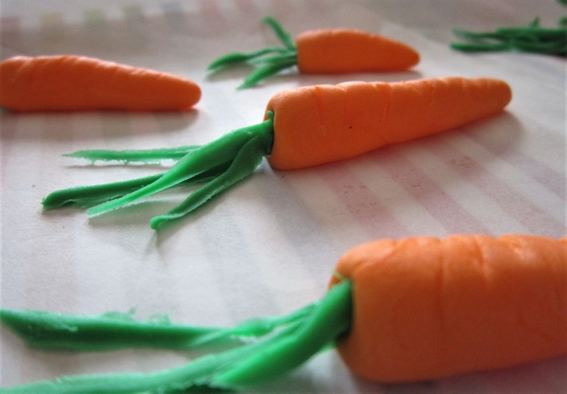
Photo 16 - Fondant Carrots.

11. Continue to fill the carrot tips, and use up any small or broken pieces, by pushing into the carrot tops with the help of the brush. This will make them all look different and more realistic.

See Photo 16.

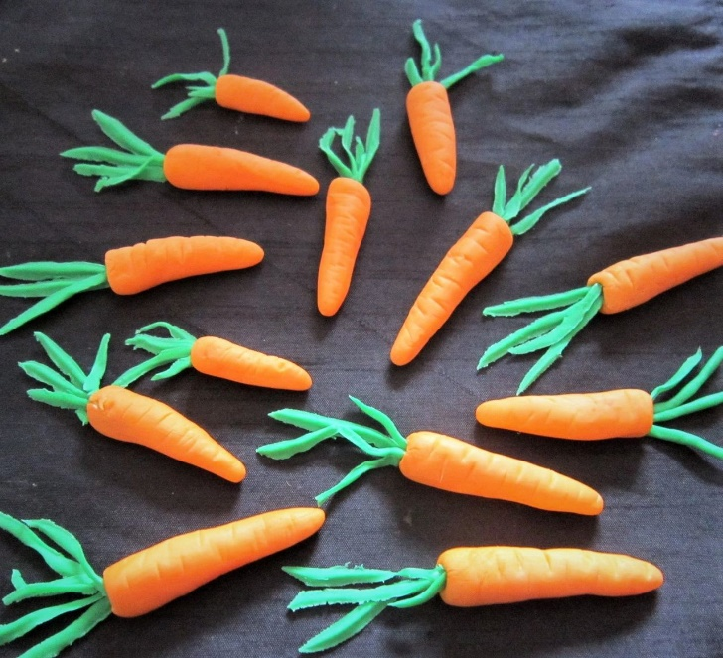
Photo 17 - Fondant carrots.

12. Carefully go over any of the carrot lines you made earlier that may have been smudged when handling them and then leave them to dry. You can let the greens sit in a curved way, and not all straight, again to help look more realistic.

See Photo 17.

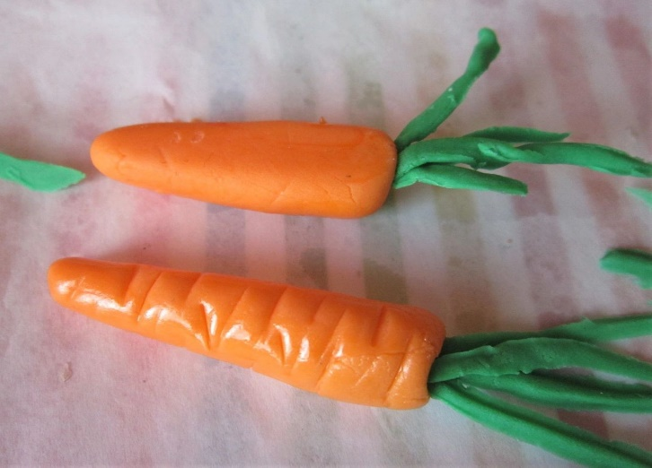
Photo 18 - Fondant faded (top) & with gloss (bottom) - see instruction 13.

13. Once they set up, the colour fades and they loose the initial shine, but do not worry, we can make them look fresh again. There are several methods on You Tube, but I used some Vodka (any clear alcohol will do) and brushed a little onto the top and sides of the carrots only (leave the greens). One coat was enough to give a great shine. The alcohol will evaporate and after time the shine will go but this will take days to happen. See Photo 18 for the difference: the top carrot is the faded one and the bottom one had vodka painted on to it.

14. Leave out to dry a little. Don’t cover as there may end up too much moisture and ruin your hard work.

ASSEMBLING THE CAKE
1. Place the flattest cake layer on a cake stand or large plate.
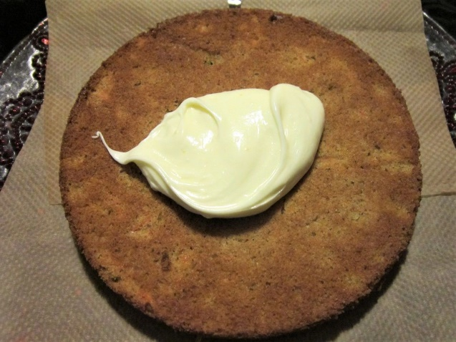
Photo 19 - 1st layer down.

2. Cut a piece of baking/parchment paper wider than the width of the cake, and cut into 4 pieces. Place these under the cake, leaving some showing further out than where the cake ends. These will catch any frosting drips and can be removed later to leave a clean plate.

See Photo 19.

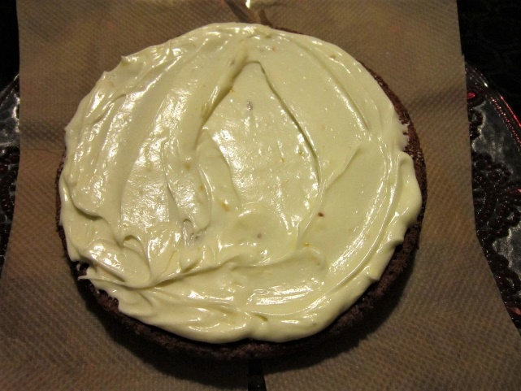
Photo 20 - 1st layer of frosting on.

3. Using a palette knife or butter knife, start spreading frosting starting from the centre and working outwards to the edges. Use plenty of frosting for a thick layer. See Photo 20.

4. Keeping the best sponge layer for the top piece, place a second layer on top of the frosting and cover in frosting as before.

5. Place the final layer on top and frost it also.

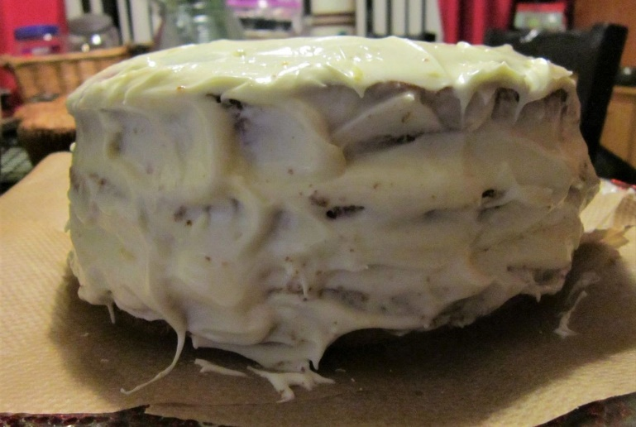
Photo 21 - 1st Coat of frosting.

6. Now apply frosting to the sides of the cake, holding your knife horizontally. You want to fill in any gaps and to apply a thin coat called a ‘crumb coat’. This is simply like an undercoat and will catch any cake crumbs. (Photo 21). Put it somewhere cold and leave for at least 1 hour to harden a little. If you wanted a final smooth appearance to the cake, you would leave for longer or even chill it. I was doing this one at night, so left it overnight in the garage, as well as the bowl of frosting, to harden up.

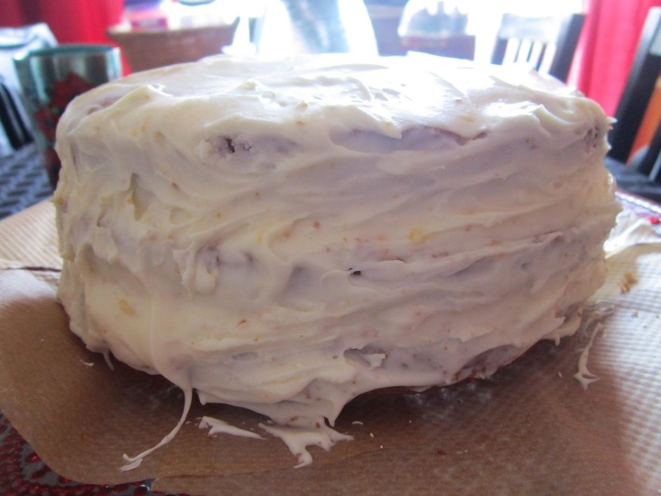
Photo 22 - 2nd coat of frosting.

7. Once firmed up, frost a thicker coating onto the sides of the cake layers until you have the same thickness as on top of the cake. If you have anymore frosting left, apply some more, evenly all over.

See Photo 22.

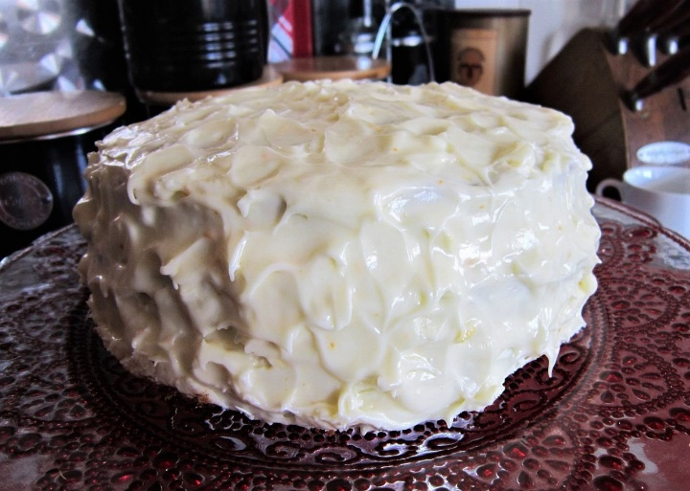
Photo 23 - Peaks created on the cake.

8. To make the cake look more professional, use the same knife, holding it up the way, lift upwards to create peaks on the top of the cake. For the sides, hold the knife horizontally, move the knife left or right and then put a little towards yourself. You can do this also by applying a small amount of the frosting onto the knife first.

See Photo 23.

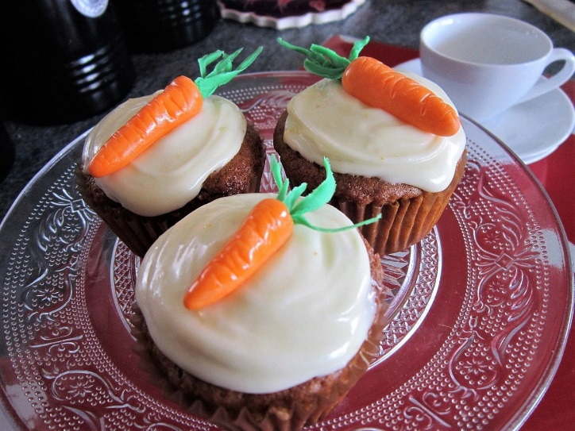
Photo 24 - Carrot Cake Cup Cakes

9. When making this I also did 12 cupcakes/muffins and frosted them too. (Half the ingredients will make 12 good sized cupcakes). I got a good amount of frosting on the knife and placed into the centre of the muffin. Spread the frosting evenly. I then use the end of the knife to do a swirl motion, starting from the outer edges and working inwards and in the middle pull up for a peak. You can also do this same method with the back of a small spoon.

10. Leave the cake in a cold/cool place again and let the frosting set up.
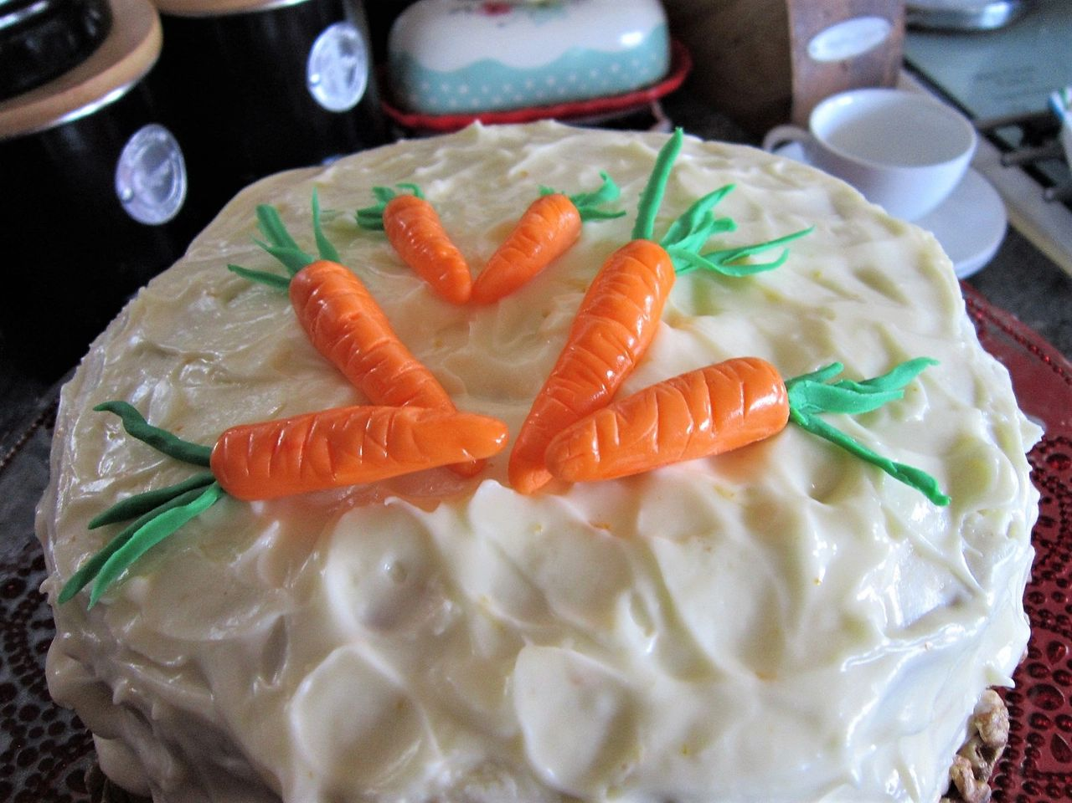
Fondant carrots decorating the carrot cake with orange flavoured cream cheese frosting.

11. Once the cake is ready, place the fondant carrots on the top, in the centre, around the edge of the cake, where ever you feel like.

12. Very very carefully pull each piece of baking/parchment paper out from under the cake, being careful not to pull any of the frosting off or onto the plate. I also added half walnuts around the bottom edge of the cake.

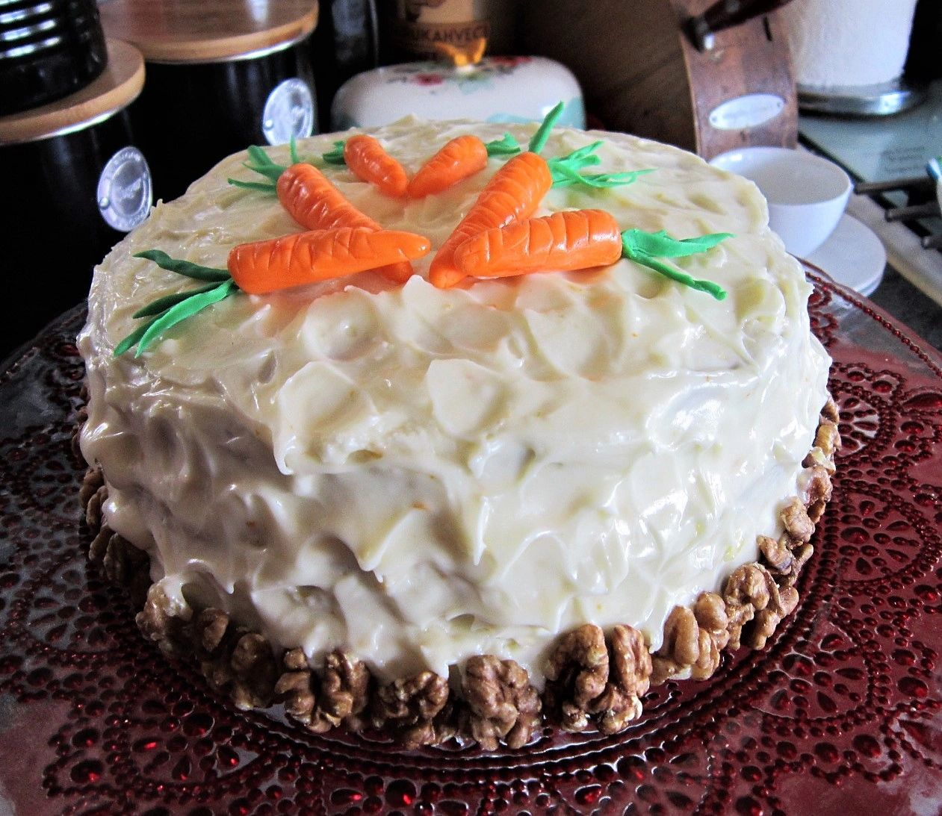
13. Slice up and serve. Home made caramel or salted caramel sauce goes lovely with carrot cake.

14. Store any left overs in an airtight container. ENJOY!

Thanks for reading &

Happy Baking & Making

Happy Tummies & Memories

Caroline x

