MAKING YOUR OWN VANILLA EXTRACT – All You Need To Know To Make At Home
Caroline’s Easy Baking Lessons INFO & BLOG

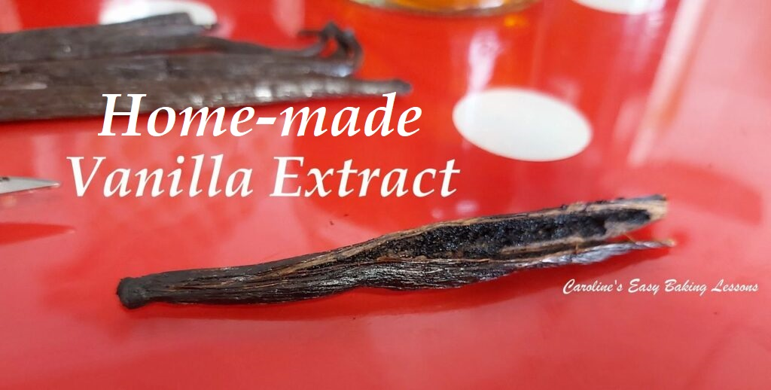

Everywhere the cost of buying decent vanilla extract is increasing in price by the day. As most of you will already know, vanilla essence, no matter the cost of it, just isn’t the same and literally a waste of money. A much better and more economical way is to make your own extract at home.

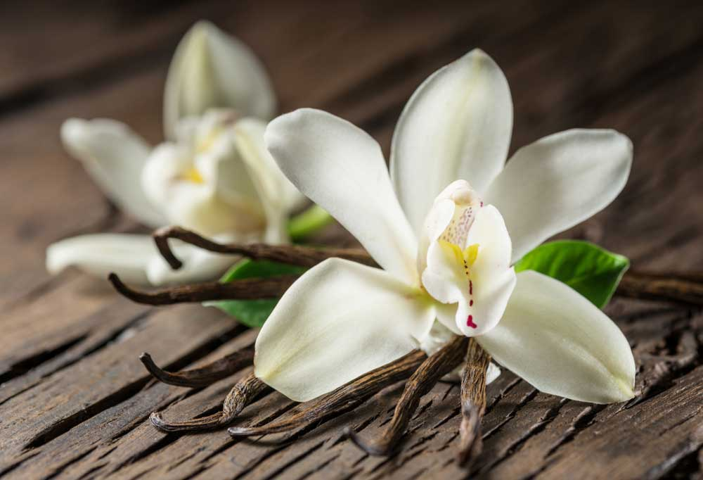
So fellow bakers and enthusiasts, is it easy to make your own extract? Yes it is – could not be simpler and doesn’t require much. Simply source the beans on-line in bulk – buying individual fancy packaged ones (sometimes in glass jars) in stores, are much more expensive per pod. Purchasing in this manner, you are paying for extras such as over-heads. So buying at least 4 on-line, that come in vacuum packaging to seal in the flavour, with no fancy packaging, will save you money in the long run.

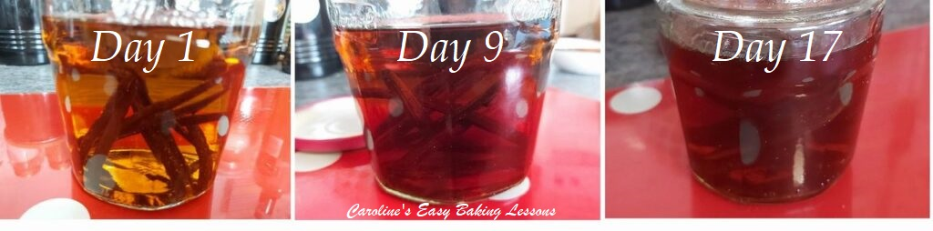My Vanilla Extract – Days 1, 9 & 17

The second component you need is clear alcohol. Preferably a 40% alcohol, that equates to 80 proof, (note commercial vanilla extract usually is about 35% and 70 proof). Any alcohol such as vodka, bourbon, whiskey, brandy or rum. You don’t need to go buying expensive brands and can use what you might have in the cupboard. Those unwanted alcohol gifts are ideal for this and can make the cost of making your own extract even less. And if you can get the pods gifted to you too, it’s a win win (this is actually what happened to me so my first batch cost me zero £s).

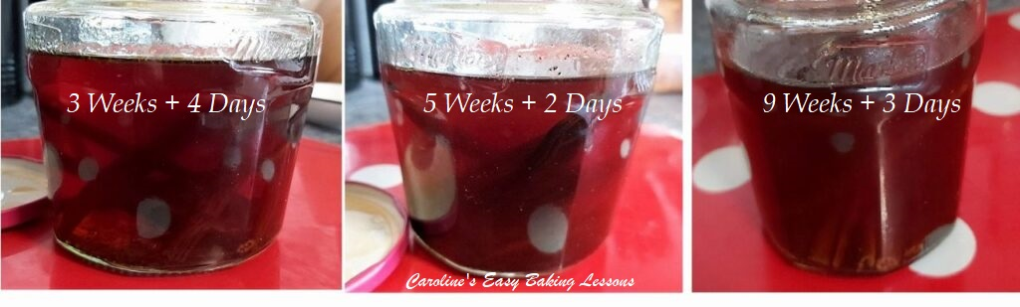My Vanilla Extract – Days 25- 66

Now when looking for the vanilla pods, you want Grade A or Grade B, (B sometimes also being referred to as extract quality and Grade A for direct cooking). These can be either Madagascan, Bourbon, Tahitian or Mexican vanilla pods. Each have different characteristics. The bourbon and Madagascar ones have the classic robust flavour that most of us are use to. The Tahitian version, has more subtle fruity and floral tones to it. And the Mexican has a smooth and spicy taste.
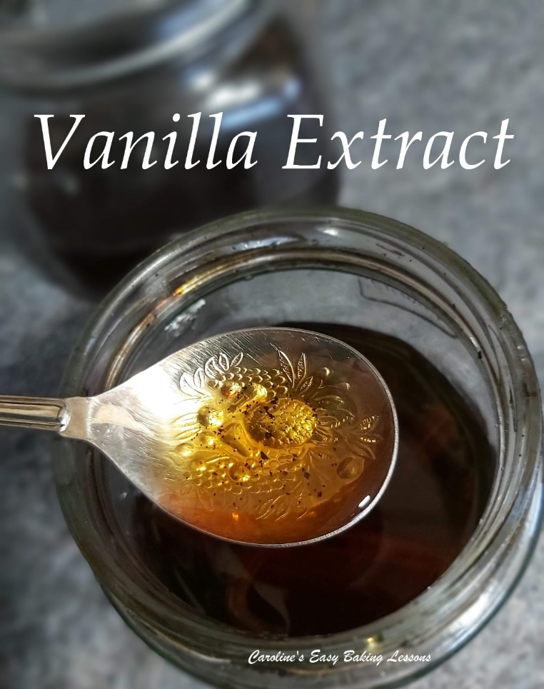

The third thing you need is a glass jar or large bottle, that you will fill will the alcohol and vanilla pods. You do not need to go purchase a new fancy jar for this (if you want to give out some of the vanilla extract as gifts, you could purchase small pretty bottles later). Old jam/jelly jars and mason jars are ideal. The tall pretty ones you see are not so easy to get the pods in and out of, so a wider neck jar is best. Just clean it well, no need to sterilise.
So those are the three things you need to make your own vanilla extract and somewhere cool and dark to store the mixture, until it is ready for use. Every week or so just give the jar a shake to get the seeds moving a bit and extract more flavour.

So how long to leave it? Well the agreed minimum seems to be 8 weeks. Be sure to label the jar so you know the exact date and can keep track of it. The longer you leave it, the darker the liquid becomes, and the more intense the flavour will get. Checking weekly or 2 weekly, you will see the colour change, the seeds expose themselves more and the initial aroma of strong alcohol will fade and once ready, it will be the vanilla scent that hits you first.

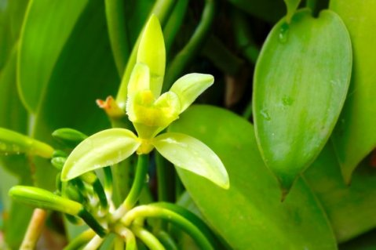
I took photos every so often of how my vanilla extract was coming on and by 9 weeks it was looking as good as the expensive brand I usually used. I also tasted it and I have to say the bought one tasted awful and there was no vanilla taste hitting me! So I feel confident in saying that by the 8 or 9th week, you can get a good enough extract. I left it a little longer though as I didn’t need it yet, and the last photo, (Photo 3 further down), is at the 10 weeks and 3 days stage. (See also the photo collages above, at different stages – day 1 – 17 & day 25 – 66 ).

Take some photos of your own and you will see your vanilla extract coming alive. Safe in the knowledge that this is quality extract.
Several of the members in my Facebook group also started making their own Vanilla extract too. Here are photos of Christine’s: showing day 1, day 21 and at 8 weeks + 1 day, using vodka & Tahitian vanilla pods.
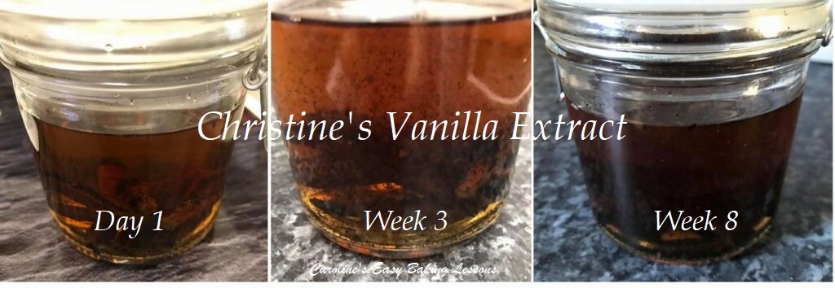Christine’s Vanilla Extract – Days 1, 21 & 56

IMPORTANT INFORMATION to note is that some alcohol that is derived from grain, may still have some left after the distillation process. There is debate about if it is gluten free and may still cause reactions to some celiac and non-celiac sufferers. Therefore, if making for yourself or someone who falls into this category, please research thoroughly the full list of ingredients within the alcoholic base you wish to use. I have below a list of brands my friend Margaret researched and found to be gluten free. Tito’s Handmade Vodka, Crystal Head Vodka, Ciroc Vodka, Grey Goose Vodka, Cold River Vodka, Ocean Vodka, Dixie Vodka & Chopin Vodka. Plain rum not made from grain: Bacardi, Havana Club, L. Longueteau, C. Caroni, Flor de Cana, Cruzan, Mount Gay, Myers & Rondiaz.

MAKE YOUR OWN VANILLA EXTRACT

INGREDIENTS
3 – 5 Vanilla Pods (grade A or B, see above)
240ml (1 cup) Clear Alcohol (see notes above and Important Information paragraph)

EQUIPMENT
Jam/jelly Jar or Mason jar (at least 10 fl oz, 285ml capacity)
Small sharp knife
Measuring cup

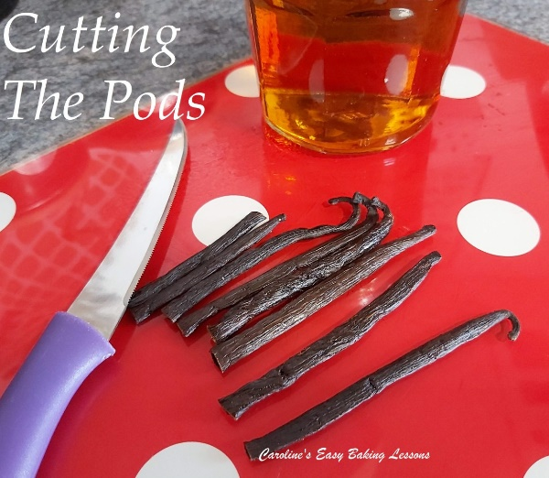

INSTRUCTIONS
1. Clean the jar well, including the lid and allow to air dry.
2. Using a sharp knife, cut the length of the vanilla pod on one side, and open the pod to expose the seeds.
3. If the pods are too long for the height of your jar, simply cut in half length ways.
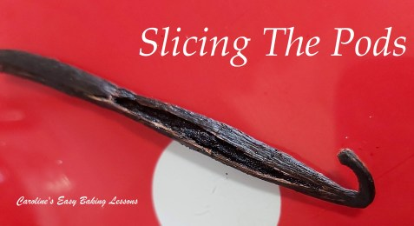

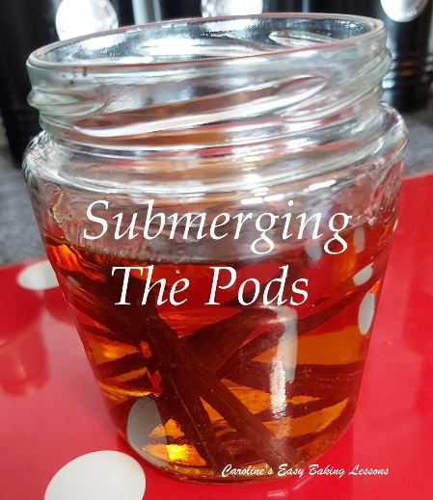

4. Place the pods in to the jar and cover with the 1 cup/240ml of clear alcohol, making sure the pods are submerged. (If using more pods than recommended, increase your liquid content appropriately). See Photo.
5. Close the jar tightly and label the jar with the production date.
6. Place in a cool dark area for at least 8 weeks. (I placed in a cupboard)
7. Every week or so, check on the extract, noting it’s colour, it’s aroma and if the seeds are visible in the liquid yet. After that close the jar tightly and shake the jar for the seeds to become exposed and start infusing into the liquid.
8. At the 8 week mark, it can usually be used. In the initial weeks, you will smell the strong alcohol aroma, but once it is ready to be used, the vanilla aroma will be what hits you first as the alcohol aroma becomes less pungent. See Photo 3 of my extract after 10 weeks and 3 days.
9.Use just as you would normally or how the recipe calls for it. You can decant into smaller jars if you want or give out as gifts.

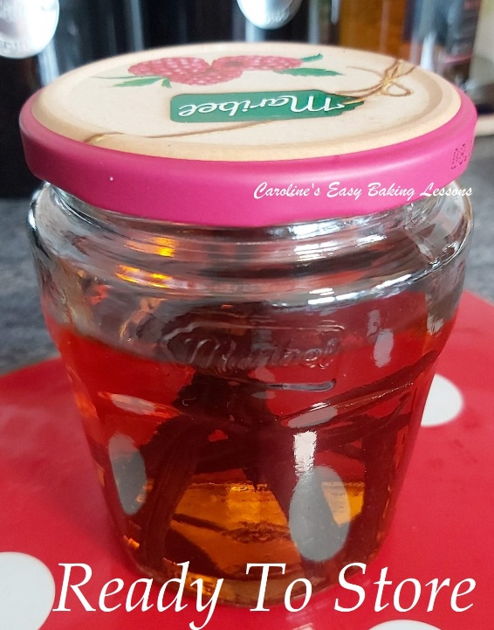
10.You can leave the pods and the seeds in the liquid. You can use from the jar and top up with a little alcohol as you go and even periodically add new pods to it. This is how some people have extract that has been going for many years. Alternatively, dry the pods and make vanilla sugar.

DIFFICULTY LEVEL : easy, beginner.

Update – I used the extract for Xmas baking and that was about the 12 weeks mark and it was great. I could smell it was more intense that the Nielsen Massey Vanilla Extract I would normally use. So no need to wait 6 months or 1 year as some website’s claim.

Thanks for reading.
Happy Baking & Making
Happy Memories and Tummies

Caro x
