CLASSIC CARROT CAKE WITH CREAM CHEESE FROSTING – The Only Recipe You Will Ever Need
Caroline’s Easy Baking Lessons Sweet/Easter

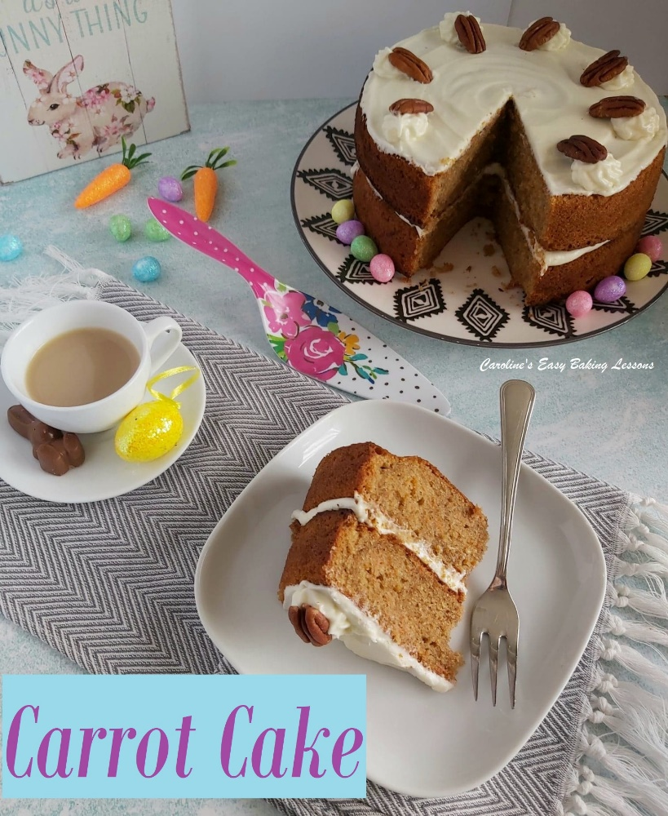
This carrot cake recipe is an adaptation of Mary Berry & Anna Olson’s recipe, with a few additions of flavour and a different cream cheese frosting that I decided this time to add orange zest to. I don’t add nuts into the cake batter, as my youngest boys doesn’t like nuts in things! You can use the recipe to make a 3 layer cake with a full covering of frosting, make as a deeper 2 layer with minimal frosting, or as cupcakes. The choice is yours.

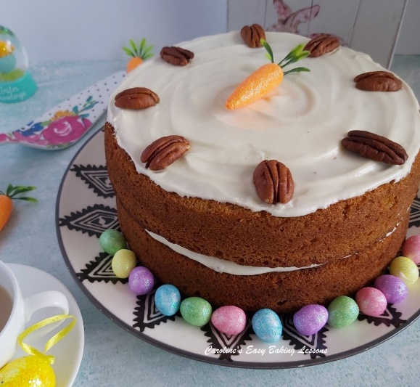

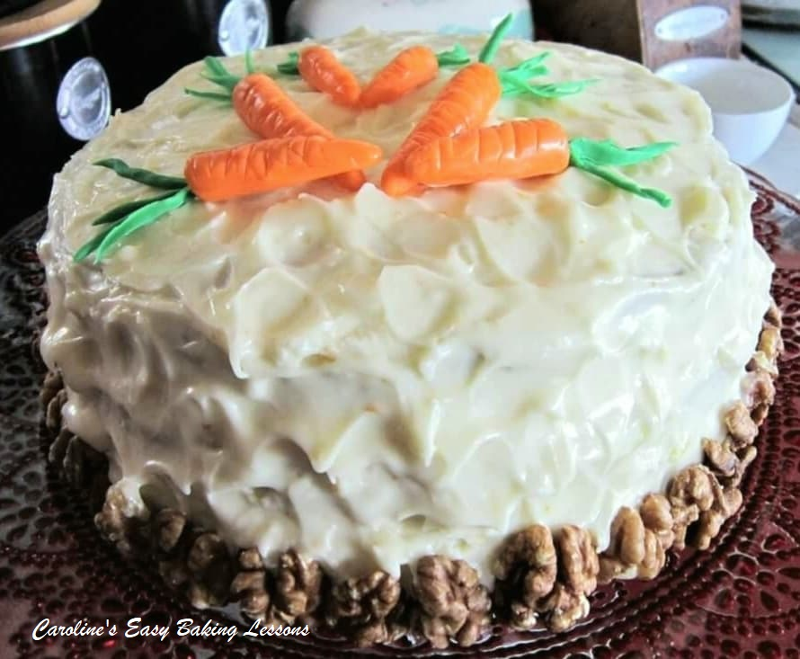

I will show you how to make this easy cake, that is tasty and impressive to look at. I also will share the link to my tutorial on how to make the fondant cake toppers by hand, with no need for any fancy tools. You can buy coloured fondant quite easily in a range of colours and shades, or buy white and colour them with food dye. You could of course make your own fondant from marshmallows and colour these too. There are many recipes on You Tube for how to do this.

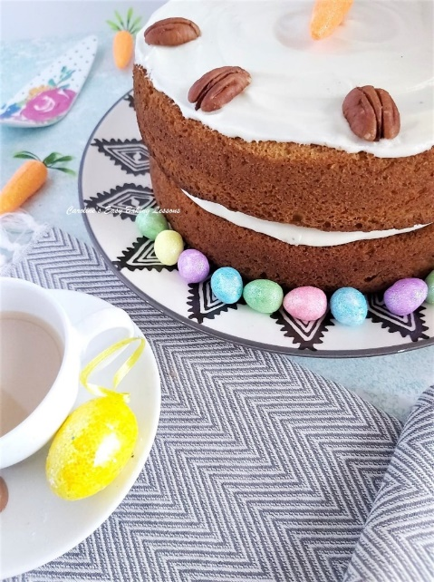
* A note on the ingredients. Light brown or even light muscovado sugar can be used. You could even try molasses to make even healthier. If I had remembered, I would have also tried using whole-wheat flour for half of the flour. As an alternative to the self-raising flour, you can make from plain/All Purpose flour by adding baking powder and salt. As a general rule, for every 1 cup (125g) of flour, you are meant to add 2 tsp baking powder and ¼ tsp salt. However, when using more than 1 cup and if there is added baking powder already in the recipe, I tend to air on the side of caution. Too much baking powder can leave a metallic after taste and cause too much of a rise that then sinks. I prefer to use 1.5 level spoons of baking powder and a scan ¼ tsp of salt and this has been extensively tested. So for this recipe I recommend 3.5 tsp baking powder and ½ level tsp salt. Remember to also add the baking powder listed in the ingredients. If you can’t get Mixed Spice, you can use All Spice, Pumpkin Spice or make your own (search the internet for the ratios, but it’s basically cinnamon (about 50%), ginger, cloves, pimento & ginger in the one I use. But recently I also started adding nutmeg too.)

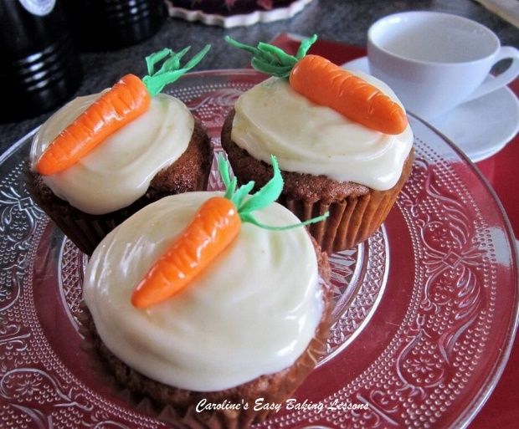
This recipe will make a 3 layer cake, using 3 x 7 or 8 inch (18.5 or 21cm) round cake tins. You can use 2 tins and have deeper layers like in the main photos. Just don’t use too wide a tin or you won’t get much of a rise. You can also make 12 good sized cupcakes from half of the ingredients.

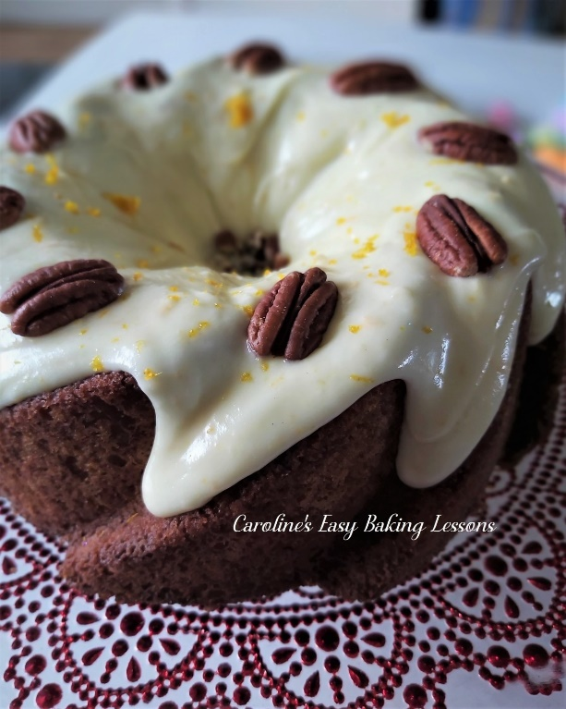
**UPDATE – I have made a Gluten Free version, that I downsized to bake in a bundt tin. I also used plain flour (All Purpose) and extra baking powder so I could replicate how it is using All Purpose flour, instead of self-raising.

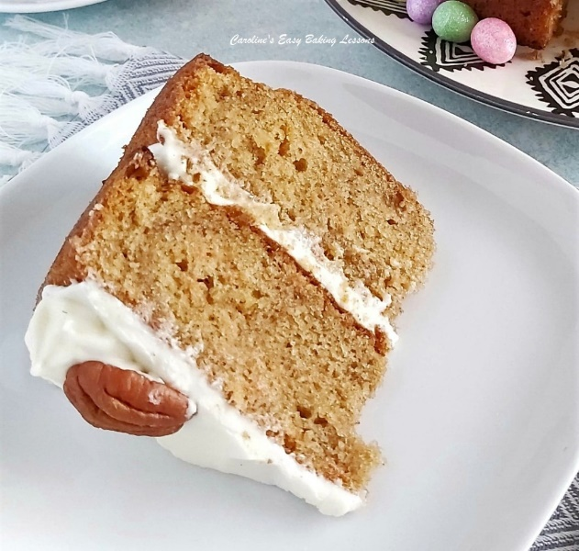

Go to Gluten free bundt cake. But if you still want to make this recipe here as a gluten free version, then use the appropriate flour and if there is no Xanthan gum or other binder in it already (see flour ingredients), add 1 & 1/4 tsp of this powder to the dry ingredients and bake for a little longer.

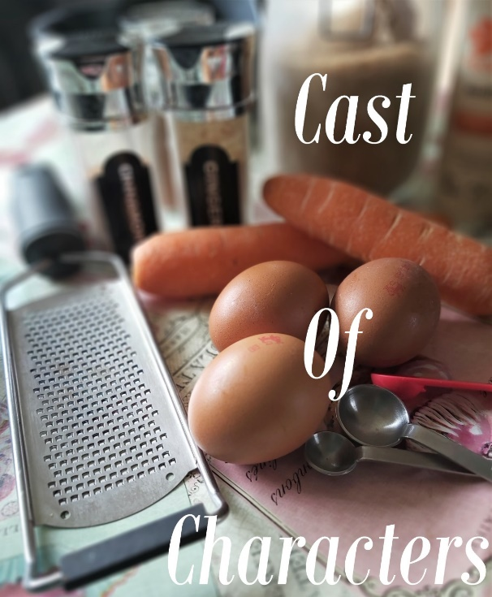
INGREDIENTS
(Makes 3 x 7 or 8″ (18.5 or 21cm) rounds, 2 deep rounds or 24 cupcakes)
- 250ml Sunflower or Vegetable oil
- (approx. 1 cup, or just under 9 fl oz)
- 4 Medium- Large Eggs
- 225g Light Brown sugar*
- (1 cup + 2 tbsp or 8 oz)
- 300g Self-raising flour*
- (2.5 cups Self-rising flour 10.5 oz)
- OR 2.5 c Plain/All Purpose flour + level 3.5 tsp baking powder + level 1/2 tsp of Salt
- 2 tsp Baking powder
- 1 tsp Mixed Spice*
- 1 tsp Ginger Powder
- ½ tsp Cinnamon powder
- 1/2 tsp Nutmeg
- 1/4 tsp Anise (optional)
- 200g Carrots, grated weight
- (2 rounded cups, 7 oz shredded)
- ** Note – half these ingredients will make 12 large cupcake/muffins.
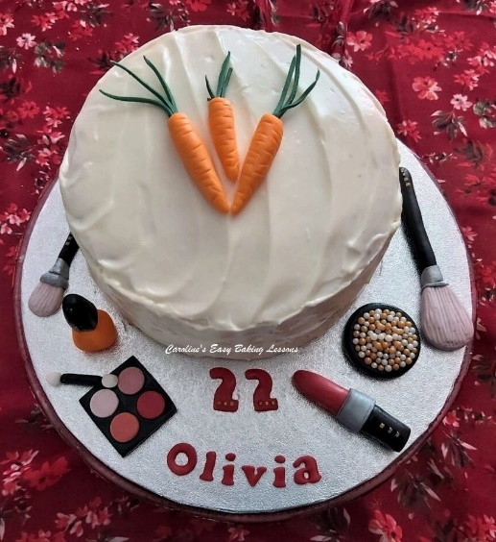

FROSTING/ICING
(Makes enough for a deep 2 layer cake with filling and a top layer of frosting as in photos)
- 187g Cream Cheese (6.75 oz), softened room temp.
- 43g Butter, unsalted, cubed, soft (1.5 oz, 1/4 stick)
- 1 tsp Orange Extract (optional) – or Vanilla or Orange zest to taste
- 375g Icing Sugar, sieved
- (3 1/3 cups, 13.25 oz), sieved
- NOTE – to make a 3 layer and completely cover with lots of frosting, double the above recipe.

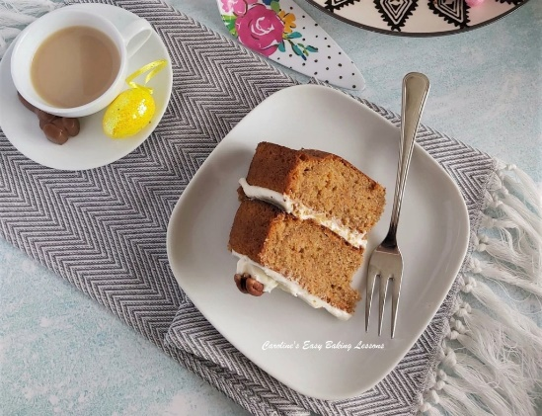
EQUIPMENT
- Weighing scales or measuring cups
- Small measuring jug
- Mixing spoon
- Stand or Hand Mixer and mixing bowl
- Sieve
- Measuring spoons
- Grater/shredder and bowl for carrots
- Cake tins – 3 x 7 or 8 inch (18.5 or 21cm) pans
- Oil, butter or lining paste for greasing tins
- Baking/parchment paper & scissors
- Timer or Phone timer
- Cooling rack
- Cocktail stick/tooth pick or wooden BBQ skewer
- tea-towel or 2
- Baking palette knife or butter knife
- Bowl for making frosting
- For fondant carrots see below

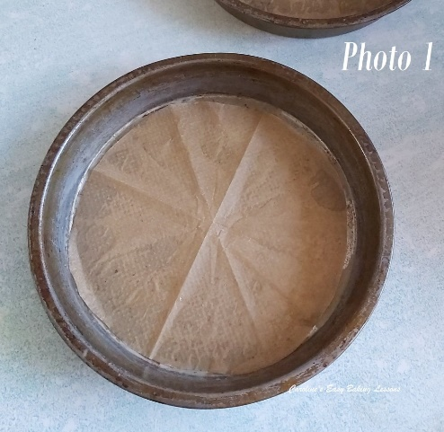

INSTRUCTIONS
1. Prepare your cake tins, by oiling/greasing them well, (bottom and sides) and covering the bottom with baking/parchment paper. For help on how to cut a circle to fit your tin, see Photo 1. For a more economical alternative to cake release spray, see my lining paste review, but also use paper on the base.

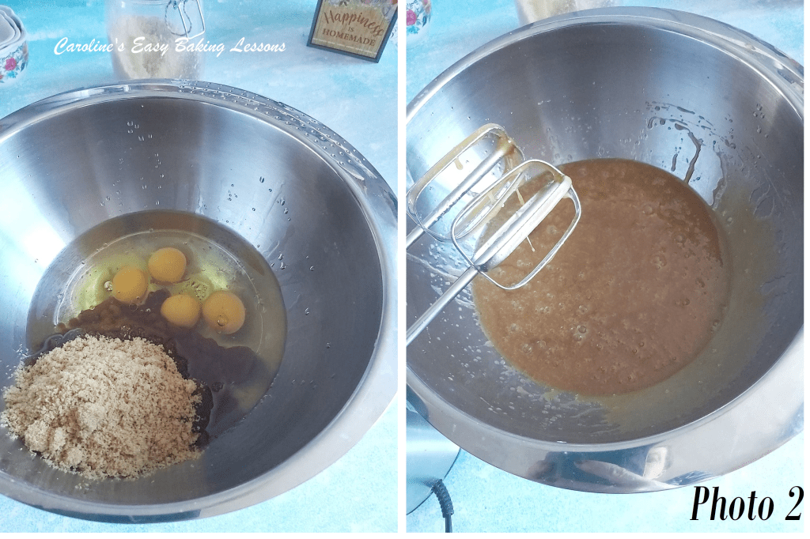

2. In a large mixing bowl, add the oil, eggs and sugar. Using a stand or hand mixer, mix them thoroughly together until incorporated. See Photo 2.

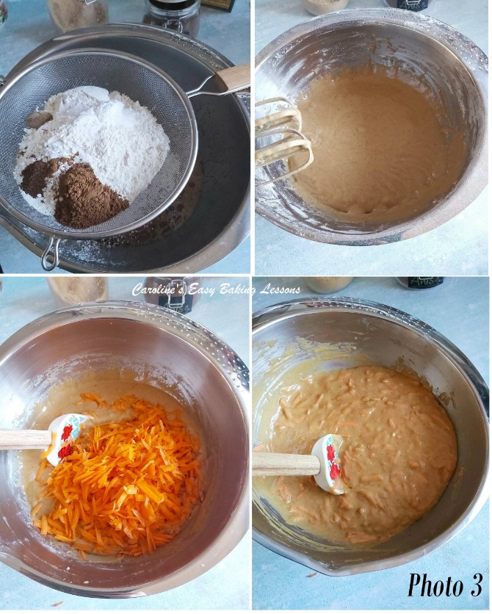

3. Place your sieve over the mixing bowl, (on top of the scales and set to zero/tare), add in the flour and baking powder. Use the back of a spoon to rub them both through the sieve. Now sprinkle in the spices. See Photo 3.
4. With the mixer on low to begin with, mix all the ingredients until they come together, with no flour visible.
5. Now add in your carrots and mix by hand, just until incorporated evenly and no more. See Photo 3.
6. Heat up the oven to: 180c/160c Fan/350f/Gas Mark 4.

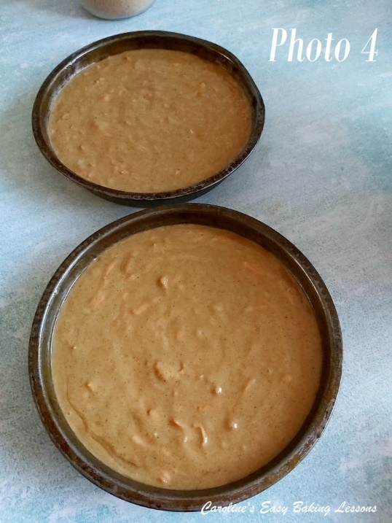
7. Spoon the batter into the 3 cake tins as evenly as you can, spreading it out and down. (Or into 2 deeper tins). Then spread out from the centre a little so as to make a little dent in the centre of the batter. This is try to create cake layers with less thick rounded tops. Also give the tins a tap on the worktop to expel any air. If you want super flat sponges for lots of layering, see my video with a tip for that. See Photo 4.

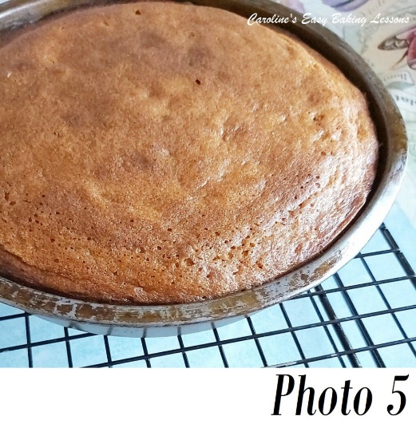
8. Bake in the centre of the oven for between 20 -25 minutes until golden brown. Check they are done by inserting a wooden cocktail stick/tooth pick into the centre of the cake and if it comes out clean it is ready. Another way to check is if the cake springs back when pressed with a finger gently. The cake will also be starting to come away form the sides of the pan too. If it isn’t done yet, continue to bake for a further 2 minutes and check again. Continue until fully baked. If they are colouring too much on top, cover with some foil/aluminium. My oven doesn’t cook evenly, so I turn the tins and rotate between the shelves and use my timer to do so on intervals. Be sure to use a timer and don’t open the oven until at least half way through the baking time. See Photo 5.
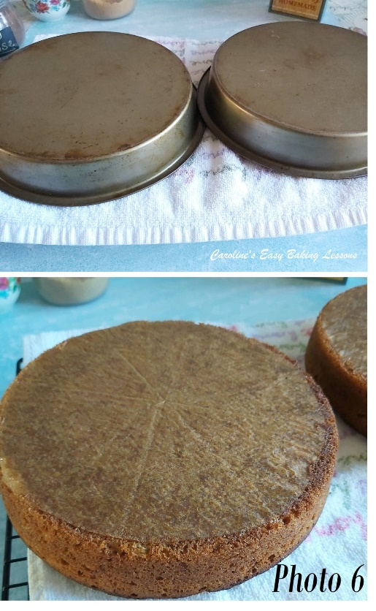

9. Leave to cool for 5 minutes and then place on a cooling rack, upside down, but still in the tins. See in Photo 6, where I folded a clean tea-towel and placed directly on the cooling rack. This means you don’t get tell-tail marks left on the top of your sponges. For flat tops, we are cooling upside down, but if you are not concerned about that, go ahead and have the right way up. See Photo 6.
10. Let the cakes cool down as much as possible before attempting to remove from the tins. (At least 20 minutes). You may need to run a palette knife down the sides to release the cake and then tap out onto the cooling rack with the tea-towel. Leave 5 minutes & then very carefully peel back and remove the paper. Leave to cool completely. If not using soon, wrap well in cling film/plastic wrap, in room temperature, until ready to use. They can also be frozen like this, with baking/parchment paper & then some foil/aluminium on top and placed in a food bag.
***TOP TIP – Place a sheet of kitchen paper/paper towel in with the cake before freezing and this helps absorb any moisture resulting on defrosting.

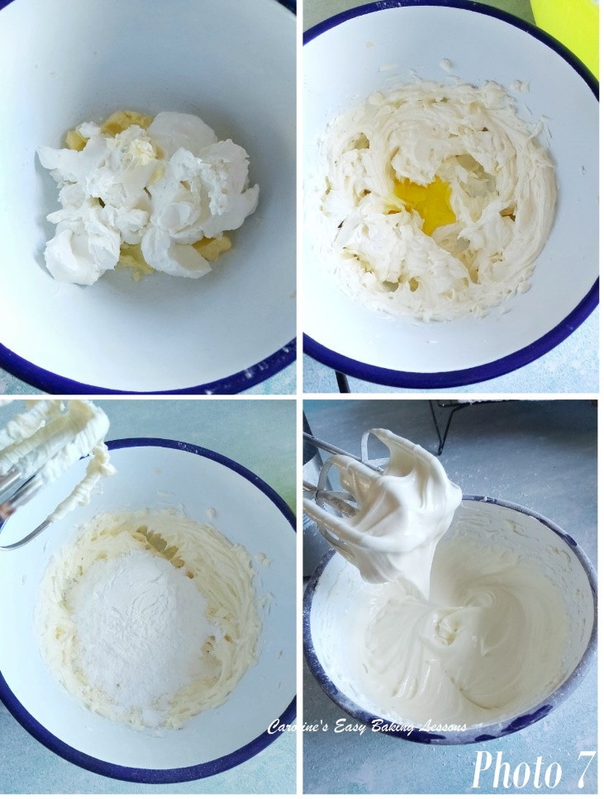
CREAM-CHEESE FROSTING
11. Beat the butter, and then with cream cheese, with a hand-held or stand mixer on med-high speed till soft and spreadable. See Photo 7, top 2 pics.
12. Add the orange extract, or alternatively the zest of one orange. Mix again just until distributed.
13. Sieve in the icing/powdered sugar, gradually and beating well, until smooth and spreadable. See how it hangs from the end of the beaters in a thick mass, with a pointed end, but not dripping. You might not need all the sugar or need a touch more. See Photo 7. Leave in the fridge to firm up before frosting the cake (cover the bowl with cling film/plastic wrap).

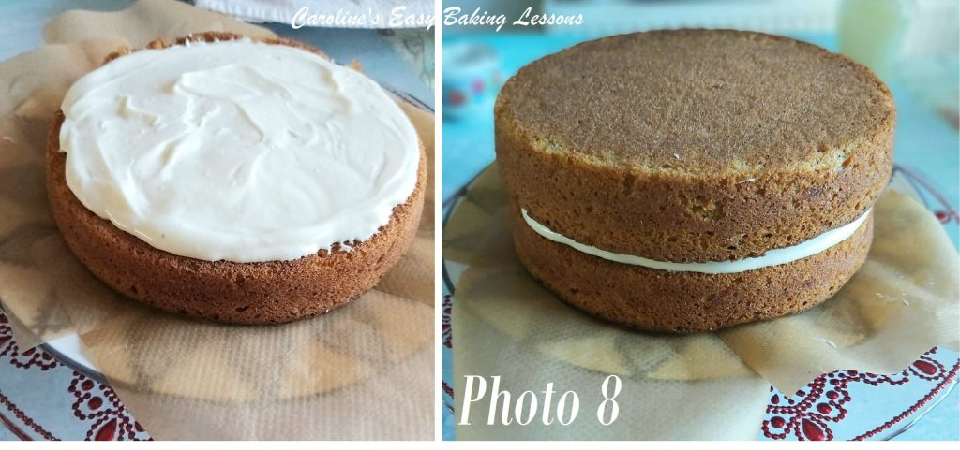
ASSEMBLING THE CAKE
14. Place the flattest cake layer on a cake stand or large plate. I like to place 4 small squares of paper under the cake if I am going to frost the sides. Keeps the plate clean! See Photo 8.
15. Using a palette knife or butter knife, start spreading frosting starting from the centre and working outwards to the edges. Use plenty of frosting for a thick layer. See Photo 8.
16. Now position the next sponge layer on top of the frosting. If you have domes on your cakes, you can position them with the domes inwards and fill the gaps with frosting. Or keep one dome top for the top most part of the cake. Photo 8 the cakes were made with no domes and this helps with thick layers, and stops them moving too much. Go ahead and add another layer of frosting if you have 3 sponge layers.
17. If using 3 layers and you want to completely cover in frosting, begin be applying a thin coat (known as a ‘crumb coat’ ) to the sides of the cake. It doesn’t need to completely cover the sides, but pay attention to filling any gaps between the layers. Now spread a complete layer on the top of the cake too. Leave in the fridge for a few hours or over-night till set. Note though it will not be as firm as buttercream frosting.

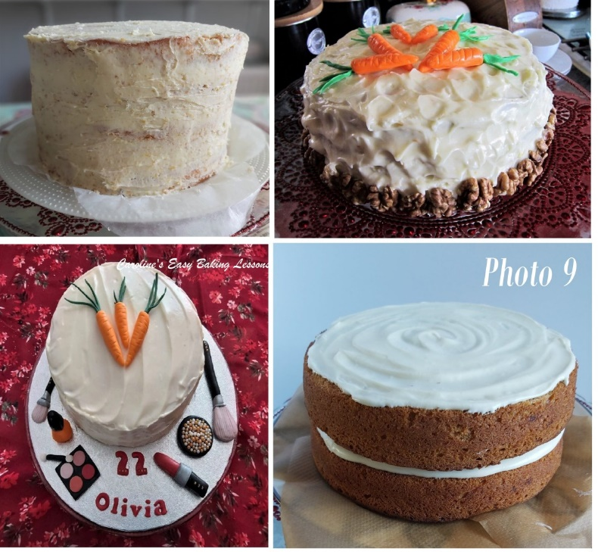
18. Once the crumb-coat (known as this as it catches any loose crumbs), is set, apply a thicker coat to the sides, and on the top of the cake. You can smooth out for a clean finish, or use the back of a large spoon to make peaks as in the photo. You can also make a swirling motion on the top of the cake. Drawing your palette knife across the sides in horizonal motions, will give a texture to the sides. You can also pipe on some rosettes on the top of the cake and add pecans or any nuts you like.

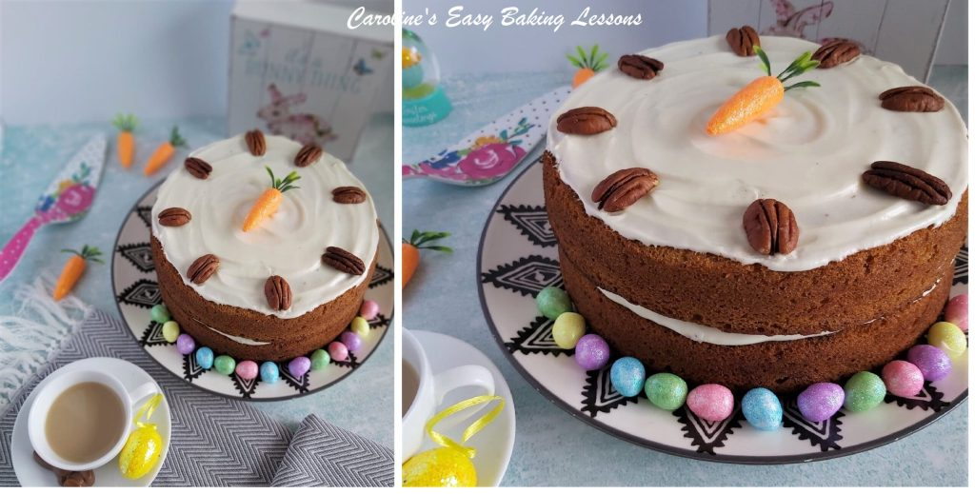
19. Once happy, leave in the fridge to set up for easy cutting and for the frosting to firm up. Alternatively, pop in the freezer for about 30 minutes. Once set up, pull out the pieces of paper from the plate for a neat finish.
20. Slice up and serve. Home-made caramel or salted caramel sauce goes lovely with carrot cake. Check out my recipe with a video to accompany it.

21. Store any left-overs in an airtight container in the fridge or somewhere cold. ENJOY!

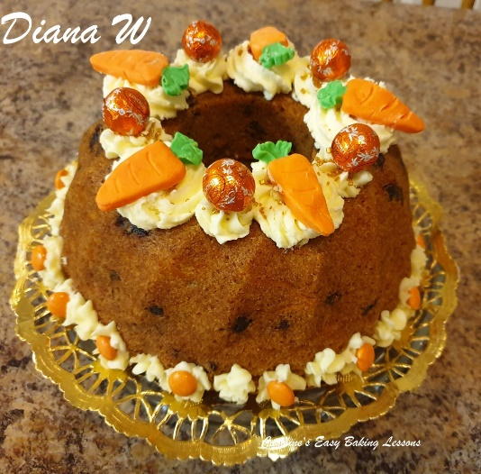
Here’s another large bundt made using this recipe, by my friend Diana, who added raisins to the batter.
Please see the sharing options or even printing, at the right/bottom of your screen (bottom of your screen for mobiles, and down the right-hand side on computers). You can even pin this to your own Pinterest page. Alternatively, you can download this article, see below. You could also leave some feedback if you like.
DIFFICULTY LEVEL: easy, beginner
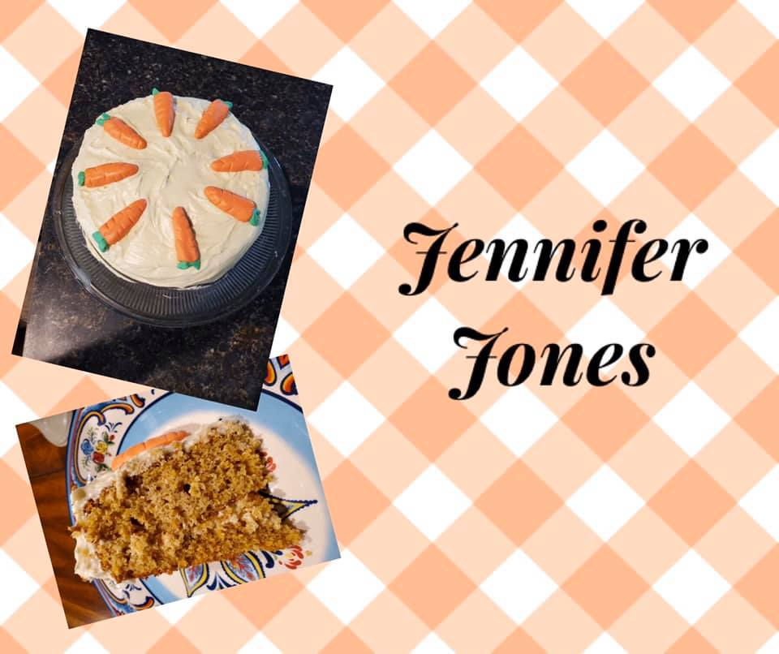
Here’s also some pics, by the runners up in a competition in Facebook Group, Great British Bake Off Fans. Where we used my recipe for the competition. Note this was made by members in the UK, America & Canada, and using All Purpose flour.
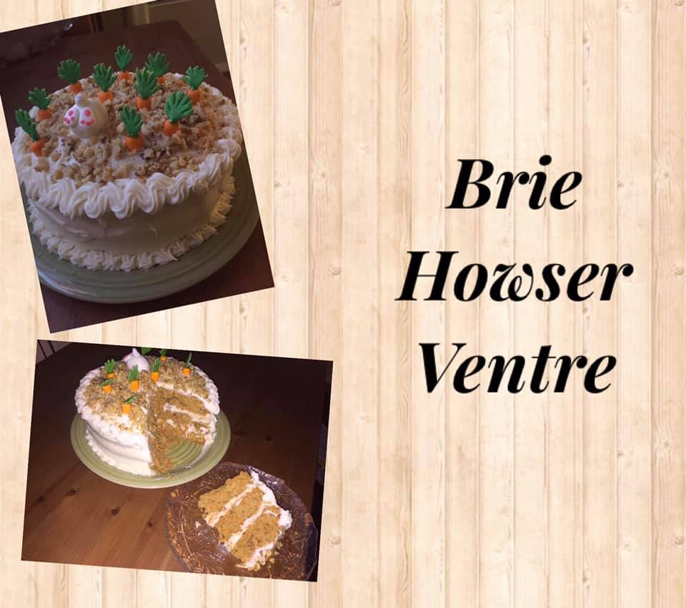
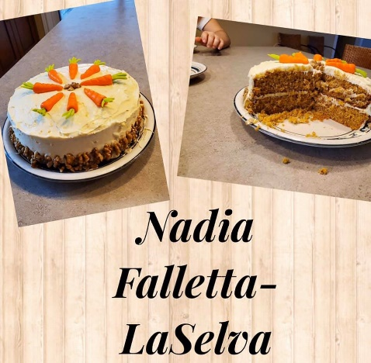

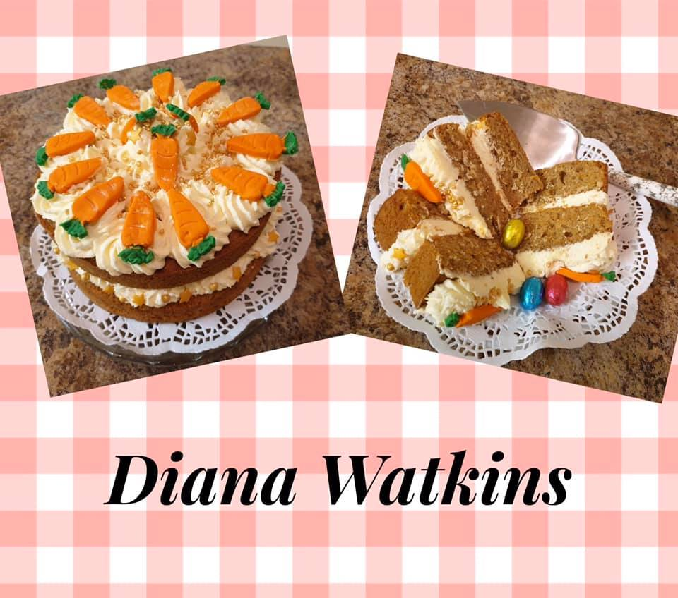
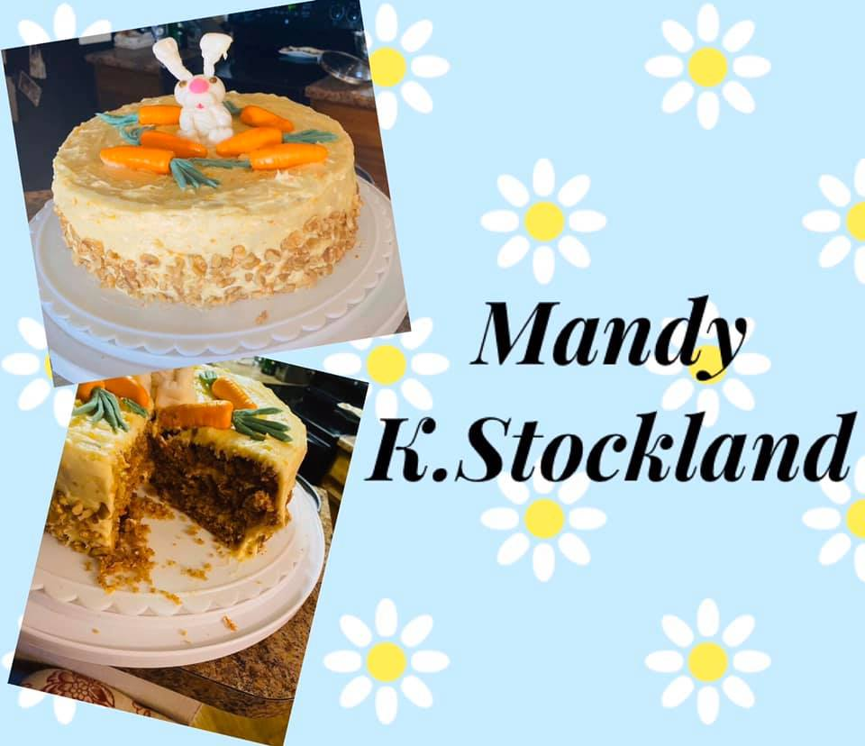

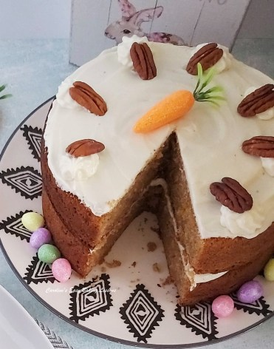

Thanks for reading
Happy Baking & Making
Happy Tummies & Memories!

Caro xx

