EASTER CAKE POP EGGS – Recipe Review From Prima – The Joy Of Baking
Caroline’s Easy Baking Lessons

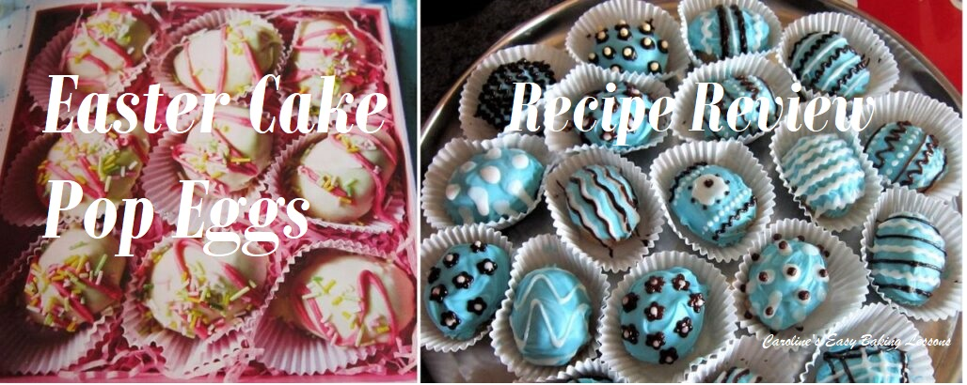
RECIPE REVIEW
As part of my recipes for Easter bakes, I decided to try out this recipe from a book I had got from a charity shop, called PRIMA The Joy Of Baking. This book has lots and lots of great recipes and ideas that inspired me to make other creations. This particular recipe I was trying was for Cake Eggs, little balls of cake shaped and decorated to look like little easter eggs. Similar idea to cake pops, which I used to make before I learned to bake from scratch. So it shouldn’t be that hard – right?
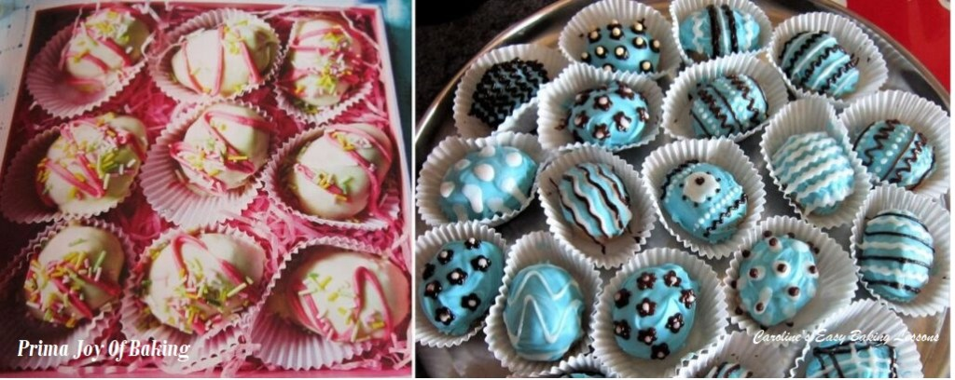
Well the recipe seemed straight forward enough – use crumbled cake and mix with butter cream frosting to form the balls and then cover in melted chocolate or candy melts and decorate. I used my really easy sponge recipe that I bake in a square tin and I reckoned it would be enough and after I baked it, it was a little over the weight the recipe suggested but not by much. Go to recipe for the sponge cake

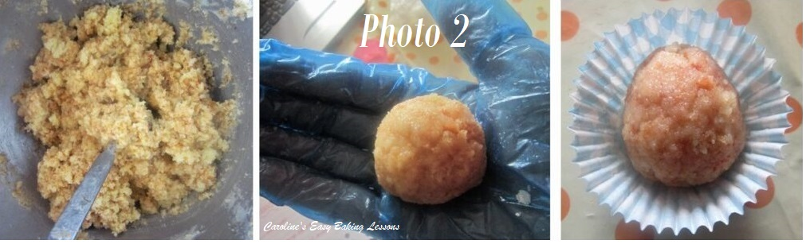
I also had some left over buttercream that I had been chilling so I didn’t even have to make that up. So I crumbled the cake and mixed with enough of the cream to hold it all together and tested it by making a ball of mixture and it held together ok. So I proceeded to make as many as I could get from the cake mixture. Now a point to note – the recipe doesn’t say what size to make them other than to put them in paper cases. I had really tiny ones (the size for chocolates or petit fours) as well as small cupcake sized ones. I opted for the larger cases, as I literally would have been all day rolling tiny cake balls! So I made a size that was perfect for the cases (about 1.5 in/ 4 cm wide balls). To make them egg like, after rolling into a smooth ball, I rolled one end between my palms to thin it to become the top of the ‘egg’. (See Photo 2). I placed them directly into the paper cases. Once they were all made up ( I think I got 20), I placed them on a tray and put into the fridge to firm up. The recipe does not specify how long to do this for but I think they were in the fridge for about 1.5 – 2 hours.

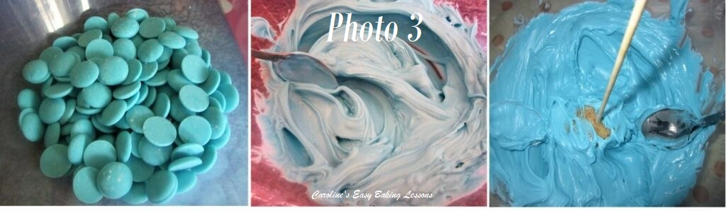
Once they were firm enough, I melted candy melts in the microwave, for a few minutes. The mixture was way too thick, as I found out when I tried to dip the first cake egg into the topping. I also tried to put a wooden bbq skewer in to lift the cake out – but this didn’t work. (See Photo 3). I had to lift out with my fingers. It got really messy and because the cake was cold the topping was setting up literally in seconds. I tried to smooth the mess that was on the topside of the cake but not very well. See Photo 4 below.

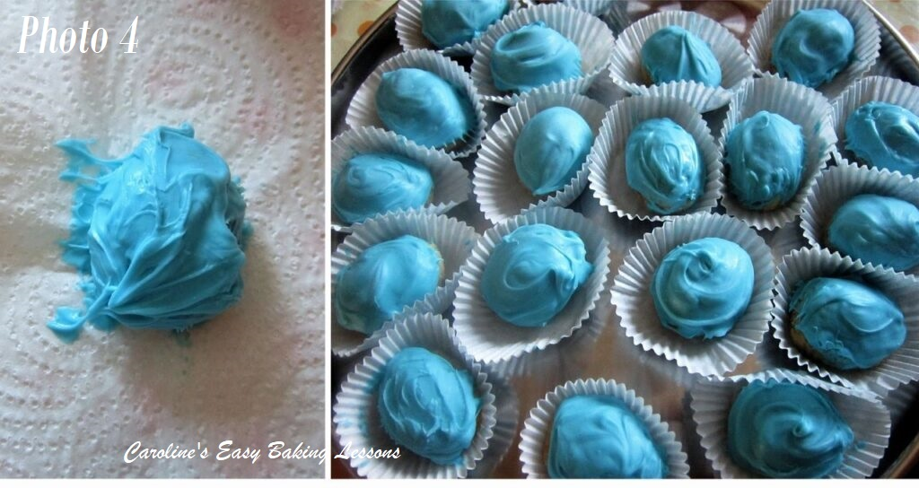
Now the recipe simply said to dip in the melted chocolate and shake off excess. No indication of how to do this. I do think though that maybe chocolate would have been more runny and easier to dip in. So I did what I had heard about Candy melts before, and added some drops of oil to thin it out. This helped a little. I had to dip the cake into the coating and lift out with my fingers and very quickly smooth down with the back of a small spoon. Trust me when I say there is no easy or neat way to do this. (See Photo 4). I also tried smoothing down with a swirling action like I do sometimes for quickly applying frosting onto cupcakes. In the end I also tried just applying with a small spoon instead of dipping. I got the odd one or two that were not too bad looking. However, when putting in the cases you can mess them up. Oh and you get the coating on your fingers and everywhere else. Kids would love this!

As I said, the topping was setting up really quick, so no need to put in the fridge again. The recipe advised colouring some icing and piping this on top of the eggs as decorations. However, I had some little icing pens I had picked up sometime ago (what for I can’t remember). Anyway they came in handy. They have a tiny tiny nozzle so would be much neater and hopefully be used to hide the mess. Some more colours would have been ideal but I worked with what I had.
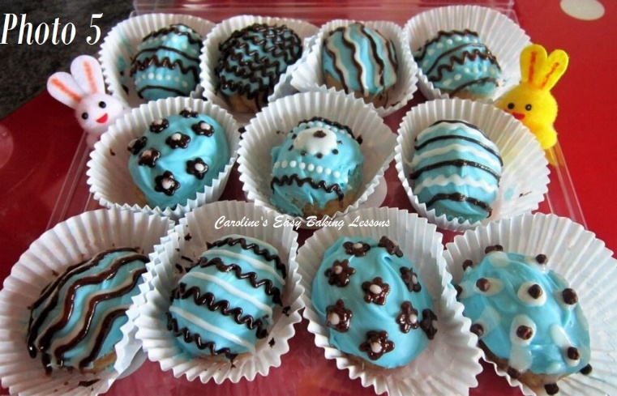
So I tried to ‘draw’ on patterns that I remembered drawing and colouring Easter eggs as a kid. (See Photo 5). I would gladly do that all day if it didn’t make my back hurt!
Well you see the end results (Photo 6). I think it’s something that could be worked on to get a better finish to the coating, but the decorations have covered up a world of sins!
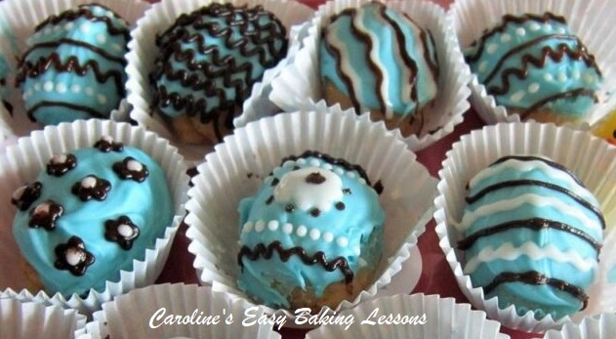
On the other hand, I think kids would love to make these. They can get there hands in from mixing and making the balls, to dipping (and licking fingers) and finally decorating any way they want. There are so many things you could add and do. With all the different types and colours of sprinkles you can get now, any type of egg could be created. And we know kids LOVE sprinkles! And even some big kids too – you know who you are -wink wink!!

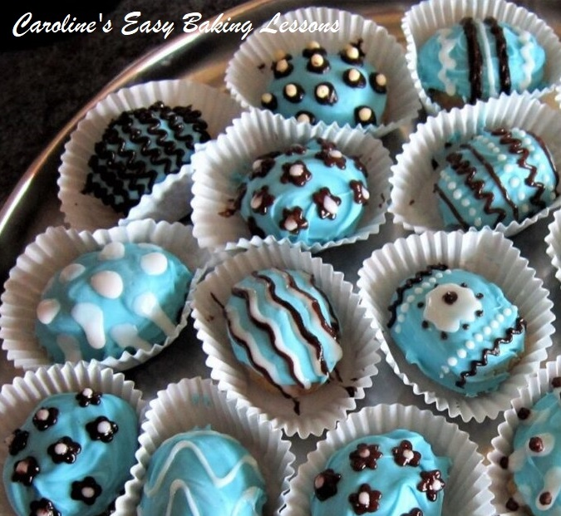
As for the recipe itself, lots of failing as detailed in the above and only one photo for the whole process. Not sure I would make again, but you never know.
Here’s the recipe as it appears in the book, but please bear in mind my suggestions above to help you out. Anything in brackets is my conversions for US/Canadian readers. Thanks for reading.

PRIMA – THE JOY OF BAKING – 139 FABOLOUS RECIPES

(HEARST MAGAZINES UK)

Ingredients
For The Eggs:
- 50g Butter, softened (3.5 tbsp, 1.75 oz)
- 100g Icing/(Powdered) Sugar (1/2 cup 3.5 oz)
- 350g Sponge Cake (I used my cake recipe with 1 stick butter, to 1c flour, 1/2c sugar and this weighed 447g/1 lb).
- (Here’s a link to my recipe for the sponge cake (note it weighs about 450g/15.75 oz/1lb): go to my sponge cake recipe.
For The Topping:
- 200g Good Quality White Cooking Chocolate (2 cups/7oz)
- Little Pink Food Colouring • Sugar Sprinkles
You Will Need:
- Small Cupcake Cases (I used mini cupcake/muffin sized)
- Small Plastic Piping Bag
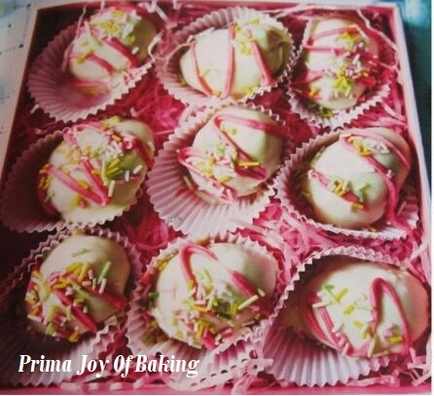
DIRECTIONS
1. To Make Butter Cream: Beat butter and sugar together until smooth.
2. Crumble cake into a bowl & stir in enough buttercream to bring mixture to a stiff paste. Place on a plate & chill until firm.
3. To Make topping: finely chop chocolate & place a bowl over a pan of gently simmering water until melted. Reserve 2 tbsp of chocolate into a separate bowl and dip each cake egg into the rest of the chocolate. Shake off the excess and place in a paper case. Add a little food colouring to the reserved chocolate (melt again if it has hardened), then place in a piping bag, snip off the end and drizzle over the truffles. Scatter over sugar sprinkles and refrigerate truffles until ready to serve.

DIFFICULTY LEVEL: intermediate, for precision

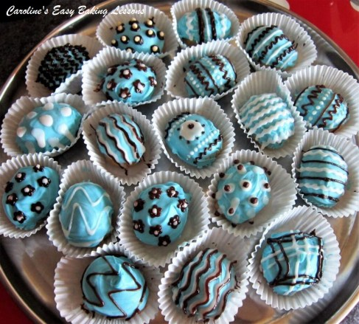
Thanks for reading
Happy Baking & Making
Happy Tummies & Memories!

Caro xx

