RASPBERRY SWIRL VICTORIA SANDWICH CAKE Caroline’s Easy Baking Lessons
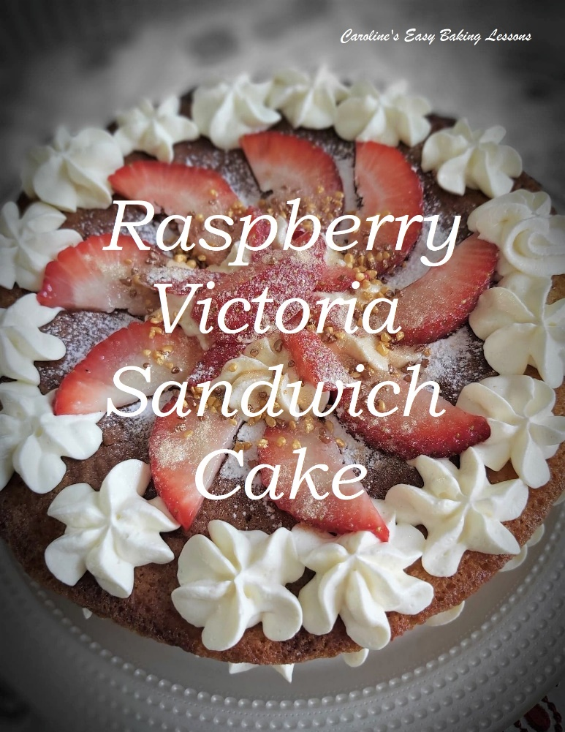
When thinking of some ideas for Mother’s Day I wanted to do a cake that is delicious but super simple to make. It then occurred to me I hadn’t made a lesson on layer cakes yet, so this is great for that too. I used an easy but classic Victoria Sandwich Sponge recipe with jam/jelly rippled through it, not only giving it a great visual aspect of marbling, but an added taste bonus. This jam/jelly can of course be homemade, but this is going to be an easy recipe for anyone to prepare, by using shop bought for this ripple in the sponge as well as for the filling. You can use any flavour you like, strawberry is also a classic combination, but I love raspberry.
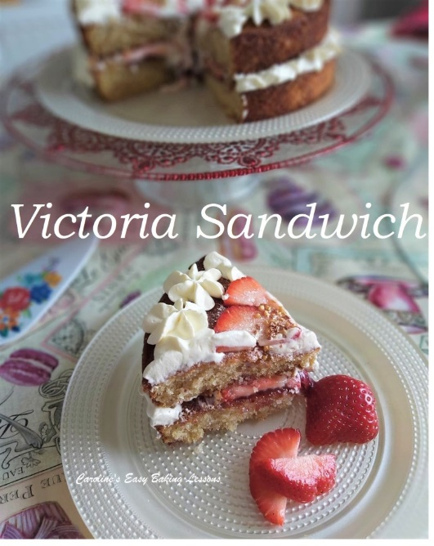

Another classic filling to accompany the fruit filling is whipped cream, all making it a truly yummy cake. Once the cake is sandwiched together, you can leave as is or sprinkle a dusting of icing/confectioner’s sugar on top. It’s as simple as that, no complicated techniques or fancy equipment. If you are using the cream, a hand held or stand mixer is ideal for whipping up the cream unless you have a lot of upper arm strength. And as I hope some boys or Daddy’s are helping with this for Mother’s Day, that is always a possibility. In the photos I have shown two different ways to decorate the cake. The simple way, or with pipped cream & strawberries. Either way, it will be great.
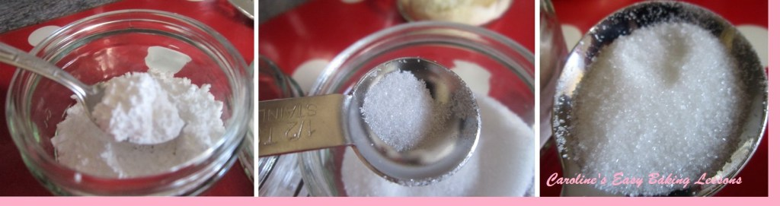 Icing (powdered) Sugar (Left), Caster Sugar (Middle) & Granulated (UK, Right)
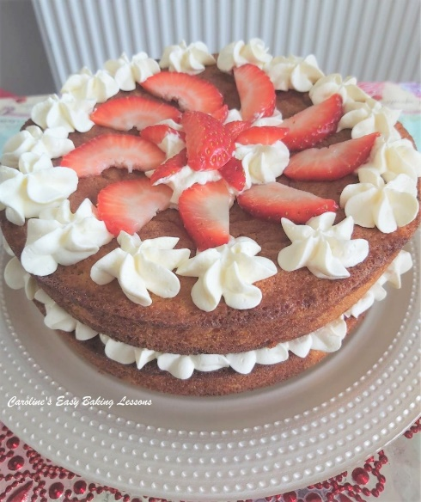
If you are in the US/Canada and can’t get extra/super fine sugar for the UK caster sugar equivalent, you can make your own by grinding regular granulated sugar a little bit or processing lightly. Do not go as fine as a powder, keep it as small granules. See photo above of the sugars we have in the UK for a comparison. Just note that US granulated is a slightly smaller granule size than the UK equivalent.
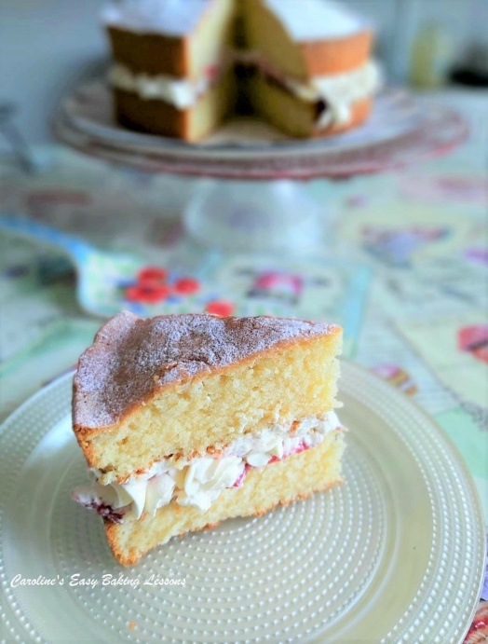

This simple classic, can however, be hard to master. It should have a light and airy texture. Beware or recipes that use too much baking powder. Some will use self-raising or self-rising flour and additional baking powder. They can give an unpleasant bitter and metallic after taste. But worst of all, because they have too much raising agent and not enough flour to support it, they prematurely rise and sink back down. And the end result is a dense cake with a much more close texture crumb. Also, ‘All-In-One’ method recipes, do not get as much air into the batter, since there is no ‘creaming’ (steps 1 & 2), of the sugar and butter. This repeated movement creates air pockets that result in air being incorporated into the batter, producing a lighter cake.

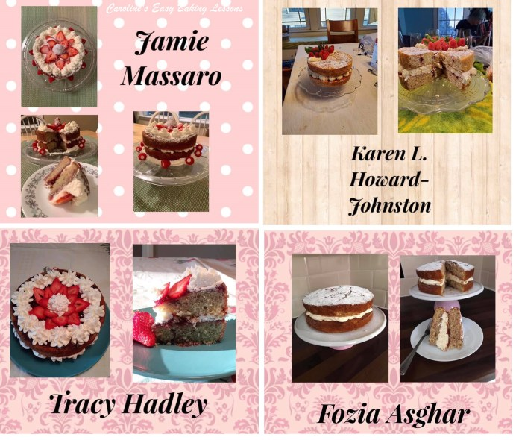
Competition Entries Using My Recipe

Here is a selection of photos by fellow bakers from across the globe. This recipe was used for a competition in Facebook group, Great British Bake Off Fans, where it was made using self-raising, plain or All Purpose flour and decorated in a variety of different ways. More pics at the bottom of the recipe, including the winner.

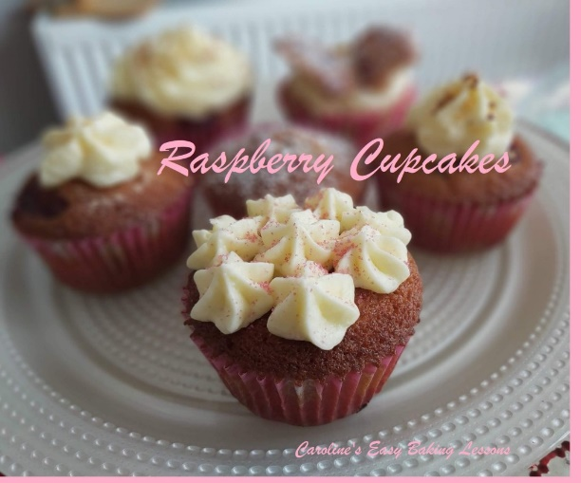
I also have a recipe lesson for cupcakes like this cake, with a raspberry jam filling. As well as a tutorial for beginners, on how to decorate. Go to recipe lesson.

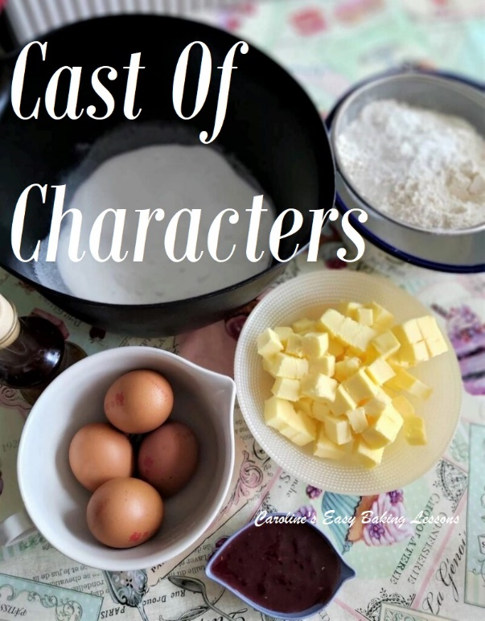

EQUIPMENT
- 7 or 8 ” (17.5-20cm) Cake Sandwich tins x 2
- Baking/parchment paper
- Baking spray, lining paste, or butter to grease (see note in instructions)
- Scales or measuring cups
- Measuring Spoons
- Hand or Stand Mixer (or a wooden spoon)
- Sieve
- Large Metal spoon
- Small bowl for jam/jelly swirl
- Cocktail sticks
- Baking Palette knife or butter knife
- Small measuring jug (optional) • Bowl for whipping cream
- Icing/Powdered sugar • Small sieve (optional)
- Timer or Phone Timer • Clean Soft Tea-towel
- Cooling rack • Piping bag & nozzle (optional)

INGREDIENTS
- 225g Butter, unsalted, soft & cubed (1 cup/ 2 sticks, 8 oz)
- 225g Castor Sugar (8 oz) (1 cup of super/extra fine sugar, Domino’s etc. *See note above)
- 4 Medium – Large Eggs
- 225g Self-raising flour, sieved (1 & 3/4c Self-rising Flour, 8 oz)
- (OR 1 & 3/4 cups All Purpose/Cake/Plain Flour plus 4 tsp baking powder + scant ½ tsp salt)
- 1 tsp Vanilla Extract
- 1 tbsp Milk
- 8 tbsp Raspberry jam/jelly/preserve (or any)

FOR THE FILLING & TOPPING
- Double or Heavy/Whipping cream (at least 200ml / 6 fl oz or 3/4 cup if using)
- Raspberry Jam/jelly (or own choice) • Few Tbsp Icing/Powdered sugar
- Strawberries or other fruit (optional) • Sprinkles & coloured lustre dust (optional)

- OVEN: 180c/160c Fan Oven/350f/Gas Mark 4

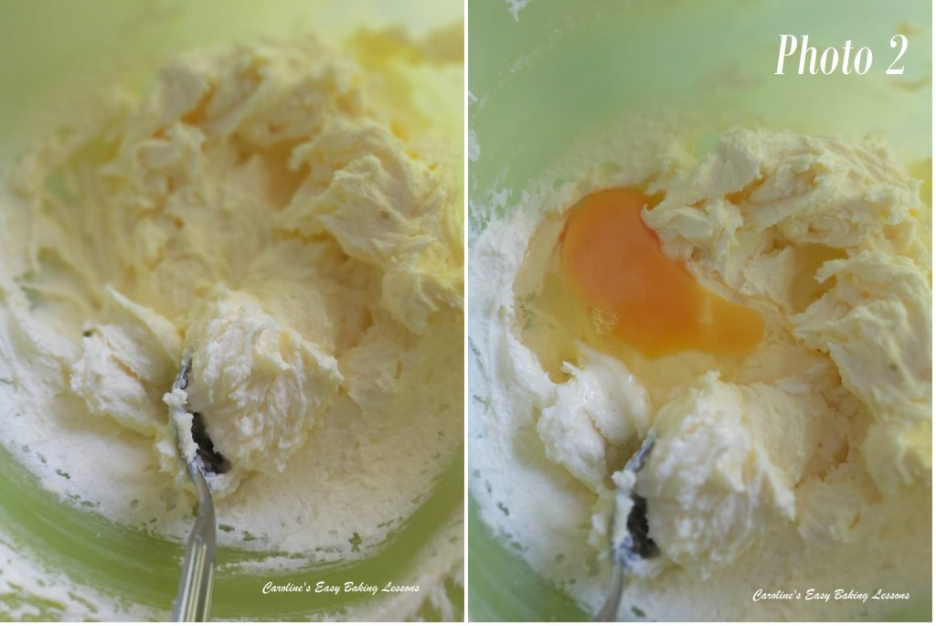
INSTRUCTIONS
1. Cube and weigh out your butter and leave to soften. A smaller surface area will soften quicker and be easier to mix with. I like to cut them about 1cm, 1/3″ size. If you are in a hurry, or forget to take it out on time, here’s a hack I tried. Soften Butter In About 12 Minutes.
2. Weigh out and add the sugar to the soft butter and mix by machine or hand for a few minutes until very creamy, smooth and soft and also paler in colour. This is known as ‘creaming the butter & sugar’. See Photo 2 for how it should look or check out the video. It is the best method for incorporating air into the batter to produce a light airy cake.
3. Gradually add in the eggs one at a time with the mixer on low to medium speed, and just briefly until mixed through, also known as ‘amalgamated’ or you might hear or read the word ‘emulsified’. To emulsify means to combine two liquids that normally do not combine so easily, such as vinegar & oil. So at this stage of the recipe, we are trying to emulsify the egg with the butter. As a result, sometimes the eggs may make the batter look a little curdled or split. If this happens just add 2 dessert spoons of the flour while mixing in the eggs. But don’t worry about it, it will bake out fine. You don’t even need to add the flour like that, as you will be adding in soon. If however, your batter is extremely curdled looking (and different to Photo 3 below, you might want to make sure next time that your ingredients are all at room temperature. If they are not all at the same temperature, it makes producing a smooth emulsion even more difficult. So make sure your butter is soft, but also that the eggs are at the same kind of temperature. Same goes for any liquid you might add.
For even more height in the sponge, you can whisk the eggs first since this activates the protein in the egg, and protein provides structure. Now mix in the vanilla extract just till combined.

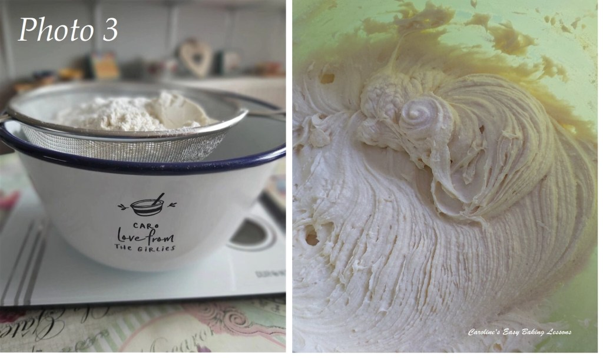
4. Now sieve in the flour (and baking powder is using plain/A.P. flour) into a separate bowl. See Photo 3. Then sieve again over the cake mixture and mix on low, then medium speed until all incorporated into a smooth thick batter. Only mix until no flour is seen, as you don’t want to over-mix it and knock out the air you incorporated. If you can hold the sieve higher up from the bowl, this too will incorporate more air into the batter. Sieving twice gets even more air into the batter. See Photo 3 .
5. Add 1 tbsp milk to thin the batter slightly.
6. Heat up the oven to 180c/160c Fan oven/350f/Gas Mark 4.
7. Now in a small bowl add about 1 tsp water to the jam/jelly and mix to combine. Just enough to thin slightly, but will depend on how thick and jelly-like your jam is. See the video for the consistency.
8. Oil or grease your baking tins well, paying particular attention to the sides. Place a circular piece of baking/parchment paper on the bottom of the tin. I recommend this greasing/lining paste recipe by Great British Bake Off winner Nancy Birtwhistle. Use pre-cut or make your own paper circles. Cut paper the width of the tin and then keep folding till you get a pointed cone shape. Then line up with the centre point of the tin and cut off the excess. Then simply unfold and if too big, fold again and trim off slightly. Then just position in place. See Photo 4. For more photo instructions – go to other pics or watch my video on how to fold it.
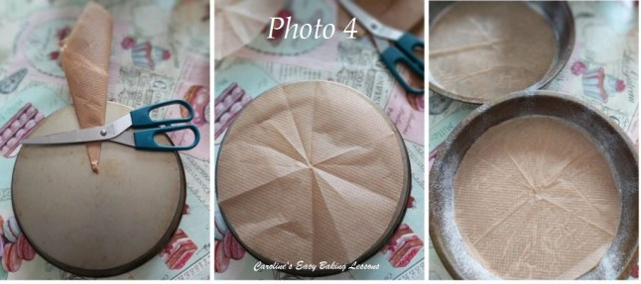Cutting Paper To Line A Circular Tin Perfectly.

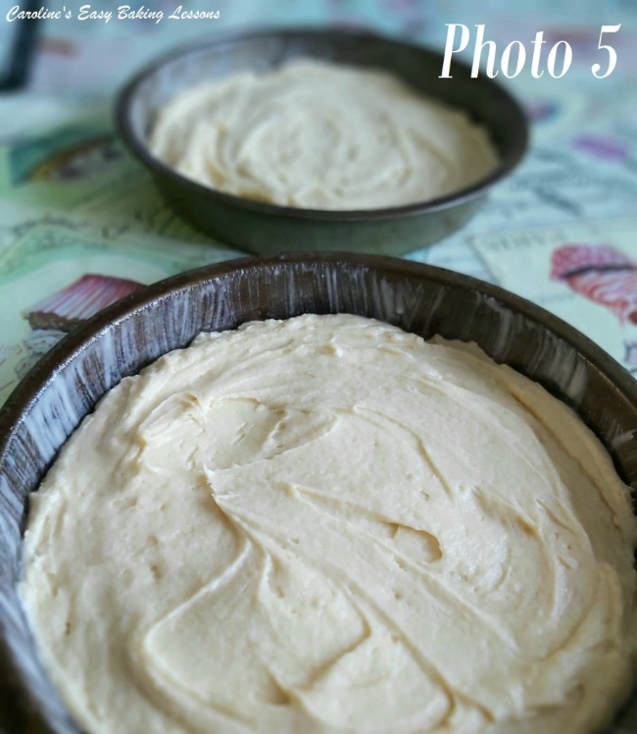
9. Put half of the jam/jelly mixture into the mixing bowl and mix lightly, leaving big streaks of colour as best you can. See video for how this is done and should look (I am sorry but couldn’t get a good still from the video).

10. Now spoon the batter evenly between the two tins and smooth out, leaving a little dip in the middle, so the cakes don’t dome too much and bake in the middle evenly. If you want super flat tops to your cakes, click here. See Photo 5, but note that the pic is of the classic batter with no jam through it.

11. Using a small spoon, drop spoonful’s of the reserved jam/jelly over the top of the cake batter. See video above.
12. Using a cocktail stick/tooth pick, make swirls in the batter. See Photo 6. Tap the tin a few times on the counter/worktop to expel trapped air.
13. Place the 2 tins in the middle shelf of the oven and bake for about 18 – 25 minutes.

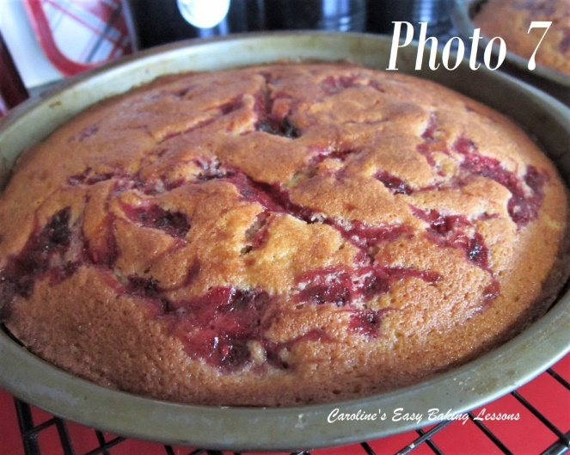
14. My oven doesn’t bake evenly, so checked them at the 13 minute mark and turned the tins before continuing baking. You don’t need to do this if your oven works fine. When ready, they should be a golden colour, but you want to make sure they are fully cooked, so using a clean cocktail stick/tooth pick, pierce the stick into the centre of the cake (not into the jam/jelly). If it comes out clean, then the cake is ready. If not, place back in the oven for a minute or two and check again until done. The cake will be springy to touch and coming away from the sides of the tin. See Photo 7 .
15. Leave to cool in the tins, on a cooling rack for at least 15 minutes.
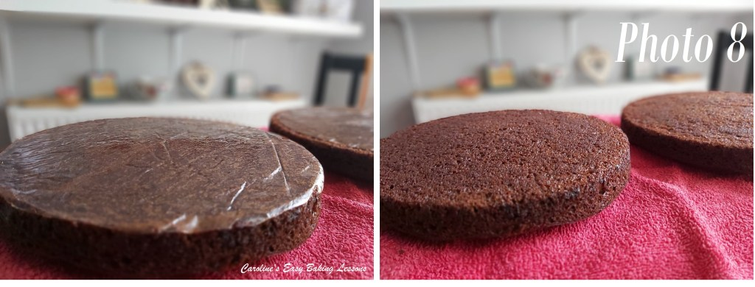
16. Run a palette knife or butter knife around the edges of the cake tin – it may stick where there is jam/jelly. Place a folded clean tea-towel on the cooling rack and turn the tin over and let the cake fall onto the towel. Might need a few taps. Leave for at least 10 minutes before you try to carefully peel the paper off the cakes. If it isn’t coming off easily, leave it to cool more. See Photo 8 for demonstration purposes, of Chocolate sponges, soon to come!
TOP TIP – Placing on the tea towel means there are no rack marks left on the cake. If you intend to decorate on top, this is not important. But if going for the classic look for a Victoria Sandwich cake, you don’t really want lines showing on top. And leaving to cool upside down also results in less of a dome. If you want you can instead turn the cakes out onto a plate, remove the paper and then place the other way up on the cooling rack. Just be careful as the more you turn them at this fragile stage, the more likely a break is.

DECORATING THE CAKE
1. Using a hand or stand mixer, whip up the cream until very thick & stands tall with stiff peaks. Watch my little video if you aren’t sure how it should be done. Be sure not to over-whisk as you can end up making butter! It will start to separate and be a yellow/cream colour.
2. Place the layer of sponge you want to be on the bottom, onto a cake stand or nice large plate, (flat side of cake at the bottom).
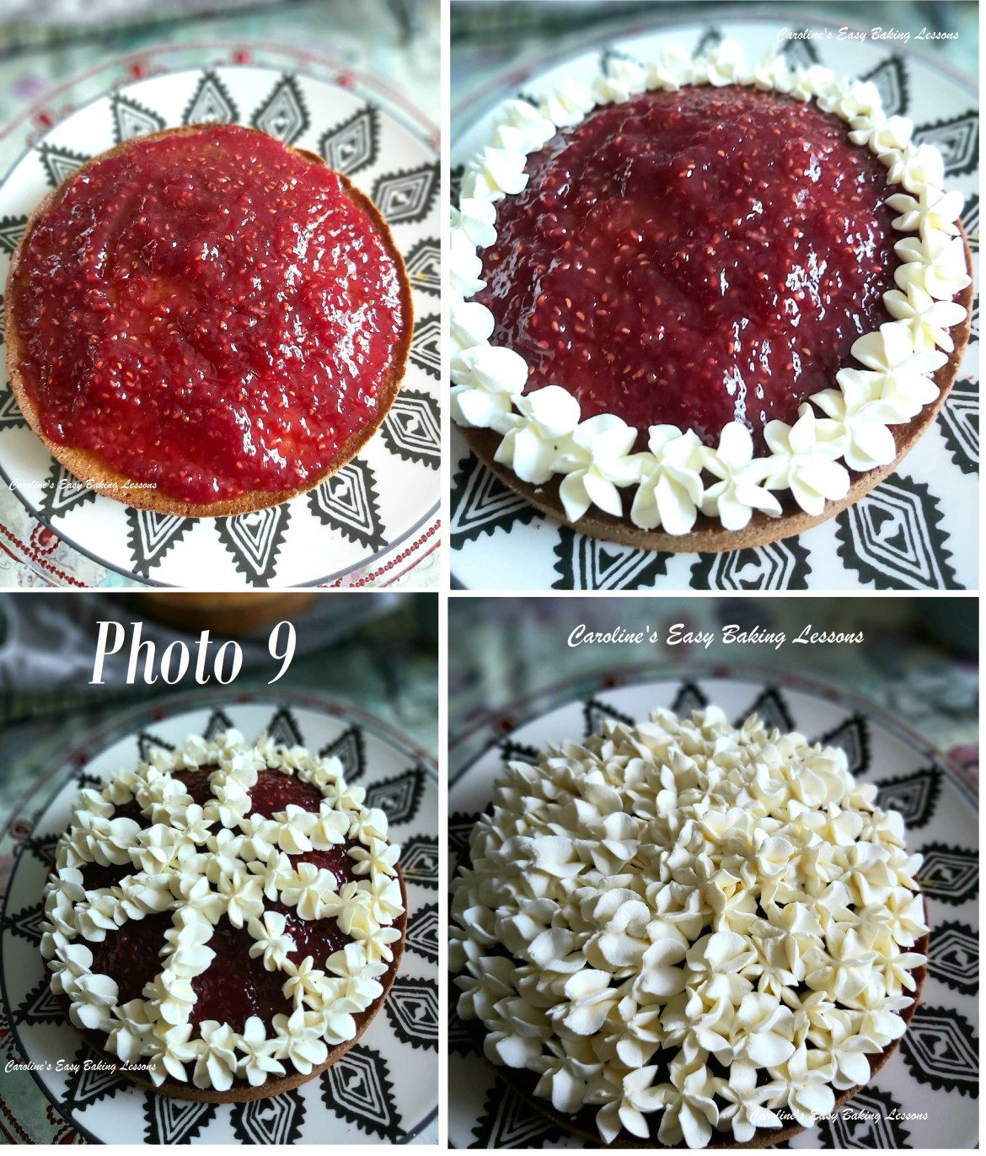
3. If this base layer of cake is domed (rounded) too much, with a serrated bread knife, carefully slice off the excess. It doesn’t need to be completely level, just flat. And only slice off if really too rounded that it won’t sit right with 2 layers on. And have a taste test – Baker’s Bonus!
4. Using a baking palette knife or butter knife, spread a generous layer of jam/jelly on top. Start in the middle and spread outwards until you get an even layer. If there are crumbs in the middle of the cake from cutting, don’t worry, just layer some more jam/jelly on top. See Photo 9 top left pic.
**Note that if your jam is quite thin and runny, pipe a border of cream first to stop it running off the cake.
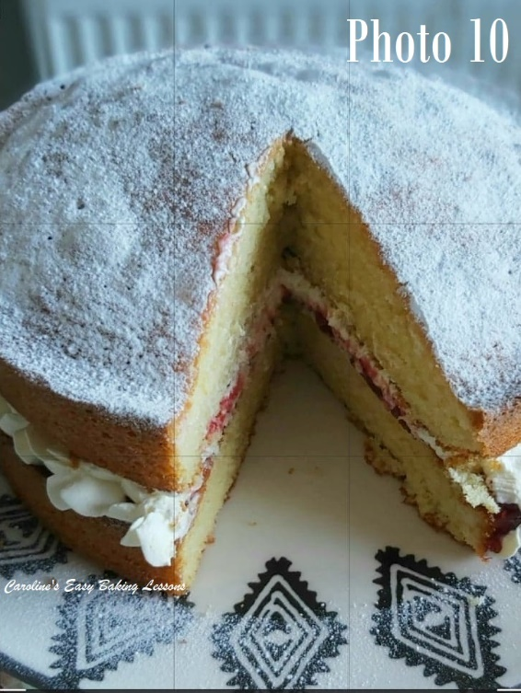
5. I piped some cream around the border and a little in the middle of the cake (see Photo 9). Alternatively, spoon some cream on top of the jam/jelly from the centre and then towards the outer edges, until you have an even and thick layer of cream. Try to not go all the way to the edges so too much doesn’t spill out later.
***TOP TIP FOR PHOTO READY CAKE – for the cream to hold it’s shape better once the top layer is on, stick the cream topped bottom layer in the fridge for 15 mins (10mins in the freezer) and then place the 2nd layer on top. Work quickly and it also helps with clean cuts.
6. Carefully place the second layer of cake on top, with the flat side down and squeeze slightly.
7. You can leave it like this, or dust with sieved icing/powdered sugar as is the classic way.
8. Sieve a thick dusting of icing/powdered sugar all over the cake. See Photo 10 (of the classic cake with no ripple of jam in the batter). Serve straight away or store in a cake stand preferably somewhere not warm & eat within 2 days. Just like before, you can chill the cake shortly before slicing it to get nicely cut slices, that are Facebook & Instagram ready!
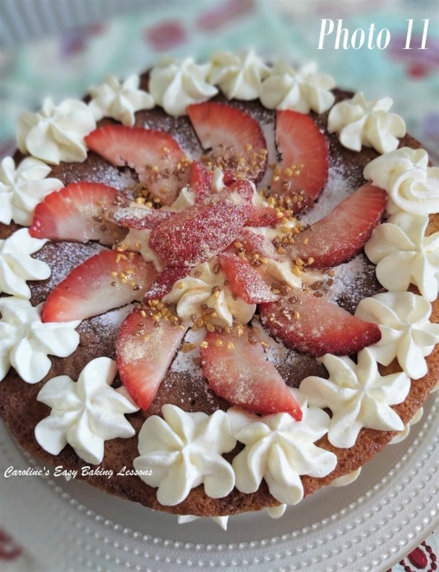
***Top Tip – you can also store in large, deep airtight container. Just place it on the under side of the lid and stored with the box upside down so it’s easy to get out later.
9. For the piped version, I piped more cream on top of the cake and in the centre. Then I added some thin strawberry slices (also sandwiched in the middle) and dusted with icing/powdered sugar. To give an extra sparkle, I also added some gold edible dust and gold nugget sprinkles. See Photo 11 and the video above. But you can decorate anyway you like.
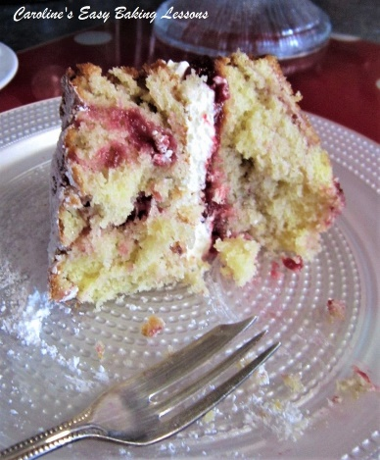

DIFFICULTY LEVEL: easy, with guidance
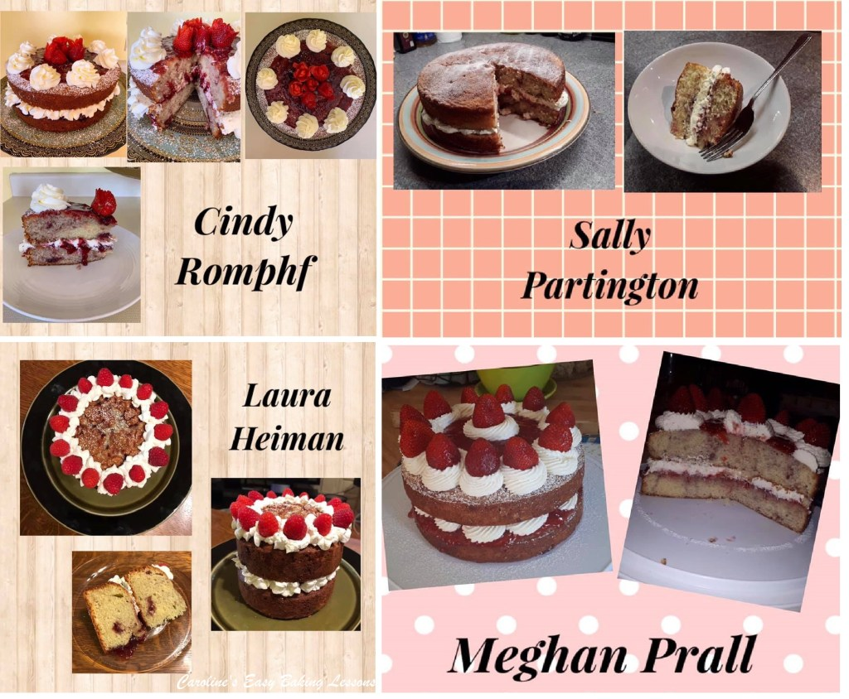
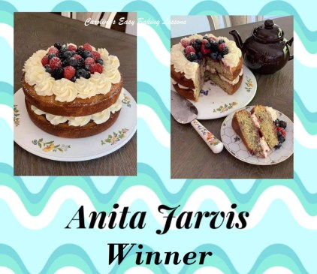

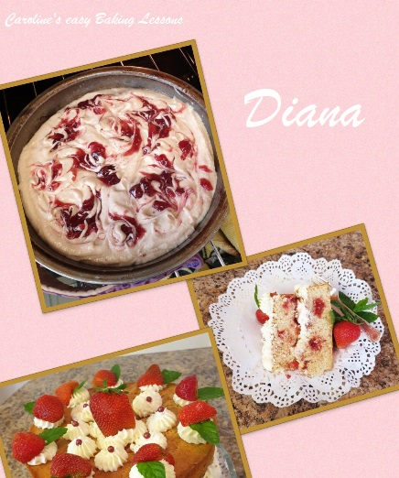

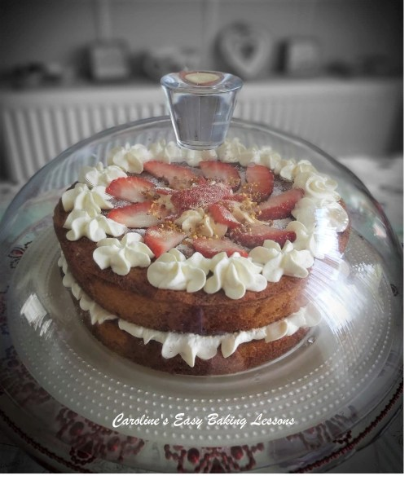

Thanks for reading
Happy Baking & Making
Happy Tummies & Memories!

Caro xx

