SPRING-TIME CUPCAKE BOUQUET – A Step-By-Step Photo Tutorial
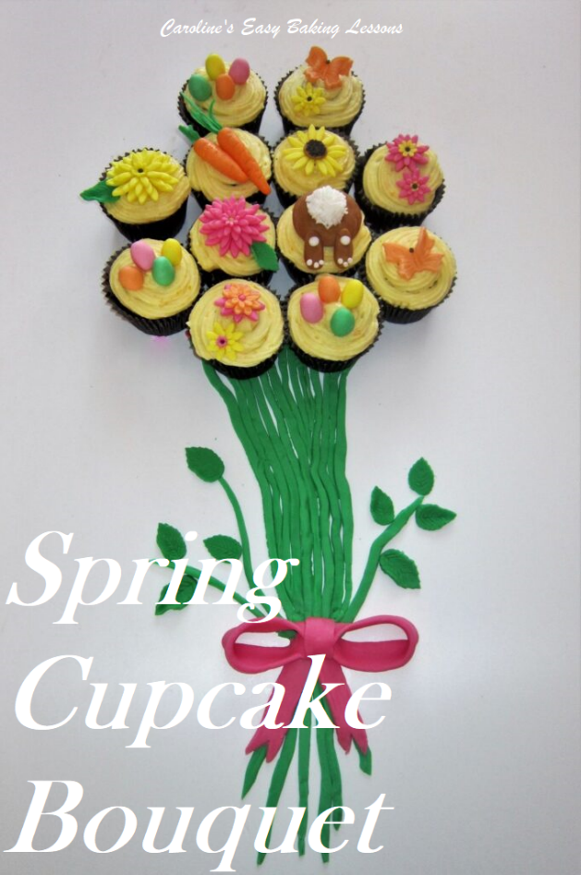
For Facebook Great British Bake Off Fans, group baking competition, you were to bake cupcakes and decorate as you pleased, but with only homemade topping & decorations. So I opted to make my go to Lemon Drizzle & Blueberry cupcakes. For the decoration I had an idea I hadn’t yet managed to get around to doing for Easter of Mother’s day, consisting of the cupcakes formed to look like a bunch of flowers with stems and a bow. I had seen it in a few books, with the stems and ribbon piped in buttercream. But I had an idea on how to make it all from fondant & top the cupcakes off with Easter and Spring themed toppers.
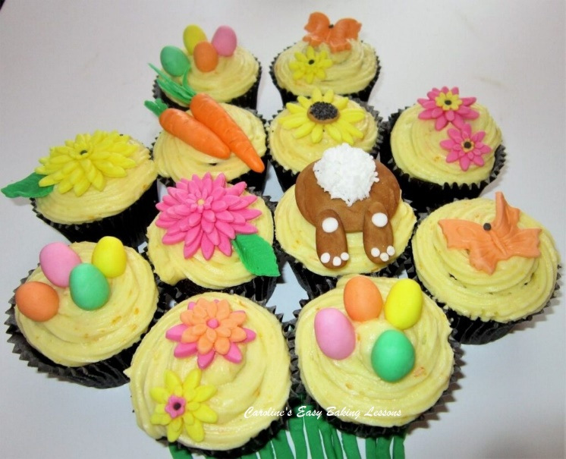
For the fondant work, I made the toppers by hand, after colouring white fondant to the colours & shades I wanted. Below I have a photo tutorial on how I made everything & put together.

EQUIPMENT & MATERIALS
- Coloured or white fondant & food colouring (small amounts for each, but in total no more than 500g/17.5 oz) (I use Sugarflair paste, but gel colouring will work too)

- Colours – red/pink, green, yellow, orange, white & brown
- Poppy seeds or tiny sprinkles • Food glue, clear alcohol or water
- Very small brush • Craft knife or small knife
- Extra large tray, cake board or board for display • Ruler (optional)
- Silicone mat or baking/parchment paper • Rolling pin (preferably fondant one)
- Icing/Powdered sugar or cornflour/corn starch • Cling film/plastic wrap
- Tray or large plate/platter • Small fine sieve
- Cutters – butterfly, various flowers, sunflower • Equipment & ingredients for cupcakes

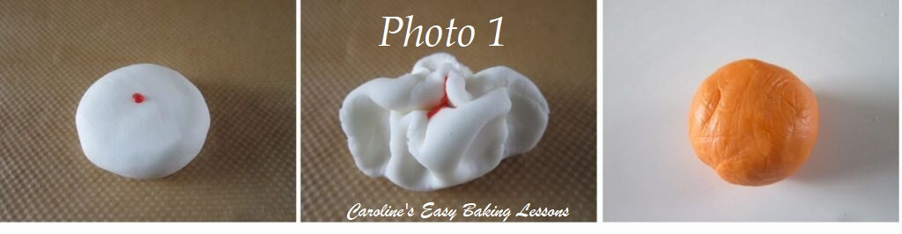

INSTRUCTIONS

How To Colour Fondant
Use coloured fondant or custom colour your own by adding food dye to white fondant. See Photo 1 for how I do this – flattening out the fondant by hand, adding a little colouring, folding over the fondant and then kneading the colour in. Use gloves as the food colouring stains! Add single drops at a time and knead the fondant until all colour is evenly distributed. Leave the fondant about 1 minute, for the colour to fully develop. If you want more colour after that time, simply add another drop and repeat the kneading process until you get the desired colour and shade. Do not cover the fondant at this stage, as the extra liquid added to it makes it more moist. I recommend using gel dye or even better still paste (like Sugarflair), as they add less moisture to the fondant and make it easier to work with. Note in Photo 1 I coloured a strong orange shade and made a little pastel peach colour for the other shapes.

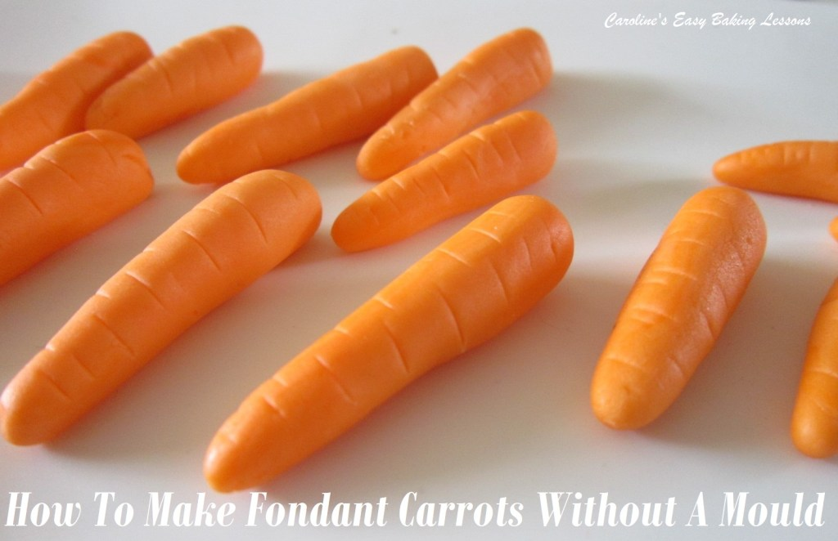

Fondant Carrots
To make the fondant carrots, go to that tutorial instead of me making this one here to long.
Go to Fondant Carrot tutorial

Fondant Eggs
1. To make these Easter eggs that look like mini chocolate eggs, colour the fondant the colours you want – I liked pastel shades for a Spring theme and also to look like Cadbury Mini Eggs.
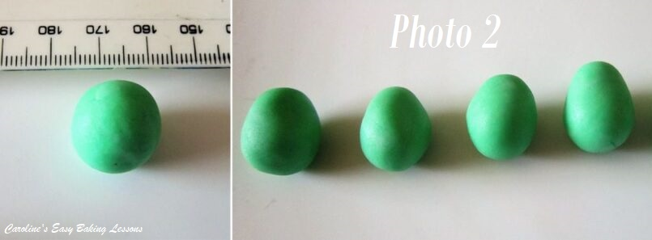
2. Roll a very smooth ball of fondant about 2cm (4/5 inch) wide. Place in the palm of one hand, and use fingers on the opposite hand to gently roll and thin down the one end of the ball that will become the top of the egg. Be careful not to make it too long and keep rounded. See Photo 2.
3. Place the fondant eggs onto baking/parchment paper and let them dry out a bit. If possible, have them standing up to make it easier for positioning them later. Once dry cover with cling film/plastic wrap if not using right away.

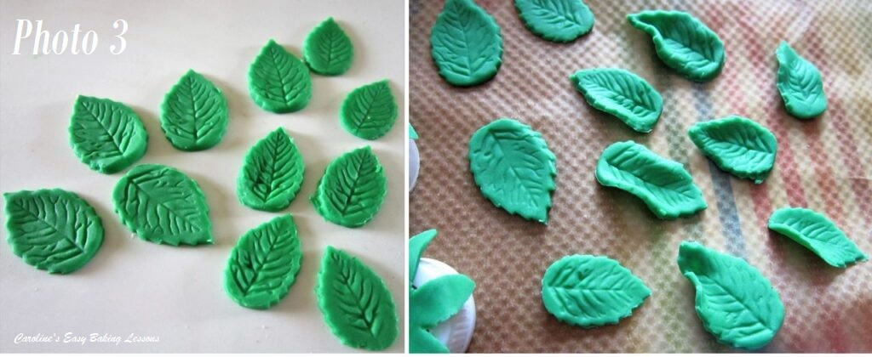
Leaves
1. To make the leaves, colour white fondant a strong green shade and roll out on a silicone mat or paper to the thickness you want. For the bigger leaves (about 1.5″/3.75cm long), roll to about 1/8″ or 3mm thickness. For smaller ones, go thinner. Often beginners roll the fondant too thick and it doesn’t look as realistic. Thinner is always better. Using a leaf cutter, cut out lots of leaves and place on the paper. Please note that to get the leaf details from the press release cutter, I had to keep the fondant in the cutter, turn upside down and use one of my small tools to press down on the fondant so that the cutter would leave an impression. See Photo 3. If there’s no impression marks on your cutter, you can make them using a scribe tool or a wooden toothpick. Be careful of dragging the fondant, and sometimes just press down to get the mark.
2. To make the leaves look more realistic and 3d, with your fingers, gently turn up random parts of the edges, some pairs of edges up and squeezing and making a pointy end of the leaves, just like in Photo 3. You can even place something partly underneath if you want. Leave to dry a little before using or covering like before.

Sunflowers
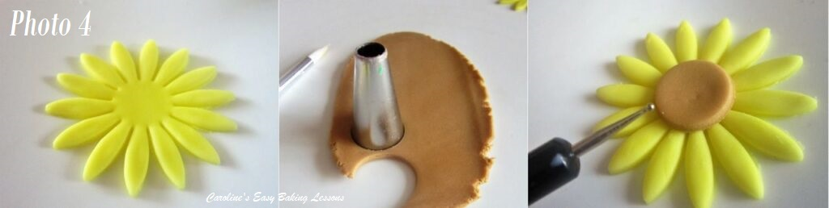
1. To make the sunflowers, colour and then roll out bright yellow fondant. Using a large flower cutter similar to a sunflower, cut out 2 or 3 of the flowers. Then roll out a little brown fondant & using an end of a piping nozzle, or something the correct size, cut out a small circle from the brown fondant. Using food glue, water or clear alcohol, attach this circle onto the centre of the flower. See Photo 4 above.
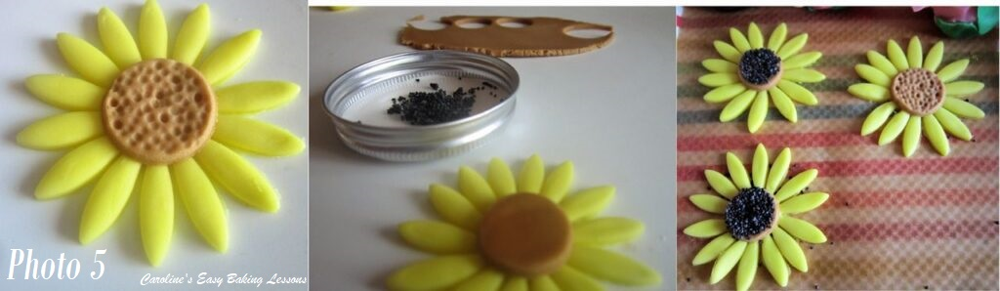
2. For the final stage there are 2 possible methods. You can use a very small ball tool or something similar, to make lots of holes in the centre of the flower like in Photo 5. Alternatively, apply some poppy seeds or very small dark coloured sprinkles. I used poppy seeds in Photo 5, 3rd pic. leave to dry before using or covering.

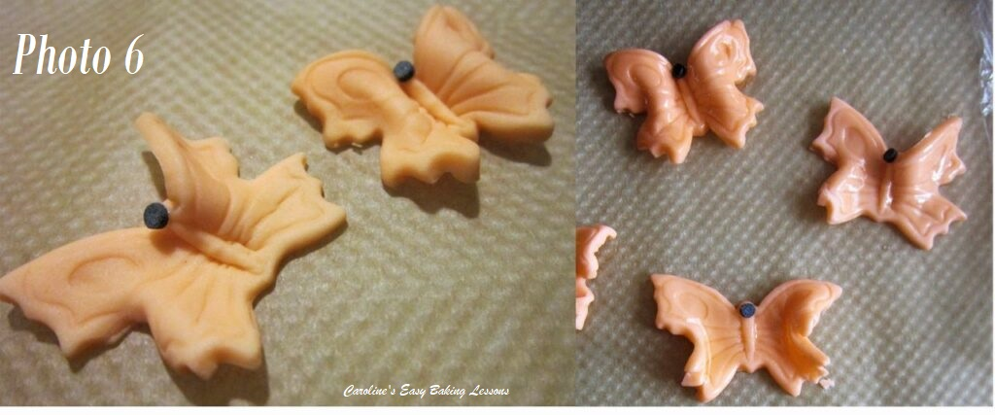

Butterflies
1. To make the butterflies, simply colour your fondant and roll it out. Then cut out the butterfly shapes. Again I had to turn the cutter upside down and press the fondant fully into the cutter to get the impression for the butterfly details. I added a large black coloured sprinkle to make the butterfly ‘head’. There is not enough space to make 2 antenni. See Photo 6 below.
2. I played about with the idea of adding sprinkles to the butterflies to add colour and more details but it was quite messy and to be really nice it would take a long time to add on each individual sprinkle by hand. In the end I opted for making them look shinny and more 3d as if they were moving. I did this by bending the butterflies vary carefully in different areas. You can lift both wings up towards each other, lift just one and bend the other slightly. The aim is to try to make them not look flat. I also painted on some vodka to give them a shine. After doing this, leave them to dry until they are no longer tacky to touch. Store as directed before.
Bunny Tails
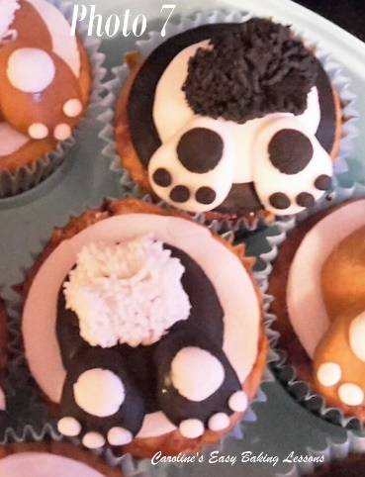
To make the bunny tails, please go to my tutorial on this. See Photo 7.
Go to the Bunny Tails Tutorial
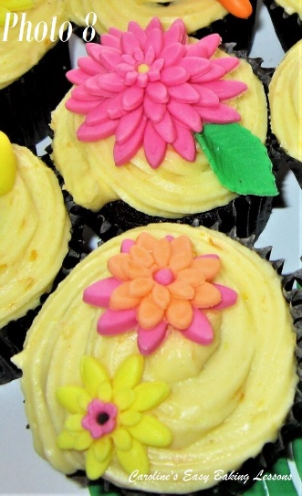

Various Other Flowers
I made various other 3d flowers with different flower cutters I had in different sizes. I would stack smaller ones on top and not have them lined up with the petals underneath, but still positioned in the centre, (see Photo 8 for what I mean). I glued them in position and if you use a ball tool or something similar, push down on top of the flower in the centre and it will make the petals stand up a little as well as make a nice little hole for a tiny sprinkle to add detail. I also lightly brushed with vodka to give a shine. You can use any colours you like and more than one colour in a single flower too.
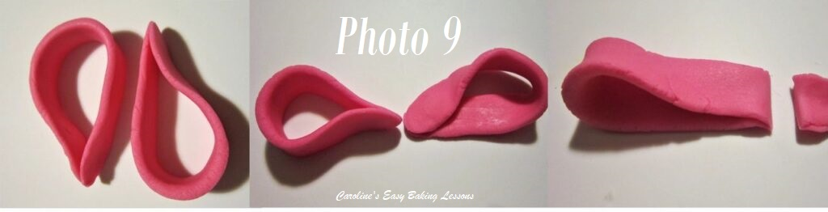

Making The Bow
1. To make the bow, colour your fondant and make two equal sized balls. Then roll into a fat log shape and from this roll out to get a long slim strip about 1 inch (2.5cm) wide and about 6 inches long (15cm). You can choose to cut the strips if you like, but I liked them with rounded rather than sharp edges. Bend them over like in Photo 9 (left pic). Angle and join the bow loops like in the middle photo. Then cut a little off the end of one of them, at the point where you just joined it. (See Photo 9, right pic)
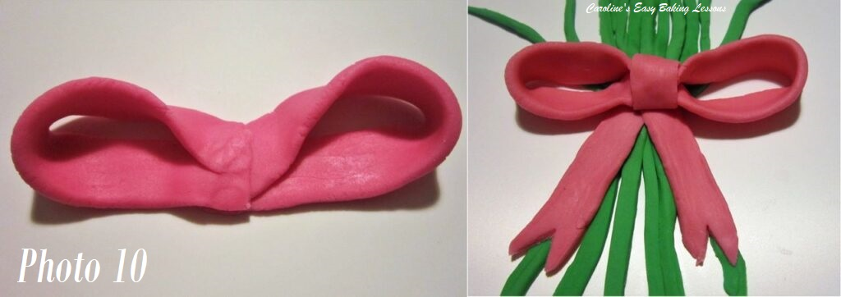
2. Now place the shorter loop (you just cut), onto the longer one. Roll out another strip of the ‘bow ribbon’ and wrap around the middle to hide the joins. (See Photo 10). Then roll out 2 more ribbon pieces and make the ribbon strands. When you are happy with the length, you can cut out small triangles at the bottom. See Photo 10. Note Photo 11 below, where I showed 2 different ways to do the bow loops/ears.

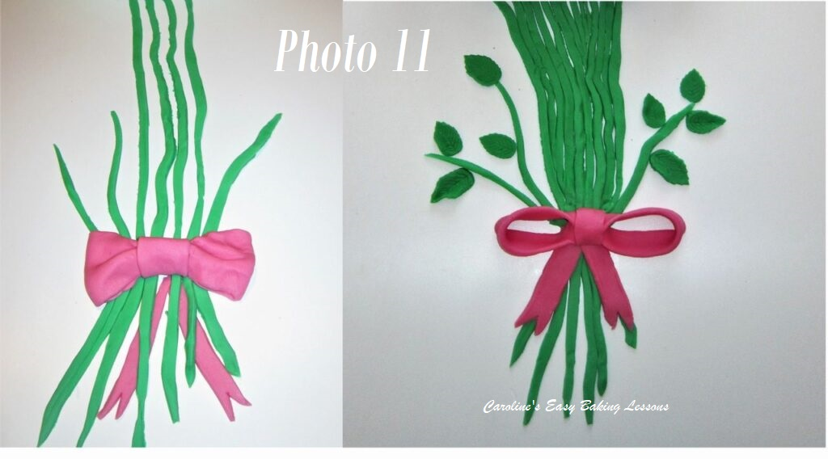

The Flower Stems
To make the stems, roll out a long strip of green fondant (at least 30 cm long (12 inches) and cut into thin strips. Note you can roll this to a thickness similar to real stems. They don’t need to have a straight edge at the bottom or on the sides. I first put some stems down on my board at where they would be and then placed the bow in position to give an idea of how thick the bunch would need to be. I then squeezed the fondant in towards the middle for where the bow would be ‘tied’ in effect. I then made the stems go at an angle and then filled in the gaps with shorter pieces of fondant until filled. I was doing this late at night and I was tired so could have done better. I also added some shorter stems as I decided to use up the leaves here to look more real and give it a bit more shape. I just put them at various points next to the shorter stems. See Photo 11.
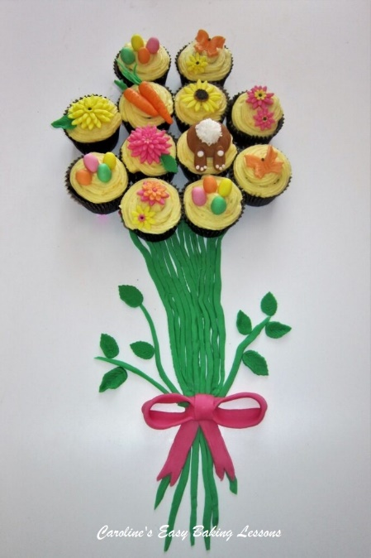
Finally Putting It All Together
Now I placed the cupcakes down in a rough circle arrangement overlapping onto the top of the stems. Then I placed all the fondant toppers on top of the frosting. I took loads of photos and breathed a sigh of relief!

***UPDATE – as I move this onto the new site, some 2 years later, I am embarrassed by the pics, but you work with what you have at the time right? And I use a better camera now and know how to take a better pic. That said, the baking, the taste and the concept I was going for here, are still the same. I hope you can give this a try and if you do, please take pics and let me know via the website or on social media. Caro xx

