CRANBERRY SPICED BRITISH SCONES

Caroline’s Easy Baking Lessons By Caro
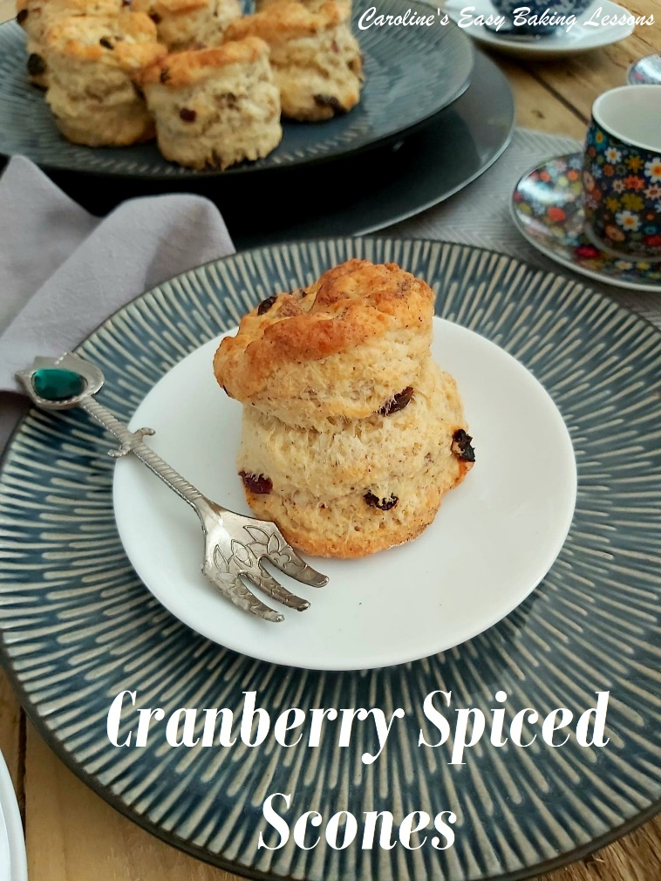
After the success of using my original British Scones recipe in the global bake-along in a Facebook group I help admin (Great British Bake Off Fans), I was asked for a recipe with some flavour additions to the scones. If you read my recipe, you will be aware that adding too much additional weight (be it in the form of dry fruit for example), can be heavy and impede the rise of the scone and the end result being that they don’t look like classic British scones. So I did some more testing and you can use chocolate chips if you want (about 60g/2 oz) but for this recipe I used dried cranberries. In subsequent tests, I also used mixed dried fruit (Cranberry and raisin mix from Aldi that flame raisins in it!) and also added some spices to pump up the flavour profile. So this recipe includes pics of these different flavours. You can also add things like lemon or orange zest and as much as you want without affecting the rise. If you want to add extract, add it when making up your liquid, so that the dough doesn’t get too moist.

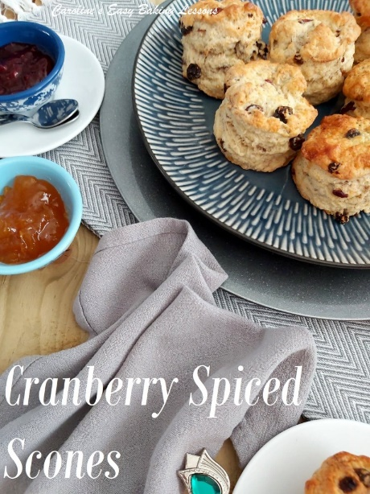
I also developed a savoury version – Cheese Scones. There is Extra Mature Scottish Cheese (like extra sharp cheddar), in the dough and also topping the scone in the final stages of the baking process. Click here to go to that Cheese Scones recipe on the old website – I will update here when it’s live on here. Here’s a sneak peak of the new pics. Hope you like it.

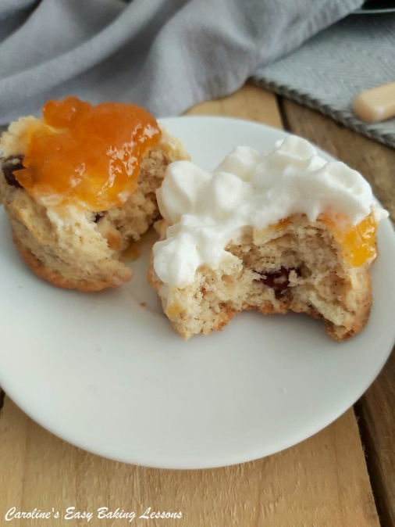

VIDEO TUTORAIL – REAL-TIME
Now I also have a couple on videos on the process of scone making. One about the things not to do, as this is where most problems arise. For more details on that, see this video on scone tips. For an almost real-time video, go to my Classic Scones Tutorial below. (My 2020 one is still on my Youtube Channel, but I made a better quality one this year which you can view below). This shows how little and gentle handling is required. Many people who joined in and used my recipe, have now got the rise to their scones just from watching this video.

A NOTE ON INGREDIENTS
Just a little note on the ingredients. I generally use self-raising flour and you can also use self-rising if you have it. But you can also use Plain or All Purpose flour. These scones were successfully baked in the States in the bake-along with generic all purpose flour. Even gluten free flour works too, (with the addition of Xanthan Gum), and some even used coconut and goats milk because of intolerances. Both worked but give less of a golden finish to the scones because of lower fat and sugar content. The recipe also uses caster sugar. Now it is only a small amount and is purely there to help with the structure of the bake and also preserves the bake a little too. Extra/ultra fine or bakers sugar is a perfect alternative or you could just pulse the sugar from regular granulated sugar. Just note that US granulated is a little finer a granule size than our UK equivalent. See photo below of our sugar in the UK. If you want to learn more about Differences Between UK & US Baking Ingredients – click here. My recipes ALWAYS include tested measurement conversions, but if you are needing help with other recipes, check out my Conversion Of Common Baking Ingredients article. It includes a handy table, easily shared or saved.

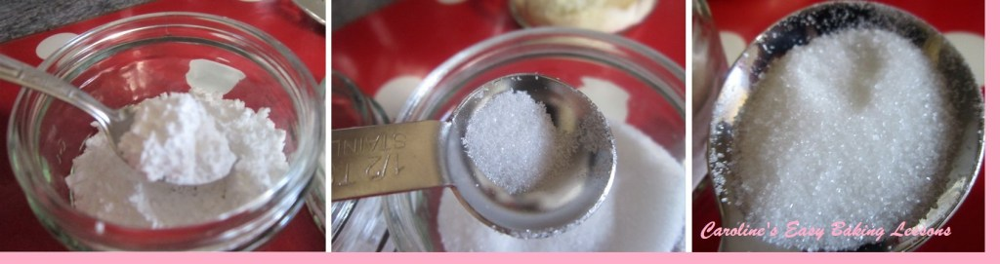
UK Icing (Powdered) Sugar (L), Caster Sugar (M) & UK Granulated (R)

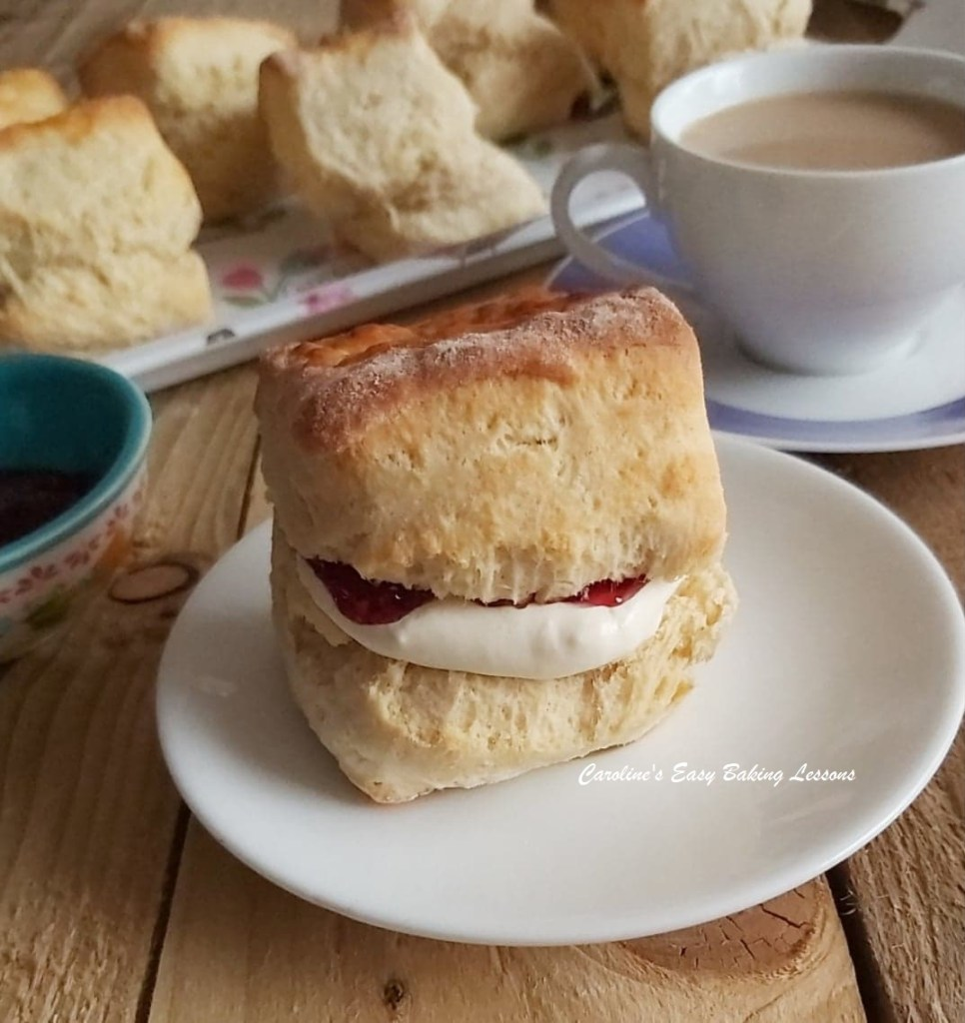
Here are some scones baked by my 15 year old son. Our scones are traditionally made with round cutters, but he made this time with a square cutter and he got a great rise. He made them for me on Mother’s Day. I wanted to show you them, as I was so proud. He has made them for Mother’s Day for the last 3 years.
You can easily save the recipe to your phone or computer, by clicking the ‘download’ button below. Or using the sharing options on screen. Hovering over an image, will also allow you to save to Pinterest, but make sure you are logged into your account on that same internet browser.
Without further ado – let’s get baking!

EQUIPMENT
- Scales or Measuring Cups Baking Tray – 1 Extra Large/2 medium
- Measuring Spoons Baking/Parchment Paper
- Knife Pastry Brush/Artist/Paint brush
- Chopping board Small Bowl
- Small Jug Timer or Phone Timer
- Large Mixing Bowl Cooling Rack
- Pastry Cutter (optional) Large Spoon
- Cookie Cutter (round), or Glass rim (6-7cm or 2 1/3 – 2 3/4″)

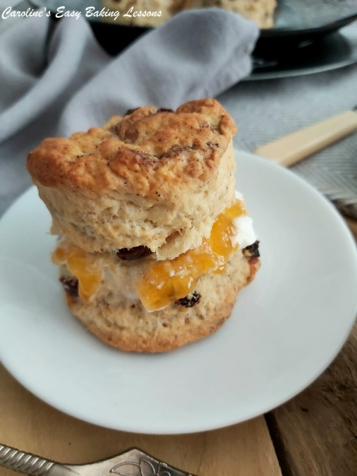
- OVEN: 220c/200c Fan Oven/425f/Gas Mark 6.

INGREDIENTS
- 450g Self-raising Flour (15.75 oz)
- OR (3 & 2/3 cups Self-rising Flour)
- OR (AP/Plain Flour plus 5 + 1/2 (level) tsp Baking powder + scant 1 tsp salt) *See above
- 2 tsp Baking Powder (rounded)
- 1 tsp Mixed Spice (or Pumpkin Spice)
- 3/4 tsp Anise (optional)
- 75g Butter, unsalted, cubed & at room temperature
- (2/3 stick or 1/3 cup, 2.5 oz)
- 50g Castor Sugar (level ¼ cup, 1.75 oz) *See above
- 80g Dried Cranberries, OR Mixed Dried Fruit, chopped (2.8 oz, 2/3 cup before chopping)
- 2 Eggs (med – large)
- 225ml Milk (up to 1 cup, approximately. 7.5 fl oz)

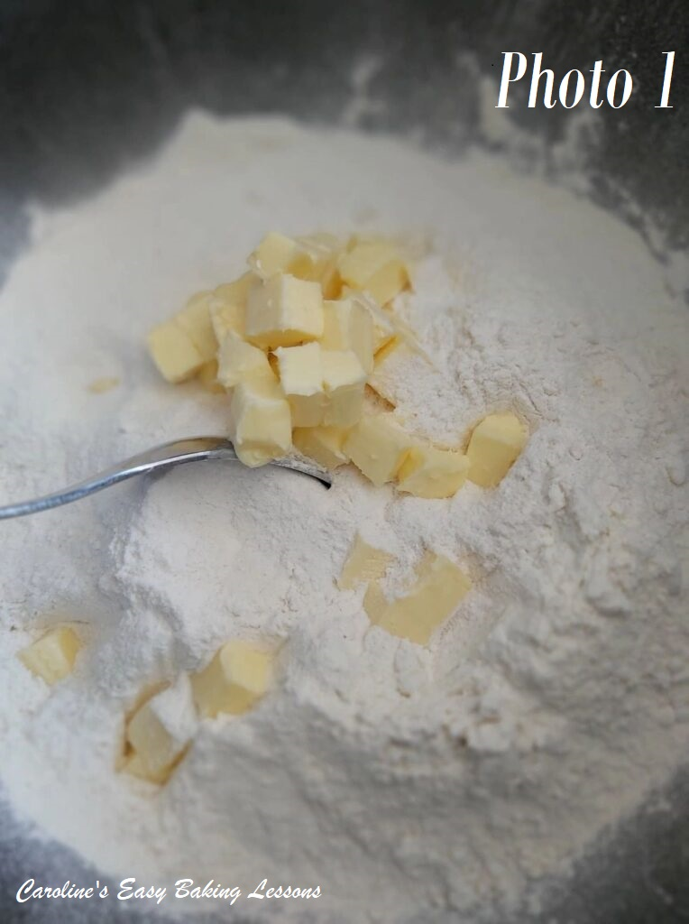

INSTRUCTIONS
1. Weigh out the butter whilst cubing it and leave out to come to room temperature. I like to cut my butter to about 1 1/4cm (1/2″) size as smaller surface area will soften quicker. But if you are short on time, try this hack I reviewed, for softening butter in about 11 minutes. See Photo 1.
2. Place baking/parchment paper on top of the baking sheets/trays. (Hold in position with some baking spray/butter/lining paste if they are flat and have no lips or your bake can fall off – this has happened to me with cookies
3. Weigh or measure in the flour into the bowl, spoon in the baking powder, give it a mix through before you drop in the butter. See Photo 1.

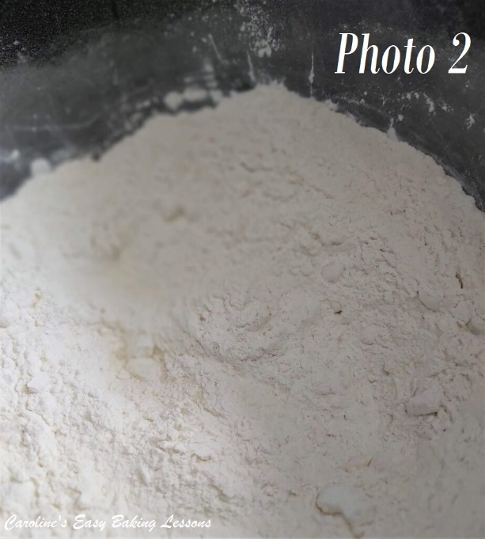
4. Using your fingertips, rub the butter into the flour & continue to do this until the mixture resembles breadcrumbs, (tiny pieces). See the video for how this is done. I use a pastry cutter for this job as my fingers get sore. You push down into the bowl and do a squishing motion whilst turning the cutter left and right. Repeat this until all the butter is now in very tiny pieces coated by the flour. Alternatively, you can use two butter knives and cut through the butter (this is where the term ‘cutting in’ comes from). See Photo 2.
5. Then add/weigh in the sugar & mix till distributed evenly. Then add in the spices if using. See Photo 2 with no spices added.

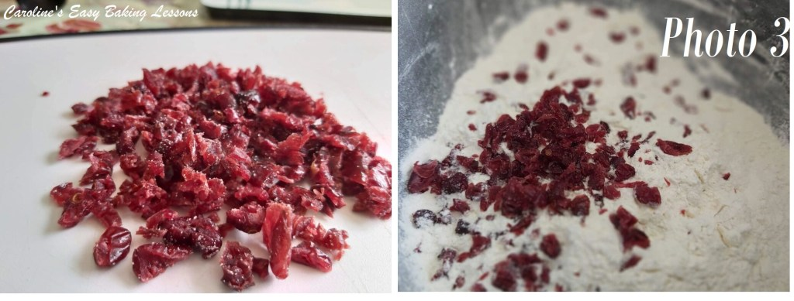
6. Next roughly chop the dried cranberries, or mixed fruit (which ever you are using), like in Photo 3.
7. Add in the chopped cranberries/dry fruit and mix till coated in the dry mixture.
8. Beat the eggs in a jug and then top up to the 300ml (10 fl oz,1 1/4 cup) mark with the milk, (depending on the size of the eggs, you might not need as much milk).
9. Give the liquid a good whisk and then take 2 tbsp of it out and place in a small bowl to use later.

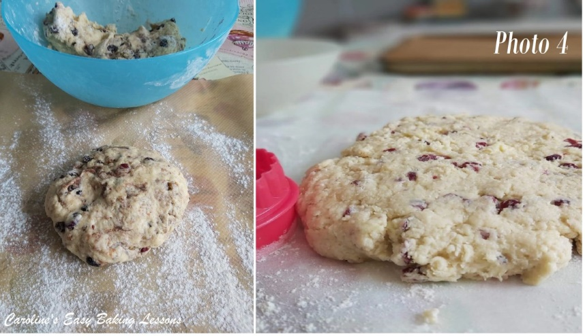
10. Gradually add the egg/milk mixture to the dry ingredients, mixing with a wooden spoon or spatula, until a soft dough is formed. Be aware that the dough being a little bit sticky is good for the scones to rise. But only add enough of the liquid until just sticky. **So you may not need all the liquid. See Photo 4 (spiced dough left, just cranberries on the right). Do this by hand and don’t use a food processor as it can make the scones tough. Same goes for kneading, only bring the dough together until combined and soft. (See video)
11. Next flour a pastry board or worktop/counter or use some baking/parchment paper with a little flour on top.
12. Heat up the oven to: 220c/200c Fan Oven/425f/Gas Mark 6, (or do so sooner if your oven takes longer to come to temperature).
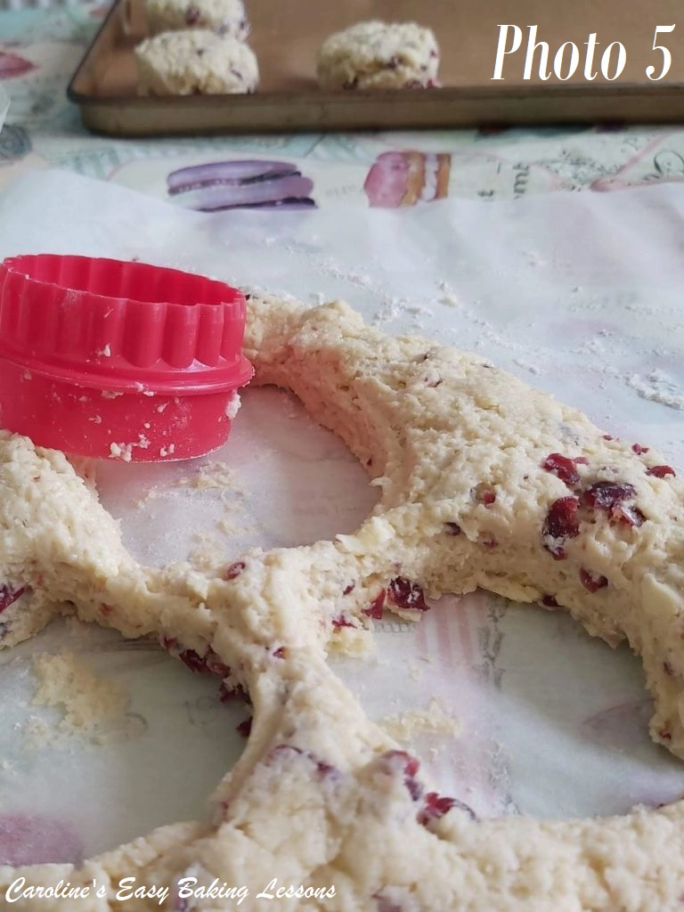
13. Meanwhile put the dough down and flatten gently with your hands until you have a level piece of dough about 1″ (2.5cm) high. Try not to go smaller than this. Don’t be tempted to roll out the dough as this won’t help the scones to rise. (If too sticky, just pat some flour on your hands and on top of the flattened dough. Do not roll back up or knead). See Photos 4 & 5.

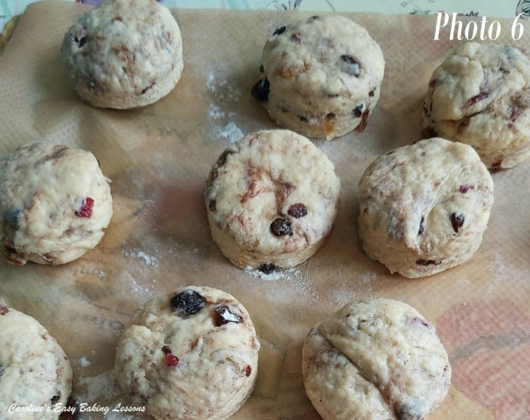
14. Flour the cutter or glass and cut out the scones. Push the cutter down and DO NOT TWIST the cutter. I know it’s tempting, but twisting can ruin the outer structure of the scones – you want that characteristic ‘rise & split’ appearance of a good scone. Use a spatula or knife to very carefully transfer to the prepared baking tray, (or let it fall onto the prepared tray). Try to touch the sides of the scones as little as possible. See Photo 6.

15. Gently roll up the scraps of dough by hand and flatten out to cut out however more scones you can get, remembering only lightly knead and handle as little as possible. (I usually get about 14 scones per batch). See Photo 6 above. (Note that the scones from the rolled up off-cuts, will not look as perfect as the first lot and it’s because of more ‘handling’ of the dough. As an alternative, you can divide the dough in half and then cut out and bring the 2 lots of scrap dough together at the end.
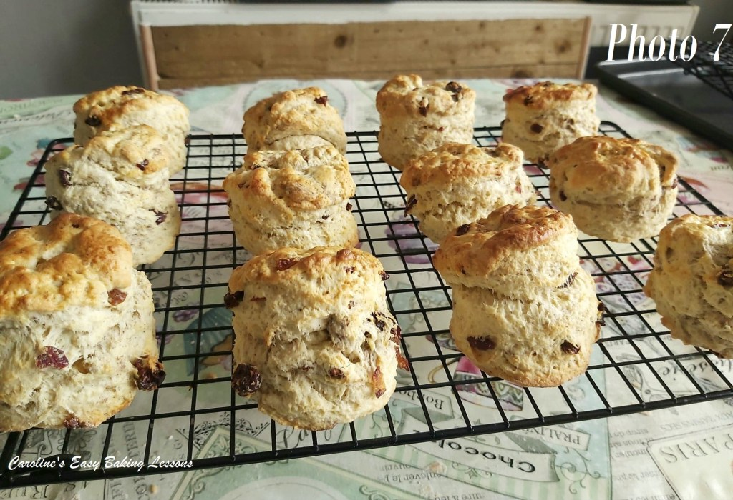
16. Now using a pastry brush, very carefully brush the egg/milk liquid you reserved earlier, onto the tops of the scones only. If the liquid goes down the sides, it can ruin the rise of the scones. So, the best way to avoid it is by shaking/tapping the brush before moving to the scone and then starting to brush from the centre and going outwards, so there is less liquid on the brush to spill down the sides. Watch the video for a visual of how to do this.

17. Bake for 8-14 minutes until well risen and golden in colour. For an even bake and colouring, and depending on your oven, turning and rotating the trays can help. You can also bake just one tray at a time if you want. At the 8 minute mark, check if they are done. They should be golden on top and bottom. Keep an eye on it as it can turn quickly. Mine were ready after a total of 10 minutes in my old oven but nearer to 14 in my new one! Leave on the baking tray 5 minutes. See Photo 7.
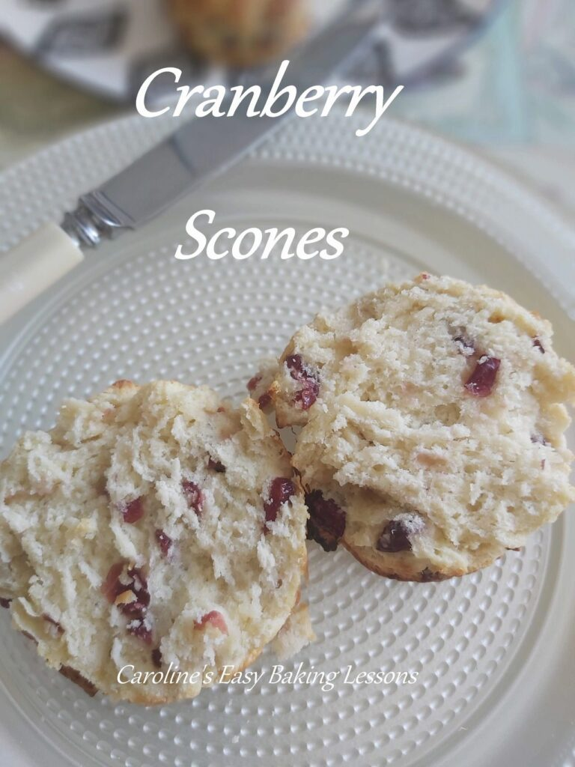
18. Cool a little on a cooling rack and enjoy warm with whatever fillings you enjoy. **You can freeze these scones and once defrosted, heat a little in a warm oven. Alternatively, slice in half and heat in the microwave for about 20 seconds. Home-made lemon curd goes great with this – go to my recipe. See photo below.

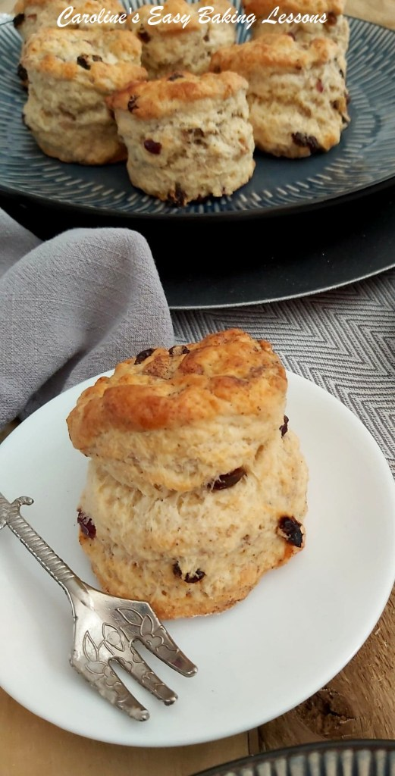

DIFFICULTY LEVEL: Easy, With Guidance

Thanks for reading
Happy Baking & Making
Happy Tummies & Memories!

Caro xx

