90 MINUTE WHOLEMEAL CHEESE PIZZA – A Quicker Way To Make A Proper Yeast Pizza
Caroline’s Easy Baking Lessons

Make Using Wholemeal or White Flour
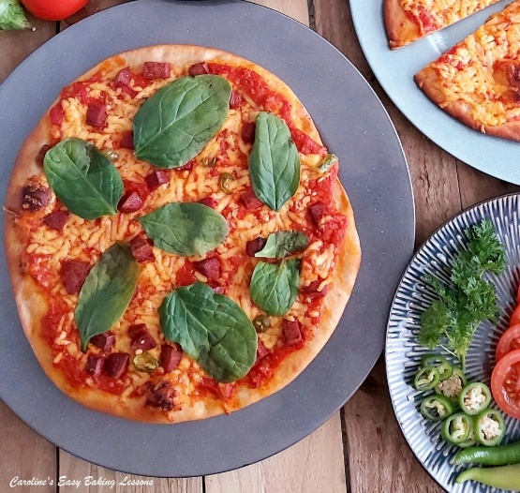
Following on from my Quicker Yeast Making Technique, that included 2 Hour Tear-And-Share Dinner Rolls, I now have developed a recipe for pizza that can be prepared, baked and out of the oven in under 90 minutes. I managed the thin crust pizza in 1 hour 17 minutes and 1 hour 20 minutes for the deep crust version. This all thanks to a quicker recipe method, that involves a little more time spent on initially preparing the dough, but has a significantly shorter rising time (also known as proving). This recipe only rests for 15 minutes, compared to my old standard yeast method of anything from 1 – 1.5 hours. So this dough, (which is still yeast based), is a game changer, especially for bakes that normally require 2 rising times and can take between 3 – 4 hours to make. Regular pizza recipes take about 2.5 hours to make so this is much quicker. But don’t think for one minute that there is any sacrifice on taste or look of the final bake. If anything it is even more yummy. I love the soft and almost bouncy texture this dough produces as a deep crust, but I recently tried the thin crust and loved that too. So I have the recipe below for making thin and deep crust, approximately 25cm/10 inches wide.A NOTE ON INGREDIENTS
So no special ingredients are required for the dough, just the inclusion of egg whites. I made these pizzas with a combination of whole-wheat/wholemeal and plain (AP) white flour, and so are a little healthier but just as good. If you want to make with all white flour, please reduce the water content to 360ml (1.5 cups, 12 fl oz). This is because whole-wheat flour absorbs more fluid than regular white flour. But why change the flour, when it works? Nobody could tell from eating it that it wasn’t all made form white flour. The only visible difference is the slight colouring of the dough.
I always use Scottish extra mature cheese for my pizzas (and any baking with cheese actually, as it’s full of flavour ), that’s the equivalent of extra sharp cheddar in the states.
*** I sometimes use Turkish white cheese (Peynir) and because white cheeses have a tendency to burn quite quickly (including grated mozzarella), I tend to add them part way through baking. I also add some Turkish Turkey meat slices, kind of like salami. You can use whatever you want, just don’t use things that burn easily or take too long to cook.

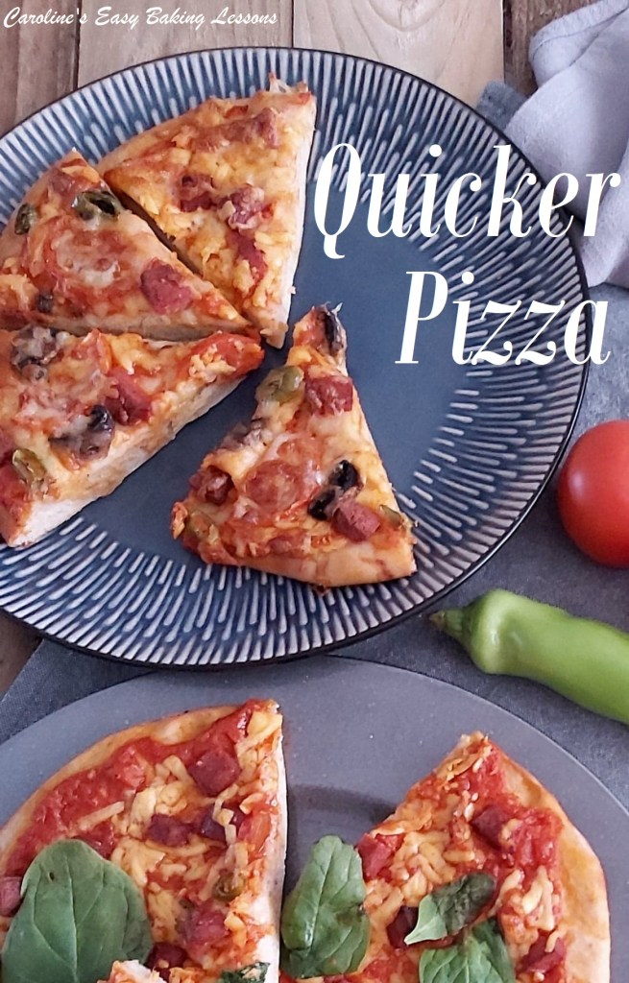

Now note the flour is separated into 3 amounts, as they need added in a specific way, and are referred to as [F1], [F2] & [F3]. This method works really well, and once you have done a few times, you really don’t need to refer to the recipe. And it’s the same process for the making the dough, in all the Quicker Yeast recipes of mine. So stick with the recipe and you will achieve the same result.

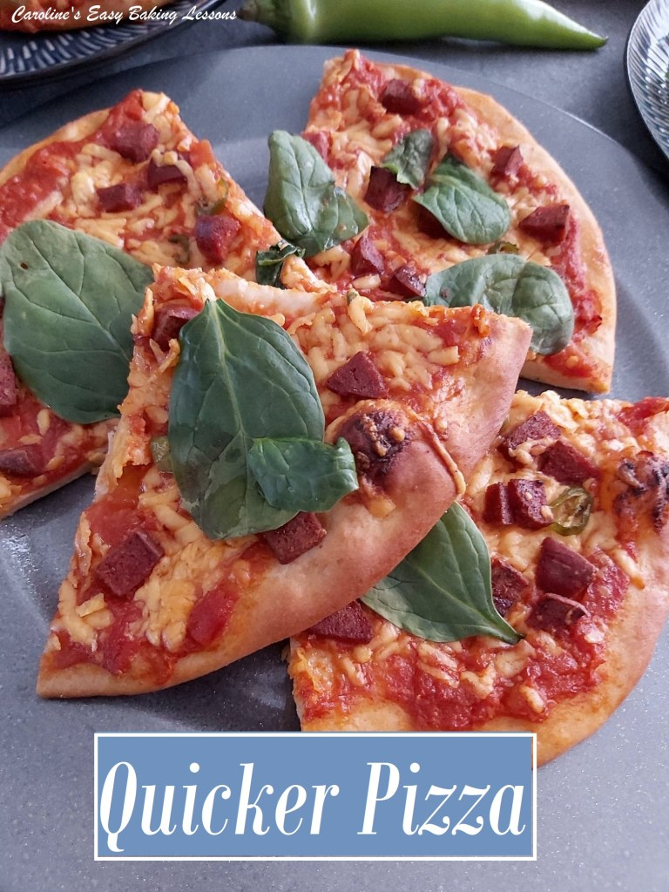

I am not going to keep you much longer from the recipe, but just have a look at the video below, that was used for a Facebook group bake-along, where my 2 hour tear-and-share dinner rolls recipe was used, to introduce beginners to bread making. It’s an almost real-time tutorial just so you can see even better how this process works. Watch it one time, and then you will have the hang of it.

EQUIPMENT
- Scales or measuring cups • Measuring spoons
- Stand Mixer & bowl [Flour 1] • 1 large bowl [Flour 2]
- 1 medium sized bowl [Flour 3] • Spoon
- Microwave bowl or jug • Small measuring jug
- Sugar/Food thermometer (optional) • 2 small bowls to separate eggs
- Spatula • Timer or phone timer
- Oil or spray oil • Towel
- 2-4 Pizza/round baking trays • Baking/parchment paper or silicone mats
- Pastry board or area of worktop/counter • Rolling pin and some flour

For Making The Sauce:
- Medium sized pan • Wooden spoon
- Vegetable Knife • Fine grater/microplane (for garlic)

Oven: 190c/170c Fan Oven/350f/Gas Mark 4.

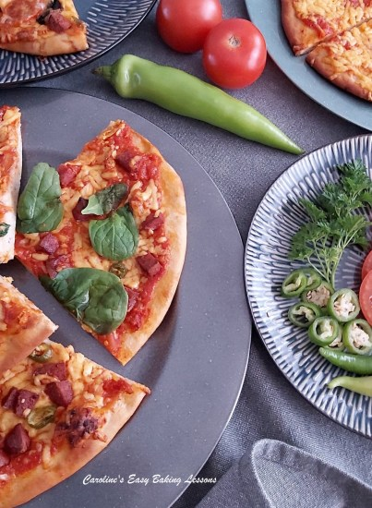
INGREDIENTS
- 250g Whole-wheat Plain Flour
- (2 cup, 8 3/4 oz whole-wheat/meal AP) – [F1]
- 2 tsp Salt
- 2 tbsp Sugar
- 2 tsp Onion Powder (optional, or Italian spices)
- 14g Instant/Fast Acting Yeast (4.5 tsp/ 2 packs)
- 400ml Water (5 fl oz, 1 2/3c cup)
- 4 tsp Olive Oil (or EVOO)
- 2 Egg Whites
- 125g Plain White Flour (1 cup, 4 1/3 oz, AP) – [F2]
- 190g – 250g Plain White Flour
- (1 1/2 – 2 cup, 6 3/4 – 8 3/4 oz, White AP) – [F3]
- ** Be sure to keep all 3 flour amounts separate.
For the tomato sauce:
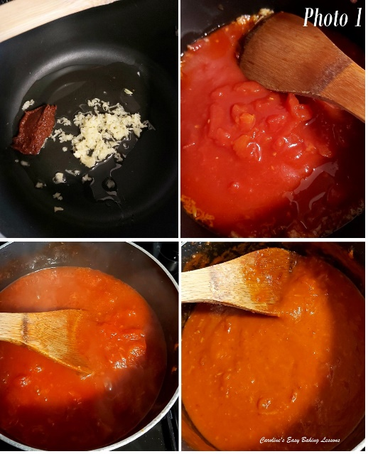
• 200g Tin of Chopped Tomatoes (1 rounded cup, 7.5 oz) • 4 cloves of Garlic, grated • 2 tsp Tomato Paste/puree Some boiled water • Salt, Pepper, Garlic powder, onion powder and any herb you like. • Cheeses and meat of your choice, about 300g cheese (3 cups)

INSTRUCTIONS
For The Tomato Sauce
1.You can make the sauce ahead of time, or make during the process of making the dough. See instruction 4 below. Grate the garlic, and fry lightly with a little tomato paste for 10 -15 seconds, before adding in the tin of tomatoes and some boiled water. Bring to a boil for a few minutes before reducing the heat to medium-low heat to simmer for 15 minutes. Add salt, sugar, pepper, garlic powder, onion powder and any other seasoning you like. You can process/blitz the sauce if you like a smooth sauce. See Photo 1.
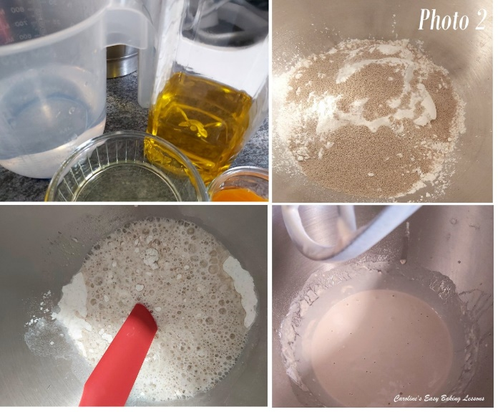

PREPARING THE DOUGH
2.Have the 3 amounts of flours weighted or measured out in separate bowls – you can use the stand mixer bowl for the first whole-wheat flour, [F1]. Place the oil and water into a microwave safe bowl or jug and heat for 30 – 45 seconds until just a little warm (120-130f, 49-54c). Alternatively used some hot water and cold water and check the temperature once mixed. It should be just above tepid.
3.Mix the salt into the first whole-wheat flour, [flour 1] and give it a good mix through. This is because yeast should never some into direct contact with salt or it will reduce the power of the yeast. This way the salt is coated in flour.
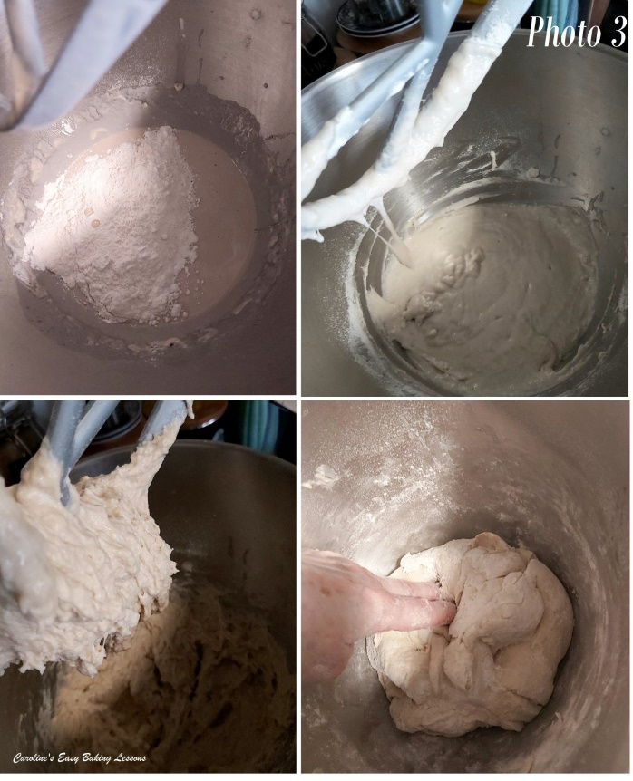
4.Add in the yeast, sugar and onion powder (if using) and mix through, one at a time. Once the water and oil is warmed, add this as well as the egg whites to this dry mixture. Using the paddle (or ‘k’ hook) on the mixer, mix for 2 minutes. Be sure to time this. Then leave to rest for 2 minutes, while the whole-wheat flour gets a chance to absorb the liquid. See Photo 2.
5.While the dough is mixing and resting, start to prepare the tomato sauce for the pizza, (if you didn’t do already). See Photo 1.
6.Now add in the smaller bowl of white flour [flour 2, F2], and mix for 2 minutes with a timer. (Photo 3, top pics). The mixing in this recipe is very important so be sure to time it. Continue on with making the sauce.
7.Slowly add in the flour from [flour 3, F3]. You might not need it all, but you want a dough that starts to come together as a very rough ball around the paddle. So mix for 10 seconds after each addition of flour and wait to see the ‘ball’ of dough. Note that the dough will be a bit sticky. See Photo 3.
8.Now put the dough hook onto the stand mixer (use a scraper to get the dough off the paddle), and knead on medium speed for 4 minutes. During this time finish off the sauce and grate/shred and prepare you cheese(s) and toppings. Leave the sauce in the pan till ready to use.
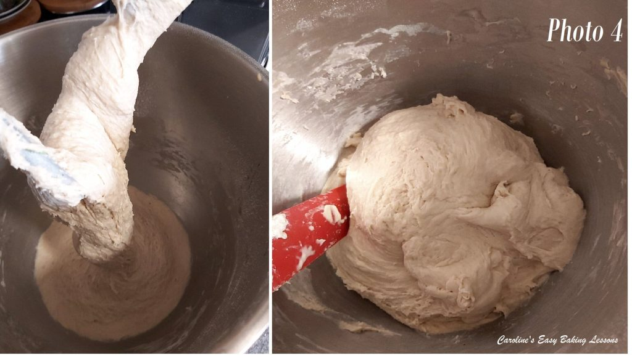
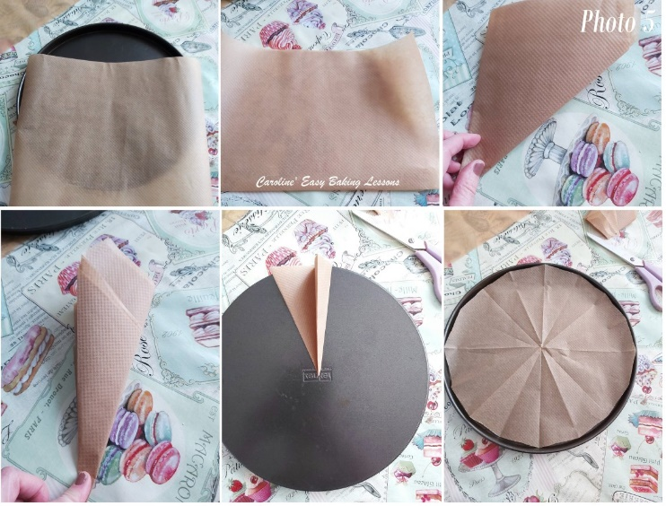
9. Using a rubber or silicone slim spatula, scrape the dough off the bowl from down the sides. Then tilt the bowl and put on it’s side, so you can see the bottom. Continue scraping the dough out towards the top of the bowl. Now wash and then put oil (or spray oil) onto your dominant hand and ease the dough out and turn it over so that the bottom of the dough is now at the top end of the bowl. Alternatively, just flick the dough over with a silicone spatula. Place the bowl back on the mixer and continue kneading for another 4 minutes. The dough does tend to stick at the bottom when kneading, and this is another reason why we turned it during kneading. Once the total kneading time is up, the dough will be forming a ball and cleaning the sides of the bowl. Have a feel of the dough to know how well kneaded dough feels. Note also how stretchy it is when you lifted the dough hook up. Scrape any dough from the hook and into the bowl. Now place a towel on top of the bowl and leave somewhere warm and draft free for 15 minutes. (Note that dough with whole-wheat/meal flour will not feel quite as soft as white flour). See Photo 4.

10.Take this time to prepare the baking trays with baking/parchment paper, or even silicone mats. To cut to the shape and size of a round tray, see the Photo 5.
11.Now heat up the oven to: 190c/170c Fan Oven/350f/Gas Mark 4.

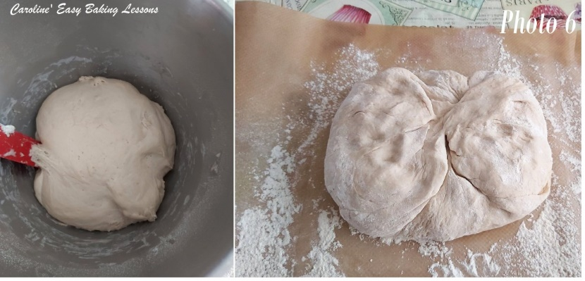
12. Well flour some baking/parchment paper or worktop/counter and your rolling pin. Release the dough from the bowl like before, (without oiled hands this time) and tipping, scrapping out onto the worktop. Turn the dough over and let it get a bit more flour on it. Knead the flour into the dough for a few seconds, adding small amounts of flour if needed for it to be manageable. (See photo 6). Now divide up the dough according to what you want to make.
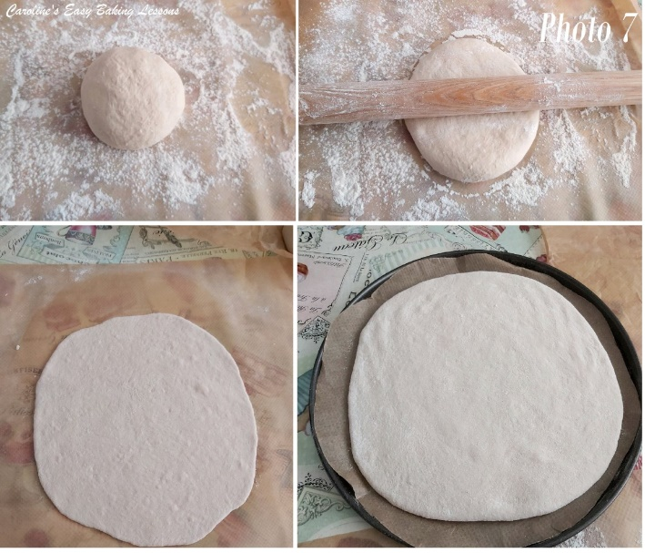
*For 3 thin & 1 thick – divide dough into 5 pieces, and add 2 pieces together to make the dough for the deep pizza.

ALTERNATIVE THICKNESS/COMBINATIONS
- For 5 thin pizzas, divide by 5.
- For 4 thin & 1 mini deep pizza, divide dough into 5.
- For 2 deep & 1 thin, divide into 5 pieces and join 2 pieces of dough two times for 2 deep pizza and the remaining one will make a thin crust.
- For 3 regular crust pizzas, divide by 3.
- I like to place on top of a chopping board when cutting the dough. Alternatively you can weigh the dough and work it out that way.

13. Roll the piece of dough into a nice tight and smooth ball using your hands, and then roll out with a floured rolling pin, into a circle approximately 25cm (10 inches) wide, but thickness of £1 coin for thin crust (3mm, 1/8 inch) and £1 + 2p (5mm, 1/5 inch) for a deep crust. Keep turning the dough when rolling it out to get as near to a round shape as you can. Sometimes you can turn the dough over too. Just don’t add anymore flour, other than to the rolling pin. Adding too much flour, especially after kneading and rising, produces a very dense and tough bake. If using a pizza dish, roll out to that width. Then simply transfer to your prepared baking sheets/trays. From there, use your fingers to stretch the dough out a little more. See Photo 7.
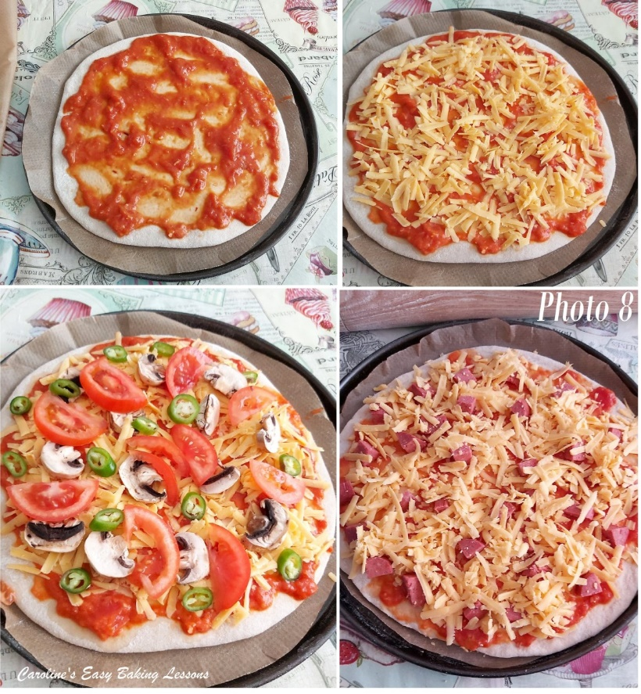
14. Repeat for the other pizza bases, and then add the tomato sauce on top, as equally as you can, trying to cover near to the edges of the pizza base. Then add the cheese(s), all the way out to the edges. If using any white cheese or mozzarella, I tend to add half way through cooking as it can burn a little.
15. Bake for approximately 15-18 minutes for the thin crust and about 20 minutes for the deep crust. Be sure to turn the trays during baking to ensure an even bake. If you want to make 3 thin crust from this dough, but only have 2 trays/sheets, only prepare 2 and place the other piece of the dough into the fridge to slow the rising, whilst you bake the first 2. If you have a pizza stone, be sure to add to the oven when heating up the oven and check the temperature with a thermometer. Baking directly on a pizza stone, the pizza’s will be a little quicker to cook and give a crispier crust.

16. Remove from the oven and leave to cool a little before cutting with a pizza cutter or sharp serrated knife. I find cutting down the way at first, reduces the amount of cheese that tears when cutting.
17. Store left-overs in tin foil/aluminium wrap in the fridge for a few days and re-heat later.

DIFFICULTY LEVEL: beginner, easy with guidance

Thanks for reading
Happy Baking & Making
Happy Tummies & Memories!

Caro

