OMA MESSER’S BUTTERMILK BISCUITS – Passing Down Recipes Through The Generations
Caroline’s Easy Baking Lessons

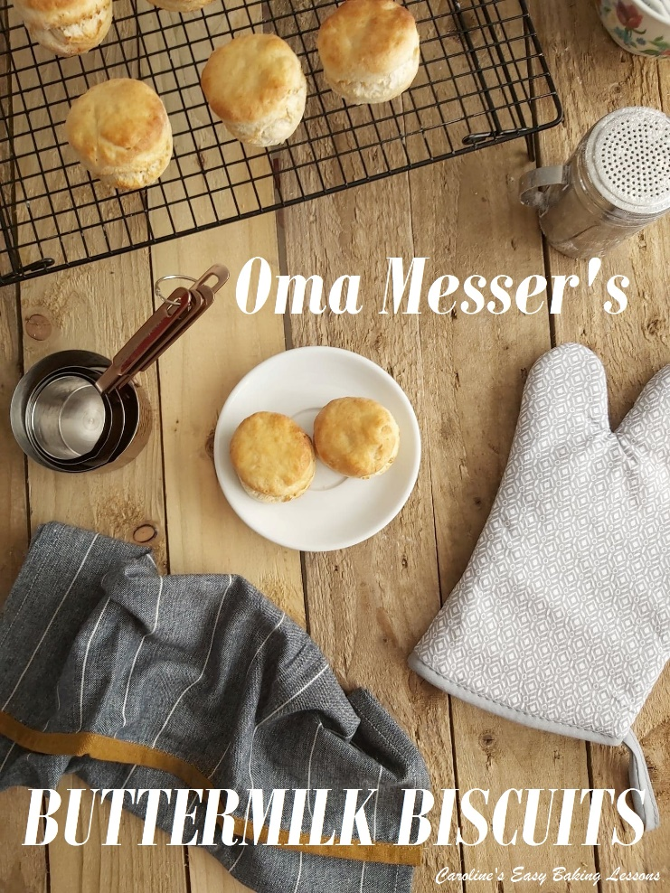
On my old website, I featured 2 old recipes that were kindly shared with me. The last was carried down the generations of my friend’s family, for nearly 100 years and I ran a ‘Bake-together’ last Christmas, as a way of keeping that traditional British Christmas Cake recipe going for many more years to come. And since it’s Buttermilk Biscuit Day on 13th May (American biscuits, not to be confused with our UK cookie-biscuits), I thought it fitting to post a recipe for those on the site. I like the site to have recipes from different countries and cultures, but make sure they are traditional and authentic. So for that task, the internet is not always your friend. Old recipe books and better still, very old family recipes are a much better bet. So via my baking friends who live in the states and Canada, I decided upon approaching Angelgale. She is one of the lovely admins of The Pioneer Woman Facebook group that I have belonged to since I first started the website. Through that group, I have made dozens of friends, who I genuinely would love to go visit if we are ever allowed international travel again (!!)

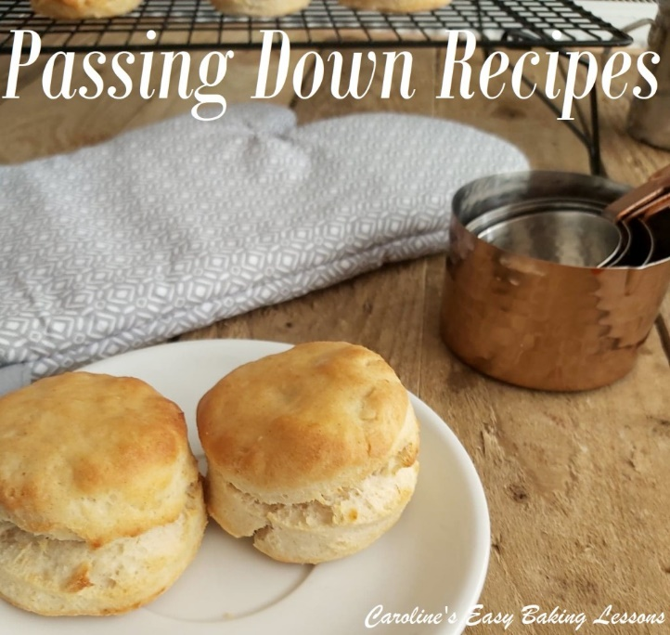
Anyway, Angelgale is also a great cook and baker, and often shares her family’s recipes in group, so she was an obvious choice to ask for a good recipe. Thankfully she too encouraged the idea of sharing old recipes, and shared with me not only the recipe, but tips and some information on the history of the recipe. This is what she shared with me:
“This recipe goes back to my Urgroßmutter (great grandmother) who was a Master Baker by trade. My Oma Messer (grandmother) was also a Master Baker & she grew up helping my Urgroßmutter bake for the village of Eschen. (Liechtenstein, southwest of Central Europe). My Opa (grandfather) deflected from Hitler and came to America. My grandparents then settled in the German town of Schulenburg, Texas. My Oma (grandmother) passed this down to my mom and my mom to myself & through our family.”

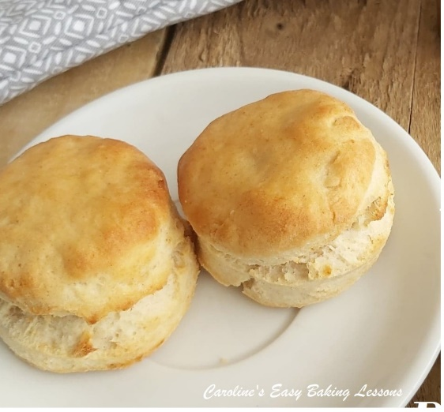
For us in the UK American/Canadian biscuits, look kind of like our Scones. (Not to get in a debate, but the proportion of the ingredients, for most of these recipes, differs considerably, leading to a different texture of the bake.) That aside, different countries and different areas within those countries, coupled with recipes often being shared by word of mouth, variations occur, and recipes evolve. Prime example being this Oma Messer recipe, that has it’s origins in Central Europe.

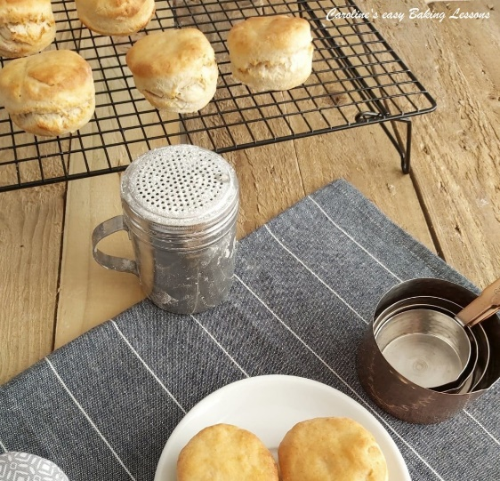
Now for us in the UK, scones are usually eaten with something sweet, such as cream and jam, as a treat (although there are cheese savoury types too). US biscuits however, are known for being paired with ‘gravy’. Not the Bisto type gravy we have, but more a combination of sausage meat and a creamy meaty gravy. And this is where biscuits differ from our scones. The biscuits have a slightly firmer texture, and so pair well with sauces, more so than say bread, which wouldn’t hold it’s shape well for example. I am reliably informed too that biscuits can be used as a mini sandwich vessel for breakfast foods, such as egg and meat. Like UK scones, these biscuits don’t contain sugar, so go well too with the likes of jams and jelly’s. Angelgale’s family often enjoy them with homemade jam, which is no doubt something that has been occurring in her family, for generations too.
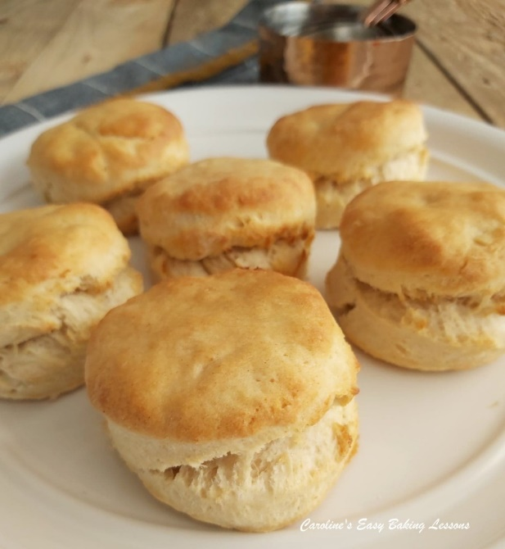

But enough about the background of this bake, how did I get on making them? Well, like our scones, I was careful to not twist the cutter, and chose to just spread the dough out gently with my hands, as it doesn’t make a big batch (so ideal for smaller households). You could of course easily double the recipe and even freeze them if needed. They were very straight forward to make, and I used my pastry blender just as Angelgale had advised, but I didn’t need quite all the buttermilk. And that’s just because different flour, different ways and places it’s milled, determines a different amount of liquid that it will absorb. It makes for a nice soft dough, that is easy to cut out and unlike our scones, you don’t put an egg-wash on top of them before baking, but rather melted butter once out of the oven. A little note too on the flour. Angelgale advised that she believed the key was the White Lily Self-rising flour. Now I can’t get that brand in the UK, but did a little research and found that that particular flour is a softer flour and has a slightly lower protein content than plain/All Purpose flour. This will help achieve a more tender crumb, so to take that into account, and because UK self-raising has a touch more baking powder in it than US self-rising, I used a little less of my flour and substituted a couple of table spoons of cornflour/starch. This was to reduce the protein content and raising agent slightly.
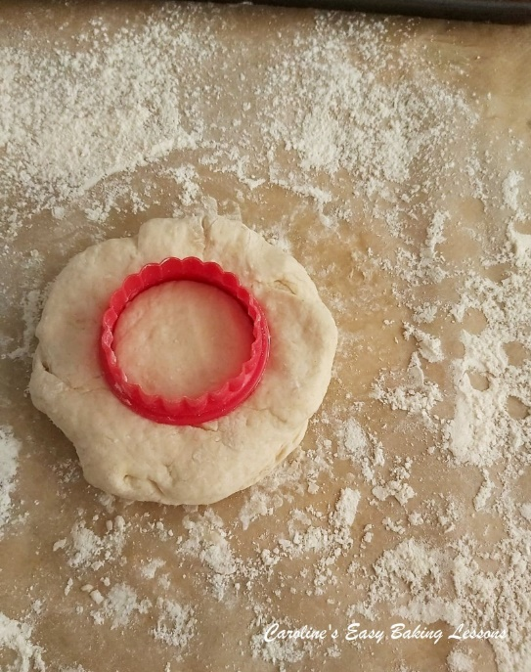
I am pleased to say, they baked off nicely (I hope so anyway), with what I would consider a good golden colour and rise. I do remember being told that biscuits can be quite pale in comparison to our scones, but I had a photo of Angelgale’s biscuits to go by, and I have always
Said, colour means flavour! Just like scones, the ones cut out from the
scraps, don’t produce as nice or pretty a shape, but they don’t taste any different, so a win.
We tried them with jam, and also we had some for dipping along side our meal. It was a Turkish meal I learned to make because my husband is from Turkey. And they are a country of bread lovers, and have with every meal. So once we get back over there, I will be sharing this quick bread recipe with them, as I am sure they will love it and the ease of making these. So thank you Angelgale, and to your mother, grandmother and great grandmother, for passing along this recipe, which I will share on the website, and wherever I go. Let’s keep this recipe going!!

THE RECIPE

Makes 7 – 8 Biscuits

Equipment
- Measuring cups or scales • Measuring spoon (optional)
- Pastry blender/Cutter or 2 Butter Knives • Measuring jug (optional)
- Medium mixing bowl • Spoon or spatula
- Fork Flour for dusting • Cookie cutter (about 2″ /5cm diameter)
- Baking/Parchment paper • Timer
- Cooling rack • Pastry brush

Ingredients
- 2 cups White Lily Self-Rising Flour (250g, 8.75oz)
- (I used 235g Self-Raising flour + 2 tbsp (15g) Cornflour)
- ¼ cup Crisco (51g, 1.75 oz)
- (I used 51g Vegetable Shortening -Trex brand)
- ¾ cup Buttermilk (180ml, 6 fl oz)
- (If no buttermilk, add 2 1/4 tsp vinegar or lemon juice to milk & leave 10 minutes).
- For topping –
- 2 tablespoons butter, melted (30g, 1 oz)

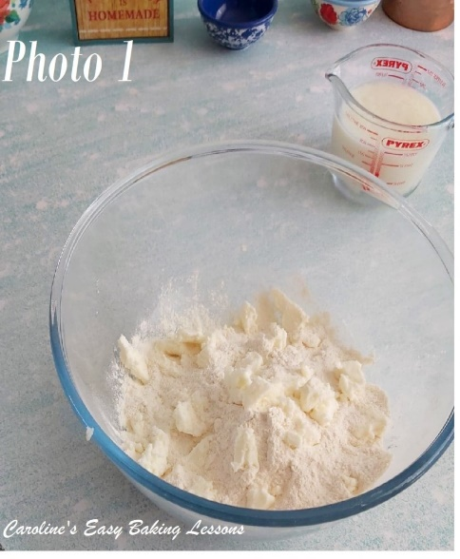
Instructions
1.Begin by heating your oven to 475°f/245c/225c Fan Oven/ Gas Mark 9.
2.Prepare a baking tray/sheet with some baking/parchment paper.
3.Next measure out your flour but be sure to read the notes carefully in the ingredients.
4.Then add in the vegetable shortening (Crisco/Trex). I roughly cut mine into small pieces just to make the process easier.

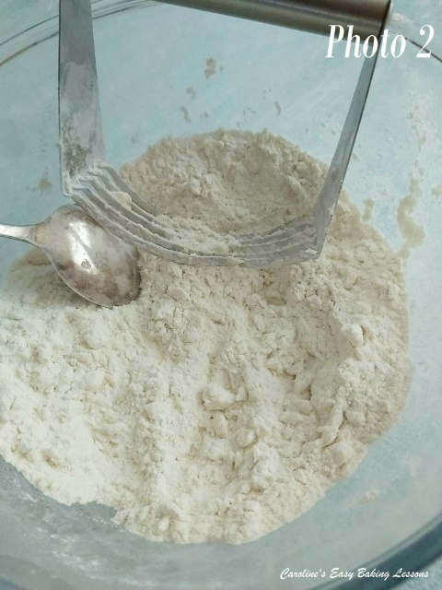
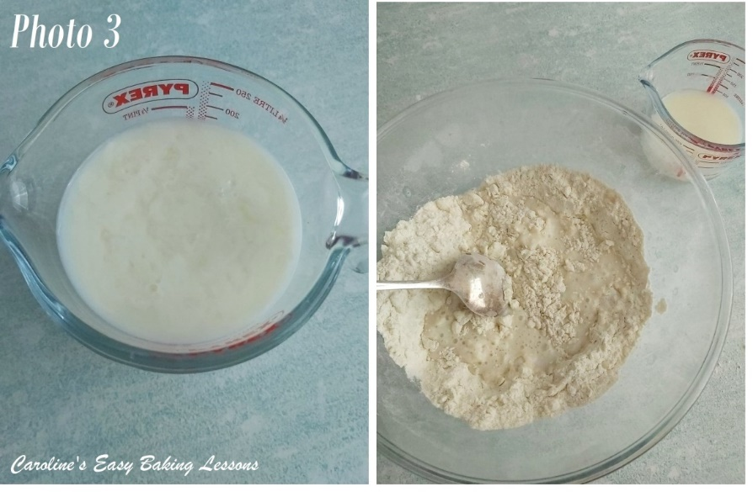
5. Give the shortening a quick mix through just to coat it in flour, before using a pastry blender/cutter to breakdown the mixture to a consistency resembling breadcrumbs (or peas size pieces). If you haven’t used a pastry blender before, just push down on the mixture, scraping the bottom of the bowl, and perform a rotating left and right motion. Repeat this all over the mixture, clearing out any mixture that inevitably get’s stuck in the blender. Alternatively, use 2 butter knives for this ‘cutting-in’ technique.

6. Once in small pieces, gradually add in the buttermilk. (If you don’t have buttermilk, add 2 1/4 tsp vinegar or lemon juice to the milk and leave for at least 10 minutes. It will look like off milk, but it will be fine I promise. It’s not actual buttermilk, but replicates the acidic level that real buttermilk has to benefit the recipe).
7. Stir in the milk gradually with a fork, letting the flour take on as much moisture as possible before adding in more small amounts. You want to add enough to make the dough manageable. See more on that above. I didn’t need all the milk, but you might, or even a touch more.

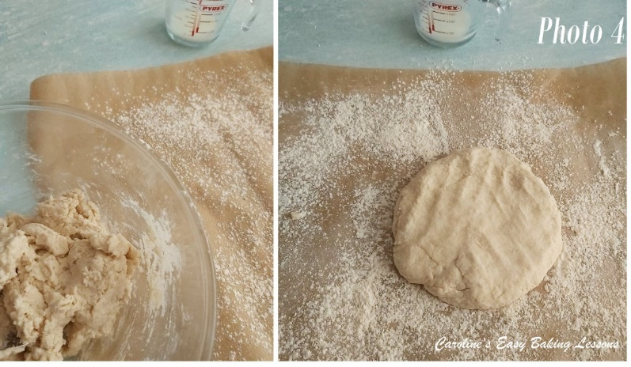
8. Turn the dough out, onto a lightly floured surface (I use baking/parchment paper for things like this, and re-use the paper. Less clean up too
9.Knead gently 5 to 6 times, just until a smooth dough is formed. (Over-handling this type of dough can impair the rise and make for a tougher bake)
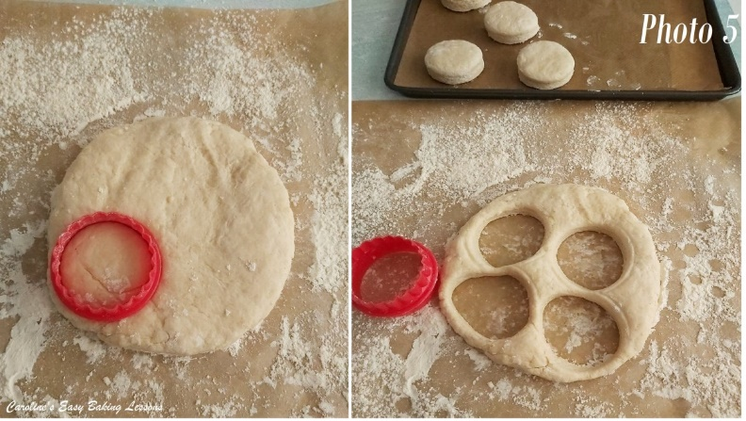
10. Roll dough out to a thickness of 3/4- 1″ (2 -2.5cm)
11. Then cut out biscuits using a floured 2 inch (5cm) biscuit (cookie) cutter. Place on the prepared baking sheet/tray, about 1-inch (2.5cm) apart. (For softer biscuits, Angelgale advises arranging so that edges almost touch.)

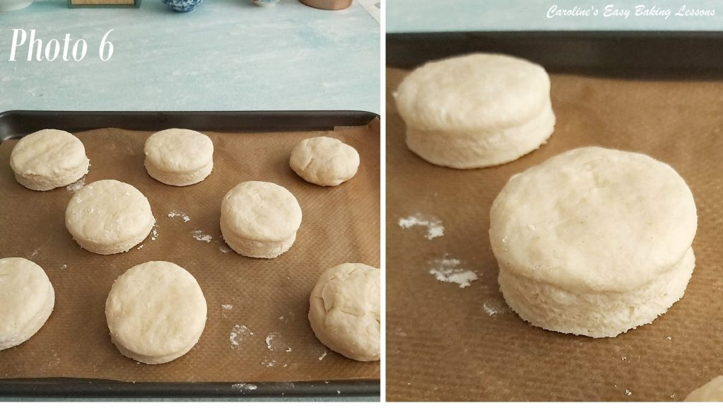
12.Gently and minimally, knead the excess dough and cut out as many more biscuits as you can get.
13. Now bake 8 to 10 minutes or until golden brown and well risen. Remove from oven and brush with butter, if desired.

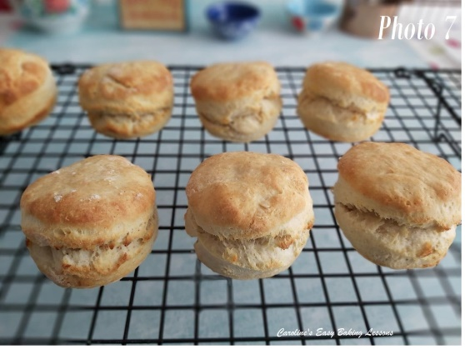
Here’s my biscuits baked off and with butter brushed on top.
If you try the recipe, please remember some pics, and message me or tag me in social media –would love to see them.

DIFFICULTY LEVEL: super simple
Happy Baking & Making, Happy Tummies & Memories!

Caro x

