EASY MINI GINGERBREAD BUNDT CAKES

Caroline’s Easy Baking Lessons

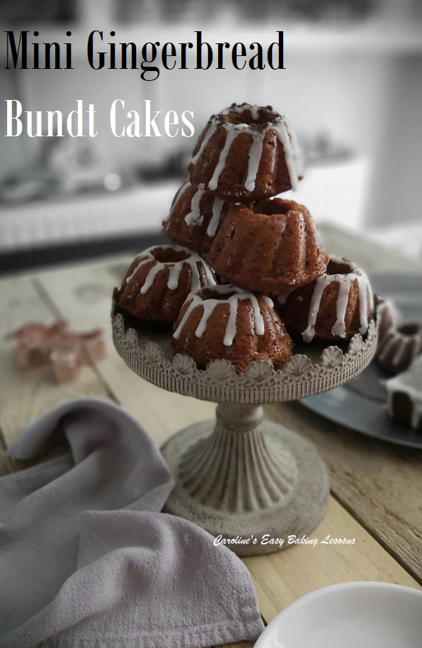
Here’s my super simple version of my gingerbread cake, but made in mini bundt cases. To make sure they would work for mini silicone bundts, I altered the recipe slightly, so rest assured, these will work out great. First year I made them, I decorated and set up photos at Christmas time and added some themed sprinkles. You will also see they can be made any time of the year and even made in different mini tins. I tried them in silicone mini bunds (that fit nicely into cupcake trays and so hold their shape great), mini metal bundts (gifted to me by my lovely friend Christine, and are made by Tala and a good solid quality), and also mini loaf tins) also by Tala). I am in no way sponsored by Tala but recommend these, and also the silicone cases which are from Aldi.

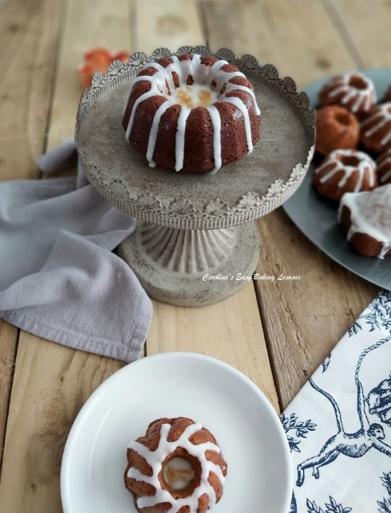

My recipe includes Golden Syrup and Black Treacle that are both products made here in the UK. Now I see debates about what Black Treacle is like on Facebook groups, people saying it is the same as molasses & dark corn starch. It is definitely not the same as corn starch. It’s closest is probably black strap molasses. However, there is no guarantee they will taste the same or have the same over-all effect on the baked cake. If I ever get some of that molasses sent over from the states, I will taste and do a test. In the meantime, some internet sites selling British products have this in stock and those that do, often have the Golden Syrup too. Yes, another British product. (Here is a list I compiled from readers in the states & Canada, of where to buy these:

WHERE TO BUY GOLDEN SYRUP & BLACK TREACLE
These are both widely available in the UK and even shops like Aldi sell their own version of the syrup. But for bakers in the US & Canada, here is a list of where you can source these:

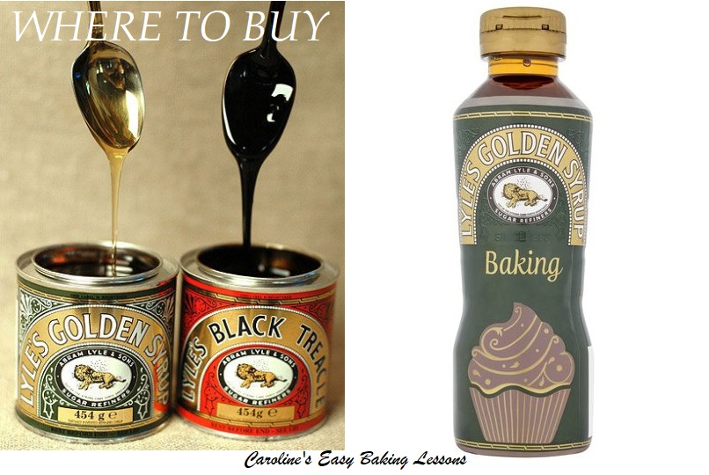
World Market, some Walmarts in Canada, Sobys, ‘Stop & Shop’, Wegmans, Frys (Smiths), Woodmans, Nugget Store, The Scottish Bakery, The British Store, Talin Market, Albertsons & in Dorgnacs. It is also available online at Amazon (free delivery for Prime accounts), 647-Florist.com, British Food Depot.com, UK Gourmet.us, World Market.com, Cost Plus World Market & Marina Market. (Information current at October 2019). Now I am also told, that you can get both the Golden Syrup & Black Treacle from: Nugget Store & online from: Marina Market, UK Gourmet, British Food Depot & Amazon. So if possible, try to get both. The Golden Syrup can even be used as is on top of desserts and cakes so won’t go to waste.

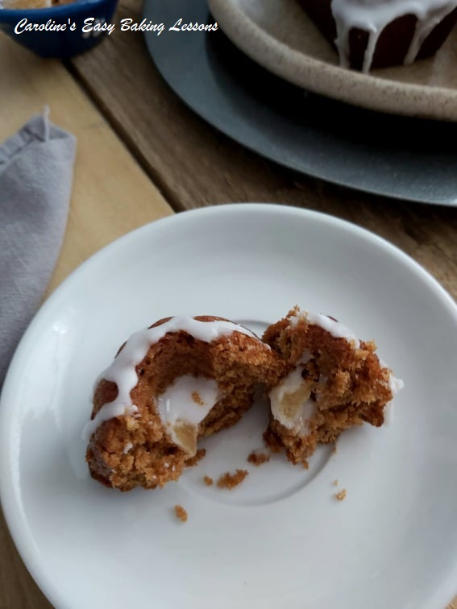
WHY THESE INGREDIENTS ARE BEST
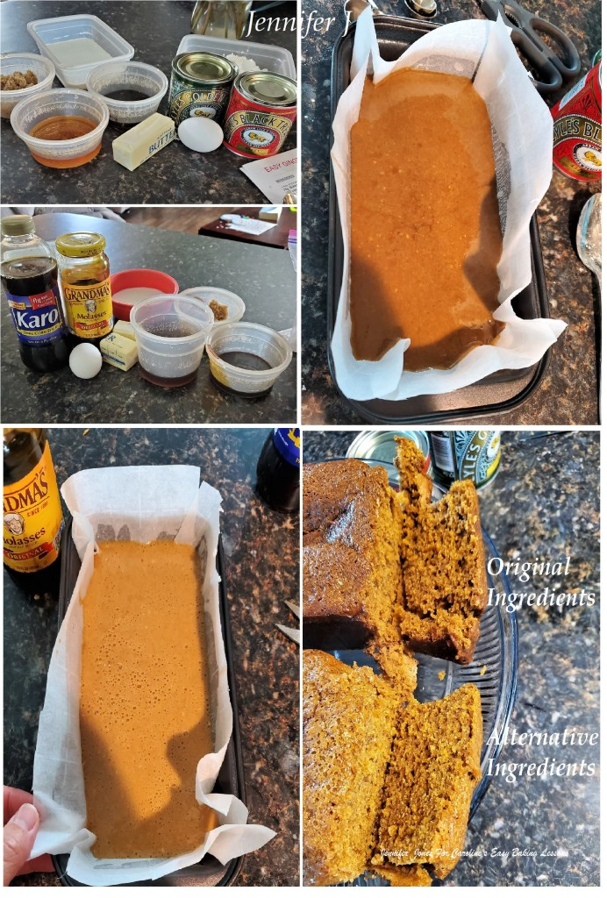
Apart from being the original ingredients intended for the recipe when it was designed, a friend from the Facebook GBBO Fans conducted a little experiment and halved the recipe. She baked half with the Golden Syrup & Black Treacle, and the other cake with US Grandma’s Molasses & Karo Dark Corn Syrup. Not only was the taste different, but the colour and more surprisingly the texture was different too. Here are Jennifer’s results in her own words:

A COMPARISON OF US VS UK INGREDIENTS FOR CARO EASYBAKINGLESSONS GINGERBREAD CAKE
“I used Karo Dark Corn Syrup in place of Golden Syrup and Molasses in place of Black Treacle in the US version.
Golden Syrup taste is just incomparable to anything I’ve ever had in the US products. It’s very similar to butterscotch, but not as heavy. Corn Syrup just does not compare at all. Black treacle tastes very like the Sorghum/Blackstrap Molasses that my Grandfather used to love. I couldn’t get any of that, but I believe it would be a good substitute.
On oven exit, the UK cake seemed fluffier than the US one. US is much lighter in colour, and lacks the strong flavor of the UK ingredients. It’s still very good, but I would recommend purchasing UK ingredients if at all possible. The taste is just that much better.
As always with Caro’s recipes, I highly recommend“
Jennifer Jones, Facebook October 2020.

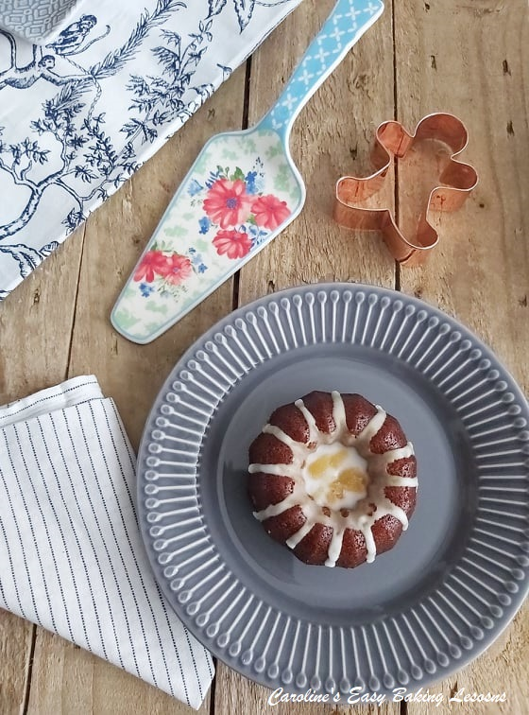
Other than that, this recipe is really simple with nothing technical to it. The recipe was originally written using Self-raising flour, but I have subsequently tested it using Plain (All Purpose) flour and have listed below how much baking powder you will need if using this type of flour.

INGREDIENTS
- 75g Butter, unsalted (2.5 oz, 1/3 cup)
- 100g Golden Syrup ( 3.5 oz or 1/4 cup + 1 tsp or 4 1/2 tbsp)
- 50g Black Treacle (see note above) (1.75 oz, 1/6 cup or 2 1/2 tbsp)
- 75g Light Brown Sugar (2.5 oz or 1/3 cup)
- 1 tsp Ground Ginger
- 1/4 tsp Ground Cinnamon
- 125ml Milk (4.25 fl oz or 1/2 cup + 1 tsp)
- 1 Medium – Large Egg
- 1/4 tsp Bicarbonate of Soda (Baking Soda)
- 150g Self-raising Flour (5.25 oz) (see note above)
- OR 1 1/4 level Cups Plain/All Purpose plus 2 scant tsp Baking Powder

For Icing/Glaze (optional
- 125g Icing/Powdered Sugar, sieved (4 oz or 1 cup)
- *If you want to use on mini loaves, double the icing/glaze for a full coverage.
- Few tsp Water
*** Makes 12 mini silicone bundts similar size to cupcakes.

EQUIPMENT
- Scales or measuring cups • Spray oil or butter for greasing
- Measuring spoons • Mini cake cases – bunts, loaves
- Small measuring jug • Sieve
- Small cooking pot • Medium bowl x 2
- Medium – Large mixing bowl • Metal spoon
- Whisk • Timer or phone timer
- Cooling rack • Baking/parchment paper
- Piping/pastry bag & fine nozzle or food baggie

- OVEN: 180c/160c Fan Oven/350f/Gas Mark 4

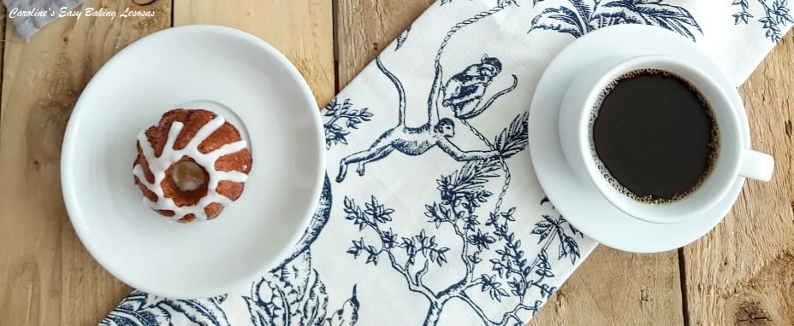Mini Gingerbread Cake With Simple Glaze & Crystallized Ginger Pieces

INSTRUCTIONS
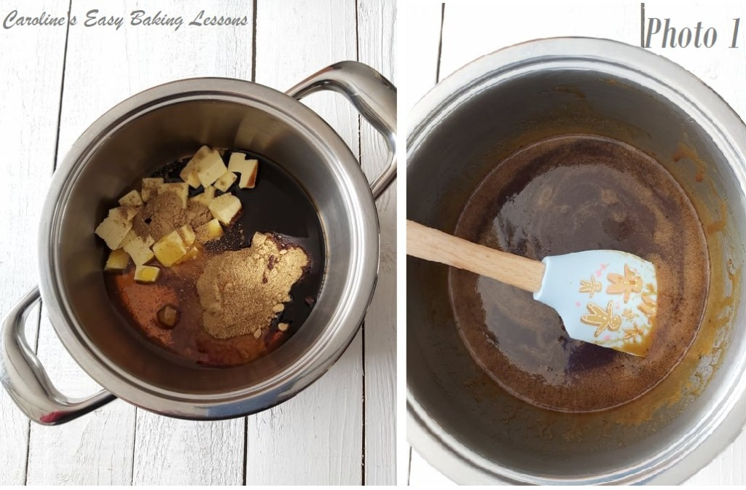
1. Place the butter, golden syrup, black treacle, sugar, cinnamon & ginger in a small saucepan and warm on medium heat until everything is dissolved and melted.
** Tip for using the syrup & treacle – spray oil on the measuring spoon and it will slip off easier. See video
2. Mix everything thoroughly and remove from the heat. See Photo 1. Transfer to another bowl & allow to cool while you prepare all the other ingredients. We don’t want it too hot when added to the eggs.
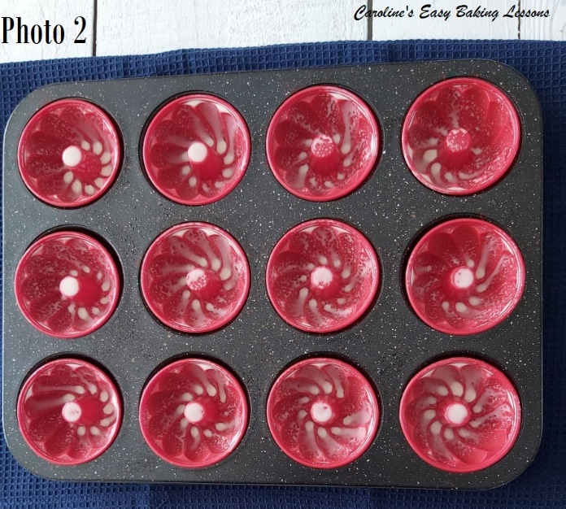

3. Heat the oven to 180c/160c Fan Oven/350f/Gas Mark 4.
4. Now prepare your mini bundts or mini loaf tins. I use Frylight Onecal spray (butter, olive oil or rapeseed oil all work for me), on the silicone bundts. For metal tins, I recommend making your own lining paste. It is less expensive that cake release spray, or using butter and flour. Can be used for any greasing in your baking or cooking. Click here to read my review on it and how to make it at home.
**Top Tip 2 – for mini silicone bundt cases, I pop them in a cupcake tray/sheet as they hold their shape better, and easier to manage too. See Photo 2.
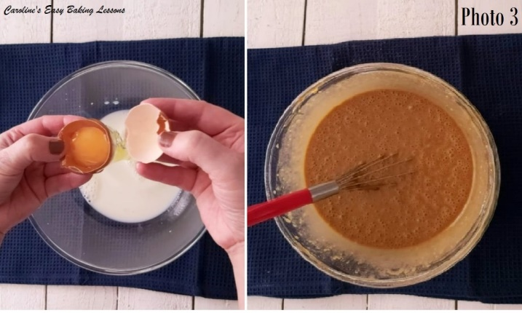
5. Place the egg in a medium sized mixing bowl and whisk lightly. This ‘wakes up’ the protein in the egg and helps provide the structure of the cake. Add in the milk and bicarbonate of soda (baking soda) and whisk till all combined.
6. Add the cooled mixture you prepared first, to this milky egg mixture and stir continually until all incorporated. I just used the whisk to do this. See Photo 3.

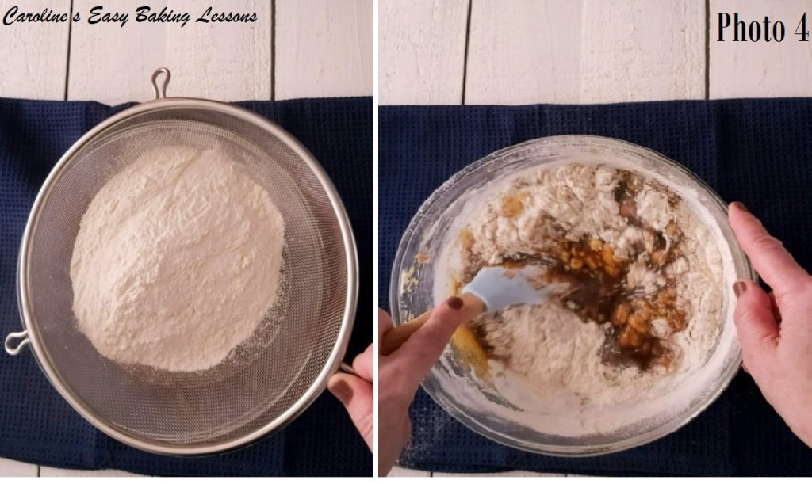
7. Finally sieve over the flour into the mixture and beat until combined and the batter is smooth. (A few small bumps is fine). No need to get the stand /hand mixer out for this. A baking spatula and a whisk towards the end will work fine. Note that this batter will be thin and runny in comparison to some other cake batters. See Photo 4 & 5 below, or the video for consistency.

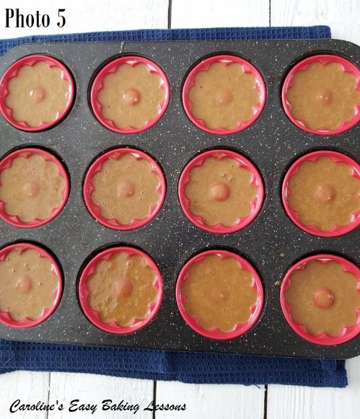
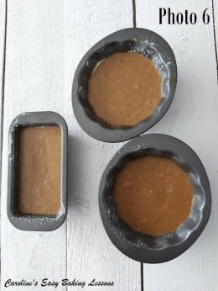
8. Now, using a small scoop or table spoon, fill the prepared bundts to about 3/4 full. In the video & Photo 5, I filled a little too much as I was making a bigger batch, and doing the large bundts and mini loaves at the same time. See Photo 6 below, filled to the right capacity But if you do fill too much, I have a trick for reducing the doming (See further down the recipe).

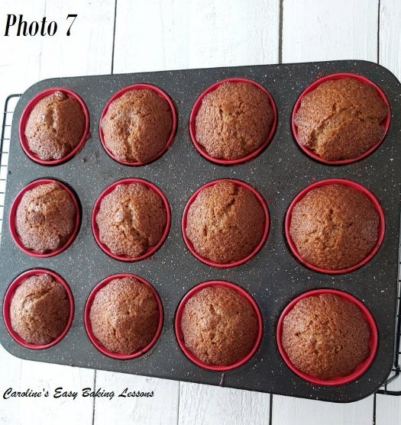

9. Bake in the centre of the oven, for about 15 – 20 minutes, until set and when you insert a wooden cocktail stick near the centre of the cake, it comes out clean of crumbs. Note if colouring too soon, cover in foil till cooked through. It will be very soft & delicate on top. See Photo 7 & 8.

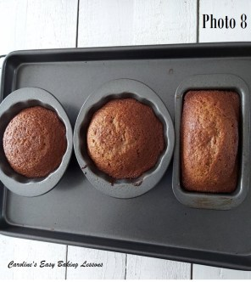
10. Leave to cool still in their cases/tins, and in the cupcake tray, on top of a cooling rack for about 10 minutes. Then remove the cupcake tray and leave to cool down completely before trying to remove. See my video on me doing this. 2 top tips below for this:
Top Tip 3: For any cakes that you are cooling, place on top of a folder clean tea-towel and this will prevent ‘tell-tail’ lines on your cakes – especially noticeable in layer cakes if the top isn’t decorated.
Top Tip 4: If you over-filled or have too much doming on the top of your bundts (mini or regular size), that may making laying flat difficult, place the cakes right way up when cooling. Doing this whilst still hot, and with gravity and the weight of the cake, it will settle a bit and become flatter. Saves you trying to trim them nicely. See Photo 9.

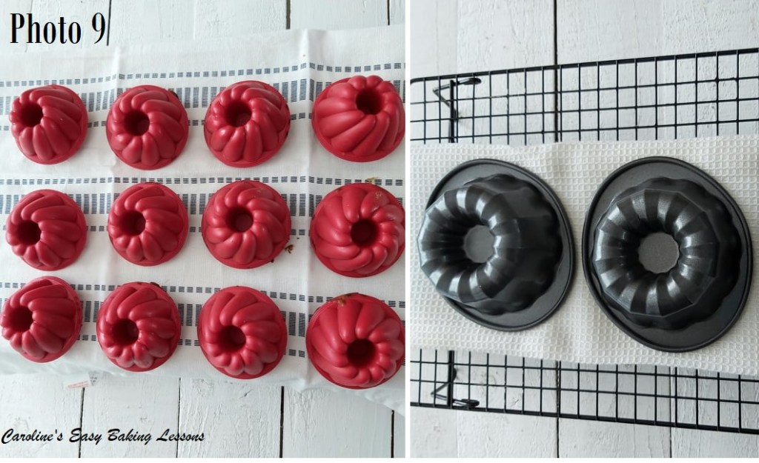
11. While the cakes are cooling, make up your icing/glaze if you want some (believe me it’s nice without it too). Sieve the icing/powdered sugar into a medium sized bowl (otherwise you will get the sugar everywhere).
12. Add 1 tsp of water (or you can use milk), and mix with a spoon. Once the water is in, use the back of a large spoon to push down on the sugar that will keep absorbing the liquid. Keep doing so – you will be amazed at how much liquid this sugar can absorb if you keep at it.
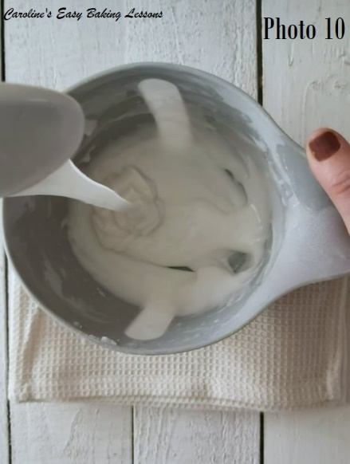
Then gradually add in a 1/2 tsp of water at a time and the sugar will become paste like. Keep rubbing in, & adding 1/8 tsp drops until you get a thick but pourable icing/glaze. Thick is best as it will form a nice layer and not ‘melt’ into the cake. To test if it’s right, hold your spoon up high above the bowl with some icing/glaze on it and point it downwards to let it drip off. You want it to run down gently. If it stays where it is, add more water a little at a time. If you have added too much water at once, sieve in more sugar and repeat until you get it right. Very gradually is the key here. Again you can refer to my video above, but I also have a quick one showing how I make icing/glaze by hand – go to video.
13. Once the cakes are cooled down, it’s time to remove from the cases/tins. For the metal tins, it will just be a case of turning out and maybe giving a few taps. For the silicone cases, I like to squeeze very gently along the top edge (well bottom really & what is going to be the top of the cake). Alternatively, you can roll or turn the top edge of the cases down onto itself, exposing the cake. I prefer the first way. Here’s another quick little video below of me trying both ways.

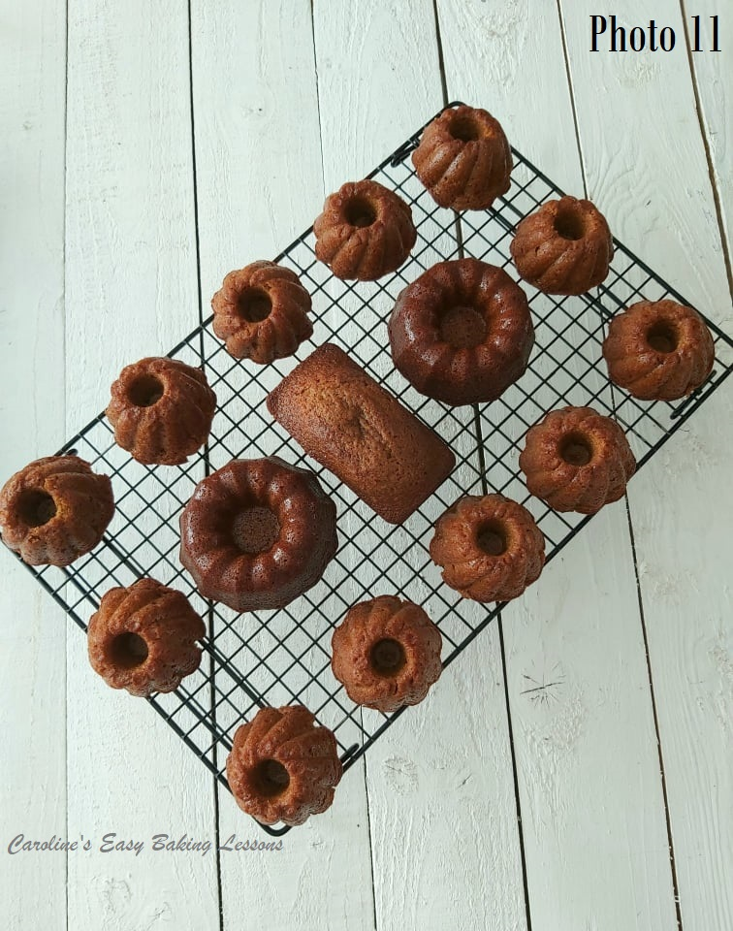

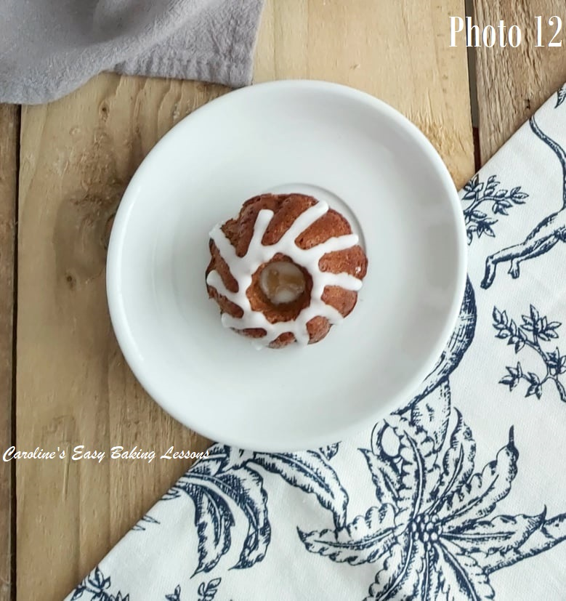

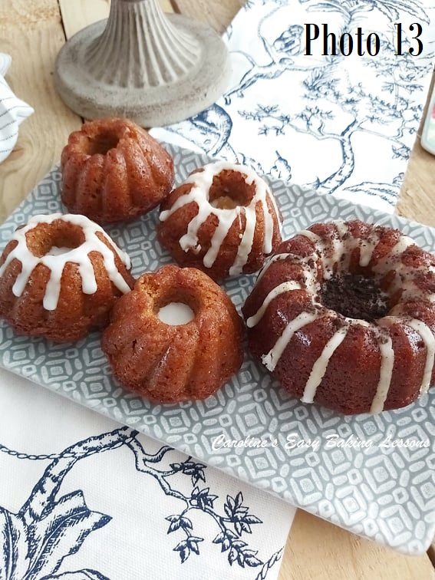
13. Once the cakes are out of their cases/tins, place on top of the cooling rack with no tea-towel this time. And place some baking/parchment paper under the rack. Then take a small spoon’s worth of the icing/glaze and hold high above the cakes. I like to start at the end/edge of the cake and draw it across the cake as the sugar drips down. Holding up high gives you a thinner drizzle. Just move your hand left and right while drizzling above the cake and do any pattern or random drizzle that you like. Any left over glaze can also be used to fill the centre of the bundts too. Alternatively, if making mini loaf versions, keep the glaze thick and spread it on, covering the whole top of the cake (be sure to increase your amount of icing/glaze for that). Starting from the middle with a thick amount and then spreading out to the edges. It should set up in minutes if the room isn’t too warm. You can also do a neater finish and drips to the bundts, by piping it on, using a tiny nozzle (#1). Here’s a video on how to do this in a few different ways.
14. Add some chopped crystalized ginger if you like, to the centre of the bundts & let the glaze set (dry to touch). Enjoy!
15. Store in an airtight container or cake stand & dome, for at least a few days. Can easily be frozen too. Just include some kitchen paper/paper towel in with it, so that this absorbs any moisture when defrosting. Thaw at room temperature.

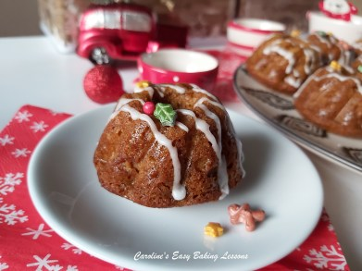

***Note in Photo 13, I added Oreo crumbs at the request of my youngest son & I regret it, in terms of how the photos look. But he enjoyed it. There are other ways to decorate them too though, as seen in the photo below, that were themed for Christmas.

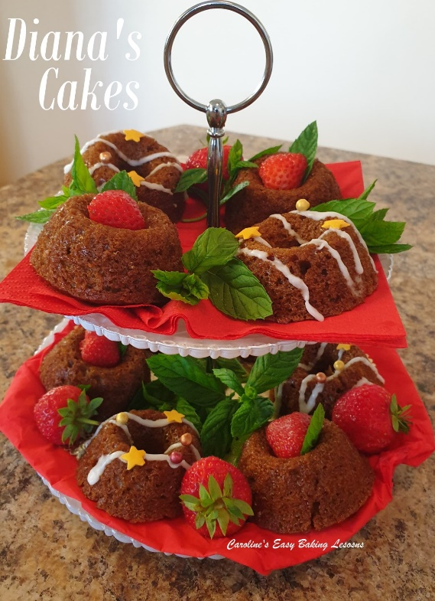

Here’s some made and decorated by my friend Diana, who tests my recipes for me.

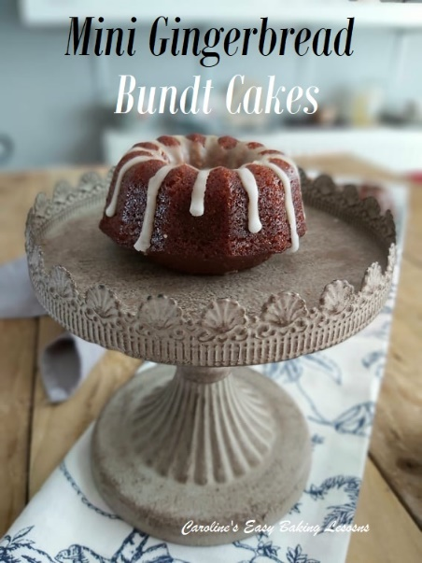

DIFFICULTY LEVEL:
Super simple, beginner

Thanks for reading
Happy Baking & Making
Happy Tummies & Memories!

Caro xx

