RAMAZAN PİDESİ – SPECIAL TURKISH BREAD – By My Quicker Method

Caroline’s Easy Baking Lessons
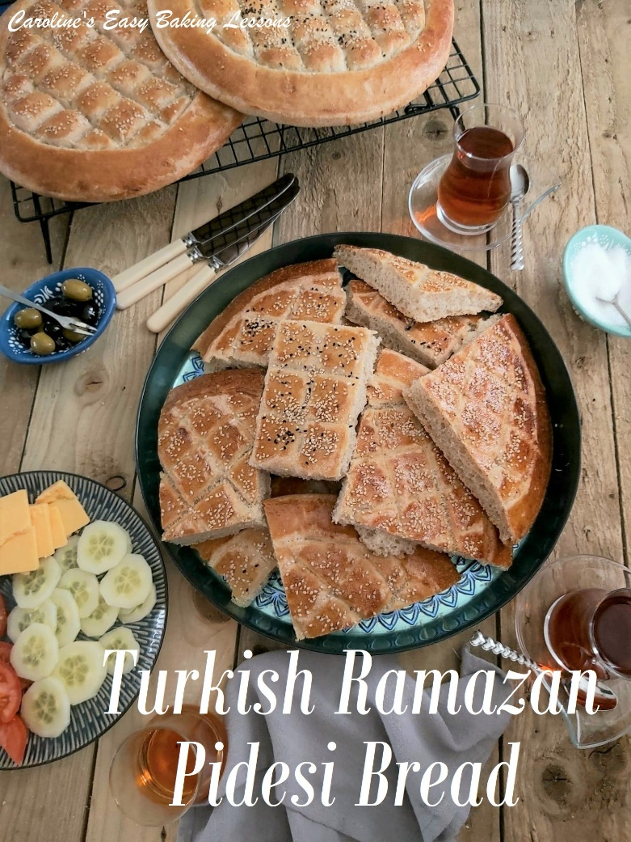

By Caro
Ramazan Pidesi is a special bread from Turkey. But can be found in lots of other countries too, with slight variations. Pronounced ‘Ra-ma-zan Pee-de-see’ it is often made during Ramadan, the time in Muslim culture, where fasting is carried out (no eating or drinking between sunrise and sundown). However, in Turkey, bread of some description is eaten with every meal. So there is no reason why you can’t have this bread, anytime of the year. Not quite a flatbread as such, this yeasted dough, still produces an airy texture. The only difference being, is that the dough is spread out quite wide, in a circle and allowed to prove again. But this bread always, has a characteristic pattern to it. A rim to the edge of the bread, and a diamond pattern in the centre, made in a deep manner, that results in the bread having a ‘pillowy’ look to the surface. Crazy I know, but these visual cues, let your bellies have a glimpse
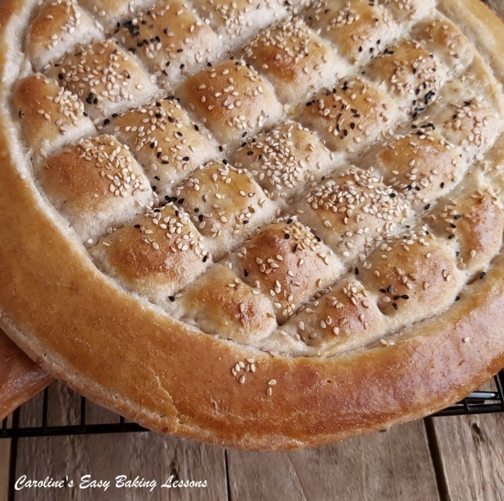
of what’s to come. So unlike most flatbreads, this produces a very open texture crumb. Soft and springy, is a good way to describe the texture, but with a little chew to the crust. And the bread is simply finished off with sesame seeds and some çörek otu – this is simply Nigella Seeds. I am not a fan of them, so usually make on bread with just sesame, and the second with both seeds.

A NOTE ON TECHNIQUE
Now you can of course make this bread using the traditional yeast dough making method. But since discovering a method, by
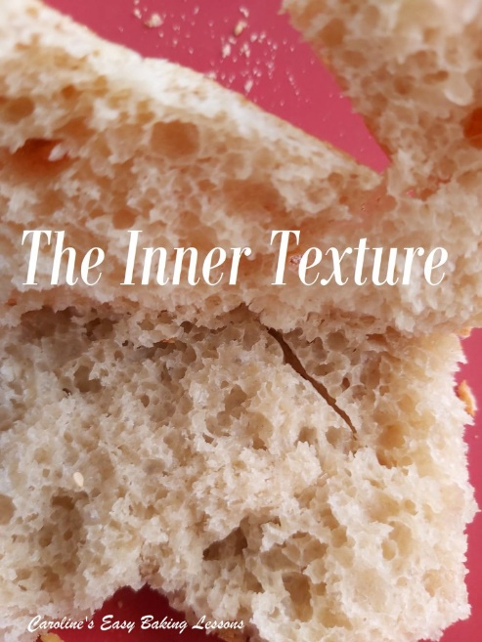
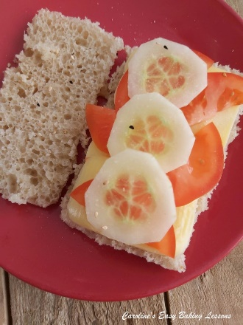
Jessica Gavin (from her book – ‘Easy Culinary Science For Better Cooking’, 2018) to make Quicker Soft Italian Breadsticks, I have since converted a lot of my go-to yeast recipes to this quicker method. Whilst the quicker method takes a little longer to form the initial dough, proving times are significantly reduced, resulting in the overall start to finish time being shorter. Some recipes can be reduced by 1/3 to 1/2 that of conventional methods. And once you have used a few times, it’s really easy to remember too. The process basically gives optimal conditions for the yeast to thrive and get to work if you like. An analogy would be, create the best and most comfortable conditions/environment for your workers, and they will work harder and more efficiently (in theory). But don’t think that the reduced time impairs the bake in terms of taste, structure or appearance. Some people say that quicker methods don’t allow flavour development, but the only way for true flavour development to occur, is by proving the dough overnight in the fridge. A slow, cold prove, allows this to happen more easily, as the process is slowed down. Conventional methods of 1 – 1 1/2 hours initial proving time, doesn’t allow for much flavour development, and that’s why this quicker method I will show you today, can taste just as good.

A NOTE ON INGREDIENTS
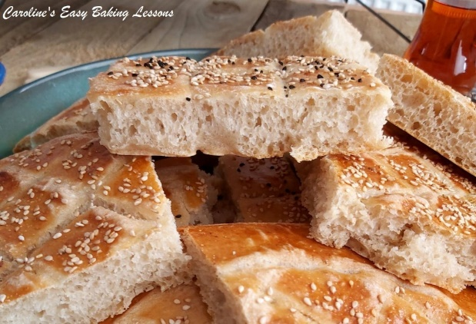
So no special ingredients are required for the dough, just the inclusion of egg whites. I made these breads with white Plain (All Purpose) flour, as there is no need to use Bread Flour (Strong Flour). If that’s the only flour you have, it’s fine to use this too.
Now note the flour is separated into 3 amounts, as they need added in a specific way, and are referred to as [F1], [F2] & [F3]. This method works really well, and once you have done a few times, you really don’t need to refer to the recipe. And it’s the same process for the making the dough, in all the Quicker Yeast recipes of mine. So stick with the recipe and you will achieve the same result. **This recipe makes 2 breads, but in the photos, I actually made 4.
I am not going to keep you much longer from the recipe, but just have a look at the video below, that was used for a Facebook group bake-along, where my 2 hour tear-and-share dinner rolls recipe was used, to introduce beginners to bread making. It’s an almost real-time tutorial just so you can see even better how this process works. Watch it one time, and then you will have the hang of it.

INGREDIENTS
- 7g Yeast, dry
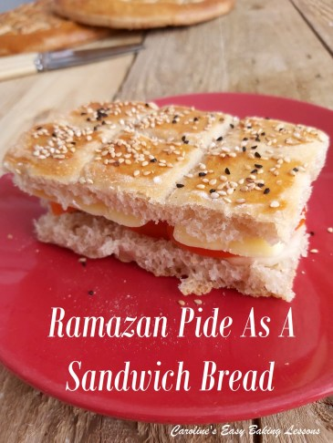
- (*1 packet/2.25 tsp Instant or 2.5 tsp Active)
- 200g Plain Flour – [F1]
- (7 oz, 1 2/3c All Purpose)F1]
- 1 tsp Salt
- 1 tsp Sugar
- 400ml Tepid Water (13.5 fl oz, 1 2/3c)
- 1 Egg White (med – large egg)
- 1 tbsp Olive Oil or E.V.O.O.
- 100g Plain Flour – [F2]
- (3.5 oz, 3/4c All Purpose – [F2])
- About 325g Plain Flour – [F3] (approx.)
- (Upto 11.5 oz, 2 2/3c A.P. -[F3]) **See notes above.
- Egg yolk & splash of Milk for topping
- Sesame seeds &/or Nigella Seeds (çörek otu)
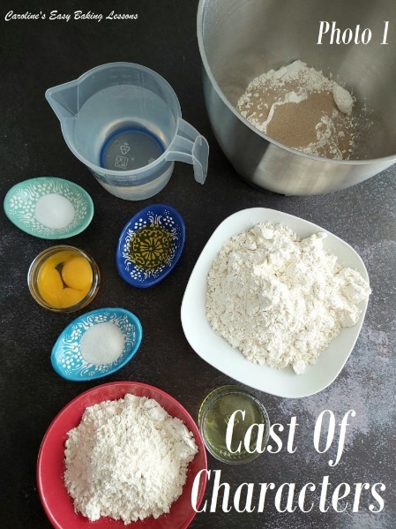

EQUIPMENT
- Stand Mixer with dough hook (optional)
- Scales of measuring cups
- Small Measuring Jug
- Pastry Brush (or small artist/paint brush)
- Small bowl for egg wash
- Baking/parchment Paper
- Baking sheet/tray x 2 (or pizza trays)
- Tea-Towel
- Small Knife or spoon with a straight edged end
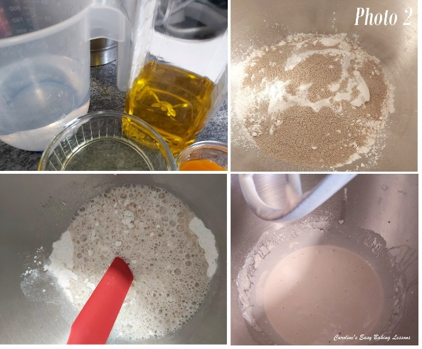
- Timer or Phone Timer
- Cooling Rack
- OVEN: 220c/200c Fan Oven/425f/Gas Mark 7.

INSTRUCTIONS

PREPARING THE DOUGH
1.Have the 3 amounts of flours weighed or measured out in separate bowls – you can use the stand mixer bowl for the first flour, [F1]. Place the oil and water into a microwave safe bowl or jug and heat for 30 – 45 seconds until just a little warm (120-130f, 49-54c). Alternatively used some hot water and cold water and check the temperature once mixed. It should be just above tepid.
2.Mix the salt into the first flour, [F1] and give it a good mix through. This is because yeast should never let yeast come into direct contact with salt or it will reduce the power of the yeast. This way the salt is coated in flour.
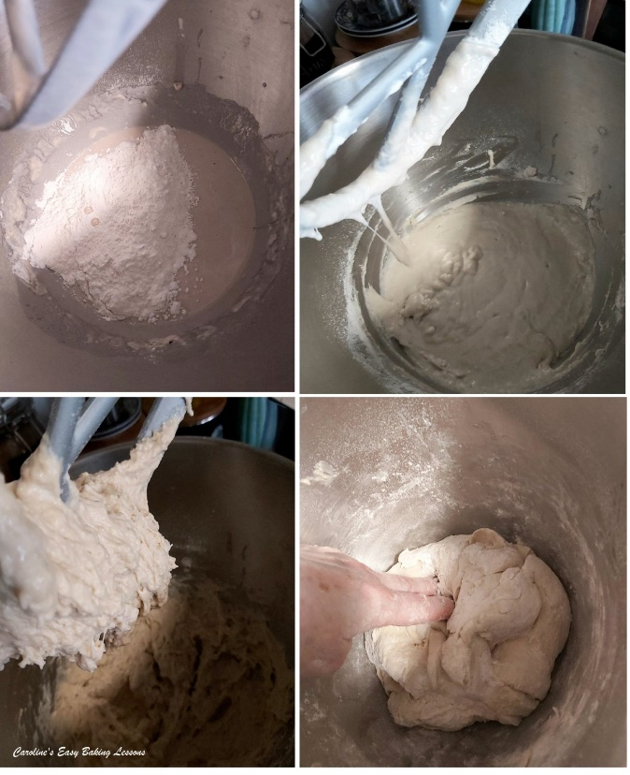
3.Add in the yeast, sugar and onion powder (if using) and mix through, one at a time. Once the water and oil is warmed, add this as well as the egg whites to this dry mixture. Using the paddle (or ‘k’ hook) on the mixer, mix for 2 minutes. Be sure to time this. See Photo 2
4.Now add in the smaller bowl of flour [F2], and mix for 2 minutes with a timer. (Photo 3, top pics). The mixing in this recipe is very important so be sure to time it.
5.Slowly add in the flour from [F3]. You might not need it all, but you want a dough that starts to come together as a very rough ball around the paddle. So mix for 10 seconds after each addition of flour and wait to see the ‘ball’ of dough. Note that the dough will be a bit sticky. See Photo 3.
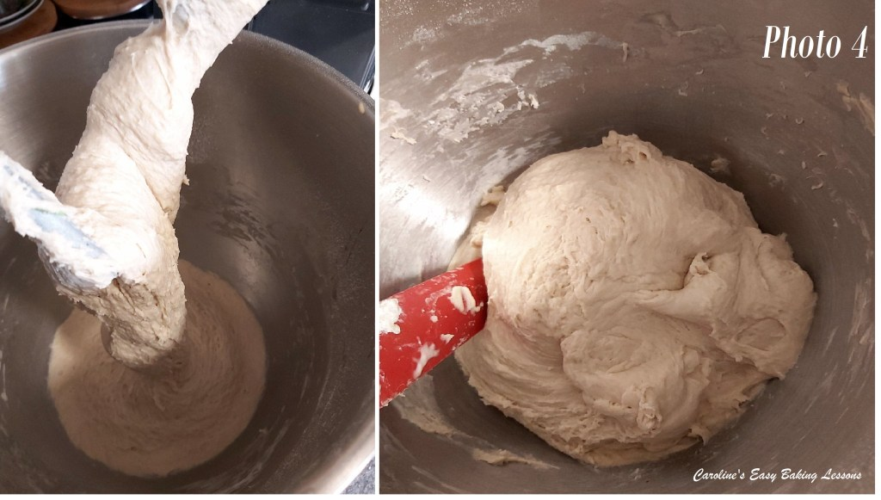
6.Now put the dough hook onto the stand mixer (use a scraper to get the dough off the paddle), and knead on medium speed for 4 minutes.
7. Using a rubber or silicone slim spatula, scrape the dough off the bowl from down the sides. Then tilt the bowl and put on it’s side, so you can see the bottom. Continue scraping the dough out towards the top of the bowl. Now wash and then put oil (or spray oil) onto your dominant hand and ease the dough out and turn it over so that the bottom of the dough is now at the top end of the bowl. Alternatively, just flick the dough over with a silicone spatula (that’s what I do). Place the bowl back on the mixer and continue kneading for another 4 minutes. The dough does tend to stick at the bottom when kneading, and this is another reason why we turned it during kneading. Once the total kneading time is up, the dough will be forming a ball and cleaning the sides of the bowl. Have a feel of the dough to know how well kneaded dough feels. Will be nice and soft compared to before and less sticky now. Note also how stretchy it is when you lifted the dough hook up. Scrape any dough from the hook and into the bowl. Now place a towel on top of the bowl and leave somewhere warm and draft free for 15 minutes. (Note that dough with whole-wheat/meal flour will not feel quite as soft as white flour). See Photo 4.

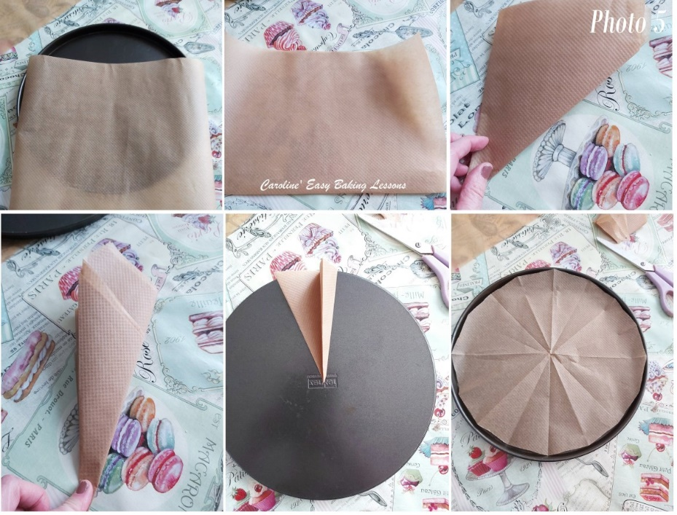
8.Take this time to prepare the baking trays with baking/parchment paper, or even silicone mats. Do not bake these without paper as they will stick. To cut to the shape and size of a round tray, see the Photo 5 (fold the paper that is tray width in half as in 2nd photo, then fold again and then fold at a diagonal to form a triangle. Then fold again to make a skinny dart. Place the point of the dart at the centre most part of the tray, and then see where at the opposite end, how much excess to cut off. Then simply unfold, and check the sizing, folding up and trimming off again if needed. You are looking for trays/sheets that will take a 25cm/10″ circle.
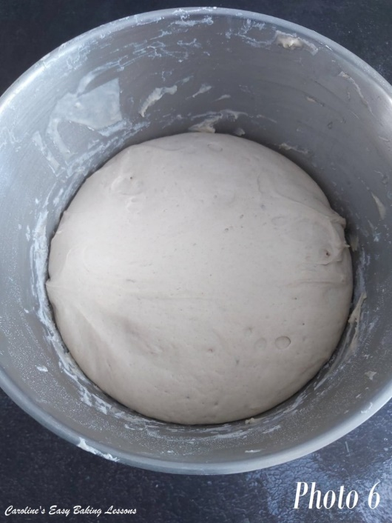
9. Well flour some baking/parchment paper or worktop/counter and your rolling pin. See Photo 6. Release the dough from the bowl like before, (without oiled hands this time) and tipping, scrapping out onto the worktop. Sprinkle on some more flour on top of it. Knead the flour into the dough for a few seconds, adding small amounts of flour if needed for it to be manageable. Now form the dough into a nice tight ball, flatten it and then cut in half (flour the blade of your knife if needed).
10. Roll the pieces of dough into a nice tight and smooth ball using your hands. Then place in the centre, on top of the paper lined pizza tray, and flatten out into a circle. Now process to spread out the dough more, with your palm and fingers, until you fill the 25cm/10″ round tray. See Photo 7 below.

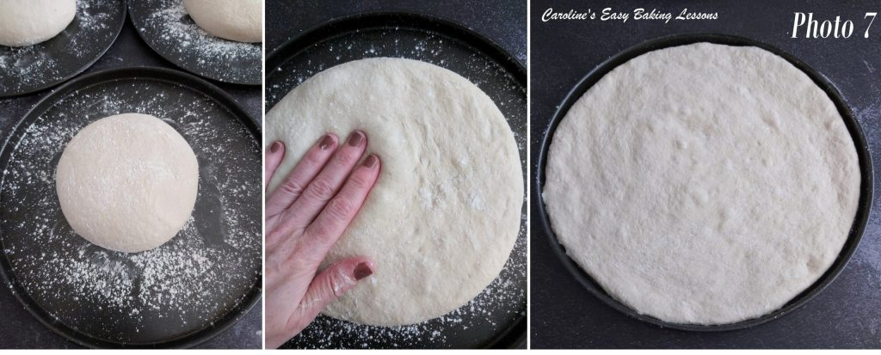
11. If you don’t have pizza trays, then roll out with a floured rolling pin, into a circle approximately 25cm (10 inches) wide. Keep turning the dough when rolling it out to get as near to a round shape as you can. Sometimes you can turn the dough over too. Only add a little flour to the work surface & to the rolling pin. Adding too much flour, especially after kneading and rising, produces a very dense and tough bake. Then simply transfer to your prepared baking sheets/trays.

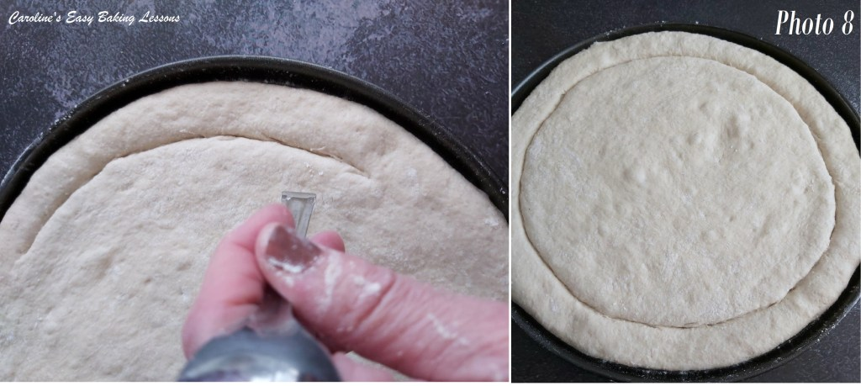

CREATING THE PATTERN
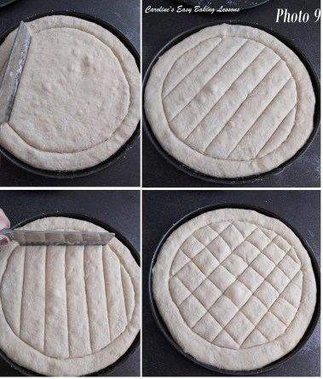
12. To make the pattern on the dough, using a small sharp knife, make an indent into the dough to create a round boarder, like in Photo 8. You can use the end of a small spoon if it has a straight edge. Leave at least 1 inch/2.5cm gap from the edge of the dough. Then make long vertical lines, no more than 1″ /2.5cm gap in-between them. Then turn the tray 90 degrees and make lines again so that you have created diamonds (or squares depending on what way you look at them). See Photo 9 below.

13. Now very carefully and gently, brush egg-wash (the yolk mixed with a splash of milk), on top of the bread, along the rim and on top of all the diamonds you created. Then sprinkle on some Nigela seeds &/or sesame seeds, or leave plain if you prefer. Just don’t skip the egg-wash, as this gives your bread and rolls a great colour and also translates as flavour. See Photo 10.

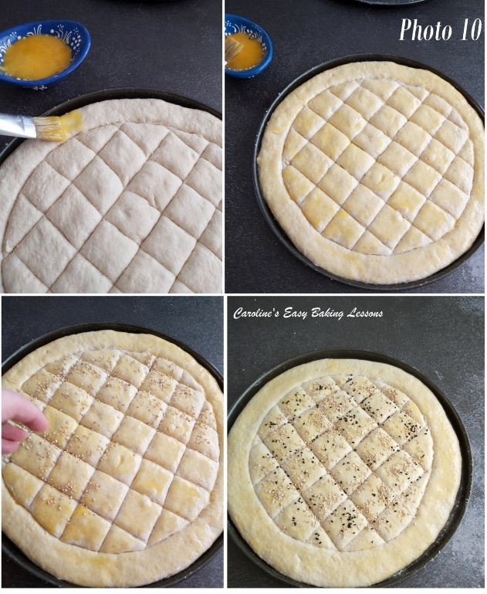
14. Repeat for the 2nd bread, and leave both in the same warm, draught free place for 30 – 45 minutes to prove and puff up a little.

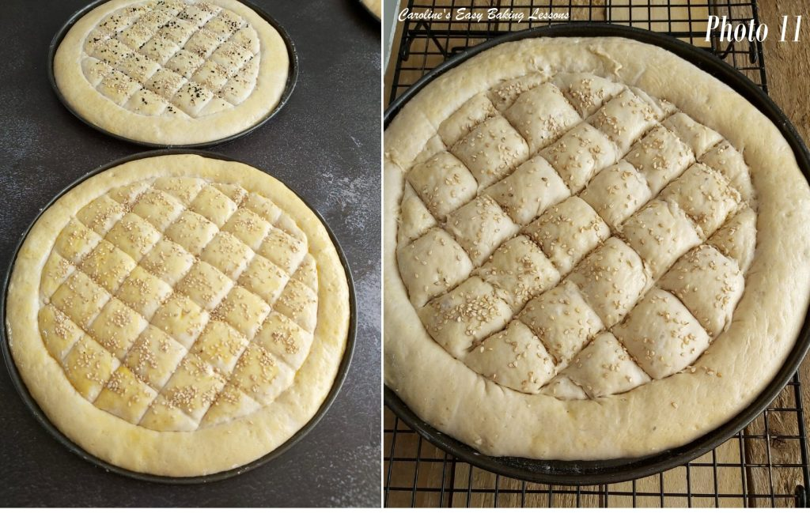

15. Heat up the oven to –220c/200c Fan Oven/425f/Gas Mark 7.
16. Just before placing in the oven, go over the cuts again you made on the bread, as they will be less defined now with proving. Just be very careful not to deflate the dough. See Photo 11.
17. Bake in the centre area of the oven, for between 14 – 18 minutes, till nice and golden, risen and the underside looks cooked all the way through to the centre. You can even bake the bread, on the last few minutes, upside down just to finish off the centre of the bottom of the bread. See Photo 12 below. My first two baked off at 15 minutes and the 2nd 2 at 16 minutes.
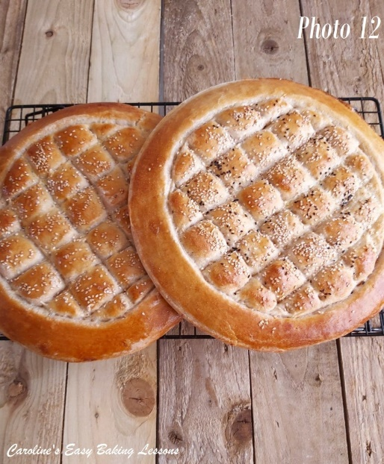
18. Leave the breads on the trays, on top of cooling racks to for about 10 minutes, before moving, paper and all, onto the racks. Cut for serving, or do as the Turks do, and just tear apart, and eat with your meal. I have also tested it, and you can slice it horizontally, and make a nice sandwich from it. Even put in a sandwich toaster machine. Either way, enjoy your bake.
19. Store any left overs in sealed food bags, or even brown paper bags. I prefer not to store homemade bread in the fridge, as it can make it go off quicker.

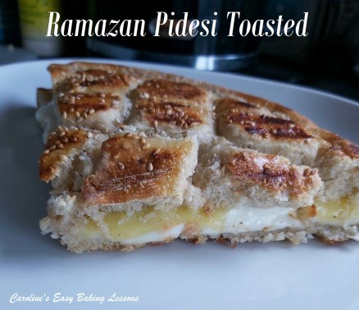
DIFFICULTY LEVEL: easy, with guidance

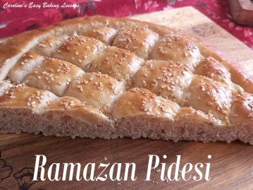
Thanks for reading
Happy Baking & Making
Happy Tummies & Memories!

Caro xx

