LAMINGTONS – Australia’s Light Coconut Sponge Cakes
Caroline’s Easy Baking Lessons
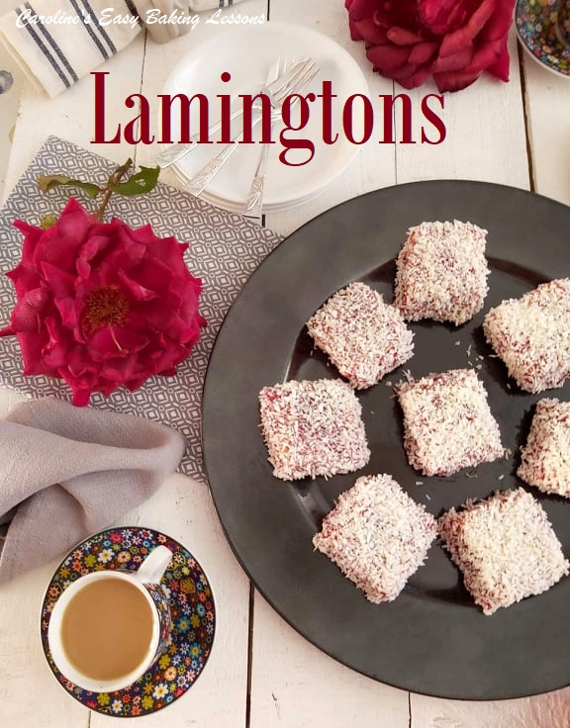
Lamingtons originated in Queensland, Australia, and were first published in Queensland Country Life newspaper in 1900. It’s believed to have been invented by Australia’s chief of the state eighth governor, Lord Lamington, to feed unexpected visitors. However, more recent research claims it was actually invented in New Zealand. But like many bakes, similarities can be found in other countries too. The classic lamington is a light ‘almost fat free’ sponge, with no baking powder, but leavened by whisking eggs and sugar to the ‘ribbon stage’. In effect a Genoise (Jen-wahz). Only a very small amount of butter is used and is traditionally dipped in chocolate and then coated in coconut. But there is also a version of raspberry jam in place of the chocolate icing. Very popular in Australia, since 2006 there has been a National Lamington Day (occurring on 21st July in 2021)
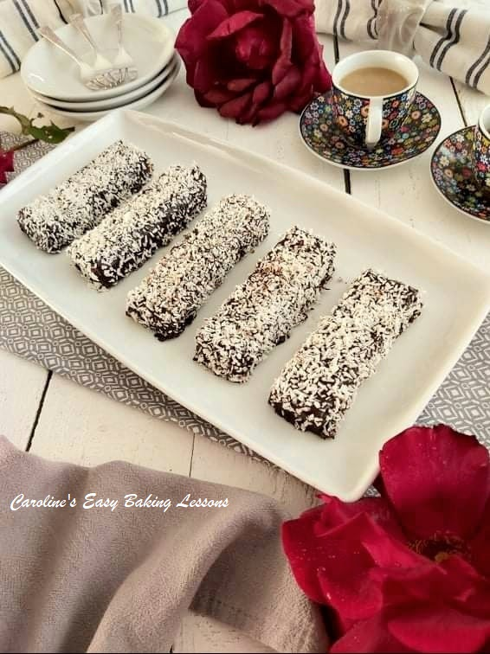
So for the new site, I have used my old recipe of 2019, but changed it up a bit. I baked thin bar/slices and coated in the chocolate glaze, but also baked a second batch in a different tin to get a slightly deeper bake and made squares cakes. These I covered with raspberry jam. So I have included the instructions for both, so you can see what tin sizes you have and what flavour you fancy. Just be warned, it does get really messy with the coating. I do not advise on dipping the cakes in the chocolate/jam as the sponge will break. You have seen it happen on The Great British Bake Off (Great British Baking Show). You could opt to pour the chocolate icing over the cakes, but I didn’t use that method as I didn’t fancy scraping the excess chocolate back up to finish them off. I made the chocolate ones first and spooned it on all ends before doing the top and got messy (a tasty mess none the less). But when it came to doing the jam ones, I made much less mess and had coconut left that wasn’t covered in jam. (See comparison Photo below). The key is to keep one clean hand and I found spreading the jam on was less messy. And the result was no broken cakes.
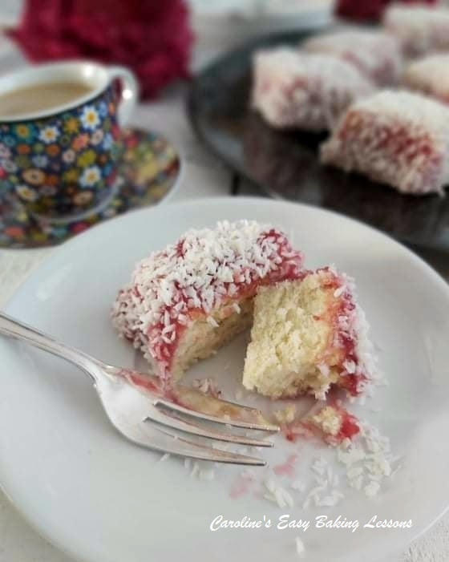
Just a little note of the size of tins. Using a square 21x21cm (8.25 x 8.25″) tin gives 12 bars/slices that are about 10×3.5cm (4×1.3″) in size once baked and coated. I wouldn’t recommend going any bigger a sized square tin than that (unless you increase the recipe), as these ones are maybe about 1cm (1/3″) deep once baked. You could use a rectangular tin, but just make sure that the length added to the width does not exceed 42cm (16.5″) or the cake will be too flat. For the square version I used a long thin rectangular tin (think long thin bread tin), that was from Lidl. (28x9cm – 11×3.5″). With the easy clip opening, releasing the cake was easy. I calculated the area of this tin to be just a little smaller than that of the square tin, so I was able to use the same amount of batter, to produce a slightly deeper cake that would make better ‘squares’. This tin also produced 12 cakes about 5cm/2″ in size when decorated. However, if you want to use the above square tin to make the deeper squares cakes, double the recipe and you can make 16 cakes. So the choice is yours.

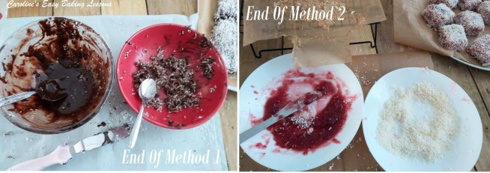
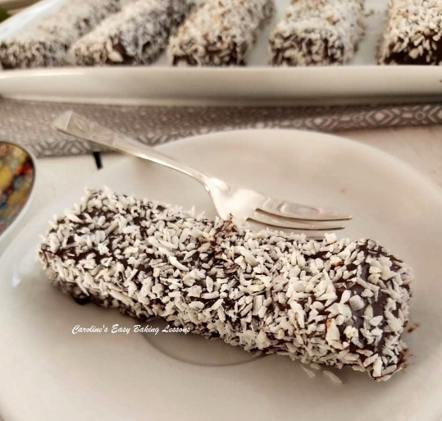
The left-overs from 2 different methods

On to the recipe. But first, you can choose to save the recipe to your phone or computer, by clicking the ‘download’ button below:

EQUIPMENT
- Measuring scales or measuring cups
- Measuring Spoons
- Bowl or pot to melt butter
- Sieve
- Cake tin – 21 x 21 cm (8.25 x 8.25″), or a rectangular tin where the length added to the width does not exceed 42cm or 16.5″ for the Cake Slices (see notes above)
- For the deeper square cakes – 28x9cm (11×3.5″), OR, use same square tin above & double recipe – this will give 16 squares.
- Baking/parchment paper
- Baking spray, butter or Lining Paste for greasing
- Stand/hand mixer or manual whisk & spoon
- (I used an electric whisk as my stand mixer is big and it was for a small quantity).
- Mixing bowl (for dry ingredients)
- Mixing bowl for batter
- Rubber/silicone spatula
- Double boiler (optional for manual whisking)
- Cooling rack
- Spoons, tsp, butter knife or palette knife
- Timer or phone timer
- OVEN: 180c/160c fan oven/350f/Gas Mark 4.
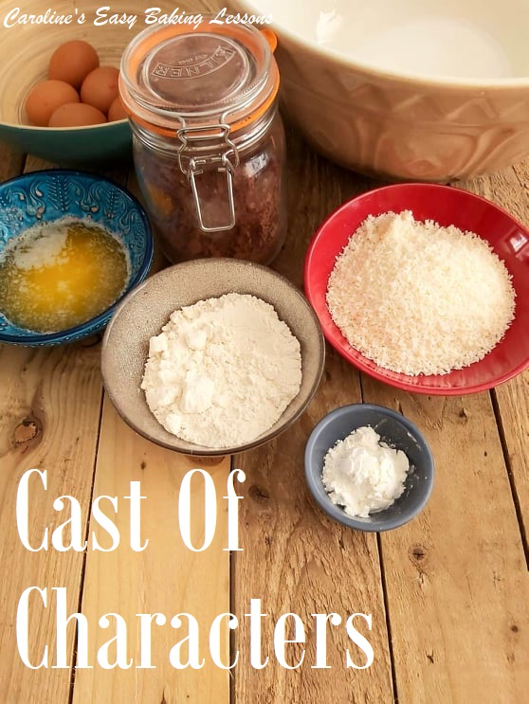
INGREDIENTS
- 40g Butter, unsalted & melted (1.5 oz, under 3 tbsp)
- 3 Eggs (med – large)
- 75g Caster Sugar (3 oz, 1/2 cup + 1 tbsp Extra/super Fine)
- 65g Plain Flour, sieved (2.5 oz, 1/2 cup A. P. Flour)
- 1 tbsp Cornflour (cornstarch)

TOPPINGS:
- 15g Butter (0.75 oz, 3 tsp/1 tbsp)
- 225g Icing Sugar
- (1/2 lb, or 1 3/4 cups + 1 tbsp Powdered Sugar)
- 37g Cocoa Powder (1.5 oz, 1/3 cup)
- Up to 120ml milk (4 fl oz, 1/2 cup) ** Will vary
- 100g Desiccated Coconut (minimum)
- (1.25 cup, 4.5oz Coconut, shredded, unsweetened preferably ) – minimum. Will need to be chopped, see photos below

- OR just Coconut & 300g Raspberry Jam (10.5oz)

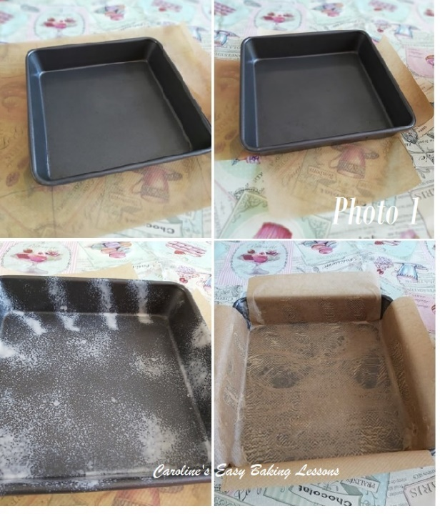
INSTRUCTIONS
1. Melt the 40g/1.5 oz butter in the microwave in 30 second intervals, stirring well in between each time. Alternatively melt on the stove top. Let the melted butter sit and cool for a few minutes.
2. Now begin preparing the cake tin you are using. I only cut the paper at this stage to fit the tin, as I prefer to grease and hold the paper in position, just before adding the cake batter, as I feel it sticks better and doesn’t dry up. I cut the paper by placing under the tin, with excess all around and cutting out squares for the ‘corners’. See Photo 1, or click here to go to my cake tin lining article.
3. Heat up your oven to 180c/160c fan oven/350c/Gas Mark 4.
4. Weigh or measure out the flour and cornflour (cornstarch) into a bowl with a sieve placed on top first. Then mix together.

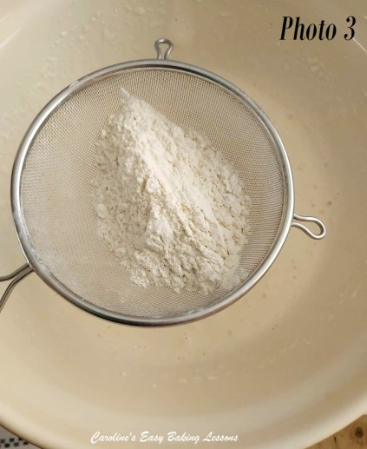
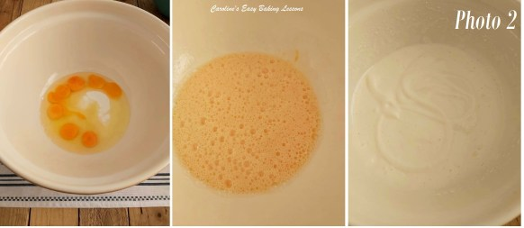
5. Put the eggs and sugar into a large mixing bowl and whisk till creamy, thick & paler in colour. (See Photo 2 above). Note the volume will have increased too. You can do this with a hand/stand mixer and the way to tell if it’s ready, is to see if it leaves a trail when you drop some of the batter from the whisk attachment onto the batter in the bowl. It’s ready if the dropped batter does not immediately disappear. See photo 2 (right pic) for what this means. This took me 2.5 mins at high speed. See also my video below on how to do this ‘ribbon test’. If you have to whisk with a manual whisk, it is recommended to do so with the bowl of batter placed over a pan of simmering water & then whisk for an additional 5 – 10 minutes off the heat. So you can see why using an electric whisk is better. Even an inexpensive little electric whisk will work and be handy.

Watch my video below on doing the ribbon or trail test, or read more about it by clicking here. You can also click on the option at the bottom of the video, to view directly on YouTube in full screen.
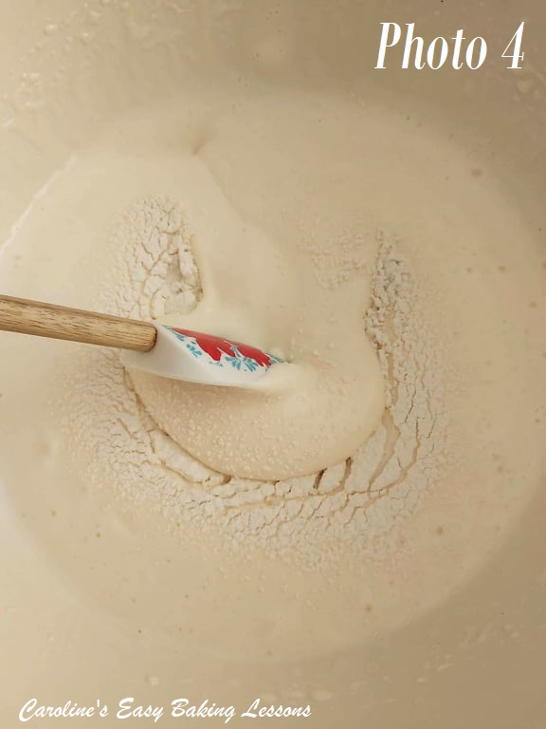

6. Place the sieve above the bowl of egg/sugar batter and sieve again half of the flour and cornflour (cornstarch) mixture and fold in with a rubber or silicone spatula. (See Photo 4). Don’t use metal as I find it knocks out a lot of the air you just incorporated. I like to do this gently with motions in the shape as if writing a number ‘8’. Think of the batter as your paper and the spatula as your pen. It mixes in the flour but doesn’t knock out the air that you spent time incorporating into the eggs & sugar. Once nearly all mixed in, then sieve in the final half of the flour mixture, again folding gently, being sure to scrape the bottom of the bowl, to see if you missed any flour. Do this folding, only until all the dry mixture is incorporated.

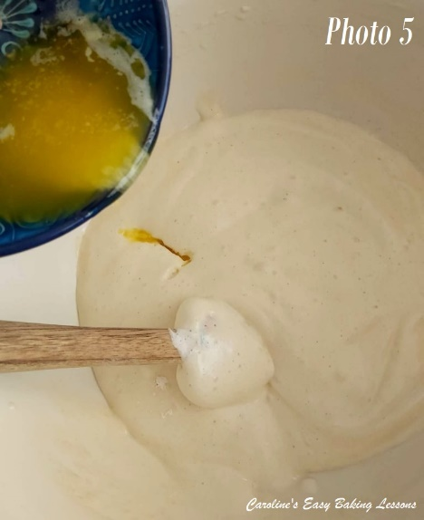
7. Pour the melted butter into the bowl of batter, at the edge of the bowl and allow it to drip down the inside of the bowl. See Photo 5. Then fold it in gently like before. You can also at this stage add a splash of vanilla extract if you like too.
8. Finish preparing the cake tin, by greasing with cooking spray or butter before placing the cut out, shaped baking/parchment paper down too. See photo 1 above for how to cut your paper to the correct shape for your dish. Alternatively, you can use Great British Bake Off winner Nancy Birtwhistle’s lining paste to keep the paper down, that is excellent and in particular for bundt pans. More economical too. Click here to go to recipe review. See Photo 6 below.

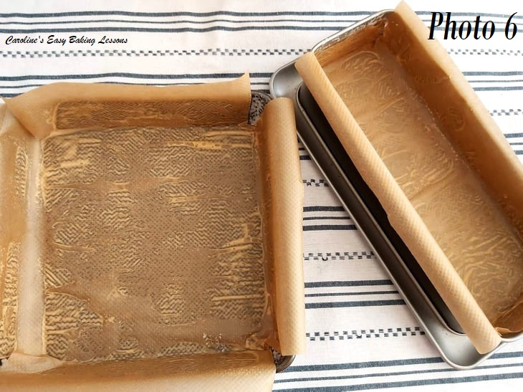
9. Now gently pour and guide the batter into the tin and try to level it off so that it is an even height throughout. Do not bang the tin on the worktop/counter as we want to keep the air in the batter. See Photo 7.
10. Bake in the oven for 15-20 minutes until a golden colour and fully cooked. Mine cooked at 16 minutes for the square tin and it had started to come away from the sides of the tin. (See Photo 8 below). You can check by inserting a cocktail stick or wooden tooth pick into the centre of the cake and if no crumbs are on it, then it is done. (Note I baked two at one time, and the deeper rectangular one, was ready at 18 minutes).
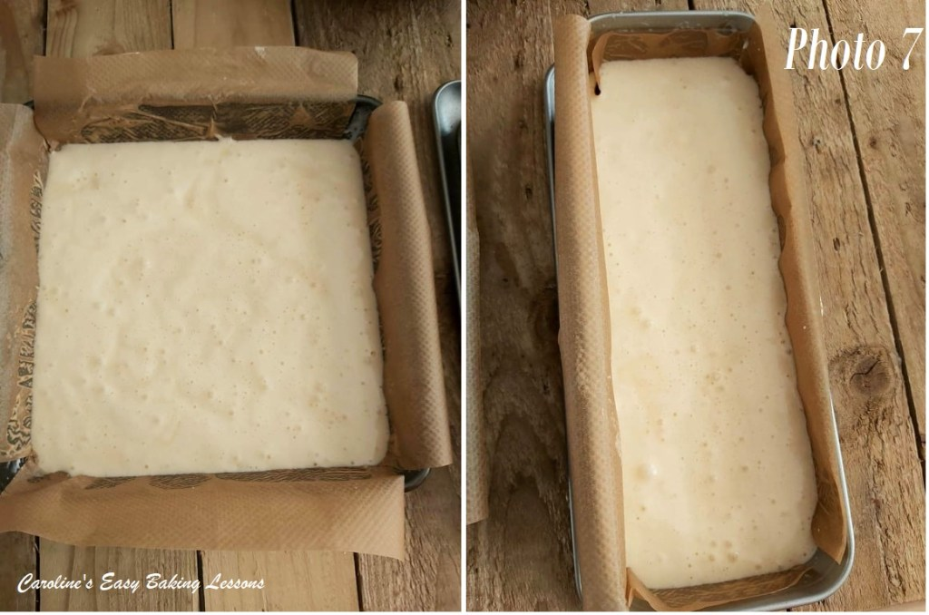
11. Leave to cool in the tin for about 10 minutes, on the cooling rack, before lifting out onto the cooling rack. This is where lining all the tin with paper helps get the cake out easier. You should be able to just lift it out by holding onto the edges of the paper. Alternatively, place a big enough plate or 2nd cooling rack on top of the cake and flip it over. Leave the cake to cool more on the rack before you make the frosting.

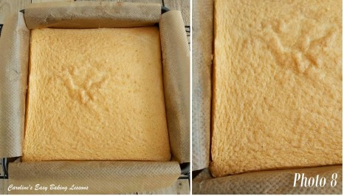
12. Melt the 15g (0.75 oz, 3 tsp/ 1 tbsp) butter in the microwave on 30 second bursts until melted. Leave to cool, then measure the icing/powdered sugar & cocoa powder through a sieve, into a medium bowl and mix together. Add the melted butter to the cocoa/sugar mixture and very gradually add in the milk, mixing and pushing down on the mixture with the back of a spoon until the mixture starts becoming darker and thick. Then add more milk and keep mixing as before until you get a thick but still runny mixture.

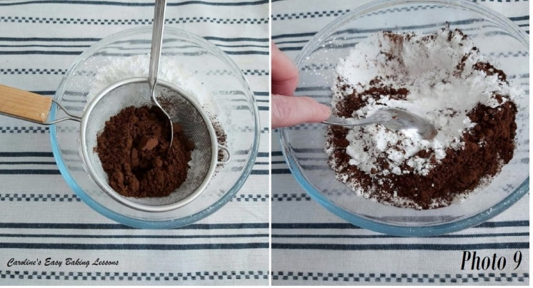

See Photo 10 below. I found it easier to use a spoon to put the frosting on. But if you want to dip in the mixture, make it thinner than in the photo. I used 125ml of milk (4.25 fl oz) but sometimes need more.

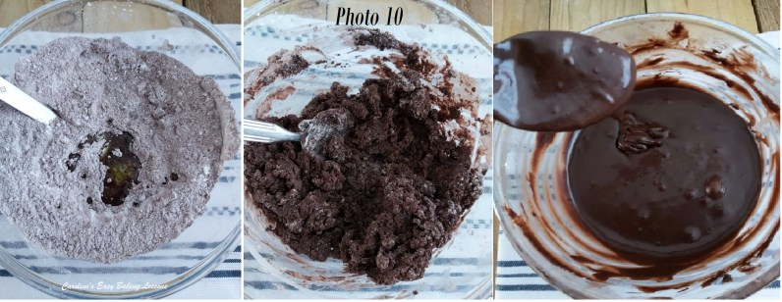
Making the chocolate glaze for the cakes

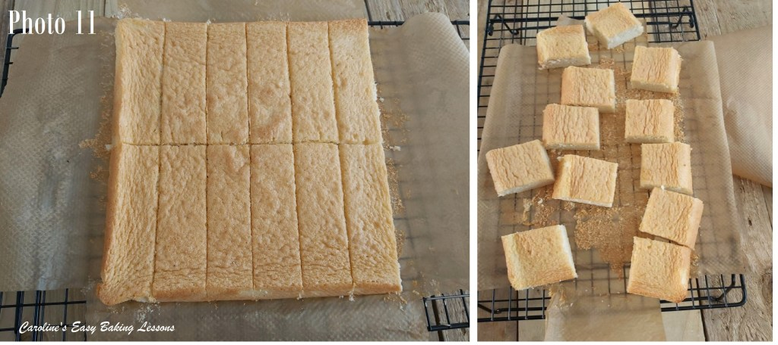
13. Cut the cake into 12 equal sized pieces (squares of rectangles depending on what shape of dish you used and what size you want – either is fine). Please read notes at beginning of recipe. Then carefully remove each cake from the paper and place back down again. See Photo 11 of the 2 different shapes.
14. Also prepare another plate with some clean baking/parchment paper (or just place on top of the cooling rack – just make sure you can fit it in the fridge).
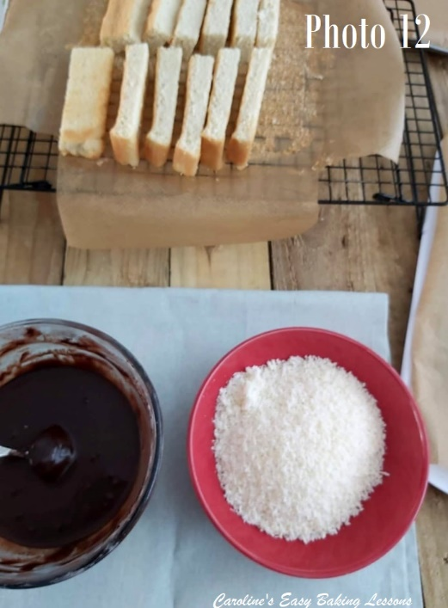
15. Arrange an assembly line before you begin. Have your bowl of chocolate frosting, a spoon or butter knife and a palette knife, a wide bowl for the coconut (I found dividing into 2 bowls was less messy, and leaving a hole in the centre of the coconut for where you will place the cake) Then lastly have your papered plate ready for the covered cakes. See Photo 12 below.

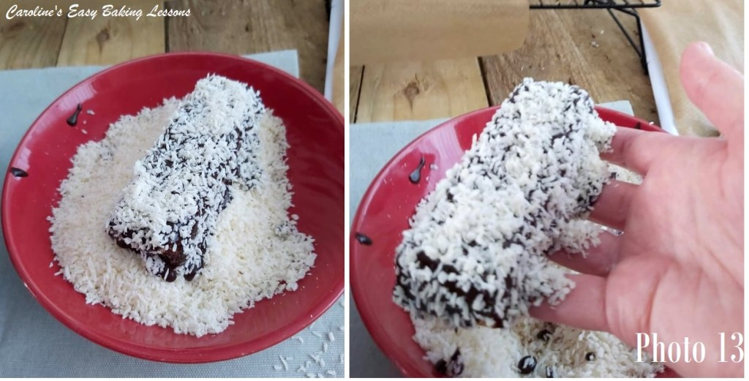
16. Begin by taking one cake piece and dipping one of the edges in the chocolate, (while still holding onto it). Then pull out and use your other hand to spoon or spread on the chocolate to the other edges, before resting it on the palm of your ‘dirty hand’. Then spoon some more chocolate on just the top side of the cake. (You won’t be covering the bottom of the cake).
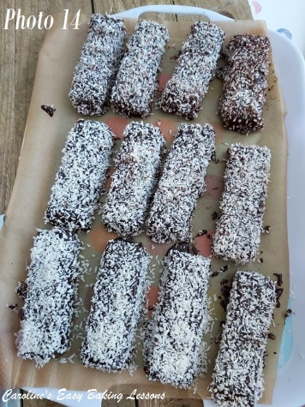
17. Next gently drop the cake into the centre of the bowl with the coconut. The bottom of the cake with no chocolate, should be at the bottom of the bowl. See Photo 13. Now use your ‘clean hand’ to push coconut up and onto the sides of the cake, letting it coat the chocolate well. Then with the same hand, or a small spoon, drop coconut onto the top of the cake. Give the side of the cake, a very gentle tap or two, for the excess coconut on top, to fall off. Then finally, use a palette knife, to lift the cake carefully, up and transfer to the prepared plate.
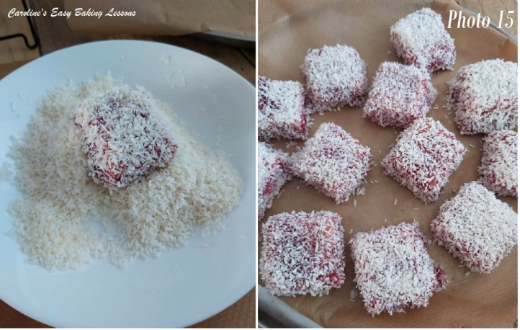
**I have in the past, applied the frosting to the sides and then placed on a cooling rack before adding the frosting to the top. But you then have to handle it to dip in to the coconut, so I found the other method easier. Same goes for if you wanted to pour the frosting (with a thinner consistency), all over the cakes.
18. Repeat for all cakes and then place in the fridge for at least a couple of hours to make lifting easier. See Photo 14. Leaving overnight in the fridge, and they will set up quite firm. They should ideally be stored, airtight and in the fridge or somewhere very cool and will last a few days.
19. For the jam version, I made square ones with a rectangular tin (read the beginning of the recipe & see Photo 11 above). For that I measured and made marking before cutting out, and had just a small edging to trim off.
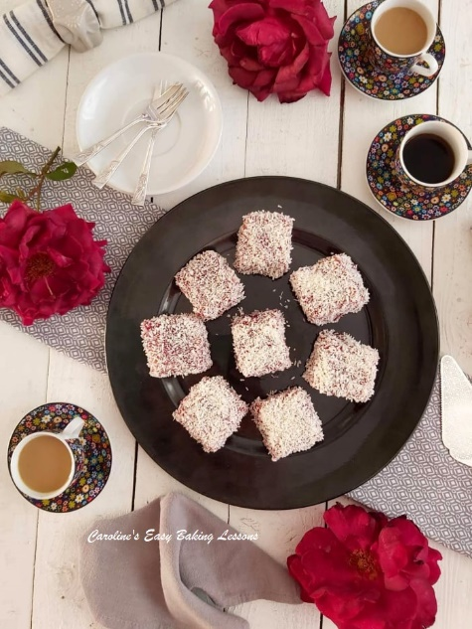
20. To apply the jam, I first added about 2 tsp water just to thin the jam a little. Just make sure not to have your jam too runny. I found it much easier just to spread the jam on the edges with a butter knife, before finally spreading on the top and coating in the coconut, just like above. See Photo 15.
21. The jam ones don’t need to go in the fridge, but they are a bit messier by nature. AND, tasty too!
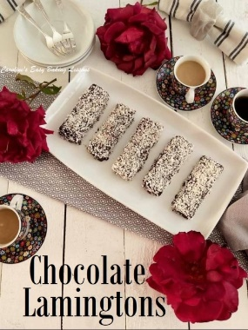
DIFFICULTY LEVEL: Easy, beginner with guidance

Thanks for reading
Happy Baking & Making
Happy Tummies & Memories!

Caro xx

