QUICKER HOTDOG BUNS
Caroline’s Easy Baking Lessons Savoury Lesson 8

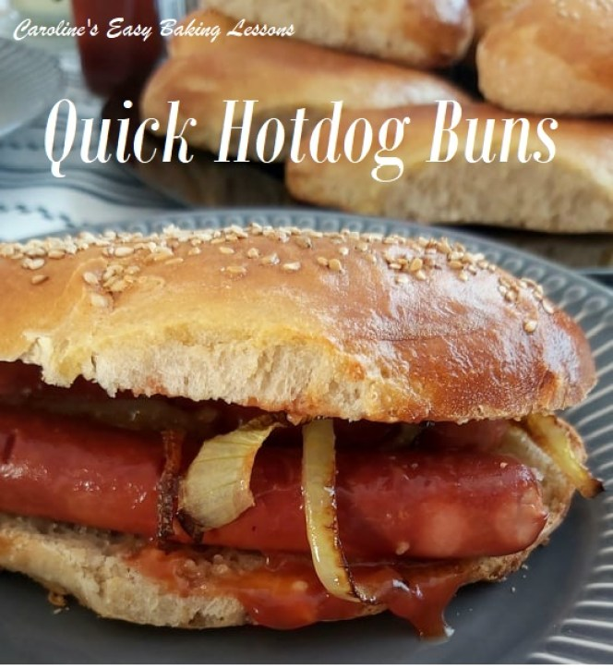
Following on from my Quicker Yeast Making Technique, that included 2 Hour Tear-And-Share Dinner Rolls, & 90 Minute Cheese Pizza, I now have developed a recipe for soft hotdog buns, that can be prepared, baked and out of the oven in under 2 hrs. This all thanks to a quicker recipe method, that involves a little more time spent on initially preparing the dough, but has a significantly shorter rising time (also known as proving). This recipe only rests for 15 minutes, compared to my old standard yeast method of anything from 1 – 1.5 hours. So this dough, (which is still yeast based), is a game changer, especially for bakes that normally require 2 rising times and can take between 3 – 4 hours to make. The recipe will take you between 1 1/2 – 2 hours to make, depending on how quick you are. But don’t think for one minute that there is any sacrifice on taste or look of the final bake. If anything it is even more yummy.

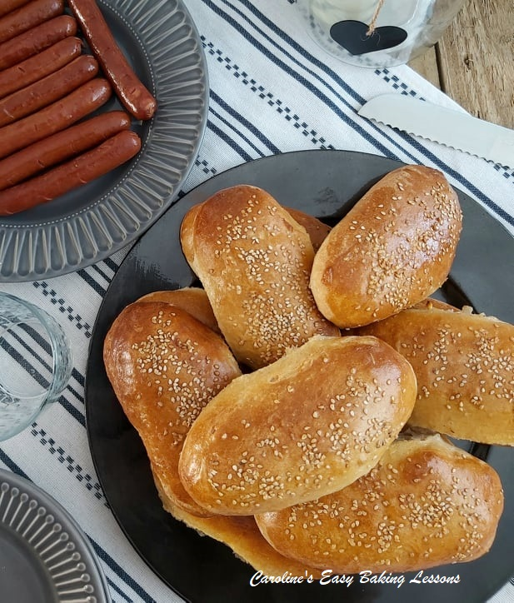

A NOTE ON INGREDIENTS
So no special ingredients are required for the dough, just the inclusion of egg whites. Now note the flour is separated into 3 amounts, as they need added in a specific way, and are referred to as [F1], [F2] & [F3]. This method works really well, and once you have done a few times, you really don’t need to refer to the recipe. And it’s the same process for making the dough, in all the Quicker Yeast recipes of mine. So stick with the recipe and you
*An additional note on the yeast. Normally I use fast acting instant dry yeast, but during the lockdown and shortages, I was only able to get active dry yeast in bulk. So this recipe has been developed and tested using both types of yeast, and with the same amount, with very little difference. If you can only get fresh yeast, you want 28g (1 oz) of this type of yeast. For more conversions of different yeast, see my Yeast Table. will achieve the same result.
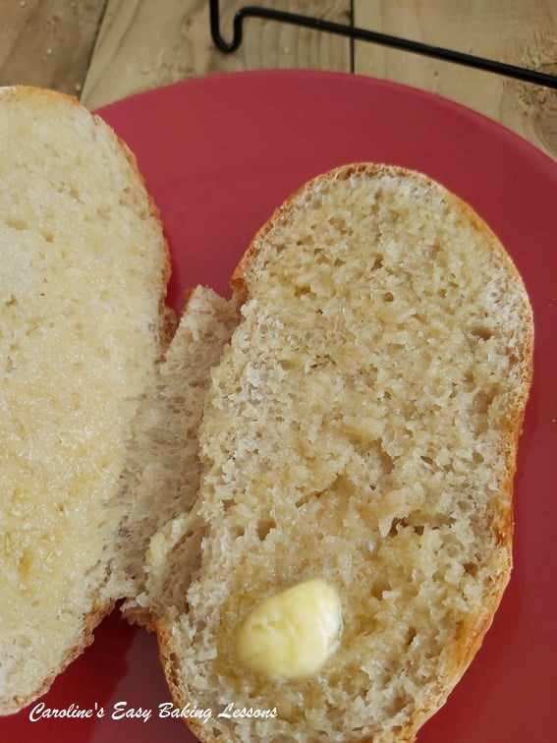

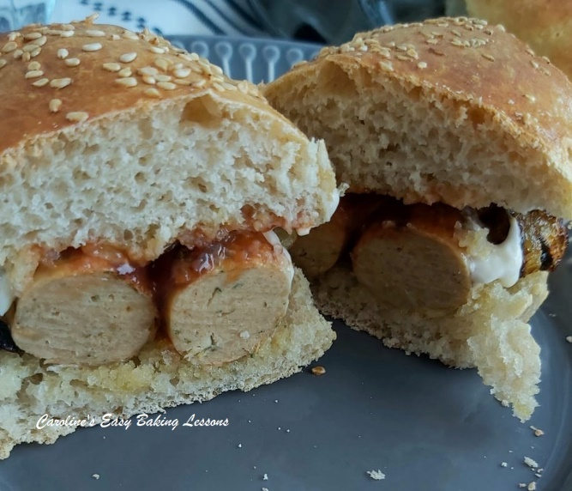
I am not going to keep you much longer from the recipe, but just have a look at the video below, that was used for a Facebook group bake-along, where my 2 hour tear-and-share dinner rolls recipe was used, to introduce beginners to bread making. It’s an almost real-time tutorial just so you can see even better how this process works. Watch it one time, and then you will have the hang of it

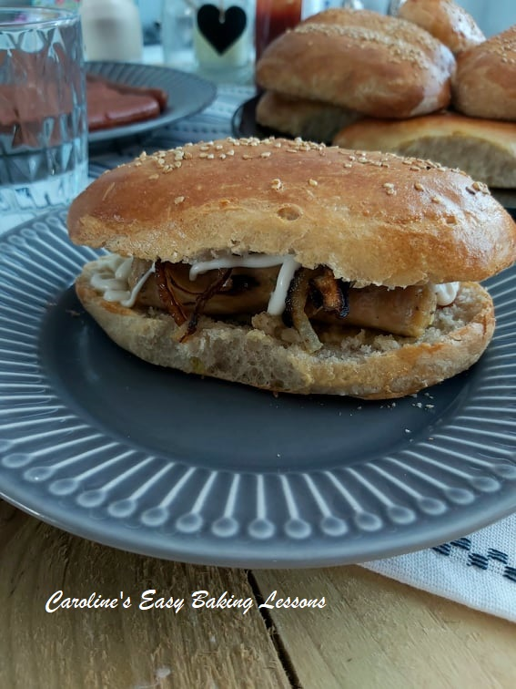
EQUIPMENT
- Scales or measuring cups
- Measuring Spoons
- Small Measuring jug
- Stand Mixer (Or large bowl and spoon)
- Small – medium microwave safe bowl if using.
- Food thermometer (optional)
- 2 small bowls to separate the egg
- Pastry brush (or small artist/paint Brush)
- 1 x-Large or 2 large sized baking trays/sheets
- Baking/Parchment paper
- Pen or highlighter
- Timer or Phone timer
- Cooling rack

INGREDIENTS
- 250g Plain Flour (2 cup, 8 3/4 oz AP)– [F1]
- 2 tsp Salt
- 2 tbsp Sugar
- 2 tsp Onion Powder (optional, or Italian spices)
- 14g Instant/Fast Acting Yeast (1/2 oz, 2 packs)*
- 400ml Water (5 fl oz, 1 2/3c cup) **(heated to 49-54c/120-129f) see below
- 4 tsp Olive Oil (or EVOO)
- 2 Egg Whites
- 125g Plain White Flour(1 cup, 4 1/3 oz, AP) – [F2]
- 250g+ Plain White Flour (2 cup, 8 3/4 oz, White AP) – [F3]
- Topping:
- Egg wash – 2 Egg yolks + 2 tsp milk
- Seeds of choice – I used sesame (optional)
- OVEN: 400f/200c/180c fan oven/Gas mark 6

INSTRUCTIONS
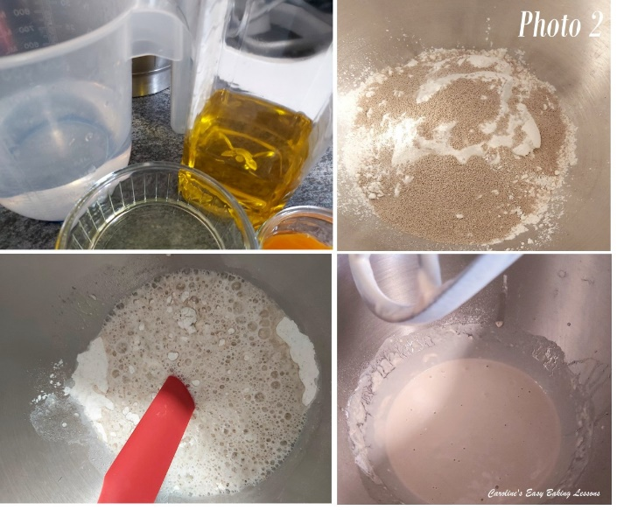
PREPARING THE DOUGH
1.Have the 3 amounts of flours weighted or measured out in separate bowls – you can use the stand mixer bowl for the first flour, [F1]. Place the oil and water into a microwave safe bowl or jug and heat for 30 – 45 seconds until just a little warm (120-130f, 49-54c). Alternatively used some hot water and cold water and check the temperature once mixed. It should be just above tepid.
2.Mix the salt into the first flour, [F1] and give it a good mix through. This is because yeast should never come into direct contact with salt or it will reduce the power of the yeast. This way the salt is coated in flour.
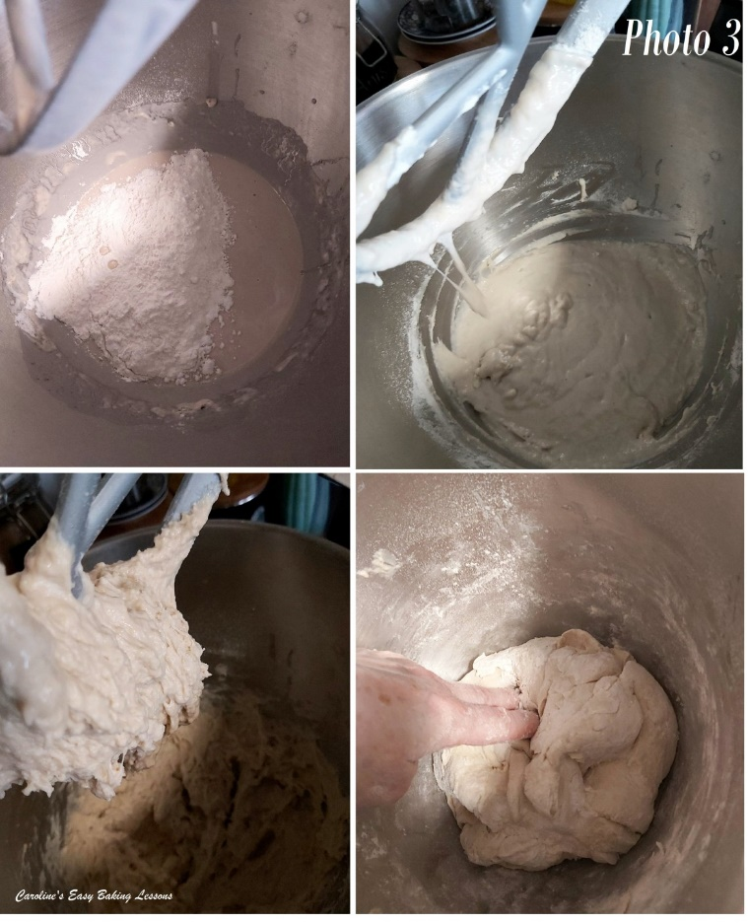
3.Add in the yeast, sugar and onion powder (if using) and mix through, one at a time. Once the water and oil is warmed, add this as well as the egg white to this dry mixture. Using the paddle (or ‘k’ hook) on the mixer, mix for 2 minutes. Be sure to time this. See Photo 2.

4. Now add in the smaller bowl of flour [F2], and mix for 2 minutes with a timer. The mixing in this recipe is very important so be sure to time it.
5.Slowly add in the flour from [F3]. You might not need it all, (or a little more - sometimes I have needed an extra 3/4c or 90g), but you want a dough that starts to come together as a very rough ball around the paddle. So mix for 10 seconds after each addition of flour and wait to see the ‘ball’ of dough. Note that the dough will be a bit sticky. See Photo 3.
6.Now put the dough hook onto the stand mixer (use a scraper to get the dough off the paddle), and knead on medium speed for 4 minutes.

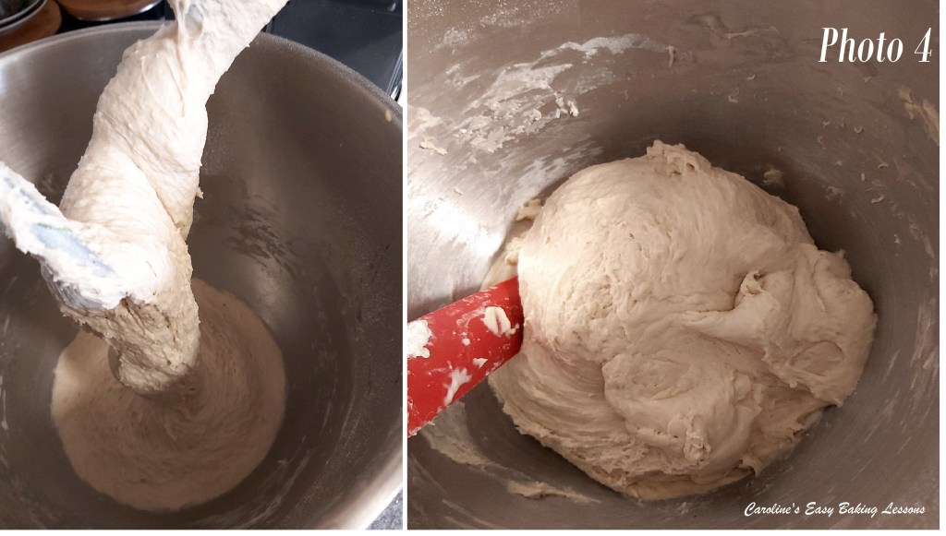
7. Using a rubber or silicone slim spatula, scrape the dough off the bowl from down the sides. Then tilt the bowl and put on it’s side, so you can see the bottom. Continue scraping the dough out towards the top of the bowl. Now wash and then put oil (or spray oil) onto your dominant hand and ease the dough out and turn it over so that the bottom of the dough is now at the top end of the bowl. Alternatively, just flick the dough over with a silicone spatula. Place the bowl back on the mixer and continue kneading for another 4 minutes. The dough does tend to stick at the bottom when kneading, and this is another reason why we turned it during kneading. Once the total kneading time is up, the dough will be forming a ball and cleaning the sides of the bowl. Have a feel of the dough to know how well kneaded dough feels. Note also how stretchy it is when you lifted the dough hook up. Scrape any dough from the hook and into the bowl. Now place a towel on top of the bowl and leave somewhere warm and draft free for 15 minutes.

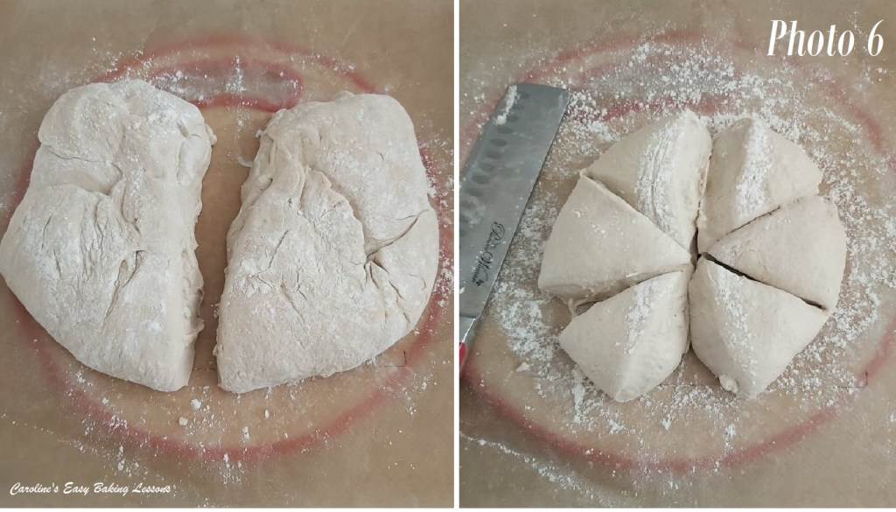
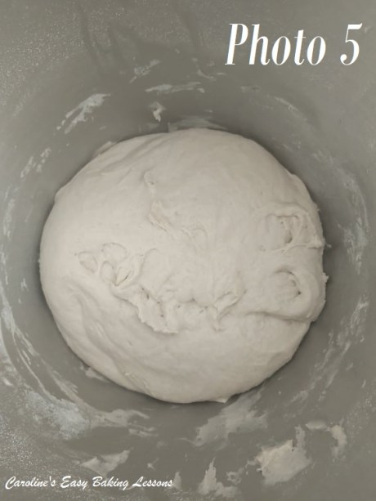

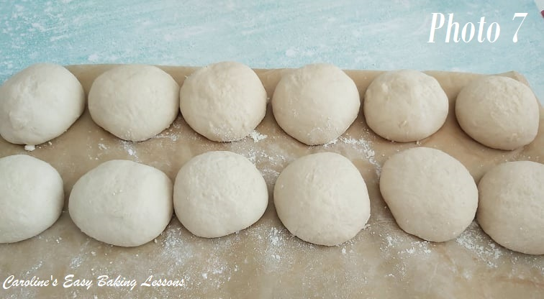
8. Well flour some baking/parchment paper or worktop/counter and your rolling pin. Release the dough from the bowl like before, (without oiled hands this time) and tipping, scrapping out onto the worktop. Turn the dough over and let it get a bit more flour on it. Knead the flour into the dough for a few seconds, adding small amounts of flour if needed for it to be manageable. Now divide the dough into 12 pieces. For equal sizes you can weigh or, divide in half and form each into one large disc shape. Then divide into 6 triangle segments like a pizza. Repeat for the 2nd disc to make 12 pieces. See Photo 6.

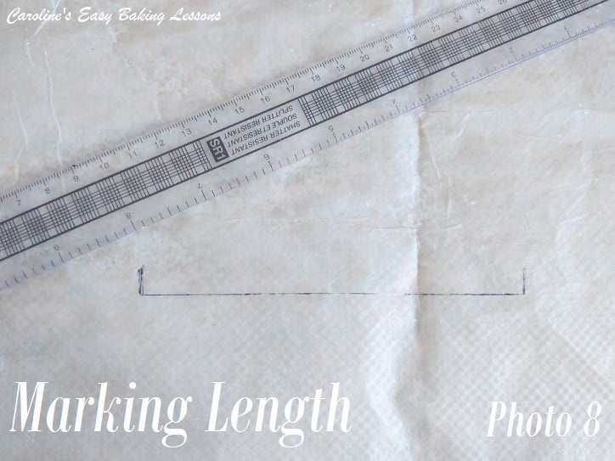

SHAPING THE ROLLS
9. Prepare 2 large baking trays/sheets with some baking/parchment paper. Oil in place if there’s no lip on them or the buns will slide off. Also take a small piece of baking/parchment paper and draw a 20cm/8 in line on one side of the paper with a thick dark marker pen and turn over. You will use this to help you with getting all the breadsticks the same length. (See Photo 8).

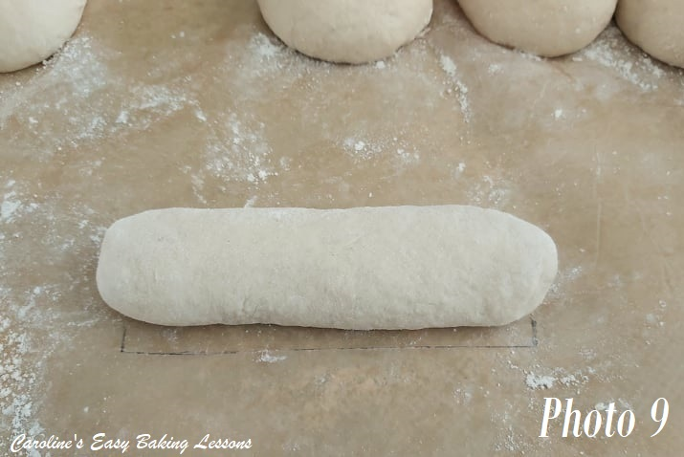
10. Take one piece of dough and roll into a ball. (See Photo 7 above). Then roll it into a rope shape between the middle of the palms of your hands, starting from the middle and working your way out. Continue until it is the length of the line you made on the paper. You can lay the rope dough on top of the paper to measure it. See Photo 8 & 9 for the guide line.
11. Place the buns on the prepared baking sheet/tray and repeat with the other 11 pieces of dough.
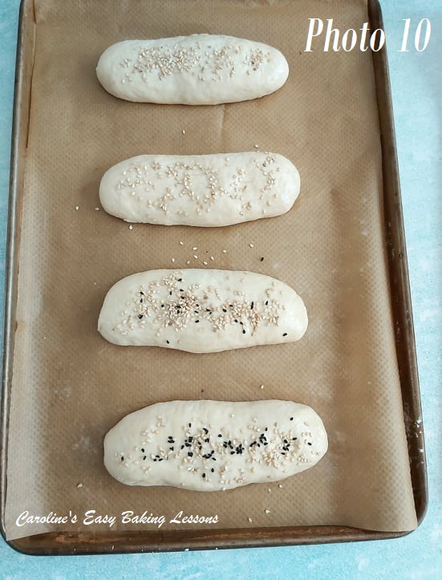
.

12. Mix up the egg yolk and milk well and then using a pastry brush, generously coat all exposed areas of the breadsticks and then sprinkle crushed rock salt or sesame seeds on top

13. Leave in the same draft free area for 30 – 40 minutes, while they will swell up and almost double in size. (This is known as proving). See Photo 11 below for how they should look. **Note that if your environment is really warm and sunny, this could take just 20-25 minutes, so keep an eye on them and get the oven on sooner if needed.
14. Heat up the oven to 220c/200c Fan Oven/425f/Gas Mark 7 before the rising time is up.

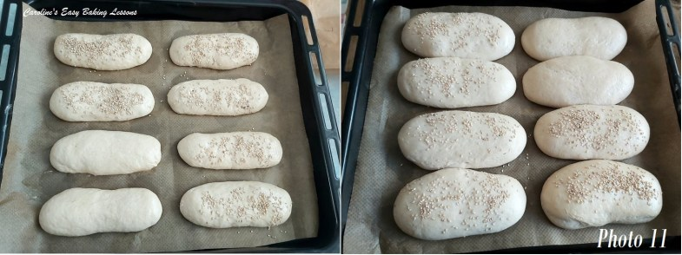

15. Place the trays of rolls into the hot oven and turn the heat down to 200c/180c Fan Oven/400f/Gas Mark 6. Bake for 15 – 20 minutes until well golden all over, remembering to apply more egg wash during baking. I was used to having an old oven, and un-even baking so I would time my bakes, turning the trays and rotating between the shelves if more than one tray was used. I would set the timer for 7 minutes, then turned the trays, brushed on more egg wash (dab it onto the ones with sesame) and baked a further 3 minutes. Then I turned and swapped the trays between the shelves, baking a further 5 minutes. At this 15 minute mark, the rolls are well browned but not fully done, so I turn them upside down and bake another 3 – 5 minutes. I like to add more egg wash to the bottom, and you might find on tapping the bottoms of the rolls, that the lower tray might need a minute or two longer.

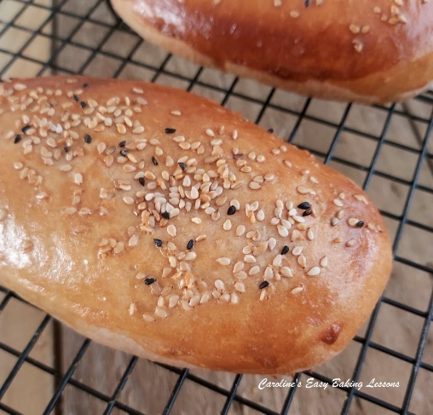
16. Once baked, leave the rolls in the trays for a few minutes before transferring to a cooling rack. Then leave to cool almost completely.
17. Slice with a large serrated bread knife and enjoy with your favourite filling. These are an ideal width and length for hot-dogs or sausages, but can be used for any filling. If your hotdogs are a little longer, you can get away with making these a little longer too as they are wide enough.
18. Store in a sealable food bag and will keep for a few days.

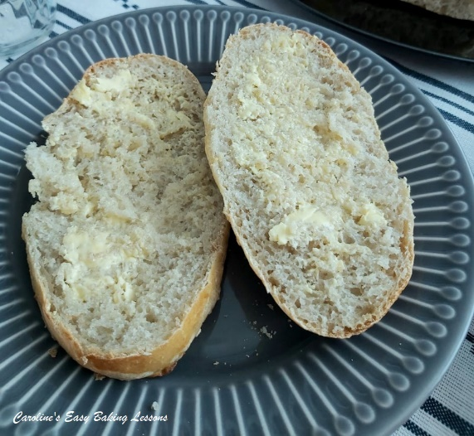
SIGN UP FOR MY NEWSLETTER – I would love it so much if you could sign up for my newsletter. I will send out monthly emails, showing the latest recipes and articles, and latest info. Being a site without ads, building a following, is even more important and will keep it up and running and for free to everyone. Occasionally there will be the odd seasonal emails, but is really a means of reaching you, if you are not already in one of the Facebook groups I admin. Please note too, that these email addresses are not shared or sold onto another party. Thanks so much
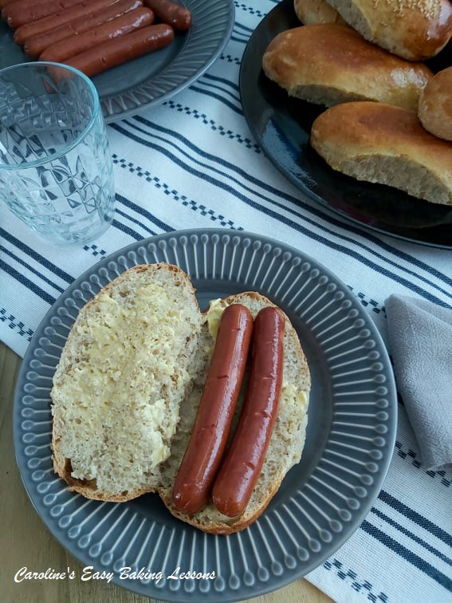
DIFFICULTY LEVEL: easy, with guidance

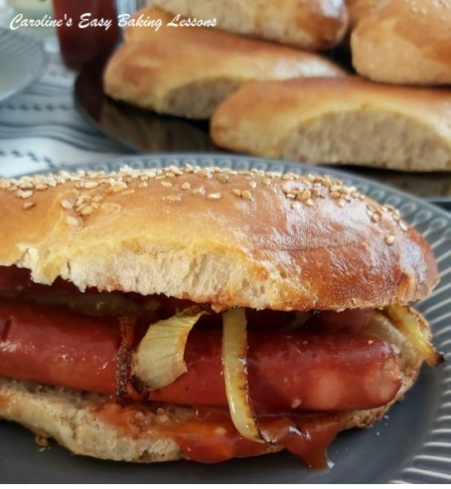

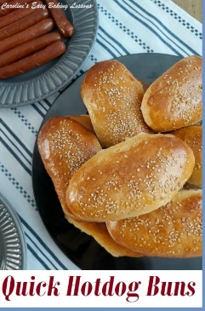

Thanks for reading
Happy Baking & Making
Happy Tummies & Memories!

Caro xx

