RHUBARB & ORANGE CAKE – A Recipe Review
Caroline’s Easy Baking Lessons

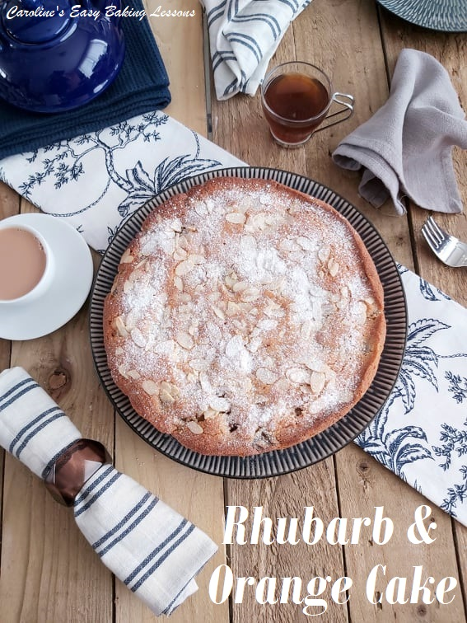
This is a review on a recipe for a Rhubarb & Orange cake, By Sara Buenf and is taken from BBC Good Food website. This came about as I had some rhubarb and was literally just looking through my baking books for a rhubarb recipe, when a friend in a Facebook group I admin, mentioned a nice recipe that she uses. So after taking a look at the recipe on-line, I decided I would give it a go and write up a review for you.
Without further ado, let’s get reviewing:

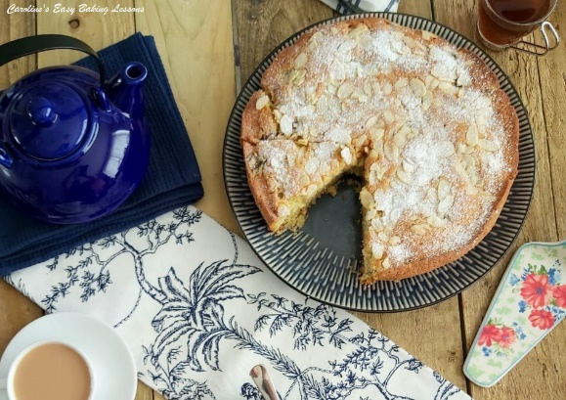

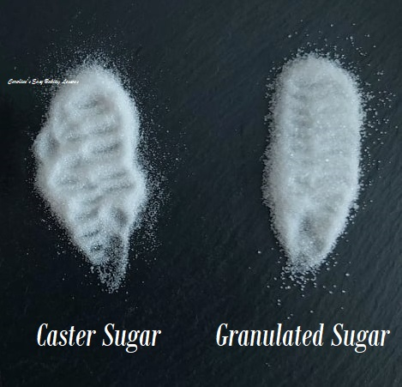

The Ingredients
Ok so let’s start with ingredients. The recipe calls for golden caster sugar, but I didn’t have any and to be honest have only ever found it and bought it once. It’s almost the same as our caster sugar (like extra/super fine or Baker’s sugar in the US & Canada), but is a light golden colour and has a mild caramel taste. But since it’s not as easily available, even in the UK, I stuck with caster sugar. (You can also substitute with caster sugar and light brown sugar – about 3:1 ratio I would recommend). Note also, that 280g of sugar is listed (but on reading the recipe instructions, you actually use 50g (1/4 cup extra/super fine sugar) of that to macerate the rhubarb). It doesn’t mention it’s to be separated in the ingredients list, so be careful of that and don’t add the 280g to the cake batter, but rather 230g (1 cup extra/super fine).
You can grind/process your own caster sugar from granulated. Just note though that US granulated is very slightly finer than our UK one, so only needs a little processing, as can be seen in the photo. For more on UK & US baking ingredients, read my article on Differences Between UK & US Baking Ingredients.
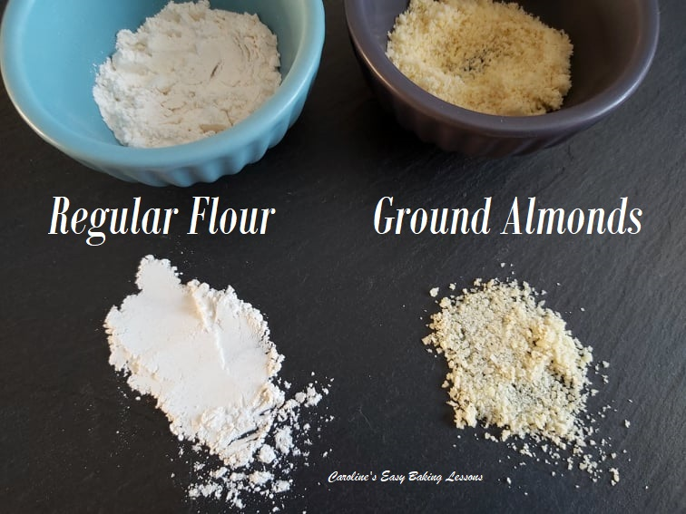
The recipe also uses ground almonds. This is NOT the same as almond flour. See my photo here of ground almonds, compared to regular flour. It is much more course than a flour and is very important in recipes for two reasons. The almonds give some moisture for the cake, via the oils within them, but most importantly, the ground almonds provide structure for the bake. Think of it as ‘bulkier’ material for building the cake. It doesn’t rise much, but makes it a ‘stronger’ cake. It also gives a slightly different texture to the cake which can be a nice change to the norm. So what should I use if I can’t get ground almonds you ask. Well you can grind your own from whole almonds (skins on as that’s where the goodness is). There are videos on YouTube on this, but basically you are lightly bashing the almonds in a food bag to break them up a little, before grinding in a food processor or grinder. Alternatively, you can use almond meal as a substitute.
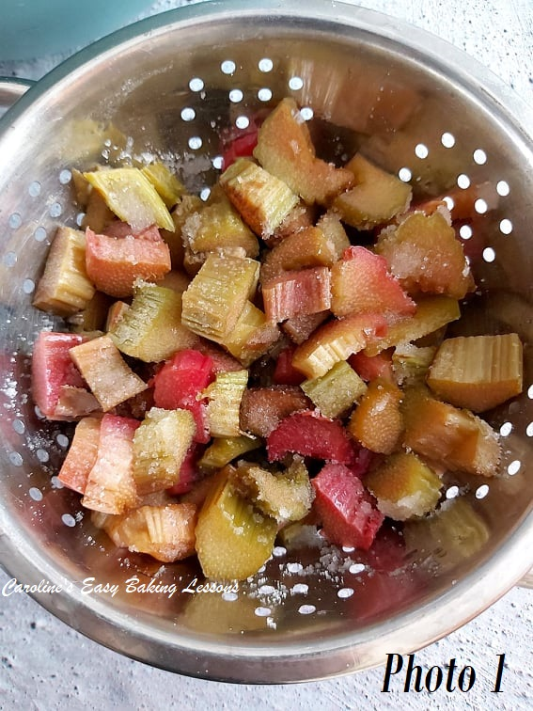

The Instructions
Next moving onto the instructions. You are advised to macerate the chopped rhubarb in the 50g (1/4cup) sugar for 30 minutes. This basically is adding sugar to the rhubarb, to draw liquid from the fruit, as rhubarb is extremely high in water content. I have since used frozen rhubarb for this recipe, and let it defrost, before draining the liquid and just coating the rhubarb in 2 tbsp of the sugar, just to take away some bitterness.
Now the oven is to be heated up, while you prepare the tin and batter. Conventional oven centigrade and fan oven temperatures, as well as the gas mark are all listed, but no mention of Fahrenheit for other countries such as the US & Canada.
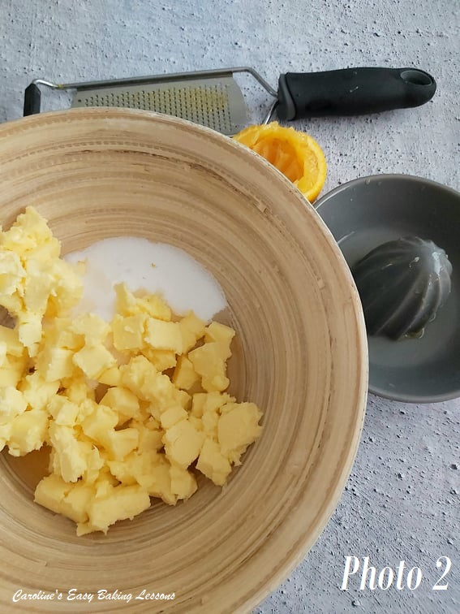

You are then instructed to add the remaining sugar, softened butter & orange zest/juice to a mixing bowl.
***Top Tip – for getting your butter to soften quicker, cut into pieces about 1cm (1/3″) size and this smaller surface area, results in the butter softening and coming to room temperature quicker. See Photo 2. (Go to my quick video for this). If you forget to take your butter out on time to soften, try this hack I tried, for Softening Butter In About 12 Minutes.

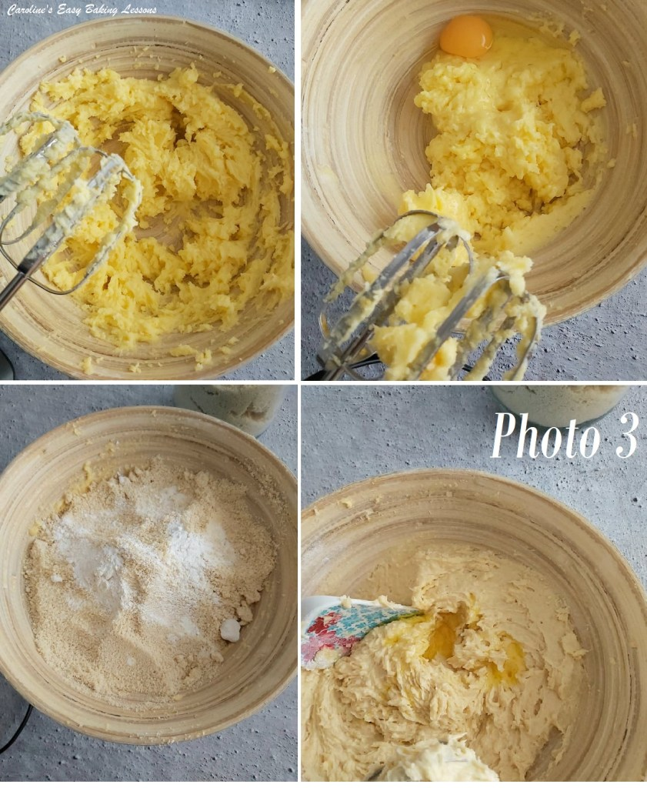
Now it doesn’t say ‘cream’ these ingredients, but rather to beat until well blended. But as I am a creature of habit, I did beat these ingredients for a couple of minutes till creamy & fluffy. See Photo 3.
You are then to add in the flour, ground almonds, baking powder and eggs. But I beat the eggs in lightly first, one at time, before adding in the dry ingredients. Finally you are to fold the rhubarb (& juices) into the batter.
***Top Tip – for less chance of all the rhubarb pieces sinking to the bottom of the cake, you should coat the fruit in flour first. I used about 2 tbsp of flour and did so, immediately before adding to the batter. And another thing I do for a more even distribution, is to add in 1/3’s. Fold in 1/3 of the rhubarb very lightly and gently, and repeat two more times. See Photo 4 below.
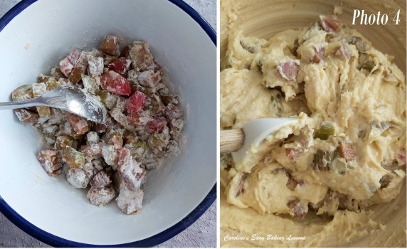

Now I greased my cake tin with lining paste. This is homemade and less expensive than butter and flour, or cake release sprays. Click here to find out how to make your own. It’s excellent for bundt pans. (See Photo 5 below).

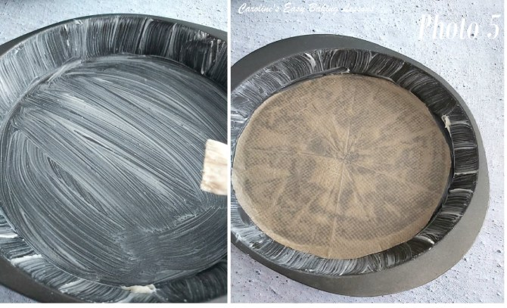
The cake is then added to the tin and flaked almonds scatter on top. Now this leads me to a problem I had with the tin. The recipe was for a 23cm (9″) round tin. My tin was actually 24cm/9.5″ but when I filled the tin with the batter, well it was F.U.L.L. See Photo 6. I was really worried I was going to have cake all over the oven. The recipe did not say what depth the tin was to be, or mention of ‘deep’ tin and from the recipe photo, it didn’t look like an overly deep cake. (My tin was 24cm/9.5″ diameter x 3.25cm (1.25″).) So as you can see from the photo 7 below, only a short time during cooking, and the cake as already up over the top of the tin by about 1cm (1/3″).

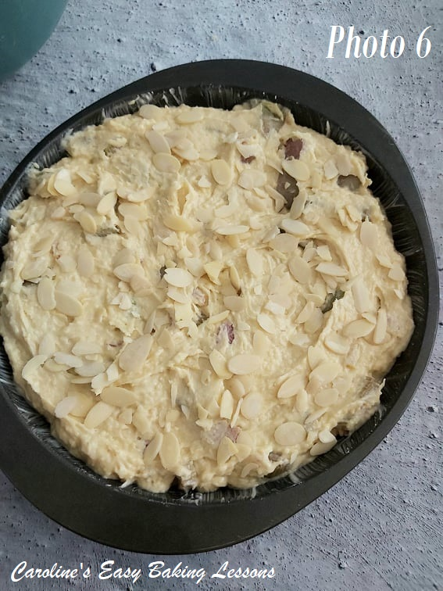
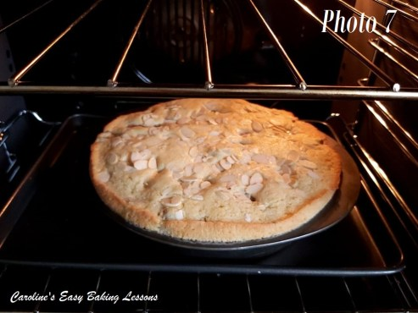

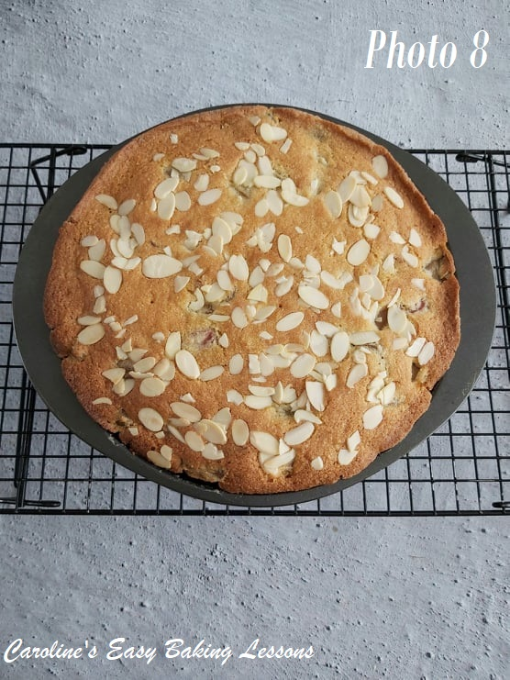

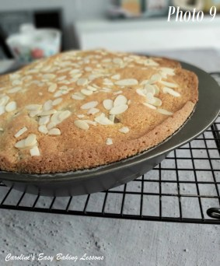
You were to bake for 1 – 1 1/4hrs, until risen, golden and a skewer comes out clean of crumbs. It did advise covering the top with foil if it colours too soon, which I actually had to do at the 40 minute mark. In the end, mine was fully baked after 1 hour. The cake is left 15 minutes in the tin to cool, before removing and allowing to cool completely. As can be seen from photo 9 below, the cake didn’t rise any further thankfully

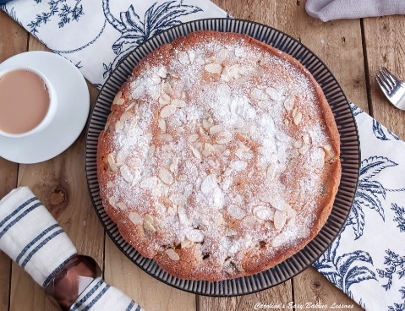

Baked Results – Did It make The Cut?
So how did it taste? Well it was nice, and the ground almonds gives a nice texture. I felt though that the rhubarb pieces were too small and could have taken a little more of them too. I could not taste any of the orange zest or juice and I think it would have been better if it had. I would suggest using a lot more zest, even doubling it and adding a few tsp of good orange extract too or maybe even a touch of salt, just to bring the flavour out a bit more.
Would I make it again? I think maybe, but with these changes as mentioned above and either with a wider tin, deeper tin, or even reducing the recipe down to fit my tin better. (If you want to learn how to reduce a recipe to a smaller dish size, check out my calculator, with hand table and video on how to do this). I would reduce by about 1/5 to 1/4 and multiply the ingredients either by 0.8 or 0.75.

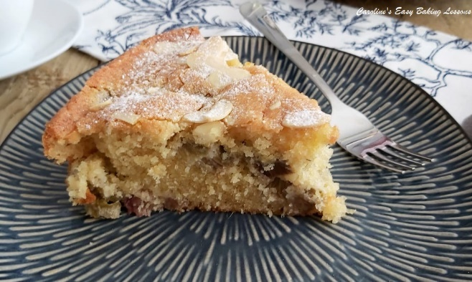
My Thoughts
How did the recipe itself fair? Well as mentioned no mention of oven temperature in Fahrenheit, or inches size for the cake tin. No cup or even ounces measurements for the ingredients, or alternative ingredient names. There was also only one photo of the baked cake, (although it did have a cut piece included, so we could see the inside of how the cake should look). No process pics, no pre-baking pic which I would have liked to see as a reference to my overly full tin. The recipe also didn’t mention ‘creaming’ the butter and sugar, which is important for getting air into the batter. It was however, a straight forward enough recipe, that I agree is considered ‘easy’. But for beginner bakers, and with only 3 steps to the recipe (& a total of 10 sentences), this might not have been as ‘easy’ or straight forward.

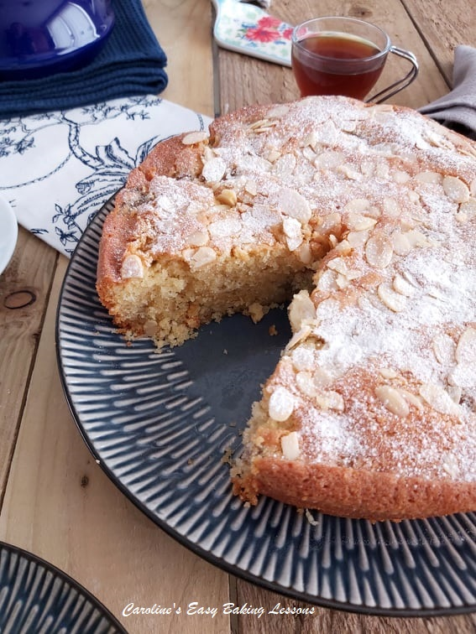
How Do I Rate It?
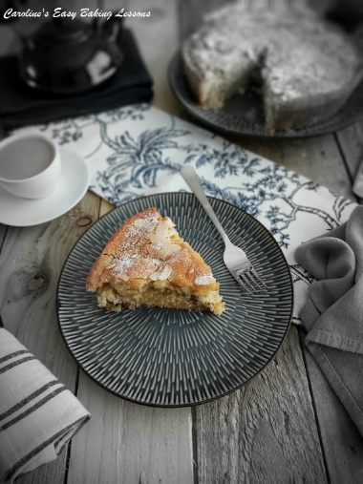
So taking everything into consideration, I rate this recipe a 6/10. It has potential, but I feel it let itself down a bit and wasn’t inclusive by it’s limited ingredients measurements. But since I like to hear what you guys think, I have added below my conversions of the ingredients, from grams to ounces and to cups. (Note I have hand measured all these, as Google can be inconsistent and inaccurate. I have my own article with a handy table of conversions for most common baking ingredients you can check out). I have also added the oven temperature and inch size of the tin for your reference. Do let me know if you try the recipe out and if you try my alterations. I would love to hear and see how you get on, so remember some photos. Tag me on social media, comment below, or send me a message.

INGREDIENT CONVERSIONS
Click here for original recipe
If using a mobile phone, simply swipe the screen to view all the table below.

INGREDIENT | OUNCES & CUPS | ALTERNATIVE | OUNCES & CUPS
Rhubarb | 14oz (3 1/4 cup) | — | —
Golden Caster Sugar | 8 oz (1 cup) | Caster, Extra/Super Fine | 8 oz (1 cup)
Butter, unsalted | 8 oz (1 cup, 2 sticks) | — | —
Ground Almonds | 3.5 oz (1 cup) | Almond Meal | (3/4 cup)
Self-Raising Flour | 8 oz (1 3/4 cup) | Self-Rising Flour | 8 oz (1 3/4 cup)
” “ | OR | Plain (A.P.) plus baking powder | 8 oz (1 3/4 cup) + 4 scant tsp baking powder
Medium Eggs | Large for US/Canada | — | —
Oven Temperature | 350f | 23cm Tin | 9″  (But a smaller diameter could be used. Just bake for longer)

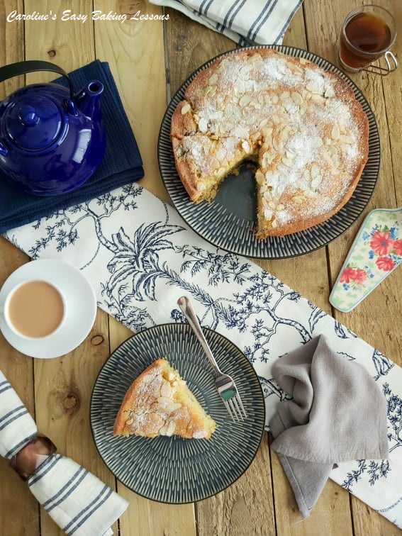
RATING: 6/10

Happy Baking & Making
Happy Tummies & Memories!

Caro xx

