FIG & ANISE POLENTA BUNDT CAKE

A Recipe Review

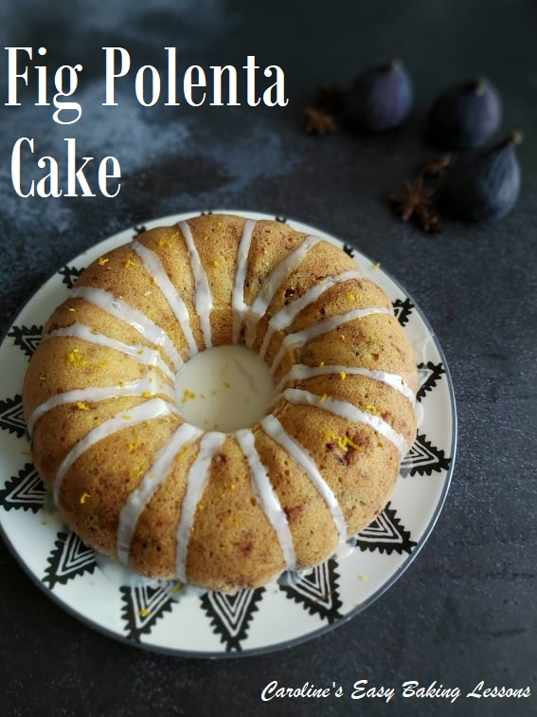
Caroline’s Easy Baking Lessons
This is a review of a recipe suggested to me, late summer last year. I was looking for fig recipes to try out when I was gifted a full tray of black figs from Bursa, Turkey. We obviously had some to eat as is, but I wanted to bake with some too. The recipe I tried in the end was entitled ‘Fig & Walnut Polenta Cake’, by Kellie Anderson of Kelly’s Food To Glow. As well as not having baked with figs before, her recipe used Polenta and I just happened to have some. That and it looked nice and was baked in a bundt pan, so not much more encouragement was required to test it out. (See original photo below).
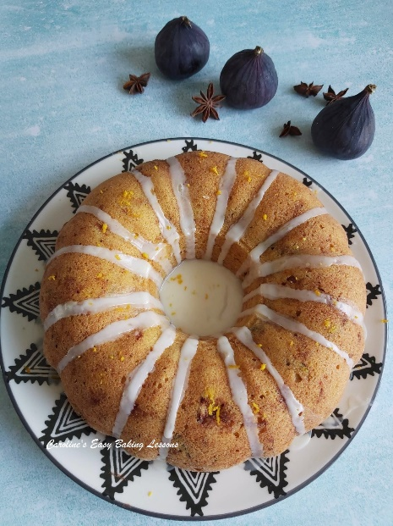

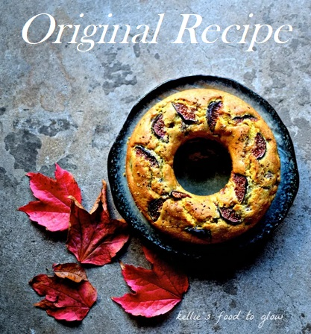
On reading her blog before the recipe, it transpires her figs were from the same region in Turkey too, and the friend who gifted them to us, was actually born in that same place! Either way, they look very colourful and photogenic, inside and out, as my photos show below.
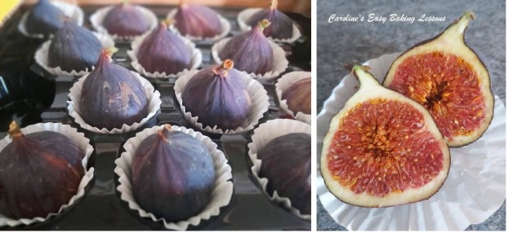
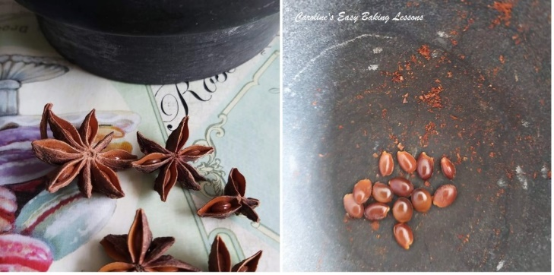
The original recipe as mentioned has ‘walnut’ in the title. This actually refers to ground walnuts, but ground almonds are also given as a suitable substitute. And rather than toast and grind walnuts, I used the ground almonds I had on hand. Paired with polenta, there is not actually that much flour in this recipe and I would imagine it could work with gluten free flour too and some Xanthum Gum. Another ingredient I changed slightly was the anise seeds. I only at that time had star anise (actually for decoration more than anything else). So I did a little research to find out how many of the little shinny pods to use from the ‘stars’ and just used a mortar and pestle to grind that down. I like aniseed flavour, but have never used anise in anything myself. I hadn’t actually tasted anything with it until a little before this, a friend made me some lovely moulded cookies that were actually flavoured with anise. I liked it so much, I was definitely using in this recipe.

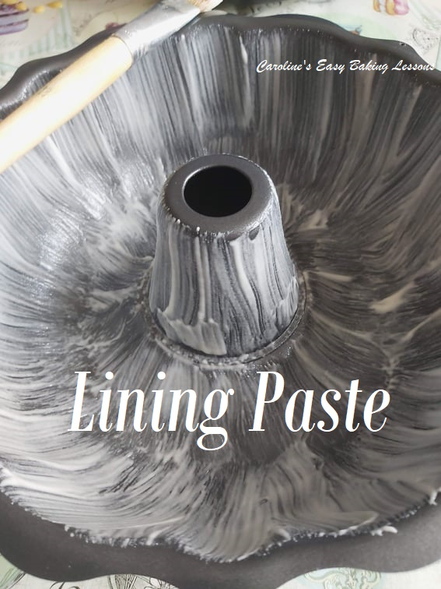
Now onto the baking! The recipe was in grams, but no ounces or cup measurements, despite there being an American oven heating provided and the author being an ex-pat American. After pre-heating the oven (which also didn’t include gas mark heating), you are instructed to line the bundt pan with butter or oil and then flour. I instead used my trusty lining paste recipe. It is perfect for bundt pans, and less expensive than using butter and flour, or buying cake release spray. Click here to go to how to make your own lining paste, that can be used for baking and cooking. (Other thing to note, I rarely turn the oven on at the very beginning, as the instructions/steps can often take a lot longer than ovens generally heat up at, especially when not a very high temperature).

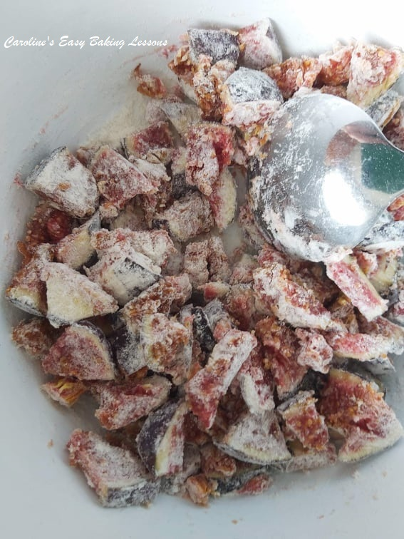
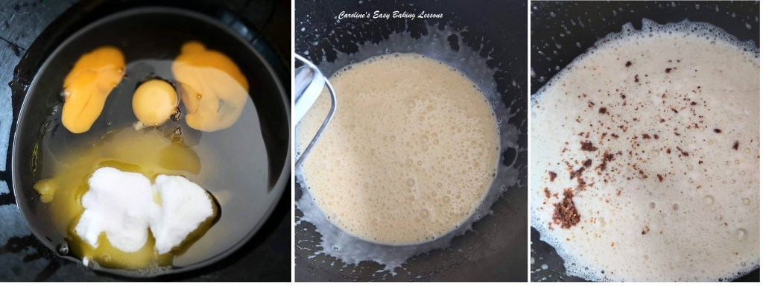

You are then instructed to blend the oil, eggs & sugar for a few minutes until “…lighter and…. changed in texture” . I did so till pale in colour and creamy looking. (See photo above).
The figs are then tossed in some flour, and this is a good instruction, as it coats the fig pieces and reduces the chances of all the figs sinking to the bottom of the cake (although with this being a bundt cake, that would end up being the top, so wouldn’t really matter).

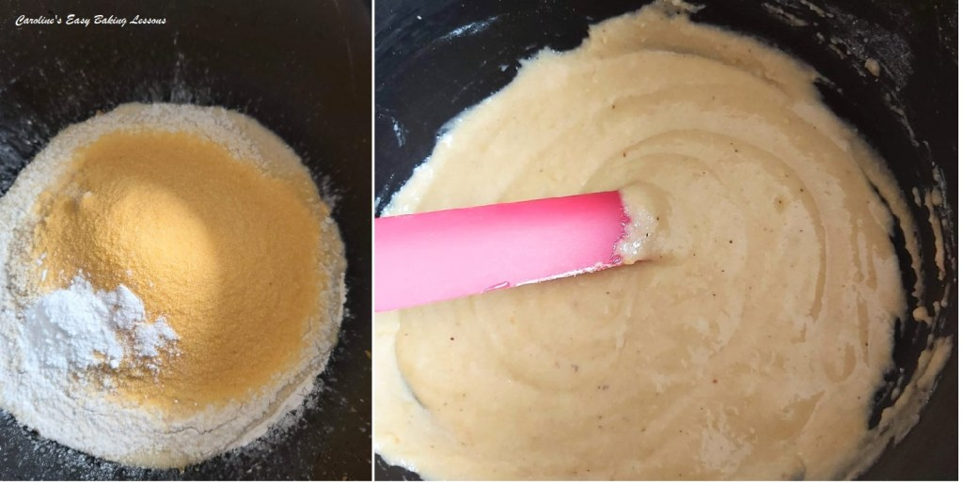
Then the dry ingredients are added to the wet, before the chopped fig pieces are folded in gently. My tip here too, and to help for more of an even distribution of the figs, add in 3 increments and just fold in lightly, being sure not to over-mix.

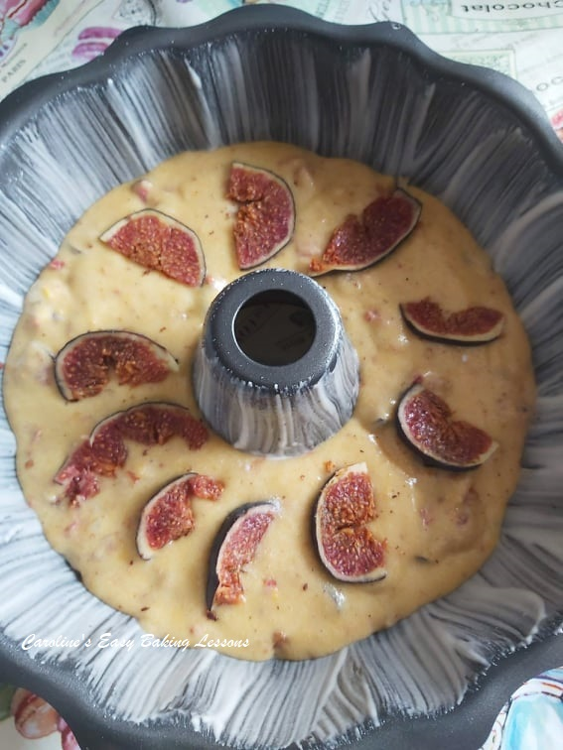
You are finally instructed to pour the batter into the prepared bundt pan, and top it off with the sliced fig pieces, before baking for 30 -35 minutes, or until the cake is coming away from the sides of the tin. It does not tell you how long to cool the cake for. So I left the bundt for at least 30 minutes cooling on the rack, before turning out of the tin by placing a plate on top of the cake and turning it over.

THE RESULTS
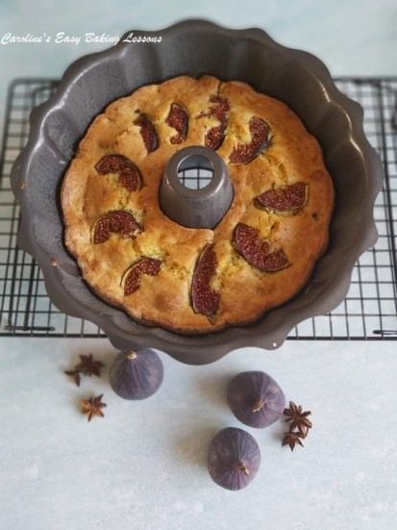

My Thoughts
The cake did release quick successfully, with not really any cake pieces left behind in the tin. But note, I did use lining paste. What I did notice though was that I did not have the sliced fig pieces on what is now the top of the cake. (See photo below). These were layered on top of the cake batter at the end, and not at the bottom of the tin. The recipe photo clearly shows slices and not pieces, and in too regular a pattern, that I think maybe that they had these at the bottom of the tin too.

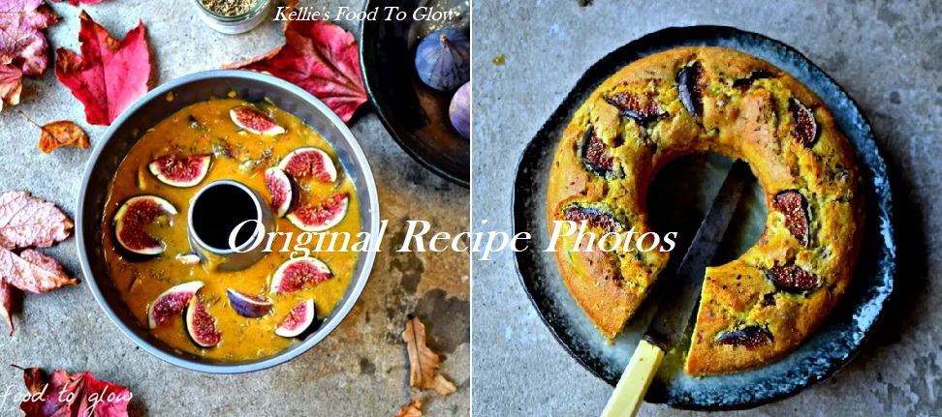
Original recipe photos – Kellie’s Food To Glow

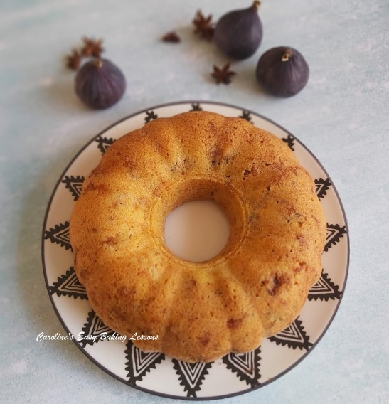
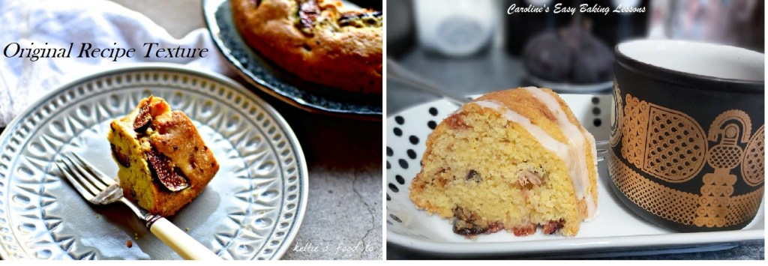
Also my cake was much more smooth a finish too I noticed. And the only different ingredient was not using ground walnuts, but I used ground almonds which are coarse too (for US readers, ground almonds are like almond meal, and not as smooth as almond flour). The pieces of fig inside the cake looked bigger too than mine, so take a note of my chopping size in my pics.

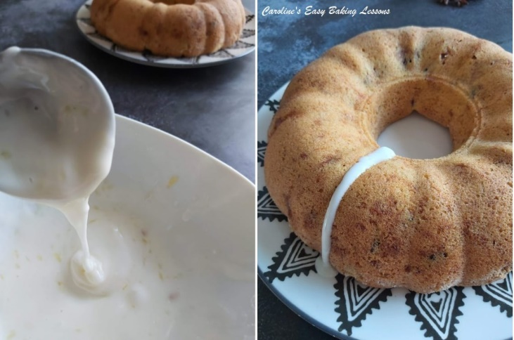
I noticed too that I had a better rise on my cake and the bundt pan was the same size, but that could have been to do with my technique habits, (no over-mixing etc). The cake also sliced nicely too. Taste wise, it was nice. I felt though that a lot more orange zest or even extract could have been used. And dare I say it, some more anise! The texture was nice too. Would I make it again? I think probably, with the alterations above, and even one without the polenta. Going to experiment more with anise, as I now have a big jar of powdered anise.
I also chose to add just a little bit of icing/glace just to give a little extra sweetness. I just used about 1 cup (125g) icing/powdered sugar and added small drops of orange and lemon juice and zest, to give a little taste. Then I carefully spooned small amounts from high above the bundt and let the glaze glide down the groves of the cake.

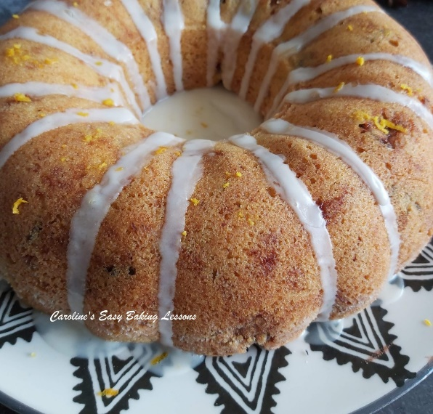
DID IT MAKE THE CUT?
How would I rate the recipe? Well it didn’t have lots of process pics, but did have more than just the one of the bake, and also of what the batter looked like before baking. The instructions however were quite short and basic and so perhaps not as enticing to a beginner baker. It is however, a very simple straight forward cake, and with no decorating required and not too sweet, this could be quite a popular recipe. And as mentioned above, there were no ounce, cup measurements etc, so taking everything into account I rate this recipe a 7/10. It’s on the high end of my rating, because it does produce a nice bake in the end. So here’s the link again to the recipe if you want to try for yourself. I have noted below the ounce and cup measurements for your convenience. Please let me know if you try it, and take some pics and tag me on social media, or add to the comments.

INGREDIENT CONVERSIONS

Go to original recipe
INGREDIENT | AMOUNT
Oil | 2/3 cup (5 fl oz)
Caster Sugar (Extra/Super Fine Sugar, Baker’s) | Level 1/2 cup (3.5 oz)
Eggs (US Large) | 3
Walnut Pieces | Heaped 3/4c chopped (3.5 oz)
Ground Almonds (Almond Meal) | Heaped 3/4 cup (3.5 oz)
Fine Polenta | 2/3 cup (3.5 oz)
Plain/All Purpose Flour | 2/3 level cup (2.5 oz)
OVEN TEMPERATURE | Gas Mark 4

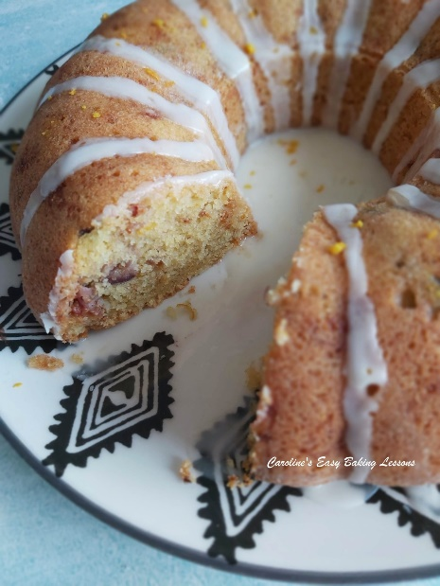

RATING- 7/10

Thanks for reading

Happy Baking & Making
Happy Tummies & Memories!

Caro xx

