THEORY LESSON 1 – Essential Baking Equipment
Caroline’s Easy Baking Lessons

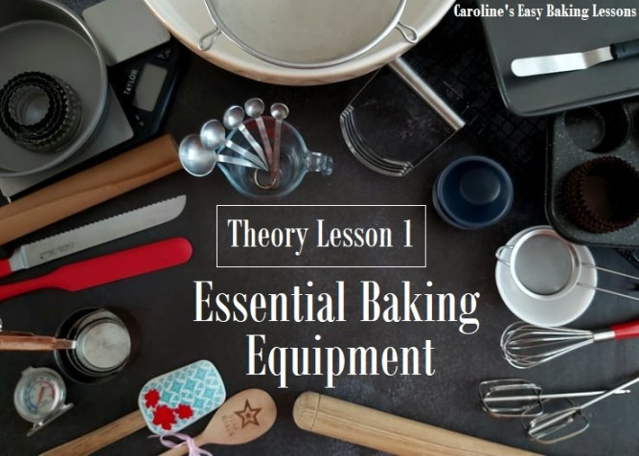
“Baking is a science – chemistry of a precisely measured set of ingredients, prepared and altered in a specific way to produce something very different in taste, texture and volume, (as well as being delicious to eat)! “
^{To quote myself}

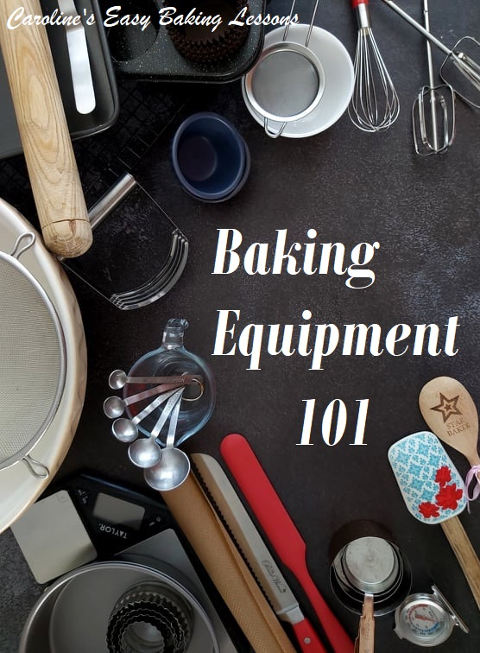

So what equipment do you really need? Below is a list of what I consider essential equipment. For the first few lessons’ recipes you won’t need everything but make sure you have a thorough read through this guide, as you will need everything at some point. Note however that there may be another household or kitchen item that you could use as a substitute and I will briefly mention those in this lesson. A fuller list will be discussed in THEORY LESSON 2. You can DOWNLOAD this lesson – click below to save to phone or computer for using later or printing off.

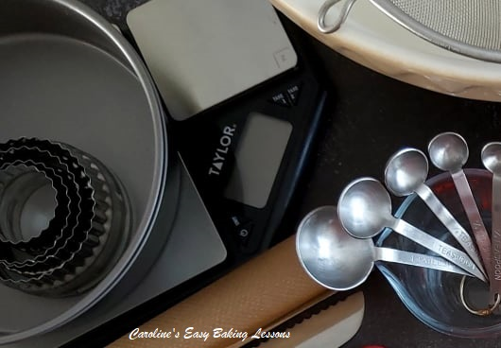

DIGITAL SCALES
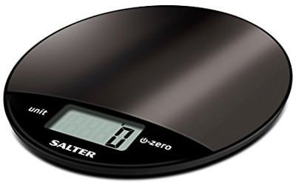
Scales are normally used for measuring dry ingredients. Can measure in Kg (kilogram), g (gram), lb (pound) & oz (ounce) units of measurement. These type of scales are more accurate & also have a larger weighing plate than other types of scales. Additional ingredients can also be added at the same time by simply resetting the scales to zero each time you want to add in a new ingredient (TARE button). A good tip is to always have a spare battery for the scales just in case, although they do generally last a long time. Also note, that most scales often offer more than one unit of measurement.
Digital Scales

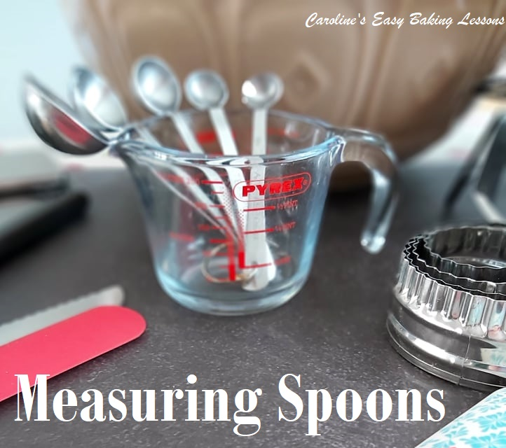
MEASURING SPOONS
These spoons are plastic or metal and come in a range of sizes: 1 tbsp (tablespoon), 1 tsp (teaspoon), ½tsp, 1/4tsp & 1/8 tsp. Sometimes – 2tbsp, ½ tbsp & 2 tsp are also available.
These are for measuring dry ingredients, (for example salt, baking powder, sugar & cinnamon) and have a corresponding gram weight for each, depending on the ingredient you are measuring. They can also be used for measuring liquids, (such as oil, vanilla extract, milk & water), and the equivalent of these are ml (millilitre). 1 tsp of liquid is 5ml & 1 tbsp is 15ml.
These are essential as ‘tea spoons’ that you use when making tea & coffee and dessert spoons are not the same as baking tsp & tbsps and would produce inconsistent results in your bakes. The plastic ones can be bought for as little as £1($1.40) and be low maintenance.
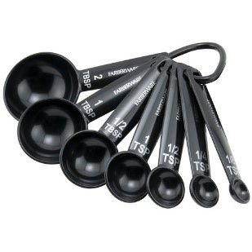
● Note that standard recipes call for roughly level measurements of these spoons so level it off with a knife and remove the excess. (It may appear in the recipe as ” 1 level tsp”.

● Note also that some recipes may describe as “rounded” or “heaped tsp/tbsp” which is one that isn’t level. But since these spoons can come in a good selection of sizes, these measurements are not too common.

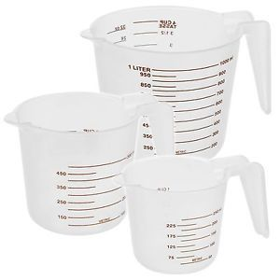
MEASURING JUGS
These are for measuring liquid volume and they come in plastic, metal or in glass. Their units of measurement are printed on them and consist of the following: millilitres (ml), litres (L) or fluid ounces (fl. oz). These are used for bigger volumes than measuring spoons can hold. They often have a spout, making pouring out easier. They can range from 50ml right upto 2 litres (1.7 – 67.6 fl oz). Some may also have ‘cup’ as a unit of measurement on them. This is often used in American & Canadian recipes and measuring cups will also be discussed next. Please note that ‘cup’ measurements on these jugs are usually for liquid ingredients.

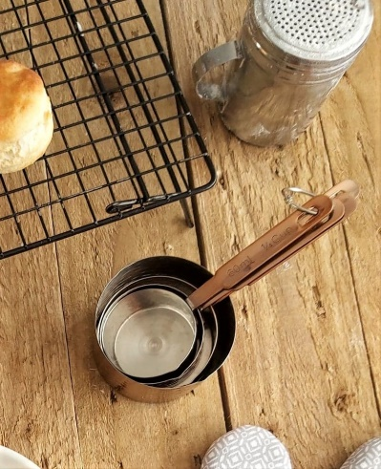
MEASURING CUPS
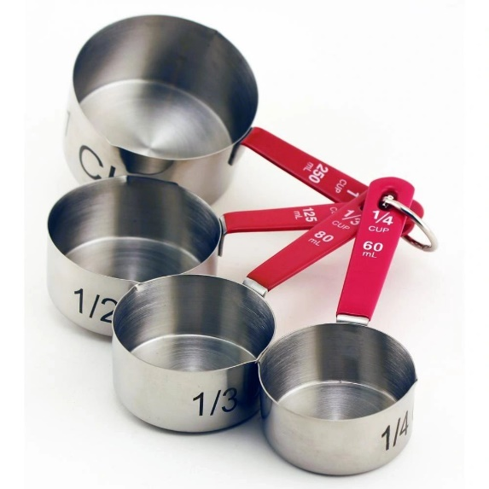
These cups are used for measuring both liquids and dry ingredients, such as vegetable oil, warm water, flour, sugar and chocolate chips, These are particularly useful if you don’t have scales and come in 1/4, 1/3, 1/2 & 1 cup sizes. They are often used in American recipes. Please note that if you want to use measuring cups but the recipe is not in cup measurements, you will need to find the relevant cup size for that particular ingredient. This is because different dry ingredients have different weights per cup size. For example, 1 cup of flour weighs 125g but 1 cup of caster sugar is the equivalent of 225g. There is even variation between similar ingredients. 1 cup of granulated (tea sugar) weighs 200g compared to caster sugar being 225g because it’s a finer grain and therefore more can be packed into a cup. You can simply Google: “150g of granulated sugar in cups” (answer 3/4 cup), I will provide a table of common ingredients and their measurements in a handy table you can download & print off later. GO TO MEASUREMENT TABLE. Plastic ones can be bought from as little as £1. Note that if you are using a scale, these are not essential, and as mentioned, scales are more accurate.

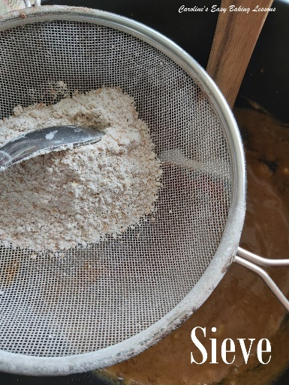
SIEVE
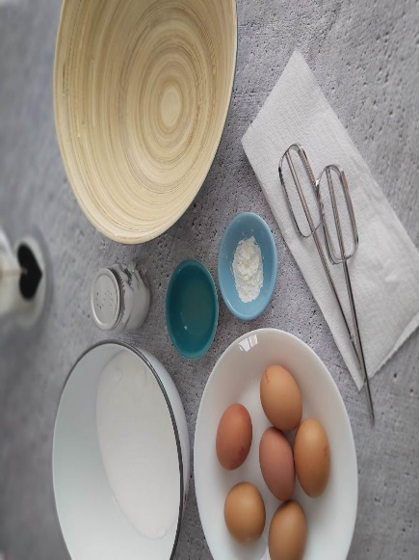
This has fine mesh within it to ensure there are no lumps in your flour or powdered sugar. They also provide more volume and rising in your baked goodies. It is known in baking terms as ‘aerating’, in other words introducing air into the mixture. I find these standard sieves to be better than ‘the sieve jugs, (known as a sifter). Whilst these have markings on them to show your volume, you must squeeze the handle lots of times to sieve the ingredient. Not only that, but they don’t come in a big enough size for me. One sieve will do, but at least 2 of different sizes will be more beneficial. I advise you purchase a metal one, standard size of about 16.5cm (6.5 inches) diameter,(or greater if you have mixing bowls that big) and will fit over medium to large bowls. An ideal size for a second sieve would be about 11cm (4.25 inches) diameter. These are good if you are short on space, or only have small bowls, but it will take a bit more time to get all your ingredients sieved. Later on you might want an extra small sieve, about tea strainer size or a bit bigger. This can be used for dusting icing sugar, (powdered sugar), over your cakes. Remember to always sieve icing/powdered sugar

LARGE MIXING BOWL
A large mixing bowl is not only essential but more beneficial than having a full set of varying sizes. You can still mix small quantities in a large bowl. Ideally you want one with a diameter bigger than your sieve and the sieve with it’s long handle will sit nicely on top. You don’t need to purchase expensive bowls, a plastic one will even do. These are particularly good when proving bread. You may even already have some suitable bowls in your kitchen, maybe even a large salad bowl. Purchasing small bowls is not necessary as everyday bowls you have in your cupboards will surely do. If you have a stand mixer, this bowl will be useful on and off the mixer, but I highly recommend purchasing a 2nd large bowl to have on hand. For weighing out small quantities, any small bowls you already have such as cereal bowls are good enough for the job.

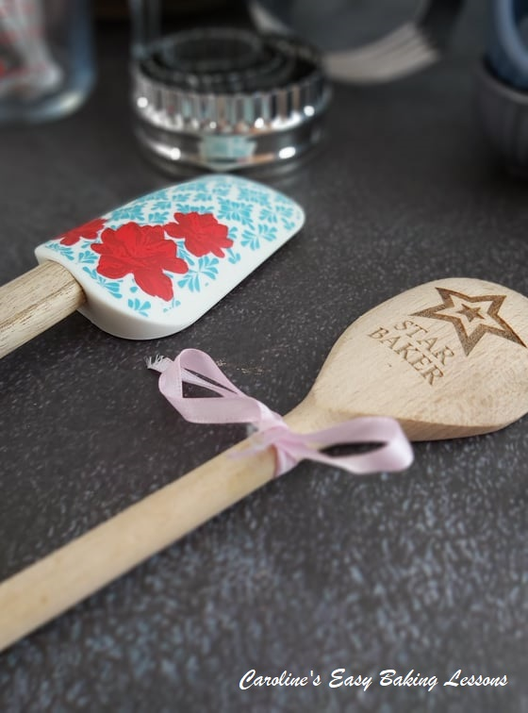
LARGE METAL OR WOODEN SPOON
A wooden spoon or even a large metal serving spoon or one for salads, would do for mixing your ingredients together, and for when not using a hand/stand mixer.

PLASTIC OR RUBBER BAKING SPATULA
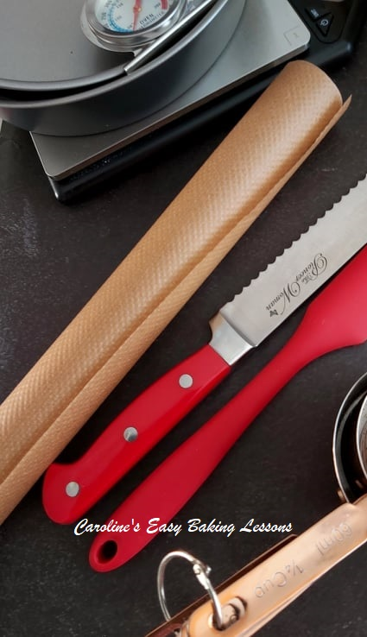
A plastic, rubber or silicone spatula is handy as they are flexible compared to spoons and good for scraping down the bowl. These instruments also help with removing batter or dough from the bowl. Particularly good for sticky bread dough. They can also be used for decorating and spreading jam/jelly for example.

BAKING OR PARCHMENT PAPER
This is an absolute MUST for me. Your dough or baked goods will not stick to the tray or tin if you use baking paper. This means you don’t need to buy expensive non-stick baking equipment. Using paper also preserves the life of your equipment. Be aware though that grease proof paper is NOT what you want. Good baking paper should be brown and not too thin. I have bought countless cheap paper (less than £1/$1.40) and regretted it when the food was stuck to the paper and ruined. I have never found any of the white paper (in the UK), good either. The best and cheapest I buy is Bacofoil Non Stick Baking Paper (usually get a 10m one for about £1.80 from Savers here in the UK but are also found in the supermarkets). It’s that good I can often re-use it and so really get my money’s worth. You will line your baking trays with it as well as cake tins. Never be without it. You can also use it as a clean area to work on, with say cookie or bread dough and means less clean up too. I also use this type of paper when making fondant cake toppers etc. Another option is silicone baking mats. These come in quite large sizes so you can easily cut to fit your baking tray/sheet. You hand wash them so are re-usable. I don’t use them anymore as I feel they give off a smell after a while.

MUFFIN OR CUPCAKE PAPER CAKES
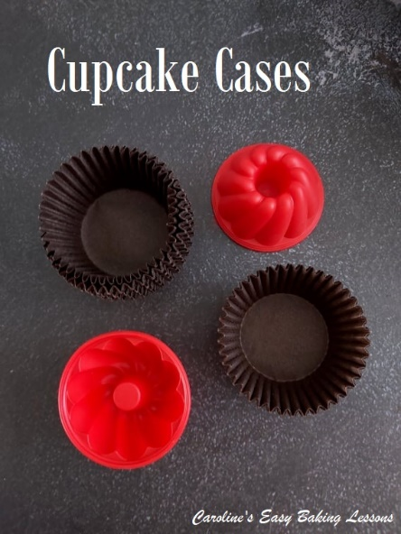
This is another must for whenever you are making cupcakes or muffins. ALWAYS bake with these cases in cupcake/muffin trays because if you don’t they do not hold their shape completely whilst baking. NEVER bake directly into the holes of these mini cake tins. Apart from making it easier to get the cakes out in one piece, you are also preserving the life of your cupcake tray, especially if it’s non-stick! Quality non-stick products are very expensive and so you really don’t want to be scraping to get the cakes out. Save yourself the hassle and buy cases, which are relatively cheap and can be bought in most places. However, please DO NOT buy the ones that have a metallic finish to the outside of them. The cakes always stick to these cases. I don’t know what it is made of in the inside, but these have proved to be a waste of money. You can even get rectangular ‘mini loaf’ shaped cases. These can be bought in discount stores now and since they are made of thin cardboard, they hold their shape quite well when baking. Cupcake cases can also be used for when making mince pies or even muffin cases for mini pies or quiches. You can also get them in smaller sizes for holding things like truffles. Silicone ones, in various shapes are also available and so reusable. And my tip for these, is to place the silicone cases inside the cupcake tray and they will hold their shape well.

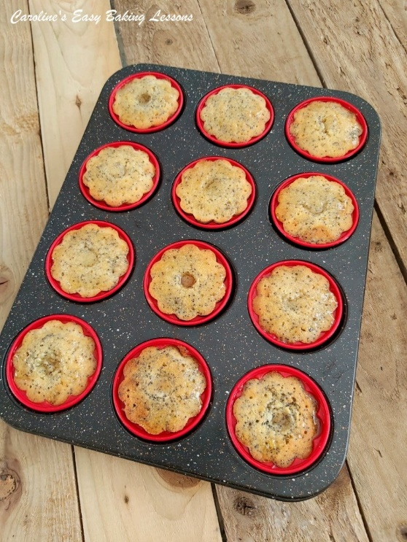

CUPCAKE TRAY/SHEET (12 HOLE OR 2 X 6 HOLE)
As mentioned before, you should always use cupcake or muffin trays and not just the cakes on their own in their cases. Most recipes are for 12 or 24 cupcakes so having at least one twelve-hole cupcake tray is an essential. Most 12-hole trays will fit in one shelf of your oven (here in the UK), so having 2 can speed up the baking time if the recipe makes 24 cakes. Use cupcake cases to line them and so cake removal will be easy. But if you can afford to buy better ones, I recommend heavy duty ones. Even some of the expensive ones are lightweight and if you can feel it might bend – don’t buy it. My best ones are from Aldi, their premium baking range and they have a black marble finish to them. They are solid and cost about £8 ($11) for a 12 holes tray. After using one tray I was so impressed with the quality, I purchased another on-line and it was delivered for free. These trays can also be used for savoury bakes and not just cupcakes. As mentioned before, you should always use cupcake or muffin trays and not just the cakes on their own in their cases.

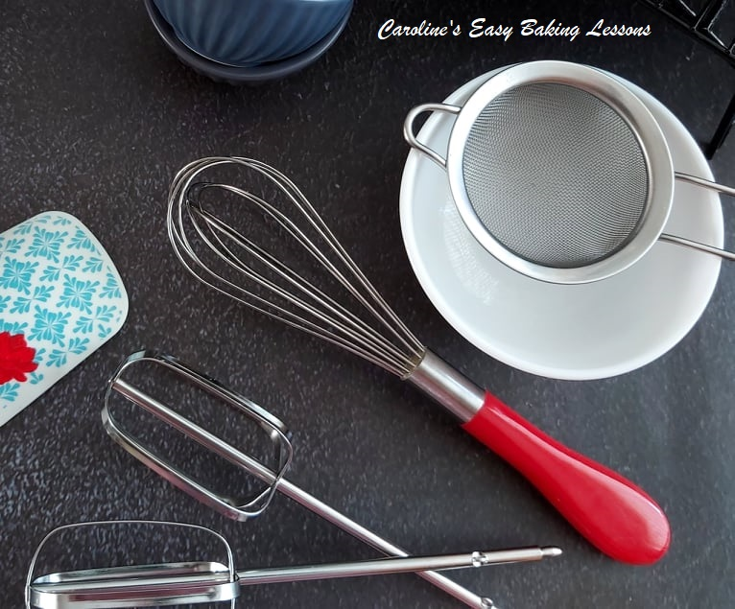

METAL WHISK
A metal whisk will be handy for beating eggs, batter etc by hand, especially if you don’t have a mixer. You can also make whipped cream for your desserts by whisking double cream. I would only recommend a silicone one if the bowl or pan you are using is non-stick. This style as in the picture is also known as a ‘balloon whisk’.

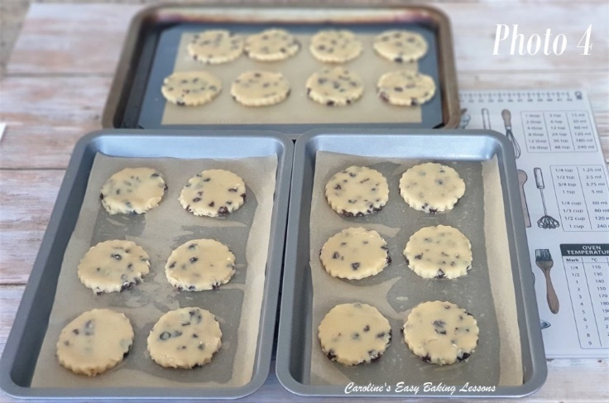
BAKING SHEETS & TRAYS x 2
Two full size baking trays/baking sheets would be more beneficial, especially for making cookies so you can get more done at the one time. Oven trays that you have already will do at first, but if they are well used and have a build up of grease, you might not want to use them for sweet baking. I have trays that I just use for sweet baking or breads and don’t bake things like pizza on them. Again, heavy duty ones are best as they don’t buckle in high temperatures and ensure a more even bake. Darker coloured trays are better for bread making as these types of trays absorb more heat, so are not so good for small, quicker bakes such as cookies. As mentioned previously, always line your tray/sheet with baking/parchment paper to preserve the life of it.

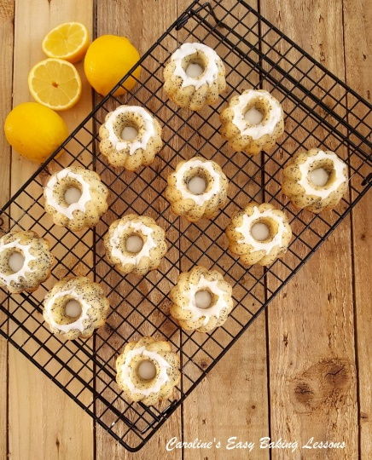
COOLING RACK
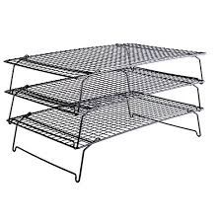
Wire cooling racks allow the bakes to cool quicker and stop the cooking process. This is why recipes will say to leave in the tray for a few minutes, (to continue to cook) and then transfer to a cooling rack (to stop cooking and cool down). These can be bought relatively cheaply. The metal part of a grill tray would work too, allowing heat to escape. I have 3 racks that stack on top of each other, saving valuable worktop space! A tip for ensuring your cookies don’t fall when transferring to the cooling rack, is to move using the paper.

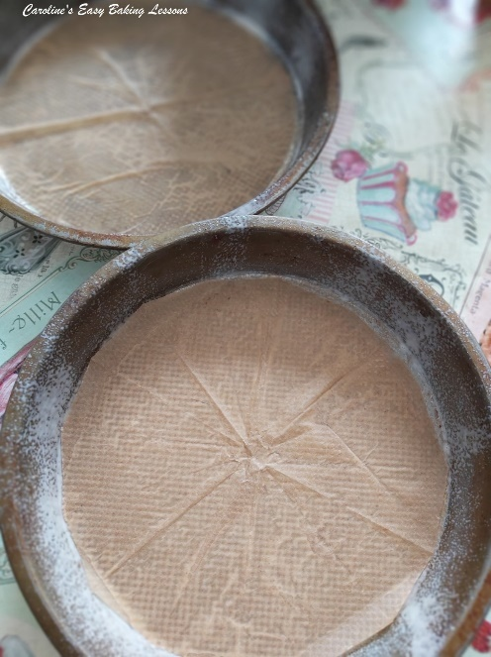
BAKING/CAKE TINS
I would recommend purchasing 2 round cake tins (also known as sandwich tins), at least 18cm (7 inches) diameter & at least 1 inch (2.54 cm) deep.
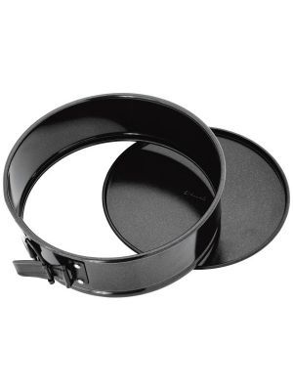
Also, a square tin at least 20 x 20 cm (8 inches square), would be good, or a rectangular tin and you can bake cakes, squares, tray bakes etc in these.
There are also pans called ‘spring-form’ which have a clip that opens and expands the sides of the tin, releasing the base and allowing easy removal of the cake. These come in various shapes such as round and square. Another option is ‘loose-based’ pans. As the name suggests the base loosens in order to release the base and the cake. These easy release types come in various sizes and shapes. As well as tart tins. These 2 types are more expensive however. If you can afford more expensive ones good but again you will line these with paper to stop the cakes sticking.

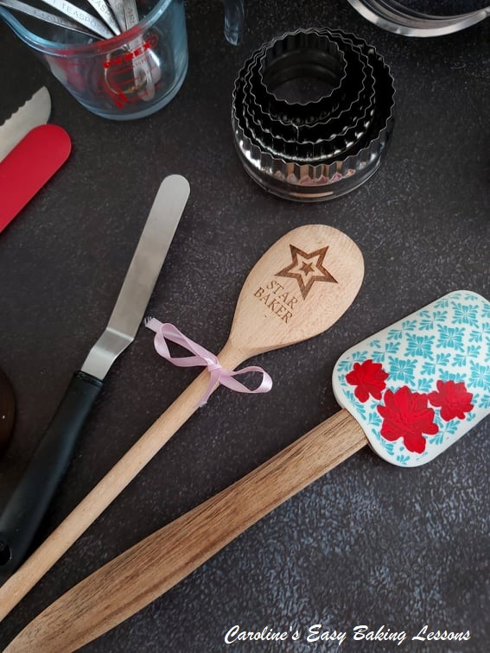
PALETTE KNIVES
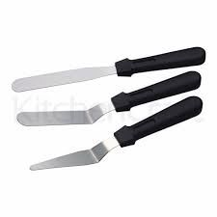
A palette knife is used for lifting cookies etc, as well as spreading frosting onto cakes and scraping down bowls. A baking palette knife can be any of the shapes in the picture above and in a variety of different sizes, each having their own use. For beginners however, the standard one (top one in the picture) will do for lifting cookies and spreading. In some cases, a good substitute could be a standard kitchen spatula, metal or plastic.

HAND OR STAND MIXER
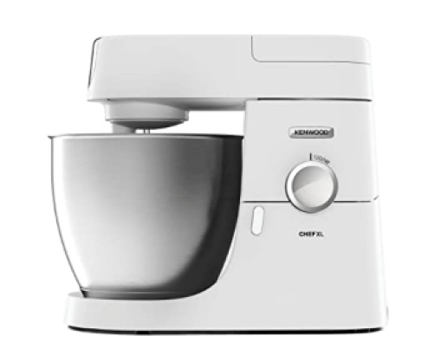
Hand-held electric mixers are obviously quicker than mixing by hand but can also be cheap and compact for easy storage. You will however find yourself standing for quite some time for certain recipes and so your hand and back can get sore. So, for most people a Stand Mixer (standalone) is better.
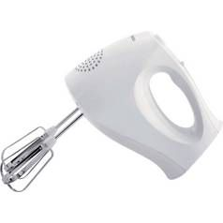
They are more expensive, but more efficient, can do the job itself and some recipes will turn out better with this type of equipment. There is no need to go out and buy a KitcheAid or similarly very expensive mixer (in the £200+ category). As long as the mixer does everything that you personally want from it and take into account how often you will use it, as well as how much worktop (counter) space you have, then cheap ones will suffice (at least for the time being – once you are star bakers you can save for a better one!). Some better machines also come with a ‘dough’ hook that is for kneading bread. This is particularly handy if you can’t knead by hand for long. Note however, that this works best if the machine has a strong and powerful motor.
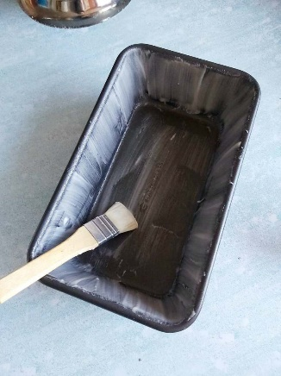

PASTRY BRUSH
This will be used for glazing uncooked bakes, such as rolls and pastry and give a nice finish to the items, as well as helping stop burning and drying out. Standard pastry brushes are wooden and come in various sizes. A small one will do to begin with, (about 1 – 2cm (2/5 – 4/5 inch) wide bristle area). Silicone brushes are widely available now, inexpensive and the bristles won’t fall out. I however, don’t like the feel of them and find the bristles too hard for some bakes. I quite often see them used in baking videos and notice once baked that these can give quite a rough finish to a bake, with it clear where the thick silicone bristles were used. You can substitute with unused painting or artist’s brushes which can be cheaper to buy or you may already have one. Just beware of cheap brushes as their bristles tend to fall out while brushing.

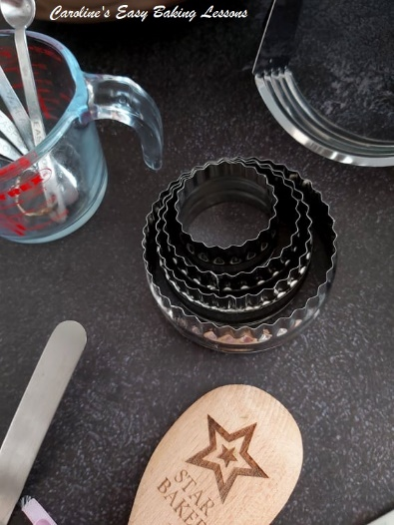

BISCUIT/COOKIE CUTTERS
Nests of varying sizes or shapes can be purchased quite inexpensively now. They come in metal or plastic and can be straight or flute-edged (scalloped edging). Note that the metal variety will cut easier, giving a cleaner cut. ALWAYS dust with flour or icing/powdered sugar or flour, before using to avoid the cutter sticking to the dough. An alternative to cutters is lids or the rim of drinking glasses.
Can also be used for cutting out pastry & fondant/sugar paste so ideal for pies and for cupcake toppers.

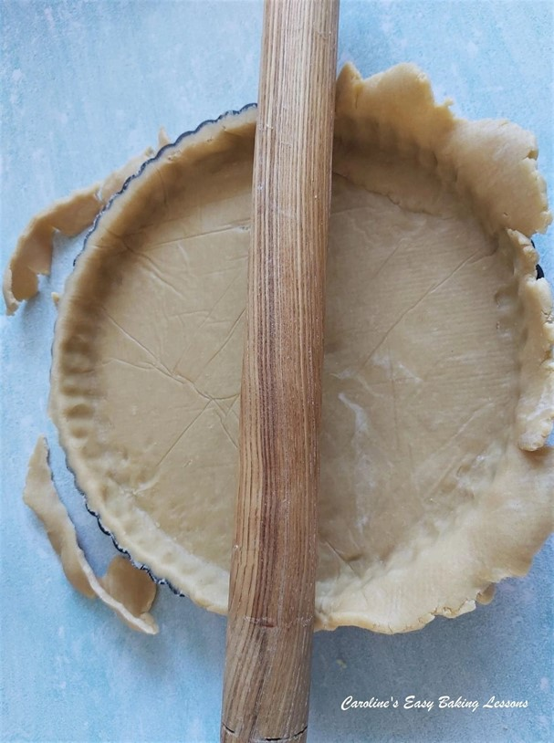

ROLLING PIN
A rolling pin is an essential part of a baker’s kit. They come in a variety of different materials, sizes, patterns etc. I recommend a long heavy wooden one. One with no handles so that you can roll out to the width of the pin. A matte one or one with as little varnish as possible is the best as varnished ones tend to stick to the dough and you end up putting too much extra flour on it (and ruining the structure of the bake). I have even in the past sanded down a varnished one and it worked perfectly. Just be sure to ALWAYS HANDWASH gently with a sponge and never immerse in water. Also leave it out to dry completely and this will help it to last a life-time.

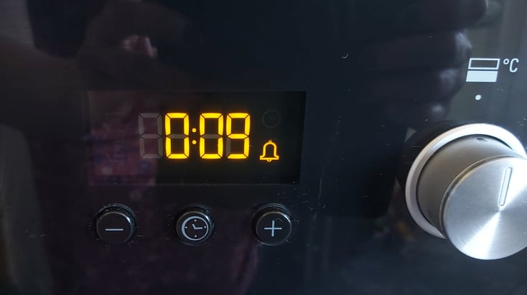

TIMER
This is an absolute must to get your timings right as a minute over or under can result in burnt or under-cooked bakes. The timings I give in my recipes are those that work for my oven, but everyones oven is different. Turning and swapping will ensure an even bake and it reduces the risk of burnt biscuits, especially when you are just learning. With practice you will know how much longer your oven will need to finish the bake, as well as when to take them out of the oven. Therefore monitoring timing is essential.
Purchasing a timer is not essential, as many ovens have items. The timer on your phone however is an even better substitute as it can give smaller time increments of seconds.

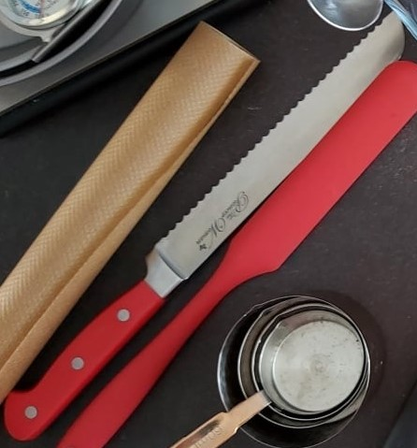
GOOD BREAD KNIFE
A long serrated knife to easily slice bread and cut open rolls is essential. It’s a case of the ‘correct tool for the job’ as little vegetable knives literally ‘won’t cut it’!!
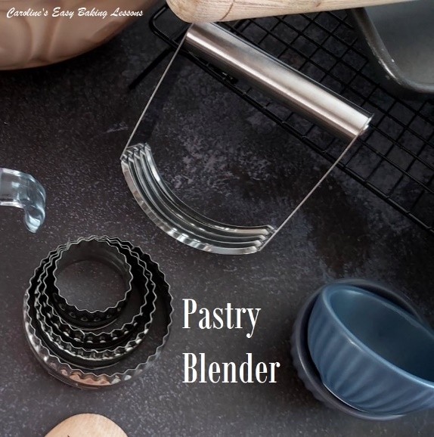

PASTRY BLENDER OR CUTTER
This is used for ‘cutting’ butter into dry ingredients such as flour, and if done long enough it will produce a texture similar to ‘bread crumbs’. This is what you want if you are making pastry, shortbread or scones.
This ‘cutting in’ technique, can also be done using 2 butter knives & will be explained later when you need to know. This tool is really essential if you have problems with your hands or fingers & don’t have a food processor.
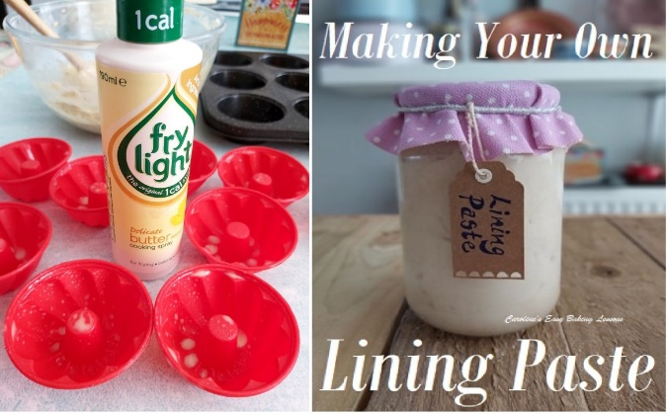
SPRAY OIL
I tend to use the butter one to be on the safe side, but I generally use it to oil baking tins and trays before lining with baking/parchment paper. I also use it in bowls when I am proofing dough for things such as bread or pizza. They tend to be expensive in supermarkets, but discount stores such as Aldi, Lidl, B&M & Home Bargains sell them for under £2 ($2.75). You can get them in a variety of different oil types as well as flavours, so can have many other uses in the kitchen. An alternative, is home-made Lining Paste. This can be used not only for lining cake tins, but for anytime you need greasing in your baking or cooking. Click here to read my review on this paste, that is excellent for bundt pans.

OVEN THERMOMETER
Last, but in no way least, is an oven thermometer. Every oven is different: running hot, running cold, or has hot spots. For these reasons, recipes can not be exact with their baking times. Purchasing an inexpensive oven thermometer, will save you from burning your bake, and some other problems. So if for example it turns out your oven is running 20c hotter, you just reduce the temperature by 20c for every subsequent bake. You can purchase in some shops or online and they start at about £4 ($5.50).

