APPLE, BLUEBERRY & SALTED CARAMEL FILO NESTS Caroline’s Easy Baking Lessons
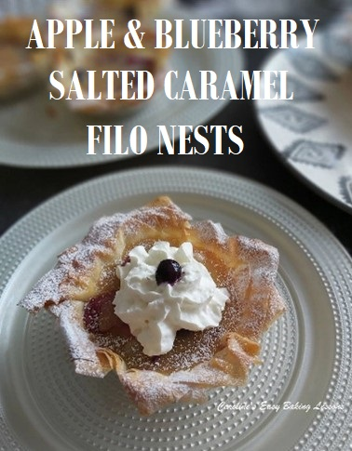
Here’s a simple Summer bake, that doesn’t require the oven to be on for too long, and you don’t even have to make the filo pastry either.
Simple nest cups, made from the filo, encasing some cooked apple and blueberry, and topped off with some homemade salted caramel sauce. Eat as is, or pair with some whipped cream! Absolutely divine. Make ahead and chill as they taste best chilled and lets the caramel set nicely and just add the cream when serving.
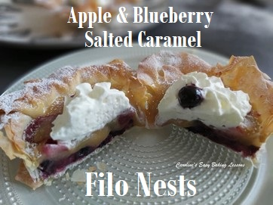

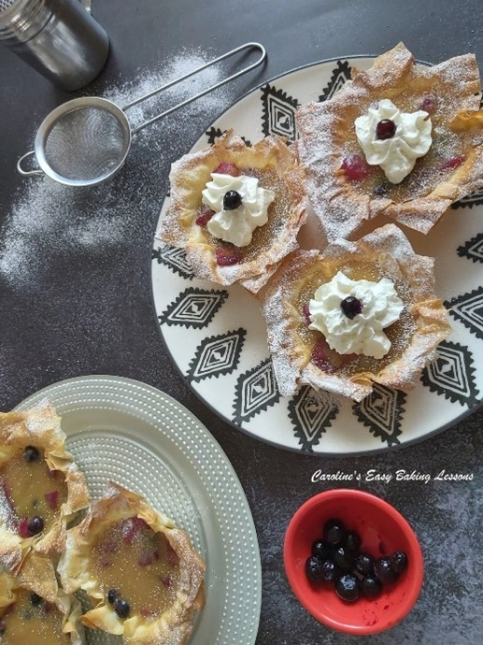

EQUIPMENT
- Digital Scales or Measuring Cups
- Measuring Spoons
- Mini Tart tins, muffin trays
- Small saucepan
- Peeler
- Knife
- Chopping Board
- Small Measuring Jug (optional)
- Pastry brush or other small unused brush
- Small microwave safe bowl
- Baking/parchment paper
- Timer or Phone Timer
- Small sieve (optional)
- 3 tbsp Melted Butter (45g/1.5 oz)
- OVEN: 180c/160c Fan oven/360f/Gas Mark 4

INGREDIENTS
- 175g Apples, peeled and cubed small (1 1/2 cups or 6 oz)
- 1 1/2 tsp Lemon Juice (coat the apples in this once chopped)
- 4 tbsp Sugar
- 60ml Orange Juice (approx. 4 tbsp )
- 41g Blueberries (3/4 cup or 1 1/2 oz)
- About 6 Sheets of Filo Pastry (about 100g/3.5 oz)
- (About half a packet, so use the rest for something else, or double the recipe – note though the caramel sauce will not need to be doubled)
- Salted caramel Sauce – go to my video
- For Decoration:
- Sieved Icing/Powdered Sugar (about 2 tsp worth)
- Blueberries (uncooked)
- Whipped cream or Ice-cream

INSTRUCTIONS
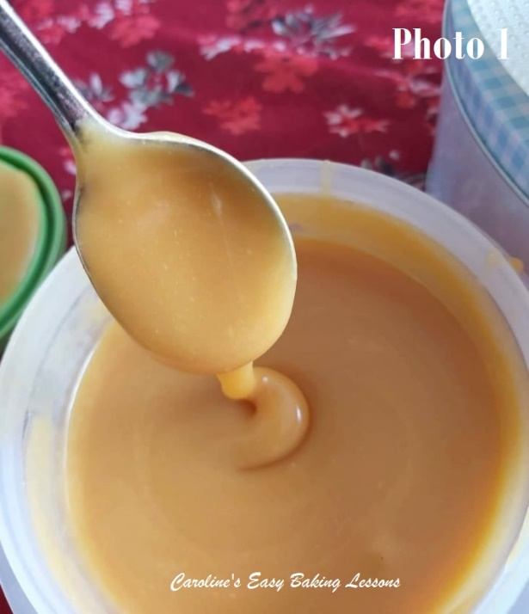
1. Prepare the caramel sauce as per my recipe and chill to set. You can also make this sauce days in advance and just chill. But as it firms up when cold, take out of the fridge, at least 30 minutes before going to use.
2. Peal & cube the apples & toss in some lemon juice till ready to use. On medium to high heat, bring the apples to a boil with the sugar and orange juice, reduce the heat to low and leave to simmer until softened slightly (don’t let them get mushy). My cooker took about 6 – 8 minutes.

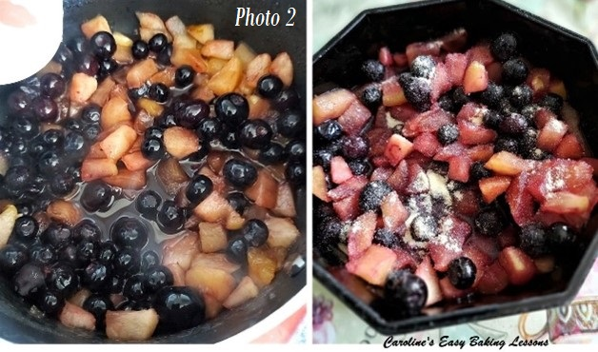
3. Add in some frozen or fresh blueberries and leave to cool a little.
4. Add in a few tsp of semolina or cornmeal and mix through. See Photo 2.
5. Heat up the oven to 180c/160c Fan oven/360f/Gas Mark 4

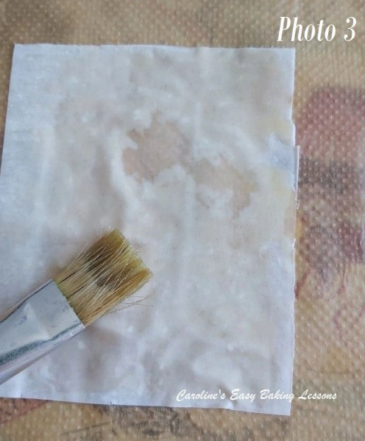
6. Cut the filo into squares that will be bigger than the size of your tart tins/cases. The diameter of my tins were under 7.5cm (3″), so I cut 10 x 10 cm (4″ x 4″) squares.
7. Melt 3 tbsp (45g/1.5 oz) butter in the microwave in 30 second bursts till melted through.
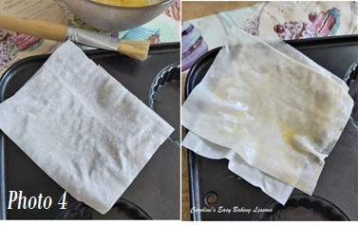
8. Brush some of the melted butter into the tart cases, to make removal easier later. You can also use baking spray or lining paste, (but we have the butter melted for brushing on the filo sheets too).

9. Next take one of the filo squares and place on some baking/parchment paper, and then brush some melted butter on top of it. See Photo 3 above. Then lift the square of filo, & position on top of the tart case. See Photo 4.
10. Brush butter on the second square of filo & then position on top of the first filo square, but at a different angle, with the points of the square pointing N, E, S & West. This will form kind of a star shape. See Photo 4, right pic.
11. Repeat the layering and alternating the position of the filo and brushing on butter, until you have 4 sheets of filo. See Photo 5 below.
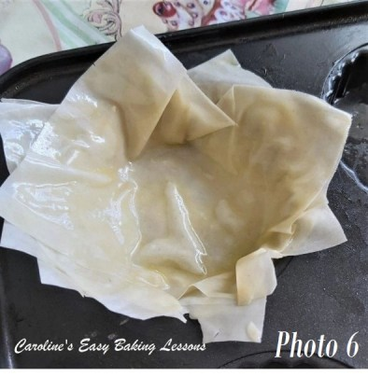
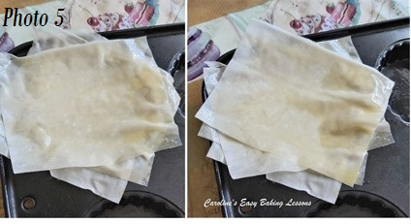

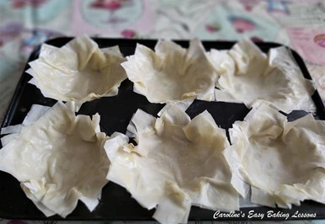
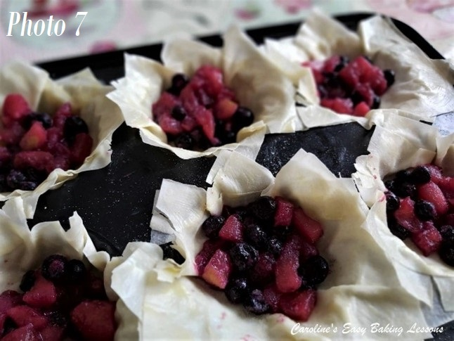
12. Gently push the filo down and into the tart tin, letting it form a nest shape with the pointy ends hanging over. See Photo 6 above.
13. Fill the nests with about 2 tbsp of the fruit mixture. There should be enough for about 6 nests. See Photo 7.
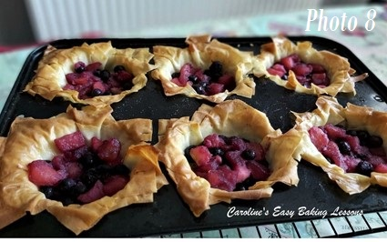

13. Bake for 5 minutes, until golden and crispy on the edges. See Photo 8. Remove from the oven and allow to cool down for about 15 minutes or so.
14. Remove the nests from the tart/pastry tins and allow to cool down before adding the caramel sauce. See Photo 9.

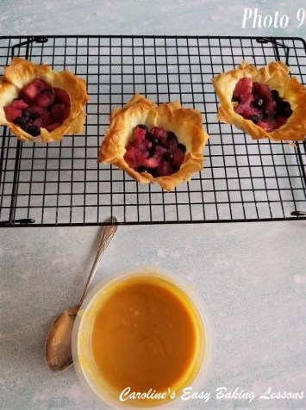

15. Once cooled, add in the salted caramel sauce. Freeze for 30 minutes or place in the fridge for 1 hour before serving. This let’s the caramel set up nicely. If in the fridge longer, you might need to remove a little before serving. See Photo 10 & 11 below.
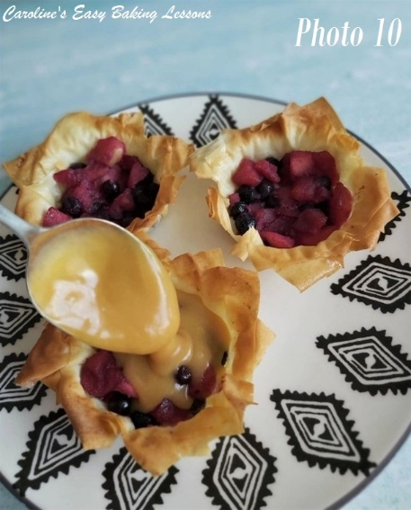
16. Best eaten cold with some icing/powdered sugar dusted over the edges and served with some whipped cream or even ice-cream. See Photo 12 further down.
17. Store left-overs in an airtight container in the fridge for a day.

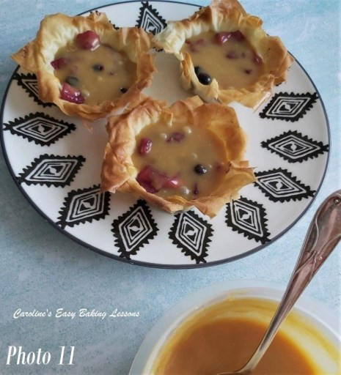
DIFFICULTY LEVEL:
Easy, super simple
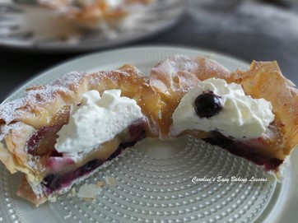
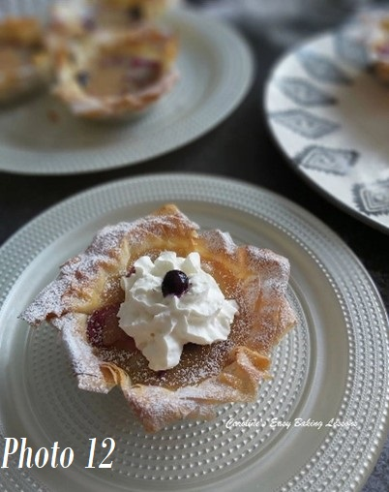

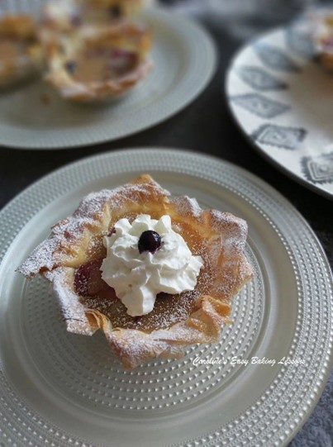

Thanks for reading
Happy Baking & Making
Happy Tummies & Memories!

Caro xx

