CHOCOLATE VICTORIA SANDWICH – A Chocolate Version Of The Classic British Sponge Cake With Jam & Cream

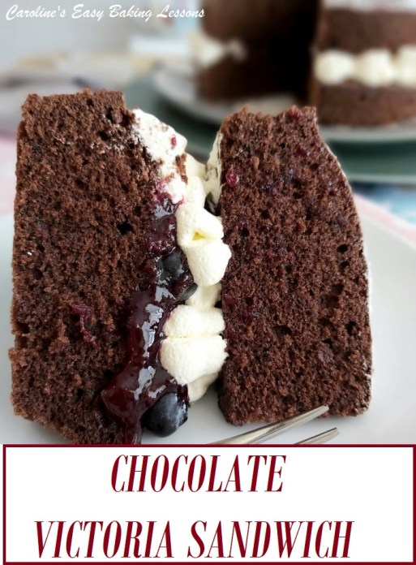
Caroline’s Easy Baking Lessons
This is my long-awaited and one of the most requested recipes I have developed. It did not take a long time because the recipe is difficult, but rather other things got in the way, like setting up this new version of the site. So rest assured, this is still a nice light cake, but full of chocolate flavour. Not quite as light as the vanilla version, but the substitution of some cocoa powder for flour, does mean a little less rise is achieved. Pairs perfectly with jam and cream or you could just use cream. One of my pics below is of just one layer of the cake, with cream on top, so you could easily half the recipe (or just freeze one layer) and top with cream. Also add any fruits you like or are in season.

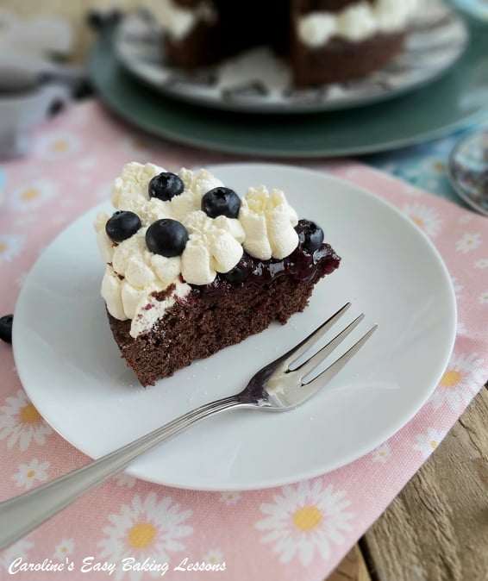
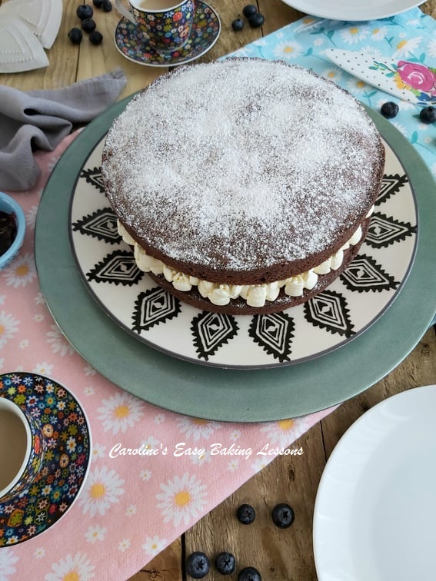

A LITTLE NOTE ON VICTORIA SANDWICH CAKES
For some, this simple classic can however, be hard to master. It should have a light and airy texture. Beware or recipes that use too much baking powder. Some will use self-raising or self-rising flour and additional baking powder. They can give an unpleasant bitter and metallic after taste. But worst of all, because they have too much raising agent and not enough flour to support it, they prematurely rise and sink back down. And the end result is a dense cake with a much more close texture crumb. Also, ‘All-In-One’ method recipes, do not get as much air into the batter, since there is no ‘creaming’ (steps 1 & 2), of the sugar and butter. This repeated movement creates air pockets that result in air being incorporated into the batter, producing a lighter cake.

A NOTE ON INGREDIENTS

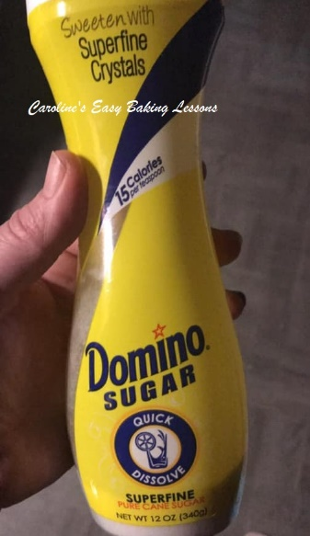
CASTER SUGAR
The equivalent is known as ‘Extra Fine or Super fine sugar’ in the US. Here is a photo of one particular brand that is available in the states. The bottle however is for tea or coffee, so isn’t in a very big bottle, (only 340g/12 oz). Berry Sugar, Fruit Sugar, Baker’s Sugar can all be used as a substitute too. You can also make your own from granulated sugar. Please note though that that US regular (granulated) sugar is finer than our UK granulated. Just be careful, as grinding in a processor too much may produce too fine a sugar, (similar to powder and be icing/powdered sugar) and possibly ruin your machine. So I would advise caution with it. Some people have also been known to use coffee bean grinders. A good tip with making your own is to crush in small batches and weigh or measure it as you go along until you get the quantity you need. Alternatively, make up a jar of your own caster sugar and use when needed. Be sure to store in an airtight container.

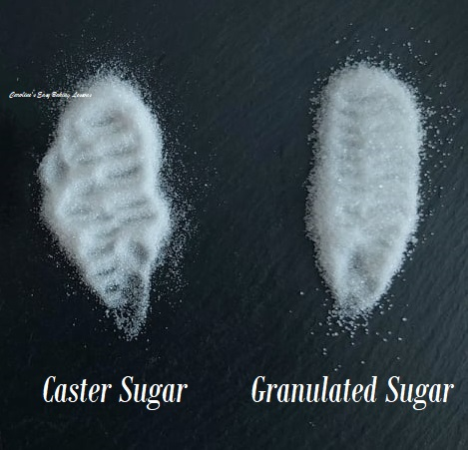

WHY USE CASTER SUGAR?
Well I am often asked this question, if granulated can just be used and the answer is that for some bakes, yes you can. However, there are a few points to note. Unless if the sugar is being melted, to say make a drizzle, then the caster sugar is there not only providing a function of sweetness and moisture, but also to create friction when you are creaming with the butter. This process of rubbing, with the small sugar crystals, creates friction, which in turn produces air pockets, which gives a nice rise and light texture to cakes. In meringues and macarons, I would always advise on using fine sugar, again because of the reactions that are occurring. For most cakes for example, they will still bake off nice, but they will not be exactly as intended by the recipe developer. And this is something to bear in mind. See here my photo of the 3 main sugars we use in baking here in the UK.

SELF-RAISING FLOUR
Classically this sponge is made using Self-raising flour. This is similar to US self-rising flour in that there is baking powder in it. However, our Self-raising flour in the UK has a bit more baking powder per 125g/1 cup. In all my recipes, I ALWAYS provide details on how to make the recipe, using plain/All Purpose flour and baking powder and have it tested too. I tend to use less than the recommended amount of baking powder though as I find it gives a bitter metallic after taste. Also I believe that over time, between being made in the factory and being used in the home, that the self-raising looses some of it’s raising powder. For more on this and other differences between UK & US/Canadian baking and ingredients, read my article.
All my recipes include conversions from grams to ounces and cups. Note that they have all been calculated by hand, by myself and tested several times, since Google is often inconsistent and inaccurate. But I also have a conversion table, with common baking ingredients for you to refer to- go to table.
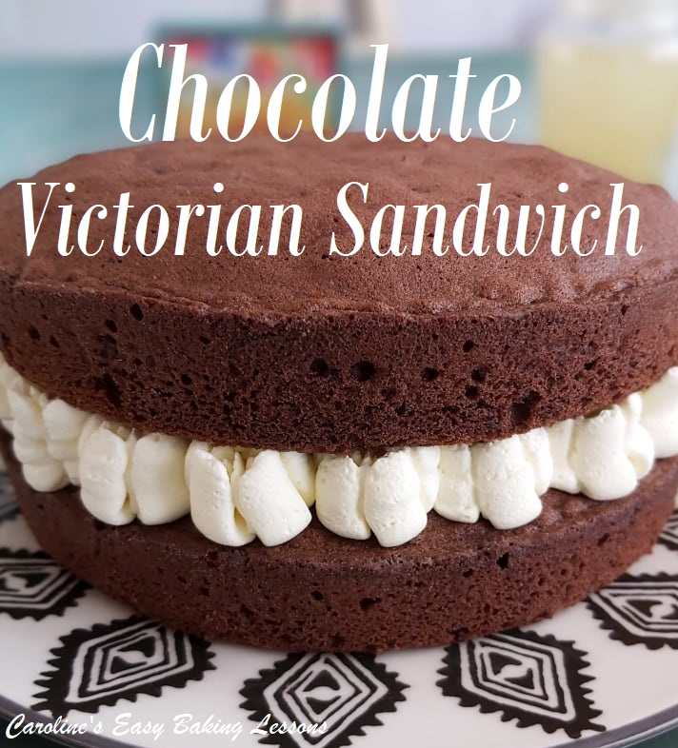

EQUIPMENT
- 7 or 8 ” (17.5-20cm) Cake Sandwich tins x 2
- Baking/parchment paper
- Baking spray, lining paste, or butter to grease (see note in instructions)
- Scales or measuring cups
- Measuring Spoons
- Hand or Stand Mixer (or a wooden spoon)
- Sieve
- Large Metal spoon
- Small bowl for jam/jelly swirl
- Cocktail sticks
- Baking Palette knife or butter knife
- Small measuring jug (optional)
- Bowl for whipping cream
- Icing/Powdered sugar
- Small sieve (optional)
- Timer or Phone Timer
- Clean Soft Tea-towel
- Cooling rack
- Piping bag & nozzle (optional)

INGREDIENTS
- 225g Butter, unsalted, soft & cubed (1 cup/ 2 sticks, 8 oz)
- 225g Castor Sugar (8 oz) (1 cup of super/extra fine sugar, Domino’s etc. *See note above)
- 4 Medium – Large Eggs US
- 175g Self-raising flour, sieved (1 & 1/3c Self-rising Flour, 6 oz)
- (OR1 & 1/3 cups All Purpose/Cake/Plain Flour plus 3 1/8 tsp baking powder)
- 50g Cocoa (Level 1/2 cup, 1.75 oz)
- 2 tsp Coffee Granules
- 1/2 tsp Vanilla Extract (click to make your own)
- 1 tbsp Milk

FOR THE FILLING & TOPPING
- 270 ml Double/Heavy/Whipping Cream (9 fl oz about 1 cup)
- 200 g Raspberry Preserve/Jam/Jelly (or less) (Or any favourite flavour, upto 7 oz, ½-¾cup)
- Few Tbsp Icing/Powdered sugar
- OVEN: 180c/160c Fan Oven/350f/Gas Mark 4

INSTRUCTIONS

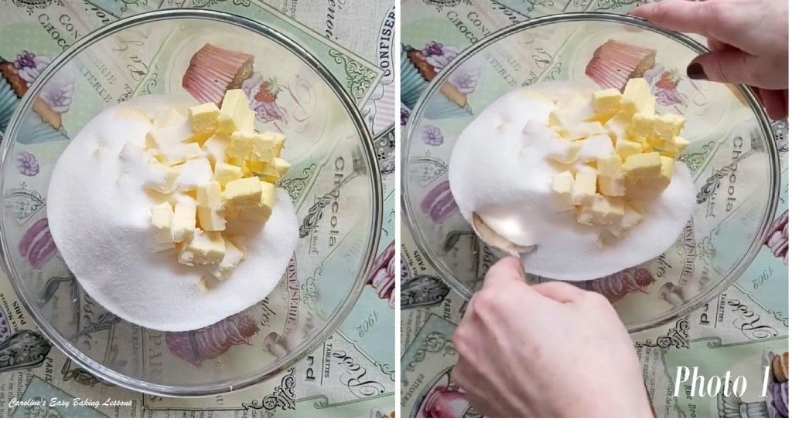
1. Cube and weigh out your butter and leave to soften. A smaller surface area will soften quicker and be easier to mix with. I like to cut them about 1cm, 1/3″ size. (See Photo 1). If you are in a hurry, or forget to take it out on time, here’s a hack I tried. Soften Butter In About 12 Minutes.
2. Weigh out and add the sugar to the soft butter and mix by machine or hand for a few minutes until very creamy, smooth and soft and also paler in colour. This is known as ‘creaming the butter & sugar’. See Photo 2 below for how it should look or check out the video. It is the best method for incorporating air into the batter to produce a light airy cake.

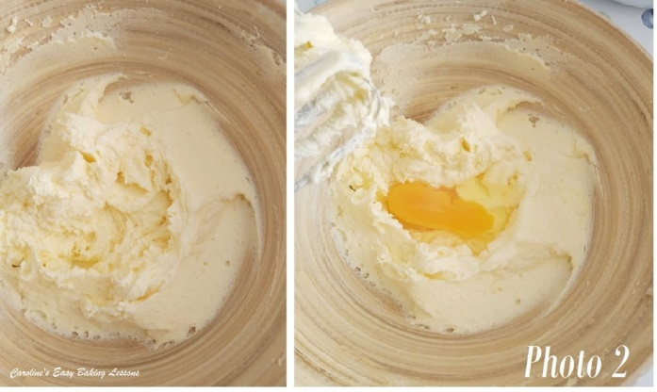
3. Gradually add in the eggs one at a time with the mixer on low to medium speed, just briefly until mixed through, also known as ‘amalgamated’ or you might hear or read the word ‘emulsified’. To emulsify means to combine two liquids that normally do not combine so easily, such as vinegar & oil. So at this stage of the recipe, we are trying to emulsify the egg with the butter. As a result, sometimes the eggs may make the batter look a little curdled or split. If this happens just add 2 dessert spoons of the flour while mixing in the eggs. But don’t worry about it, it will bake out fine. You don’t even need to add the flour like that, as you will be adding in soon. If however, your batter is extremely curdled looking (and different to Photo 3 below, you might want to make sure next time that your ingredients are all at room temperature. If they are not, it makes producing a smooth emulsion even more difficult. So make sure your butter is soft, but also that the eggs are at the same kind of temperature. Same goes for any liquid you might add.
For even more height in the sponge, you can whisk the eggs first since this activates the protein in the egg, and protein provides structure. Now mix in the vanilla extract just till combined. Click here to make your own.

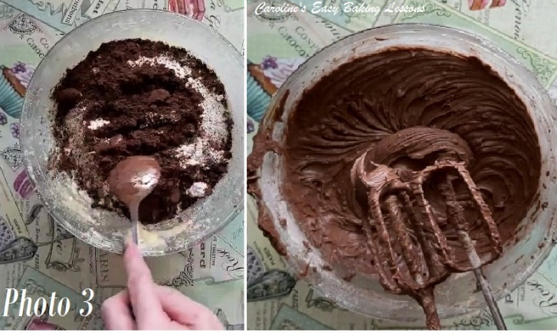
4. Heat up the oven to 170c/150c Fan oven/325f/Gas Mark 3.
5. Now sieve in the flour (and baking powder if using plain/A.P. flour), cocoa powder & coffee into a separate bowl. See Photo 3. Then sieve again over the cake mixture and mix on low, then medium speed until all incorporated into a smooth thick batter. Only mix until no flour is seen, as you don’t want to over-mix it and knock out the air you incorporated. If you can hold the sieve higher up from the bowl, this too will incorporate more air into the batter. Sieving twice gets even more air into the batter. See Photo 3 .
6. Add 1 – 2 tbsp milk to thin the batter slightly.

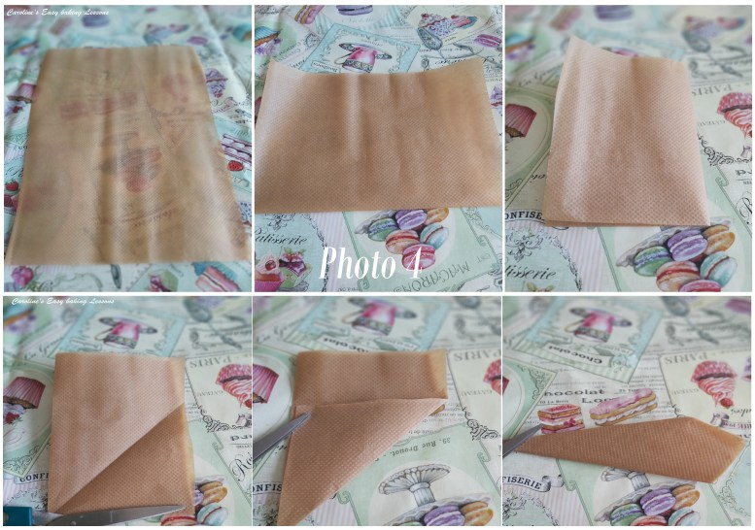
Making paper circles to fit round cake tins – part 1

7. Oil or grease your baking tins well, paying particular attention to the sides. I recommend this greasing/lining paste recipe by Great British Bake Off winner Nancy Birtwhistle. I use a few tsps of the paste and add about 1/8 tsp cocoa powder, just to tinge the paste a beige colour since it’s a chocolate cake. Also place a circular piece of baking/parchment paper on the bottom of the tin. Use pre-cut or make your own paper circles. Cut paper the width of the tin and then keep folding till you get a pointed cone shape. Then line up with the centre point of the tin and cut off the excess. Then simply unfold and if too big, fold again and trim off slightly. Then just position in place. See Photo 4 above & Photo 5 below. For more photo instructions – go to other pics or watch my video on how to fold it.
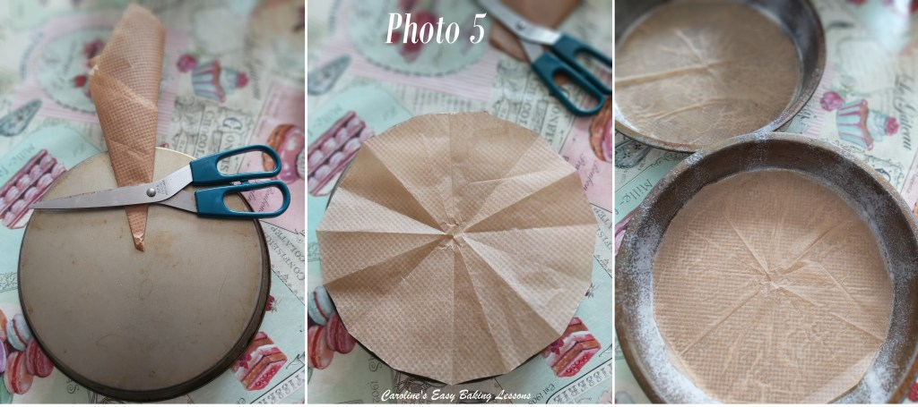
Making paper circles fit round baking tins part 2

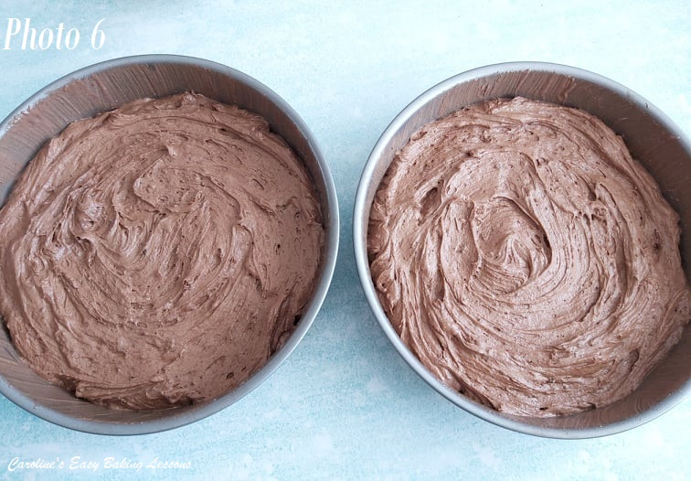
8. Now spoon the batter evenly between the two tins and smooth out, leaving a little dip in the middle, so the cakes don’t dome too much and bake in the middle evenly. If you want super flat tops to your cakes, click here. But to be fair, classic Victoria Sandwich cakes, are known for their great height and not being flat on top. Looks more homely too. See Photo 6.
9. Give the tins a few taps on the worktop/counter to expel any trapped air on the surface, and then bake in the centre of the oven, for 25 – 30 minutes. You can check the cakes after 15 minutes if your oven doesn’t cook evenly or has hot spots and turn or swap at that point if necessary. When ready, they should be a golden colour, but you want to make sure they are fully cooked, so using a clean cocktail stick/tooth pick, pierce the stick into the centre of the cake. If it comes out clean, then the cake is ready. If not, place back in the oven for a minute or two and check again until done. The cake will be springy to touch and coming away from the sides of the tin. See Photo 7 below.

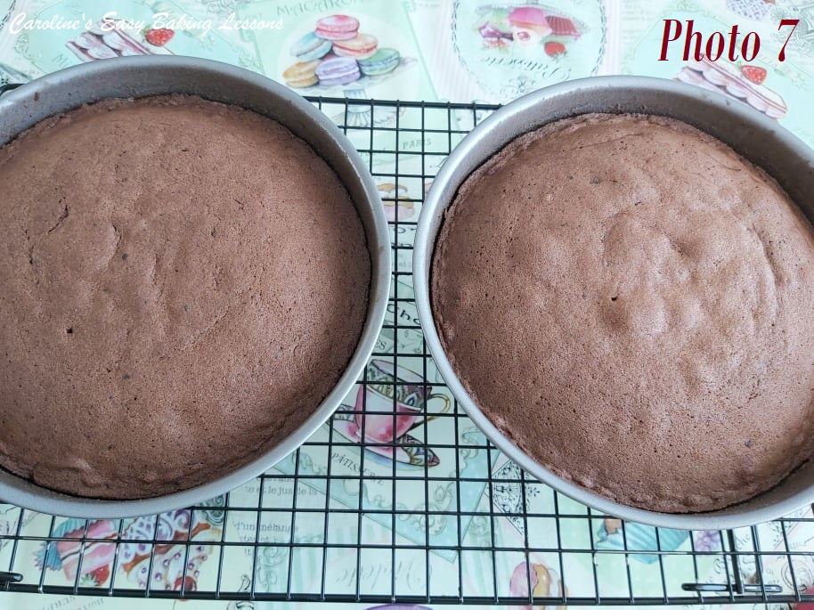
10. Leave to cool in the tins, on a cooling rack for at least 15 minutes.
11. Run a palette knife or butter knife around the edges of the cake tin – it may stick where there is jam/jelly. Place a folded clean tea-towel on the cooling rack and turn the tin over and let the cake fall onto the towel. Might need a few taps. Leave for at least 10 minutes before you try to carefully peel the paper off the cakes. If it isn’t coming off easily, leave it to cool more. See Photo 8
TOP TIP – Placing on the tea towel means there are no rack marks left on the top of the cake. If you intend to decorate on top, this is not important. But if going for the classic look for a Victoria Sandwich cake, you don’t really want lines showing on top. And leaving to cool upside down also results in less of a dome. If you want you can instead turn the cakes out onto a plate, remove the paper and then place the other way up on the cooling rack. Just be careful as the more you turn them at this fragile stage, the more likely a break is. See Photo 8 below.

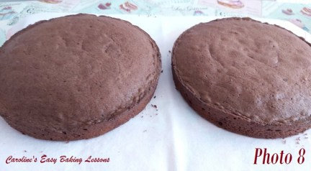
DECORATING THE CAKE

1. Using a hand or stand mixer, whip up the cream until very thick & stands tall with stiff peaks. Watch my little video if you aren’t sure how it should be done. Be sure not to over-whisk as you can end up making butter! It will start to separate and be a yellow/cream colour.
2. Place the layer of sponge you want to be on the bottom, onto a cake stand or nice large plate, (flat side of cake at the bottom).
3. If this base layer of cake is domed (rounded) too much, with a serrated bread knife, carefully slice off the excess. It doesn’t need to be completely level, just flat. And only slice off if really too rounded that it won’t sit right with 2 layers on. And have a taste test – Baker’s Bonus!
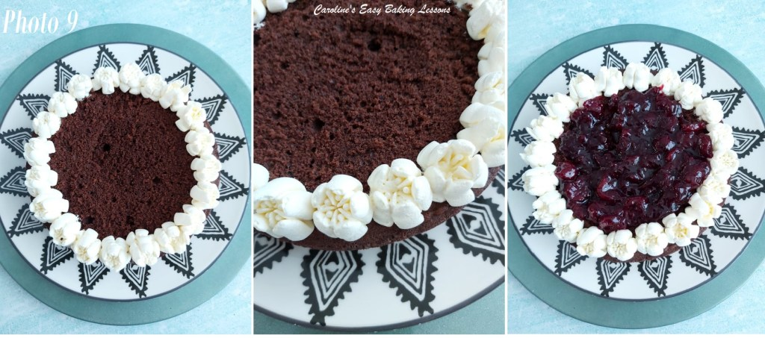
Filling the chocolate cake with cream and jam
4. Using a baking palette knife or butter knife, spread a generous layer of jam/jelly on top. Start in the middle and spread outwards until you get an even layer. If there are crumbs in the middle of the cake from cutting, don’t worry, just layer some more jam/jelly on top. **Note that if your jam is quite thin and runny, pipe a border of cream first to stop it running off the cake. See Photo 9 above. In the photo I actually used the large Russian piping nozzle and it gave a nice shape and height. But you can also use an open star nozzle too like in my video – it actually gives a nice pretty, flower kind of look to the cream.
5. I piped some cream around the border and a little in the middle of the cake (see Photo 9). Alternatively, pipe some cream on top of the jam/jelly layer too from the centre and then towards the outer edges, until you have an even and thick layer of cream.

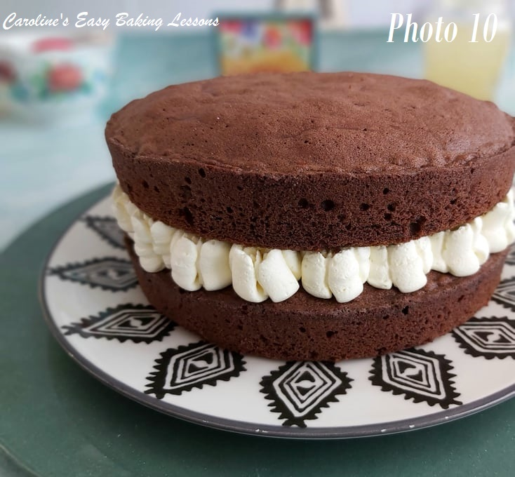
***TOP TIP FOR PHOTO READY CAKE – for the cream to hold it’s shape better once the top layer is on, pop the cream topped bottom layer in the fridge for 15 mins (10mins in the freezer) and then afterwards place the 2nd layer on top. Work quickly and it also helps with clean cuts
6. Carefully place the second layer of cake on top, with the flat side down and squeeze slightly. See Photo 10.
7. You can leave it like this, or dust with sieved icing/powdered sugar as is the classic way.
8. Sieve a thick dusting of icing/powdered sugar all over the cake. Serve straight away or store in a cake stand preferably somewhere not warm and eat withing 2 days. Just like before, you can chill the cake shortly before slicing it to get nicely cut slices, that are Facebook & Instagram ready!
***Top Tip – you can also store in large, deep airtight container. Just place it on the under side of the lid and stored with the box upside down & over the cake, so it’s easy to get out later.

DIFFICULTY LEVEL: Easy, Beginner

Thanks for reading
Happy Baking & Making
Happy Tummies & Memories!

Caro x

