DIANA’S ROCK CAKES
Caroline’s Easy Baking Lessons By Diana
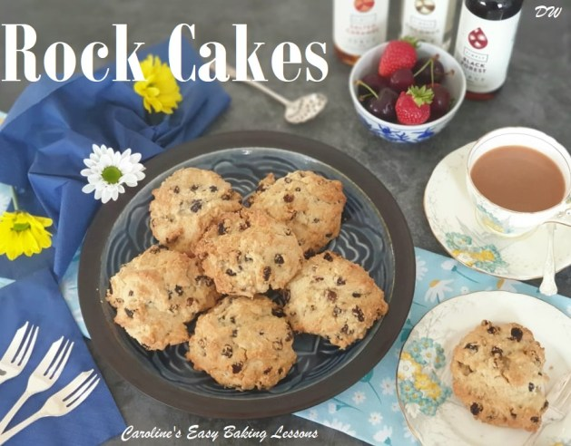
These cakes are a big favourite of my family. They are so easy to make that even the kids can have a go. I know some people ask what the difference is between these and scones , well rock cakes are a stiffer dough and dropped like cookies onto the baking sheet, whereas a scone dough is gently patted and cut into shapes before baking. The scones also rise much more and have a different structure. They are better eaten on the day but they also freeze beautifully if you’re lucky enough to have any left!
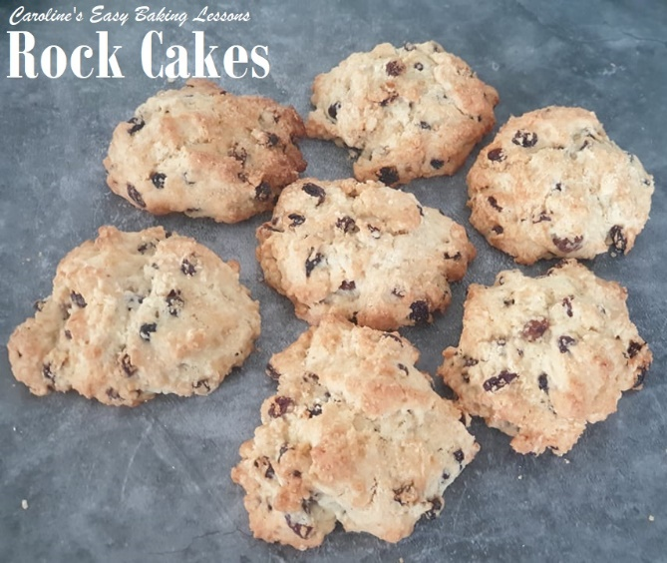

Note On Ingredients
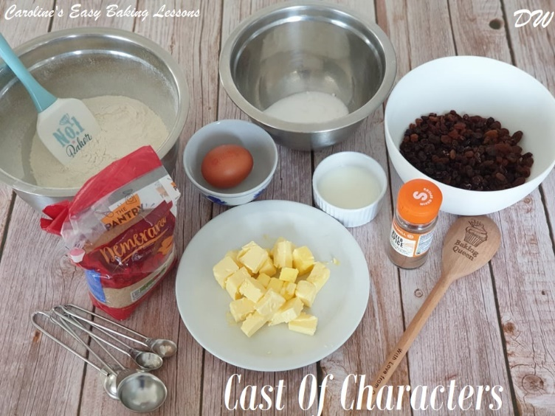
All Spice is used in this recipe, and is a blend of ginger, cloves, cinnamon & nutmeg. A good substitute is Pumpkin Spice. Self Raising flour is used but you can use Self Rising, or Plain/All Purpose flour instead, but add some baking powder too (all amounts given in the ingredient list below). Sultanas & Currants are the usual dried fruit for these, but raisins would also work and at a pinch cranberries. Finally, the sugar that’s added to the top of the cakes, just be before baking, is Demerara sugar. I know this isn’t available in the states, but a substitute could be Turbinado sugar, or indeed just use some granulated sugar or course sugar.

No fancy equipment is required for this and is really simple for kids to make or help you with so let’s get started.

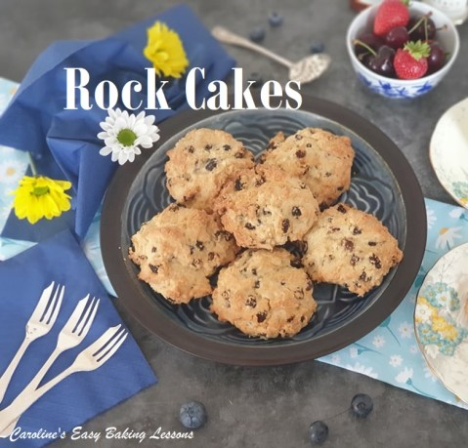
INGREDIENTS
225g Self Raising Flour (8 oz, 1 3/4 cups)
(OR Plain/A.P. Flour + 2 3/4 tsp Baking Powder)
(OR Self-rising Flour + 2 3/4 tsp Baking Powder)
100g Butter, unsalted & cubed (3.5 oz, or 7 tbsp)
50g Granulated Sugar (1.75 oz, 1/4 cup)
225g Sultanas and Currants, mixed
(or raisins & cranberries, (Total of 8 oz) )
1 large egg (US/Canada – XL)
About 1 tbsp Milk (15ml)
½ tsp Mixed Spice (Pumpkin Spice)
Topping:
25g Demerara Sugar (2 tbsp) (or turbinado/granulated)

• Make 12 or 8 large cakes

EQUIPMENT
Scales or Measuring Cups Measuring Spoons
Baking/parchment paper or silicone baking mats 2 Large baking sheets/trays
Timer or phone timer Sieve
Cooling rack Medium sized mixing bowl
Wooden spoon 2 teaspoons
Palette knife Pastry cutter/blender

OVEN: 200/180c Fan Oven/400f/Gas mark 6

INSTRUCTIONS
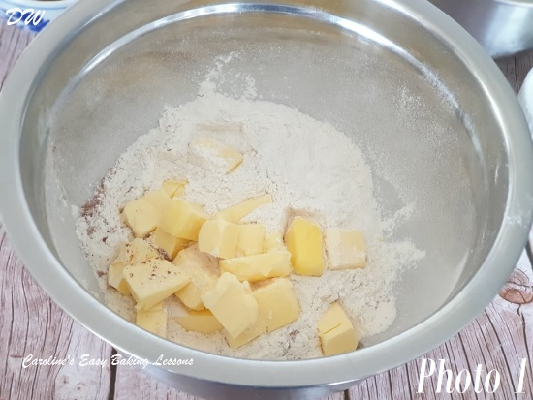
1. Pre-heat the oven to : 200c/180c Fan Oven/400f/Gas mark 6
2. Line baking trays/sheets with baking/parchment paper, remembering to grease the corners down, just in case it were move & to slide off as this has happened to me with one without a lip. I often use silicone baking mats but you can use either.
3. Sift the flour into the mixing bowl and add the cubed butter along with the Mixed Spice ( Pumpkin Spice). See Photo 1.
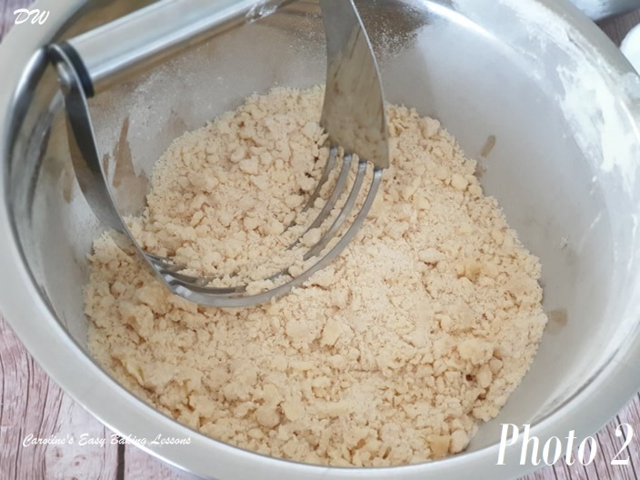

4. Rub in the butter until it resembles fine breadcrumbs. Do this by lifting some flour and butter between your finger tips, & rub them together. (See my Scones video, 5 mins in for a demo of this). You can also use a pastry cutter/pastry blender as in Photo 2 if you prefer, or you can use a food processor but this makes for more washing up and as I’m our dishwasher the pastry cutter it is! (Just push down on the bottom of the bowl and perform a rotating left and right motion, before lifting up and repeating on another area.). Repeat until the butter is fully coated in flour & in smaller pieces, the size of breadcrumbs. See Photo 2.

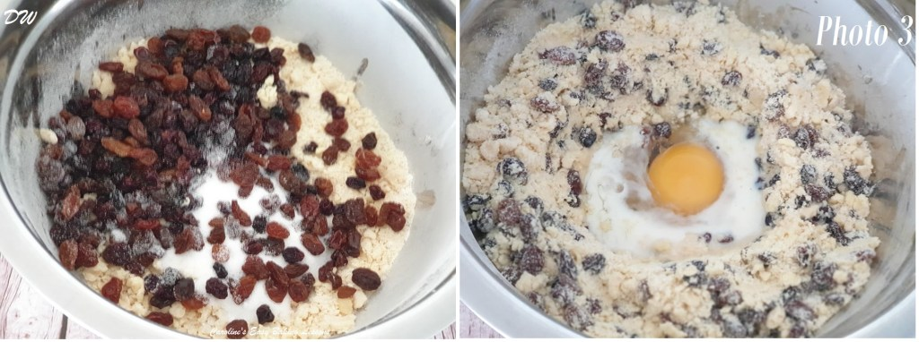
5. Add the sugar and fruit and mix together. See Photo 3, left pic.
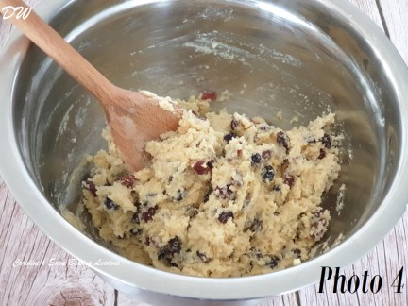
6. Make a well in the centre and add the egg and 1 tbsp milk (See Photo 3, right pic). Now the dough needs to be a thick lumpy dough (see Photo 4 below). Add a teaspoon more milk if you need it to make the mixture stick together but you don’t want a wet dough otherwise the cakes will spread and end up like cookies and we don’t want that!

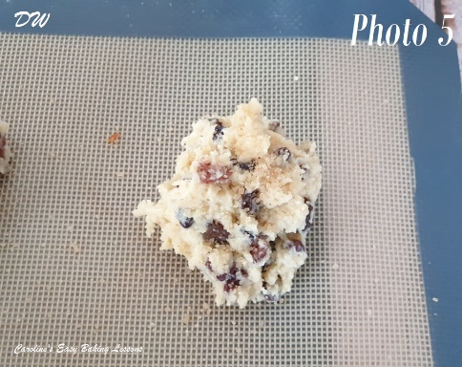
7. Using 2 teaspoons, shape the mixture into 12 round mounds, or you can do 8 which I did as it made them a little larger. (See Photo 5). Leave a space of about 3inches/7.5cms between them as they will flatten slightly and spread out during baking.

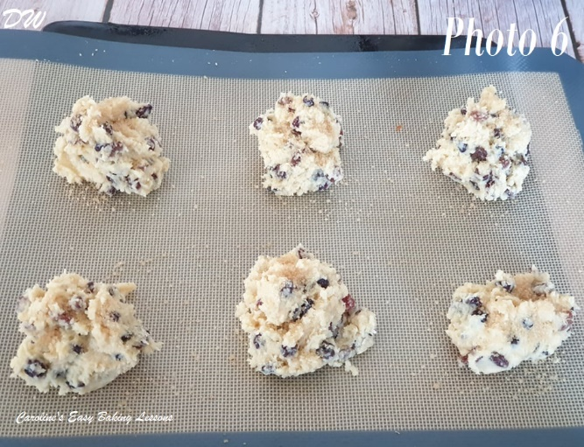
8. Sprinkle a little demerara sugar (Turbinado or granulated), onto the top of each one, this gives a nice finish. See Photo 6.
9. Carefully place in the oven and bake for 15-20 minutes until golden brown around the edges. Use a timer to be sure and get an adult to help if needed. I didn’t need to turn my trays but if your oven doesn’t cook evenly you can turn then after 12 mins. Mine took 18 mins to cook but it all depends on your oven. (See Photo 7 below.

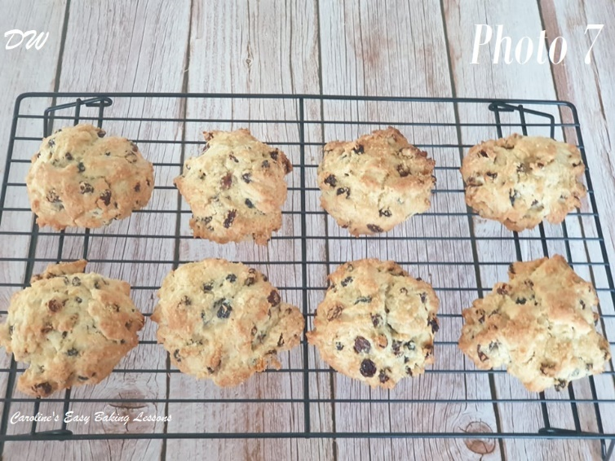
10. Carefully open the oven with gloves or ask an adult to take the trays out of the oven and get them to put on top of a cooling rack for about 5 mins.
11. Using a palette knife carefully put them onto the cooling rack to cool . See Photo 7..

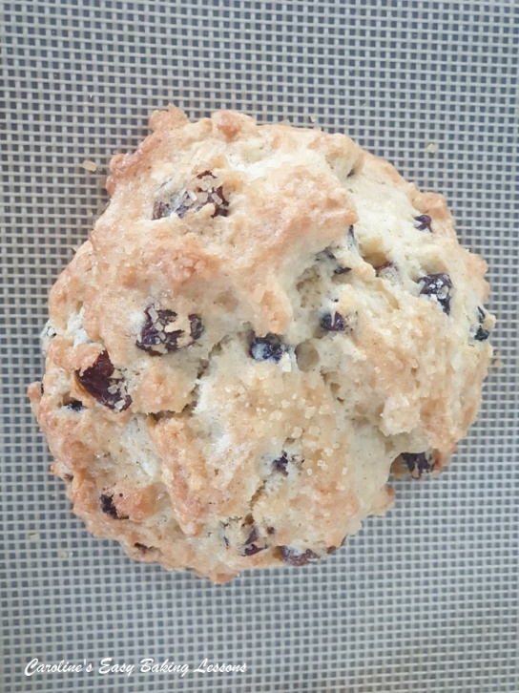

Now all that remains is to make a nice cup of tea and sit and enjoy! Oh and make sure you get someone to do the washing up.

DIFFICULTY LEVEL: easy, beginner

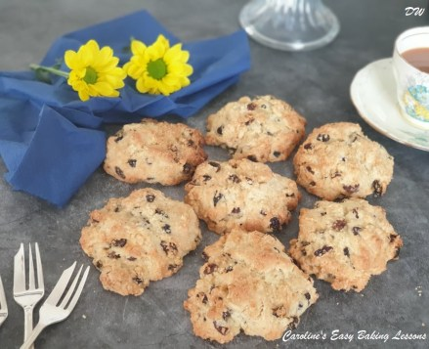

Thanks for reading
Happy Baking & Making
Happy Tummies & Memories!

Diana xx

