DIFFERENCES BETWEEN UK & US BAKING INGREDIENTS

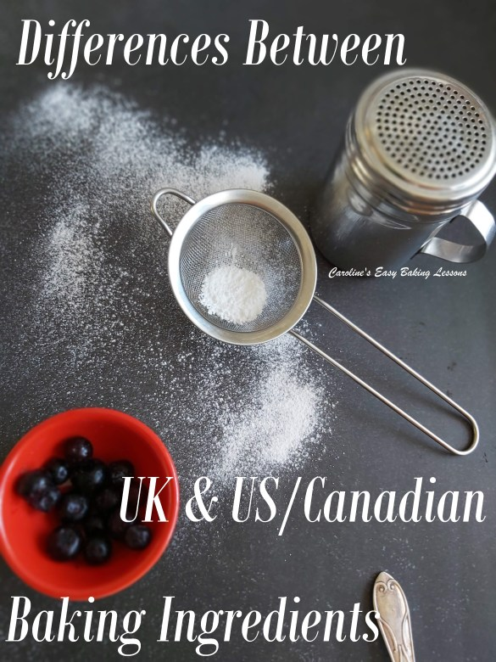
Caroline’s Easy Baking Lessons
Since I have many baking friends & readers from the US & Canada, I thought I would take the time to talk about the differences between UK & US/Canadian baking ingredients & the different names used. Likewise, if you watch US/Canadian food programs or are trying out a recipe with different ingredient names this should be beneficial too. With the Great British Bake Off tv program, (The Great British Baking Show), being so popular abroad, I do often read on Facebook groups, people asking questions about ingredients and measurements but sometimes, there are incorrect answers given out.
Also, some of these ingredients are either more expensive or difficult to find in another country, so I did some research to find out how to make them by altering ingredients that are widely available. (Thank you so much Beth Hurst for helping me out with this – my friend who lives in the states. )
For help with recipes in grams, ounces or cup measurements, go to my handy Conversion Table Of Most Common Baking Ingredients.

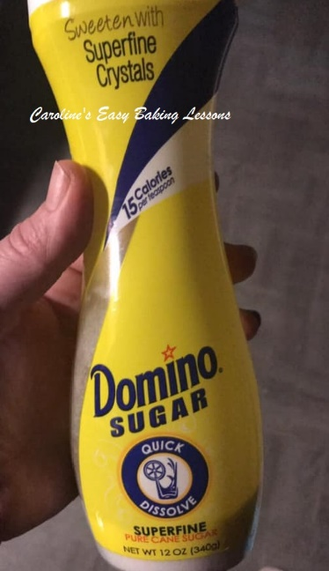

CASTER SUGAR
The equivalent is known as ‘Extra Fine or Super fine sugar’ in the US. Below is a photo of one brand that is available in the states. The bottle however is for tea or coffee, so isn’t in a very big bottle, (only 340g/12 oz). There are others listed in the table too but may not always be easily available as regular granulated sugar. However, after I showed my friend a video of the differences between our granulated, caster and icing sugar (confectioners’ sugar), it turns out that US regular (granulated) sugar is finer than our UK granulated. So US Granulated is easily ground or processed lightly to resemble our Caster sugar. Just be careful, as grinding in a processor too much may produce too fine a sugar, (similar to powder and be icing/confectioners’ sugar) and possibly ruin your machine so I would advise caution with it. Some people have also been known to use coffee bean grinders. A good tip with making your own is to crush in small batches and weigh or measure it as you go along until you get the quantity you need. Alternatively, make up a jar of your own caster sugar and use when needed. Be sure to store in an airtight container.

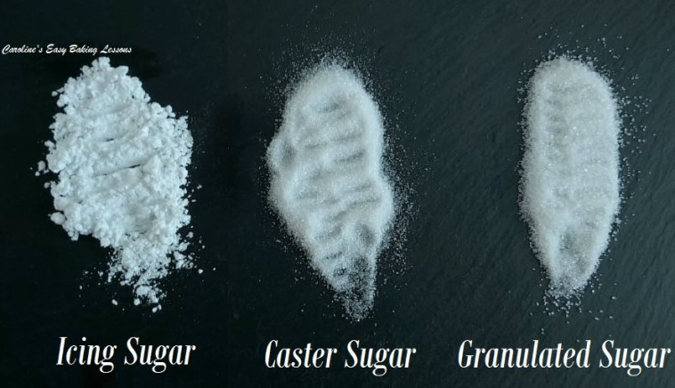
)Now something I hear getting asked a lot too is ‘can I not just use regular sugar in place of caster sugar?’ Well for some things, like cakes you can, but the texture is going to be different slightly because of the differences in granule sizes. You should also bear in mind that the original recipe has been developed using a specific ingredient. For things like meringues though, too big a granule is not something I would advise as you are trying to change the structure of the egg whites and produce a stability that wouldn’t hold if, for example you used confectioners, (icing) sugar. Also for things like making a sugar syrup, granulated can be used in place of caster, since you are melting down the sugar anyway in the process. You should also be aware that during the ‘creaming’ of the sugar and butter stage of cake making, you will need to beat a bit longer if using granulated, because of the bigger granule size.
Another note about caster sugar, is that some recipes call for golden caster sugar. This isn’t as widely available and more expensive in general. The only difference between this is the colour and a slightly more caramel taste to the sugar. It will not affect the bake in any other way than maybe a slight taste difference. You can also make an alternative to it, by combining light brown sugar and caster sugar (of a ratio of about 1:3). *Literally as I am typing this, I was answering a question on caster sugar on Facebook and I was informed that some Walmart’s stock super fine/extra fine sugar, however it may be more expensive.

ICING SUGAR
Icing Sugar is simply Confectioners’ sugar or powdered sugar. It’s used in the same way and normally pushed through a sieve first before using in foods or on top as a decoration. See photo above.

GRANULATED SUGAR
This is just regular, everyday tea sugar. Note that US granulated granule size is slightly finer than our UK equivalent. See photo above.

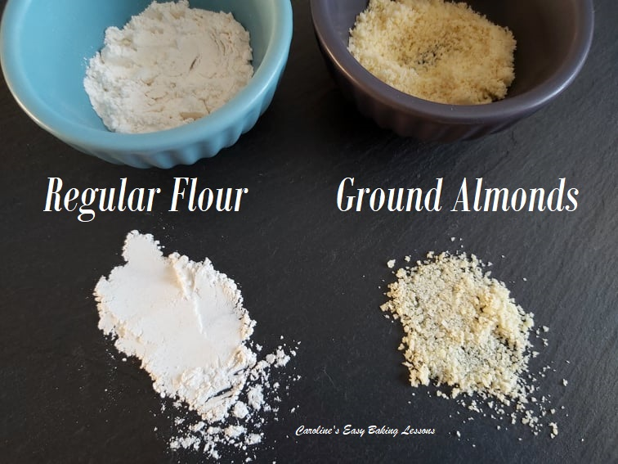

GROUND ALMONDS
In the US/Canada the equivalent is Almond Meal and Almond flour is sometimes available but is a lot finer and hence it’s name. The ground almonds provide moisture from it’s oils but most importantly provide a solid structure and is why it’s better to use this than regular flour. If you can’t get ground almonds or almond meal, you can make you own by using whole almonds, and with the skin on is fine (as it helps retain the good oils). You simply place them in a zip-lock plastic food bag and ‘bash’ them with a rolling pin or something similar until a lot finer and like large breadcrumbs. From this point you can then place in a food processor (in small quantities at a time) and grind a little finer, but not too much to a powder consistency. It should be like fine breadcrumbs, and crumbly. You can find videos on YouTube showing you how to do this. See the photo of how our ground almonds looks like compared to regular flour.

CORN FLOUR
Corn Flour from the UK is also known as corn starch. Used as a thickener but also used a lot in the UK in baking things such as shortbread and is very important in this. It’s what gives the classic crumbly melt in the mouth texture of real Scottish Shortbread. I also use a little in my soft sugar cookies.

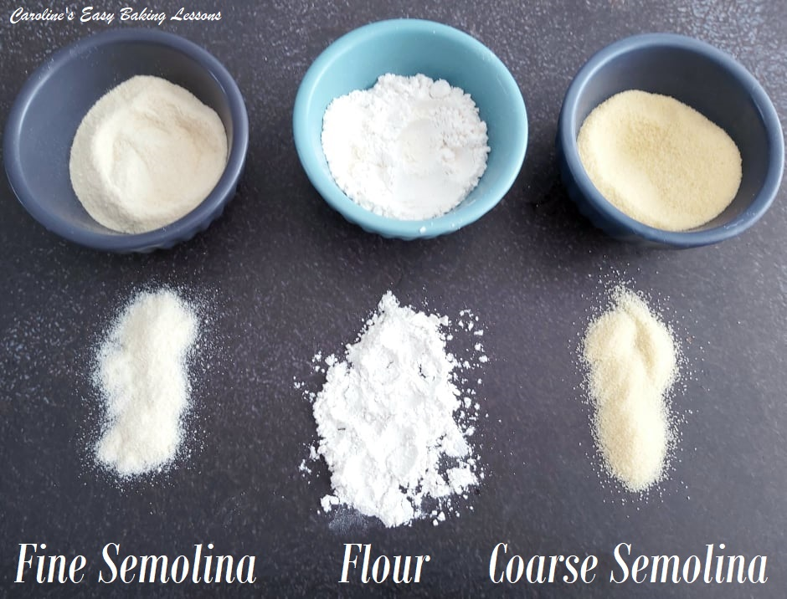
SEMOLINA
Often in recipes as fine or course. Fine semolina is a bit more coarse than semolina flour, but still very fine. See photo opposite comparing semolina to regular four. Still fine, but has a course texture if you run it through your fingers and is pale beige/yellow in colour. Used in cakes and also on top of breads or rolls. Both give a slight different texture feel to the sponge, and obviously the coarse one more so. Note that semolina can be found in bigger supermarkets, and in foreign food stores/aisles and also online. It can be used in a lot of baked goods and I have a Turkish cake, Revani also known as Sambali, coming up that uses it. See my photo of the semolina compared to regular wheat flour. See online for more pics.
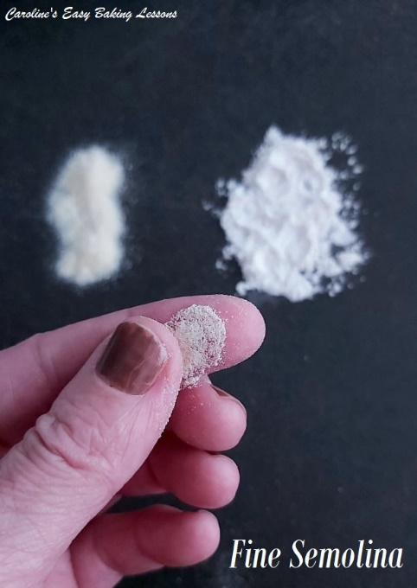
SELF-RAISING FLOUR
This is roughly the equivalent to US self-rising flour. It can be more expensive and hard to come by in the states and Canada, but it’s easily made from All purpose (Plain flour in the UK) flour by adding baking powder and I add a little salt. The ratio for UK self-raising is, for every 125g (1 cup) of self-raising, you add 2tsp baking powder to 1 cup of all purpose or plain flour. However, US Self-rising, is 1.5 tsp of baking powder and ¼ tsp of salt. I personally find the 2 tsp of baking powder too much if there are several cups of flour involved, and especially so if there is baking powder in the recipe you are using also. I go between 1.25 – 1.5 tsp baking powder per 125g/1 cup of flour and a scant ¼ tsp salt. I prefer this combination, as I don’t like the metallic taste of too much baking powder. For British scones, I use the 1.25 tsp ratio as there is additional baking powder in the recipe. For cakes, I typically use 1.5 tsp. Note that too much baking powder, can give a good rise, but if there is no support for the bake (ie. enough flour), it will deflate and be very dense. * Note also, that in my recipes, I always give the corresponding ratio of baking powder to use that has worked for me.

MY PREFERRED FORMULA FOR MAKING SELF-RAISING FLOUR FOR CAKES
*Note there is no salt added to self-raising flour, but I add as I find it helps bring out the main flavour. One mobile phone, swipe left/right to see all the table.
SELF-RAISING | US CUP SIZE | BAKING POWDER | SALT*
113g | 1 scant Cup | 1 & scant 1/2 tsp | Scant 1/4 tsp
125g | 1 Cup | 1 & 1/2 tsp | 1/4 tsp
225g | 1 3/4 Cup | 2 3/4 tsp | Scant 1/2 tsp
250g | 2 Cups | 3 tsp | 1/2 tsp
450g | 3 1/2 Cups | 5 1/2 tsp | Scant 1 tsp
My preferred quantities for making Self-raising flour for cakes

BUTTERMILK
Buttermilk can be made in several ways. This is the easiest. For every 1 cup of buttermilk required, add 1 tbsp lemon or vinegar to 1 cup (240 ml) milk and preferably not skimmed/no fat milk. Mix and leave to settle for 10 minutes. This doesn’t give you actual butter milk, but it provides the acid that is required for the baking process in the particular recipe you are using. **Note the milk will look curdled, but that is exactly what we want and is just the fat separating from the liquid.

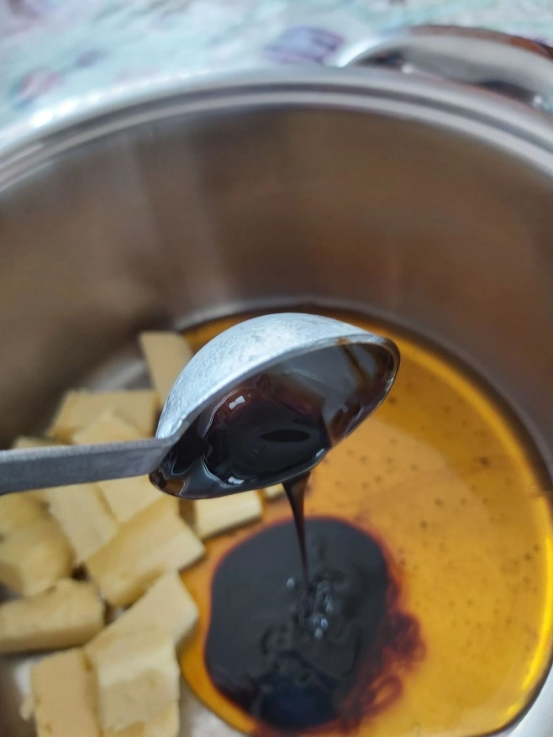
GOLDEN SYRUP
Golden Syrup from the UK is NOT the same as corn syrup. Different processes to make them, but on baking terms, the consistency is not equal with the Golden Syrup being thicker. But more importantly, the Golden Syrup has a unique taste that does not have a 100% comparison. The closest is to a cross between a caramel, butterscotch and syrup taste. It is great in recipes and also can be drizzled straight on top of a cake or even ice-cream. Using corn syrup will not give the same depth of flavour as using the Golden syrup. A friend from the Bake Off group I help admin, did a little experiment with my Gingerbread Cake, that requires Golden Syrup and some Black Treacle.. She made using the original ingredients and also one with the American substitutes of Corn Syrup & Black Strap Molasses. And she too confirmed as I suspected, that the original recipe and it’s intended ingredients produced a much better tasting cake and with a slightly lighter texture too. Thanks Jennifer! (Here’s a link to that recipe, where I list where in the states you can buy Golden Syrup).

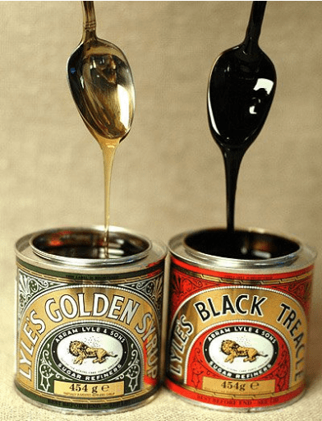
BLACK TREACLE
As mentioned in the last paragraph, US Black Strap Molasses is the nearest equivalent to Black treacle and NOT Dark Corn Syrup. Here’s where to buy it in the States & Canada.
For lots more conversion tables and useful baking information click here.
DOWNLOAD this article, to save to you phone or computer for using or printing off later. Click the ‘download’ button below:
DIFFERENCES BETWEEN UK & US INGREDIENTS Download

Below on the next page, is a table of the corresponding or alternative ingredients commonly used in baking. Note there may be some regional variations.

Thanks for reading
Caro xx

NAME IN THE UK | KNOWN IN THE US/CANADA | NOTES
1/2 Double Cream 1/2 Milk | “Half & Half” | Not low/zero fat milk
BBQ Cooking | Grilling
Bicarbonate Of Soda  (Sodium Bicarbonate) | Baking Soda
Bread/Strong Bread Flour | Bread Flour | Higher protein %
Caster Sugar | Extra/Super Fine Sugar, Baker’s Sugar,  Fruit Sugar, Berry Sugar | ‘Domino’ brand, or make own
Cling Film | Plastic Wrap, Saran Wrap
Cornflour | Corn Starch
Custard | Like a pudding, thinner than creme pat  (pastry cream)
Double Cream | Heavy or Whipping Cream | Slightly different fat % but  still whip the same
Semolina | Fine or Coarse Semolina | Not semolina flour but gritty
Frying Pan | Skillet
Gas Mark 1 – 9 | 275ºf – 475 ºf | 140-250 ºc (see temps)
Golden Syrup | No 100% equivalent | Dark Corn syrup/honey for  consistency but not flavour
Granulated (tea) sugar | Regular white sugar | UK slightly larger grain
Grease-proof/Baking Paper | Parchment Paper
Grilling/Grill | Broiling/broil
Ground Almonds | Near to Almond Meal | Or make your own, see above
Icing | Frosting or glaze | Also Fondant (sugar paste)
Icing Sugar | Powdered Sugar (or Confectioners’) | No corn starch in Icing Sugar
Jam | Jelly (in some cases)
Jelly | Jell-O | Can be squares, or powder
Kitchen Paper/Towel/Roll | Paper Towel
Kitchen worktop | Kitchen counter
Liquidiser/Blender | Blender
Pastie/Pasty, pastry | Hand pie, Turnover
Pickles/preserves in jars | “Canning” in glass jars
Plain Flour | All Purpose (A.P.) Flour | Very close protein percentage
Self-raising Flour | Plain/A.P. flour plus baking powder | Self-rising similar but slightly  less baking powder
Single Cream | Light Cream | 18% & 20% fat respectively
Slow Cooker | Crock Pot
Sodium Bicarbonate, Bicarb | Baking Soda | Also Bicarbonate of Soda
Stove, Hob | Hot, Burner or Range
Strong Flour | Bread Flour | Higher protein %
Tin Foil, Aluminium Foil | Aluminium/Aluminum Foil
Tin of ….. | Can of … | e.x. fruit
Wholemeal Flour | Wholewheat Flour
UK & US/Canadian baking names/terms table

