INDIVIDUAL CHOCOLATE TARTS – How To Easily Make This Indulgent Dessert
Caroline’s Easy Baking Lessons

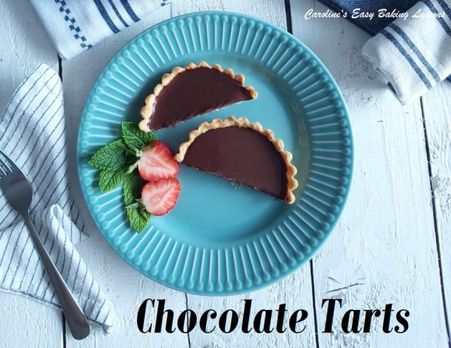
This is my new recipe to make thoroughly indulgent, individual chocolate tarts. Let me guide you through the process to make a crowd pleasing dessert. Can be made in two stages, saving you some time, and can also be made ahead of time if stored in the fridge. I made them in individual fluted tart tins with loose bases, and are 8.5cm/ 3.25 “ in diameter. I have also made with scraps of pastry in mini tart tins too. Just make sure to roll your pastry a little thinner and bake a little less. You can even use small cupcake liners in a cupcake tray if you don’t have any pastry/tart tins. For cutting out the pastry, I used a pastry/cookie cutter larger than the diameter of the tart tins. I used my largest one at 12cm (4.75″), to give enough pastry to go up the sides of the tin too.
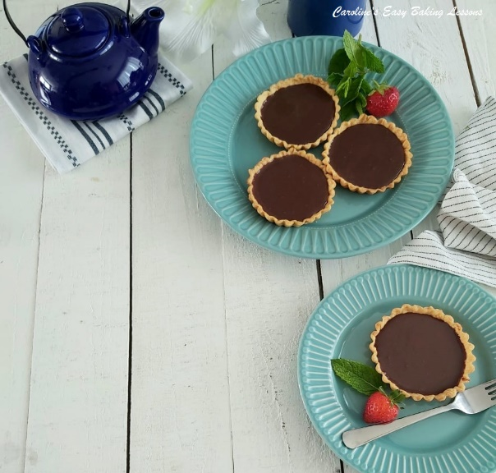
Now the recipe is for 6 individual tarts, but there will be left over chocolate filling and pastry. Rather than downsize the recipe, you can of course use the leftovers to make mini ones or just save the uncooked pastry, and freeze for another day. Label it and periodically add to it and you will have enough for a pie in no time. Also I have a great recipe for leftover chocolate filling – it is essentially a chocolate ganache that you could use to cover cupcakes if you wanted. But I like to let it firm up and add some more simple ingredients to make delicious chocolate truffles or Protein Power-balls if that’s your thing). Go to my chocolate truffle recipe.

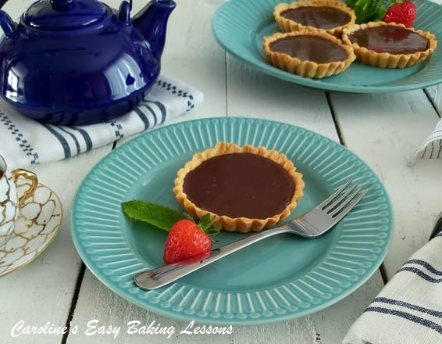

These will pair nicely with fresh cream and seasonal fruits. Whatever you fancy. Now the recipe consists of a sweet shortcrust (pie) pastry & chocolate ganache. Both of which I have separate recipes for. So as not to make the recipe too long (and because you can make in stages), I have added links to make the pastry and ganache and then how to construct and bake the tarts. The pastry recipe, also includes lots of tips if you have problems making pastry.
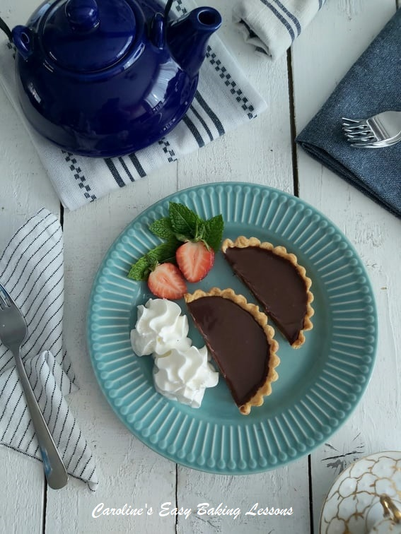

INGREDIENTS
FOR THE PASTRY
- 175g Plain Flour (6 oz, 1 ¼ Cup + 1 tbsp All Purpose)
- 75g Butter, cubed (cold) (2.5 oz or 2/3 stick)
- 20g Icing Sugar, sieved (3 Tbsp Powdered sugar, sieved)
- 1 Medium Egg, beaten (Large US)
- Ice Cold Water

FOR THE CHOCOLATE FILLING
- 300ml Double Cream (10 fl oz, 1 1/4 cup Heavy/Whipping Cream)
- 150g Milk Chocolate (5.25 oz semi-sweet chocolate)
- 150g Dark Chocolate (5.25 oz bitter chocolate)
- 1 tbsp (rounded) Liquid Glucose (optional)
- 60g Butter, unsalted & cubed small (2 oz, 4 tbsp)
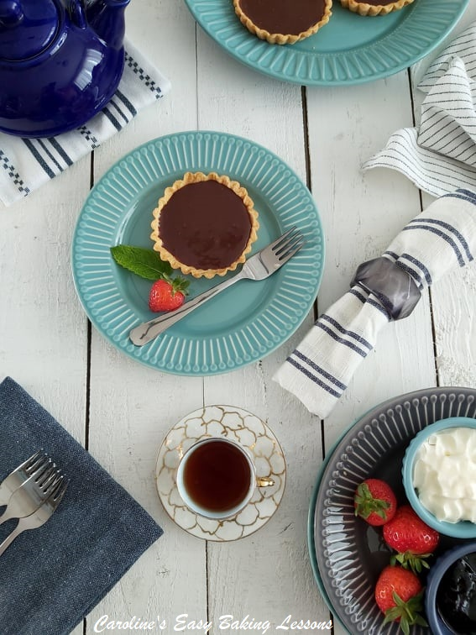

EQUIPMENT
- Scales or Measuring Cups
- Large spoon
- Knife
- Measuring spoons
- Cling film/plastic wrap
- Dinner plate
- Small Jug (optional)
- Medium pan or Microwave-safe Bowl
- Chopping board and large knife Mixing spoon
- Small pie/tart tins (see above)
- Rolling Pin
- Baking/parchment paper (optional)
- Tin Foil (aluminum foil)
- Some flour, cornflour/starch or icing/powdered sugar
- Large cookie/pastry cutters/lids for cutting & bigger than your tart tin diameter
- Baking beans/dried uncooked beans/uncooked rice
- Timer
- Cooling rack
- Baking tray/sheet to hold the tart tins
OVEN: 190/170c Fan Oven/375f/Gas Mark 5

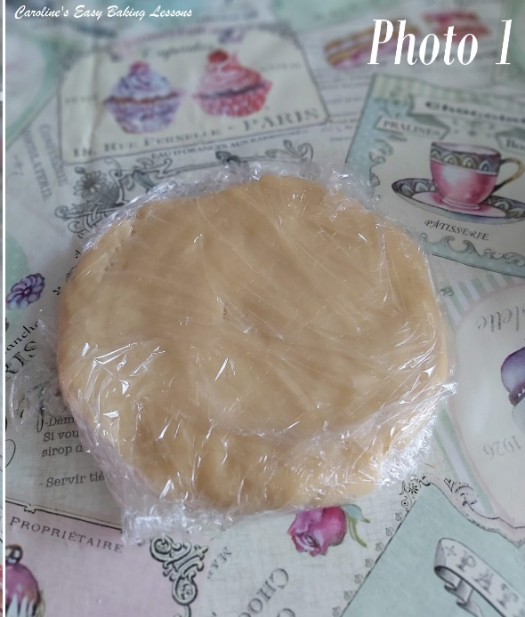
INSTRUCTIONS

MAKE THE PASTRY
1. First step (and you can do day before), is to prepare the pastry. To make the pastry, go to the Sweet Shortcrust Pastry recipe. See Photo 1.
2. Once prepared, wrap in cling film/plastic wrap and place on a flat plate, into the fridge for 30 minutes before rolling out. You can also leave overnight to make the next day. Just be sure to bring out of the fridge at least 30 minutes before you want to use it or it will be too cold and hard to roll. Just make sure it doesn’t get too soft or you will need to refrigerate again before rolling out.

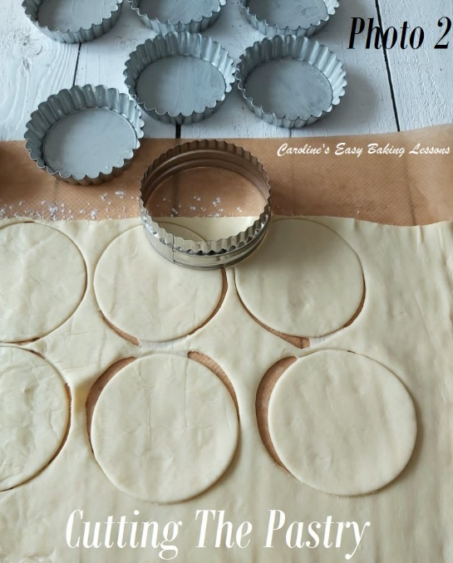

MAKE THE PIE TART CASE
3. Cut some baking/parchment paper to work on (optional but means less mess and easier to roll out), and then dust with either some flour, cornflour/starch or icing/powdered sugar.
4. Now dust the rolling pin too and either roll the pastry out directly with the pin, or use a 2nd piece of paper on top. Roll out in all directions till the pastry is about 3mm (1/8″) thick. (See Photo 2). If using smaller tins than I did, you might want to roll out just a little thinner.
5. Once all rolled out, take a cookie/pastry cutter or something like a large round lid (wider than the pie dish diameter, see above note) and dip in flour to prevent it sticking.
6. Cut out 6 circles of pastry and then carefully pull back the scrap excess pastry and either roll again for smaller tarts, or wrap in paper and then in a food bag, label and freeze for another time. See Photo 2.
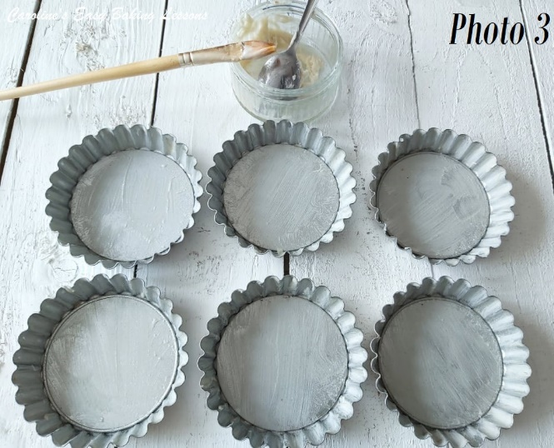
7. Grease your tart tins. I either use baking sprays (Frylight Onecal is good), or homemade lining paste (see recipe). See Photo 3.
8. Before lifting the pastry, hold one of the tins above the pastry just to check it’s going to be wide enough. If it looks a little too small for the depth of your tins, take your rolling pin and roll the ends out a little. Then carefully lift one of the pastry circles (use a baker’s palette knife is needed) and place into the centre of the tart tin. Use your fingers to guide the pastry into the shape of the tin, and into the fluted sides. You can also take a small ball of the scrap dough and use it to press against the pastry, to fit in to the tin.

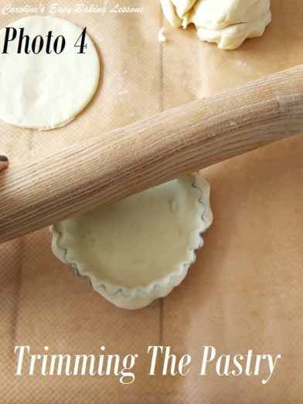
9. Run the rolling pin over the top of the tin to remove any excess pastry from the top edges. Then something I like to do to avoid too much shrinking on baking, is to gently squeeze the pastry on the sides of the tin, up a little bit. Don’t do it too much and make the pastry too thin. See Photo 4 above.
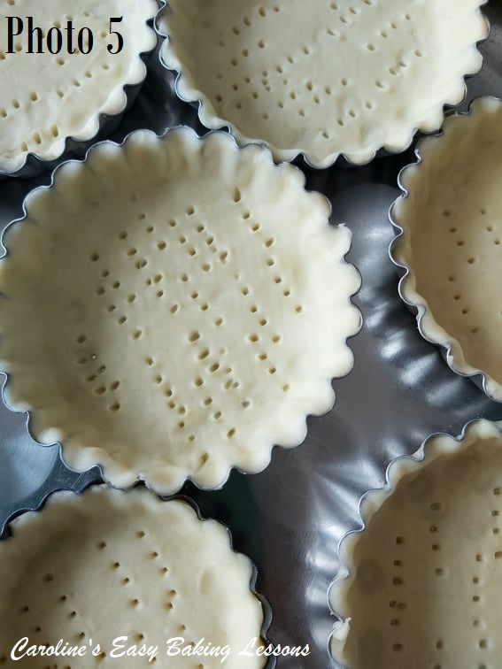
10. Now take a fork and ‘dock’ the base of the pastry by simply making lots of holes. This ensures that steam can escape when baking and reduces the chances of a ‘soggy bottom’ to your tart. Repeat for the other 5 pastries. See Photo 5.
11. Now a very important stage is to chill the pastry before baking. This relaxes the gluten in the pastry (over-worked gluten produces a tough pastry), as well as firming the dough to help keep it’s shape on baking. Simply place the 6 tart tins on a baking tray/sheet that will fit in your fridge and chill for 30 minutes (or you can freeze for 15 minutes if in a hurry).

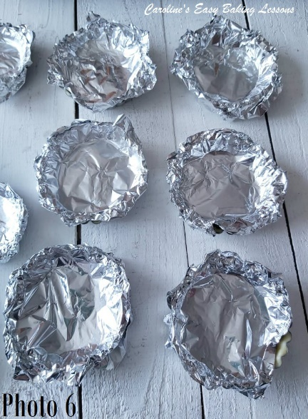
12. Once the chilling time is nearly up, heat up your oven to 190/170c Fan Oven/375f/Gas Mark 5.
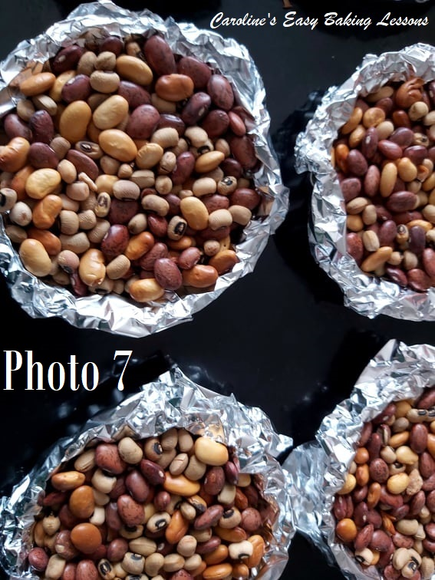
13. Now prepare to weigh down the tarts by cutting squares of tin foil/aluminum foil (you can use baking/parchment paper but I am not as keen on it and a tip is to scrunch it up and then flatten out, to soften the paper and reduce chances of making holes in your pastry). You want squares that are just a little wider than your tart tins to be able to cover them, including the edges. I tend to cut a piece and then cut in half to make 2 pieces. See Photo 6.

14. You can use silicone baking beans, uncooked rice or uncooked dry beans (I use the latter and store once cooled in a jar ready for next pastry baking). And they are used to weigh down the pastry, giving us a ‘case’ as opposed to just a block of pastry on baking. Take a square of the foil, place in the centre of the pastry, push down and up the sides, and let the foil go over the edges, so no pastry is visible. Then simply use enough of the beans to fill the pastry case, right up to the top. This is important as if you just fill to hold the foil down the foil, you can have shrinkage on the sides. Repeat with the other 5 pastries. See Photo 7.
15. Bake the pastries like this with no filling (called ‘blind baking’ or ‘par/part baking’, for 15 minutes.

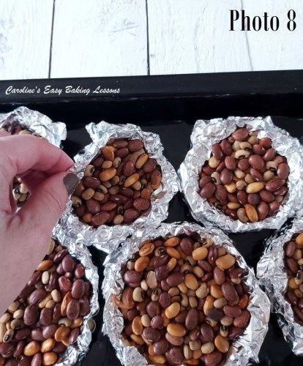
16. Very carefully turn the foil up over the beans, close it & remove from the pastry. Be careful not to drop any beans in the pastry (if you do, use a fork to remove it, remember it will be hot and smooth down the pastry). See Photo 8 above. Leave the foil and beans out to cool down. Note if any of your pastries are not forming a ‘case’ shape keep the foil and beans on top and continue baking a few more minutes. You might notice this if you make very small ones and your pastry is rolled too thick, it will puff up too much with not enough weight to weigh it down. See Photo 9. Reduce the oven temperature to 170/150c Fan Oven/350f/Gas Mark 4.
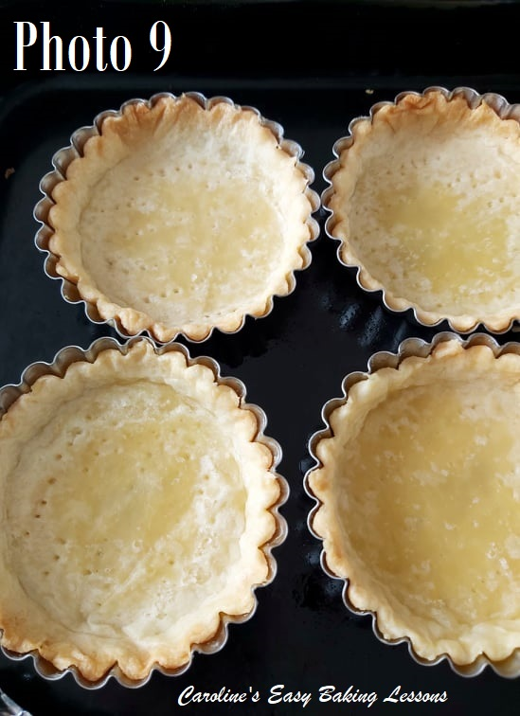

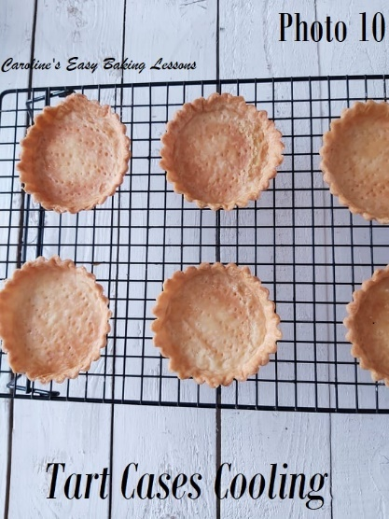
17. Whisk an egg with a splash of milk and brush this ‘egg wash’ onto the base of the pastry and onto the edges, before placing back in the oven to finish baking for about 5-10 minutes until golden and set all the way through. See Photo 10. (Mine took 8 minutes).
18. Remove from the oven and leave on the baking sheet/tray, on top of a cooling rack for about 10 minutes before removing the tray/sheet. Then leave to cool down completely before removing the cases. The filling should not be added until the pastries are cooled.

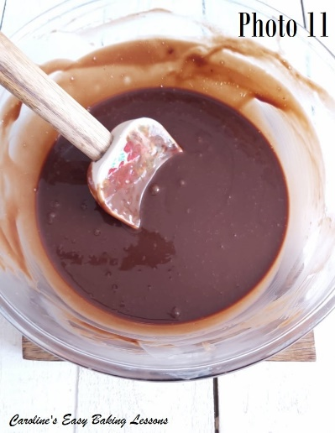
MAKING THE FILLING
19. To make the filling, see my ganache recipe. Proceed to step 5 of the ganache recipe. At the same time as mixing the cream and chocolate, you can add in the 1 rounded tbsp liquid glucose (or you can add at the same time as the chocolate like in the video). This is optional but does firm and set the ganache a little quicker. Then add in gradually, the small cubes of butter, mixing well in-between each addition. Once all mixed through, it should be smooth and shiny. See Photo 11. Leave to cool for another 10 minutes or so, while the cases cool.

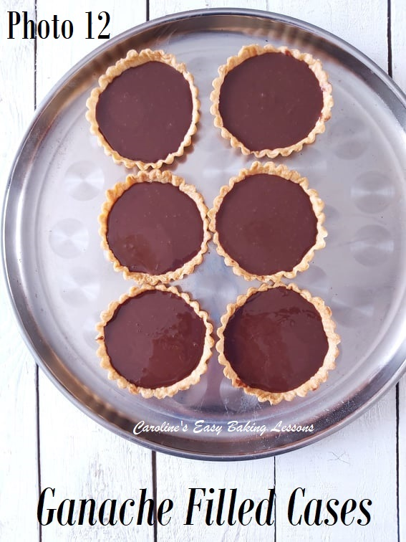
CONSTRUCTING THE TARTS
20. Place the tarts on a tray that will fit in your fridge.
21. Very carefully spoon the ganache into the pastry cases, leaving a little gap from the top (about 2 – 3 mm or 1/8″). See Photo 12.
22. Now carefully transfer the tray with the pastries into the fridge to set for at least 3 hours. If you don’t use liquid glucose, this might take longer.
23. Any left-over ganache can be left in the bowl, covered with cling film/plastic wrap and left at room temperature (just be aware placing in the fridge, it will set up and you might have to then leave at room temperature before you can use it). Use the left over to top cupcakes, cakes, or whisk it to make a lighter topping – see my whisked chocolate and orange ganache recipe. Alternatively, use to make Chocolate Truffles.

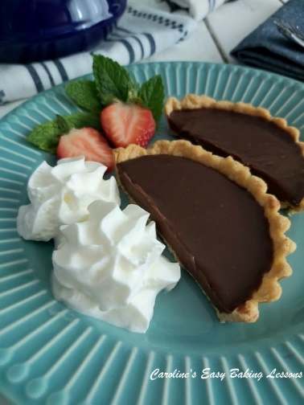
SERVING THE TARTS
24. Once the tarts are set or you are ready to eat, simply add some whipped cream, and or fruits of your choice.
25. Left-overs can be stored in the fridge, covered and last a few days.
26. Pre-baked or even baked pastry shells could also be frozen. Just well-wrap in paper first. before cling film/plastic wrap and when you want to use them, part defrost them at room temperature and bake while still cold. You might need to bake a little longer.
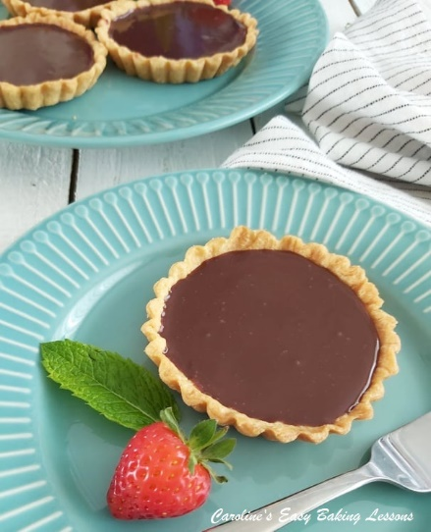

DIFFICULTY LEVEL: easy with guidance
:Thanks for reading

Happy Baking & Making
Happy Tummies & Memories!

Caro xx

