SIMPLE FRUIT CAKE – No Hassle Boiled Fruit Cake For Afternoon Tea
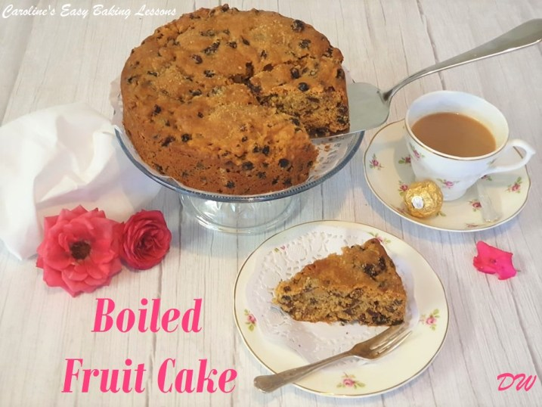
Caroline’s Easy Baking Lessons

This recipe is written by my friend and fellow baking enthusiast (should we be called addicts? ) Diana Watkins. Diana kindly helps me out with the website, testing my recipes, providing photos and being an invaluable source of experience and knowledge over the last year. There would not have been a new version of the website this year, had it not been for her help. So I am forever thankful.

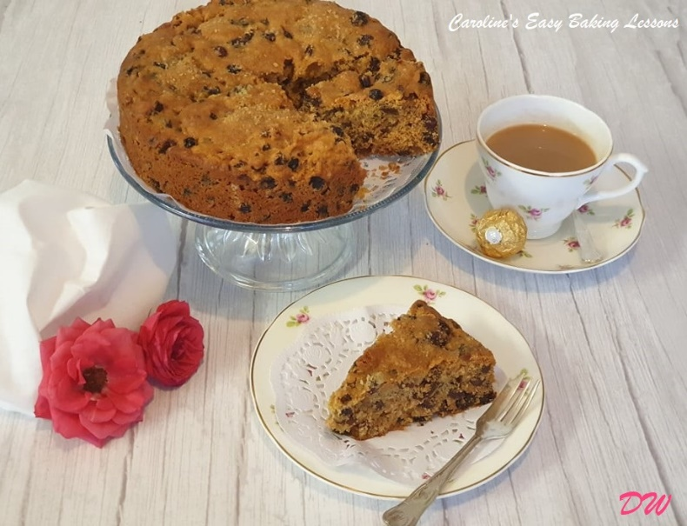
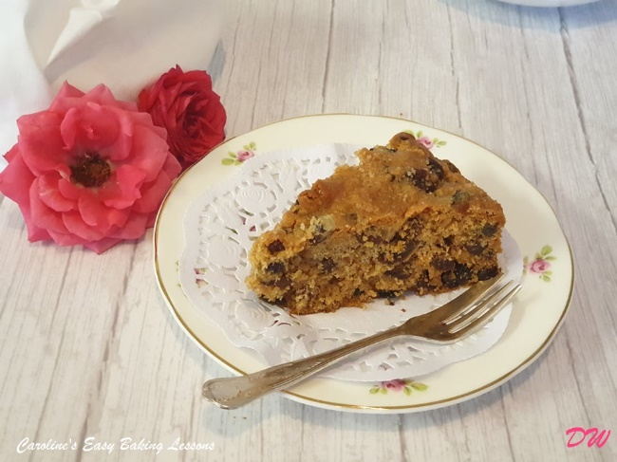
Anyway, this recipe is so simple that it is ideal for beginner bakers, and also using a new feature to the site called RECIPE CARDS. You know my style of recipe writing is very different, and very thorough in instructions and includes step-by-step process photos. But sometimes, if you have baking experience, or if indeed the recipe is so simple, you don’t need that level of detail. And here is where the Recipe Card comes in. It’s basically what us food bloggers/writers use as a template for recipes. For you readers it is essentially an abbreviated version of the recipe, and more like what you would find in recipe books. You can also print these cards, that could be folded up and placed in recipe card boxes or inside personal recipe books. I will also include the download version, that includes this whole post and recipe, which you can quickly & easily save to your phone or computer for use later.

So without further ado, here is the Recipe card below and Diana’s recipe for Fruit Cake. Hope you enjoy it and let us know or tag us if you make it. Thanks so much, Caro xxx

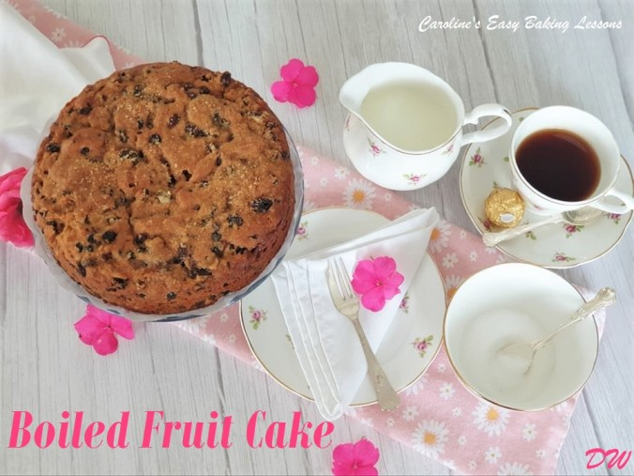

RECIPE CARD

SIMPLE FRUIT CAKE

An Easy Boiled Fruit Cake For Afternoon Tea
Diana Watkins (DW)

I’m always making sponges so hubby decided he would like a fruit cake as he is a great lover of it so I found this recipe which is so quick to make if you don’t have a lot of time. It is based on an old Bero recipe, but I have added some of my own touches to it over the years. It really is a lovely moist cake and this is because you actually simmer the fruit in the butter and sugar so the fruit really swells up. I let the mixture cool for about 40 minutes before I added the flour and egg. Also I added a tsp of mixed spice, (pumpkin spice in the US) and I used butter instead of margarine as butter gives a much better flavour. I also used light brown sugar instead of castor sugar so it gave it a nice colour but you could use whatever sugar you like. Another good tip is to sprinkle demerara sugar over it before you bake or sugar crystals as this gives a nice crunchy topping.

Course Dessert: Snack Cuisine: British Servings: 8 slices
Prep Time: 30 mins Cook Time: 1 hr 15 mins
Cooling Mixture: 40 mins Total Time: 2 hrs 25 mins

Equipment
- Scales or measuring cups Teaspoon
- Baking/Parchment paper Sieve
- 6-7” Round Cake tin (15-18 cm) Wooden spoon
- Saucepan Timer or Phone Timer
- Medium sized mixing bowl Wooden Cocktail stick/toothpick
- Cooling rack

Ingredients
- 340 g Mixed dried fruit – raisins, currants, sultanas etc dusted in some flour (12 oz, 2 cups approx)
- 113 g Sugar – granulated, caster or light brown (4 oz, ½ cup, rounded)
- 113g g Butter or Margarine/Baking Spread (4 oz, ½ cup or 1 stick)
- 1 Egg, Large, beaten (US X Large)
- 150 ml Water (5 floz, ⅔ cup or ¼ pint)
- 225 g Self-raising Flour (8 oz, 1 ¾ cups All purpose flour + 2 ¾ tsp baking powder)
- 1 tsp Mixed spice (optional) (Pumpkin Spice alternative)
- Demerara Sugar for the topping (optional)

Instructions

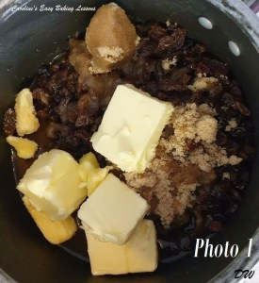
PREPARE THE CAKE TIN
1. Line a deep 6-7”( 15-18 cm) round cake tin with baking/parchment paper, on the bottom and up the sides (lining the sides helps with cakes that are rich in fruit and require a longer baking time and reduces the chances of the sides cooking too quickly). Grease the paper in position with either butter, cooking/baking spray or try lining paste (see notes below).

PREPARE THE BATTER
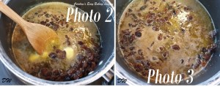
2.Place butter, sugar and water in a pan and simmer on a low-medium heat, for 20 minutes (Photo 1). You do not want it boiling, so as the fruit absorbs the water and makes for nice soft plump fruit. Stir occasionally so that the mixture doesn’t burn or stick to the bottom of the pan. (See Photo 2 and 3 below)

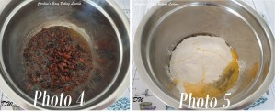
3.Remove pan from heat and pour into a mixing bowl. (See Photo 4 below). Allow the mixture to cool down. I left mine for about 40 minutes.
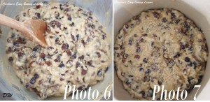
4.Pre-heat your oven 170°c/150°c Fan Oven/325°f/Gas Mark 3

5. Now add the beaten egg and stir in the sieved flour and the mixed spice/pumpkin spice if you are using it. (See Photo 5 above)
6.Make sure you mix the mixture well. (See Photo 6 below)

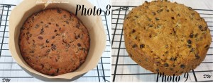
7.Turn the mixture into your lined cake tin and spread evenly. At this stage you can sprinkle demerara sugar or sugar crystals over the top of the cake. (See Photo 7 above)

BAKE THE CAKE
8.Bake in the oven for approximately 1¼ hours. Check with a cocktail stick that the cake is cooked, it should come out clean of crumbs.
9.Remove from oven and leave in the tin to cool down for 15 mins. (See Photo 8 below)
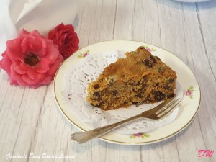
10.Turn out to cool on a wire rack and remove the baking/parchment paper carefully. (See Photo 9 below).
11.Leave to cool before cutting & serving.

Notes
This cake will last for about 10 days in an airtight container/tin. But in my house it lasts about 3 and that’s if I’m lucky! It’s ideal to have made so if anyone pops in you can offer them a nice piece of fruit cake which is so easy to make.

TOP TIPS
There are variations you can make with this recipe. You can add cherries but make sure you deduct the weight of them from the dried fruit weight, so the total weight is still the same.

Also make sure you coat them in flour so they don’t sink to the bottom.
You could even put flaked almonds on top which will give you a lighter type of a Dundee cake.

To make your own baking/cooking lining paste for greasing, click here.
For more on using Plain/All Purpose flour instead of UK Self-raising, click here.
For my handy baking ingredient measurement conversion table, click here.

DIFFICULTY LEVEL: Super simple, beginner

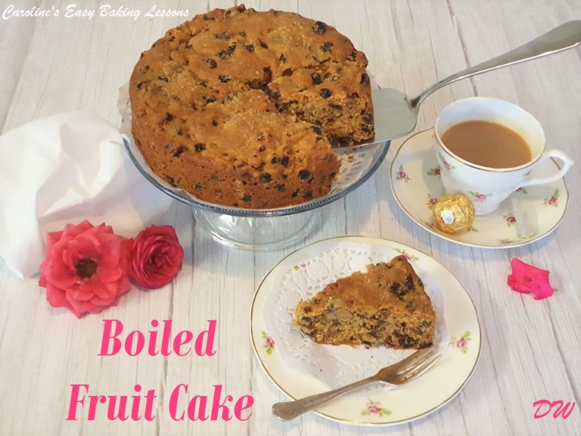

Caroline’s Easy Baking Lessons

