SWEET SHORTCRUST (PIE) PASTRY Pastry 101
Caroline’s Easy Baking Lessons
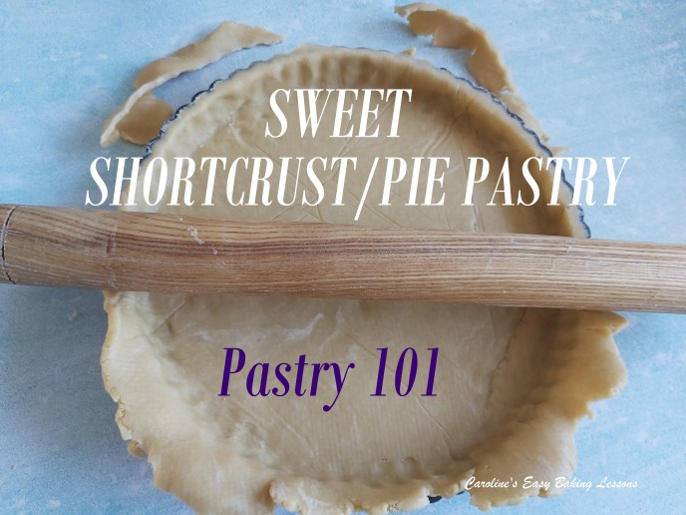

In this lesson you will learn how to make simple sweet shortcrust pastry. It is very versatile and can be used for so many sweet desserts, not just pies. This is the most straight forward of the types of pastry to make and it is also the quickest. For our American and Canadian readers, it’s similar but not identical to Pâte sablée or Pâte sucrée. These are both classic French versions of a sweet shortcrust pastry. The different proportions of the ingredients, basically produce a difference in the texture and flake of the pastry. In short, different ones are better for a specific filling. This recipe here is great for things like mince pies and has more of a buttery, soft and crumbly texture.

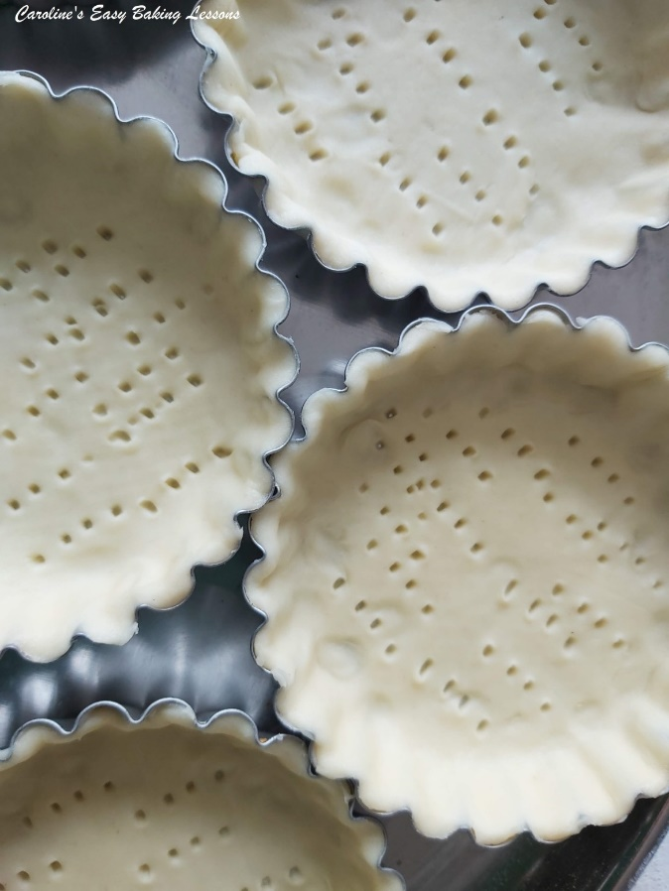
SOME INFO ON THE PASTRY
For this sweet pastry, I have altered the recipe slightly from my savoury recipe, by using a little less fat and adding an egg, as well as obviously including sugar (in the form of icing/powdered sugar) and omitting the salt.
A lot of recipes call for a 50% butter to 50% lard ratio for the fat content in their shortcrust or pie pastry. But, for a vegetarian or slightly healthier option, I use 100% butter. Some older recipes use a percentage of margarine, but it depends on what type of flake or crumble you want in your pastry as well as how buttery you want it to taste.
In some recipes you will also find a difference in the proportion of fat to flour content. This recipe is nearer to a Pate Sucreé pastry, and has a slightly lower proportion of fat to flour, and is is enriched by adding egg.

IMPORTANT PASTRY INFORMATION
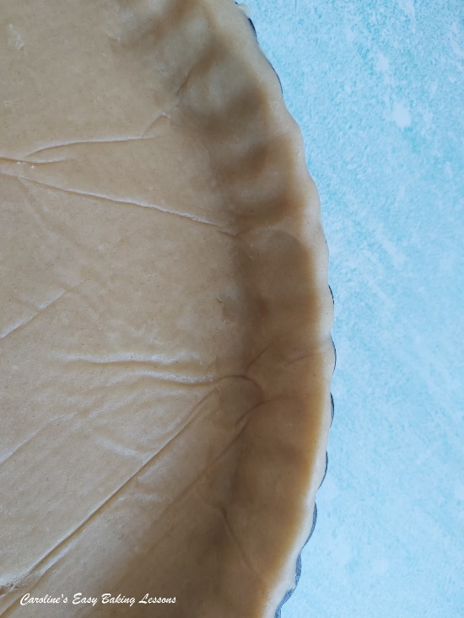
OVER-WORKING THE DOUGH
Too much handling or kneading of the dough, will produce a tough pastry that is less enjoyable. This because it work’s the gluten and causes the gluten stands to elongate and result in a bake that is not light and crumbly. You want the pastry to be soft, buttery & flaky
DON’T USE COLD BUTTER, STRAIGHT OUT OF THE FRIDGE
You weigh/measure & cube it & then place in the fridge until 30 minutes before you intend to use it. This is to soften it only a little & just enough for you to be able to work it in with the flour.
ALWAYS CHILL THE PREPARED PASTRY DOUGH.
After you have prepared the pastry dough, you should always place in the fridge for at least 30 minutes (depending on the particular recipe). This is extremely important as it relaxes the gluten that you have worked up whilst preparing & handling the dough. You will also do the same after you have rolled out and formed the dough into a pie crust.
‘BLIND BAKE’ THE CRUST
This is when you line the crust with paper & baking beans & bake for a short time, with no filling. Other terms you might hear it known by, are pre-bake or par-bake. All meaning the same thing, it ensures you don’t have the dreaded ‘soggy bottom’ to the end baked pie. (Also be sure to ‘dock’ the base of the crust first – just piercing holes in the bottom of the pastry with a fork, so that steam releases when baking).

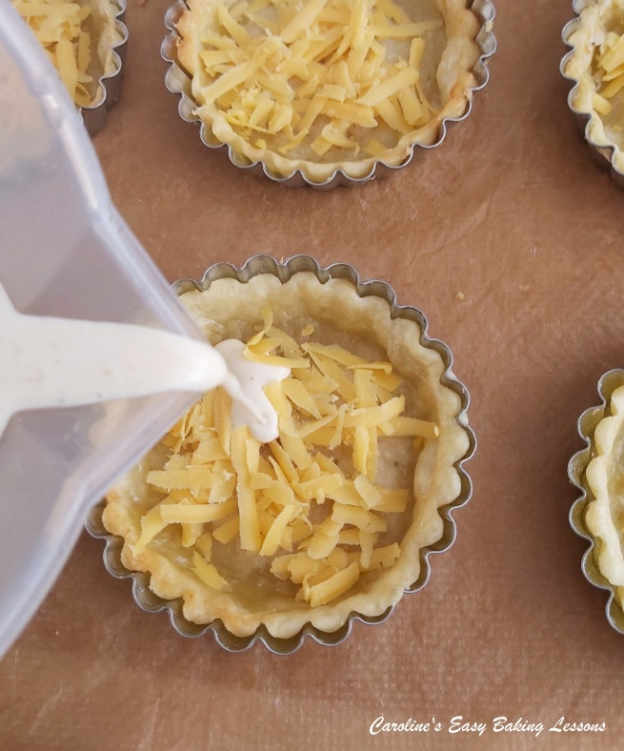
I will be writing a more in-depth article on Pastry, including the different types and handy hints and tips, but for the moment this will be enough to get you going.
This recipe makes enough pastry dough for a round 16cm (6 inch) pie crust, 12 mince pie cases or 24 mini mince pies (both have pastry cut outs on top) – go to my Mini Mincemeat Pies recipe.
If you are completing this recipe as part of the Sweet Lessons Course, please REMEMBER to read the recipe through well before attempting it in case you need to do anything in advance.

EQUIPMENT
- Scales or Measuring Cups
- Sieve
- Large spoon
- Knife
- Measuring spoons
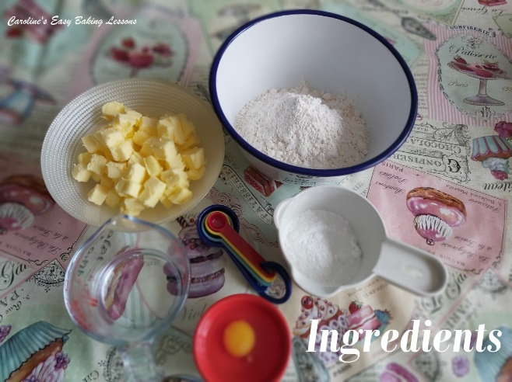
- Small jug or dish (for water)
- Cling film/plastic wrap
- Dinner plate
Bakes usually at: 200/180c Fan Oven/400f/Gas Mark 6

INGREDIENTS
- 175g Plain Flour
- (6 oz, 1 ¼ Cup + 1 tbsp All Purpose)
- 75g Butter, cubed (cold, see note above) (2.5 oz or 2/3 stick)
- 20g Icing Sugar, sieved (3 Tbsp Powdered sugar, sieved)
- 1 Medium Egg, beaten (Large US)
- Ice Cold Water

INSTRUCTIONS

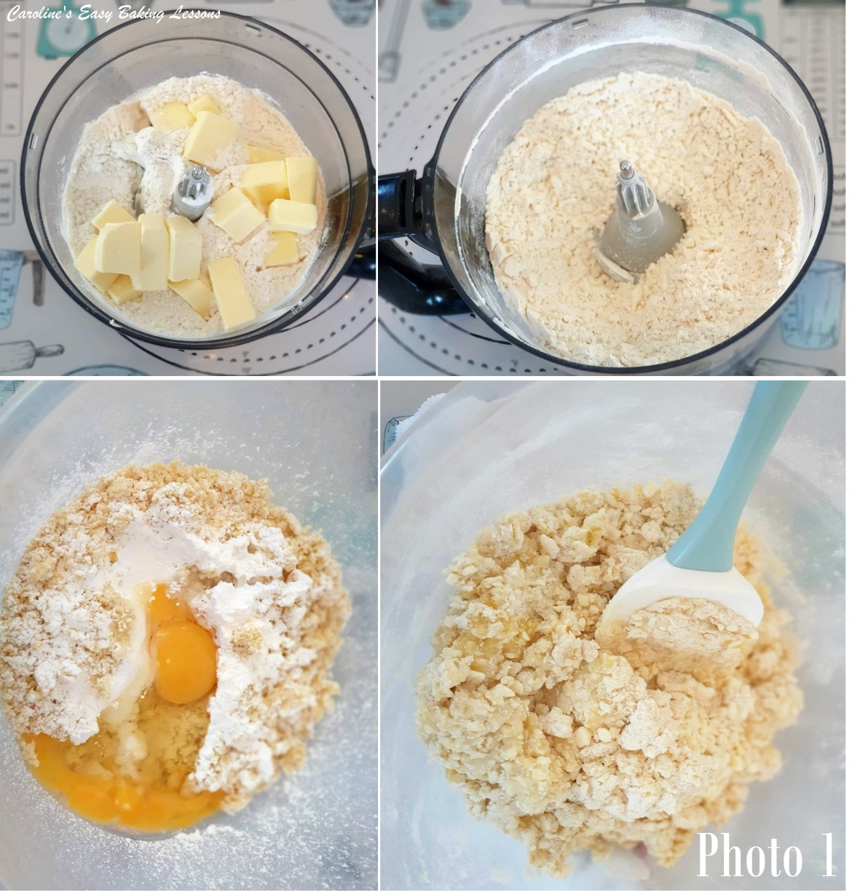
1. Weigh out the butter while cubing to rough squares about 1cm (1/3″) into a bowl and then return to the fridge. (I always recommend cubing butter small for any recipe, but in this case, it’s to make working the butter into the flour easily. Remove the butter from the fridge, 30 mins before starting the recipe. This ensures the butter is soft enough to handle, but still cold.
2. Place a large bowl onto the scales, set to zero (TARE) & weigh in the flour.
3. Add or measure in the sugar, (3 Tbsp) & give it all a good mix through.
4. Next add in the butter and take a knife to ‘cut the butter in’. This just means using your knife to cut the pieces of cold butter into smaller pieces as quickly as you can. Rotating the bowl around whilst doing this is good. So, cut the butter in until it looks fairly evenly blended. It doesn’t need to be exact. (See Photo 1, top right pic).
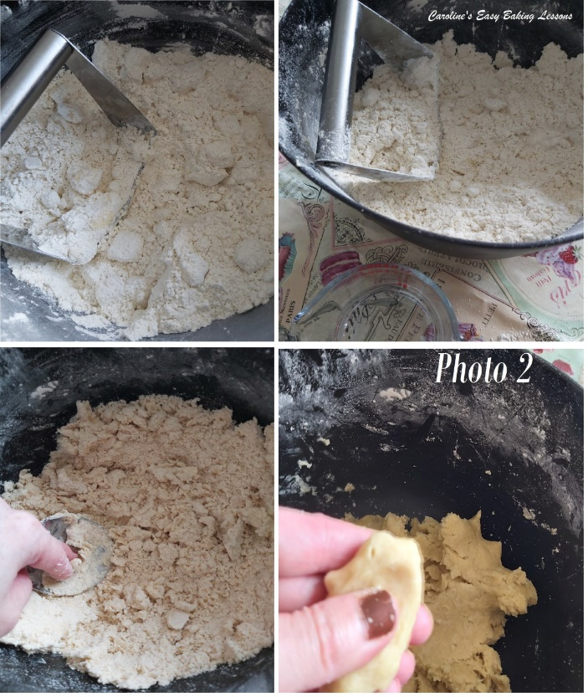
5. You can rub the butter into the flour using your fingertips. This just means picking up some of the flour and butter between your finger tips and squashing it together so that the butter takes on some of the flour. Continue to do this until you have a crumbly mixture with only a few odd lumps. This can be done quickly in a food processor but isn’t as gentle and can produce a tough pastry for beginner bakers. If your hands/finger get tired or sore easily, buy a PASTRY CUTTER/PASTRY BLENDER (see Photo 2). You can get these online inexpensively. You use this by pushing down on the cutter into the mixture and perform a squashing motion: push down and squash while rotating the cutter left and right. You keep rotating like this and the butter will become fully incorporated with the flour. Just periodically, clear the blender of any blocked butter pieces. See Photo 2, top right pic.

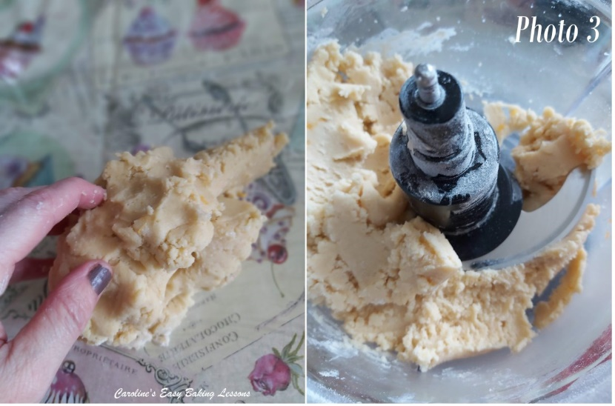
6. Now to add in the beaten egg and mix altogether. You can do this by hand or by machine. Mix until it starts to come together. By hand, knead in the dough or use a processor. The dough is ready once it comes clean away from the sides of the bowl. (See Photos 1 & 2 above). If it’s still a little dry add a drop of cold water and mix again. You might need a tiny bit more water or none at all. Just be sure to make sure the dough is nice and smooth and not dry. See also Photo 3 – test the dough by taking a piece and squeezing it together with your fingers. it should come together nicely.

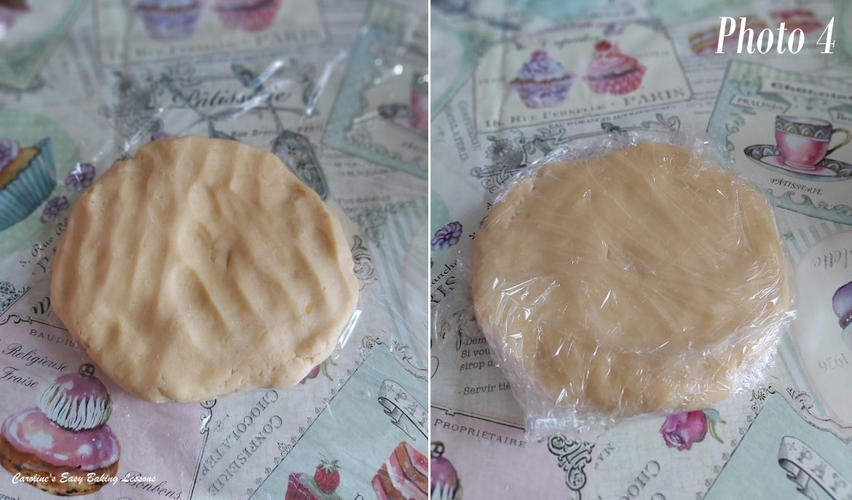
7. Form the dough into a ball, then flatten into a disc, (to make rolling out later on a lot easier). See Photo 4.
8. Wrap in cling film/plastic wrap, place on a dinner plate and put in the fridge for 30 mins to chill.
The pastry will always roll easier when chilled and gives a chance for the gluten in the pastry to relax & be less of a tough bake. So take this opportunity and do the same yourself!

*If not going to use after 30 mins, then remember to take out of the fridge at least 15 mins before wanting to use it, so that it isn’t too hard to roll. Will be fine in the fridge for 2 days, well wrapped.
**You can of course freeze the pastry now, by simply popping the wrapped dough into a food bag and remembering to label it with a date and that it’s sweet shortcrust. You can do the same with any left-over pastry. Simply keep a labelled food bag in the freezer and add to it whenever you have scraps. Defrost at room temperature.**

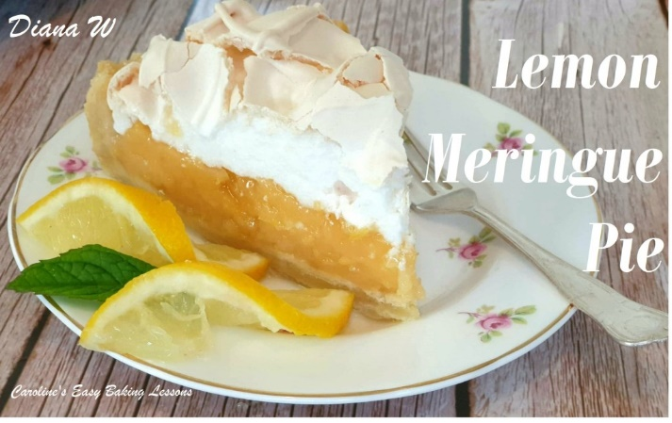
This is how to prepare sweet short crust pastry and is ready for rolling out for the recipe you want to use. So read the next lesson for how to make EASY MINI MINCE PIES in time for Xmas. Why not make as gifts and make up food baskets? If you have made meringue before, why not try my Luscious lemony Lemon Meringue Pie? – go to recipe (see photo below).

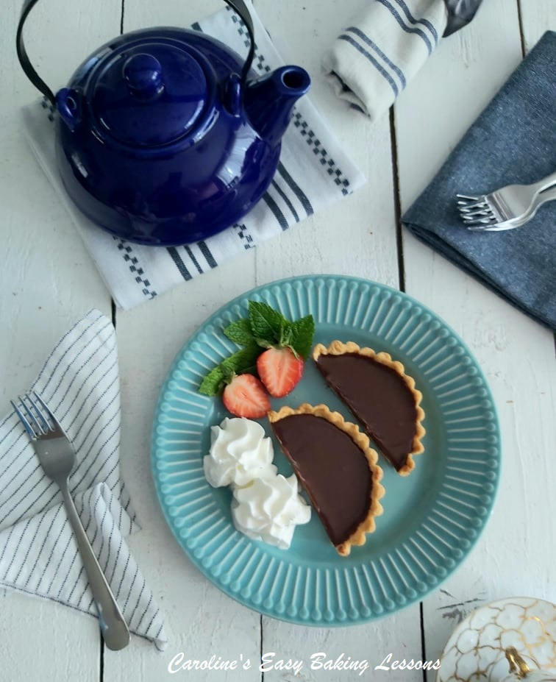
Look out for this new recipe coming soon – Individual Chocolate Tarts (See photo).

DIFFICULTY LEVEL: beginner to intermediate, easy with guidance

Thanks for reading
Happy Baking & Making
Happy Tummies & Memories!

Caro xx

