OVEN TEMPERATURE CONVERSIONS TABLE
Caroline’s Easy Baking Lessons
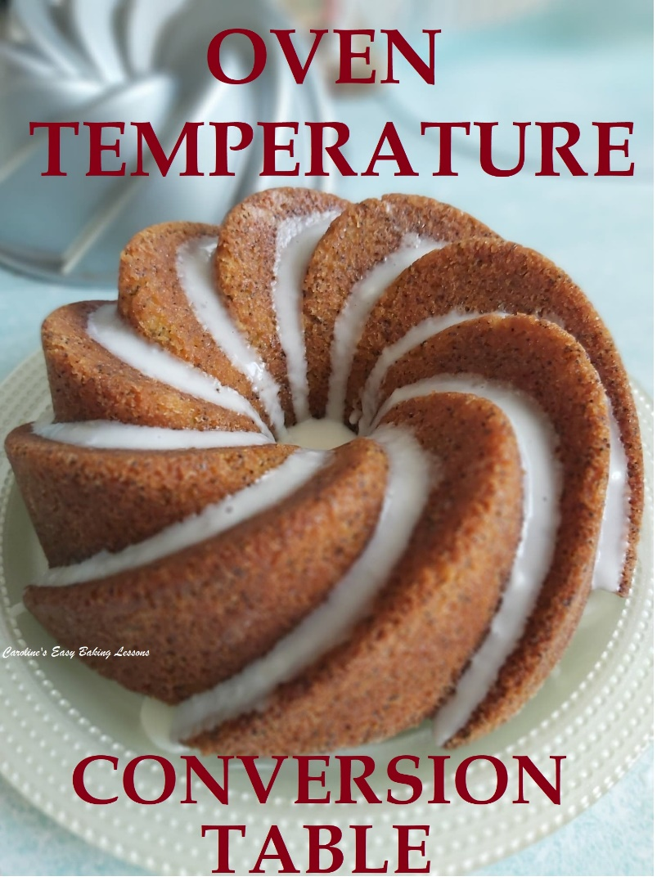
I am often hearing fans of the Great British Bake Off (Great British Baking Show) asking about the different types of oven temperatures that exist. My recipes cover all types of oven temperatures because my recipe followers are from all around the world, but I thought it useful to make up this handy table for you to save and print off for future reference.

Oven Temperature Settings In The UK
So in the UK, we use ° C (Celsius) or Gas mark in our ovens. US & Canadian bakers have ovens which have their temperatures in ° F (Fahrenheit) and these numbers are much higher, (nearly double the °C temperature). What confuses these bakers even more when they want to bake something using a UK recipe, is that there is also often listed a Fan Oven temperature too. So just to clarify, in the UK we have 2 types of °C oven temperatures: regular or standard ovens (also known as conventional), which will be simply listed as .. °C, and secondly the Fan oven (also known as convection), that will be listed as ..Fan oven .. °C. Note that these fan assisted ovens, are hotter and so when setting the temperatures, you do so to approximately 20 °C lower than the standard oven temperature.
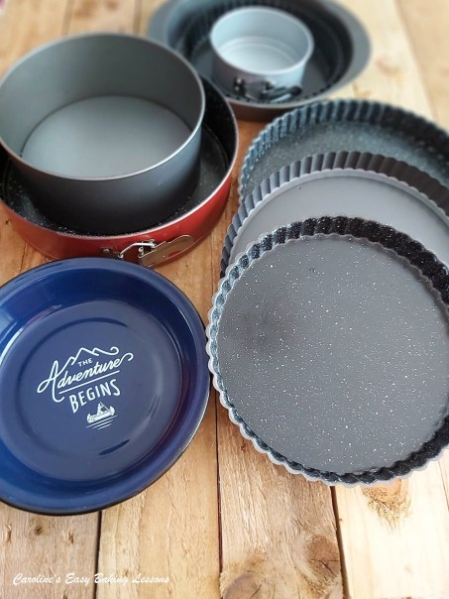

Oven Temperature Conversion Examples
So for example, if a recipe has stated just 180 °C, and you have a fan assisted oven, set to 160 °C. For Fahrenheit ovens (with a fan oven), the corresponding temperature would be 350 °F. Also, it’s good practice to check your bake a little before the recommended bake time if you are using a fan assisted oven and the recipe is designed for an oven without a fan. The reason for this, is the fan oven, circulates the heat better, so in turn can bake the food quicker.

OVEN TEMPERATURE CONVERSIONS TABLE
Caroline’s Easy Baking Lessons

US/CANADIAN ºF | UK ºC | FAN OVEN ºC | GAS MARK
225 | 110 | 90 | 1/4
250 | 120 | 100 | 1/2
275 | 140 | 120 | 1
300 | 150 | 130 | 2
325 | 160 | 140 | 3
350 | 180 | 160 | 4
375 | 190 | 170 | 5
400 | 200 | 180 | 6
425 | 220 | 200 | 7
450 | 230 | 210 | 8
475 | 240 | 220 | 9
500 | 260 | 240 | 10
Oven Temperature Conversions Table Caroline’s Easy Baking Lessons

More Oven Temperature Examples
If however, the recipe is stating fan oven temperature, (and often is in TV programmes), here is an example: 180 °C fan oven = 200 °C regular oven = 400 °F = Gas mark 6. Further examples can be found in the table above.
It is also an idea to purchase an oven thermometer to regularly check that your oven isn’t running too hot so you can avoid burning your bakes. These can be purchased on-line inexpensively and you just put them in the oven and let it register the actual temperature of the oven, for you to compare with what you set it at. From then on, you can set your oven temperature accordingly.

For more conversions, go to my Baking Information Page.

Thanks for reading
Happy Baking & Making
Happy Tummies & Memories

Caro xx

