TRADITIONAL CHRISTMAS CAKE

Bake-together Part 2 Baking The Christmas Cake
Caroline’s Easy Baking Lessons
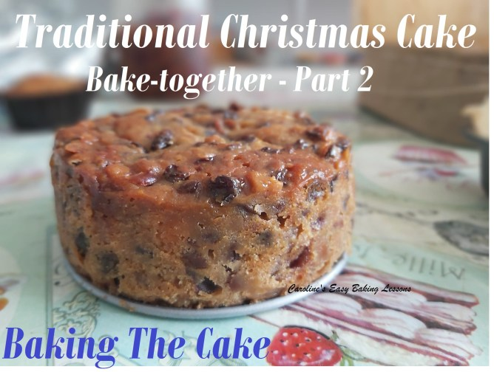
Ok bakers, so this is Part 2 of the recipe for a Traditional British Christmas Cake. As mentioned in Part 1, this cake is very dis-similar to US fruit cake. So go ahead and have a try this year. The preparation begins in October with soaking of the dried fruit for a week (usually in alcohol but can be make non-alcoholic with orange juice. I made some last year, and they were really nice, especially with some orange and lemon zest in the batter) – that is Part 1 of this Traditional Christmas Cake series. Once the fruit has been soaked you then use it in the cake batter and bake the cake on a low heat for a longer time. The Christmas Cake is then ‘fed’ with more alcohol or juice every week or two up to December. From that point you can decorate, typically with marzipan and then either fondant or Royal icing on top. The fun part is the decorating as you can make it your own, personalize and try new things. When it comes to that part, I will include photo tutorials (perhaps videos) of various easy and more difficult ways to decorate your Traditional British Christmas Cakes.
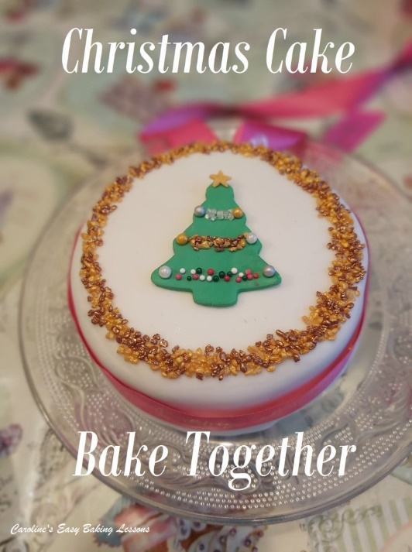
THE PERFECT TRADITIONAL CHRISTMAS CAKE RECIPE
Now since it’s my first time making a Traditional Christmas Cake, I am using my good friend Christine’s family recipe. It is an old Be-Ro recipe. And for those that don’t know, it’s a book that’s been around for a long time, with lots of editions and they also make baking products like flour being one example. This particular Christmas Cake recipe has been used for at least 3 generations, every year and so as close to a traditional cake as you will get. Click to read more about the history of this 100 Year Old Traditional Christmas Cake Recipe.

A NOTE ON CHRISTMAS CAKE INGREDIENTS
I know that in the states and Canada, some things are not as easy to come by as in the UK. Examples being the citrus peel and Glacé cherries. Maraschino cherries can also be used and for the citrus peel, that’s similar to candied citrus. There are recipes on the internet to make your own, which of course you can try, or add another dried fruit, such as cranberries. I am told Amazon are selling the candied peal in the states.
The recipe for the cake also uses self-raising flour (not to be confused with US Self-rising, which has slightly less baking powder in it). But I have included how much baking powder to add if using plain or All Purposes flour instead and tested it out successfully.
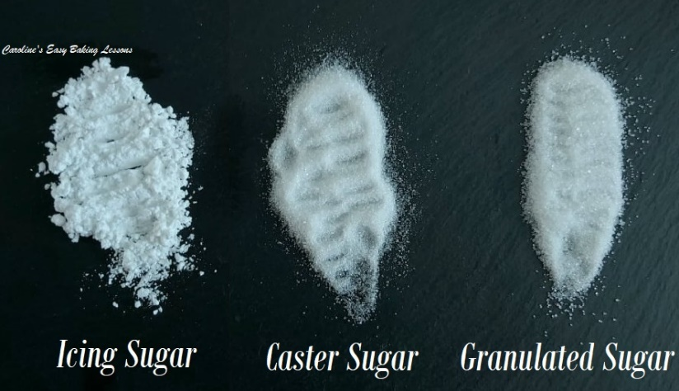
There is also caster sugar used, (nearest alternative being Extra/Super Fine sugar), but because the cake is baked for a long time on a lower heat, granulated sugar can also just as easily be used. (See photo above of the 3 British sugars used in baking). If you want to learn more about different ingredients/names, read my article DIFFERENCES BETWEEN UK & US BAKING INGREDIENTS

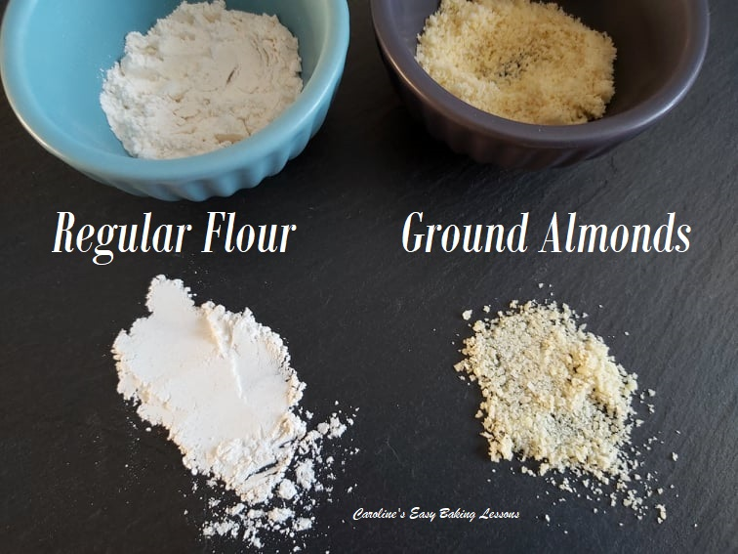
Also there are ground almonds in this Traditional Christmas Cake. By that we mean almond meal, not Almond Flour. (See photo comparing ground almonds to regular flour). Almond flour is finer, but if you have to use it, this can be used too. Just know that the texture will not be quite the same as the Christmas Cake should be. Ground Almonds are there for moisture, but also for structure in the bake. Lastly, Mixed Spice is very similar to US/Canadian Pumpkin Spice.

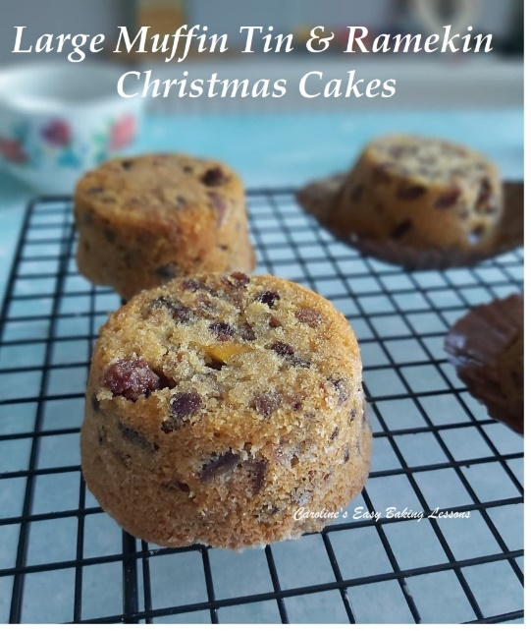

SIZE OF CAKE TIN FOR THE TRADITIONAL CHRISTMAS CAKE
The original Christmas Cake recipe is for – a 8″ (19cm) Square or 9″ (23cm) Round deep tin (at least 3″, so about 7.5cm). Now below I have included a table to tell you how much batter you need if using a smaller tin, or a number of mini tins. I also have an article to help you know how to reduce the recipe. Reducing a recipe to fit a smaller tin size also gives worked examples. I did have one for increasing a recipe, but not on the new site yet. That article will also help you with trickier things like cups and tsp conversions. So I thought I could show you how I am making one for the first time this year, and if you like, bake along, a week or so behind me.
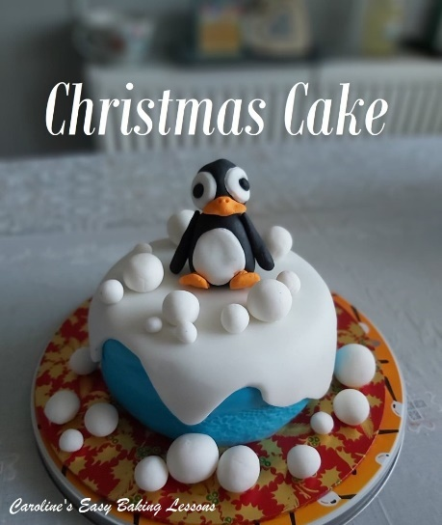

TRADITIONAL BRITISH CHRISTMAS CAKE

Recipe By Be-Ro (with my conversions)

INGREDIENTS
- Dried fruit soaked for about 1 week – Part 1 Soaking Fruit For A Christmas Cake (Drain off the juice/alcohol and use for making mincemeat for example).
- 12 oz Self-Raising Flour* (340g, 2 & 3/4 cup)
- OR Plain/All Purpose Flour & 4 & 1/8 tsp baking Powder)
- 1 tsp Mixed Spice (Pumpkin Spice)
- 4 oz Ground Almonds/Almond Meal (113g, 1 & 1/4 level cups)*
- 8 oz Butter, unsalted & softened (226, 1 cup, 2 sticks)
- 8 oz Caster Sugar/(Extra/Super Fine) (226g, 1 & 1/8 cup) OR Granulated Sugar (same as above)*
- 4 Medium – Large Eggs, (L/XL USA) beaten with –
- 8 tbsp Milk (or 1/2 milk & 1/2 Brandy/Orange Juice) (120ml, 4 fl oz or 1/2 cup)

CHRISTMAS CAKE INSTRUCTIONS
*Note the instructions are taken from the old Be-Ro books, and my additions/conversions in parentheses & in red font

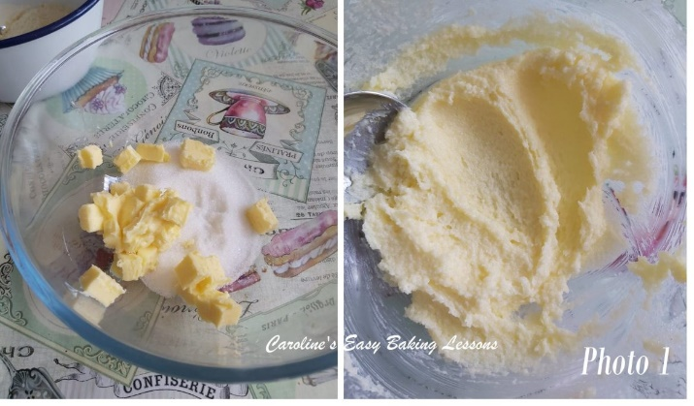
1. Begin by sieving the flour, spice (and baking powder if using). Then add in the ground almonds/almond meal.
2. Cream the butter and sugar together (in a large mixing bowl. Make sure your butter is soft and you can squeeze between your finger easily. Cubing and before leaving to soften will be quicker with a smaller surface area. Try a hack I reviewed for Softening Butter In About 12 Minutes if you forget or are short on time. **Note that in Photo 1, that was when I was making a smaller batch of the Christmas Cake recipe. Mix until soft, fluffy and paler in colour.)

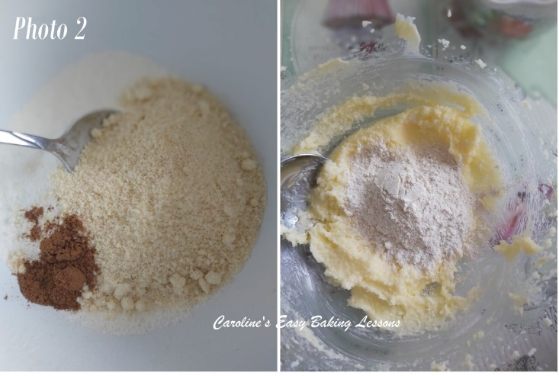
3. (Mix all the dry ingredients together). Stir in (some of) the flour, then (some of) the egg/milk mixture into the creamed sugar/butter, (alternating till all is added. Mix through in-between each addition. See Photos 2 & 3 below.)
4. Lastly add the (pre-soaked) fruit. (I like to fold it in gently in increments to get a more even distribution, but not knocking the air out. See Photo 3).
5. Heat the oven to 275-300f ( Gas Mark 1 – 2/135 – 149c/ 115 – 129c Fan Oven).

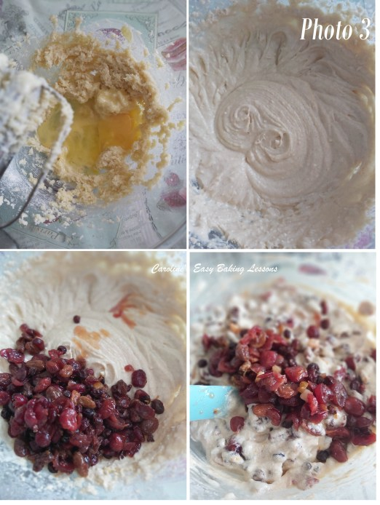

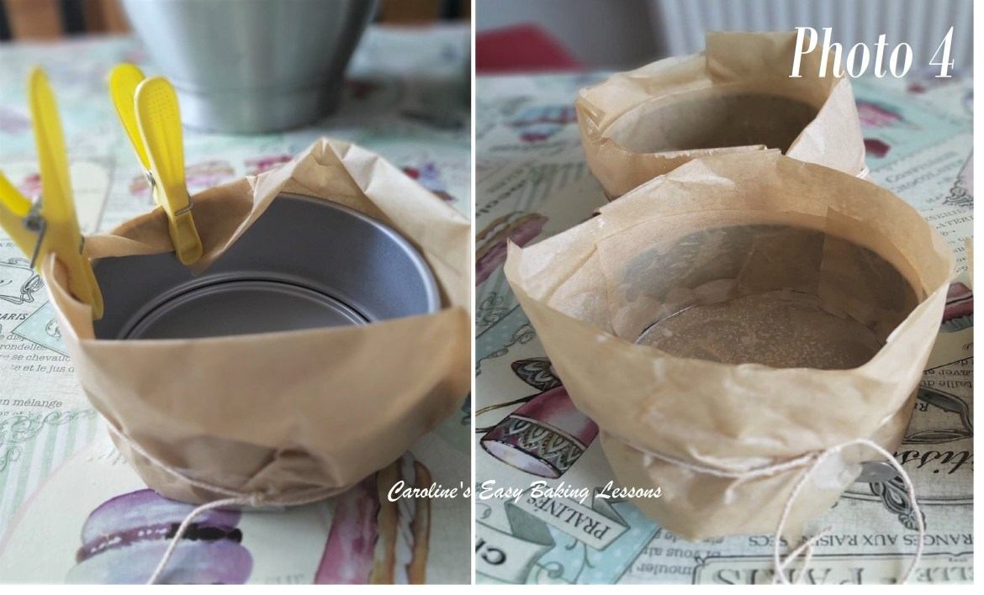
6. Prepare the cake tin(s). (Grease and line the bottom of the tin(s). Go to my article on how to line round, square or rectangular tins. For round tins, use the same article to see how to cut a perfect sized circle of paper for the bottom of the tin. Also cut strips to line in the insides of the round tin too -they don’t need to be one continuous piece & you can use left over pieces. Hold in position with some baking spray, butter or lining paste. See Photo 4, right pic. See also the Christmas Cake video above for how the square/rectangular tins are lined. Try to use brown paper & not too thin or the cake will brown too much -you could try an extra layer of paper.

Then you want 2 layers of paper to be wrapped around the outside of the cake tin, and to be about 2″ (5cm) higher than the top of the tin. See Photo 5. I folded the paper over to get a double layer and then wrapped it around the tin – this was the hard part and paper clips broke so I held in place with pegs. Then I tied butchers string around the tin tightly, twice and finally removed the pegs. I then trimmed the tops of the paper as it was quite a bit higher than 2″ and I was baking several cakes in the oven at one time. You might not need to do this. All this paper is to protect the outside of the cake drying and cooking too much while in the oven for a long time. See Photos 5 & 4 above. More pics of mini sized cake tins are at the bottom of the recipe instructions – Photos 7, 8 & 9).

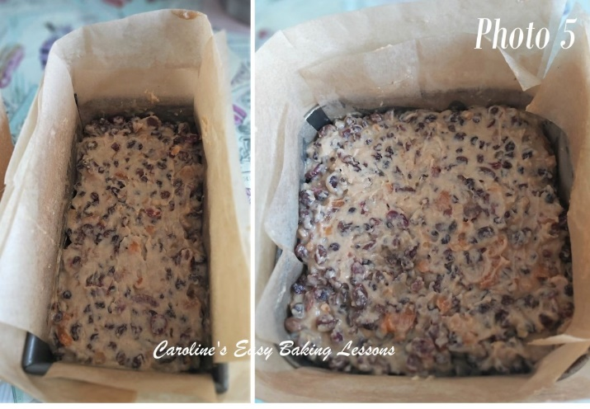
7. Pour the batter into the cake tin(s). (Photo 6). Bake in a slow (cold/low) oven 275-300f ( Gas Mark 1 – 2/135 – 149c/ 115 – 129c Fan Oven) for 4 – 5 hours. (Christine has reliably informed me to cover the tops of the cakes with paper, after about 1 hour, once the batter on top has set. See Photo 6. Also, check the cake(s) are ready by inserting a wooden cocktail stick in the centre – trying to avoid fruit if possible. If clean of crumbs and no wet batter, it’s ready. Note that smaller tins will take a shorter time to bake. So I have included estimated baking times in the table below with each of the smaller tin sizes, including what mine baked off at).

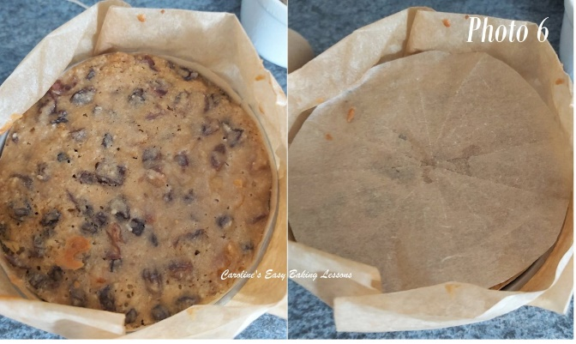

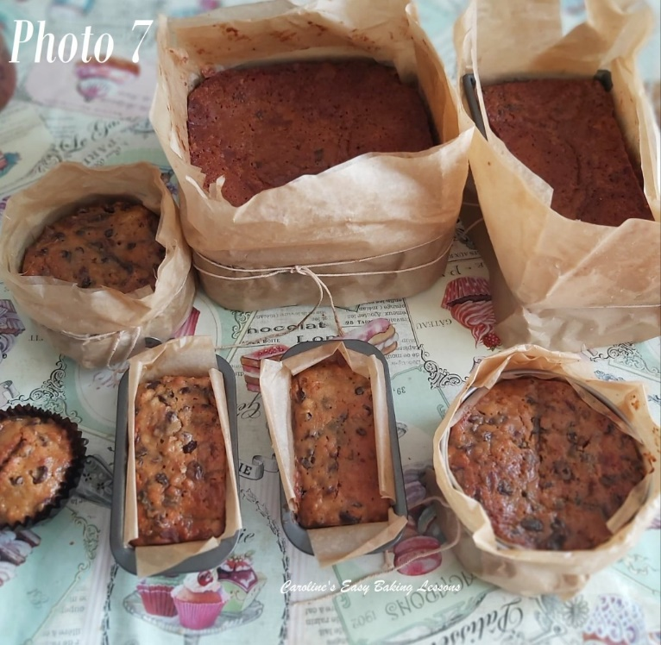
8. (Allow to cool in the tin, on top of a cooling rack. Whilst still a little warm, poke some holes in the top of the cake and spoon over a couple of tbsp of alcohol or some orange juice. For mini cakes, probably 1 tbsp would be enough. Leave to cool down completely. See Photo 7 & 8 above of the ones I baked from a double batch of ingredients.
Cut the ties and remove the outer paper. Don’t bin, as you can use these for wrapping up the cakes. Release the cakes out onto a cooling rack.
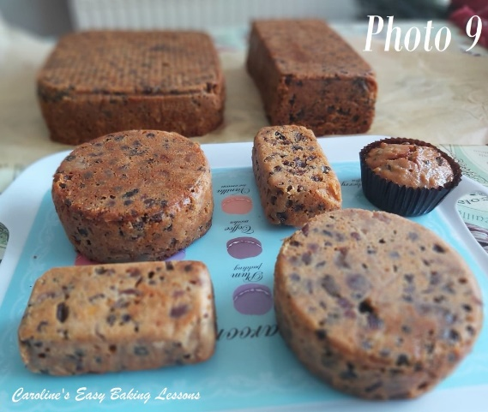
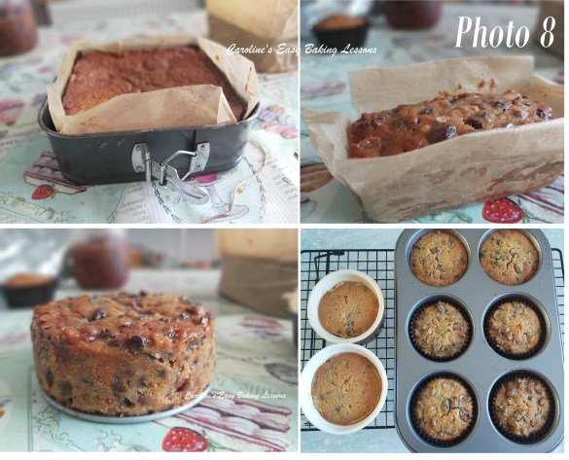

TOP BAKING TIP
I am going to use mine upside down but if you want to use the right way up, place a folded tea-towel on top of the rack and then release the cake normally. This is a good tip for not getting tell-tale lines on the top of your cakes from the cooling rack.
Carefully peal back the lining paper from the bottom of the cake & leave to cool completely. See Photo 9 below.)
(Once completely cooled, wrap in paper and hold in place with tin/aluminium foil. You can also wrap in a tea-towel on top if you like, like Christine does. Never wrap directly in foil as it will affect the taste of the cake. Store in a cool dark place until December. See Photo 10 below.

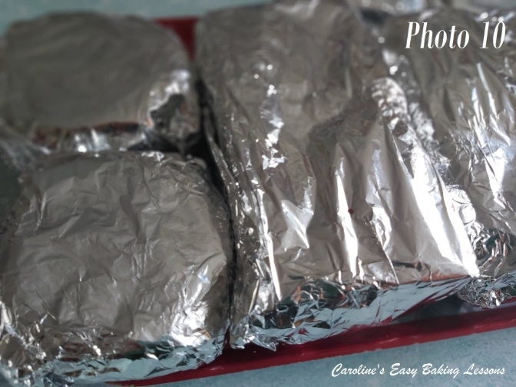

NEXT STAGE OF THE CHRISTMAS CAKE
Regularly ‘feed’ the cake by spooning and spreading on more alcohol/orange juice every week or 2 until December, when ready to decorate it. This is an important stage to keep infusing the cake and combined with the alcohol and sugar in the fruit, the cake is preserved. Just keep away from heat and light, no need for placing in the fridge.
So over the following weeks I will post part 3, to remind you about the ‘feeding’ of the cake.
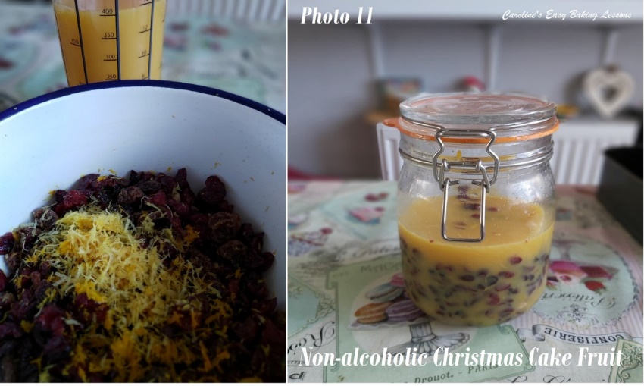

FOR CHRISTMAS CAKES WITH ONLY FRUIT JUICE & NO ALCOHOL
For Christmas cakes with only fruit juice, it’s best to only feed the cake up to week 3, and then wrap really well with 2 layers of new paper and freeze till 2 days before decorating in December. Otherwise the fruit will start to ferment and we don’t want a wasted cake. During the 3 weeks, you should store somewhere cool & dark or place in the fridge. When feeding, replace the paper if soggy to prevent mould forming & wrap again in 2 layers of paper, then foil & cling film/plastic wrap, wrapping really well like before. Leave out to defrost at room temperature, decorate when fully thawed & dry, & discard all wrapping. At this stage you could store in an airtight container or tin. Then decorate as per instructions to follow in Part 4.
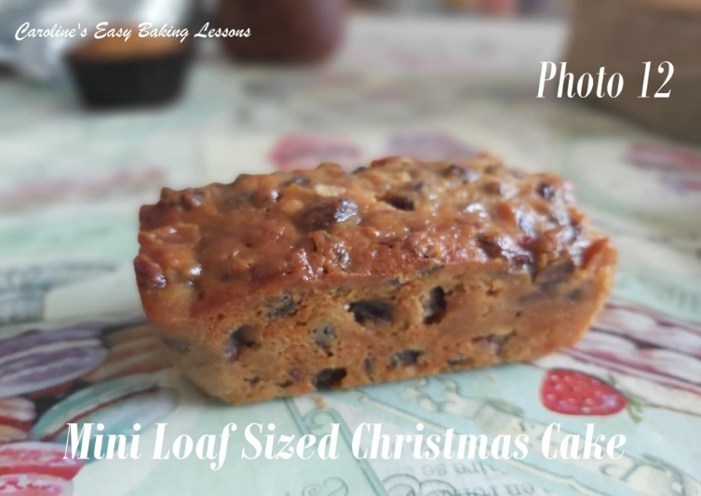

BAKING MINI OR A COMBINATION OF SMALL SIZED CHRISTMAS CAKES
Ok so I doubled the Traditional Christmas Cake recipe and worked out how much batter the original recipe makes, in order to know what different sized cakes I could make. I did a 8″ square tin , a 2lb loaf tin to make into mini rectangle pieces, 2 x 4″ (10cm) round tins & 2 mini loaf tins (See Photo 12). . Also see Photo 9 above & the tables below for all the dimensions. I later realised I needed to do at least 2 non-alcoholic mini ones so I made 6 in a large muffin tray using an additional 26% of batter. See Photo 8.
But to help you I have included a table below with how much of the Christmas Cake recipe is needed for a range of smaller tin sizes, as well as how many you can make out of one batch of batter. This batter is ok to

make and store in the fridge while some are baking, if you don’t have enough tins. Alternatively, you can reduce the recipe down using my table below. Just simply use a calculator/phone calculator to multiply the ingredient quantity by the number listed in the tables below.

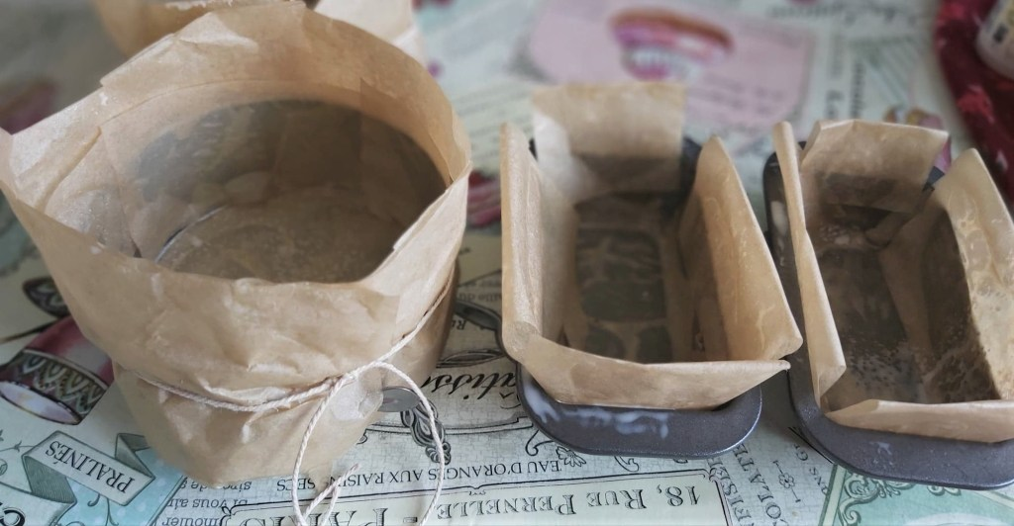
LINING & COVERING SMALLER TINS FOR CHRISTMAS CAKES
Now this extra paper lining of the cake tins inside and out is not so quick and easy to do when using small tins to make a Christmas Cake. You may well find or think of some better ideas, but this is how I did it in the end. Using pegs to hold paper in place before tying with string helped. I tried cello tape, but it didn’t hold good. And the paper clips didn’t work too well and is a pity because they can go in the oven. Some big metal bulldog clips would be good. See previous photos & the video.

USING MUFFIN TINS FOR CHRISTMAS CAKES
For using the muffin tin tray for Christmas Cakes, I lined with 2 different methods to do some tests. Some where I used 3 paper muffin case liners nested together, and for others I used Nancy’s lining paste and placed a circle of baking/parchment paper on the bottom. (See Photo 15 further down). But since these cakes are cooked for a longer time, and have paper on the outside, I thought of a way to protect the outsides of the muffin tin. I used paper, but had to use foil to hold it in place but I think it worked well. (See Photo 14 & 15 below). I also covered the tops of the cakes by placing a large baking sheet on the rung just above the cakes to stop them browning too much. The muffin tray was also placed on top of a lined baking sheet to keep the foil strips from falling off. See Photo 15 below.
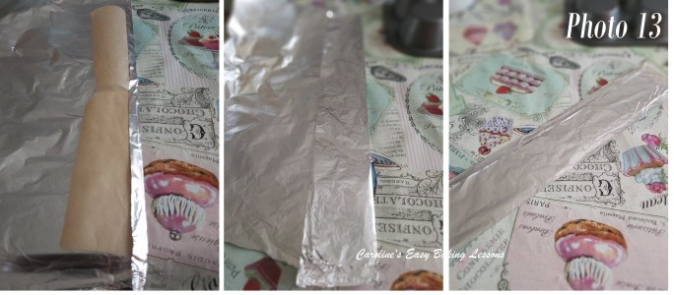
I began by cutting strips of baking/parchment paper a little taller than the length of the muffin tray. These were then placed on top of a strip of foil and the foil folded over. See Photo 13 above. I then bent the strip around one of the muffin holes (tray upside down for this), and cut just past where the foil would join (Photo 14, left pic). This cut off piece, I then cut the corners off and was placed on top of the ‘bottom’ of the muffin holes (Photo 14, middle pic). The strip of foil is then wrapped round the muffin and squeezed closed at the sides and on top. (Photo 14, right pic).

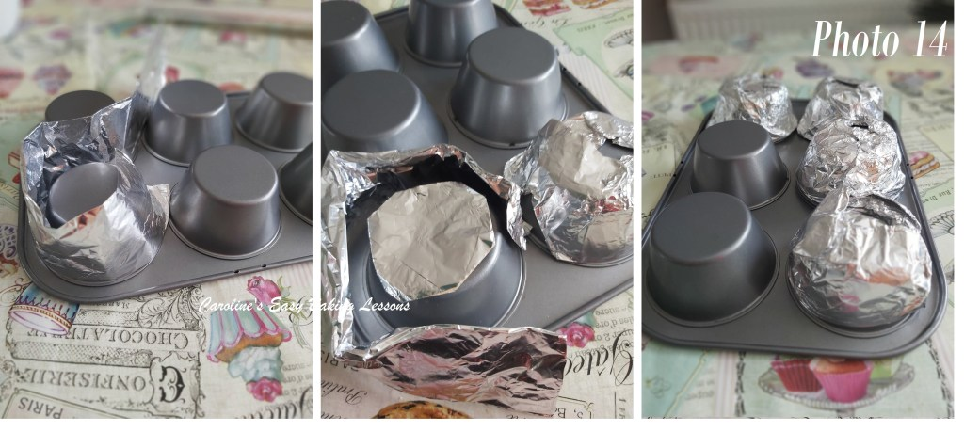
I then repeated for the other 5, and placed a lined baking sheet/tray on top of the upturned muffin tray, before holding all together and flipping over. See Photo 15 below, left pic.

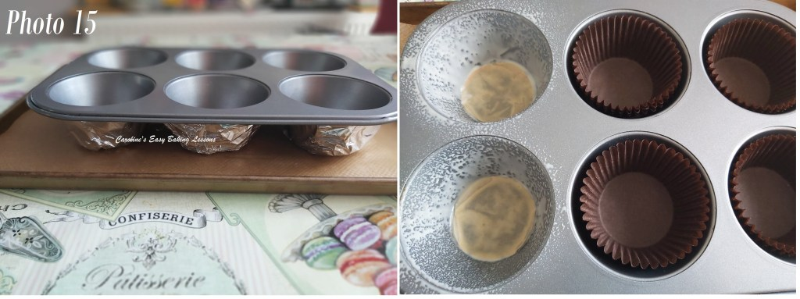
Getting good flat tops to these muffin sized cakes, it’s good to tap the tray several times right before baking to expel any trapped air. Also be sure not to overfill. I filled them about 85-90% of the way up. You can actually buy strips to go around bigger cake tins or make your own and this is where I got the idea from (Cake/Baking straps). (See Photo 15.)

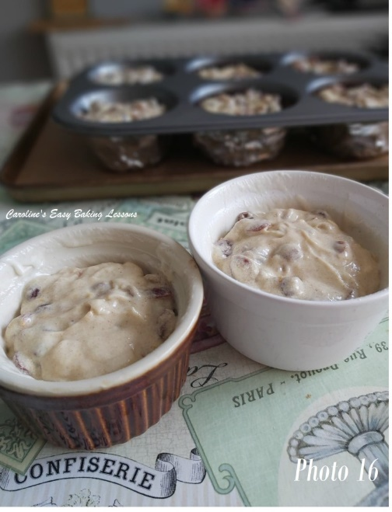
An Alternative would be to line a deep dish near the size of the muffin of tray & place inside. Once baked, these small Christmas Cakes didn’t have any doming, so no need to trim them and I liked the shape the muffin tin gave the cakes when turned upside down.
I also used some Christmas Cake batter in ramekins. These were good too. See Photos 16 & 17 above. All the dimensions of the tins, etc used are given below in the table. As well as the oven timings and quantity of batter needed.

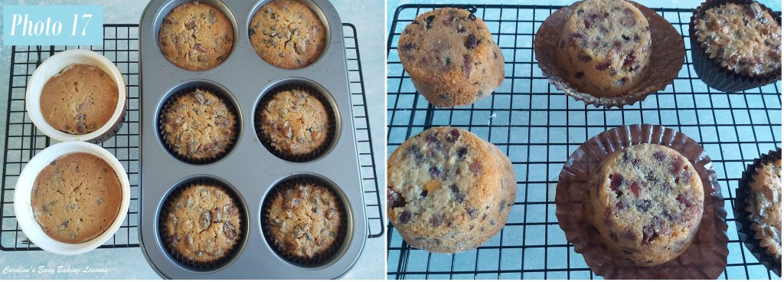

TABLE OF ALTERNATIVE SIZED/SHAPED TINS FOR MAKING THIS TRADITIONAL CHRISTMAS CAKE

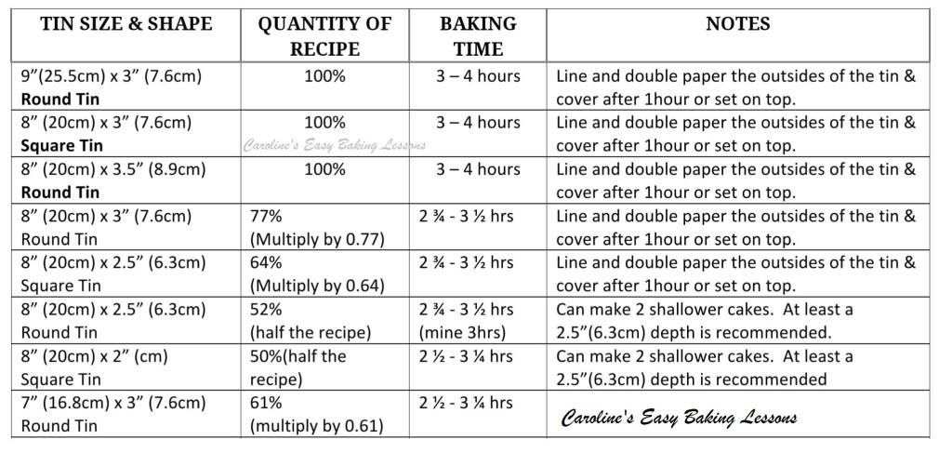Christmas Cake recipe reductions & bake times for 7″-8″ round & square cake tins

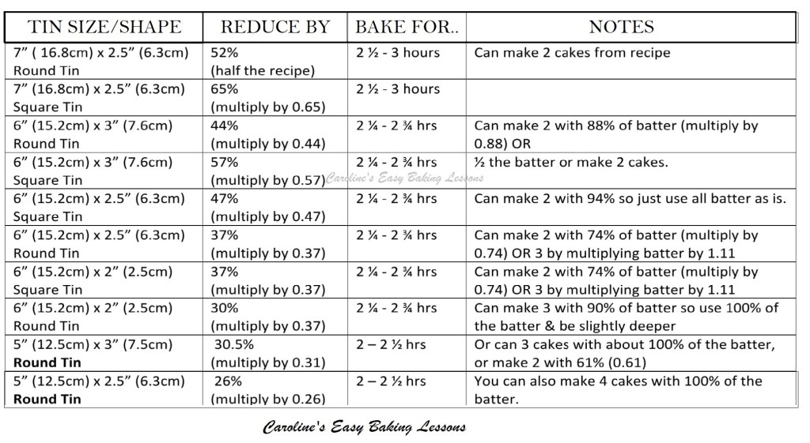Christmas Cake recipe reductions & bake times for 5″-7″ round & square cake tins

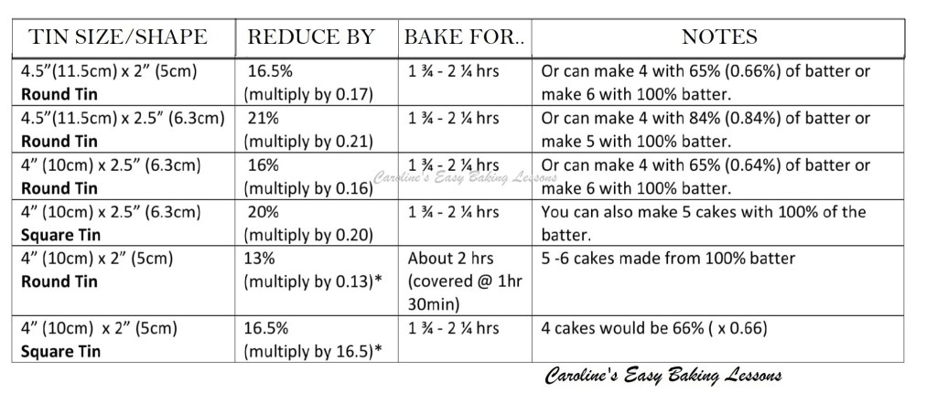Christmas Cake recipe reductions & bake times for 4″-4.5″ round & square cake tins

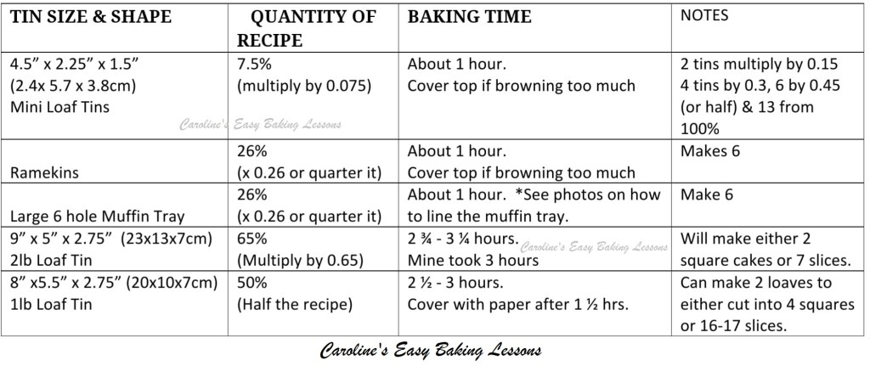Christmas Cake recipe reductions & bake times for mini loaf tins, ramekins, muffin trays & loaf tins

Ok so in case, anyone is not sure on what these figures mean, he’s an example. Say you want to use the 2lb loaf tin (as in Photo 14 above), where the table instructs to “..multiply by 0.65”. This just means, multiply every ingredient amount by 0.65. Example being 226g x 0.65 = 147g (ie. 147g flour). For how to do with cups and tsp, see my Recipe Reduction Calculator where I explained it more in-depth, how to calculate these, other examples and also a quick video.

I hope all this helps you make a Christmas Cake in nearly any cake size or shape you want. A little second note too, say you used the above loaf tin, but wanted to make some mini ones with left over batter from making same quantity as the original recipe. Then just check the table for what other tins are 35% or less (ie. 100% – 65% = 35% left over).

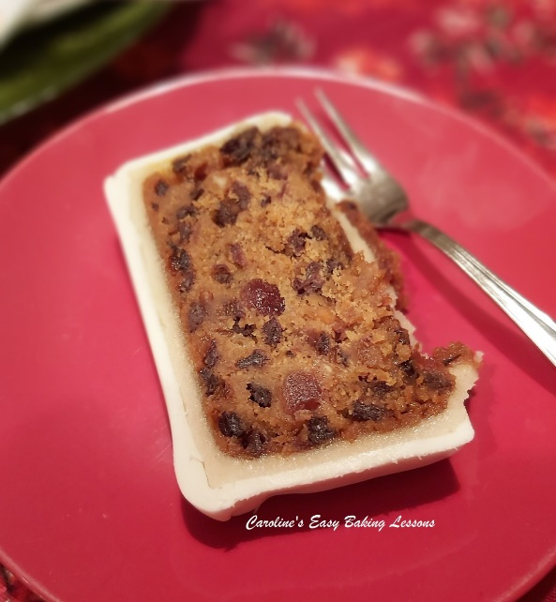
So I look forward to seeing your Traditional British Christmas Cakes when they are baked. Please remember to also post on the Bake-together post in the Facebook GBBO Fans group (found in the Announcements), or even contact me via the website contact form on the bottom of the home page. Tag me on social media too if you like (see links below).
Look out for Part 3 in The Facebook group, when I will periodically remind you to feed your cakes up till December. In the mean time, here’s the Christmas Cake Feeding Video.

Then there’s Part 4 – Covering A Traditional Christmas Cake
For decorating ideas and the rest of the bake-together series click Traditional Christmas Cake Bake-together.

Thanks for reading
Caro xx

