CHOCOLATE PUMPKIN MUFFINS – With Chocolate Pudding
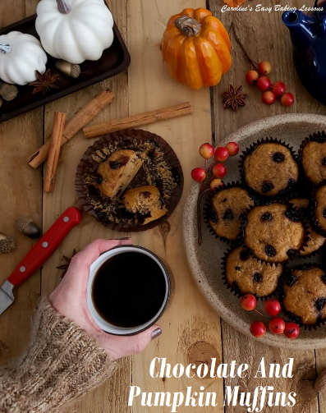
Caroline’s Easy Baking Lessons

Try this new recipe for muffins, with pumpkin and all the spices that resonate Fall, but with a special ingredient of chocolate pudding! Instead of chocolate chips or chocolate cake, try making up an easy packet of chocolate pudding mix and use to give some surprise pockets of moist chocolate goodness

A Note On The Ingredients

The Pumpkin Puree

This is a super simple recipe to make and can easily be increased too. I use my own roasted pumpkin puree as it’s hard to come across it in a can here in the UK. If you can get your hands on a pumpkin and better still, also a butternut squash, this is easily made at home. Before pureeing, it can even be used as an alternative to roast potatoes as a healthier option with no oil/fats or salt added. Check out my Homemade Roasted Pumpkin Puree recipe.

Choice Of Flour
I have initially developed these chocolate pumpkin muffins using UK Self-raising Flour, not to be confused with US Self-rising. The amount of baking powder is slightly different. I have also tested using Plain/All Purpose flour and added baking powder to get the correct rise. Amounts for that are given in the ingredient list (note all my recipes give alternative flour guidance). You could also try using half wholemeal/wheat flour. Just note that wholemeal/wheat flour absorbs more fluid so would be ideal to add some extra liquid or milk to the batter at the end stage (just make sure to leave the batter a few minutes to see how much liquid it absorbs first).

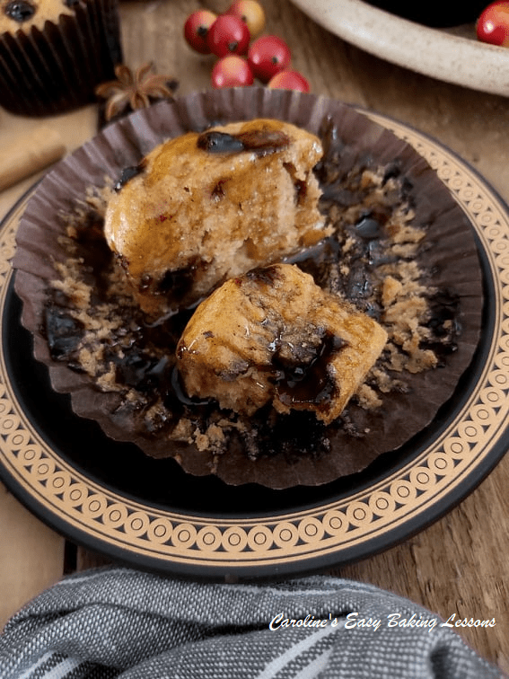
The Type Of Sugar Used

Since we are using oil, we are not ‘creaming’ butter and sugar together like we would for a lighter more airy sponge cake, and so the type of sugar you use doesn’t actually matter. Castor is better for creaming, but for these muffins I used a combination of granulated and light brown sugar (2:1 ratio). Sugar is not just there for sweetness, but for structure, & preserving the bake. So I would not recommend the use of artificial sweeteners, but rather coconut sugar which you can use about 20% less of. For more on how common baking ingredients work together, check out my Baking Science article.

A Little Note On The Spices
These chocolate pumpkin muffins have all the usual flavours associated with Fall and pumpkin bakes. In the UK we use a blend of spices called Mixed Spice which is essentially a combination of cinnamon, ginger, anise, nutmeg & cloves. You can substitute with Pumpkin Spice. I love anise and nutmeg so tend to add some of them on top of the Mixed Spice. The anise is very subtle but if you like it go ahead and increase to 1/2 tsp. And talking of the nutmeg, I grate it fresh and it gives off the most amazing scents.
The Special Ingredient – Chocolate Pudding
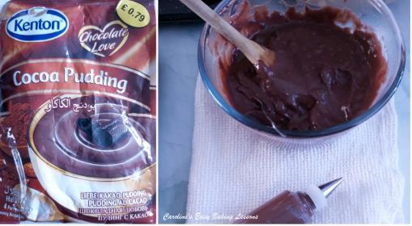
And finally the secret or unexpected ingredient in these muffins, is chocolate pudding mix. You can make your own chocolate pudding, but I just used a packet I had (that I intended on using for something else). I know these are very common in the US, and often used added dry into cake recipes. In this recipe however, you are making up the chocolate pudding mix, as per the instructions on the packet (which usually involves boiling and simmering). The chocolate pudding is then left to cool while you make the muffin batter. You then add drops of the chocolate pudding to the muffin cases, alternating with the pumpkin muffin batter to get an even distribution. In the end it gives a kind of animal print look to it, but most importantly, unexpected pockets of sweet chocolate when you take a bite.INGREDIENTS
- 200g Light Brown Sugar (7 oz, 1 cup)
- 100g Granulated Sugar* (see note above) (3.5 oz, 1/2 Cup)
- 2 Medium Eggs (US Large)
- 60ml Vegetable Oil (2 fl oz, 1/4 cup)
- 415g Self-raising Flour (14.5 oz, 3 1/3 cups)
- **OR Plain/All Purpose Flour PLUS 5 tsp Baking Powder)
- 1/4 tsp Salt
- 1 1/2 tsp Mixed Spice (Pumpkin Spice, see notes)
- 1/4 – 1/2 tsp Anise (see notes)
- 1/4 Fresh Nutmeg (or 1/2 tsp, optional)
- 425g Pumpkin Puree (see notes for homemade) (15 oz, scan 2 cups)
- 240ml Milk, approx. (8 fl oz, 1 cup)
For Chocolate Pudding:
- Chocolate Pudding Mix (I used a 100g/3.5 packet of powder)
- Milk as per the packet (approx. ) Note you will only use about half of the pudding when made up.
OVEN: 180c/160c Fan Oven/360f/Gas Mark 4

EQUIPMENT
- Digital Scales or Measuring Cups •12 hole Cupcake tray/sheet x 2
- Small jug •18 Muffin/Large Cupcake Paper Cases
- Measuring Spoons • Small spoons
- Large mixing bowl • Piping bag/syringe (optional)
- Hand/Stand Mixer • Timer
- Wooden Cocktail Stick • Cooling racks
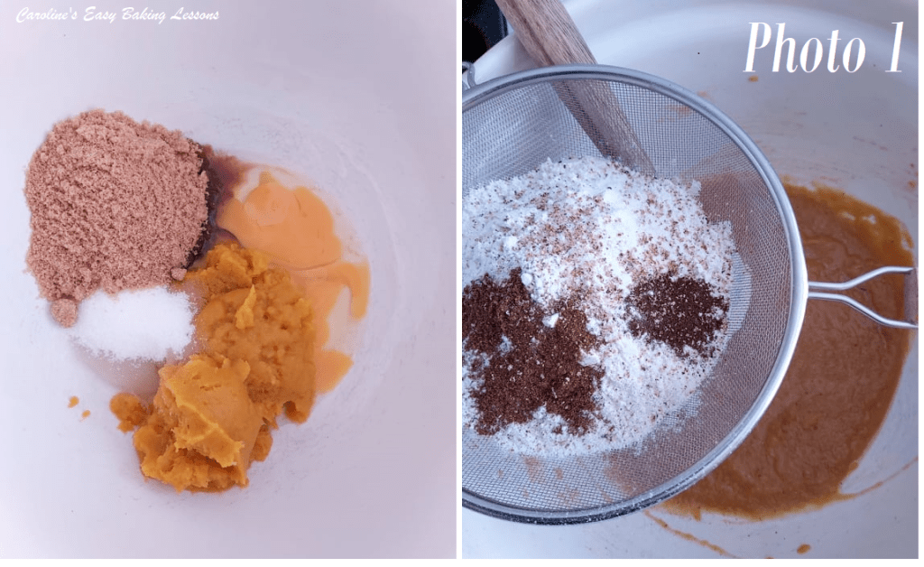
- Cooking Pot for pudding

INSTRUCTIONS

Prepare The Chocolate Pudding
1. Start by making the chocolate pudding mix as per the instructions on the packet (usually adding milk and bringing to a boil, then simmering till thickened) and then leaving to cool with some cling film/plastic wrap placed on top of the surface of the pudding.
Make The Muffin Batter
2. Pre-heat your oven to: 180c/160c Fan Oven/360f/Gas Mark 4. Begin making the muffins by mixing together in a large bowl or stand mixer, the sugar, oil and eggs. Mix just until incorporated. See Photo 1 above.
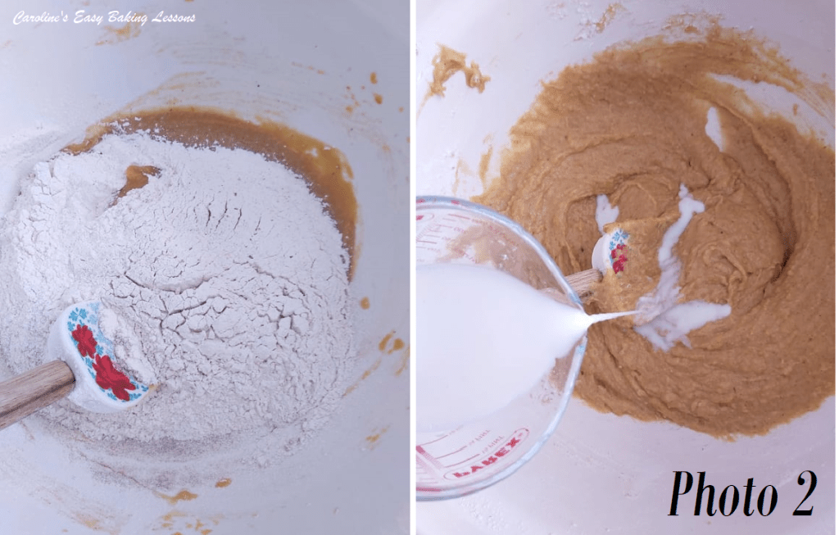
3. Next sieve over the flour, salt & spices and mix just until fully incorporated. No over mixing or you will have a tough bake. See Photo 2.
4. Finally mix in the milk & then fold in the pumpkin puree till evenly distributed. Note you will have quite a thick batter. You can thin just a little if you like by adding a touch more milk. See Photo 3 below.
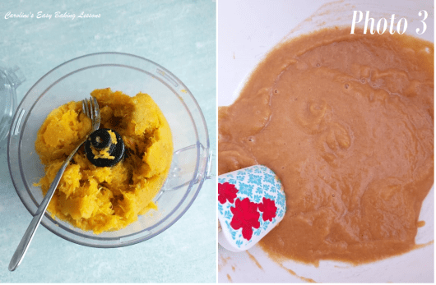
5. Now line your cupcake trays with 18 paper cases and place the cooled down chocolate pudding into a piping bag (I like a piping syringe for smaller jobs, see photo above). This is optional but if you use the smallest piping nozzle (#1) or just cut a tiny hole, you have more control. Alternatively, you can use some small spoons.
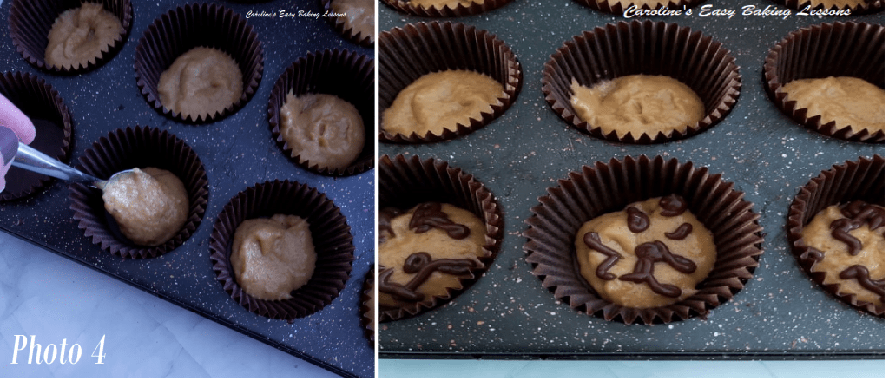
6. Scoop about a tbsp (or small scoop worth) of the pumpkin batter into the bottom of the paper cases. See Photo 4.
7. Next pipe some small random ‘blobs’ (for want of a better word), on top of the pumpkin batter. I did a kind of animal pattern with random sized and shaped spots. Just don’t do too big an area of the pudding as you need some of the pumpkin batter to be in-between to work as the structure of the bake and for it not to collapse. See Photo 4.
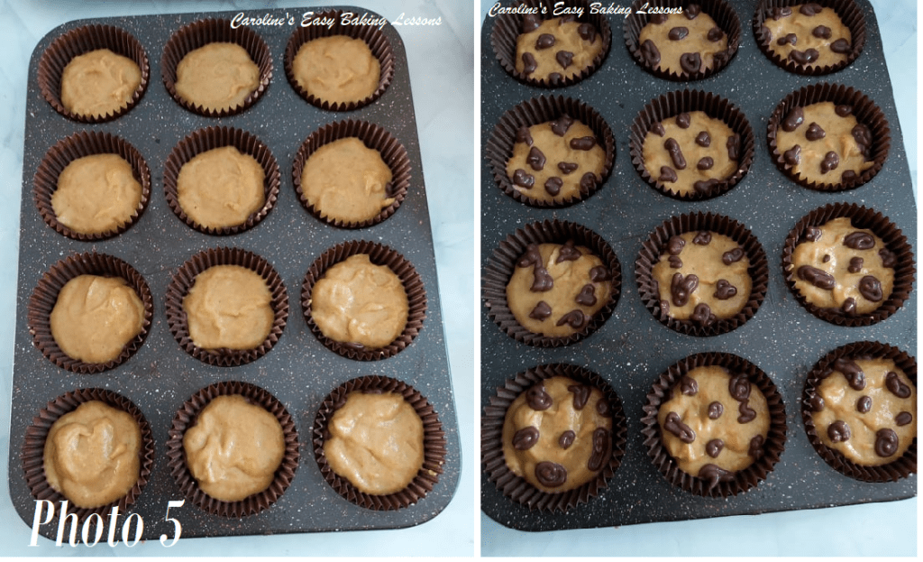
8. Now spoon some of the pumpkin batter back on top of the chocolate pudding layer. Alternate this layering till you get to near the top of the cases (about 85% full) and all the pumpkin batter is used up. Then top with some more of the pudding. You will probably use only about half of the pudding mix (depending on the size of the packet you used). So enough left to place in little bowls and have as a dessert. See Photo 5.
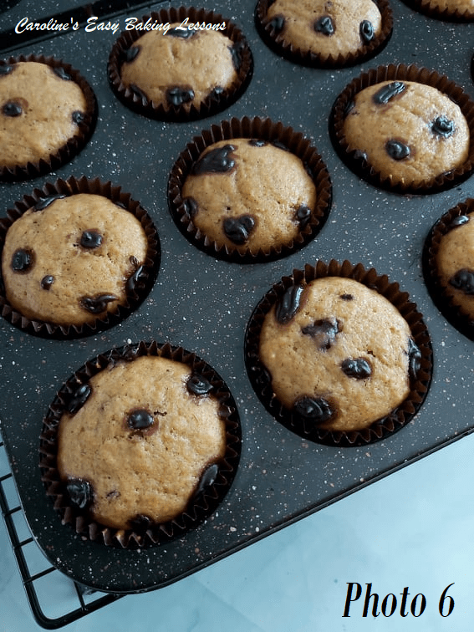
9. Give the cupcake trays a few taps on the counter/worktop to expel any trapped air, and then place in the centre of the oven to bake.
Bake The Chocolate Pumpkin Muffins
10. Bake for about 25 to 30 minutes, until risen, golden and a wooden cocktail stick comes out clean of crumbs. See Photo 6.
11. Leave in the cupcake tray on top of a cooling rack, for about 5 -10 minutes, before removing and allowing to cool down completely.
12. Serve as is, or with your favourite syrup or ice-cream topping, oh and even with some cream!
13. Store left-overs in an air-tight container. I prefer a metal cake tin and will last 3 to 4 days. Can easily be frozen, wrapped in baking/parchment paper and then foil or cling film/plastic wrap or food baggie and defrosted at room temperature.
Caro xxx

