SCARY SAUSAGE ROLL MUMMIES – Kids In The Kitchen
Caroline’s Easy Baking Lessons

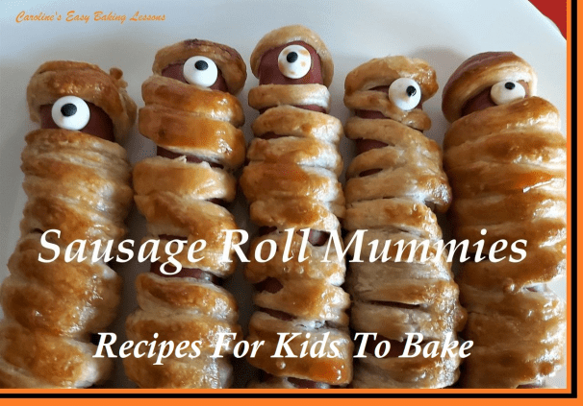

SCARY SAUSAGE ROLL MUMMIES

Recipe For Kids

By Caro

WHO IS BAKING?
Here’s my youngest son baking again (doesn’t want me to keep mentioning his name!). This time he’s making sausage rolls with a Halloween theme and choose to make them into ‘Mummies’ – Mummy Sausage Rolls! Simple to make, bigger kids can do themselves or younger ones with adult assistance of course.
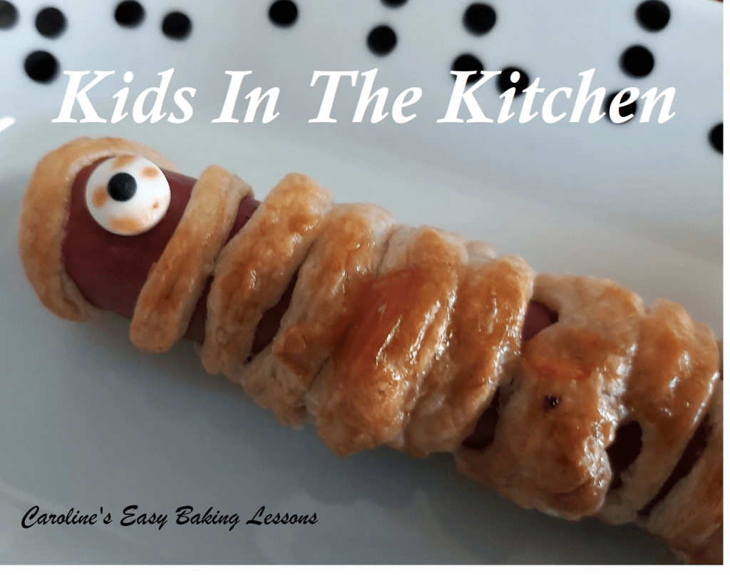

INGREDIENTS FOR SCARY MUMMY SAUSAGE ROLLS
Use shop bought puff pastry for these super simple but tasty savoury nibbles. I prefer to buy frozen as there are less additives and preservatives in them. Even better still for kids to use, is the pre-rolled out pastry – as it can sometimes be tough and hard work to roll out so much pastry. My roll of pastry measured 26cm x 38 cm (10 inches x 15 inches), and little over half the pastry was used for wrapping up 6 standard sized hot dog sausages. You could use more or thicker sausages or save excess pastry to make something the next day. Just don’t re-freeze (unless you bake first of course).

WHICH SAUSAGES TO USE?
For sausage rolls you can use any sausages you have and no need to cook them first. You can also use cocktail sausages if you want to make mini ones.

DECORATING THE MUMMIES
You can use whatever you like as eyes for the mummies. We had some sugar eyes for cupcakes, and the little man decided to make them one-eyed monster mummies! You could use cake sprinkles, or cut up olives. Lots of possibilities
On to the recipe which I will word for kids. Please make sure you supervise young children and assist with the oven if need be.

INGREDIENTS FOR SCARY MUMMY SAUSAGES
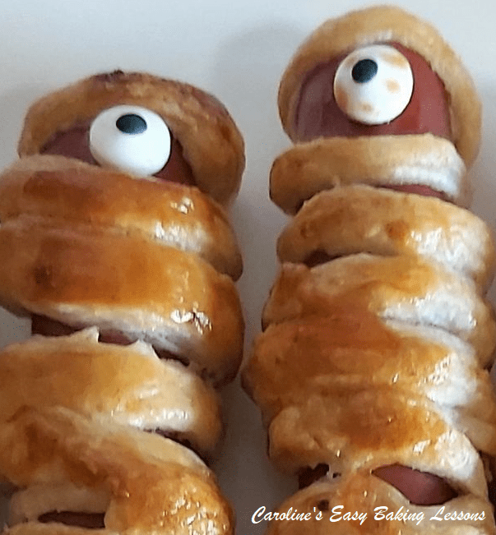

You will need the following:
- 340g+ Packet of frozen puff pastry (12 oz or more)
- Sausages of choice. (6 hotdog sized sausages were used here)
- Egg Wash: 1 egg beaten & splash of milk mixed together
- Candy eyes, olives etc for eyes (see note above)

EQUIPMENT FOR SCARY MUMMY ROLLS

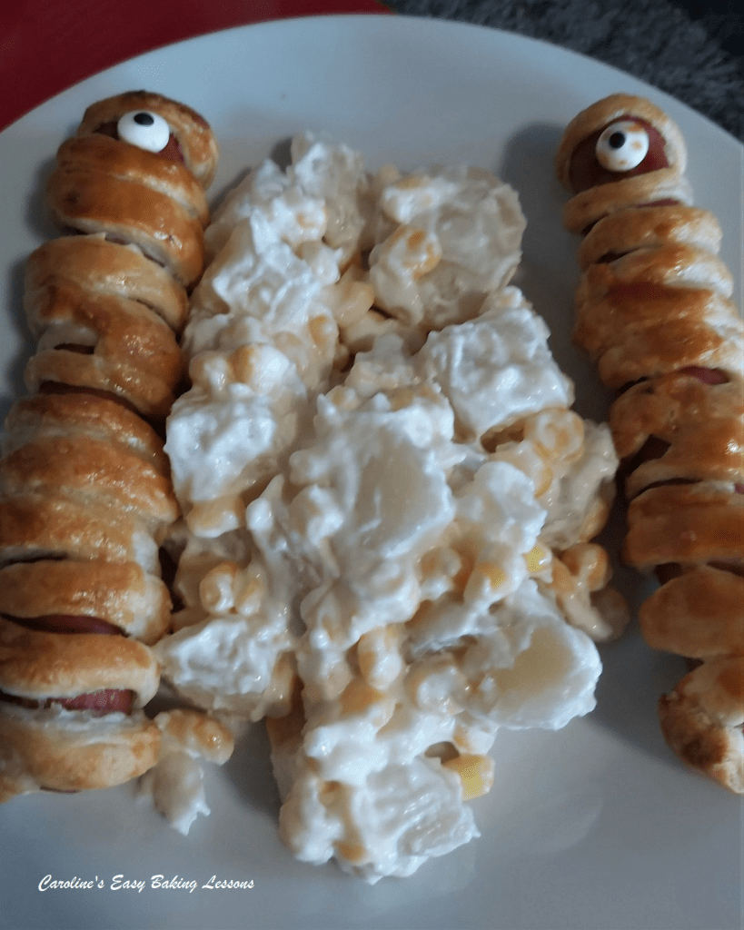
- 1 Large baking tray/sheet
- 2 Large pieces of baking/parchment paper
- Rolling pin (optional)
- Knife (butter knife will do)
- Chopping board
- Pastry brush (or small clean paintbrush)
- Small dish for egg wash
- Pastry board (optional)
- Timer or Phone Timer
- Ketchup
OVEN: 200c/180c Fan oven/400f/Gas mark 6

INSTRUCTIONS

1. Begin by defrosting the frozen puff pastry if needed, or you can leave in the fridge overnight to defrost. If the pastry is moist, remove the packaging and sprinkle a little flour on the palms of your hands and pat onto the top of the moist pastry. Pat the flour into the pastry and repeat on the other side too. Place on a dry sheet of baking/parchment paper and leave to absorb the flour. Then place in the fridge to firm up a bit.

2. If you don’t have a ready-rolled out sheet of pastry, place the block of pastry between 2 sheets of baking/parchment paper and roll out to a rectangle about 38 x 25 cm (15 x 10 inches) or the thickness of a £1 coin (3mm or 1/10 inch) . When rolling it out, try to keep a rectangular shape. Because it’s puff pastry, we won’t be re-rolling off-cuts as you lose a lot of the flake and puffyness in the pastry by doing that. If you have a bigger pack of pastry, roll out wider but not too thin.

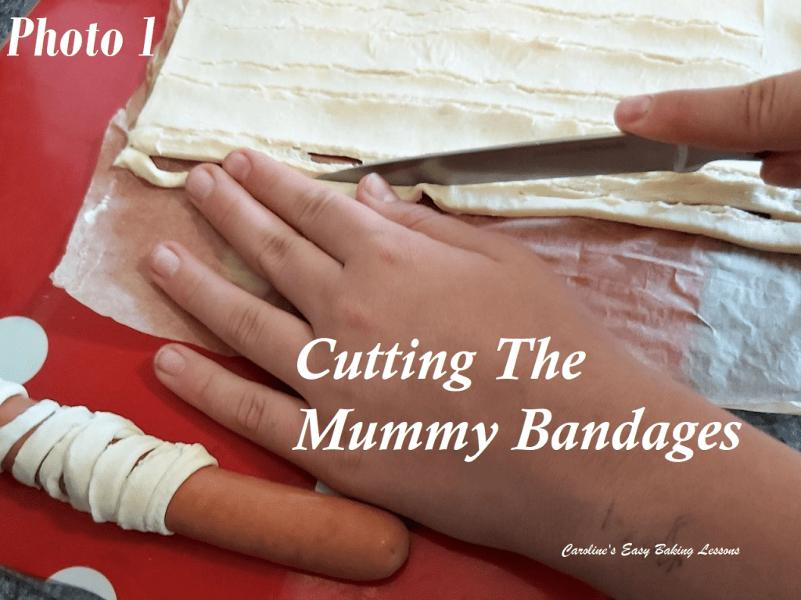
3. Use the 2nd sheet of the paper to line your baking sheet/tray. If the baking sheet/tray is all flat with no lip to it, rub a little oil on the corners of it, before putting the paper down. This helps the mummies not slide off and onto the floor!

4. Using a knife (even a butter knife), cut thin long strips of pastry to make the mummy bandages. It’s easiest to cut on the shorter end of the pastry rectangle and use two strip to cover one sausage. Cut the strips about 5mm (1/5 inch) wide. Don’t worry if they are a little wider and not straight. When you lift them up, they stretch and thin a little anyway. See Photo 1.
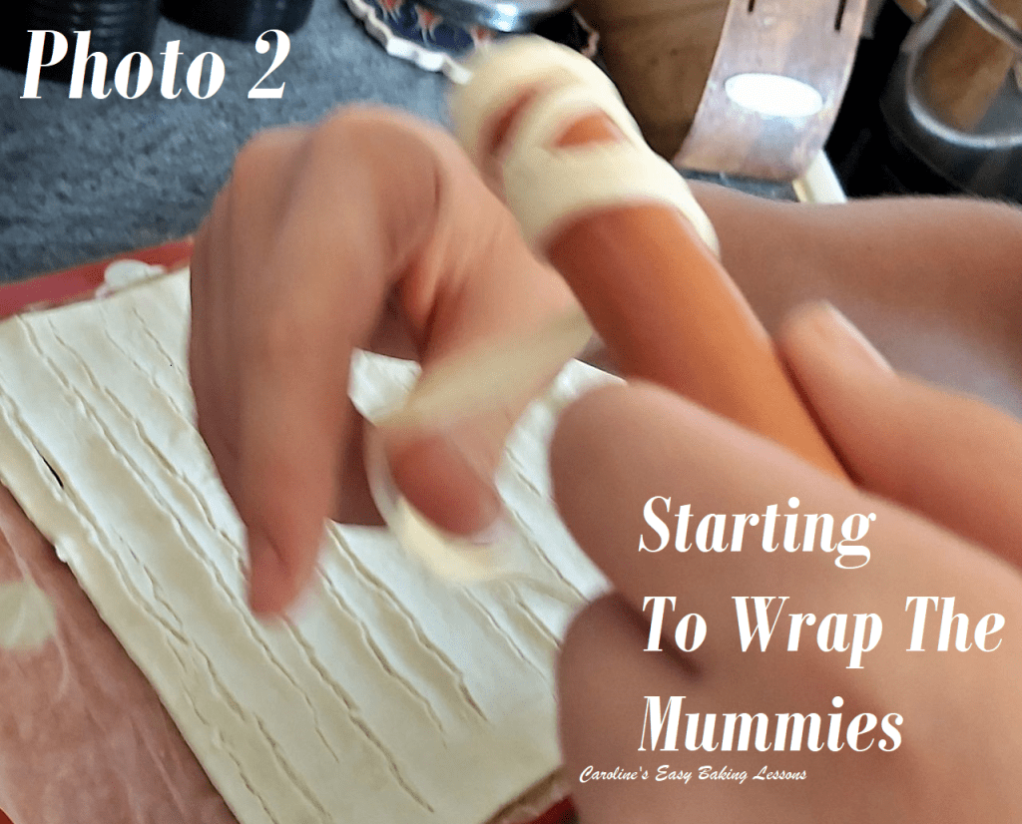

5. Poke some holes in the sausage with a fork, and start wrapping the sausage in pastry.
6. You will begin dressing the sausages with like a ‘hat or hood’. Press one end of your pastry strips on around the top of the sausage and squash together, then start wrapping the rest of that same strip of pastry around the sausage. But first leave a gap for the eyes. See Photo 2. Then continue wrapping around the sausage. Doesn’t need to be perfect, or straight. Wrapping at angles are good and a little over-lap is good too. Take a second strip of pastry and finish wrapping at the bottom of the sausage. Squeeze the end piece of pastry together & in place. Then put on the baking sheet/tray you already prepared.

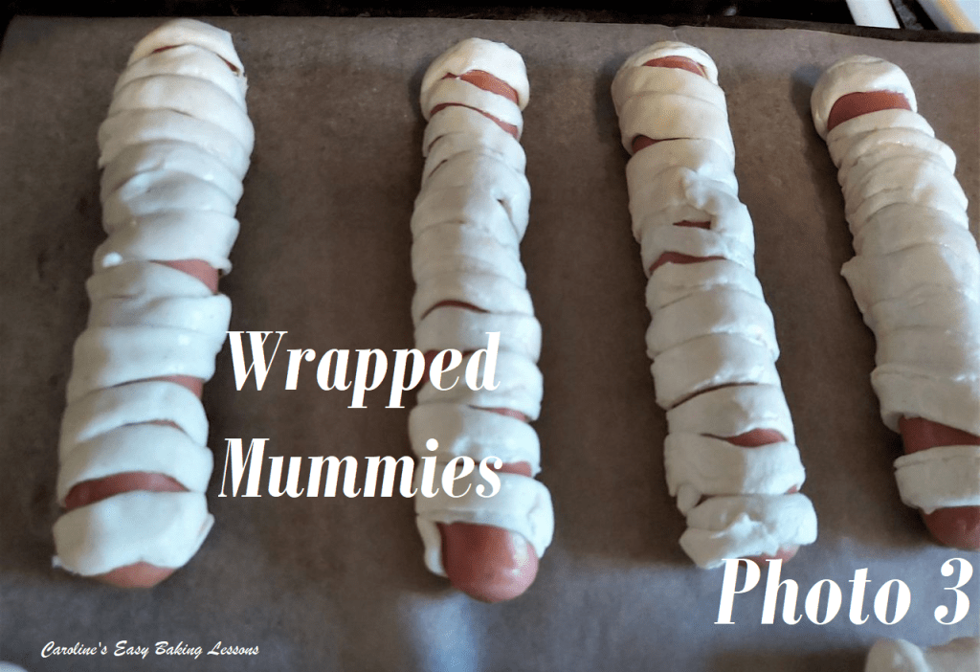
6. Wrap the rest of your sausages and when finished, brush the egg wash all over where there is pastry on the sausages. (To make the egg-wash, just break one egg into a small bowl, add a splash of milk & whisk with a fork, to mix the two together). See Photo 3. Then put the tray/sheet of mummies in the fridge for at least 20 minutes. Put a timer on for this.
7. Meanwhile, ask an adult to heat up the oven – 200c/180c Fan oven/400f/Gas mark 6.

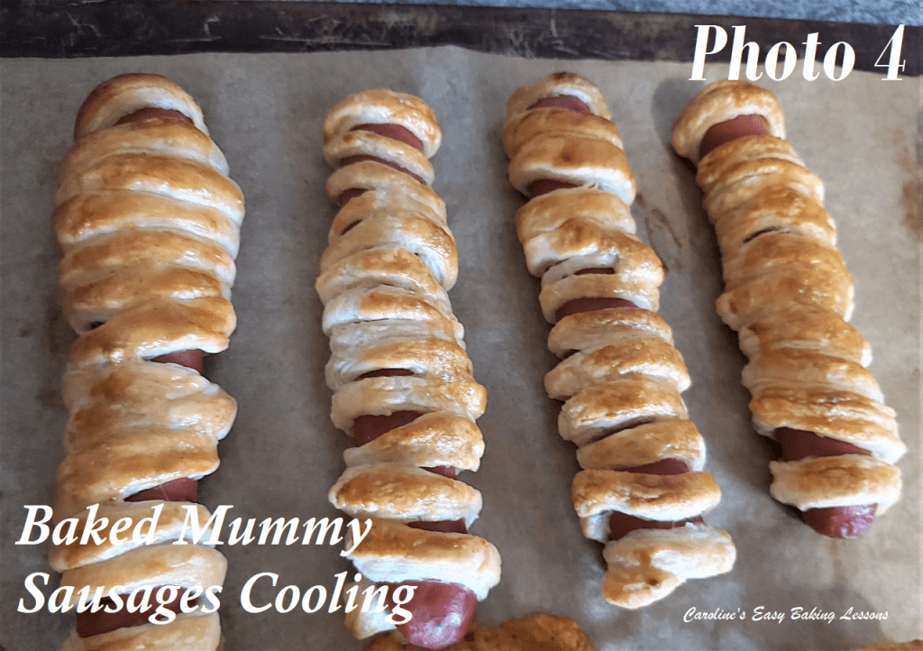
8. Get an adult to put the mummies in the oven for about 10 – 14 minutes, until all golden. Set a timer for 9 minutes and ask them to check they are ready. My son baked for 7 minutes and then turned the tray and finished cooking with another 4 minutes, taking the total baking time to 11 minutes. Be sure to keep an eye on them after 9 minutes of baking. See Photo 4.

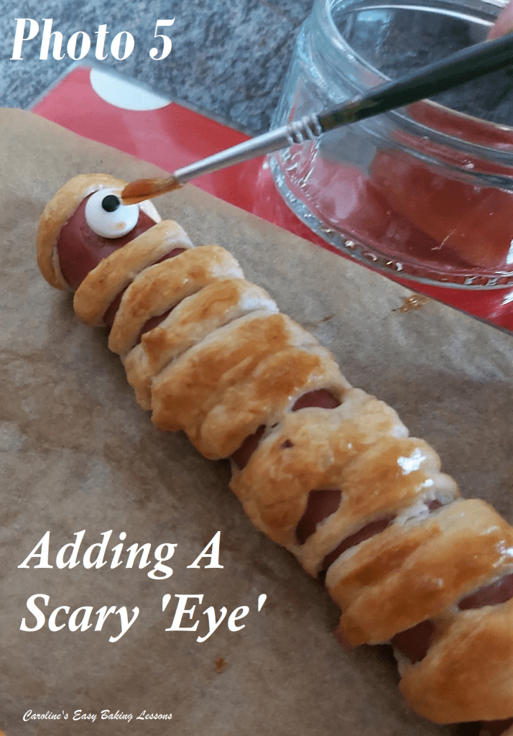

9. Once out the oven, leave to cool a little on the tray.
10. My youngest son (who will remain nameless) used some ketchup to hold the sugar eyes in place on the sausage mummies, and then added some extra ketchup to look like blood! See Photo 5.
11. Enjoy warm as a snack or as your dinner, with some vegetables.
12. Left overs can be stored in the fridge for a few days and reheated when needed.
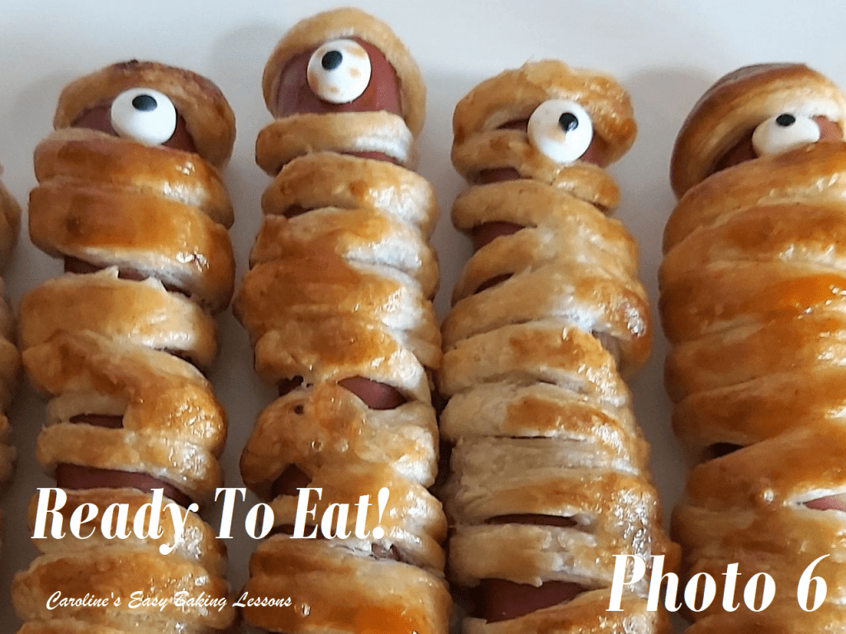

DIFFICULTY LEVEL: easy, with some help

Thanks for reading
Happy Baking & Making
Happy Tummies & Memories!

Caro xx

