INCREASE A RECIPE – Made Simple!
Caroline’s Easy Baking Lessons
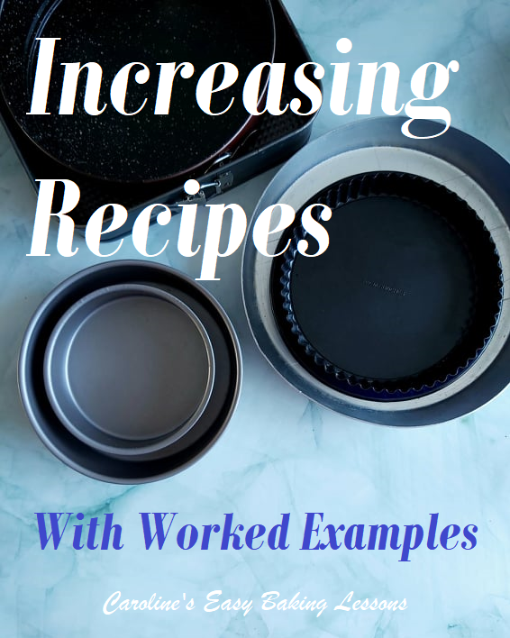

INCREASE A RECIPE TO FIT A BIGGER SIZED TIN OR DISH
Running some Facebook baking groups & having a degree in Mathematics, I am often asked about scaling recipes. Doubling or halving a recipe is simple enough, but when it comes to wanting to use a different sized tin or dish, people often make guesses and are in the end disappointed with the results.
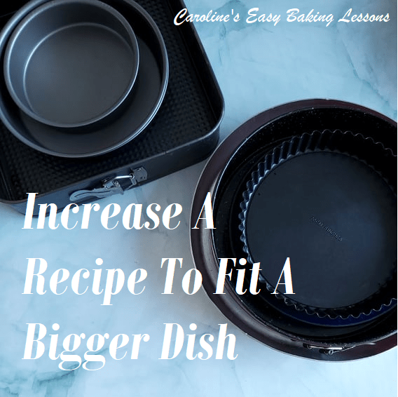

How Do You Increase A Recipe To Fit A Bigger Tin?
I often hear asked – “How to scale up a recipe?”, “How do you resize a recipe?” and questions like “How do you adjust baking ingredients?”.
The process to increase a recipe, has 2 steps: calculating how much bigger the new tin size is, and increasing the recipe ingredients accordingly.

More Reasons To Read On
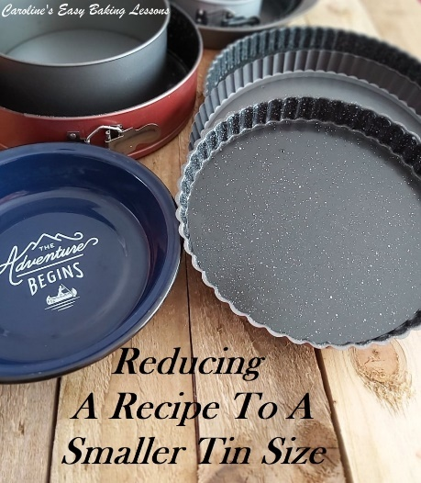
But my help doesn’t just stop there. I also provide worked examples using my factor or formula to increase a recipe. AND I show how to use it when working with measuring cups & measuring spoons. This is much more difficult for people to work out, but I have developed a simpler method. There’s even a video to show you how to do the calculations.

Down-sizing A Recipe For A Smaller Tin
I also have an article on decreasing or down-sizing a recipe to a smaller tin, for cakes and pies etc. For that I also have a quick video showing me do some worked examples. The principle for increasing a recipe is exactly the same. The only difference is the number you multiply the ingredients by. Go to How To Reduce A Recipe For A Smaller Dish.

FAQs Relating To Increasing A Recipe
Before you get to the recipe, (or in this case tables), the writer will provide all the information you need and often include answers to commonly asked questions. So below I have included answers to some frequently asked questions that always arise when you want to increase a recipe to a bigger sized dish or tin.

Q1. Will the cooking time be longer for baking in a bigger tin?
Baking time in a wider tin or dish, will not affect the bake time. Only if the depth of the cake is more than the original recipe intended, then the cake will take a little longer to bake. Note though that if you use a recipe in a wider tin and don’t increase the ingredients, your level of batter for example, will be shallower, and the cooking time should be reduced.

Q2. Should I adjust the cooking temperature when using a bigger tin?
No need to adjust the original recipe temperature when increasing a recipe. (Same applies if reducing a recipe). I always advise on purchasing an inexpensive thermometer to check what temperature your own oven is running at. This will help with your bake time and not over-bake. If for example, your oven is always running 20c higher than you set it for, lower the temperature 20c for future bakes and bake for the usual time. Similarly, if you find your oven running 20c lower than you set, increase it by 20c and bake as normal.

Q3. What If The Answers Are Not Whole Numbers?
If you increase the recipe ingredients using the formula, & it doesn’t come to a whole number, here’s an example of what to do.
If the answer for say flour is 258.61 g, then round to 259g.
*Rule – When the number after the decimal point is 5 or higher, you round up to next whole number. And if less than 5, reduce or round down, to the next lowest whole number.
So 374.21g would be 374g.

Q4. What About Eggs?
When it comes to eggs, use your judgement if it’s not a whole number. The size of the egg will also play a part in this. Adding half or 1/4 of an egg more, will not make too much difference.

Round & Square Tins
To increase a recipe from a round tin to a larger round tin, uses the same formula for increasing from a square tin to another bigger square tin. You can not use the formula to change to a different shaped tin. It can not be used to swap from say a 7″ round to 10″ square tin, as the 10″ square would have a bigger volume capacity than a round 10″. I have however, included the formula to use for increasing from a round tin to a rectangular larger tin.

INCREASE A RECIPE – THE FORMULA
Here’s the factor you new to increase a recipe and it’s ingredients to fit a bigger sized tin. Works for cake tins and pie tins etc.

Increasing From A 4″ (10cm) Round Or Square Tin
INCREASING TO: | MULTIPLY INGREDIENT BY
5″/ 12.7cm Tin/dish | x1.63
6″/15.2cm Tin/dish | x2.33
7″/17.8cm Tin/dish | x3.25
8″/20.3cm Tin/dish | x4.11
9″/22.8cm Tin/dish | x5.30
10″/25.4cm Tin/dish | x6.47
Table 1 – Increasing from a 4″/10cm Cake Tin

Increasing From A 5″ (12.7cm) Round Or Square Tin
INCREASING TO: | MULTIPLY INGREDIENT BY
6″/15.2cm Tin/dish | x1.43
7″/17.8cm Tin/dish | x2.00
8″/20.3cm Tin/dish | x2.52
9″/22.8cm Tin/dish | x3.26
10″/25.4cm Tin/dish | x3.97
Table 2 – Increasing from a 5″/12.7cm Cake Tin

Increasing From A 6″ (15.2cm) Round Or Square
INCREASING TO: | MULTIPLY INGREDIENT BY
7″/17.8cm Tin/dish | x1.37
8″/20.3cm Tin/dish | x1.78
9″/22.8cm Tin/dish | x2.2
10″/25.4cm Tin/dish | x2.79
Table 3 -Increasing from a 6″/15.2cm Cake Tin

Increasing From A 7″ (17.8cm) Round Or Square
INCREASING TO: | MULTIPLY INGREDIENT BY
8″/20.3cm Tin/dish | x1.27
9″/22.8cm Tin/dish | x1.63
10″/25.4cm Tin/dish | x2.00
Table 4 – Increasing from a 7″/17.8cm Cake Tin

Increasing From A 8″ (20.3cm) Round Or Square
INCREASING TO: | MULTIPLY INGREDIENT BY
9″/22.8cm Tin/dish | x1.29
10″/25.4cm Tin/dish | x1.57
11″/27.9cm Tin/dish | x1.90
12″/30.5cm Tin/dish | x2.27
Table 5 – Increasing from a 8″/20.3cm Cake Tin

To Fill A Rectangular 9x13x2″ (23×31.2x5cm) Dish
Going from the original recipe size below & increasing to fit this large rectangular dish.
RECIPE DISH SIZE: | MULTIPLY INGREDIENT BY
Recipe 8″/20.3cm | x4.73
Recipe 9″/22.8cm | x3.70
Recipe 10″/25.4cm | x3.00
Recipe 11″/27.9cm | x2.48
Recipe 12″/30.5cm | x2.00
Table 6 – Increasing to a 9x13x2″/23×31.2x5cm Cake Tin

To Fill A Rectangular 11x14x1″ (28×35.5×2.54cm) Sheet Pan
Going from the original recipe size below & increasing to fit this 1″/2.54cm deep Sheet Pan.
RECIPE DISH SIZE: | MULTIPLY INGREDIENT BY
Recipe 9″/22.8cm | x2.39
Recipe 10″/25.4cm | x2.00
Recipe 11″/27.9cm | x1.61
Recipe 12″/30.5cm | x1.36
Table 7 – Increasing to an 11x14x1″/28×35.5×2.54cm Sheet Pan

^{s}
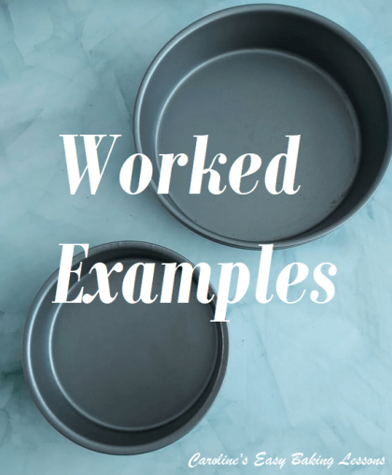
Worked Examples
Ex1. Increasing from 4″ to 7″ – multiply by 3.25 (from Table 1 above)
Recipe is 63g flour & you need to increase by the factor found in Table 1 (3.25)
63 x 3.25 = 204.75 which becomes 205g Flour
For Flour in Ounces, 63g = 2¼ oz
Similarly, just multiply 2.25 x 3.25
Which equals 7.215 so answer is 7¼ oz flour

Ex2. Increasing from a 6″ to 10″ – multiply by 2.78 (from Table 3 above)
Recipe calls for 1 egg & you need to increase by the factor found in Table 3 (2.78)
1 x 2.78 = 2.78 which becomes 3 eggs

Ex3. Increasing from an 11″ round x 1″ deep to A Rectangular 9x13x2″ (23 x 31.2 x 10.1cm)
-multiply by 2.48 (from Table 6 above)
Recipe calls for ½ tsp cinnamon & you need to increase by 2.48
0.5 x 2.48 = 1.24 which becomes 1¼ tsp

Ex4. Increasing from a 9″ round x 1″ deep to Rectangular 11 x 14 x 1″
-multiply by 2.39 (from Table 7 above)
Recipe is for 120ml Oil & to be multiplied by 2.39
120 x 2.39 = 286.9 which becomes 290ml but measuring 300ml would be fine.

Teaspoon Examples
Ex5. Recipe calls for ¼ tsp Baking Soda/Bicarbonate. And if the increase factor was 1.40 as in Table 3 above
¼ – 0.25 x 1.40 = 0.35 but how do you measure 1/3tsp?
Think of ¼ tsp as the same as 2 x 1/8 tsp
2 x 1.40 = 2.8 & becomes 3
Which is the same as 3 x 1/8 tsp or, ¼ tsp + 1/8 tsp
So even if you don’t have an 1/8tsp, you could measure one ¼ tsp & then half a ¼ tsp to be accurate.

Ex6. Another tsp example where the answer after multiplying is not clear.
2 tsp x 1.57 = 3.14 tsp, but what is 0.14 tsp?
Most people will just use 3 tsp, but if you use this other method, you will find the exact amount & have better results. Since baking is a science, accuracy is key.
2 tsp is same as 16 x 1/8 tsp
16 x 1.57 = 25.12 & round down to 25
25/8 tsp reduces down to 3 + 1/8 tsp which is easier to use.
So if you had went by the simpler method & left at 3tsp, you would have been 1/8 tsp short.

Increase A Recipe With Measuring Cups
For measuring cups it’s not quite as easy, so purchasing an inexpensive digital scale, would be easier and actually more accurate. Most come with grams and ounces as standard measurement units. But if you only have measuring cups, here is some examples to guide you & increase a recipe. The smallest cup size is 1/8 cup & so using that we can increase the recipe more accurately. Don’t worry if you don’t have 1/8 cup, you can still half fill a ¼ cup.
*Simplest example
2 cups flour multiplied by 1.63 = 3.26 So answer would obviously be 3 ¼ cups flour.
But not all answers after multiplying are so obvious:
Say ½ Cup Oil was to be multiplied by 2.28 ½ cup = same as 4 x 1/8 cups
So 4 x 2.28 = 9.12 9.12/8 = 1.14 (use the calculator on your phone).
This equals 1 cup plus 14% of a cup (ie. 0.14)
Now 1 cup = 240ml/8 fl oz & 14% = 33.6ml (ie 240×0.14)
2 tbsp Oil = 30ml, so 2 tbsp is near enough.
Therefore, the exact answer is 1 cup + 2 tbsp oil.
That 2 tbsp oil might make the difference in whatever you are making.

You can alternatively use the same principles as for the tsps section above to do calculations, but here are some handy numbers to refer to when you use a calculator just to simply multiply the cup amount by the increase factor & are left with a number you don’t know what it is exactly and don’t want to just guess. Also handy if you don’t have a 1/3 cup.
0.12 =1/8
0.25 = ¼
0.33 = 1/3 & also equals ¼ +1/8
0.5 = ½
0.66 = 2/3 & also equals ½ +1/8 (or use ½ c + half a ¼ c or, use ¼ cups & measure 2.5 times)
0.75 = ¾
0.87= ¾ + 1/8 (or ¼ cup x 3.5)

Other Useful Information
1 Cup Liquid | 240ml
1 tsp Liquid | 5ml
1 tbsp | 3 tsp
1 tbsp Liquid | 15ml
1 Cup Flour | 125g/4.5 oz
1 tbsp Flour | 8g
1 tbsp Butter | 15g
1 tbsp Sugar | 12.5g

More Conversions
For more conversions, please see my article on CONVERSION OF UK & US COMMON BAKING INGREDIENTS, complete with a handy table to save.

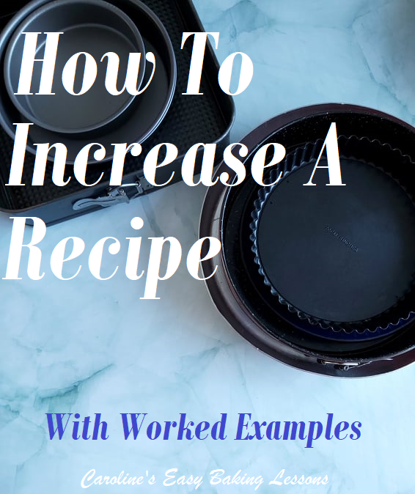
Thanks for reading
Happy Baking & Making
Happy Tummies & Memories!

Caro xx

