Chocolate & Orange Yule Log - Bûche de Noël

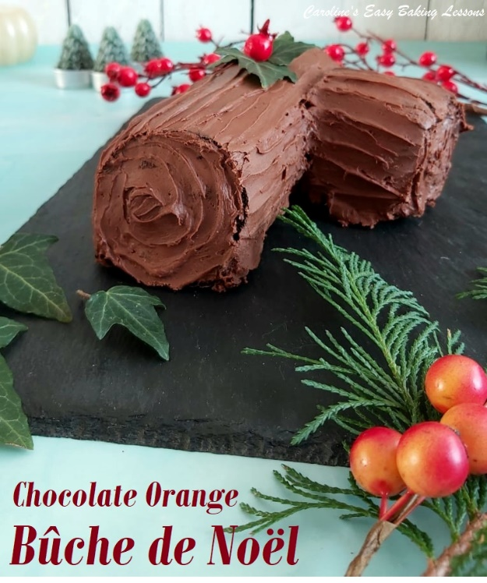
Caroline’s Easy Baking Lessons

Here’s my recipe for a Chocolate & Orange Yule Log. Also known as a Bûche de Noël, I originally developed this recipe in 2019, & I just updated with some new improved photos in 2021. It just happens to be Gluten Free too, so ideal for holiday entertaining. Hope you enjoy it, as much as we do!

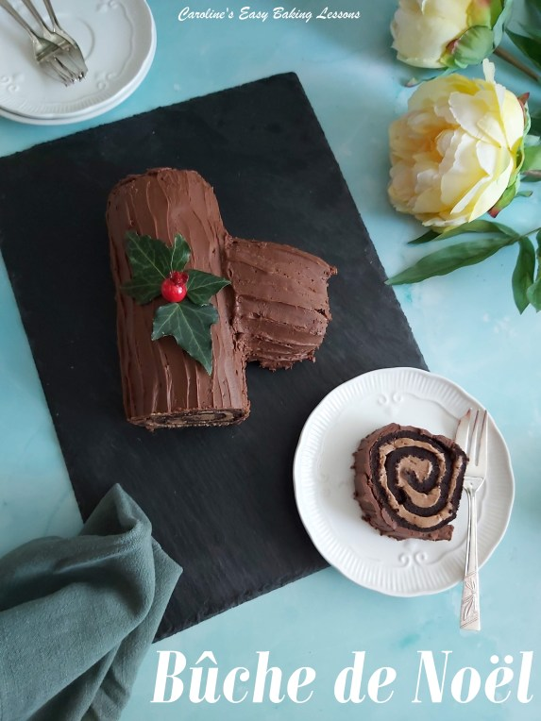

Such An Easy Process
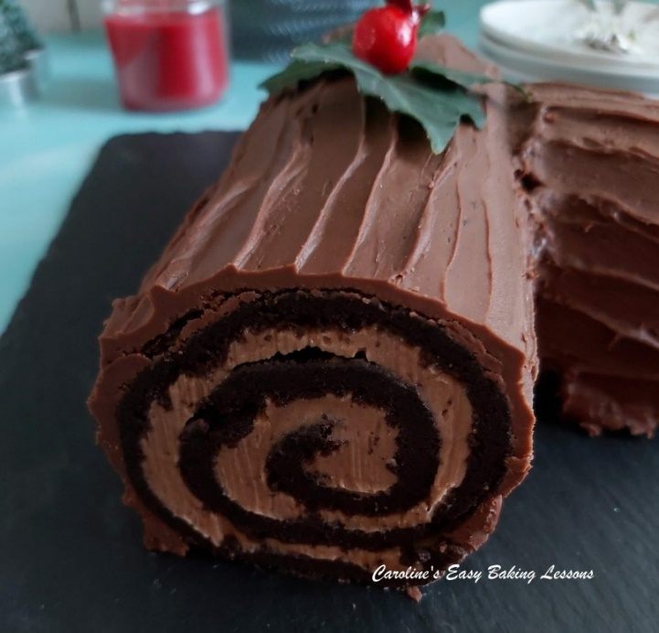
This really is a very simple process to make this Christmas Chocolate & Orange Yule Log cake. The only time-consuming part is waiting for it to firm up. If the buttercream is too soft, it just won’t cut nicely and show the ‘swirl’. It really is worth it though. A real showstopper in looks and taste, we won’t tell anyone how easy it was.

Flour-free & Gluten Free
The Bûche de Noël also just so happens to be gluten free too, with no flour in the cake batter or raising agent. Just check your flavour extract though, as some are not gluten free.

Flavouring The Cake
Which leads me onto the flavouring. I opted for orange to pair nicely with the chocolate, but peppermint and also coffee extract would work well too.

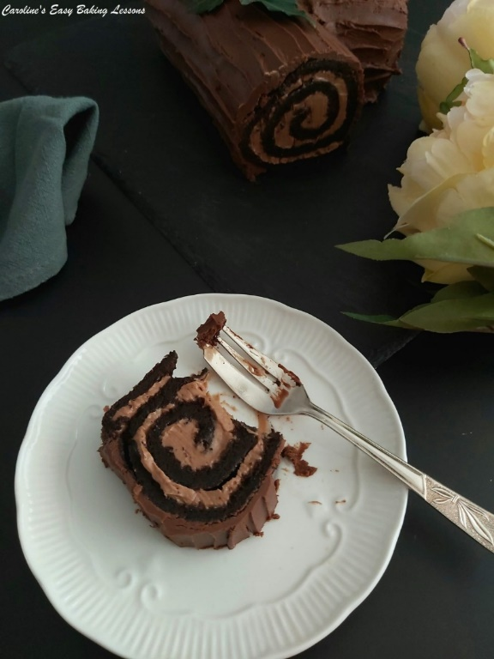

A Note On The Ingredients
I want to get right to the Chocolate & Orange Yule Log recipe, but here are some quick notes first before we get there. A note on the ingredients. Caster sugar, equivalent in the states and Canada is extra/super fine sugar. If you can’t get that, you could make your own by a little pulsing of granulated sugar in a food processor.
Just be aware that US granulated is a slightly smaller granule size than our UK version. Do not go as far as a powder. See the photo below of our sugars in the UK. Alternatively, use rounded 2/3 cups of granulated sugar.

UK Baking Sugars
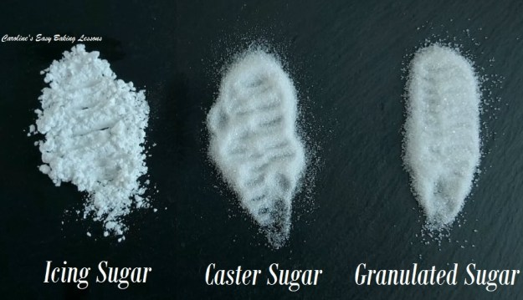

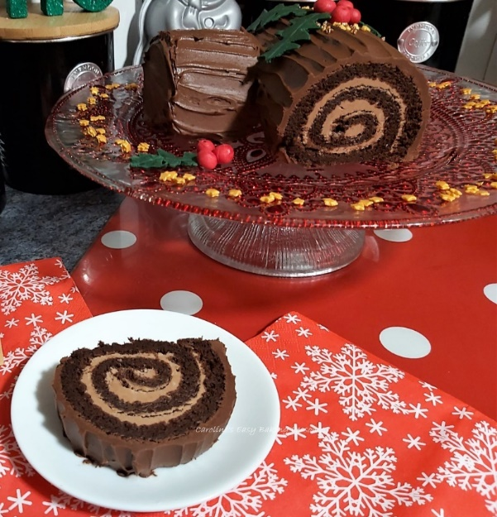
Chocolate For A Chocolate & Orange Yule Log
No need for baking chocolate, or expensive high cocoa content chocolate. Supermarket own brand is fine, as long as a high proportion of all chocolate used, is made up of dark/bitter chocolate. If you really don’t like dark/bitter chocolate, lower it & increase the milk/semi-sweet chocolate but no more than say 45% of the total chocolate used.

Baking Equipment
For the Chocolate & Orange Yule Log I used one of my regular baking sheets/trays that has a bit of a lip. It is 33 x 23 x 1.5 cm, or 13 x 9 x 0.5″. A Swiss or jelly roll sheet/tray will work too. Try not to go more than 2.5cm or 1 inch bigger or smaller than this, or it will be too shallow or thick a sponge layer.

Fondant Holly
In my original pics of 2019, I added fondant holly & berries. The fondant holly is entirely optional for the Chocolate & Orange Yule Log cake, but really easy to do. (See photo above). You could of course use real holly or even fake. This is up to you.

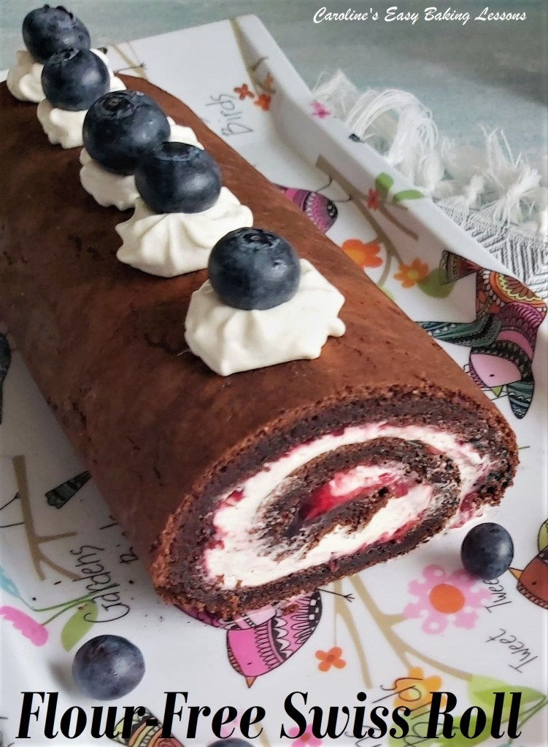

Swiss/Jelly Roll Video
You can also refer to this newer recipe – Chocolate Swiss/Jelly Roll, that includes more photos, as well as a video tutorial. **Note a new video for the Yule Log will be on-line soon.
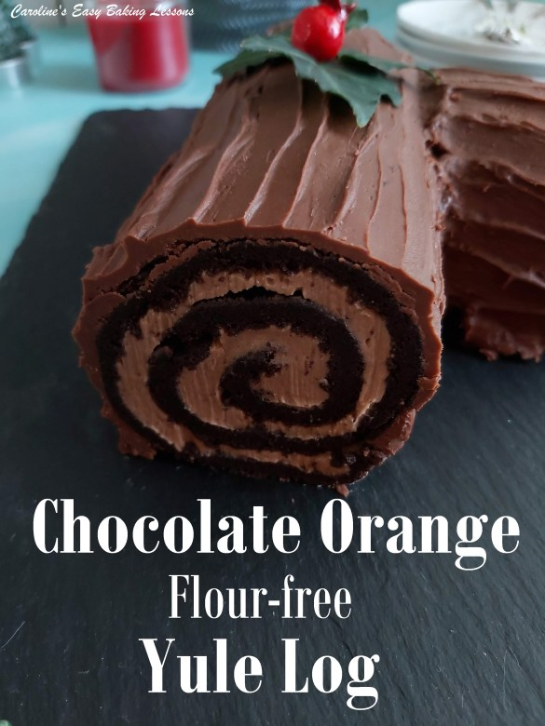
Click to view the Chocolate Swiss Roll Recipe, or watch the video below.

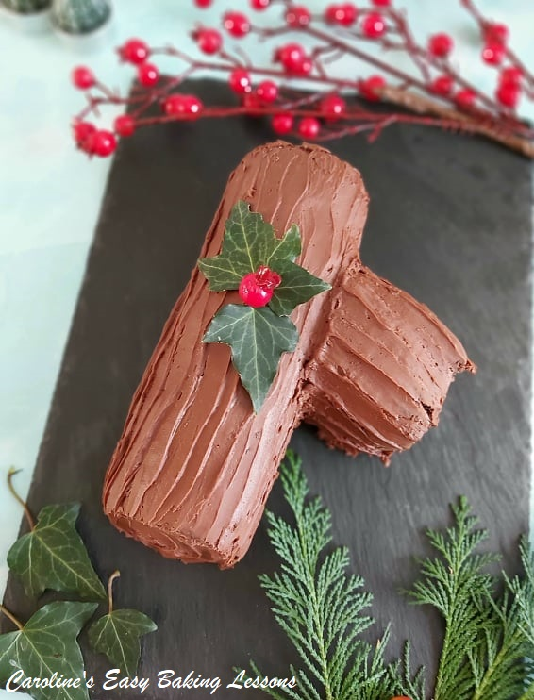
INGREDIENTS
6 Medium – Large Eggs, separated.
150g Caster Sugar (1 cup extra/super fine, see note)
50g Cocoa Powder (1/3 cup), sieved
125g Dark/plain Chocolate, broken up (4.5 oz, bitter chocolate, see notes)
75g Milk Chocolate, broken up (2.5 oz, semi-sweet chocolate, broken up)
200g Icing/confectioners’ sugar, sieved (1 2/3 c)
200g Butter, cubed & softened (1 stick (or 1/2c) + 1/3 cup)
2.5 – 3 tbsp Orange Extract or peppermint or coffee
OVEN: 180c/160c Fan Oven/360f/gas mark 4
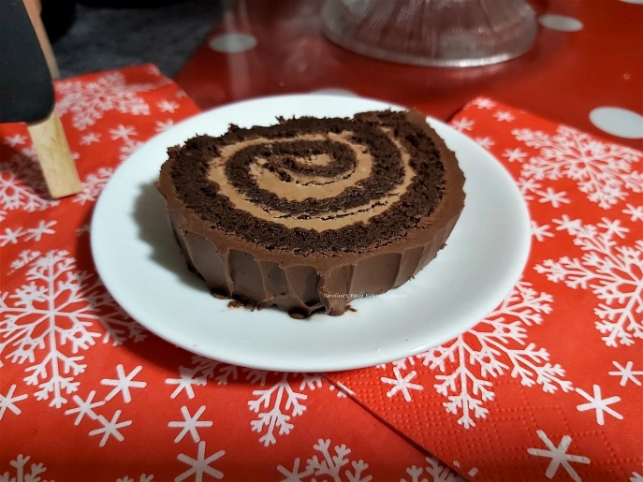
EQUIPMENT
Scales or measuring cups
measuring Spoon – tbsp
Large mixing bowl
Hand or stand mixer
Medium bowl
Sieve
Plastic/rubber spatula for folding
Baking tray/sheet or jelly/Swiss roll tray/sheet (see notes)
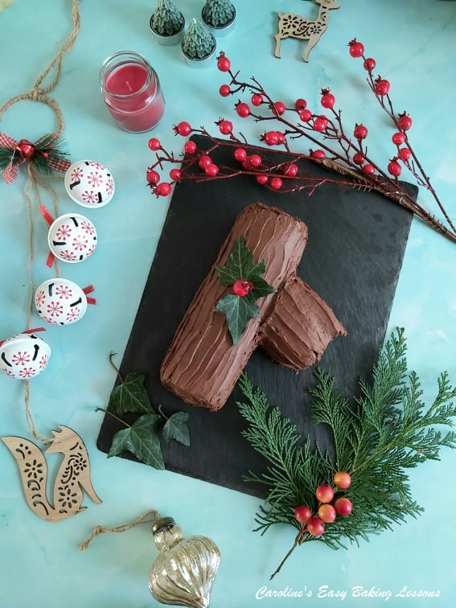
Baking spray oil or butter for greasing
Baking/parchment paper
Timer
Wooden Cocktail stick/tooth pick
2nd tray/sheet, at least size of the one baking in
A clean tea-towel, wider and longer than the baking sheet/tray
Icing/confectioners’ sugar
Wide pastry brush or Small sieve & spoon
String or something to tie with
Baking palette knife, off-set best
Cake stand or large display plate
Cake dome/lid (optional)
Red & Green Fondant icing OR white fondant and red & green food colouring, (preferably paste over gel). Only a small amount needed.
Gloves for colouring the fondant
Fondant rolling mat or baking/parchment paper
Rolling pin
Craft knife or sharp blade.
Edible black pen (see notes).
Holly Leaf template (or draw free-hand. You can print off this recipe and it will include a Holly leaf template to cut out and use as a guide)
Sprinkles (optional)

INSTRUCTIONS
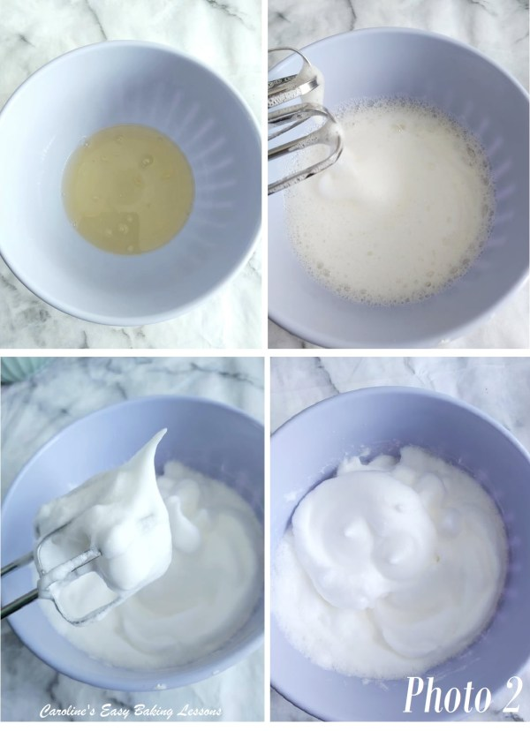
1. Heat up the oven to 180c/160c Fan oven/360f/Gas mark 4. Use baking oil spray or some butter to lightly grease your baking tin/sheet and place a cut piece of baking/parchment paper on top.
2. Whisk the egg whites in the medium bowl for at least 1 minute at high speed, until stiff peaks are formed. (The volume will increase considerably, and the whites will be like clouds). Lift the beaters upwards and see how the whites fall, like in Photo 2 below.
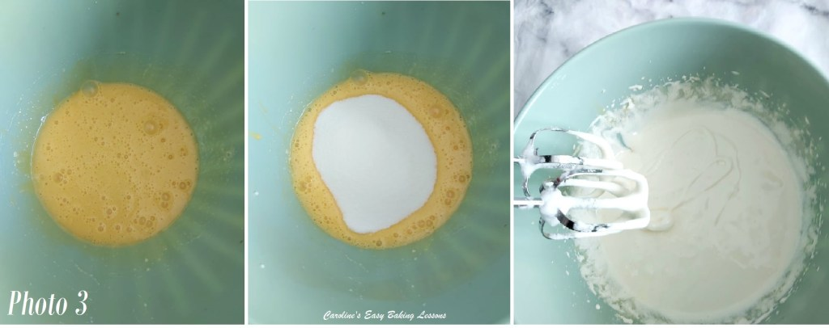
3. Place the egg yolks into the large bowl or stand mixer bowl, and add or weigh in the sugar. Then whisk on high speed for about 2 minutes, until the mixture changes from a strong orange colour to much paler, thicker, creamy and if you drizzle some mixture from the end of the mixer, it will fall onto the rest of the mixture, and ‘leave a trail’ for a few seconds before it disappears. This is also known as the ‘ribbon stage’ or ‘trail stage’. See Photo 3 below or check out my Ribbon Stage Video.
4. Next fold the cocoa powder into the whisked egg yolks/sugar mixture. Use a plastic or rubber baking spatula as metal will knock out the air you incorporated. There is no other rising agent (also known as leavening) in this recipe, so we want to keep as much air as we can. Mix as if you were writing a number 8, where the spatula is your pen & the batter your paper. See Photo 4.

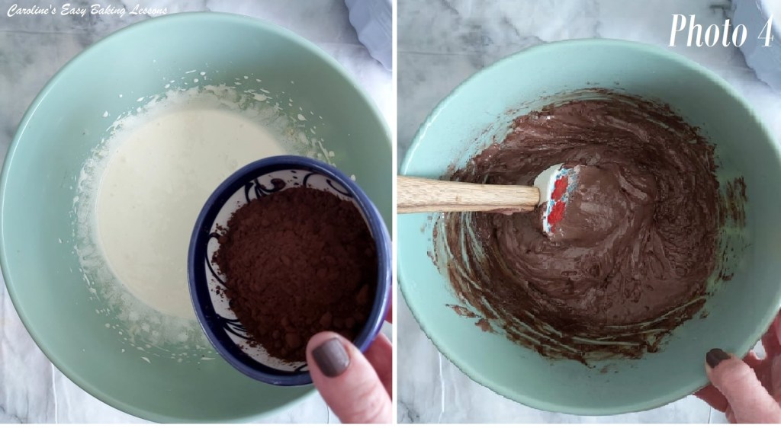
5. Now fold 1/3 of the egg whites into the cocoa batter. Go slow and be gentle. Then add another 1/3 of the whites and fold in again. Repeat for the final 1/3 of whites. Remember to scrape the sides as you ‘write’ or ‘fold’ the whites in and do so just until no more whites are visible. See Photo 5 & 6 below.
6. Pour the mixture into the prepared cake tin, moving the bowl as you let it drop down, filling any gaps as you go. Give the tin a shake to distribute it evenly, using the spatula as little as possible. Give the tin a few taps on the worktop/counter to expel any trapped air and place in the oven. See Photo 6.
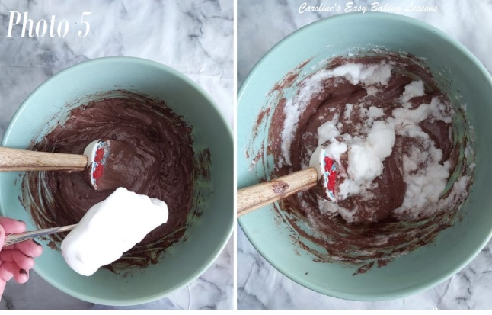
7. Bake for about 15 minutes until a cocktail stick inserted in the middle comes out clean, and the cake is starting to come away from the sides of the tin. I like to turn the tin half-way through cooking to ensure an even bake. I used the end of a spoon to pull out the tin without getting my thumb in the cake! See Photo 7.
While the cake is baking, get a clean tea towel, baking/parchment paper, icing/powdered sugar & a small sieve ready for the next stage.
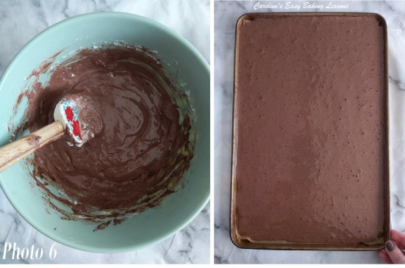
8. Place the baking/parchment paper on top of the clean tea-towel and sprinkle or sieve icing/powdered sugar on top of the paper. You can use cocoa powder instead if you are not going to cover the Chocolate & Orange Yule Log, but I prefer icing sugar as it’s less expensive and prevents sticking. See Photo 8.
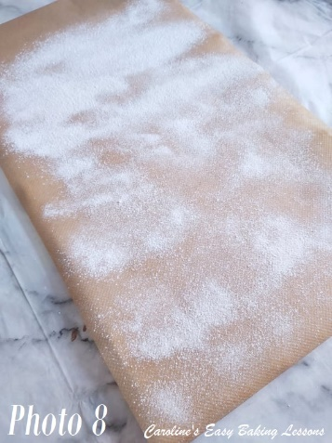
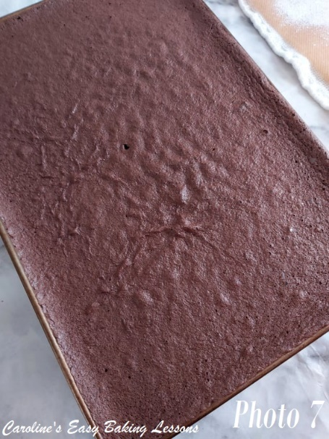
9. As soon as the cake is out of the oven, run a knife along the edges to make sure it will release. Then, with oven gloves till on, flip the baking tin/sheet over, and onto the prepared tea-towel and paper. (Be warned, there will be a sugar cloud. I used to brush the sugar onto the tea-towel, but it still sometimes stuck).
**Top Tip – for any Swiss/Jelly Roll, it needs to be removed from the tin/sheet immediately and rolled while still hot. This stops as many cracks and rolling with paper & the tea-towel inside, the cake creates a ‘memory’ if you like. I will remember that rolled shape and be easier when coming to fill it later.
10. Gently peel back the baking parchment paper from around all the edges, before pulling off completely. Don’t worry if there are some crumbs stuck on, just pay attention to it not breaking. Little breaks/tears at the outer edges is fine, as these will be trimmed off.
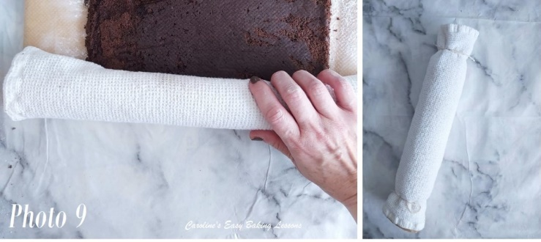
11. Start at the short width end, and fold and squeeze the cake together to get a good start to the swirl, making sure to have the towel & paper rolled inside too. Once started, roll up quickly while still warm. See Video. Let it sit with the seam side underneath. Then use some string, pegs etc, to hold the ends closed tight. See Photo 9. Place on a tray & chill for about 45 minutes for it to cool down.
12. Meanwhile, cube and weigh/measure out your butter for the buttercream, and leave out to soften. Then sieve and measure out the icing/powdered sugar. 5 minutes before the chilling time is up, make up the frosting and filling. Add the icing/powdered sugar gradually to the softened & beaten butter, (I sometimes place a clean towel over the mixer). Then add in the orange extract. See Photo 10 below.
13. Melt the broken chocolate up in the microwave, in 30 second bursts, mixing well in-between each burst. Never heat longer than 30 seconds or you might burn the chocolate. Leave to cool a little, so it doesn’t melt the butter.
14. Now add in only 2 tbsp of the melted cooled chocolate and mix till fully incorporated. See Photo 11.
15. Reserve just over half of this chocolate frosting and place in a different bowl, that will be used for the filling.

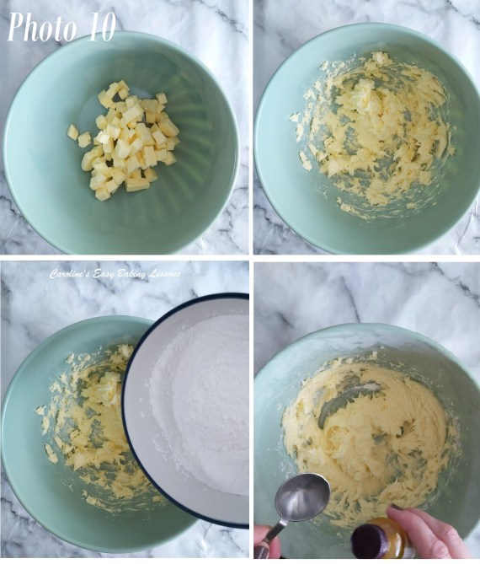
16. Next add in the rest of the melted chocolate to the remaining cocoa buttercream mixture and mix till fully incorporated. Also do a taste test and add more orange extract if needed. See Photo 12.

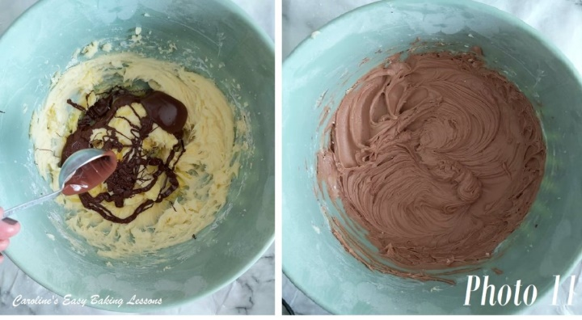

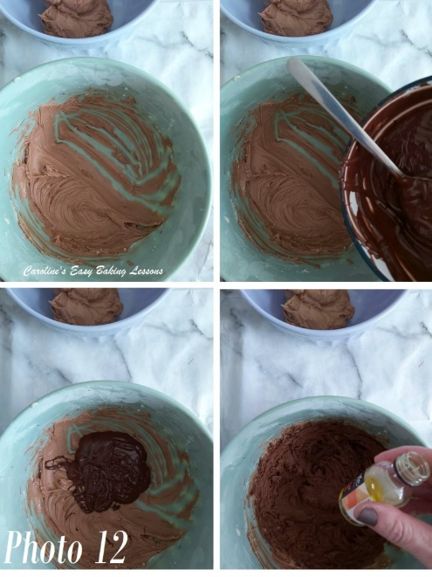

17. Unroll the cake and leave it flat, still on the paper. Then use the reserved (paler chocolate coloured frosting) and divide up on top of the rolled-out cake. Then using a palette knife, spread out the filling evenly, getting right to the edges. Try to make it as even as possible. See Photo 13.
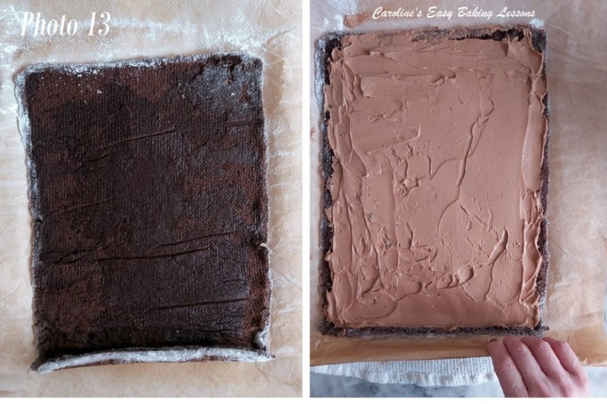

18. Next begin to re-roll the cake without the paper or tea-towel, making sure to get a tight start to it, and roll right to the end. (See in Photo 13, where the cake has ‘remembered’ the rolled up state, and is curled over at where you will begin to roll up).
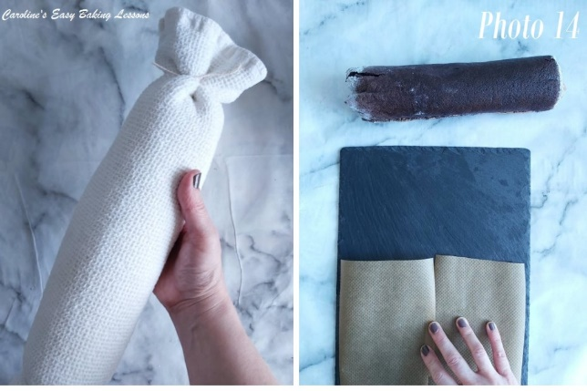
19. Wrap the rolled-up cake in the tea-towel & tie the ends like before. Place on a tray or large plate in the fridge and make sure the seam side is underneath. Chill for 1 hour to firm the buttercream and give cleaner slices. See Photo 14.
***Tip – you can instead, leave in the fridge overnight and finish the cake next day.
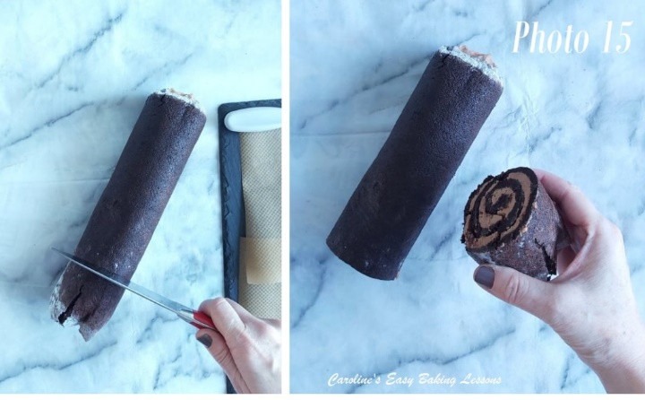
20. Get a cake stand, rectangular platter or large serving plate ready. Cut a piece of baking/parchment paper a bit wider than the size of the plate/stand and cut into 4 pieces. Then position on top of the plate/stand to cover it, (that will catch all the frosting mess). See Photo 14.

21. On top of some baking/parchment paper, use a very sharp long knife, & cut off a little under 1/3 of the cake roll off, (if you want a branch coming off the roll). Pick the least perfect end. See Photo 15.
22. Next, very carefully, position the main cake ‘log’ on top of the plate/stand, ensuring the paper stays in place.
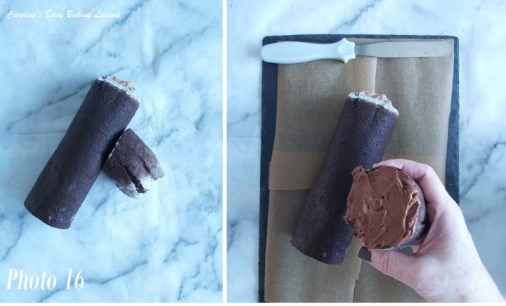
23. Now decide on which side you want to place the branch. You will cut a little of the cake off the end at an angle so that the branch doesn’t point straight out when you join it. I put mine on the right side, and cut off from the top right edge, and angled the knife towards the bottom, a little off from the left. See Photo 16, left pic, where I checked the cake by placing against the main log.
24. Turn the piece of cake branch over and apply a layer of frosting to use as cement. See Photo 16.
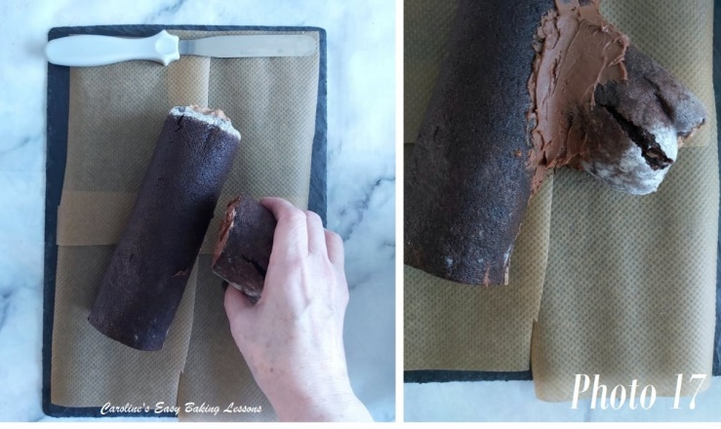
25. Position the branch a bit before the half-way mark, and push into place. Take a small tea making spoon and drop some frosting over the join area and use the end of the spoon or your finger to spread it into the gap all the way around. Doesn’t need to be perfect. See Photo 17.
26. Now apply some frosting onto the ends of the cake roll. You can either use your palette knife to spread flat or, do so in a swirl to create an appearance of tree rings. See Photo 18 below.

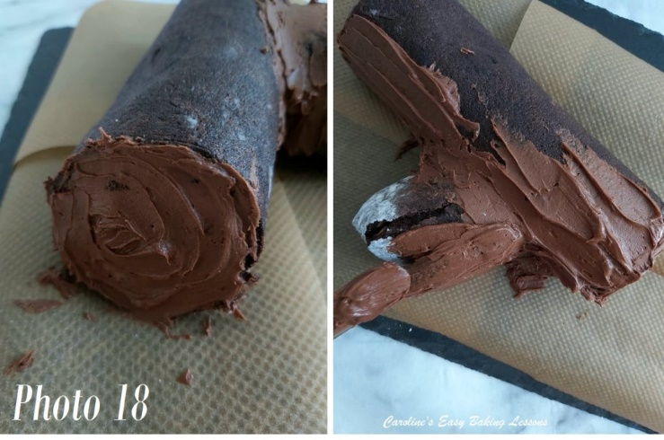
28. Next apply a layer of buttercream along the sides, same side as where the branch is – see Photo 18, right pic. Apply using the palette knife and spread by pulling the palette knife horizontally, in one direction, you can create and build up a ‘bark-like’ covering. Repeat this, working your way up a little, letting it overlap slightly. Do both ends like in Photo 18, and then begin on the tree branch.
29. For the ends of the log, let the frosting come to a rough end when you come to the ends as it will look more natural. No need for perfect straight lines. You will be building up the ‘bark’ too, so lots of practice.
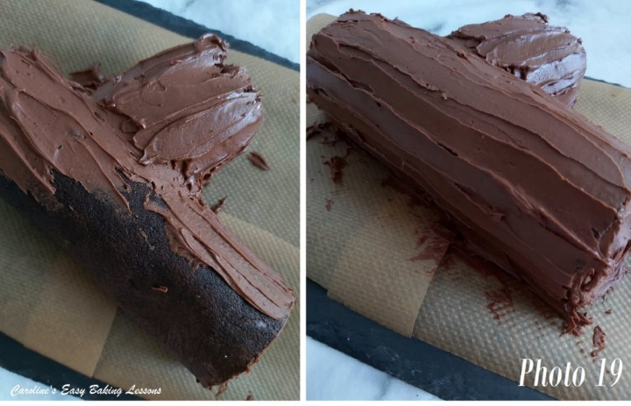
30. Next I found it easiest to work round in this order, applying to the top of the log, going over the branch join area. Note too, when pulling the palette knife to the end, scrape any excess buttercream onto the top of your bowl. Just like if you were applying a buttercream crumb-coat to a layer cake. See Photo 19.
31. Work your way down till all the yule log is covered with ‘bark frosting’. Then simply, repeat the process until you have several thick layers of coating. I did about 3, and then just tidied it up till I was happy with the finish. See Photo 20 below.

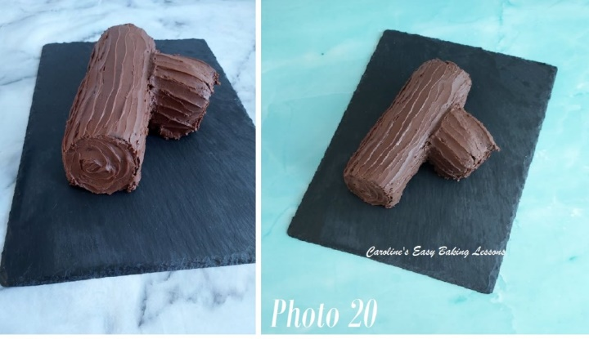
32. Once happy or all the frosting is used up (you can save the left-over frosting for something else), cover the Chocolate & Orange Yule Log with a cake cover if possible and place in the fridge or somewhere cold. I put in the garage, where it was cold. ***Don’t forget to carefully pull the 4 pieces of baking/parchment away before chilling.
You can wait 5 or 10 minutes to do this if needed. You can eat right away if you wish, but when it sets up, it gives not only a nicer look, slices easier too & best of all, you can show the ‘swirl’ better. So chill at least 1 hour. See Photo 20. Your Chocolate & Orange Yule Log (Bûche de Noël) is formed.
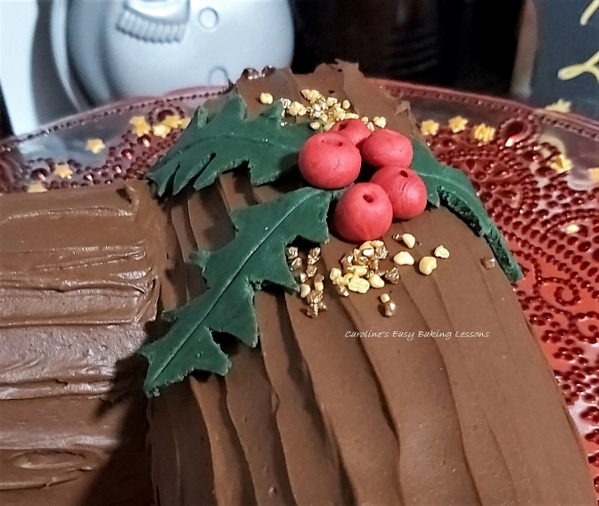
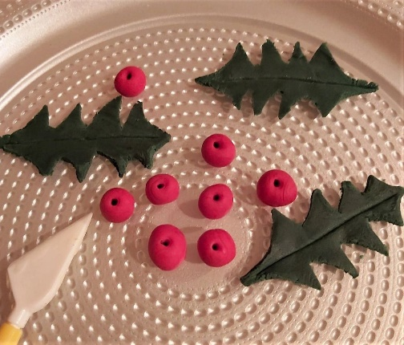

Making Fondant Holly
33. While the cake is chilling, you can make holly leaves if you like, like I did for the 2019 photos. Free-hand, just draw a few Holly leave shapes that would fit your Yule Log, on some paper (baking/parchment paper would be good). Cut these leaves out and then use as stencils to cut leaves, from rolled out green fondant. To make it more realistic, be sure to roll the fondant very thin. (Maximum 2mm or 1/12″ for something small like this). Alternatively, use leaf shaped fondant cutters.
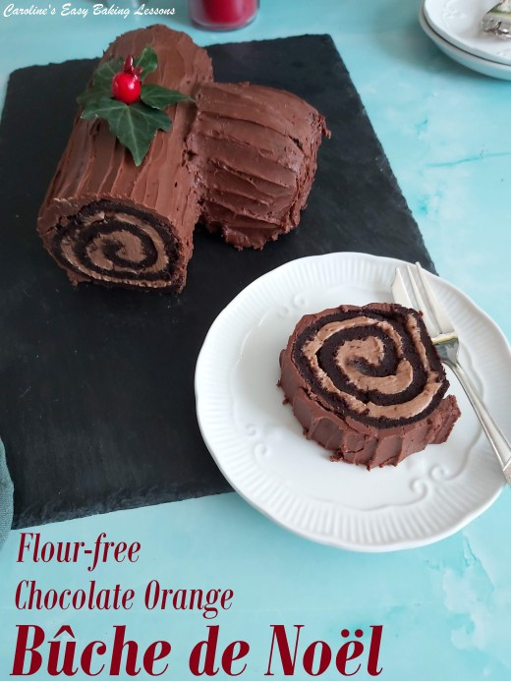
34. Roll at least 6 little balls from the red fondant for the berries. They don’t all need to be the same size. But at least 5mm, or 1/5″ in diameter. Take a black food pen or regular pen (make sure no one eats them), and push down to make a hole part of the way through and leaving a black indent behind.
35. Leave the berries & leaves on a piece of baking/parchment paper to dry. Note these can be made ahead of time, even weeks before. Just cover well with cling film/plastic wrap, store at room temperature and away from direct sunlight as this can fade the colours. Don’t put in the fridge as it creates condensation on the fondant.
36. Position 3 of the leaves on top of the middle of the cake, letting them curve round the cake. Then position the berries in the middle, on top of the ends of the leaves. You can also place spare leaves and berries on the side of the place. Sprinkle the cake and or place with some decorative sprinkles if wished. See Photo. Before serving, you can also dust with icing/powdered sugar if you wish.
37. Slice with a sharp knife and enjoy! Store leftovers somewhere cold and will last up to 3 days.

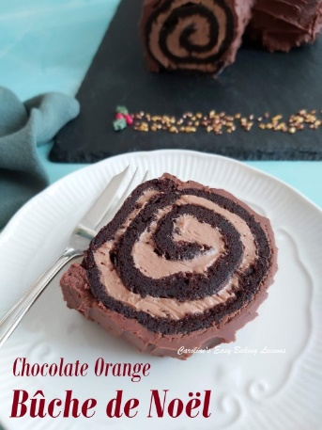
DIFFICULTY LEVEL: Intermediate

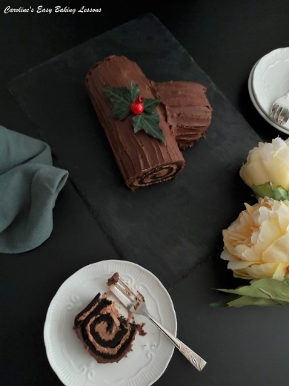

Happy Baking & Making
Happy Memories & Tummies

Caro xx

