EASY CINNAMON & APPLE BUNDT CAKE
Caroline’s Easy Baking Lessons SWEET

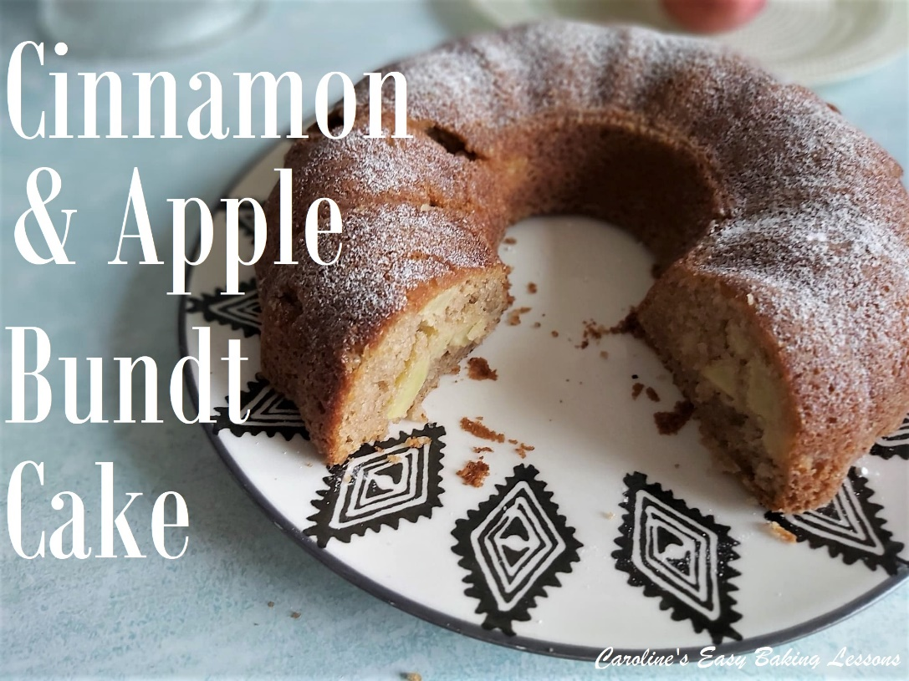
This cake was inspired by another recipe I developed back in 2019 – Wholemeal Pear & Cinnamon Bundt Cake.
We used that for a Facebook group competition & everyone loved it, (see Photo). This recipe today is made using white flour, and instead of tinned pears, I used some apples I needed using up. I also added a bit more spices to this recipe, with the addition of ginger & fresh nutmeg.
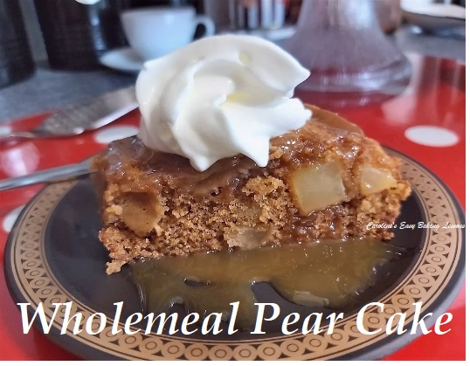
It’s a super simple recipe, you could easily prepare in an hour. You don’t even need to get the hand or stand mixer out. It pretty much includes store cupboard basics with a little dairy. You don’t even need butter. Looks pretty made in a bundt or Savarin tin and doesn’t require any decoration other than a simple dusting of icing/powdered sugar. Goes great with a little cream and some Golden Syrup.

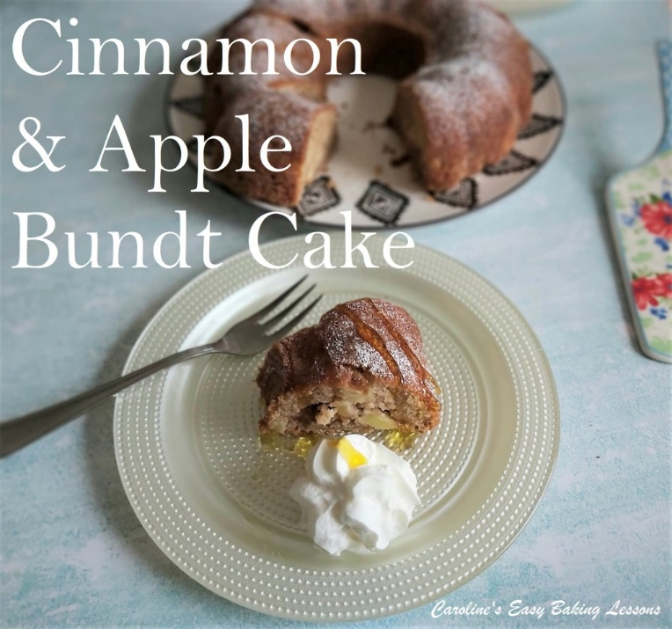
A little note on the ingredients. I used self-raising flour, but I have also listed how to make using plain or All Purpose flour and how much baking powder I like to use. You can use granulated, caster, ultra/super fine, or brown sugar (light or dark). I used 2 medium sized Gala apples, that weighed about 300g (10.5 oz) before peeling and coring.

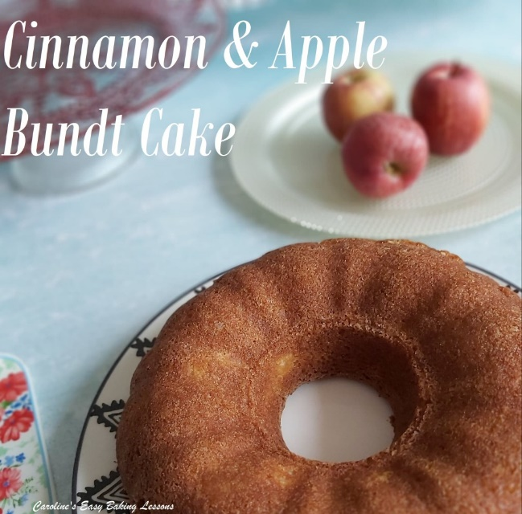

My bundt pan measures 25.5cm (10”) at it’s widest. Just note that the batter only fills a little over half way up my tin, so I wouldn’t be tempted to try a bigger diameter tin, but smaller would be fine.

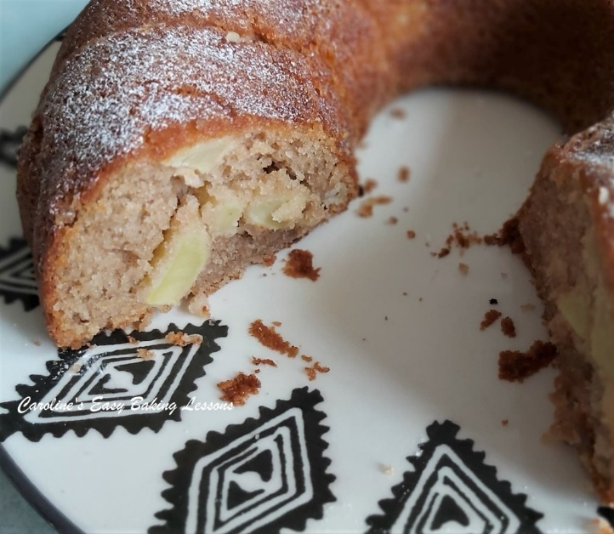
On to the recipe……

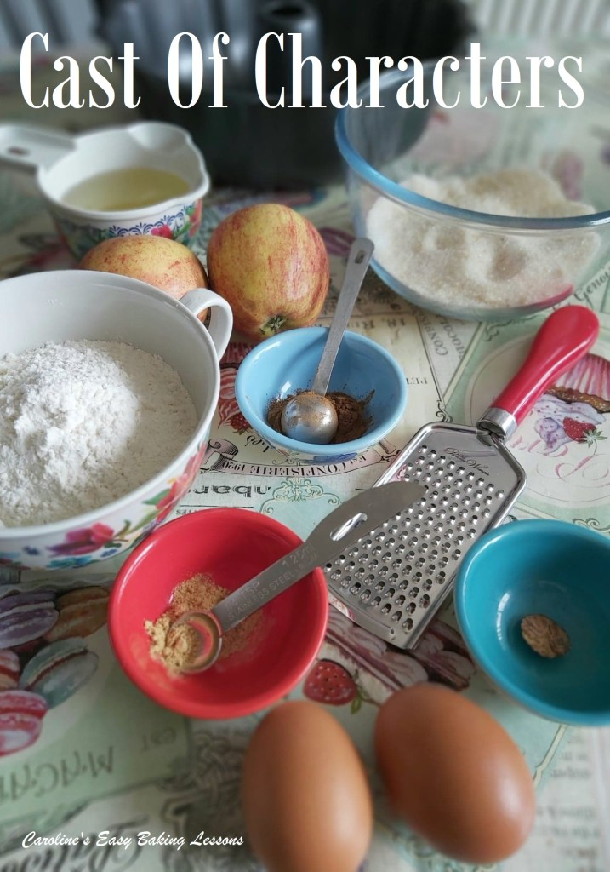
INGREDIENTS
- 188g Self-raising flour (1.5 cups, 6.5 oz)
- OR Plain/A.P. plus 2 tsp baking powder & 1/4 tsp salt
- 1 tsp Baking Powder (level)
- 1 1/2 tsp Ground Cinnamon
- ¼ tsp Ginger
- 1/3 Nutmeg, grated or 3/4 tsp Ground Nutmeg
- 2 Eggs, med-large
- 200g Sugar ( 1 packed cup, 7 oz)
- 130 ml Vegetable Oil (1/2 cup, 4.5 fl oz)
- 2 Apples, (medium sized, I used Gala, weighing 300g (10.5 oz) whole)
- • Milk (enough to loosen batter - approx. 3/4 cups/180ml/6 fl oz)
To Serve: cream and Golden Syrup or caramel sauce (optional)
OVEN: 170c/150c Fan oven/325f/Gas Mark 3

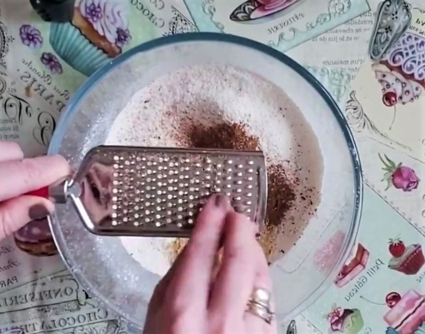

EQUIPMENT
- Measuring scales or measuring cups
- measuring spoons
- Vegetable Peeler
- Vegetable Knife
- Chopping Board
- Small bowl for apples
- Sieve
- Large mixing bowl
- Hand mixer (optional)
- Small measuring jug
- Spoon
- Silicone or Plastic spatula
- Bundt Pan (*see notes above)
- Lining Paste, butter & flour, or Cake Release Spray
- Small sieve (optional)
- Timer or phone timer
- Cooling rack

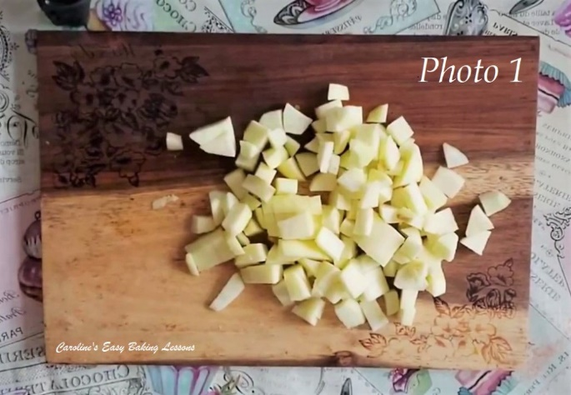
INSTRUCTIONS
1. Begin by peeling, coring & chopping the 2 apples, to about 1cm (1/3″) pieces. See Photo 1. Keep them small so there’s no need to part-cook them. Toss into a bowl with some lemon juice and leave to the side while you prepare the rest of the cake.
2. Heat the oven to: 170c/150c Fan oven/325f/Gas Mark 3

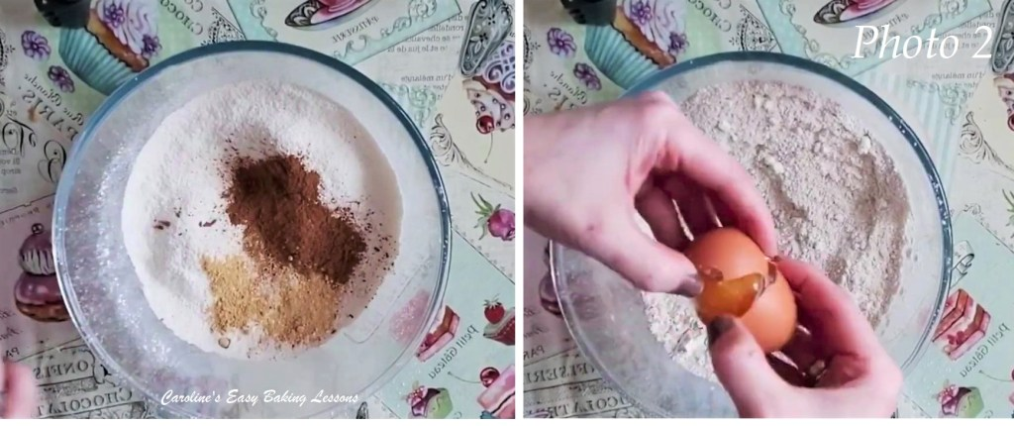
3. Next sieve the flour, baking powder, into a large mixing bowl (you don’t even need to get the hand/stand mixer out for this) and mix to evenly distribute. Then add in the ginger, cinnamon, nutmeg & finally the sugar. I grated nutmeg for it to be fresh as I just love it, and it lasts such a long time. See Photo 2.
4. Then add in one egg at a time, mixing well in-between each addition, letting the flour get as moist as possible. (see video).

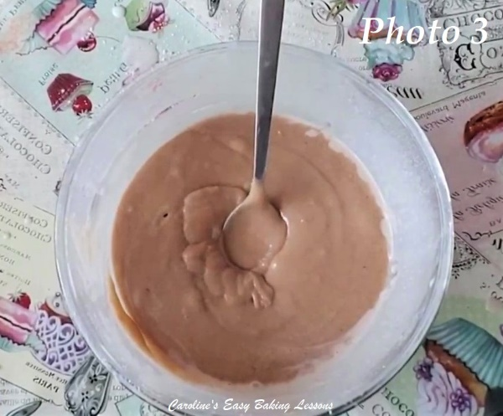
5. Next stage is to add in the oil gradually. I mixed all by hand as it’s a quick recipe, but you can use a mixer on low speed too for this.
6.Add in the milk gradually too until you have a batter that is thick but pourable, and leaves a ‘trail’ or ‘ribbon’ (see video & Photo 3). I have approximated the Milk. Use enough to loosen batter - approx. 3/4 cups/180ml/6 fl oz.

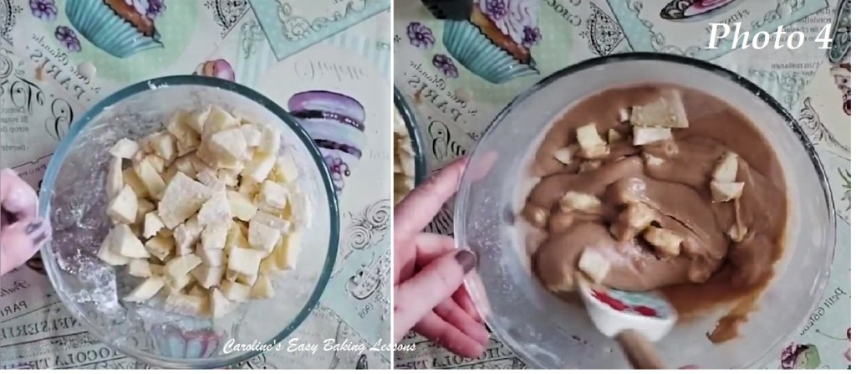
7. Finally add in a few tbsp of flour to the apple pieces and give them a toss to coat them. This reduces the amount of fruit sinking to the bottom of the cake when baking.
8. Fold the fruit into the batter, with a plastic or silicone spoon or spatula (metal cuts out air from the batter). Do so in 3 increments to ensure an even distribution of the apples. See my video for how to fold in the fruit gently. See also Photo 4.

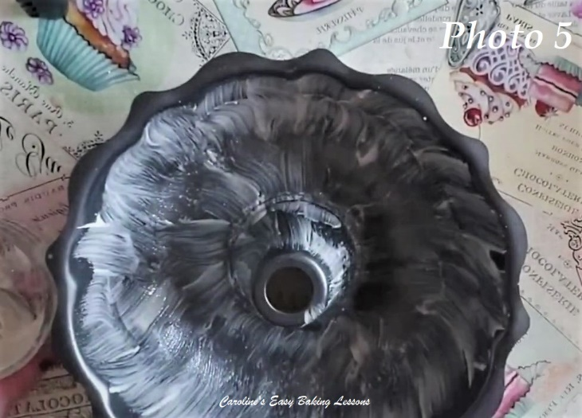
9. Time to prepare your bundt pan. You can go down the usual route of butter and flouring, or cake-release spray, but this Lining Paste is great, cheaper and also excellent for bundt pans. Click here to go to my review & how to make it at home.
10. Be sure to take a few tsp of the lining paste from the jar, and brush on the inside of the pan, in upward strokes. I like to give it two coats. See Photo 5.

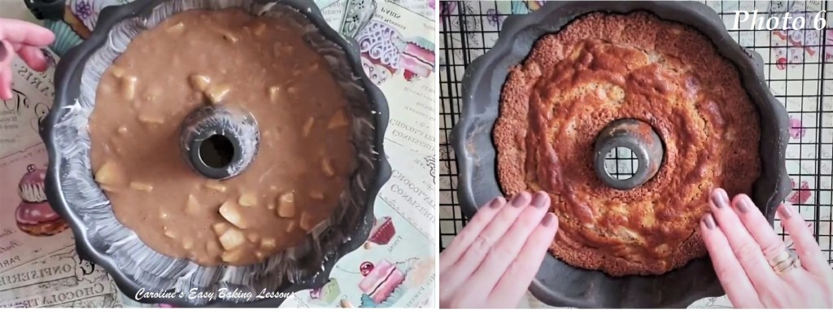
11. The next step is to pour (or spoon), the cake batter into the prepared bundt pan. I always give the cake pan a few taps on the worktop/counter, (just to expel any trapped air), before popping in the centre of the oven and baking for 25 - 40 minutes. The top will be golden (& if that’s the case early on, just cover the top of the pan with a baking sheet/tray and continue baking). You want to check the cake is done, by inserting a wooden cocktail stick into the cake and it coming out clean of crumbs (can be a little moist though because of the apples). Another indication it’s ready, is when the cake is starting to come away from the sides of the pan. See Photo 6.

12. Leave to cool in the tin, on top of a cooling rack for about 30 minutes.
13. To turn out of the tin, place a large plate or cake stand on top of the tin, and whilst holding everything together, flip it over. See Photo 7. Then place the plate on top the cooling rack (this will allow more heat to escape than placing on a table for example. I find flipping over onto the cooling rack directly can be difficult when it comes to trying to transfer the whole cake off the cooling rack.). You might need to give a few gentle taps to the top of the bundt pan (but maybe not), before lifting off the pan. Leave the cake a little longer to cool to touch, before trying to cut or decorate.

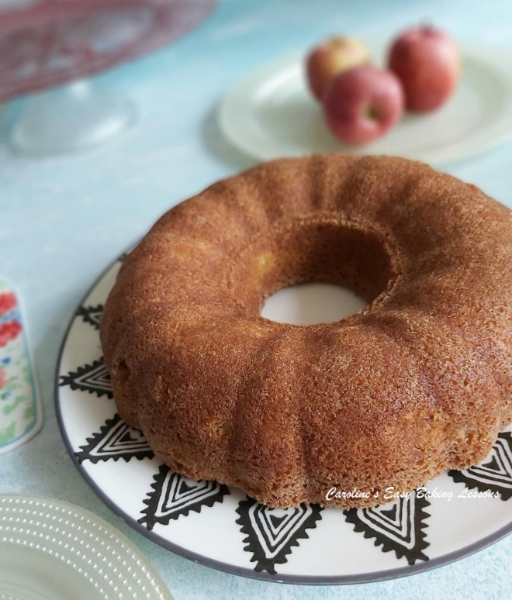
14. This cake only needs a very simple finishing touch of a dusting of icing/powdered sugar. See my video of how to do that. The cake will serve about 10-12 nice sized pieces, and pairs lovely with some cream and Golden Syrup (for where to buy that in the states & Canada, go to my Gingerbread recipe for a full list). Alternatively, caramel sauce would be lovely too, or just eat as is. The choice is yours.
15. Will keep for up to 3 days on a cake stand with dome, or in an airtight container or tin. Try to avoid the fridge or somewhere too cold, or condensation will accumulate and make the cake soggy.
**For a Pear & Wholemeal/wheat version – go to my old recipe

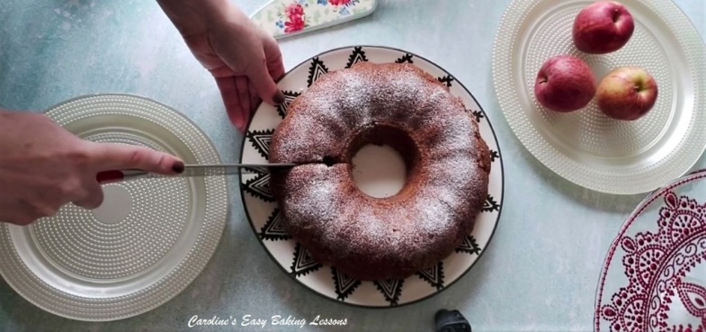
Please see the sharing options or even printing, at the right/bottom of your screen (bottom of your screen for mobiles, and down the right-hand side on computers). You can even pin this to your own Pinterest page. Alternatively, you can download this article, see below. You could also leave some feedback if you like.

DIFFICULTY LEVEL: easy, beginner

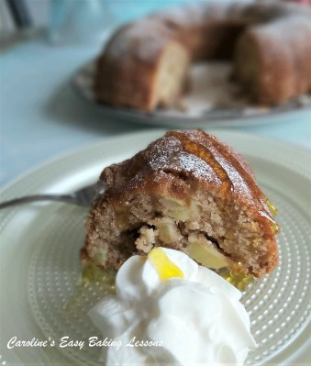
Thanks for reading
Happy Baking & Making
Happy Tummies & Memories!

Caro xx

