Raspberry Jam & Coconut Sponge Squares

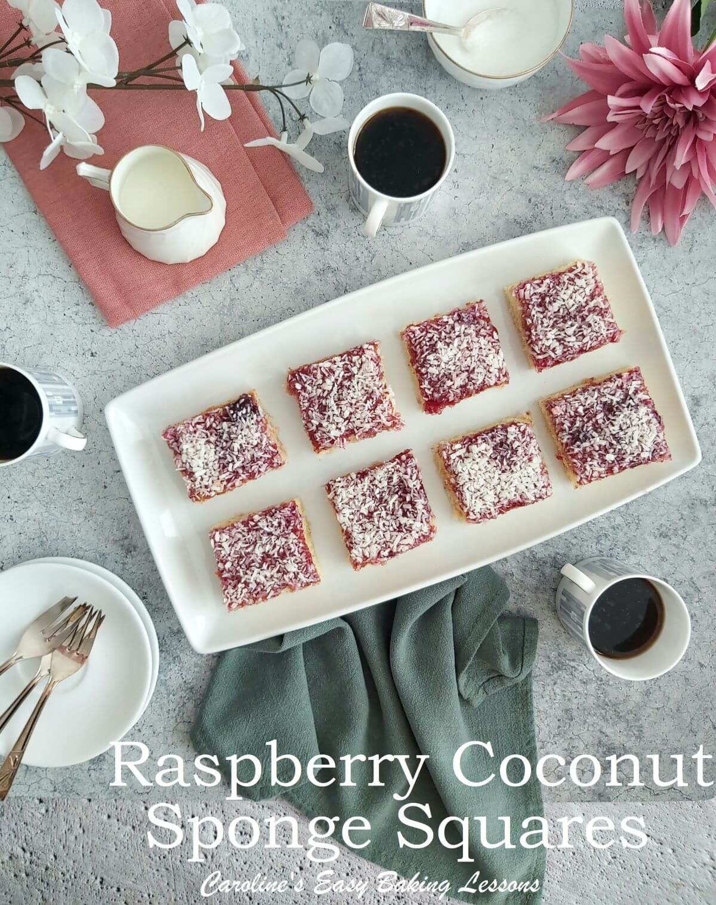
Caroline’s Easy Baking Lessons Sweet Lesson No.1

By Caro

Raspberry Jam & Coconut Sponge Squares are not only tasty cakes to make, but an ideal first baking lesson for beginner bakers. Start simple, and learn the basics of baking before advancing in your baking journey.

BEGINNER NOTES

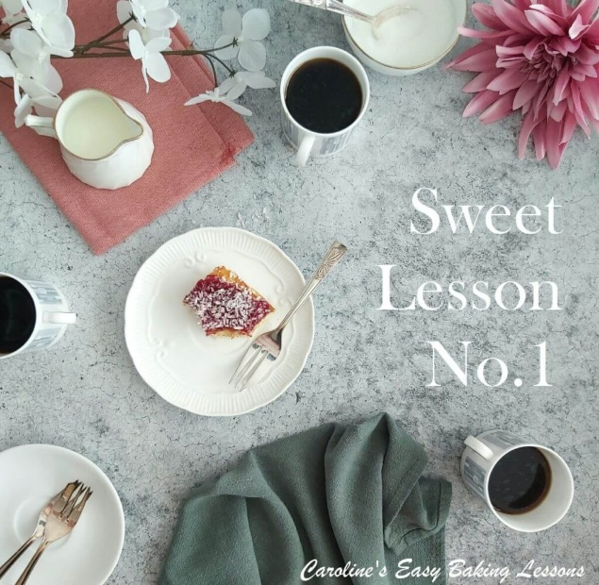
***ALWAYS read the recipe through well before planning to make it or weighing anything out. Often butter needs to be left out to soften & come to room temperature, (as in this recipe). The same can be said for eggs, if you store in the fridge only ever bake with ones at room temperature. In addition to these reasons, in my recipe lessons, if I can dirty even 1 less plate or bowl, then I will include this too. You will also need to know what you will be baking in and adjust accordingly.
Published 17/08/18, updated 24/03/22

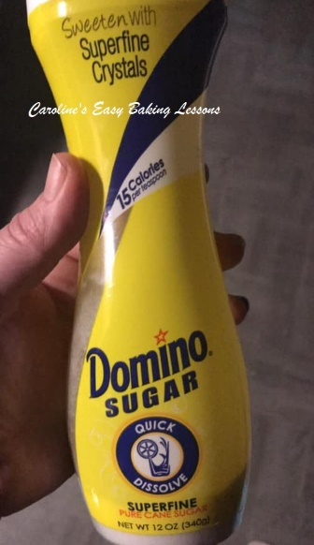
A NOTE ON INGREDIENTS
Caster Sugar
The equivalent to UK Caster Sugar is known as ‘Extra Fine or Super fine sugar’ in the US. Here is a photo of one particular brand that is available in the states. The bottle however is for tea or coffee, so isn’t in a very big bottle, (only 340g/12 oz). Berry Sugar, Fruit Sugar, Baker’s Sugar can all be used as a substitute too. You can also make your own from granulated sugar. Please note though that that US regular (granulated) sugar is finer than our UK granulated.

How To Make Your Own Caster Sugar
Just be careful, as grinding in a processor too much may produce too fine a sugar, (similar to powder and be icing/powdered sugar) and possibly ruin your machine. So I would advise caution with it. Some people have also been known to use coffee bean grinders. A good tip with making your own is to crush in small batches and weigh or measure it as you go along until you get the quantity you need. Alternatively, make up a jar of your own caster sugar and use when needed. Be sure to store in an airtight container.
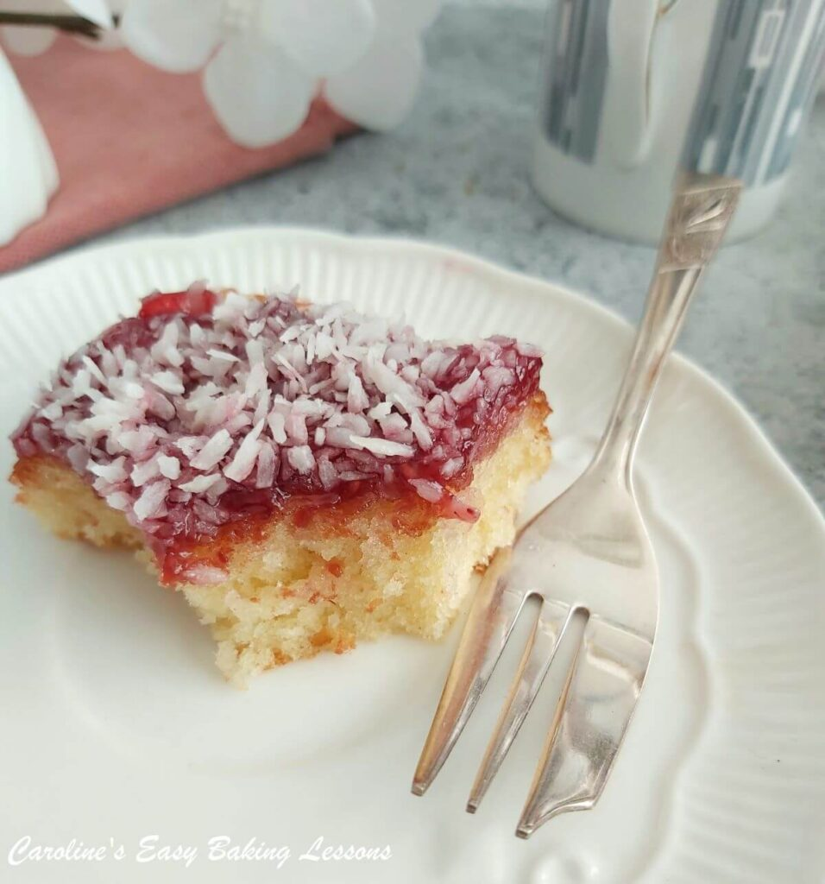
Why Use Caster Sugar? Can Granulated Be Used?
Well I am often asked this question, if granulated can just be used and the answer is that for some bakes, yes you can. However, there are a few points to note. Unless if the sugar is being melted, to say make a drizzle, then the caster sugar is there not only providing a function of sweetness and moisture, but also to create friction when you are creaming with the butter. This process of rubbing, with the small sugar crystals, creates friction, which in turn produces air pockets, which gives a nice rise and light texture to cakes.
In meringues and macarons, I would always advise on using fine sugar, again because of the reactions that are occurring. For most cakes for example, they will still bake off nice, but they will not be exactly as intended by the recipe developer. And this is something to bear in mind. See here my photo of the 3 main sugars we use in baking here in the UK.

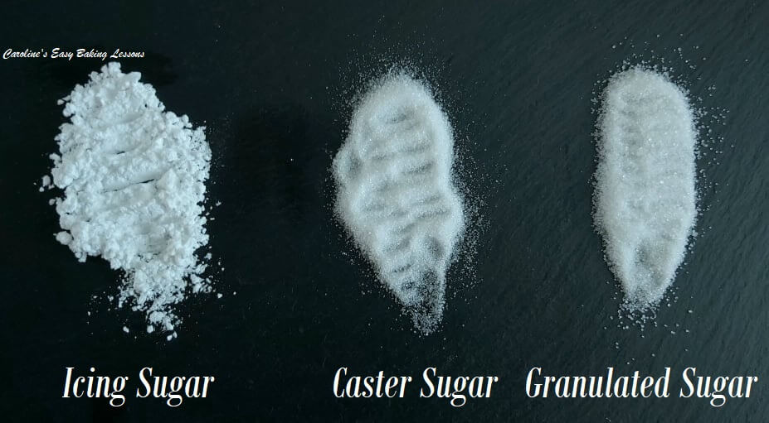
Comparing UK Sugars

Self-raising Flour
This easy sponge recipe uses Self-raising flour & is very easy to find in UK shops. This is similar to US self-rising flour in that there is baking powder in it. However, our Self-raising flour in the UK has a bit more baking powder per 125g/1 cup.

How To Make With Plain/A.P. Flour
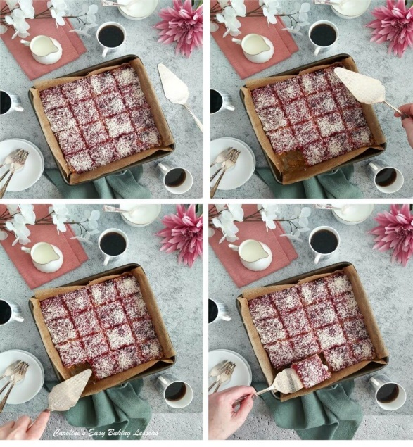
In all my recipes, I ALWAYS provide details on how to make the recipe, using plain/All Purpose flour and baking powder and have it tested too. I tend to use less than the recommended amount of baking powder though as I find it gives a bitter metallic after taste.
Also I believe that over time, between being made in the factory and being used in the home, that the self-raising loses some of its raising powder. For more about UK & US/Canadian baking and ingredients, read my Differences Between UK & US Baking Ingredients article.

Jam/Preserve & Coconut
You can use Jam, Jelly or Preserve for this cake recipe. If too thick for spreading evenly, you might require to thin just a little with a splash of water.
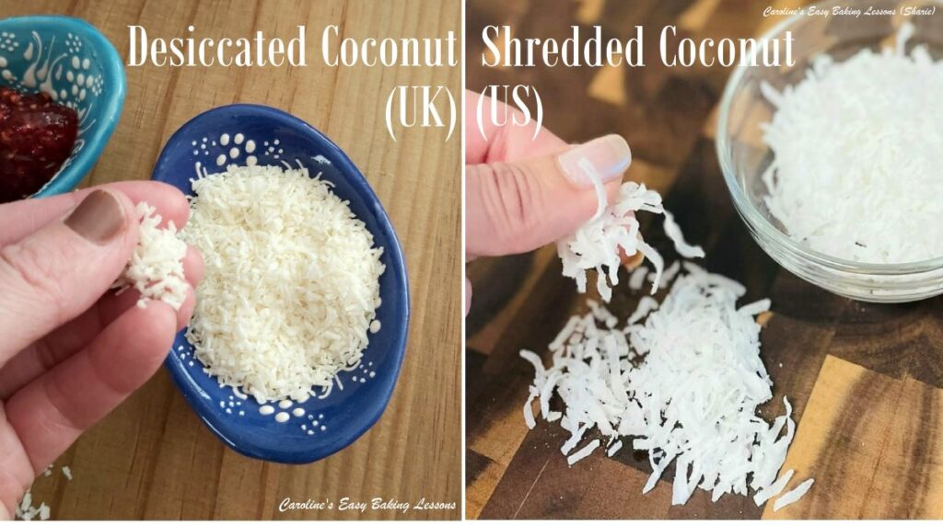
The equivalent of UK Desiccated Coconut, is US Unsweetened Shredded Coconut. However, the US version, is in larger pieces. You can choose to process just a little, lightly chop or just leave as is, the choice is yours. The amount needed for the topping is also an approximate amount. See my photo comparing the 2 types of coconut use in baking. If you love using coconut in your baking, check out my Coconut Lovers article. Or go to my coconut & raspberry recipes.
It also is very moist and stays so, if you store in a tin with the original baking/parchment paper. So is a perfect recipe for beginner bakers.

ALL RECIPES CONVERTED & MEASURED
All my recipes include conversions from grams to ounces and cups. Note that they have all been calculated by hand, by myself and tested several times, since Google is often inconsistent and inaccurate. But I also have a conversion table, with common baking ingredients for you to refer to- go to my Baking Ingredient Conversion table.

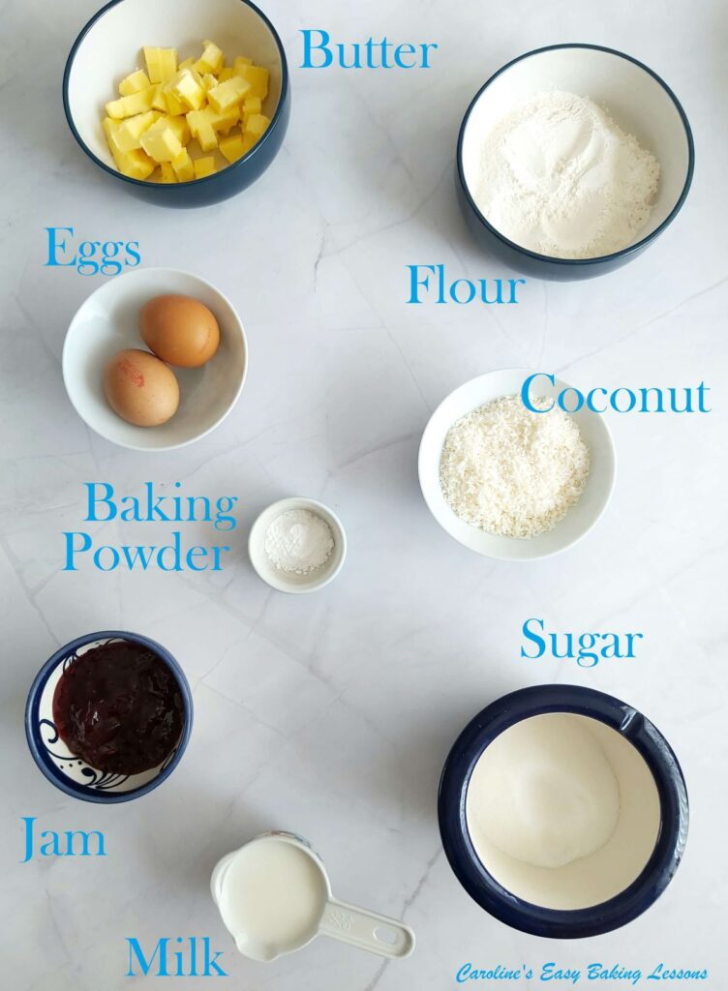

INGREDIENTS
113g Soft butter, cubed (1 stick, 1/2 cup)
113g Self-raising flour*
OR 1 cup A.P./Plain Flour, plus 1 + 1/2 tsp Baking Powder)
113g Castor sugar (1/2c extra fine sugar* see above)
1 tsp Baking powder
2 Eggs (med-large, large-XLarge US)
75ml Milk (5 tbsp)
8-10tbsp Raspberry jam/jelly/preserve
100g Desiccated coconut
(1 cup max. US larger, unsweetened, shredded coconut is fine too, maybe just lightly chop it)

EQUIPMENT
Scales or measuring cups
Measuring spoons
Hand or Stand Mixer: to cream the butter & sugar, or a wooden spoon & hard work.
Sieve
Spray Oil ( other oil or butter for greasing)
Baking/Parchment Paper
Square baking tin: 22x22cm (9 in x 9 in). Or rectangular tin up to 30 x 16cm (12 x 6 inches), but no more than a total of 18 inches/44cm when you add the length and width. Otherwise cake will be too shallow
Cooling rack
Timer or Phone Timer
OVEN: 190c/Fan oven 170c/375f/Gas Mark 5

INSTRUCTIONS
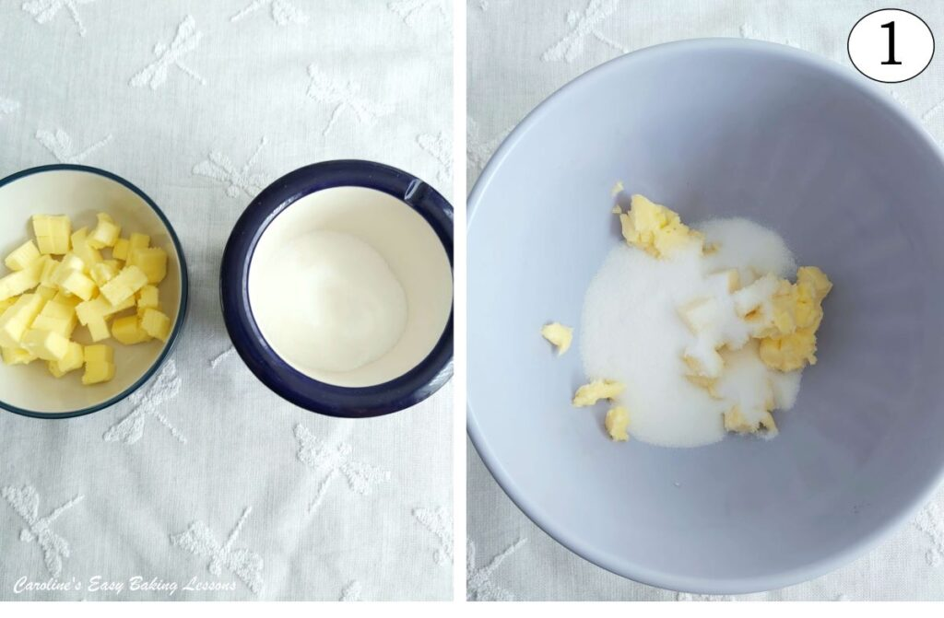
1. Cube the butter while measuring out. I like to cut to about 1.25cm (1/2″) size roughly, as a smaller surface area softens and comes to room temperature quicker. It’s also easier to mix in too. See Photo 1.
But if you forget or are short on time, try this hack I reviewed, for Softening Butter In About 12 Minutes. Also see photo 2 below for how soft the butter looks.
Place the softened butter in a mixing bowl & place on the scales and set it to zero (Tare). This will save on the washing up by measuring like this. Alternatively, you can use measuring cups, or have all your ingredients measured out before beginning (known as ‘Mise en place‘).

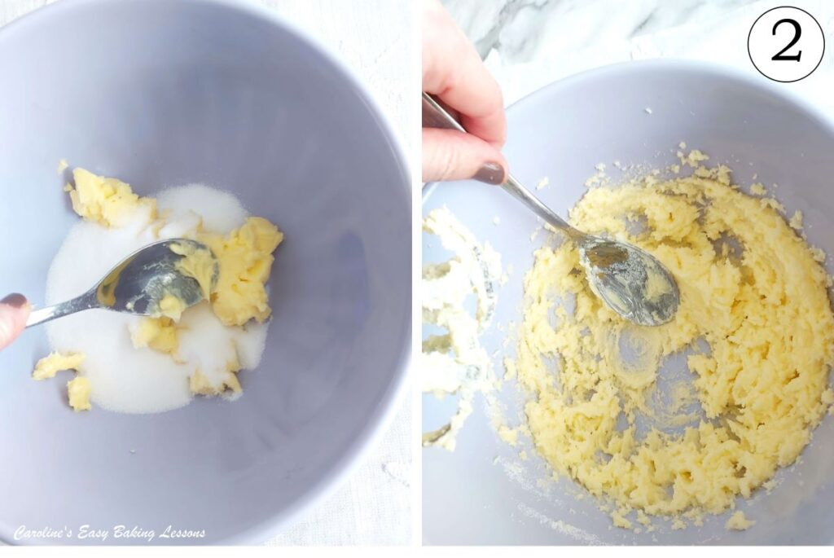
2. Next weigh in the sugar to the softened butter and mix briefly by hand (just so the sugar doesn’t go everywhere). Then mix until combined and soft and fluffy (also known as ‘creaming’). This can be done quickly with a stand mixer or even a hand mixer which can be bought cheaply and are compact for storage. See Photo 2 for how the creamed butter should look.
Alternatively, use a wooden spoon and a lot of elbow grease. The mixture will also appear a little paler in colour too once beaten enough. How long this takes, will depend on how soft your butter is and the power of your mixer, but will generally be a few minutes. This stage is important for incorporating air into the batter and producing a good rise and light cake. Don’t worry about over-mixing at this stage.

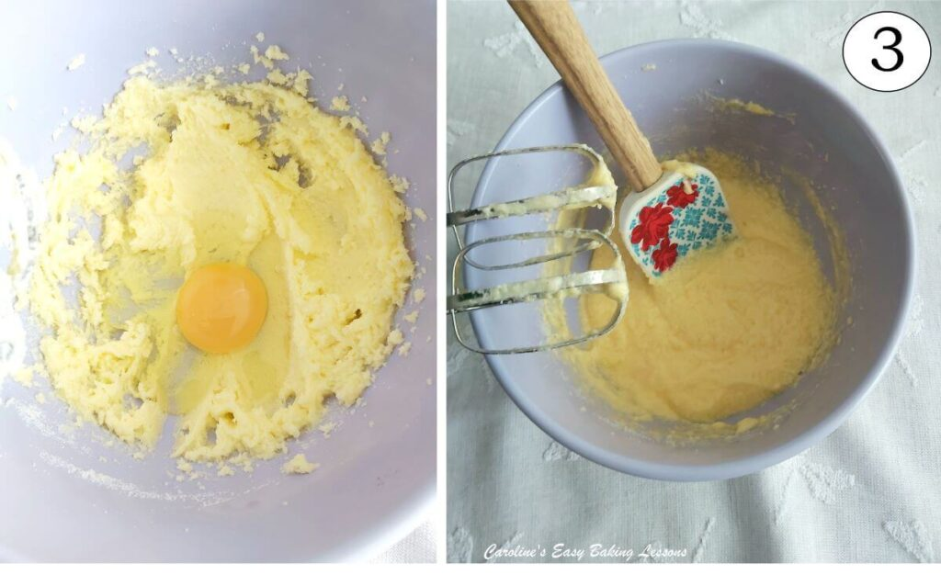
3. Add one egg at a time to the mixture and mix well in-between each addition. If you want more rise in your bake, you can whisk the egg first (this activates the gluten, that helps with structure).
You can sprinkle on a spoon of the flour before the last egg, if the mixture is looking a little curdled. But don’t worry if it still does, it will still come out nice. See Photo 3.

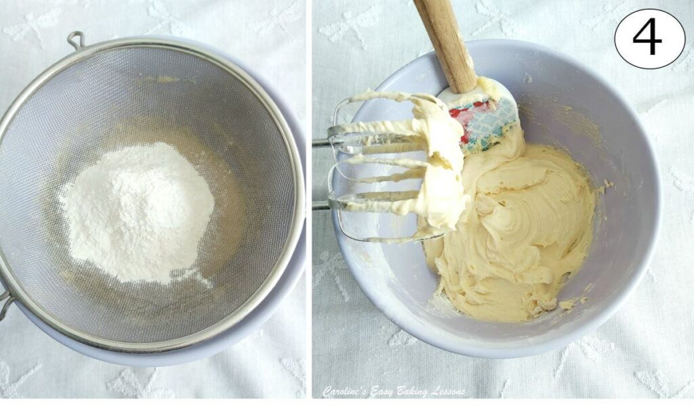
4. Next, place the mixing bowl on top of the scales, with the sieve on top, setting to zero (Tare) and weigh in the flour & baking powder. If using A.P. or Plain Flour, be sure to add the extra baking powder too. See Photo 4.
While these ‘dry ingredients’ are in the sieve, mix them together, thus ensuring an even distribution of the baking powder in the batter). Remove the sieve & mix until just combined and no more flour is visible. If you hold the sieve higher up, it will incorporate more air into the batter.

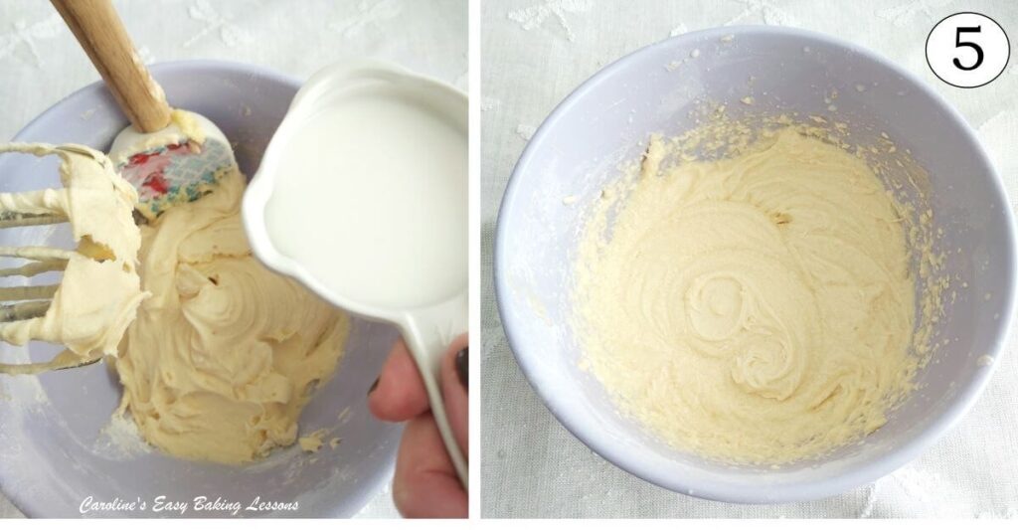
5. Add in the milk and again mix until just until combined, (over-mixing will produce a dense cake, not light and airy. Let the baking powder do it’s magic). Read my article on Over-mixing & Dense Cakes – Lesson 5. See Photo 5.

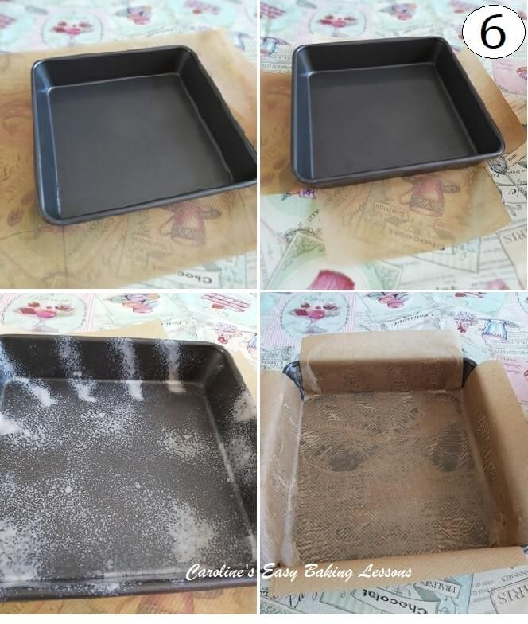
6. Pre-heat the oven to 190 ◦c/Fan Oven 170 ◦c/375◦f/Gas mark 5. (Do this earlier if your oven takes longer to come to temperature). Cut out baking/parchment paper for your tin. Lay the paper under the tin and ensure there is enough paper to go up the sides of the tin. In the 2nd pic in Photo 6, I have a cross shape cut out (you can draw the areas to cut out to produce this, see first pic).
Lightly grease (use spray oil, such as Frylight or make your own lining paste), the insides of the tin generously and lay the paper inside, firming it in place. (Turn the paper over if you have drawn lines on it). Use more butter/oil/paste if needed to get it to stay down in position. Trim the excess paper hanging over is too long (sometimes can end up in the cake). See Photo 6. Or go to my Cake Tin lining article.

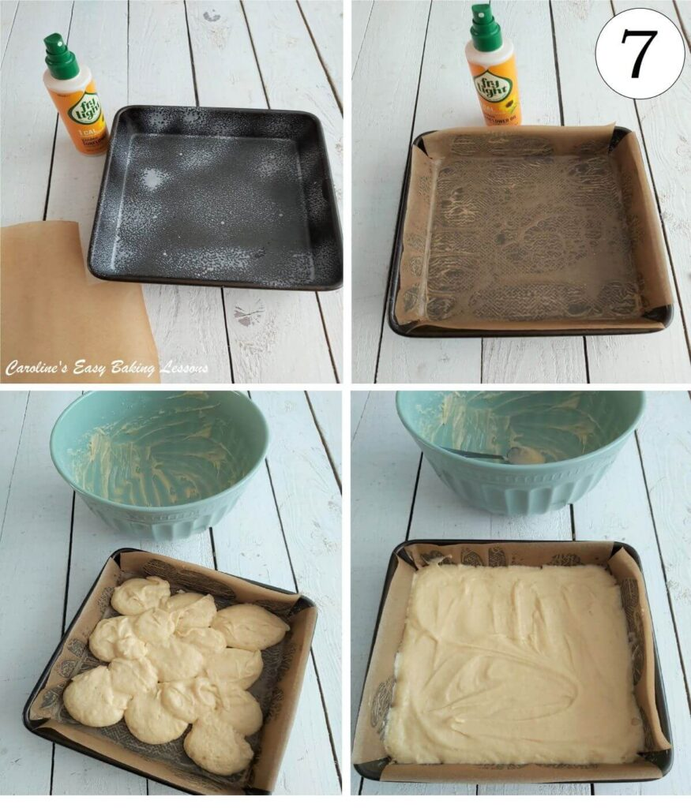
7. Now pour/spoon the cake batter into the prepared tin. Level it out as best as possible with a spoon and then give a few taps on the worktop/counter to remove any air. See Photo 7.
Frylight cooking spray, is great for quickly and easily greasing your cake tins, pastry tins etc. Also great in cooking too. I use the Butter, & Sunflower varieties for my baking, as they are more neutral flavours. You can purchase these less expensively than the big supermarkets, by buying at Lidl.
8. Bake in the centre of the oven for about 15-22 mins, until evenly golden brown on top (turn the tin around during baking if it’s not evenly golden, but don’t do so, until past the half-way mark). Do not be scared of getting a nice colour on your bake – colour equals taste and flavour.

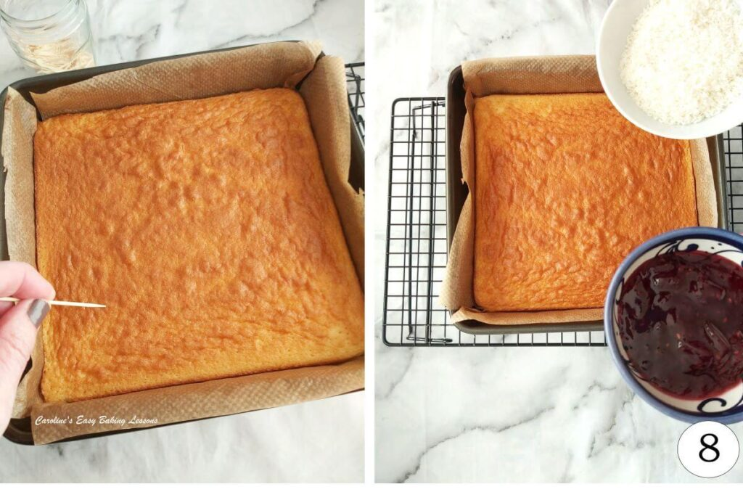
To test if it’s done, insert a cocktail stick/wooden tooth-pick into the centre of the sponge and if it comes out clean, it is ready. If not, put back in the oven for another 2 minutes and check again until done. See Photo 8.
**If the cake is a good golden colour on top but not ready in the middle yet, cover the top of the cake with tin/aluminium foil and continue to bake till done with the cocktail stick test.
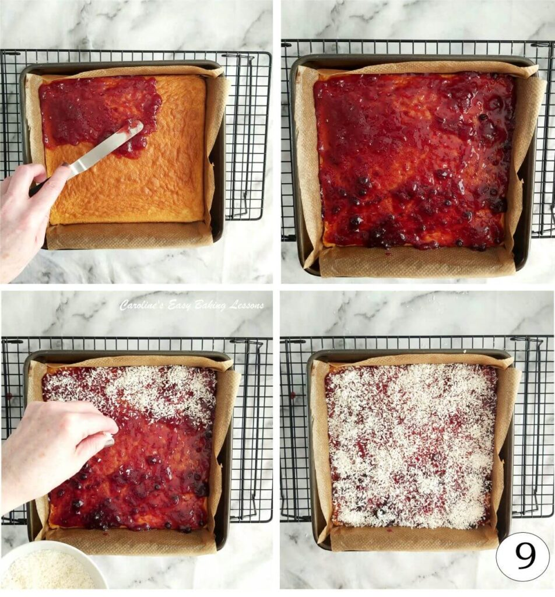

9. Leave to cool in the tin on a cooling rack. Meanwhile, mix the jam in a small bowl with about 1-2 splashes of water and mix it through to thin it out slightly if needed.
10. Spoon the jam on top of the cooled sponge cake and spread evenly getting right into the corners. Now sprinkle coconut on top of the jam layer. Let it absorb the coconut a bit and then sprinkle another light layer of coconut. If you can resist, leave to set a bit before cutting. See Photo 9.

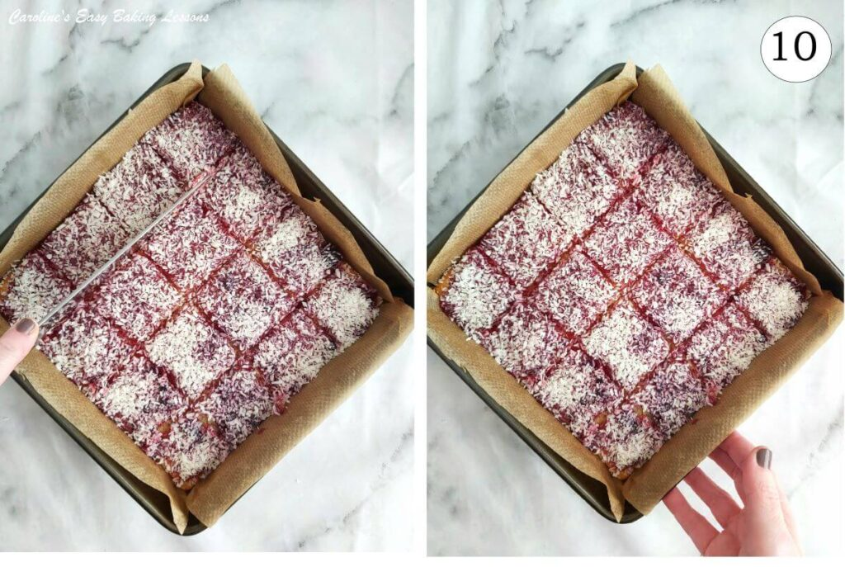
11. Either cut in the tin or lift out with the baking paper and cut on a chopping board. I usually get 16 squares but you can cut them into whatever size you want. See Photo 10.
12. Store in an air-tight tin. I have an old biscuit tin the right size for this and if you keep stored with the baking/parchment paper, it helps keep the moisture in the cake a little bit longer. These will be fine for a few days if stored properly and in a cool environment.
13. If you want to freeze the cake, I would suggest just freezing the sponge cake without the topping. I haven’t tested freezing jam toppings yet. Just wrap in baking/parchment paper and then either cling film/plastic wrap or a food bag and mark the baked date. Use within a few months.
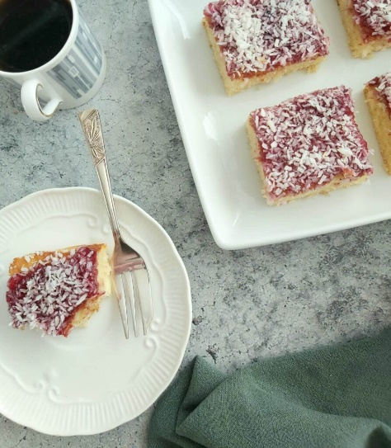
Difficulty Level – Super Easy, Beginner

BAKING STUDENTS
NEXT STEP – Once you are ready, go onto Theory Lesson 2, After that go to Savoury Lesson 1. – 30 Minute Yeast Free Cheesy Bread, see pic below.

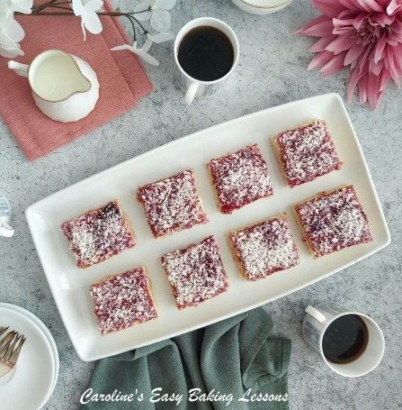
Happy Baking & Making, Happy Memories & Tummies!

Caro xx

