Easy Banana Bread Caroline’s Easy Baking Lessons

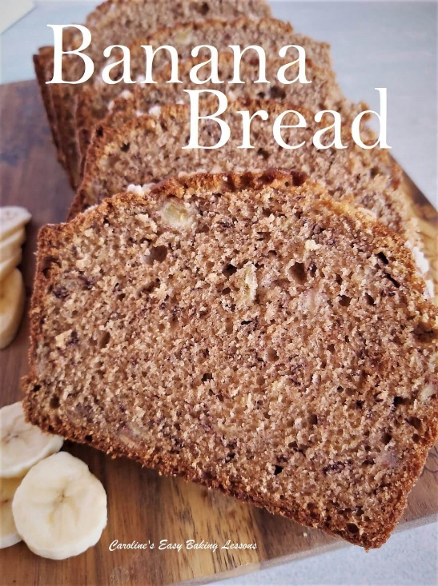
So Easy Even Kids Can Make It

By Caro

Here's my Easy Banana Bread recipe. Quick and simple to make, even kids can make it. Makes a great beginner bake. Recipe in grams, cups & ounces

Originally posted 25/03/20 & updated 5/5/22

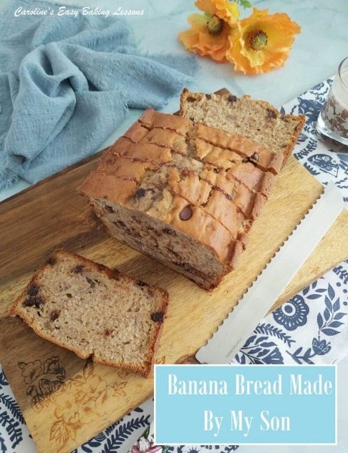

1. Quick & Easy Recipe
My banana bread recipe, is so quick to make. Using digital scales you can even measure, make & bake in one bowl. Not only saving you more dirty bowls to wash, but time too.
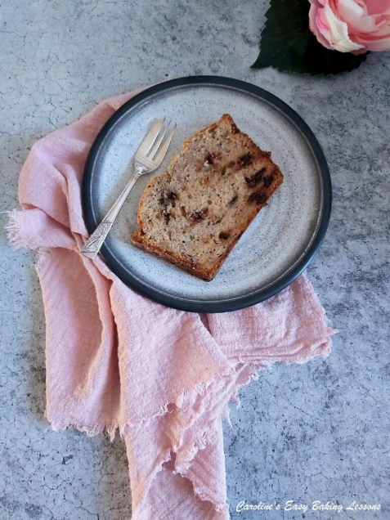
The process could not be simpler too. Beginner bakers or kids can even make these. Simply ‘creaming’ butter & sugar together & then adding in the other ingredients, before adding to the loaf pan & baking. Some of the photos are from the recent banana bread my 15 year old son made me for Mother’s Day. He is the one making it in the short video below.

2. Healthier & Taste Good
I have published this recipe, using white flour, but often use wholemeal/wheat flour, including the bran. I use butter & sugar, but I use less butter than regular loaf cake, & it works too using dark brown sugar. I have also made using unprocessed Coconut Sugar, (which also requires a little less sugar – I recommend using 25% less).
Of course there’s bananas too, which are providing the recipe & us with many things. Once the bananas are ripe, the starch converts to sugars (glucose, fructose & sucrose). Bananas however have a relatively low glycaemic index (GI) of 42-58 dependent on how ripe they are. To read more got to my Healthier Banana Bread Muffin recipe. See photo below, or Healthier Banana Bread Muffin video.

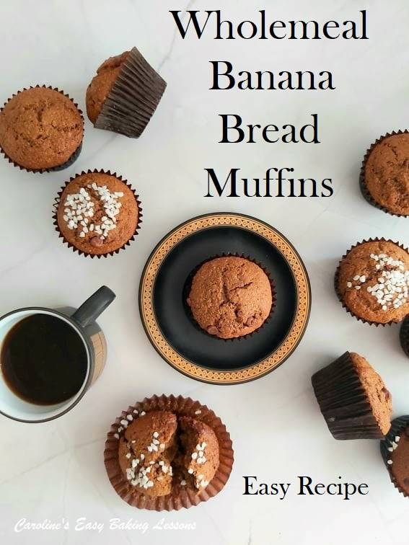
3. No Special Ingredients/Equipment
All ingredients are easy to find or have on hand already. Instead of the Greek yoghurt, you can use any plain/natural, thick-set yoghurt. The alternative to UK Mixed Spice, is US Pumpkin Spice. And no special equipment needed either.

4. Easily Add Inclusions
Now by that I mean things like chocolate chips, dried fruit, sugar nibs/pearls etc. And yes that will make them a bit less healthy, but things in moderation, right? And don’t have them with home-made salted caramel sauce (only joking). See the photo further down.

5. Inexpensive
These banana bread muffins are relatively inexpensive compared to other muffins or cupcakes. Not using lots of butter, frostings, and bananas that are past their best, these can work out cheap to make. I have not included the cost, as that is going to vary from country to country.

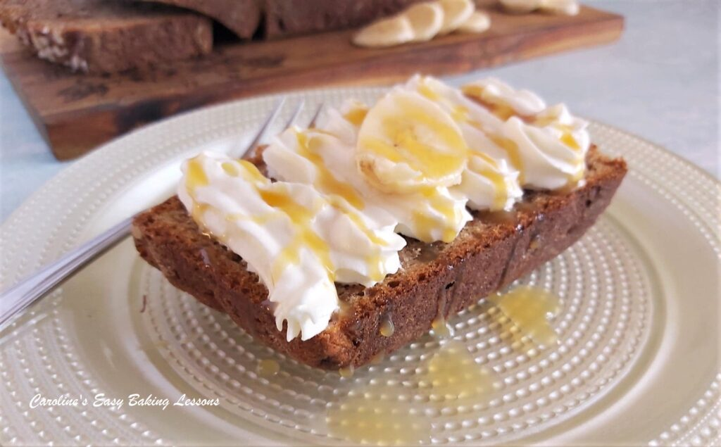

Recipe Yield & Tin Size
Now the recipe ingredient quantities listed below as for a 2lb loaf/bread tin. (About 21 x 11 x 7cm or 6 x 4 x3″) . Those can vary a little in shape, but this recipe by design, grows with a nice big dome in the centre so you can get decent sized slices out of it. If you want to use a 1lb tin, the ingredients are reduced by about 25%. So at the very bottom of the recipe I will also include those calcs for you.
You will get about 12 slices from this loaf.
You can also view my Banana Bread Chocolate Chip Muffins video (photo above).

Tip
Another point to note, is to cover the top of the tin with foil at the half-way, 20 minute mark as it will have risen, the crust set up & be browned by then. The centre will not be anywhere near ready, so that’s why making a little foil tent is advisable. Just don’t put the foil on until the top crust has set. The cake will be ready once a wooden cocktail stick comes out from the centre, clean of crumbs.

Kids Baking
As mentioned, some of the pics are from the banana bread loaf made by my son and he is making it in the video below. He did really well for a comedian (point to note there is also a little video of him and his comments when making it – go to video). He added chocolate chips to his loaf.

INGREDIENTS
- 72g Soft, cubed unsalted butter (1/3 c, 2.5 oz)
- 200g Granulated Sugar (1 c, 7 oz)
- 3 Med – Large Eggs (Large USA)
- 242g Mashed Bananas (3/4 bananas) (1 c, 8.5 oz)
- 212ml Greek Style Yoghurt or Mayonnaise (2/3 c, 7 fl oz) Approx*
- 352g Plain Flour or Strong Flour* (2 3/4 c All Purpose or Bread Flour, 12.5 oz)
- 1 1/2 tsp Cinnamon
- 1 tsp Bicarbonate of Soda (Baking Soda)
- 1 tsp Salt (level)
- 1/2 tsp Ginger
- 1/2 tsp Mixed Spice/All Spice or Pumpkin Spice
- 1/2 Nutmeg, freshly grated (or 1 tsp ground nutmeg)
- Sugar Pearls (optional)
- Butter or Cream & sauce (optional)

* I have made with both Plain/A.P. & Bread flour. After adding the dry ingredients to the wet, you might need a few more tbsp of the yoghurt to get the correct consistency (different flour & way/places it’s milled, results in a variation in amount of liquid it absorbs) Same can be said for wholemeal flour. Refer to recipe photo as a guide.

EQUIPMENT
- Weighing scales or measuring cups
- Measuring spoons
- Fork
- Large mixing bowl
- Medium sized bowl
- Hand/stand mixer
- Small measuring jug
- plate/bowl to mash bananas on
- Rubber or silicone baking spatula
- 2lb Loaf Tin (See above. To use a 1lb see foot of recipe)
- Lining Paste, melted butter or cake release spray
- Small pastry or artist brush for greasing
- Large spoon
- Timer or phone timer
- Cooling rack
- Large sharp or serrated bread knife
OVEN: 180c/160c Fan Oven/350f/Gas Mark 4

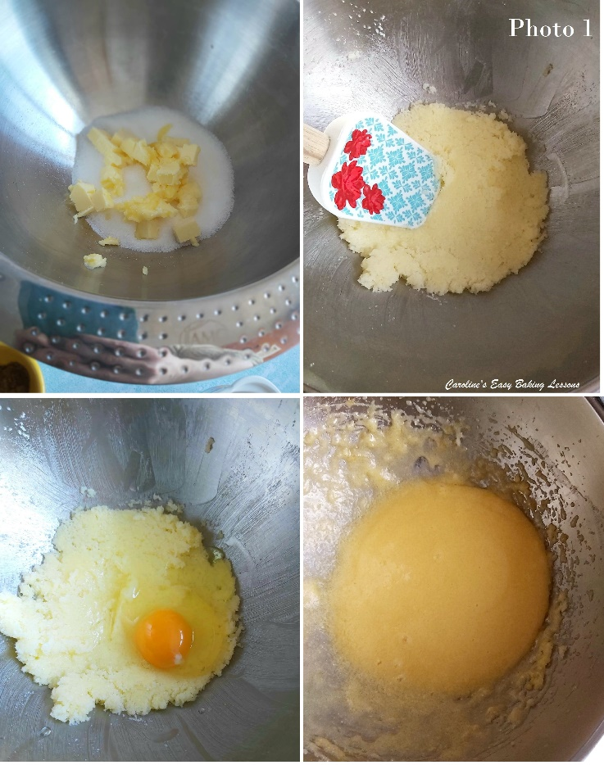
INSTRUCTIONS

1. Begin to ‘cream’ the butter and sugar together with a hand or stand-mixer. Beat it on high until soft and paste like. Note that the sugar will still be large crystals at this stage so you don’t need to mix for too long. See Photo 1.
2. Next, add in one egg at a time, mixing well in-between each addition till distributed through. See Photo 1.
3. Heat the oven to: 180c/Fan Oven 160c/350f/Gas Mark 4. If your oven takes a long time to heat up, do this before starting.
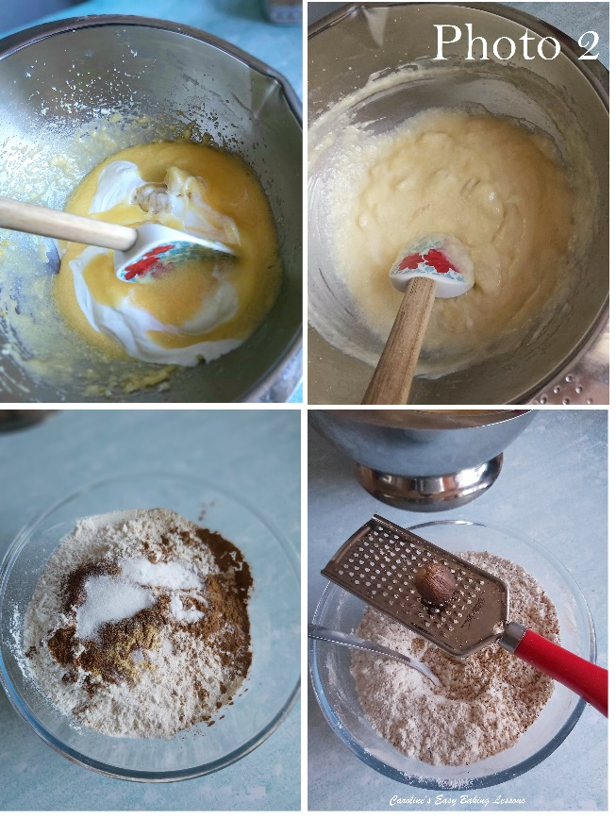
4. Fold in the mashed banana and yoghurt (or mayonnaise) just till evenly distributed. (Note if you leave some large ‘pieces’ when mashing the banana, you will have some nice surprise banana pieces in the final bake). Fold in with a rubber or silicone spatula, like you were writing a number 8 in the batter. When doing this, be very careful to not knock out any air. Only do so until all mixed through. See Photo 2.
5. In a medium – large mixing bowl, mix together the flour, salt, bicarbonate of soda (baking soda) & spices.

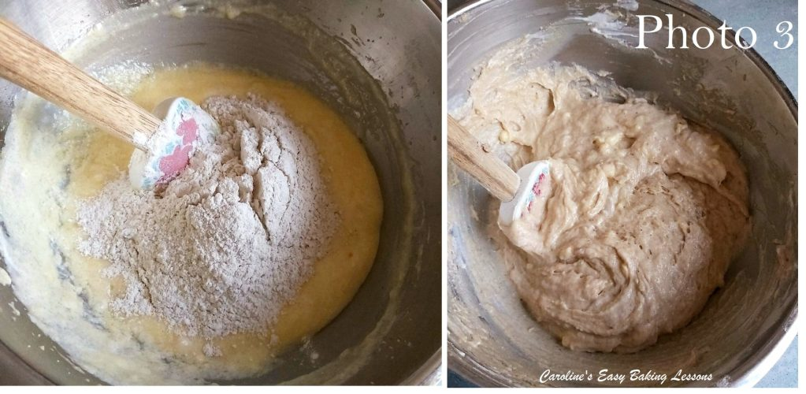
6. Next, fold the dry ingredients into the wet ingredients, again in the shape of an ‘8’, but do so gradually in 3 increments. Be very careful to ensure you don’t leave any of the flour at the bottom of the bowl. Again mix just until everything is evenly distributed and no more. See Photo 3.

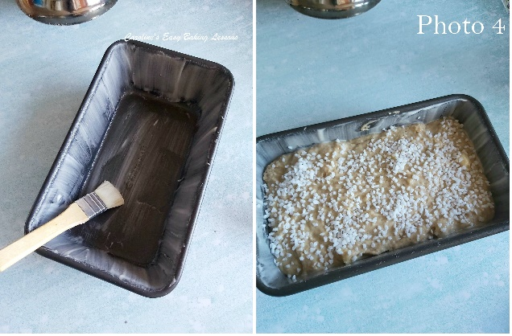
7. Now it’s time to line your loaf tin. I used Nancy Birtwhistle’s lining paste recipe – go to lining paste recipe. (See Photo 4.) Alternatively, brush a good coat of melted butter on the inside of the tin, brushing in upward strokes, or even some cake release spray. You can also line with a piece of baking/parchment paper too if you would like. I strongly recommend making the lining paste as it works a treat, even in bundt pans and is cheap to make. See my video below, of the bake just popping out of the tin.
8. Pour the batter into the tin and level off with the back of a spoon and tap the tin a few times off the top of the counter/worktop to expel any trapped air. You can also top with some sugar pearls (note that if you want a good coverage once baked off, you need to apply more than you think you need). See Photo 4.
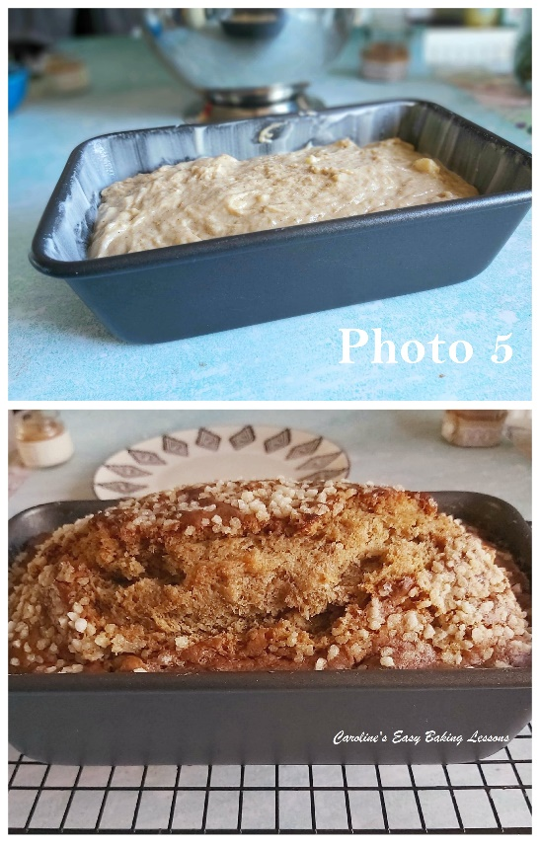
9. Finally, bake in the centre of the oven for between 45 – 60 minutes. This time will depend on how hot your oven is running at (I check mine every time with a thermometer), and which tin size you used (for 1lb tin it will be a little quicker). So I recommend putting the timer on for 20 minutes. Then turn the tin around and cover the top of the bread with foil (by this point the bread will be well risen and set on just the top crust). Don’t put the foil on before that or the batter will stick to the foil. Now bake for at least another 20 minutes and then check the bread is done, by inserting a wooden cocktail stick into the centre of the bread. If it comes out clean of crumbs it is ready. If not, turn the tin, place the foil back on and bake another 5 minutes. Keep checking until ready. Then remove from the oven and leave to cool in the tin, on top of a cooling rack, for about 30 minutes . See Photo 5.
10. Now turn out the bread onto a cooling rack and allow to cool down more. If you used the lining paste, it should literally slip out when turned upside down. See my little video below of this happening.
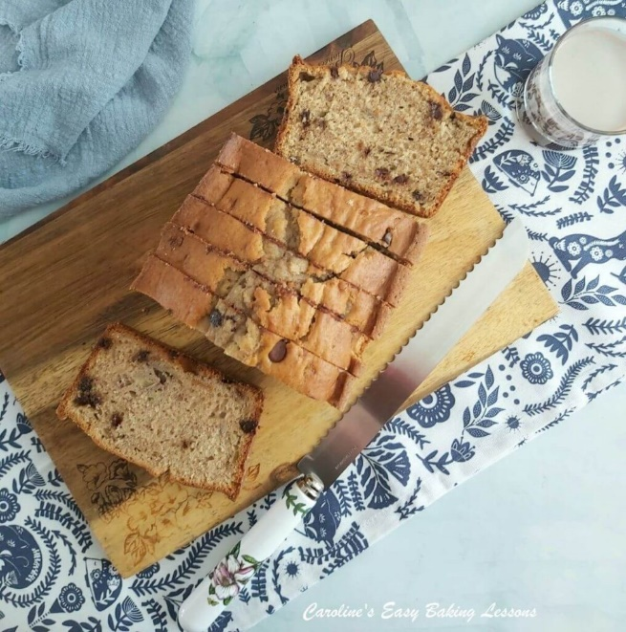

11. Once cooled enough and ready to eat, slice with a large sharp, or serrated bread knife very carefully. See Photo 6. Eat as is, or as my oldest son did, with some cream on top and some caramel sauce. Banana bread and caramel sauce go well together. Store in a cake box or something similar for a few days (if you are lucky!) I like to slice and then wrap individually in tin/aluminium foil, to keep fresh and quick to grab for a snack.
Can easily be frozen as a whole loaf or sliced. Just cover with baking/parchment paper and then some foil and cling film/plastic wrap or a food baggie. Just defrost at room temperature.
Thanks for reading, Caro xxx

